## Sample After Hospital Care Plan (AHCP)

## **Bring This Plan to ALL Appointments**

After Hospital Care Plan for:

Oscar Sanchez

Discharge Date: August 1, 2012

TRY TO QUIT SMOKING: Call Jon Doe at (555) 555-3344 at ABC Medical Center.

Question or Problem with this Packet? Call your Discharge Educator: (555) 555-2222

Serious health problem? Call Dr. Mark Avery: (555) 555-5555

**EACH DAY** follow this schedule:

MEDICINES

| What time of day do I take this medicine? | Why am I taking this medicine? | Medicine name  Amount | How many (or how much) do I take? | How do I take this medicine? |
| --- | --- | --- | --- | --- |
| sunMorning | Blood pressure | PROCARDIA XL  NIFEDIPINE  90 mg | 1 pill | By mouth |
| Blood pressure | HYDROCHLOROTHIAZIDE  25 mg | 1 pill | By mouth |
| Blood pressure | CLONIDINE HCl  0.1 mg | 3 pills | By mouth |
| Cholesterol | LIPITOR  ATORVASTATIN CALCIUM  20 mg | 1 pill | By mouth |
| Stomach | PROTONIX  PANTOPRAZOLE SODIUM  40 mg | 1 pill | By mouth |
| sun | Heart | ASPIRIN EC  325 mg | 1 pill | By mouth |
| To stop smoking | NICOTINE  14 mg/24 hour | 1 patch | On skin |
| Then, after 4 weeks use 🡪 | NICOTINE  7 mg/24 hour | 1 patch | On skin |
| Blood pressure | COZAAR  LOSARTAN POTASSIUM  50 mg | 1 pill | By mouth |
| Infection in eye | VIGAMOX  MOXIFLOXACIN HCl  0.5% solution | 1 drop | In your left eye |
|  | | | | |
| http://www.ricksmath.com/pics/12oclock.gif  Noon | Blood pressure | ATENOLOL  75 mg | 1 pill | By mouth |
| Blood pressure | LISINOPRIL  40 m | 1 pill | By mouth |
| Infection in eye | VIGAMOX  MOXIFLOXACIN HCl  0.5% solution | 1 drop | In your left eye |

|  |  |  |  |  |
| --- | --- | --- | --- | --- |
| What time of day do I take this medicine? | Why am I taking this medicine? | Medicine name  Amount | How many (or how much) do I take? | How do I take this medicine? |
| swirls,southwest,southEvening | Infection in eye | VIGAMOX  MOXIFLOXACIN HCl  0.5 % solution | 1 drop | In your left eye |
|  | | | | |
| http://www.artvogt.com/Images/MGconcept03.jpgBedtime | Blood pressure | CLONIDINE HCl  0.1 mg | 3 pills | By mouth |
|  | | | | |
| If you need  it for headache | Headache | TRAMADOL HCl  50 mg | 1-2 pills  Every 6 hours  If you need it | By mouth |
| If you need it for  chest pain | Chest pain | NITROGLYCERIN  0.4 mg | 1 pill every 5 minutes  (if need more than 3 pills, call 911) | Under your tongue |
| If you need it to stop smoking | To stop smoking | NICORELIEF  NICOTINE POLACRILEX  4 mg gum | Gum | Chew |

** Bring this Plan to ALL Appointments**

Oscar Sanchez

What is my main medical problem?

Chest Pain

When are my appointments?

|  |  |  |
| --- | --- | --- |
| Wednesday,  August 8  at 11:30 a.m. | Thursday,  August 16  at 3:20 p.m. | Wednesday  September 12  at 9:00 a.m. |
| Dr. Mark Avery  Primary Care Provider (Doctor) | Dr. Anita Jones  Rheumatologist | Dr. Lin Wu  Cardiologist |
| 100 Main St, 2nd Floor  Anytown, ST | 100 Pleasant Rd, Suite 105  Anytown, ST | 100 Park Rd, Suite 504  Anytown, ST |
| For a Followup appointment | For your arthritis | To check your heart |
| Office Phone #:  (555) 555-5555 | Office Phone #:  (555) 555-6666 | Office Phone #:  (555) 555-4444 |

What exercises are good for me?

Walk for at least 20 minutes each day.

What should I eat?

Eating food that is low in fat and low in cholesterol will help you stay healthy.

What are my medicine allergies?

**REMEMBER you are ALLERGIC to MOTRIN.**

Where is my pharmacy?

Joe’s Pharmacy

1234 Summertime Ave.

Anytown, ST 55555

(555) 555-7777

**Questions for**

**Dr. Avery**

For my appointment on

**Wednesday, August 8th, at 11:30 am**

**Check the box and write notes to remember what to talk about with Dr. Avery.**

I have questions about:

 My medicines

 My pain

 Feeling stressed

What other questions do you have?

* I am having trouble with the stairs in my house.
* Someone I live with smokes.
* I feel stressed or overwhelmed.
* I am having trouble getting food.
* There are other things going on in my life that are effecting my health.

Dr. Avery: When I left the hospital, results from some tests were not available. Please check for results of these tests.

* I am having trouble with the stairs in my house.
* Someone I live with smokes.
* I feel stressed or overwhelmed.
* I am having trouble getting food.
* There are other things going on in my life that are effecting my health.
* I am having trouble with the stairs in my house.
* Someone I live with smokes.
* I feel stressed or overwhelmed.
* I am having trouble getting food.
* There are other things going on in my life that are affecting my health.

August 2012

* I am having trouble with the stairs in my house.
* Someone I live with smokes.
* I feel stressed or overwhelmed.
* I am having trouble getting food.
* There are other things going on in my life that are effecting my health.

|  |  |  |  |  |  |  |
| --- | --- | --- | --- | --- | --- | --- |
| **Sunday** | **Monday** | **Tuesday** | **Wednesday** | **Thursday** | **Friday** | **Saturday** |
|  |  |  | **1 Delivery of Bed by Martin, Inc. 555-555-6767** | **2**  **N.E. VNA to visit 555-555-8888** | **3**  **Pharmacist will call** | **4** |
| **5** | **6** | **7** | **8**  Dr. Avery at 11:30am  100 Main St, 2nd Floor, Anytown, ST | **9** | **10** | **11** |
| **12** | **13** | **14** | **15** | **16**  Dr. Jones at 3:20 pm, 100 Pleasant Rd, Suite 105, Anytown, ST | **17** | **18** |
| **19** | **20** | **21** | **22** | **23** | **24** | **25** |
| **26** | **27** | **28** | **29** | **30** | **31** |  |

September 2012

|  |  |  |  |  |  |  |
| --- | --- | --- | --- | --- | --- | --- |
| **Sunday** | **Monday** | **Tuesday** | **Wednesday** | **Thursday** | **Friday** | **Saturday** |
|  |  |  |  |  |  | **1** |
| **2** | **3 Labor Day** | **4** | **5** | **6** | **7** | **8** |
| **9** | **10** | **11** | **12**  Dr. Wu at 9:00 am at 100 Park Rd, Suite 504, Anytown, ST | **13** | **14** | **15** |
| **16** | **17** | **18** | **19** | **20** | **21** | **22** |
| **23** | **24** | **25** | **26** | **27** | **28** | **29** |
| **30** |  |  |  |  |  |  |

My Medical Problem:

Noncardiac Chest Pain

Noncardiac chest pain is pain that is not caused by a heart problem.

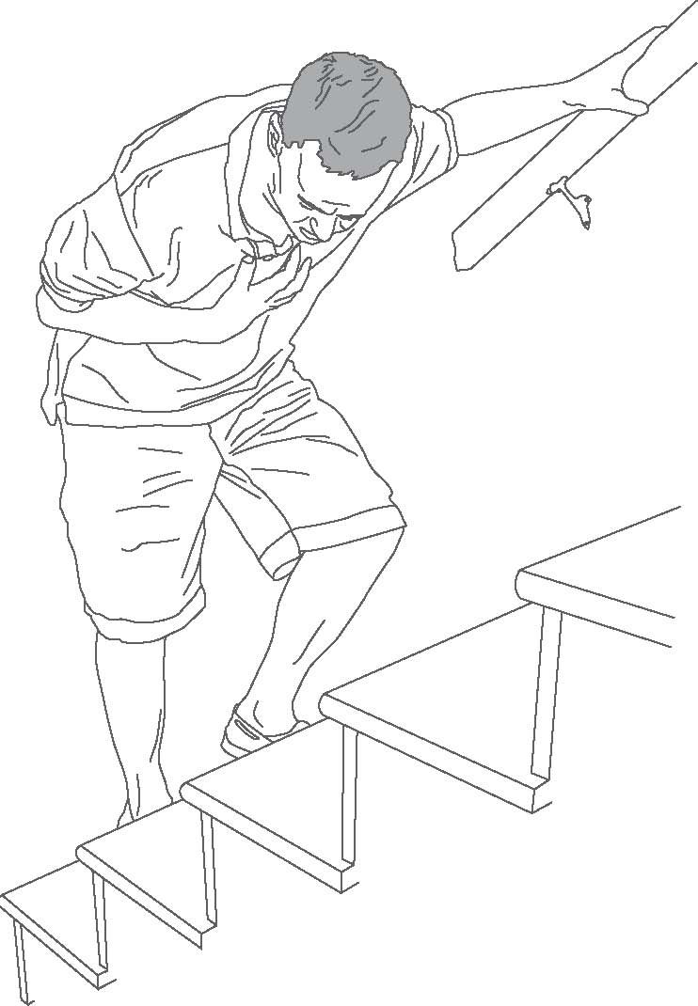

* If your chest pain gets different or worse, call your doctor.
* Take your medicines as prescribed.
* See your doctor and ask questions.

My Medical Problem:

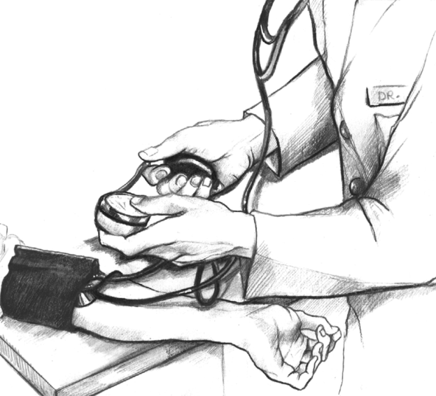High Blood Pressure

High blood pressure is also called hypertension.

* Avoid salty foods.
* Take your medicines as prescribed.
* See your doctor and ask questions.

**Source:** National Institute of Diabetes and Digestive and Kidney Diseases (NIDDK).