Communicating With Patients and Families About Antibiotic Decisions
Ambulatory Care

Slide Title and Commentary | Slide Number and Slide
Communicating With Patients and Families About Antibiotic Decisions  Ambulatory Care  SAY:  Welcome to the presentation titled, “Communicating With Patients and Families About Antibiotic Decisions.” | Slide 1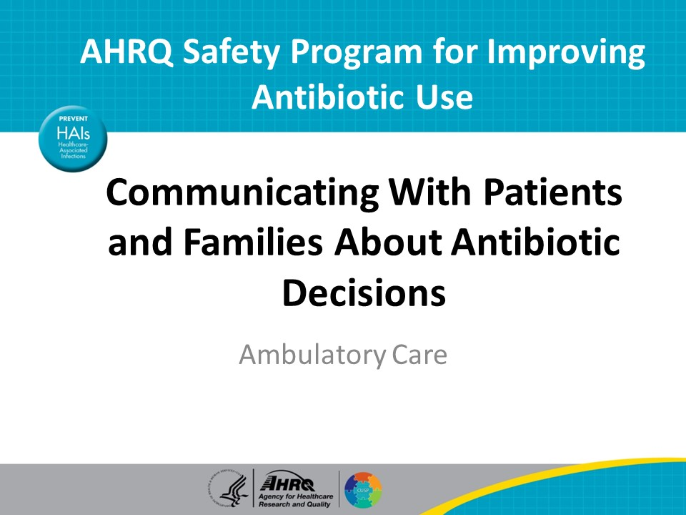
Objectives  SAY:  By the end of this presentation, participants will be able to—  - Describe communication strategies to consider when discussing antibiotic use with patients and  - Learn how to effectively communicate about antibiotic use with patients | Slide 2
Why Focus on Communication?  SAY:  Understanding how to effectively communicate with patients about antibiotic prescribing decisions can reduce unnecessary and potential harmful antibiotic prescribing.  If all members of the practice use clear and consistent messaging about antibiotic prescribing, including about conditions for which antibiotics are not necessary,  clinic visits will be more efficient and result in both improved clinician and patient satisfaction. | Slide 3 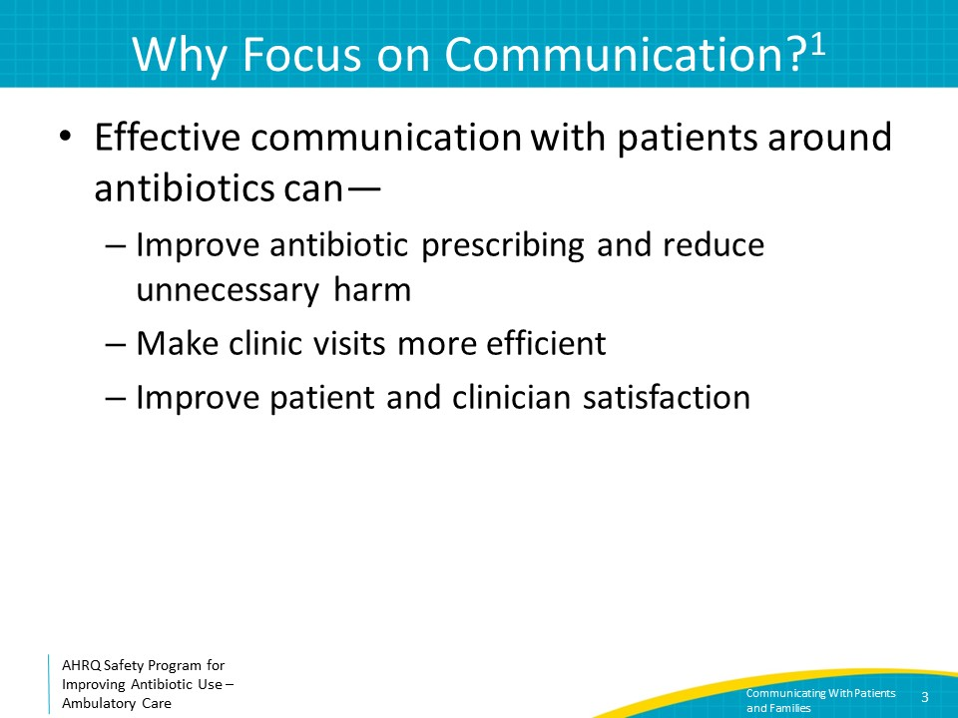
Misconceptions About Antibiotic Prescribing  SAY:  A common scenario clinicians face is a patient or family member requesting antibiotics. However, what we think the patient wants may not always correlate with what the patient actually wants.  In a 2014 systematic review of 13 pediatric studies on parent-clinician communication and antibiotic decision making, parental concerns were often misinterpreted as pressure to prescribe antibiotics. Perceived antibiotic expectation was a major source of antibiotic over-prescribing.  There is a common belief that not receiving an antibiotic prescription decreases patient satisfaction. This is not necessarily the case. While some studies have identified correlations between patient satisfaction and antibiotic prescribing, other studies have not shown correlation. Effective communication and good relationships with patients have been more consistently associated with favorable patient satisfaction scores than antibiotic prescribing.  There is a false perception that it takes longer to explain why an antibiotic is unnecessary than to provide an antibiotic prescription. Studies have shown that, on average, discussions around not prescribing antibiotics generally take only 1 to 2 minutes. Using effective communication can go a long way in promoting patient satisfaction and avoiding harmful antibiotic prescribing. | Slide 4
Improving Communication  SAY:  Patients want to be heard, and patients want their concerns validated.  A 2013 overview of communication in medical consultations, mostly around those with chronic illness, found that patients highly valued a strong relationship with their clinician and a genuine emotional tone in patient-clinician conversation. In essence, trust-building and empathy are key.  To demonstrate to patients that their concerns are being taken seriously, clinicians should speak to patients at eye level, preferably by sitting down. Additionally, they should summarize and repeat back to patients the information the patient provides about their concerns. Both actions emphasize that the clinician is listening and assist with avoiding miscommunication. | Slide 5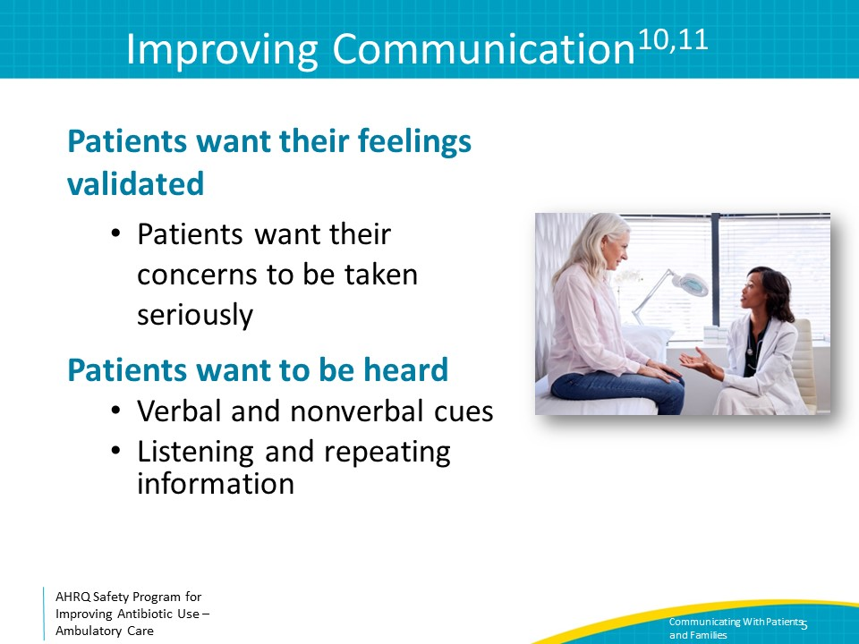
Addressing Patient Concerns  SAY:  We will discuss two scenarios that focus on concerns patients commonly raise during clinic visits. We will also discuss potential responses healthcare practitioners can provide. | Slide 6
First Scenario – Past Experience  SAY:  A patient is being seen for bronchitis. He says: “My doctor always gives me an antibiotic for a cough.”  The problem is that another healthcare practitioner has prescribed antibiotics for similar symptoms in the past. It is difficult to question the judgement of another colleague.  Perhaps the patient’s perception is that the other clinician “always” gives them a prescription, which may not be the case; or perhaps the previous healthcare practitioner saw the patient in a different context that necessitated antibiotics at that time. It is important to validate the patient’s feelings but explain clearly how the suggested management is still in his or her best interest. | Slide 7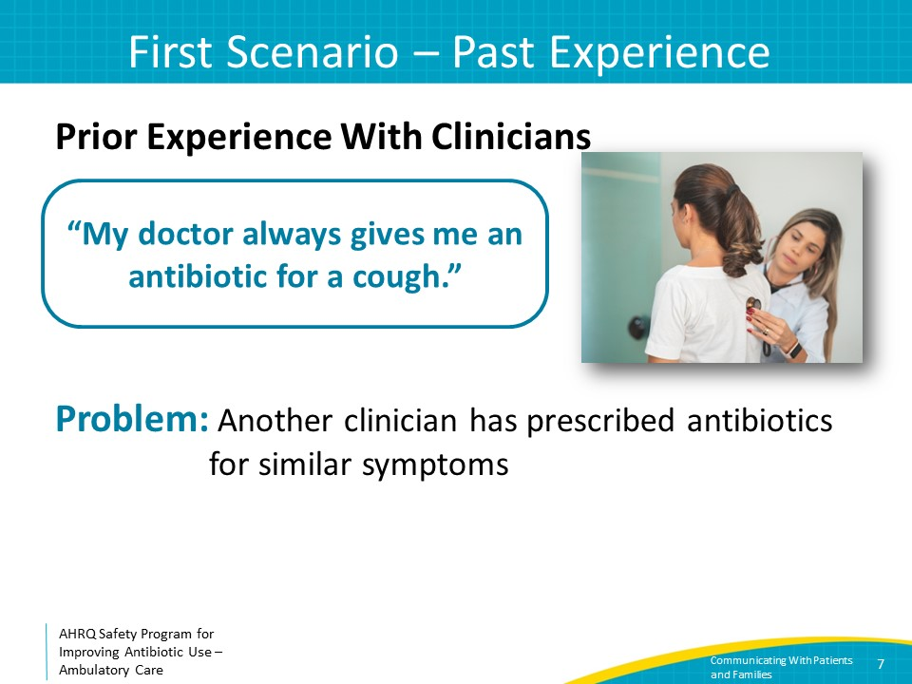
First Scenario – Response  SAY:  This response starts by sharing up-to-date information with the patient to indicate that what is being recommended is considered best practice and confirming that the primary focus is on symptom recovery.  For example, one could say: “There’s a lot of newer evidence showing antibiotics have more side effects than we used to think, so we are becoming more careful about only prescribing antibiotics when really necessary. I can give you a few other recommendations to help you feel better.” This can be followed with examples of over-the-counter cough suppressants or throat lozenges. Provide specific information, like “it is OK to use generic brands, drink at least five 8-ounce glasses of water a day, and consider a humidifier” depending on the symptoms. | Slide 8 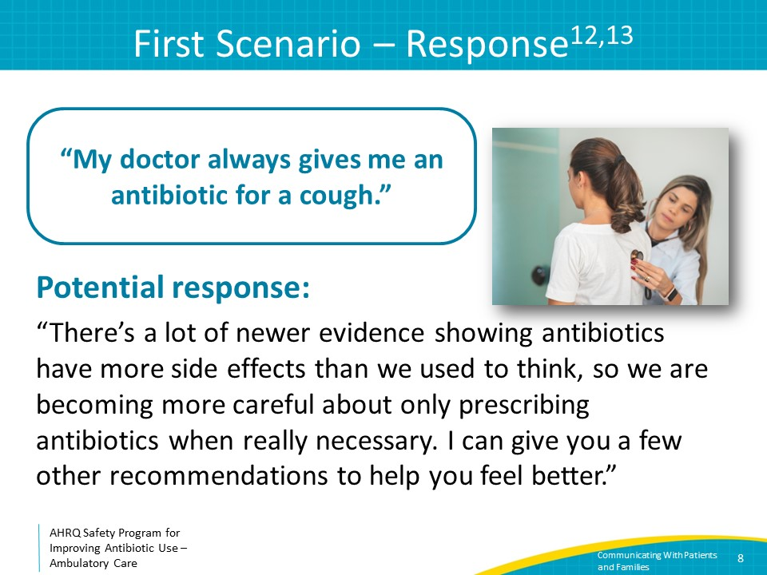
Second Scenario – Past Experience  SAY:  The patient might say: “But antibiotics are the only thing that has ever helped this cough get better.”  Antibiotics do not help acute bronchitis. It is possible that the symptoms previously improved because of the natural course of bronchitis—symptoms are often improving by the time patients seek help. Alternatively, other supportive measures recommended by the clinician may have helped. These may have coincided with starting antibiotics, leading the patient to falsely believe that the antibiotics were helpful. | Slide 9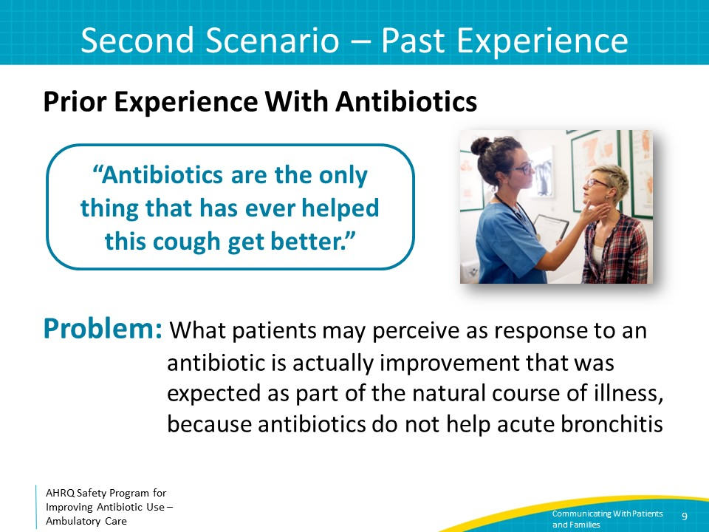
Second Scenario – Response  SAY:  A healthcare practitioner can respond to this comment by emphasizing that it is good that the patient does not need antibiotics and by explaining why that is good. Afterward, the focus should shift to specific steps the patient can take to feel better.  For example: “I understand that you feel terrible, and a cough can certainly be frustrating. The good news is that this time, you have a virus, and antibiotics don’t fight viruses. We want to avoid putting you at risk for unnecessary diarrhea or discomfort that comes with antibiotic use. Let’s work on some other things that could help you feel better.” | Slide 10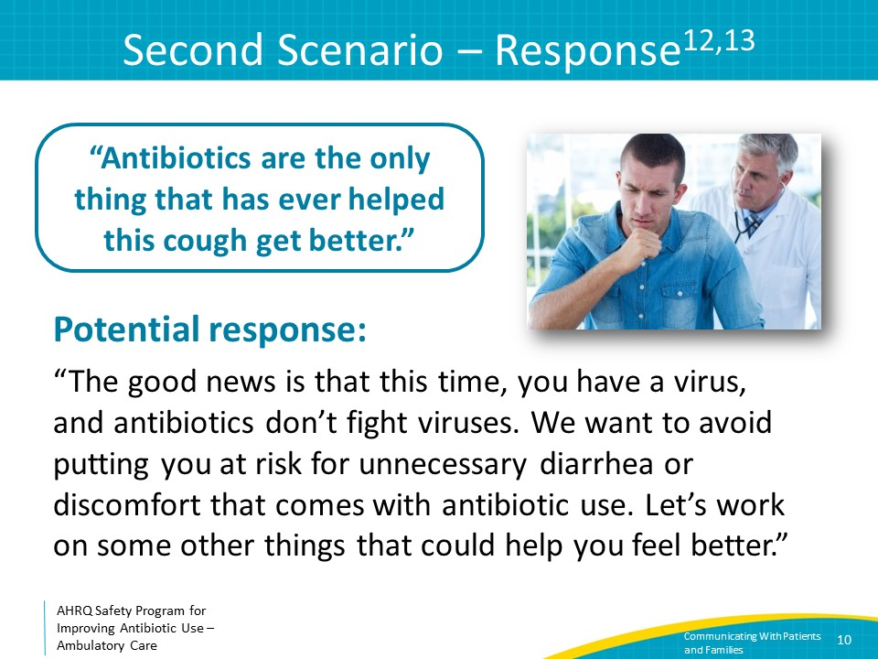
Third Scenario – Concern  SAY:  Let’s discuss another scenario.  A parent brings in their child with an acute respiratory infection. The parent says “I had the same illness as my child, and my doctor gave me an antibiotic. So, I think he might need one, too.” | Slide 11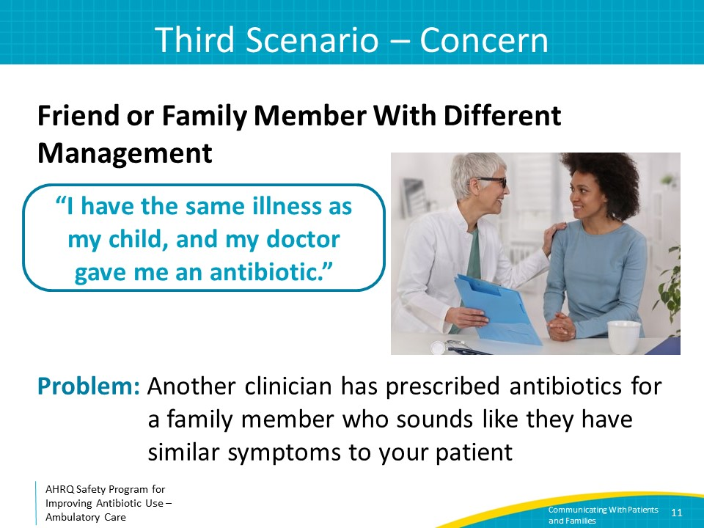
Third Scenario – Response  SAY:  In this case, it is important to formulate a response that acknowledges the parent’s feelings, demonstrates diligence in examining the child prior to making a management plan, and offers alternative options that might reduce symptoms.  For example, one could say to the parent: “I am sorry your son is not feeling well. After a close examination, it looks like your child has a virus. Antibiotics don’t help viruses, and viruses are quite common in children. Most kids will bounce back quickly on their own, but here are some things that can help your child feel better.” Follow up with specific recommendations while also including realistic expectations for when the child should feel better and specific criteria that warrant a return to medical care.  During the physical examination, it is helpful to say out loud what is normal on the physical exam with positive adjectives. For example, “His throat does not look red or inflamed. That’s great. His lungs sound very nice and clear.”  In a 2010 study of 522 pediatric URI encounters, parents were more likely to question non-antibiotic treatment plans when pediatricians made no comment or named only problematic findings, versus those encounters where normal exam findings were mentioned prior to a no-antibiotic treatment plan. The same is likely true for adult patients also.  For both clinical scenarios, after discussing why antibiotics are not necessary, why it is good that antibiotics are not necessary, and alternative symptomatic management, provide clear guidance on signs and symptoms for which a patient should return to medical care. Ask patients to repeat their understanding of when they should return to medical attention to avoid misunderstandings. | Slide 12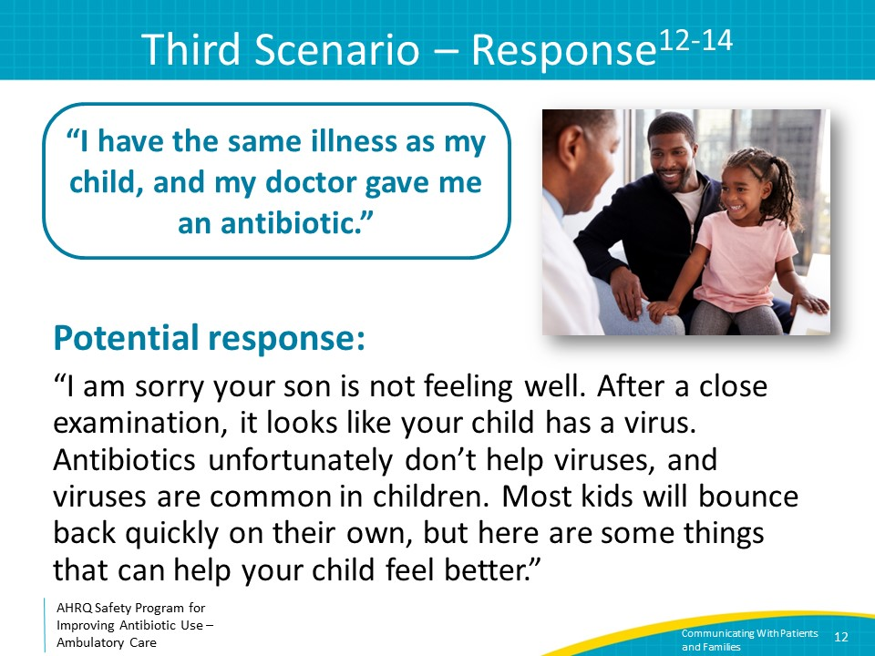
Take-Home Messages  SAY:  To summarize, effective communication with patients around antibiotic prescribing decisions can reduce unnecessary antibiotic use.  Both patient and clinician satisfaction will improve if all members of the practice use clear and consistent messaging around antibiotic prescribing decisions, including conditions for which antibiotics are not necessary.  Provide positively focused messages about why it is good when patients do not need antibiotics and provide concrete alternatives as well as clear guidance on when they should return to medical care. | Slide 13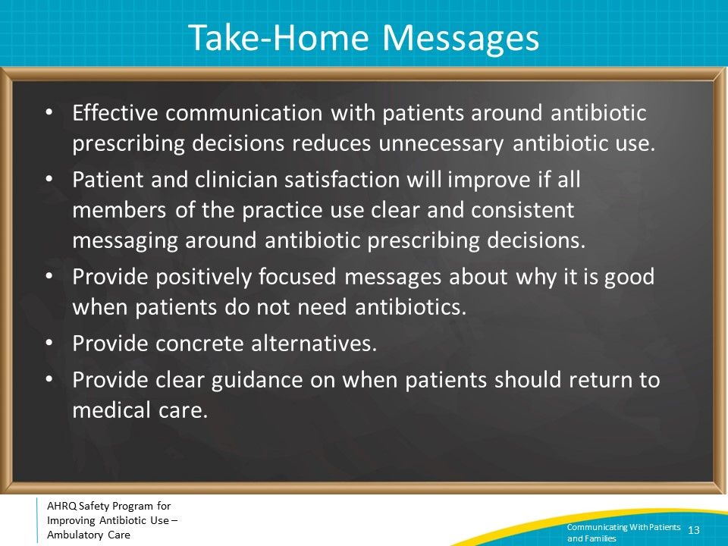
Additional Tools  SAY:  For more resources on communicating with patients and families, please access tools listed below, available on the AHRQ Toolkit To Improve Antibiotic Use in Ambulatory Care.  Refer to the Discussion Guide to determine how your practice can work together to develop a cohesive message about antibiotic use and improve communication about these issues with patients.  Refer to the one-page document of strategies to use when you are discussing antibiotic use with your patients.  The patient handout discusses the reasons your patient might not receive an antibiotic at their appointment and the risks associated with taking antibiotics when you don’t need them. This is available in English and Spanish. | Slide 14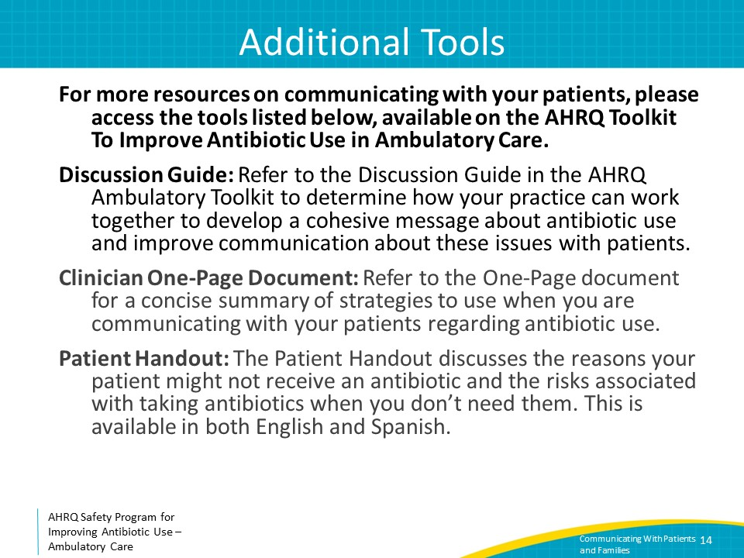
Disclaimer  SAY  The findings and recommendations in this presentation are those of the authors, who are responsible for its content, and do not necessarily represent the views of AHRQ. No statement in this presentation should be construed as an official position of AHRQ or of the U.S. Department of Health and Human Services.  Any practice described in this presentation must be applied by healthcare practitioners in accordance with professional judgment and standards of care in regard to the unique circumstances that may apply in each situation they encounter. These practices are offered as helpful options for consideration by healthcare practitioners, not as guidelines. | Slide 15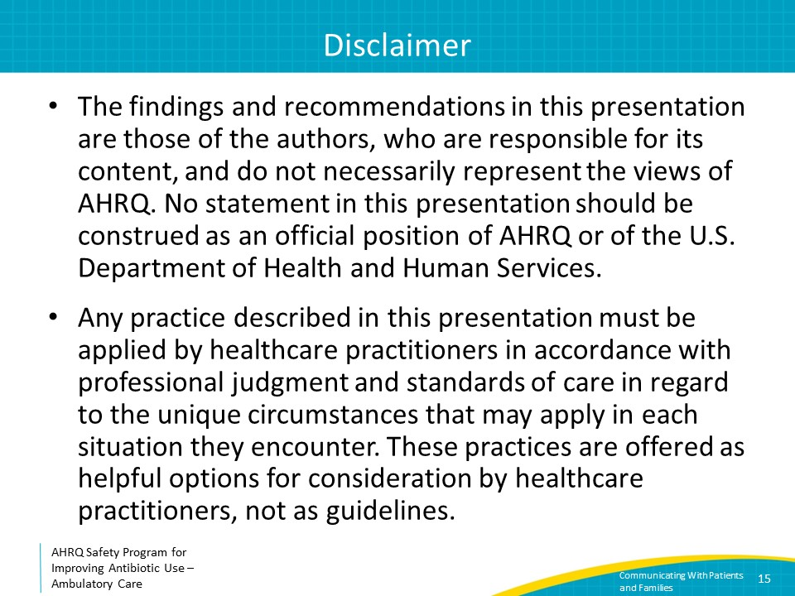
References  SAY:  Here are the references. | Slide 16 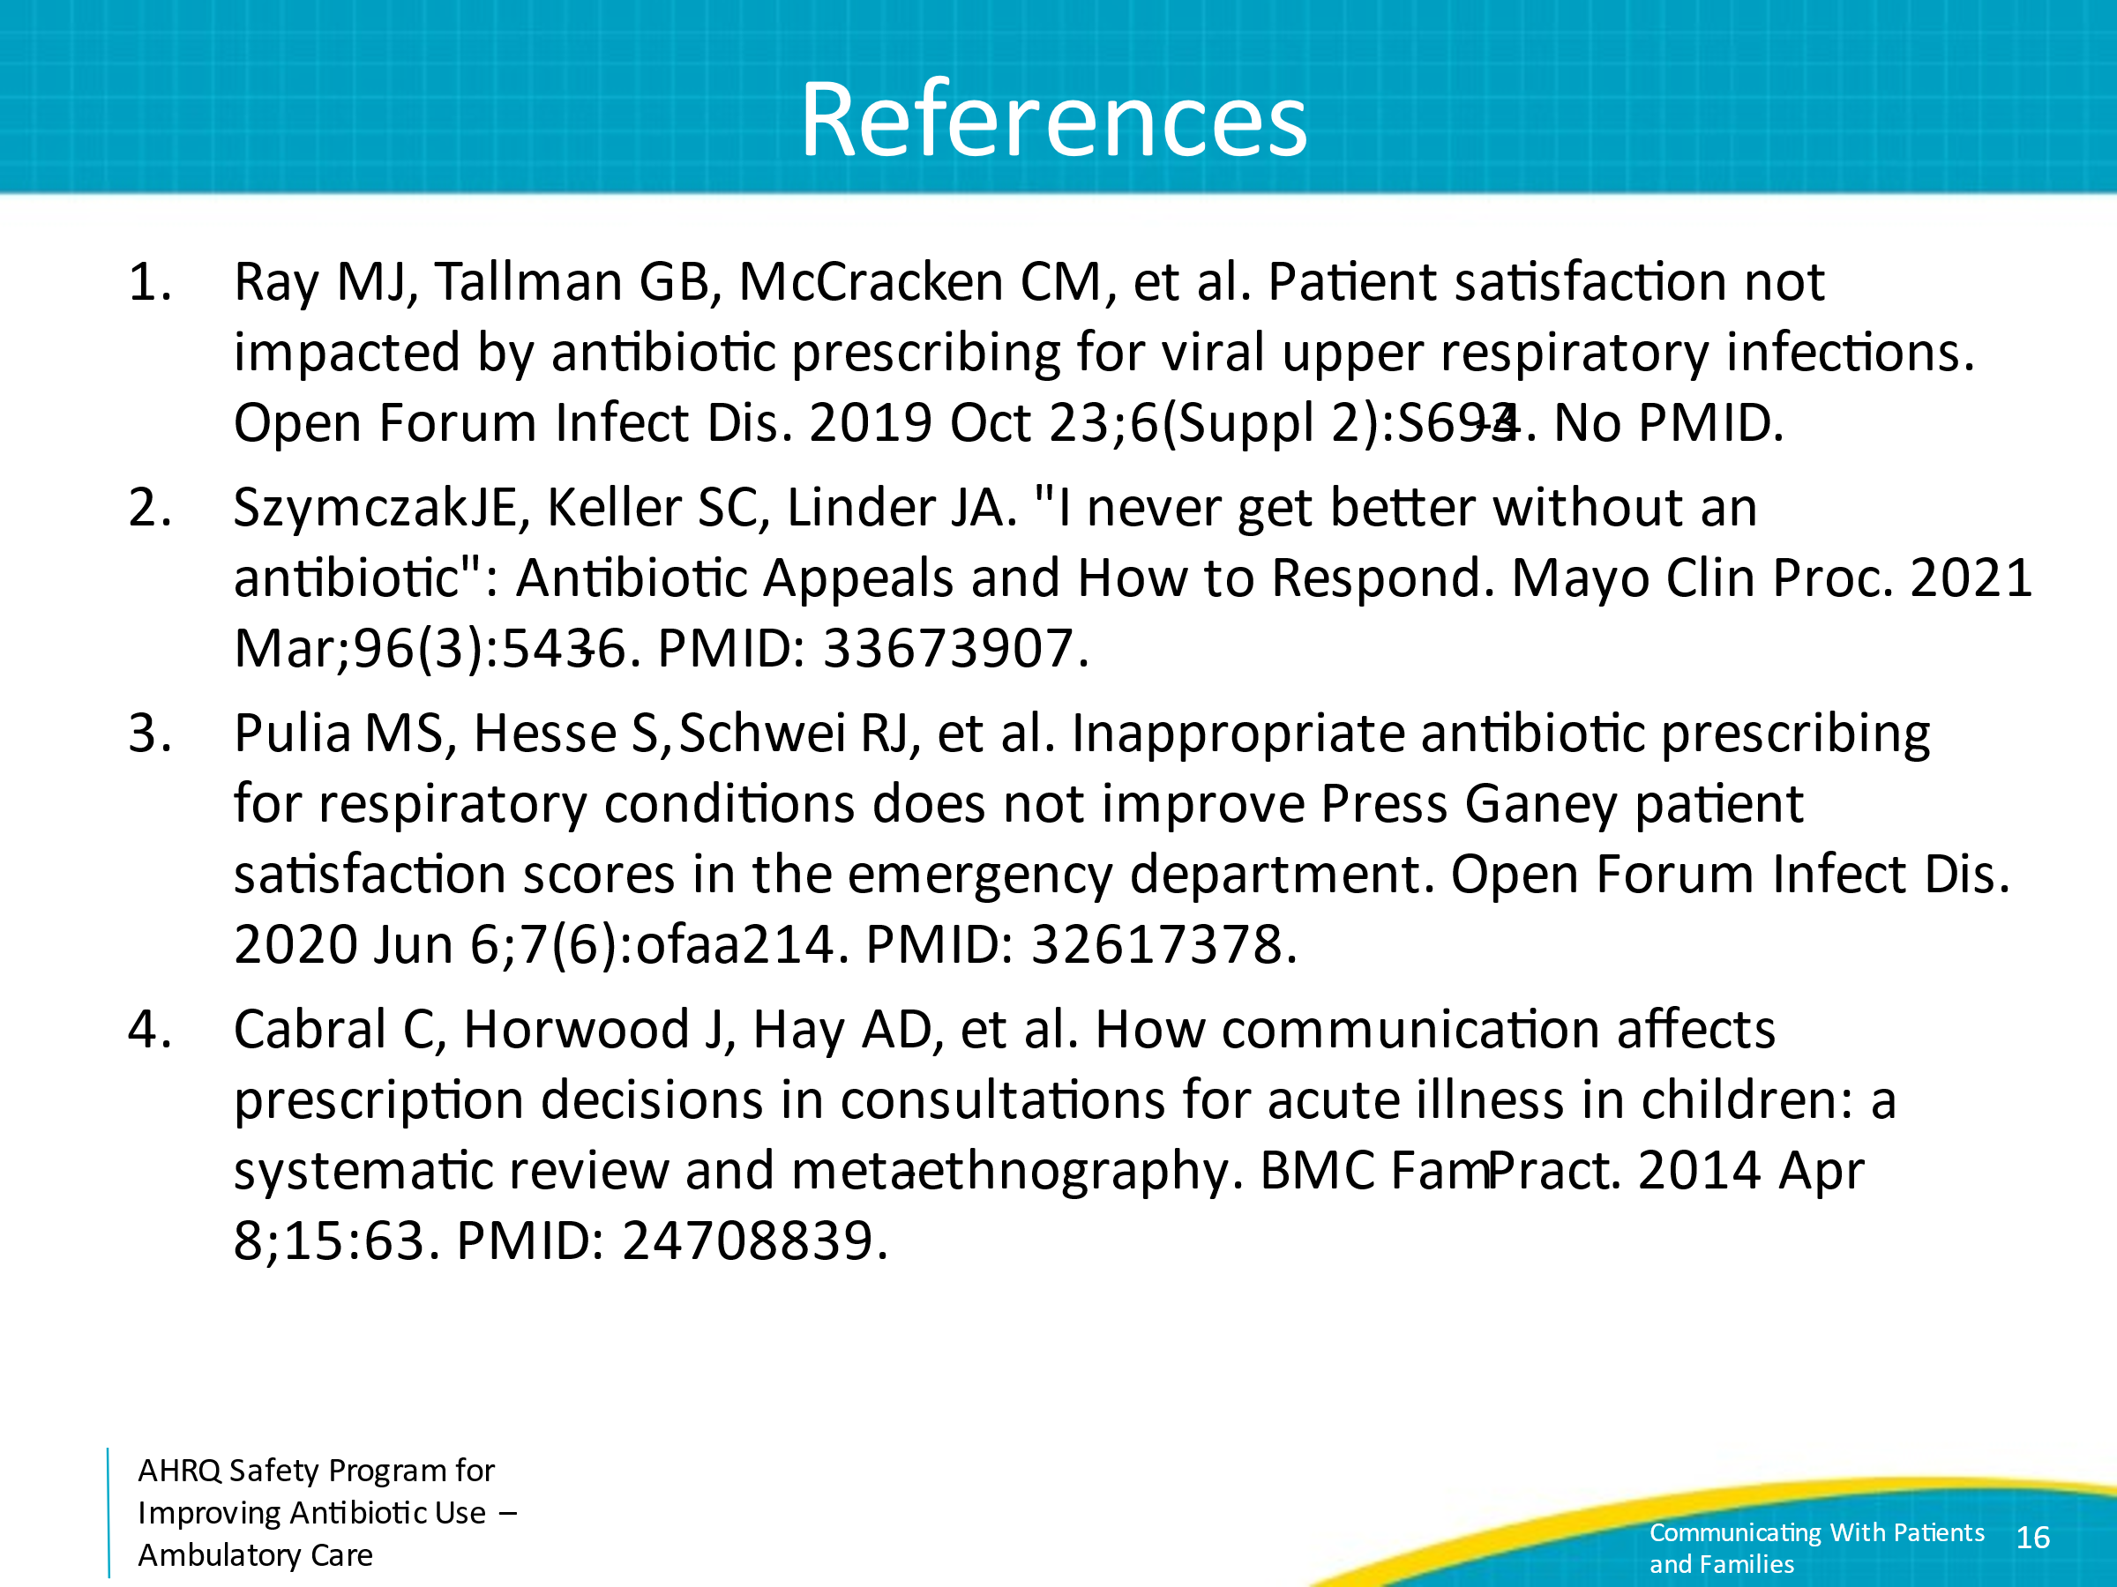
References | Slide 17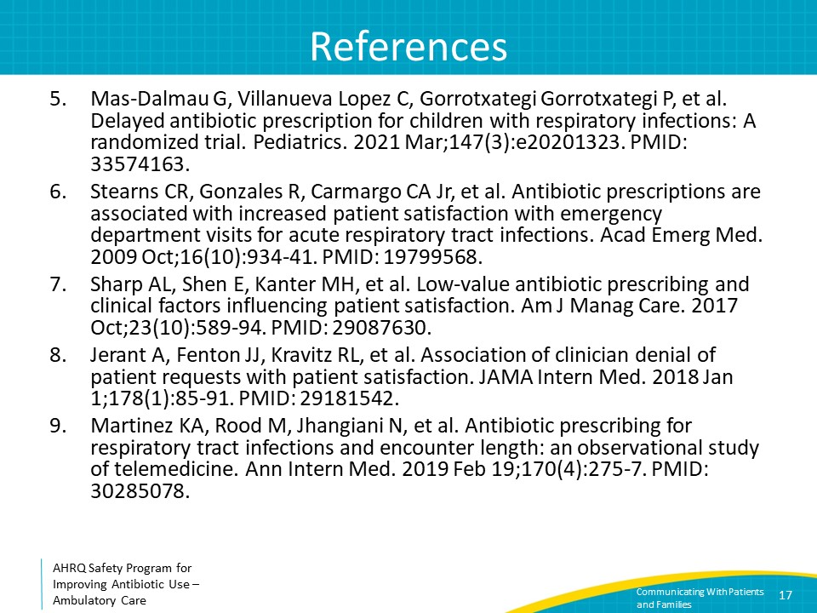
References | Slide 18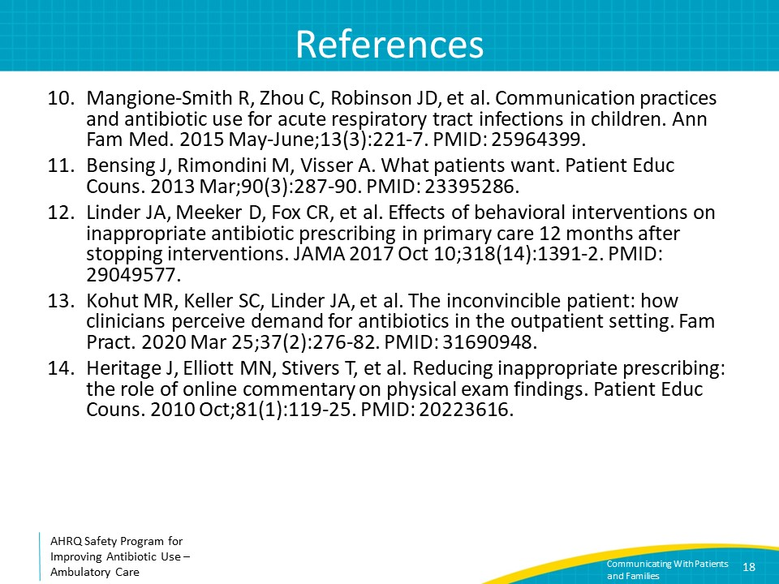
AHRQ Pub. No. 17(22)-0030
September 2022

