Implementing Antibiotic
Stewardship in Your Practice
Ambulatory Care

Slide Title and Commentary | Slide Number and Slide
Implementing Antibiotic Stewardship in Your Practice  Ambulatory Care  SAY:  Welcome to the presentation, “Implementing Antibiotic Stewardship in Your Practice.” | Slide 1
Objectives  SAY:  By the end of this presentation, participants will be able to—  - Describe the role of senior leadership in promoting antibiotic stewardship activities in ambulatory practices  - Establish an Antibiotic Stewardship Team  - Garner support from other members of the practice for implementing antibiotic stewardship activities  - Develop guidance for the management and treatment of common infectious disease syndromes seen in outpatient settings  - Identify sources of antibiotic prescription data and develop effective approaches to feedback antibiotic use data to the practice | Slide 2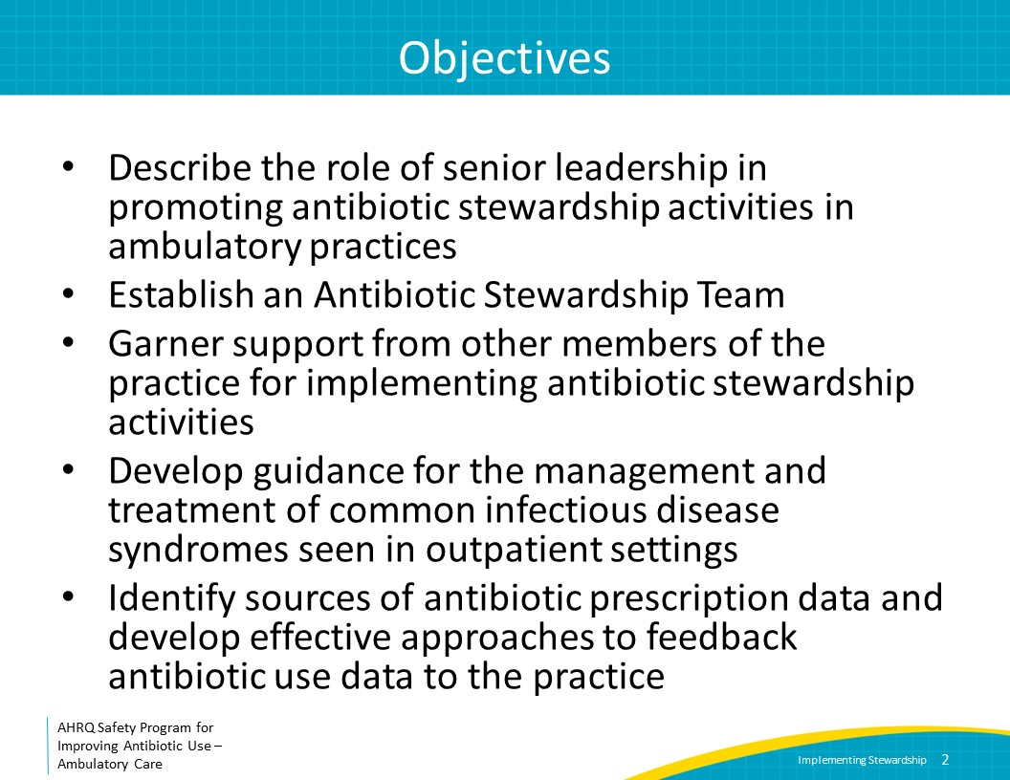
Importance of Antibiotic Stewardship Activities in Ambulatory Care  SAY:  In the United States, 59 percent of antibiotic expenditures occur in the outpatient setting. Further, approximately 30 percent of all antibiotics prescribed in ambulatory settings are likely unnecessary. Thus, implementing approaches to improve antibiotic use in ambulatory practices is essential. The need for such approaches has been recognized by the Centers for Disease Control and Prevention, or CDC, the Joint Commission, and the Centers for Medicare and Medicaid Services, or CMS.  The CDC has developed the Core Elements of Outpatient Antibiotic Stewardship, which consist of evidence-based strategies to improve antibiotic use in ambulatory settings, including (1) committing to the principles of antibiotic stewardship, (2) performing actions to promote safe and effective antibiotic prescribing, (3) tracking data to evaluate progress in improving antibiotic prescribing and reviewing the data with other relevant stakeholders, and (4) educating clinicians and patients on appropriate antibiotic use. | Slide 3
Importance of Antibiotic Stewardship Activities in Ambulatory Care  SAY:  In 2020, The Joint Commission released antibiotic stewardship requirements for accredited ambulatory practices that include (1) identifying an antibiotic stewardship leader; (2) establishing an annual antibiotic stewardship goal; (3) implementing evidence-based practice guidelines related to the antibiotic stewardship goal; (4) providing clinical staff with educational resources related to the antibiotic stewardship goal; and (5) collecting, analyzing, and reporting data related to the antibiotic stewardship goal.  Finally, CMS has developed the Merit-based Incentive Payment System, or MIPS, as part of Medicare Part B. MIPS assigns both penalties and rewards to clinicians and practices for quality improvement activities and for the quality of care. Earning rewards through MIPS (or avoiding penalties) is based on quality-of-care measures, use of electronic health records, control of the cost of care, and participation in practice-based improvement activities. These can apply either to individual clinicians or entire practices. Some quality improvement opportunities within MIPs concern antibiotic prescribing, including for sinusitis and acute bronchitis.  The remainder of this presentation will provide a step-by-step approach to develop antibiotic stewardship teams and activities in the ambulatory setting. This work can also assist with aligning the practice with CDC, the Joint Commission, and CMS guidance and requirements. | Slide 4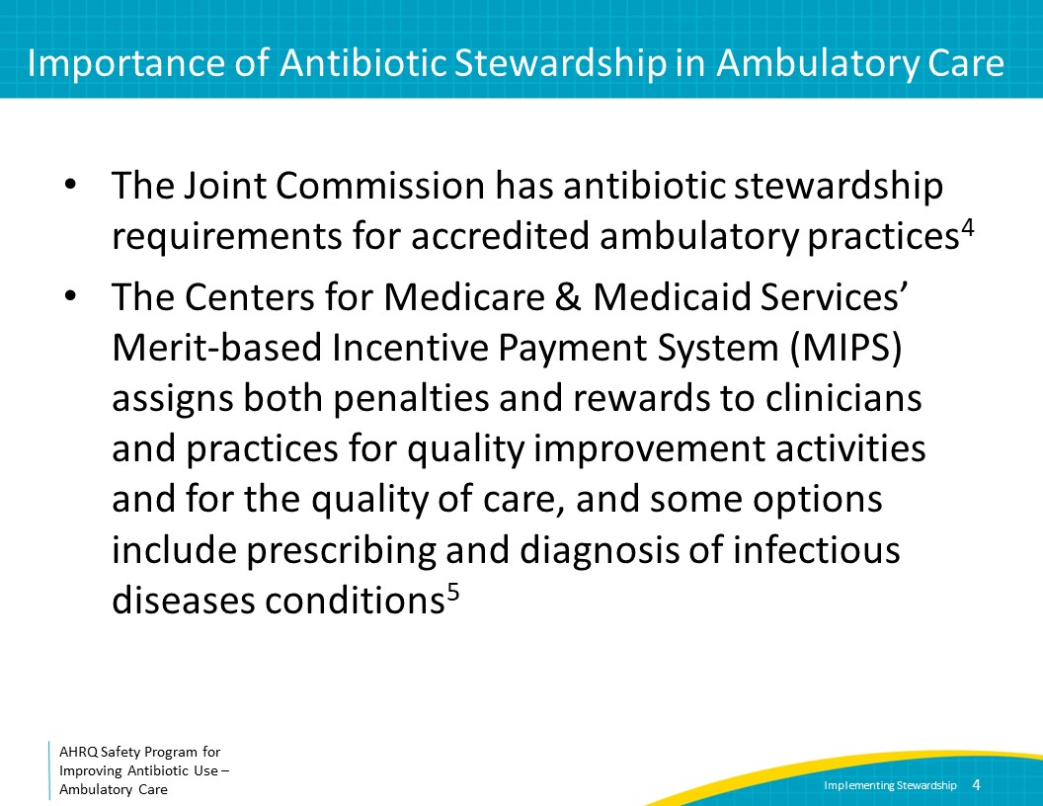
Step 1: Engage Practice Leadership  SAY:  The crucial first step of implementing antibiotic stewardship activities is to develop a leadership structure, including engaging senior practice leadership and identifying a stewardship leadership team. Engagement of the leadership of the practice is crucial to obtain the necessary support for antibiotic stewardship activities. Leadership support includes a senior leader communicating to all members of the practice that appropriate antibiotic use is a priority within the practice. Additionally, it involves the provision of resources needed for the practice to engage in stewardship activities.  Senior leaders may have different titles and roles depending on the specific practice type and size, but fundamentally, this person or people should have a role in the organization who can support structural and sustained change. They may include practice owners, medical directors, or the most senior clinician in the group.  There are two important resources that senior leadership should provide to improve antibiotic prescribing in a practice. First, they should aim to provide the Antibiotic Stewardship Team with sufficient protected time to lead antibiotic improvement efforts. Second, they should assist with access to information technology (IT) support so that the stewardship team has the ability to review antibiotic prescription data and associated medical condition codes—to determine if antibiotics were likely warranted for a condition—at regular intervals.  Senior leadership also can assist with decoupling patient satisfaction scores for upper respiratory tract infection visits from bonuses, particularly at the start of stewardship interventions when patients may respond negatively to not receiving an antibiotic prescription for a condition for which antibiotics are generally not indicated (such as bronchitis) after having previously received such a prescription at past visits.  Senior leadership can also assist by directly communicating with healthcare practitioners who continue to prescribe antibiotics unnecessarily despite interventions from the antibiotic stewardship team.  The stewardship team should provide regular updates about successes and barriers to keep senior leadership engaged in stewardship activities. This can occur at practicewide meetings or as periodic written summaries. | Slide 5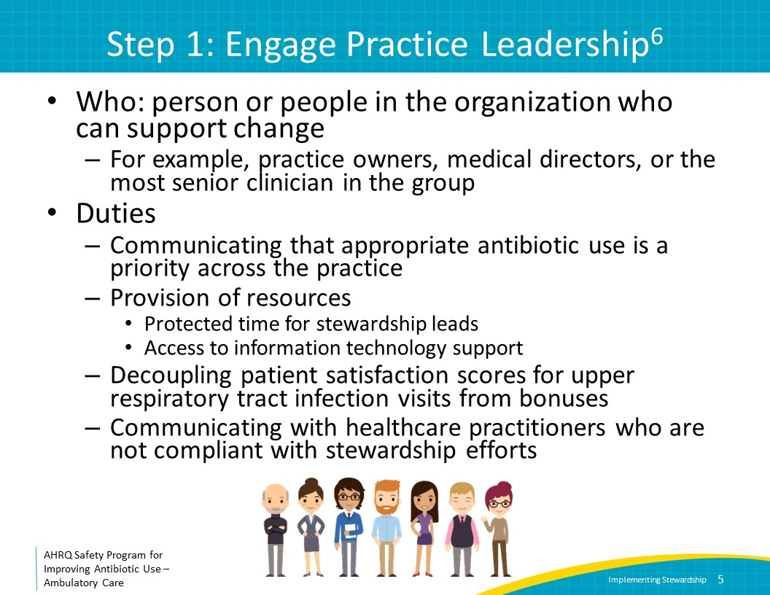
Step 2: Establish an Antibiotic Stewardship Team  SAY:  Although many practice members will be engaged in antibiotic stewardship activities, two essential individuals should be identified to lead the group: a prescribing clinician, such as a physician or advanced practitioner, and an administrative lead, such as a practice manager, nurse, or pharmacist.  The clinician lead is responsible for determining stewardship goals and needed interventions, building consensus on antibiotic prescribing decisions in the practice, and communicating with senior leadership. Important characteristics this person should have include knowledge of and interest in the diagnosis, management, and treatment of common infectious diseases syndromes as well as in patient safety and quality improvement. This individual should be viewed as a thought leader in the practice and be diplomatic, collegial, and a good communicator.  The administrative lead is responsible for ensuring that stewardship issues are regularly included on practice-wide meeting agendas, distributing relevant communications in the practice, and organizing the extraction of electronic data. The usual role of this person may differ from practice to practice but could be a pharmacist, an office manager, or a nurse manager. This individual should have strong organizational skills and be comfortable interacting with all members of the practice.  Once the Antibiotic Stewardship Team is established, members should review several documents in the Toolkit To Improve Antibiotic Use in Ambulatory Care. These include the Gap Analysis Tool for Antibiotic Stewardship in Ambulatory Care, which can assist in assessing what activities are currently occurring in the practice and what work needs to be done, the Implementation Guide for Ambulatory Care Antibiotic Stewardship, which outlines how to use the materials in the Toolkit to Improve Antibiotic Use in Ambulatory Care to start stewardship activities, and the Timeline for Implementing Antibiotic Stewardship in Ambulatory Care, which provides month-by-month guidance for stewardship activities. | Slide 6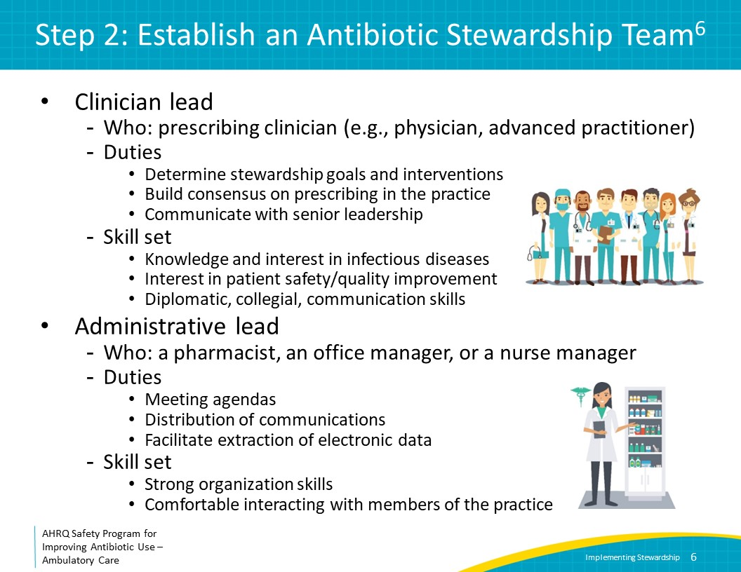
Step 3: Garner Support From Other Practice Members  SAY:  Improving antibiotic use depends on garnering support from practice members. This includes those who prescribe antibiotics, but also other staff such as nurses, medical assistants, front-desk staff, and pharmacists because all of these individuals may interact with patients and may inadvertently set expectations regarding the likelihood of receiving an antibiotic prescription.  An illustrative case can be an effective way to persuade practice members to view antibiotic stewardship as a patient safety issue. This case should be delivered succinctly, ideally at a practicewide meeting, and should include information about harm associated with nonjudicious antibiotic prescribing as well as the benefits of developing a practicewide strategy for optimizing antibiotic decision making. The presentation titled “Why Your Practice Should Focus on Improving Antibiotic Prescribing” assists practices with making the case for why antibiotic stewardship is a patient safety issue.  The practice should consider displaying commitment posters that indicate that clinicians in the practice have made a commitment to prescribing antibiotics only when necessary. A commitment poster is available in the Toolkit To Improve Antibiotic Use in Ambulatory Care (English and Spanish). Consider adding photographs of members of the practice and including their signatures on the posters. Commitment posters can be displayed throughout the practice to remind patients, families, and clinicians that antibiotics will only be prescribed for indicated reasons. | Slide 7
Step 4: Determine How To Access Antibiotic Prescribing Data  SAY:  Data on antibiotic use are critical to stewardship activities in ambulatory care, both to assess areas of potential overuse and to track the impact of interventions over time. The number of antibiotic prescriptions makes up the numerator, and the number of clinic visits makes up the denominator of the metric to measure antibiotic use in the outpatient setting.  These data can be stratified by prescriber to compare individual antibiotic prescription patterns and/or by ICD-10 codes to differentiate conditions for which antibiotic use is expected, such as community-acquired pneumonia and streptococcal pharyngitis, from those for which antibiotic use is not indicated, such as acute bronchitis and upper respiratory tract infections. Antibiotic prescribing data should be provided in the form of a rate such as the number of antibiotic prescriptions per 100 visits. Reports containing these data should be developed and reviewed by the stewardship team at regular intervals such as monthly or quarterly.  Sites with an electronic health record (EHR) should be able to obtain these data with the assistance of an IT expert. Please refer to the document in the Toolkit to Improve Antibiotic Use in Ambulatory Care titled “Accessing and Reporting Antibiotic Prescription Data” for information to present to IT experts regarding obtaining antibiotic use data. Consider determining if automated reports can be developed for the stewardship team to access when needed.  Approaches for data feedback will be discussed later in this presentation. | Slide 8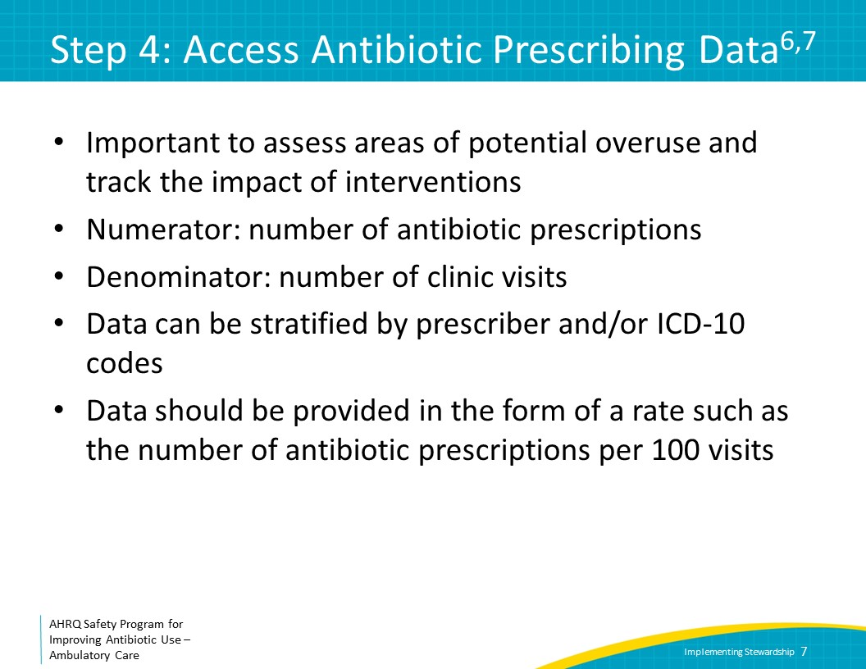
Antibiotic Prescribing Report  SAY:  This slide shows a hypothetical example of a graph that tracks antibiotic prescriptions for acute respiratory tract infections over time, stratified by antibiotic class. The x-axis is time by month, and the y-axis is the number of antibiotic prescriptions per 100 visits for acute respiratory tract infection. This type of graph can be used to track antibiotic prescribing over time. For example, the start of a particular intervention can be noted on the graph with the expectation that the rate will decrease in response to the intervention. | Slide 9
Step 5: Build Communication Skills Around Antibiotic Use in the Practice  SAY:  Effective communication among practice members and between practice members and patients and families are both essential to improve antibiotic use.  Members of the practice should agree on approaches to manage common infectious syndromes in order to avoid situations in which patients received mixed messages depending on which practice member they interact with. It will be confusing for the patient, for example, if an on-call healthcare practitioner prescribes antibiotics for a viral upper respiratory tract infection when the patient’s primary healthcare practitioner generally does not. Or alternatively, when an on-call healthcare practitioner does not feel an antibiotic prescription is appropriate for a patient whose primary healthcare practitioner typically does prescribe antibiotics in similar circumstances.  Ultimately, if the entire practice can reach consensus, less time will be required to explain to patients why antibiotics are or are not needed. This will improve satisfaction among members of the practice as well as patients. | Slide 10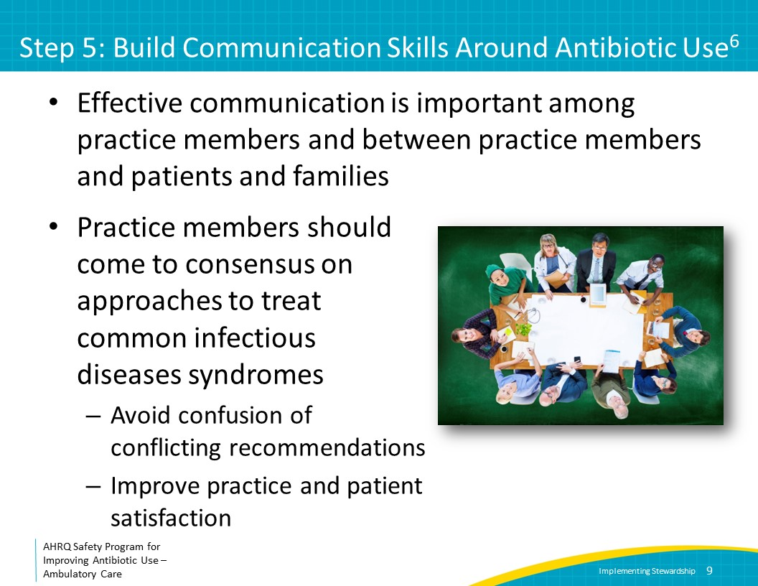
Improving Communication Among Clinicians by Developing Guidance for Antibiotic Decision Making  SAY:  Reaching consensus can be accomplished by developing guidance or protocols for the management of common infectious conditions. Guidance and protocols should be reviewed with and agreed upon by all prescribers in the practice.  One strategy for developing guidance documents is for the clinician lead of the stewardship team to make a draft based on materials in the Toolkit to Improve Antibiotic Use in Ambulatory Care and national guidelines and then present it at a practice meeting to gain consensus. The Toolkit to Improve Antibiotic Use in Ambulatory Care contains One-Page documents that can be used as a template for development of guidelines and Discussion Guides that provide topics to review at practice meetings.  While ultimately it will be helpful to have guidance for all infectious disease syndromes, start with the topics that are of greatest relevance to the practice first. Whenever possible, integrate guidelines into existing workflows such as placing them in the EHR, posting them in common work areas, or developing pocket cards. | Slide 11
The Four Moments of Antibiotic Decision Making  SAY:  Guidance documents should include recommendations based on the Four Moments of Antibiotic Decision Making for Ambulatory Care, a framework that helps healthcare practitioners optimize their antibiotic prescribing. Moment One is, “Does my patient have an infection that requires antibiotics?” For syndromes in which antibiotics are not indicated, such as acute bronchitis, state this clearly in guidance documents. For syndromes in which antibiotics may be indicated, such as bacterial sinusitis, provide information about when they should be considered.  Moment Two is, “Do I need to order any diagnostic tests?” When relevant, comment on whether microbiology tests or imaging studies are needed.  Moment Three is, “If antibiotics are indicated, what is the narrowest, safest, and shortest regimen I can prescribe?” When antibiotics are indicated, provide specific recommendations about the agents, dose, and duration of therapy. Consider providing options for patients with severe penicillin allergies. Whether or not antibiotics are indicated, provide suggestions for symptomatic therapy. Given the large number of over-the-counter products, it can be helpful for the practice to generate a short list of options that can be agreed upon.  Moment Four is, “Does my patient understand what to expect and the followup plan?” It is useful for the practice to develop a standard approach for when and how patients should be guided to return to care if they are not feeling better. | Slide 12
Improving Communication With Patients and Families  SAY:  Developing consistent, practicewide strategies for communicating with patients and families about conditions for which antibiotics are not or only sometimes necessary is also important.  The antibiotic stewardship clinician lead should review communication methods at a practicewide meeting. Some suggested approaches include use of language that demonstrates the healthcare practitioner understands that the patient feels ill and is not minimizing the patient’s concerns (e.g., “I am sorry you are feeling so bad, and I want to help you feel better”), review of findings during the physical exam (e.g., “Your lungs sound clear so you don’t have pneumonia”), posing the lack of need for an antibiotic as a good outcome (e.g., “The good news is that you don’t need an antibiotic to treat this infection”), and explaining why the patient may have gotten antibiotics in the past but now does not need them (e.g., “Even though I used to prescribe antibiotics for coughs that would not go away, new data show that antibiotics don’t help and may cause bad side effects.”  More information about communication strategies can be found in the presentation titled “Communicating With Patients and Families About Antibiotic Decisions” in the Toolkit To Improve Antibiotic Use in Ambulatory Care (slides and facilitator guide). | Slide 13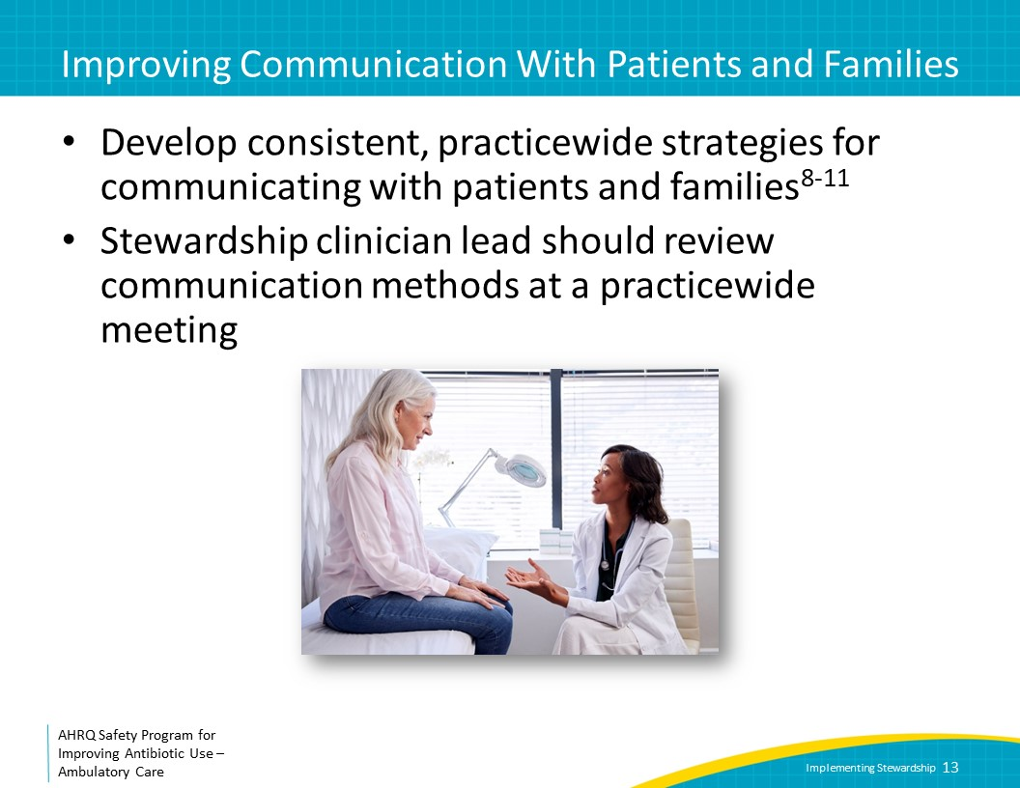
Step 6: Implement an Educational Intervention Around an Infectious Condition  SAY:  The antibiotic stewardship team in conjunction with the practice should decide what infectious conditions to target first for improvement. In the Toolkit To Improve Antibiotic Use in Ambulatory Care, infectious conditions are stratified by those for which antibiotics are always indicated, sometimes indicated, and never indicated. It may be easiest to focus first on conditions for which antibiotics are never indicated, such as upper respiratory tract infections, acute bronchitis, influenza without pneumonia, respiratory syncytial virus infections, or COVID-19.  As discussed in Step 5, it is important to develop practicewide consensus on the approach that will be taken for the management and treatment of the targeted infections. Development of written guidance is part of this process, but it should be accompanied by discussions and education during practice meetings as well review of prescribing data with other members of the practice to highlight where improvement is needed.  Finding sufficient time on the agenda of practice meetings must be prioritized, and engagement of senior leadership is recommended to ensure that this happens. The antibiotic stewardship team should develop brief presentations with relevant information on the diagnosis and treatment of common infectious conditions during these meetings. The presentation also should include discussion points to seek input from the group so that consensus can be reached on management approaches.  The Toolkit To Improve Antibiotic Use in Ambulatory Care contains syndrome-based slide presentations with accompanying facilitator guides (or scripts) that the antibiotic stewardship team can review with the practice, one-page documents that succinctly summarize each syndrome, and discussion guides that have questions that can be discussed by the group.  Changing longstanding practices can be challenging; thus, the antibiotic stewardship team should request a standing agenda item on stewardship during practice meeting to provide feedback to the practice on progress.  The antibiotic stewardship team also should consider how to maintain interest in the intervention between practice meetings. This may include brief, informal, one-on-one meetings with healthcare practitioners to check in on their experiences with implementing the guidance and answer any clinical questions or questions about feedback on antibiotic prescribing reports. In addition, emails can be sent at standard intervals to provide reminders about the initiative and clinical pearls about infectious disease syndromes.  If certain healthcare practitioners continue to be outliers with regard to prescribing practice, the stewardship clinician lead should meet individually with them to understand why they are prescribing more antibiotics that their peers. If there is not an explanation and the aberrant prescribing continues, then the senior leadership may need to be engaged.  Once the antibiotic stewardship team and practice members believe sufficient progress has been made on a syndrome, it is reasonable to move on to the next syndrome. | Slide 14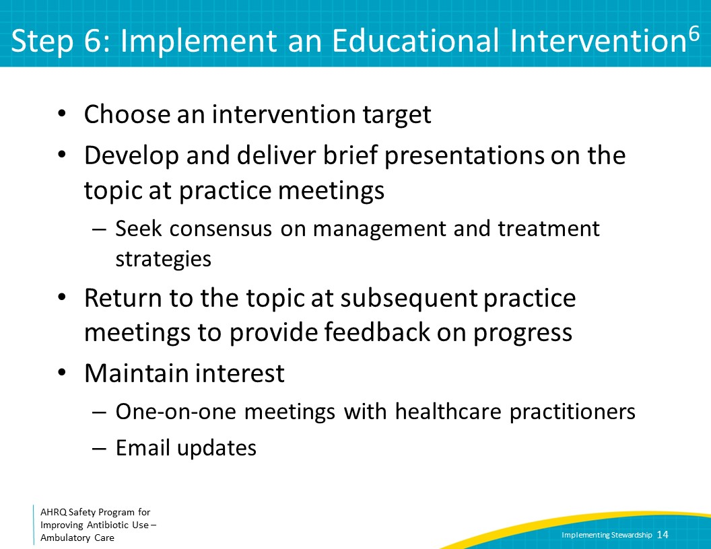
Step 7: Monitor Antibiotic Prescription Data  SAY:  Antibiotic prescribing data should preferably be monitored at both the practice level—for example, what proportion of visits for acute bronchitis have an antibiotic prescription across the practice—as well as at the individual prescriber level—for example, what proportion of visits for acute bronchitis have an antibiotic prescription stratified by each prescriber.  Practice-level data can be used to determine areas that may need improvement in the practice. For example, assessment of inappropriate use of fluoroquinolones for cystitis or the proportion of patients with “never antibiotic” and “sometimes antibiotic” diagnoses who receive antibiotics could be evaluated to understand if there is room for improvement. Practice-level data also can be used to track the progress of interventions to improve antibiotic use over time. Practicewide data should be presented briefly at practice meetings.  Prescriber-level data can be used to make peer comparisons, in which antibiotic prescribing feedback is delivered to clinicians so that they can compare their antibiotic prescribing practices with those of their colleagues. | Slide 15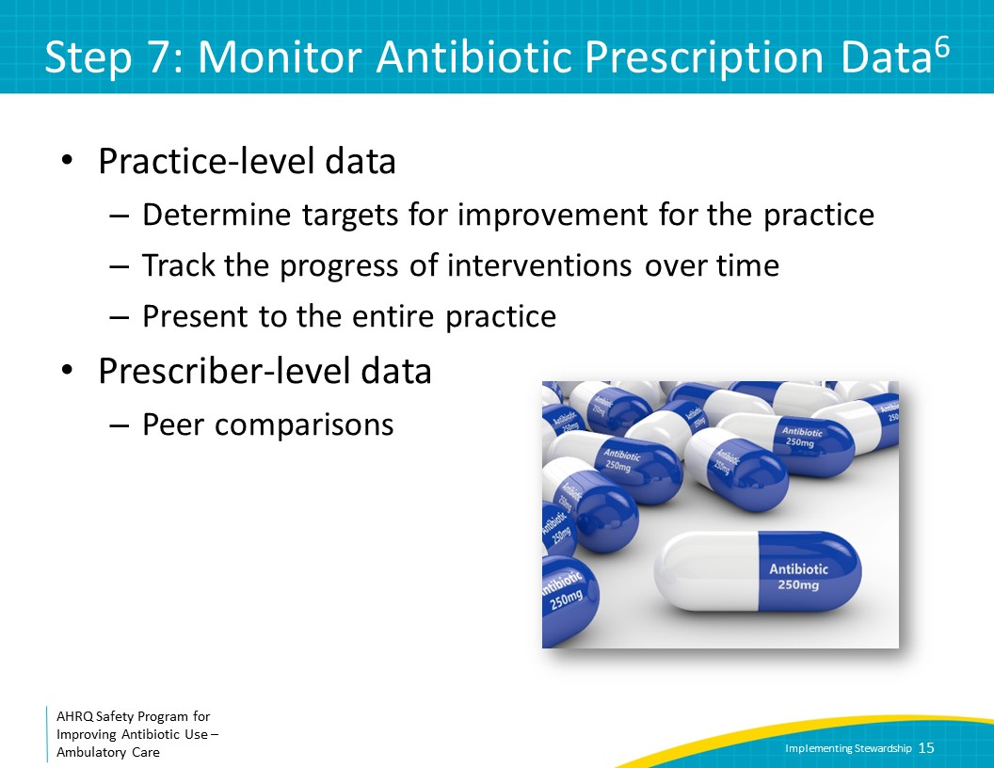
Considerations for Presenting Data to the Practice  SAY:  There are several considerations for presenting data to practice members. First, reports should be simple and easy to understand. All of the information needed to interpret the data and to transmit the intended message across should be present on the report.  Second, ensure that the antibiotic stewardship leads present the data in person or that emails with data come from these individuals. It is important for the messenger of the data to be a trusted individual who is able to address questions and concerns about the data.  Third, the data should be as up to date as possible, ideally no more than 1–3 months old. Older data will feel less relevant to practice members.  Fourth, the data should be provided regularly, such as monthly, because regular feedback improves engagement in interventions.  Finally, include messages of appreciation or congratulation when improvements in antibiotic prescribing are observed. When areas for further improvement are identified, underscore how the practice will need to continue to work as a team to identify effective approaches to optimize antibiotic prescribing. | Slide 16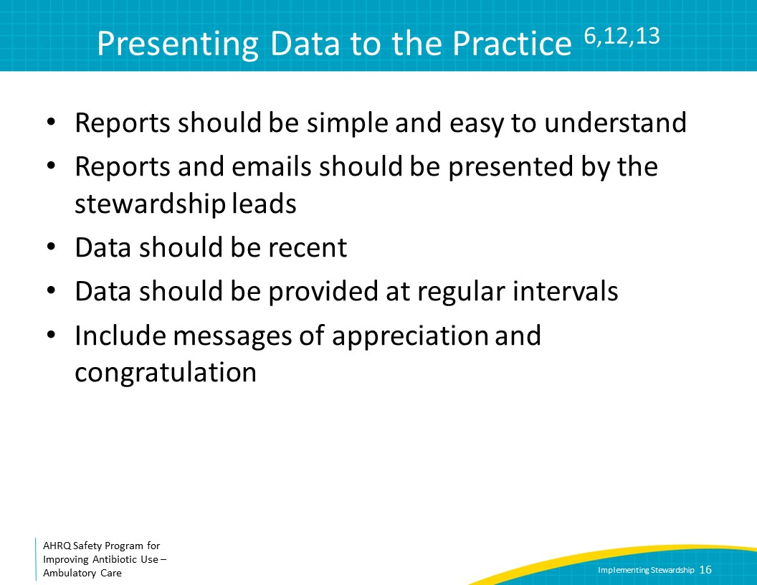
Considerations for Presenting Peer Comparisons  SAY:  Many clinicians do not appreciate or trust peer-comparison reports, in part because such reports may be perceived as a threat to longstanding practices. Thus, care should be given when providing this type of feedback. Consider engaging prescribers from the start in the design of the reports by discussing at practice meetings whether individualized reports should include names of practice members or only the name of the individual the report is intended for.  A recommended approach for reporting is to identify “top performers” (i.e., in the top 10–20 percent of appropriate antibiotic prescribers) or “not top performers” (i.e., all other clinicians). This demonstrates to everyone what good performance looks like, shows that some prescribers achieve it, and tends to push behavior toward that of the top performers. The approach may be better than showing a graph with each prescriber’s data, even if de-identified, because those who fall in the middle of the graph may feel content being at the median level of prescribing when in reality, they should strive to be top performers. It may also be helpful to provide specific information to each prescriber on the patients who did and did not warrant antibiotics so that they can review the cases to understand their prescribing habits.  One challenge in presenting peer-to-peer comparisons is ensuring that prescriptions are attributed to the correct prescriber. This is straightforward in a clinic that is staffed by prescribers who see their own patients, but can be more complicated in a clinic in which trainees or advanced practitioners are being supervised by others. It is recommended to discuss these issues with IT experts to develop approaches for correct attribution.  Second, small numbers of prescribing episodes can make peer comparison interventions challenging. Ideally, analyses should be based on at least 20 visits per condition per clinician, and longer time periods may need to be evaluated to reach this number.  Third, when clinicians know their prescribing is being monitored, they may stop coding one diagnosis and start coding another one. For example, if a clinician figures out that she is performing poorly on an acute bronchitis measure, she might simply stop using that code and start using sinusitis instead. To detect diagnosis shifting, measure overall antibiotic prescribing and antibiotic prescribing for a broader range of diagnoses than those just in the target measure. This allows assessment of whether rates of diagnoses shift and if antibiotic prescribing overall, within those diagnoses, does or does not change. | Slide 17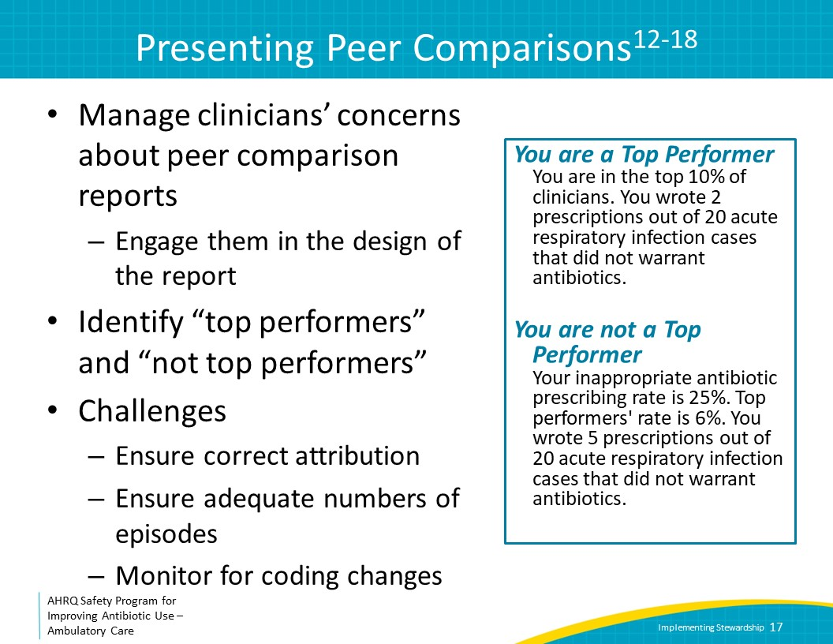
Step 8: Implement a Sustainability Plan  SAY:  The antibiotic stewardship team should develop a sustainability plan that includes the primary goals the antibiotic stewardship team plans to meet over a designated time period, for example 2 years, as well as an approximate outline of the month-to-month plans during this time, for example the order of the syndromes to focus on, the approximate amount of time that will be spent on each syndrome, and how frequently to review antibiotic prescription data as a practice. The sustainability plan should be developed after the Antibiotic Stewardship Team has been formed; there is no need to wait until after interventions begin, although it is helpful to revisit and revise the plan depending on the progress of interventions. It may be useful to complete the Gap Analysis Tool for Antibiotic Stewardship in Ambulatory Care on an annual basis to track progress. Consider other activities and interventions that may enhance stewardship efforts, such as prompts in the medical record that encourage guidance-compliant prescribing or use of triage protocols to prevent unnecessary office visits for conditions where antibiotics are not needed. The sustainability plan should be reviewed with senior leadership.  More information on sustaining antibiotic stewardship activities can be found in the presentation titled “Sustaining Antibiotic Stewardship Efforts” in the Toolkit To Improve Antibiotic Use in Ambulatory Care (slides and facilitator guide). Also, a monthly planning document, titled “Timeline for Implementing Antibiotic Stewardship in Ambulatory Care” can be found in the Toolkit To Improve Antibiotic Use in Ambulatory Care. | Slide 18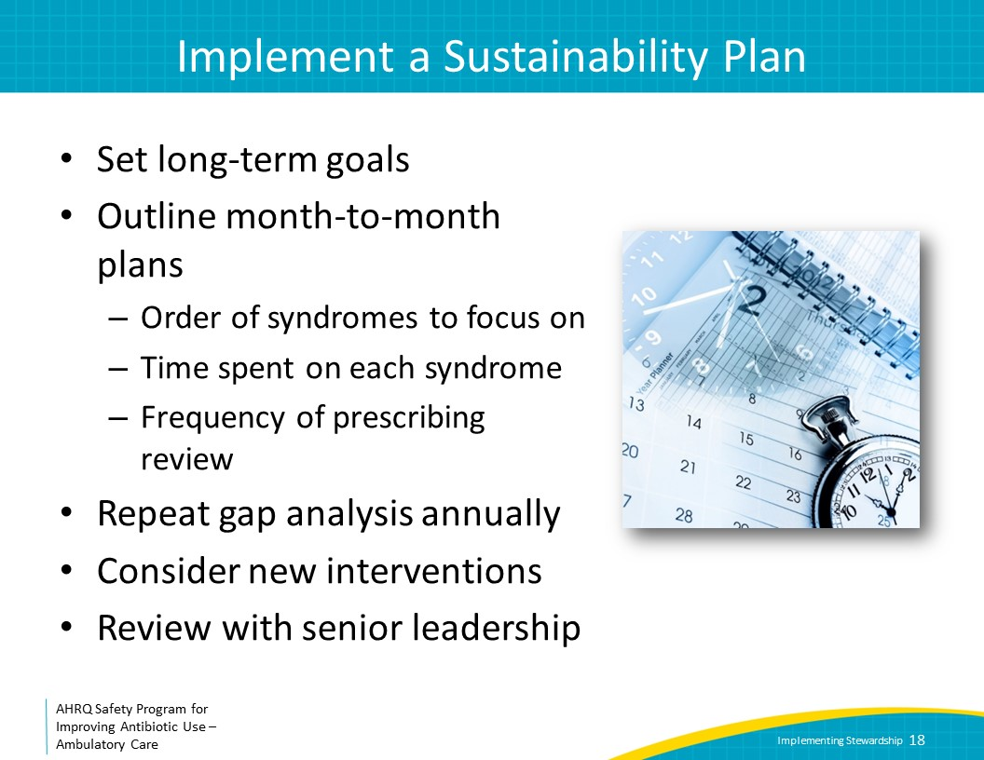
Take-Home Messages  SAY:  Antibiotic stewardship activities in an ambulatory practice should be supported by senior leaders and directed by both a clinical and an administrative leader. It is critical to gain support for antibiotic stewardship activities from practice members through regular communication at practice meetings.  Stewardship activities include developing guidance for management and treatment of common infectious diseases syndromes, improving communication skills between practice members as well as practice members and patients and families, evaluating and reporting data, and implementing antibiotic stewardship interventions based on the needs of the practice. | Slide 19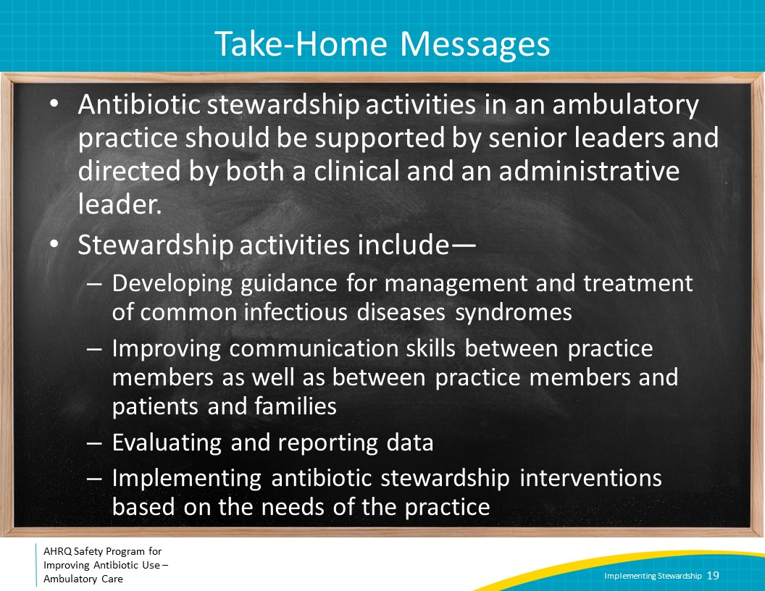
Disclaimer  SAY:  The findings and recommendations in this presentation are those of the authors, who are responsible for its content, and do not necessarily represent the views of AHRQ. No statement in this presentation should be construed as an official position of AHRQ or of the U.S. Department of Health and Human Services.  Any practice described in this presentation must be applied by healthcare practitioners in accordance with professional judgment and standards of care in regard to the unique circumstances that may apply in each situation they encounter. These practices are offered as helpful options for consideration by healthcare practitioners, not as guidelines. | Slide 20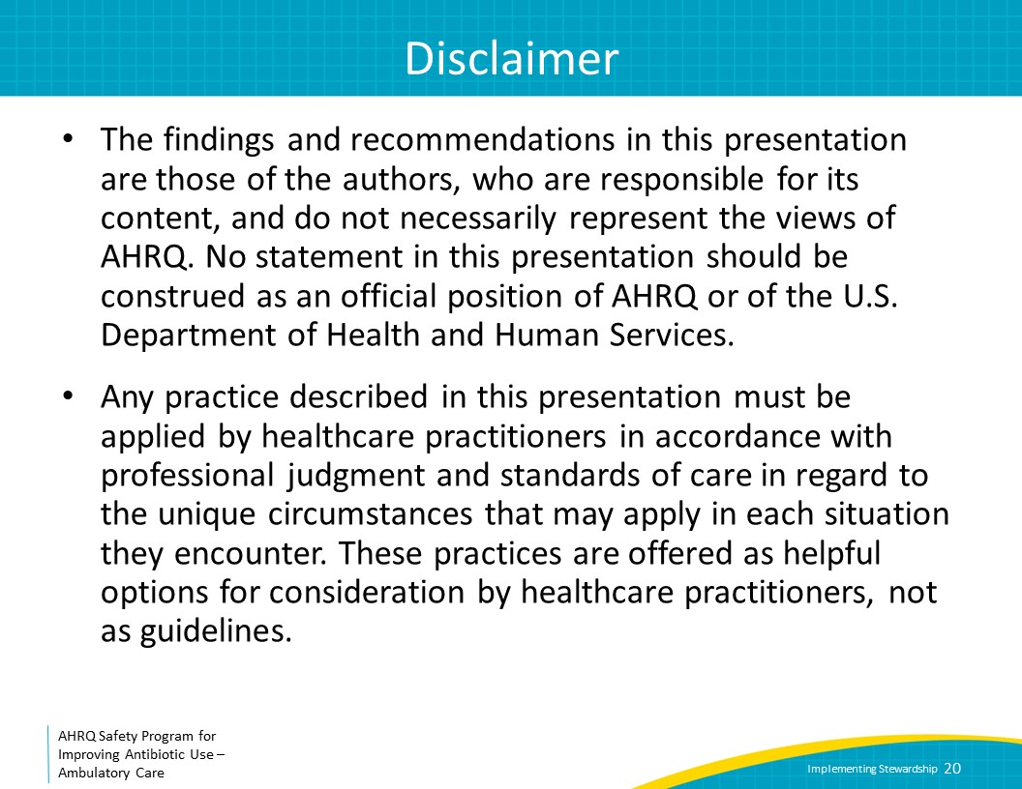
References | Slide 21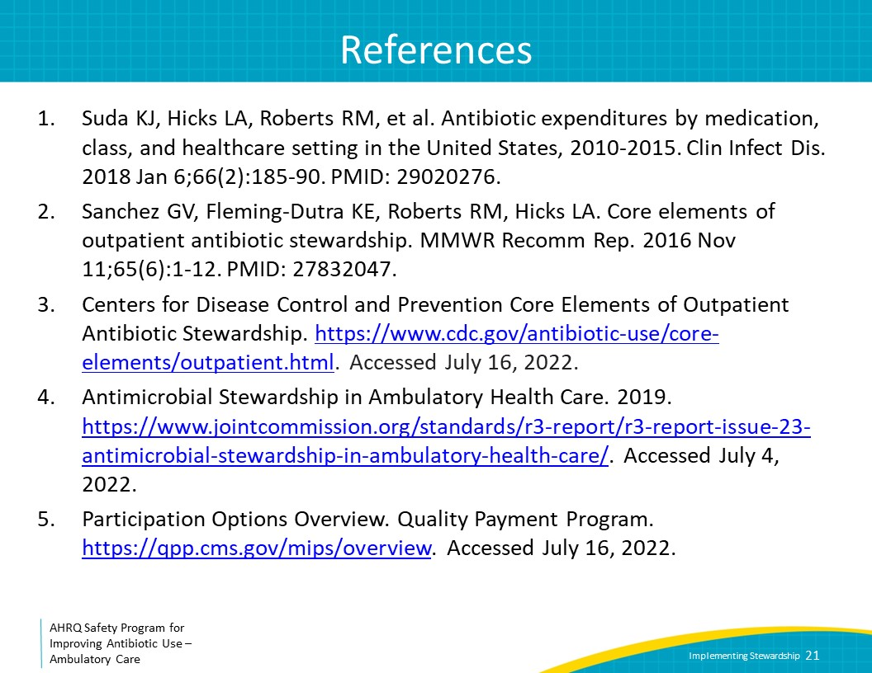
References | Slide 22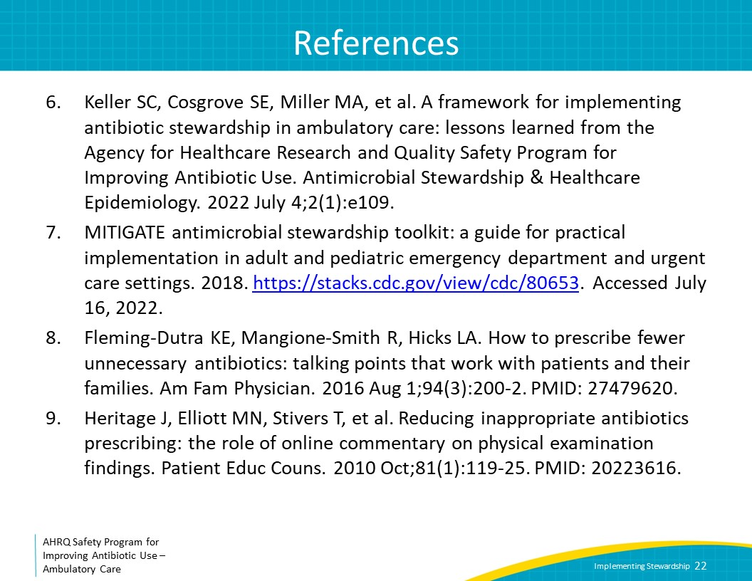
References | Slide 23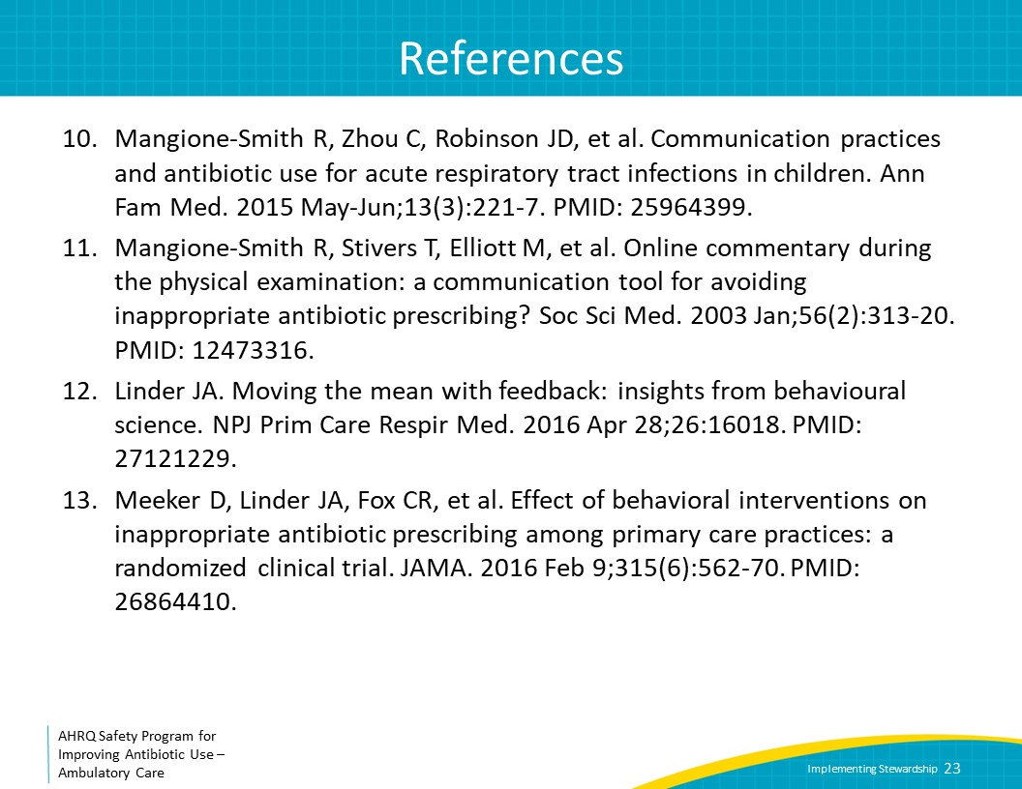
References | Slide 24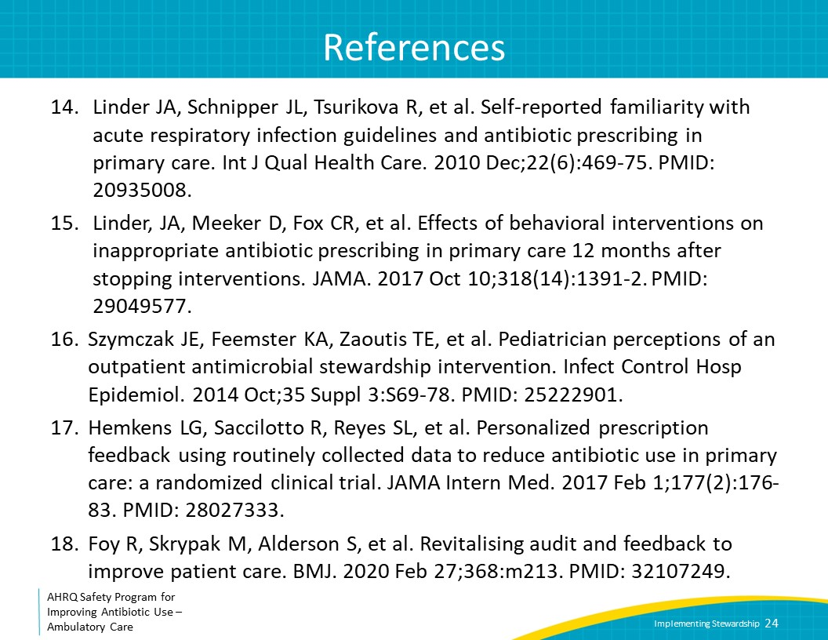
AHRQ Pub. No. 17(22)-0030
September 2022

