The “Sometimes Antibiotics” Diagnoses: Pharyngitis
Ambulatory Care

Slide Title and Commentary | Slide Number and Slide
The Sometimes Antibiotics Diagnoses: Pharyngitis  Ambulatory Care  SAY:  Welcome to the presentation titled, “The ‘Sometimes Antibiotics’ Diagnoses: Pharyngitis.” | Slide 1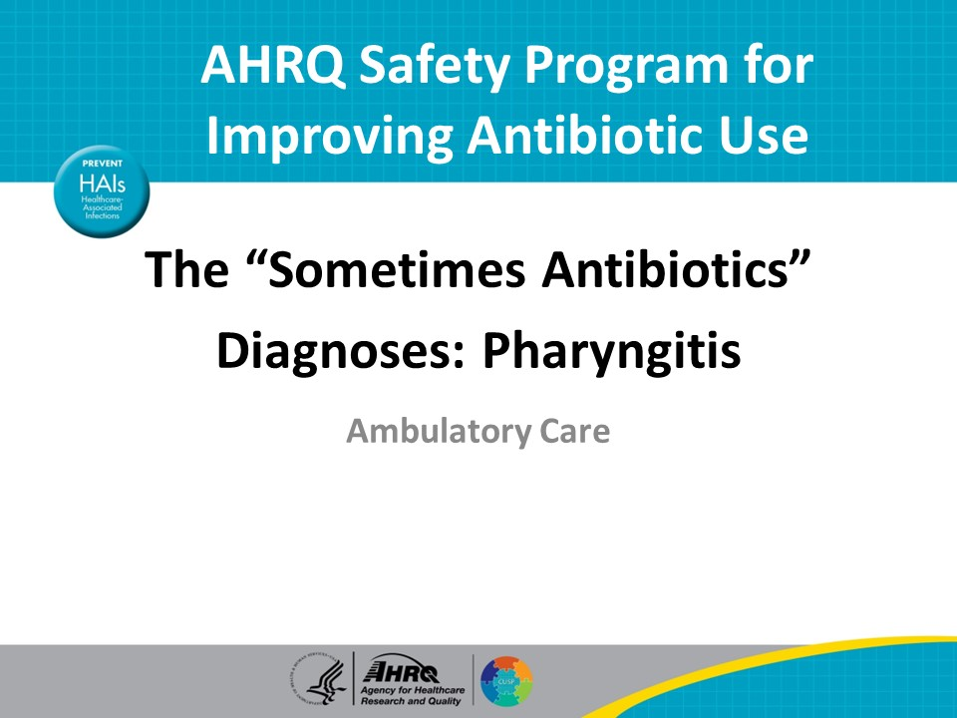
Objectives  SAY:  By the end of this presentation, participants will be able to—  - Review common infectious causes of pharyngitis  - Identify criteria for determining whether to test for streptococcal pharyngitis and  - Describe the treatment of streptococcal pharyngitis | Slide 2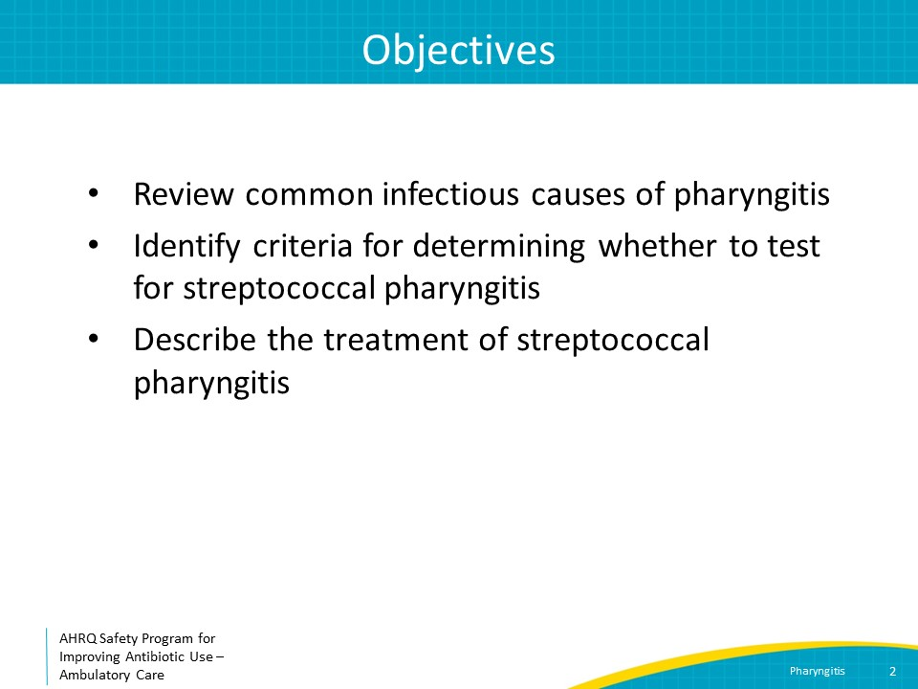
The Four Moments of Antibiotic Decision Making  SAY:  We will review pharyngitis using the Four Moments of Antibiotic Decision Making.  1. Does my patient have an infection that requires antibiotics?  2. Do I need to order a diagnostic test?  3. If antibiotics are indicated, what is the narrowest, safest, and shortest regimen I can prescribe?  4. Does my patient know what to expect and the followup plan? | Slide 3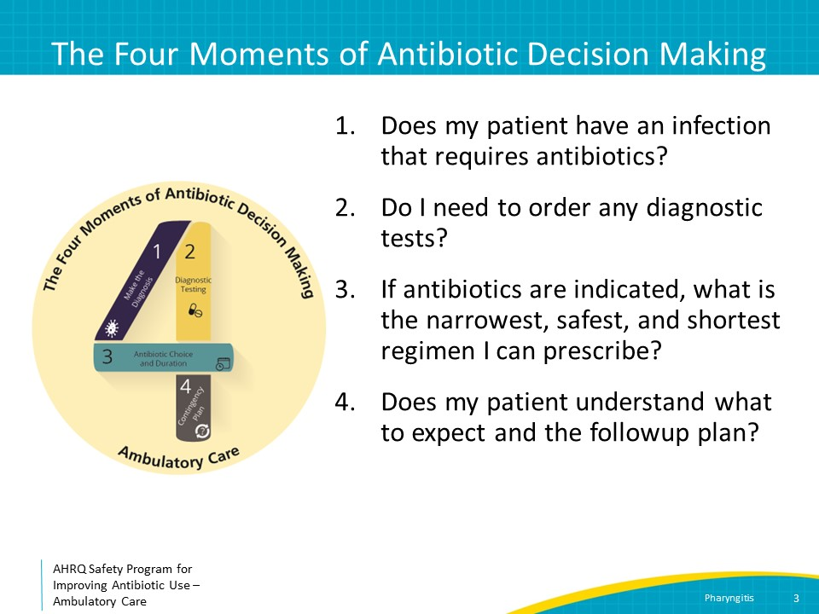
The Four Moments of Antibiotic Decision Making  SAY:  Moment One is: Does my patient have an infection that requires antibiotics? | Slide 4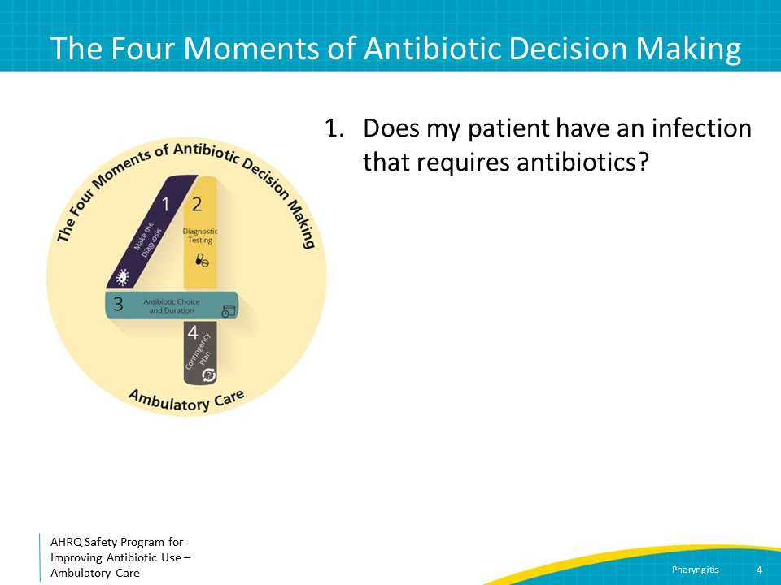
Moment 1: Does My Patient Have an Infection That Requires Antibiotics?  SAY:  The vast majority of cases of pharyngitis are caused by viruses in both children and adults.  Patients with viral pharyngitis have other signs and symptoms suggesting a viral infection such as low-grade fever, malaise, fatigue, rhinorrhea, cough, and conjunctivitis.  Patients with bacterial pharyngitis have a sore throat with tonsillar exudates, fever, and cervical lymphadenopathy adenopathy, but generally do not have typical viral symptoms. The most common bacterial causes of pharyngitis are group A streptococcus or other beta-hemolytic streptococcal species like group C or group G streptococcus. More rarely, other bacteria can cause exudative pharyngitis, such as Arcanobacterium haemolyticum, Fusobacterium necrophorum, or Neisseria gonorrhoeae, as discussed on the next slide.  Mononucleosis, otherwise known as mono, is a viral cause of pharyngitis that is commonly confused with strep pharyngitis. Mono is caused by the Epstein-Barr virus, and symptomatic infection most commonly occurs in adolescents and young adults.  Mono is spread through contact with saliva. Of those who experience clinical symptoms, the presentation generally includes fever, exudative pharyngitis, and cervical lymphadenopathy. | Slide 5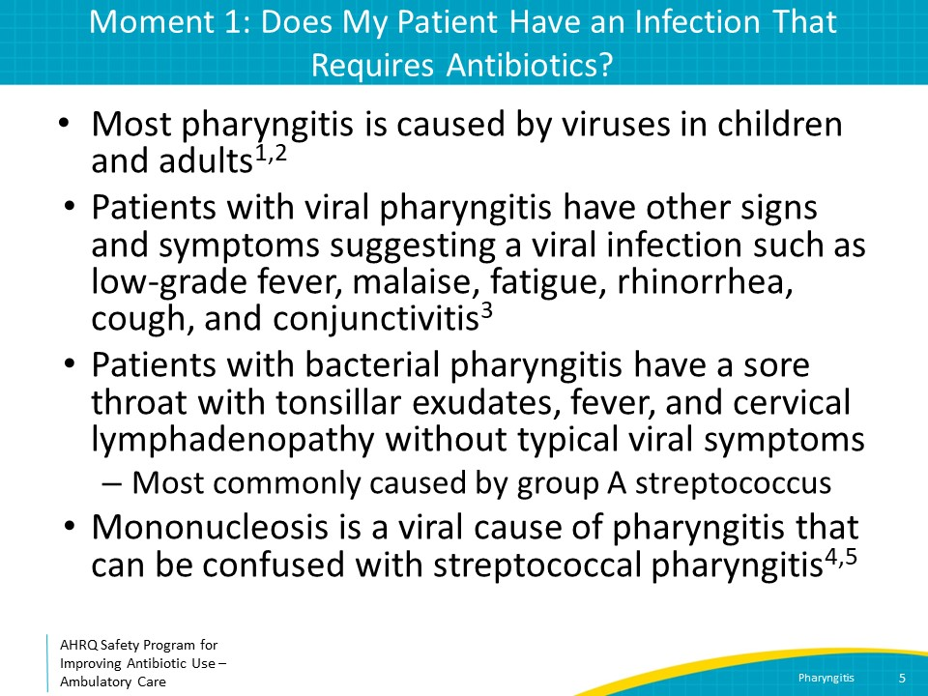
Other Nonstreptococcal Causes of Bacterial Pharyngitis  SAY:  Arcanobacterium haemolyticum is a gram-postive rod that can cause bacterial pharyngitis that mimics streptococcal pharyngitis in presentation. It most commonly causes pharyngitis in adolescents and young adults. About half the time, Arcanobacterium is associated with a scarlatiniform rash. Invasive disease is rare. If Arcanobacterium is identified in a bacterial throat culture, antibiotic therapy may not be indicated as symptoms resolve in the absence of antibiotic therapy. If considerable throat pain is present, consider a treatment course of no more than 3–5 days of azithromycin.  Fusobacterium necrophorum is an anaerobe that is a member of the normal oropharyngeal flora but can occasionally cause pharyngitis, most commonly in adolescents and young adults. Fusobacterium rarely causes infected thrombi within neck veins leading to a syndrome called Lemierre syndrome. Lemierre syndrome is associated with bacteremia and disseminated infection. Evidence is lacking that treating Fusobacterium pharyngitis with antibiotics reduces symptoms or prevents Lemierre syndrome. However, if Fusobacterium is detected in a throat culture and the patient is ill appearing, consider referral to an emergency department to determine if further evaluation for Lemierre syndrome or a deep neck space infection is necessary.  Gonococcal pharyngitis should be considered in sexually active adolescents or adults. Although often asymptomatic, it can present with sore throat, pharyngeal exudates, and/or cervical lymphadenitis. Although Neisseria can be identified on routine cultures, it can sometimes be difficult to grow. If there is a high suspicion for gonococcal pharyngitis, nucleic acid amplification or NAAT testing of a pharyngeal swab should be obtained. A single intramuscular dose of ceftriaxone 500 mg (or 1 gram if the patient weighs 150 kilograms or more) is the preferred treatment for gonococcal pharyngitis. Treatment for chlamydia and screening for other sexually transmitted infections should be considered. For more information on alternative treatment regimens for gonococcal pharyngitis and other sexually transmitted infections that should be investigated, refer to the Centers for Disease Control and Prevention’s Sexually Transmitted Infections Treatment Guidelines. | Slide 6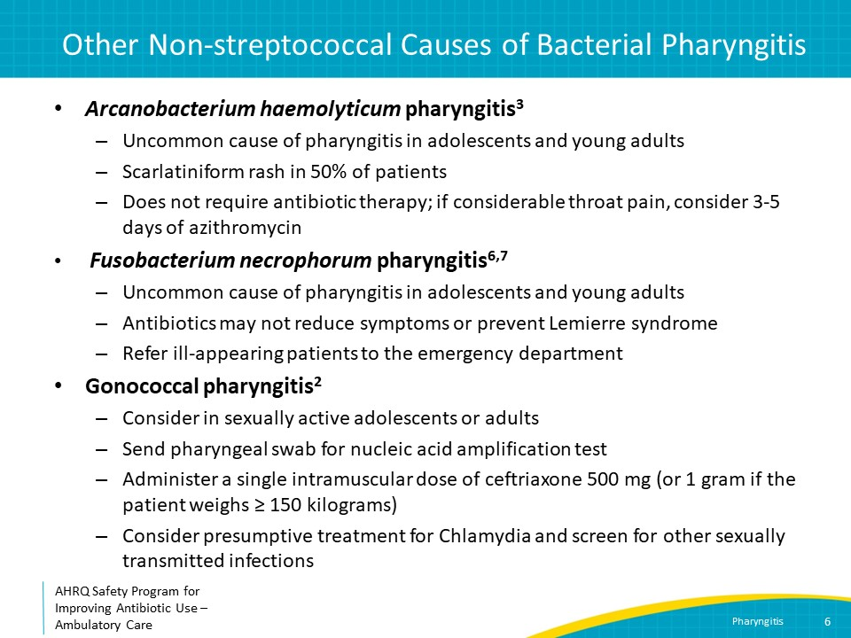
Moment 1: Pharyngitis: Centor Criteria  SAY:  For older children and adults, the Centor criteria can be useful in deciding whether a patient is likely to have streptococcal pharyngitis. Centor criteria are composed of four findings: fever, tonsillar exudate or swelling, tender anterior cervical lymphadenopathy, and the absence of cough. The probability of strep pharyngitis increases as more criteria are met.  If a patient meets zero or one criterion, the probability of strep throat is minimal, and it can be ruled out as the etiology of a patient’s symptoms without performing a rapid strep test. If a patient fulfills two or three criteria, the probability of strep is increased, and a rapid strep test should be performed to help confirm your clinical findings. If a patient meets all four criteria, the probability of strep pharyngitis is high enough that patients can be diagnosed with strep pharyngitis with or without a confirmatory rapid strep test. | Slide 7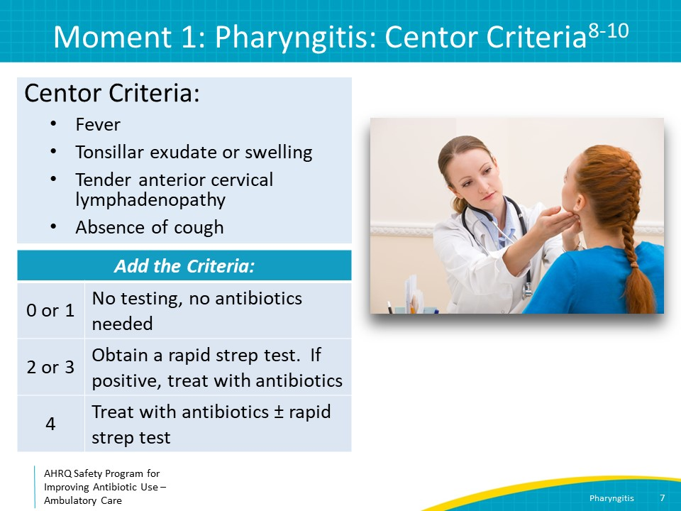
Case Presentation  SAY:  Here is an example case: A 50-year-old man who babysits his 5-year-old grandchild has had 3 days of sore throat and a dry cough. He has not had any fevers. On exam, he has sinus tenderness, an erythematous posterior oropharynx, normal appearing tonsils, and no cervical lymphadenopathy.  Does this patient require antibiotics?  While this patient is experiencing some discomfort from his sore throat and dry cough, he does not meet any Centor criteria; thus, a rapid strep test is not indicated, and he does not require antibiotics. | Slide 8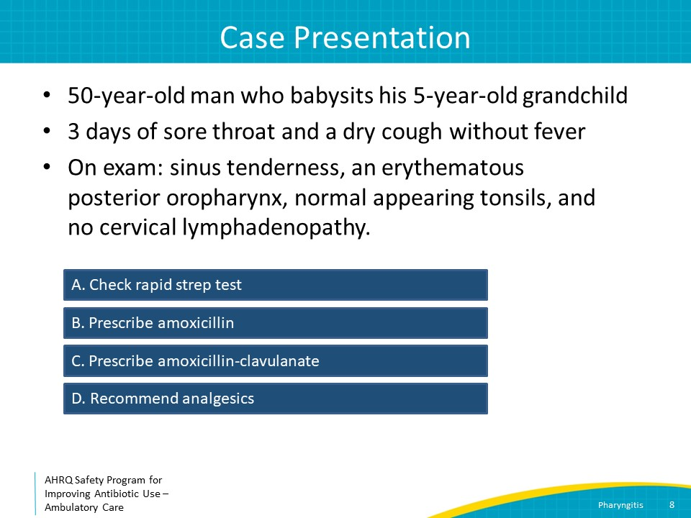
Case Presentation  SAY:  If the patient were also febrile and had tender anterior cervical lymphadenopathy, would management change?  Both fever and tender anterior cervical lymphadenopathy are components of the Centor criteria. He now has two of the four criteria, so he should undergo a rapid strep test.  Counseling about analgesics for pain should be part of your recommendation. Anti-pyretics for fever are appropriate if the patient is uncomfortable, but not required if the patient is otherwise fairly comfortable as fever is a natural part of the immune response. | Slide 9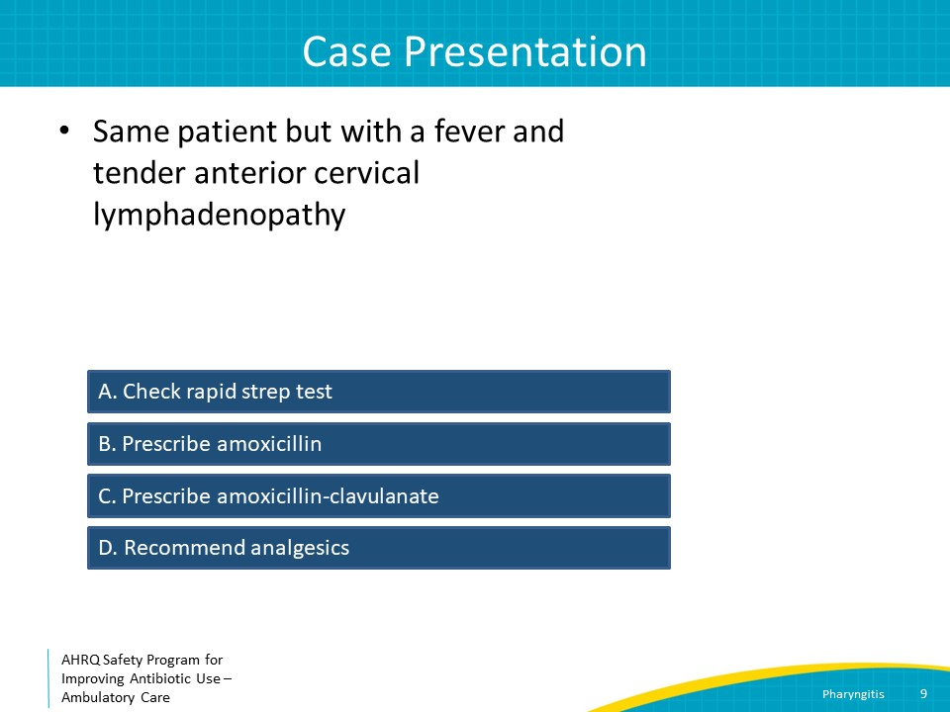
The Four Moments of Antibiotic Decision Making  SAY:  Moment Two is: Do I need to order any diagnostic tests? | Slide 10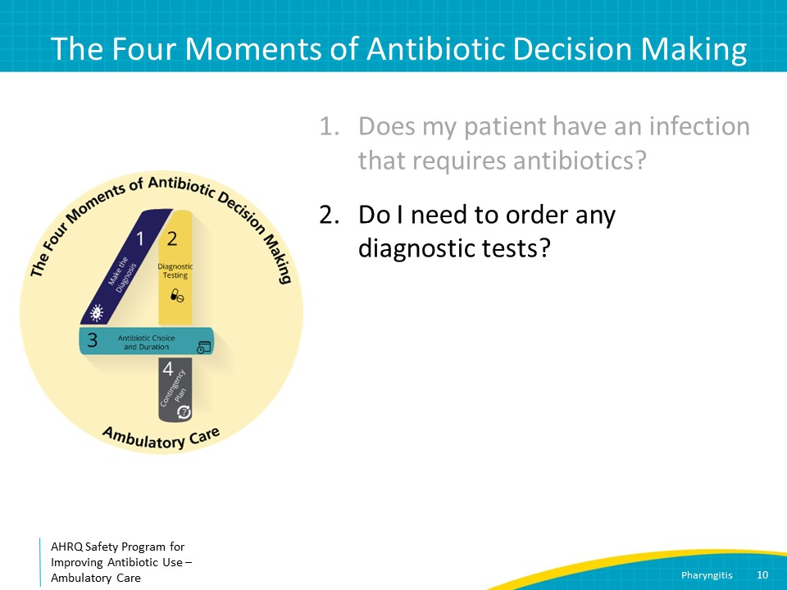
Moment 2: Do I Need to Order a Diagnostic Test?  SAY:  Consider sending a rapid strep test for patients 3 years of age and older with at least two Centor criteria.  A throat specimen should be obtained by swabbing the tonsils and posterior pharynx. Avoid contact with the tongue and uvula to minimize risk of contamination with normal oral flora.  Often, a reflex bacterial culture is performed by the laboratory if the rapid strep test is negative. This is helpful in children where the prevalence of group A streptococcal pharyngitis is relatively high but generally not necessary in adults.  A reflex culture is also not needed if the lab does a molecular rapid test because the sensitivity and specificity of molecular testing are greater than 95 percent. | Slide 11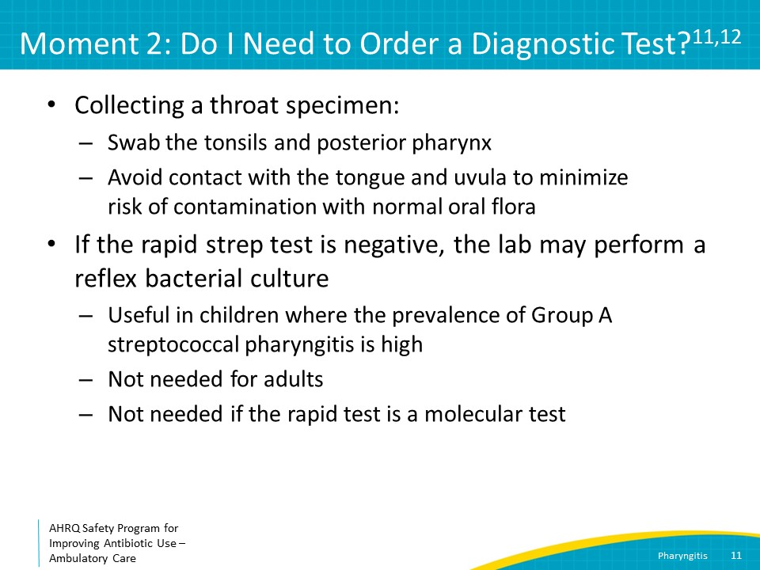
Moment 2: Do I Need To Order a Diagnostic Test?  SAY:  Adolescents who present with fatigue, fever, and tonsillar exudates should be tested for mononucleosis via a heterophile antibody test (Monospot test) or EBV serologies.  Antibiotics are not indicated for pharyngitis caused by Epstein-Barr virus. Patients with mono who are given amoxicillin can develop a nonallergic erythematous, macular rash, which can erroneously be recorded as a penicillin allergy. | Slide 12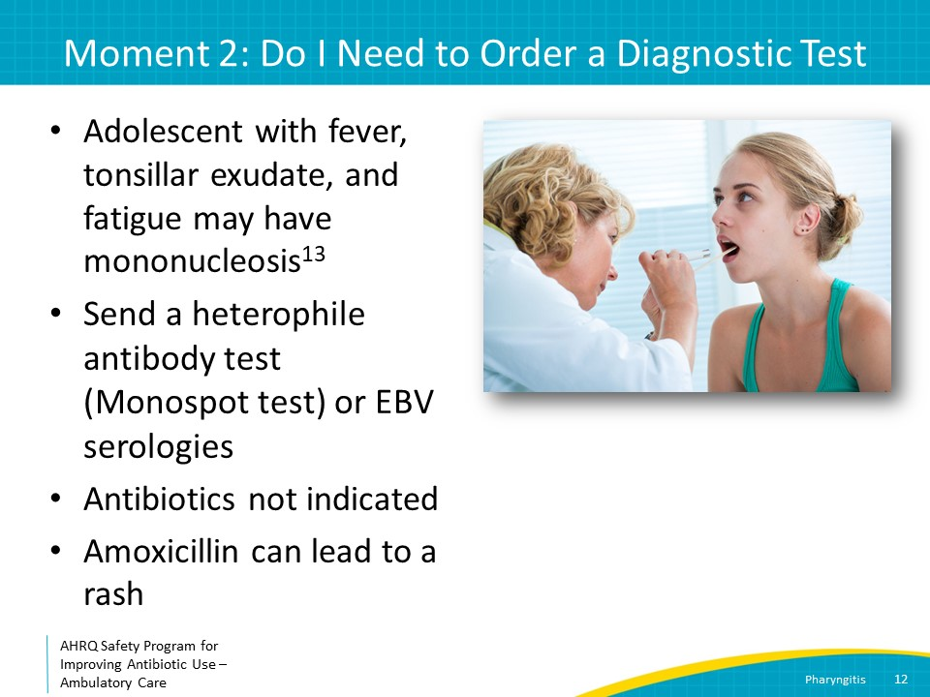
The Four Moments of Antibiotic Decision Making  SAY:  Moment Three is: If antibiotics are indicated, what is the narrowest, safest, and shortest regimen I can prescribe? | Slide 13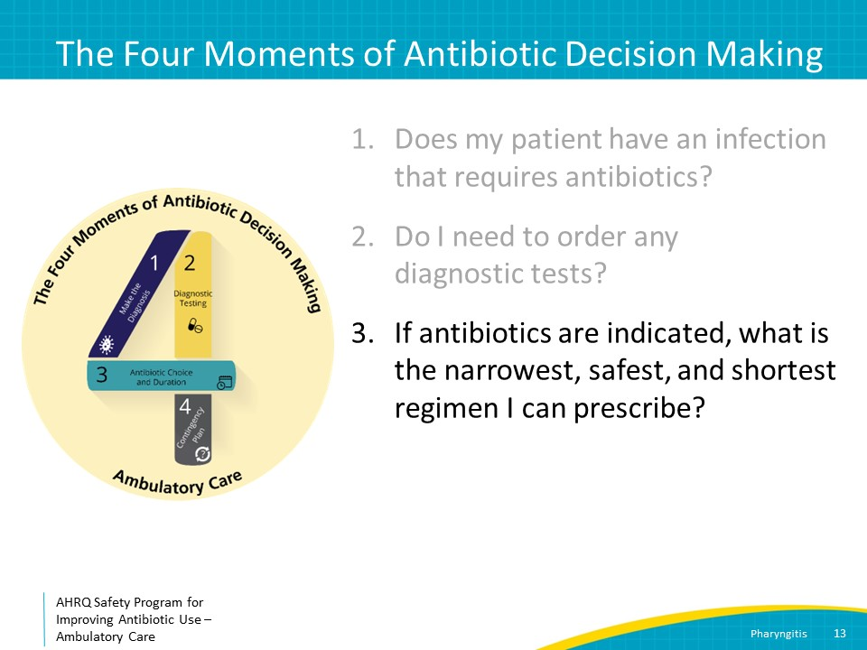
Moment 3: Narrowest, Safest, and Shortest Regimen  SAY:  Patients in whom there is strong clinical suspicion for strep pharyngitis, or with microbiologically confirmed strep pharyngitis, should be treated with penicillin or amoxicillin. A single dose of intramuscular benzathine penicillin G is an alternative to a course of oral antibiotics. Penicillin-resistant group A streptococci has not been reported.  For patients who have mild allergies to penicillins, first-generation cephalosporins such as cephalexin or cefadroxil are reasonable alternatives, and both are given twice a day.  For patients who have severe allergies to penicillins, such as anaphylaxis, clindamycin or azithromycin may be options. Clinicians should be alert to the fact that resistance to both of these agents is increasing.  The duration of antibiotic therapy for strep throat for both children and adults is 10 days. In rare cases where azithromycin is prescribed, treatment is 5 days, given azithromycin’s long half-life. | Slide 14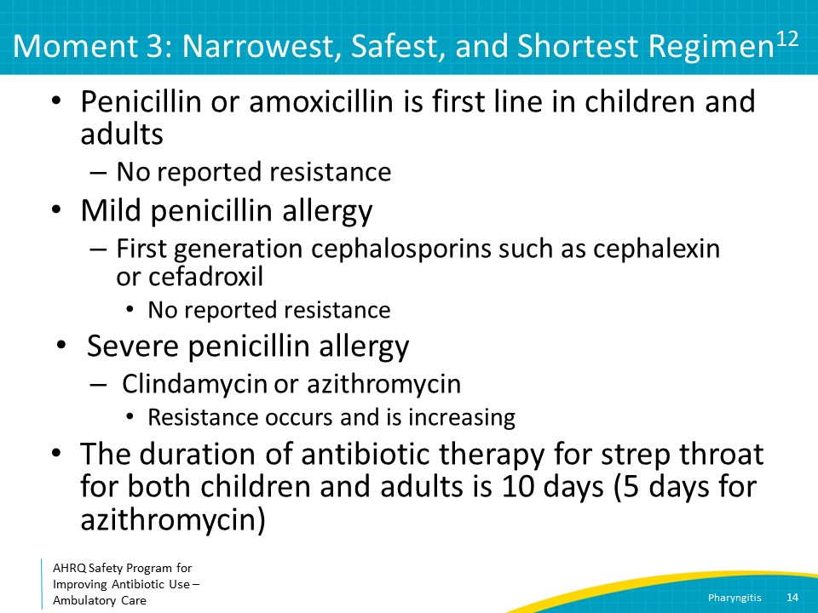
Moment 3: Additional Considerations  SAY:  For patients completing an antibiotic course for strep throat, a test of cure at the end of therapy is not recommended because some patients—particularly children—remain asymptomatically colonized with this organism, and this does not pose any known harm.  The clinical significance of group C or group G strep in throat cultures is unclear and there is no consensus if antibiotic therapy is necessary. You may consider treating with antibiotics if the patient is experiencing severe symptoms. These organisms have not been associated with rheumatic fever, so focusing on symptomatic relief only with analgesics is also a reasonable approach. If you do treat, penicillin or amoxicillin is first-line therapy. Consider limiting the antibiotic course to no more than 5 days. | Slide 15 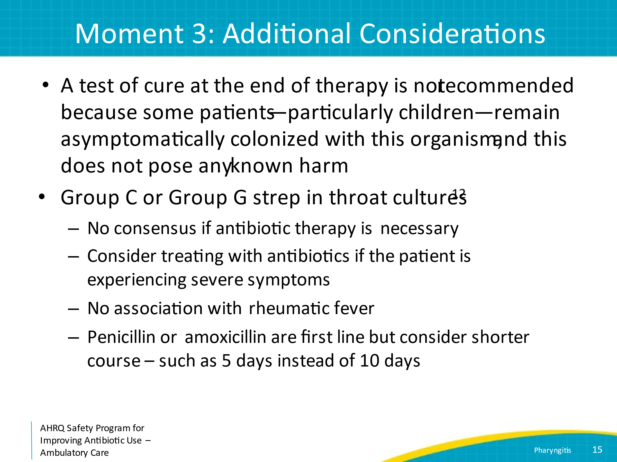
Symptomatic Relief  SAY:  For patients with pharyngitis—regardless of whether the patient has strep throat or not—supportive measures like warm tea, honey, and throat lozenges or analgesics such as acetaminophen or ibuprofen can also be considered. | Slide 16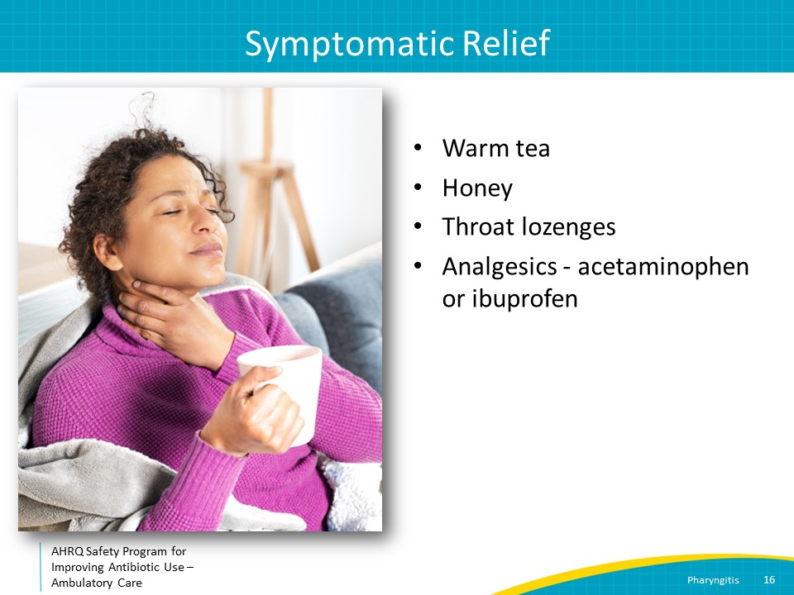
The Four Moments of Antibiotic Decision Making  SAY:  Moment Four is: Does my patient understand what to expect and the followup plan? | Slide 17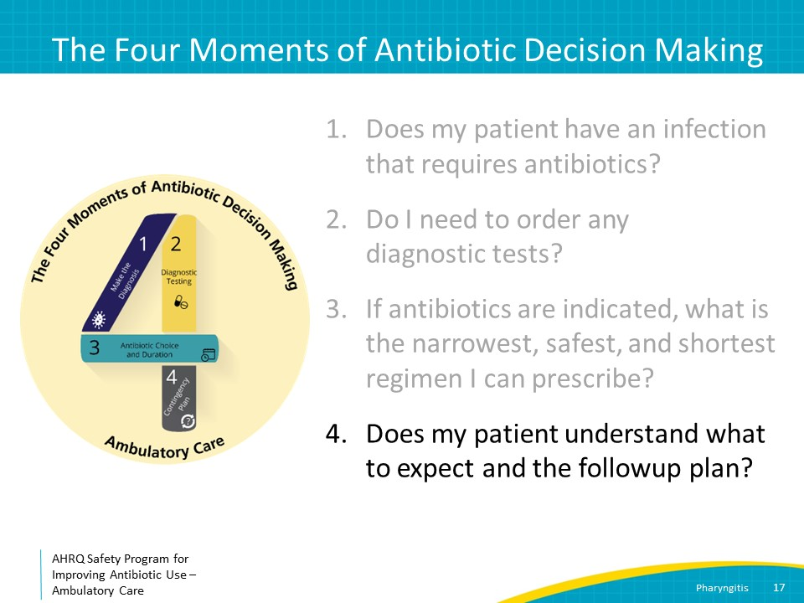
Moment 4: Followup Plan  SAY:  Regardless of viral versus bacterial etiology, fever and sore throat typically resolve within 1 to 3 days.  Antibiotic treatment can potentially reduce symptoms of bacterial pharyngitis by about half a day, and may reduce the risk of purulent complications such as peritonsillar or retropharyngeal abscesses. If the patient has continued fevers or worsening throat pain, he or she should be advised to return to medical attention for evaluation of progression to one of these infections.  For those with strep pharyngitis diagnoses, it is important to remind patients that streptococcal pharyngitis is contagious. It is spread through droplet particles, so make sure to practice good hand hygiene when in contact with respiratory secretions.  Patient with active EBV infection are at risk for splenic rupture. Splenomegaly can occur in EBV, but the clinical exam may not be able to rule this out. School-aged children, college athletes, or other highly active individuals are often advised to avoid contact sports while they recover. While there is no clear consensus as to when it is safe to allow athletes to return to contact sports after a mono diagnosis, the general recommended range is anywhere between 3 and 6 weeks from onset of symptoms to avoid splenic rupture. | Slide 18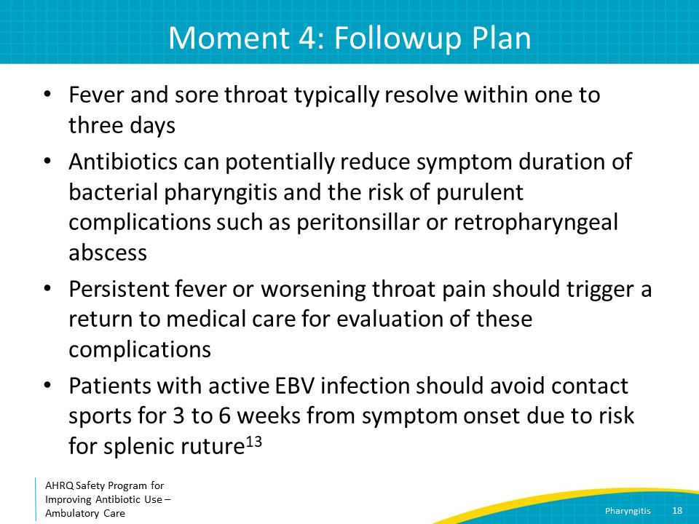
Take-Home Messages  SAY:  In summary, use the Centor criteria to guide diagnostic testing for pharyngitis, and consider also testing for active EBV infection in adolescents or young adults.  Penicillin and amoxicillin are first-line treatments for streptococcal pharyngitis.  Over-the-counter analgesics and home remedies can be recommended for symptom relief.  Patients should be instructed to return to medical care if they have continued fevers or worsening throat pain, as these may indicate a peritonsillar or retropharyngeal abscess. | Slide 19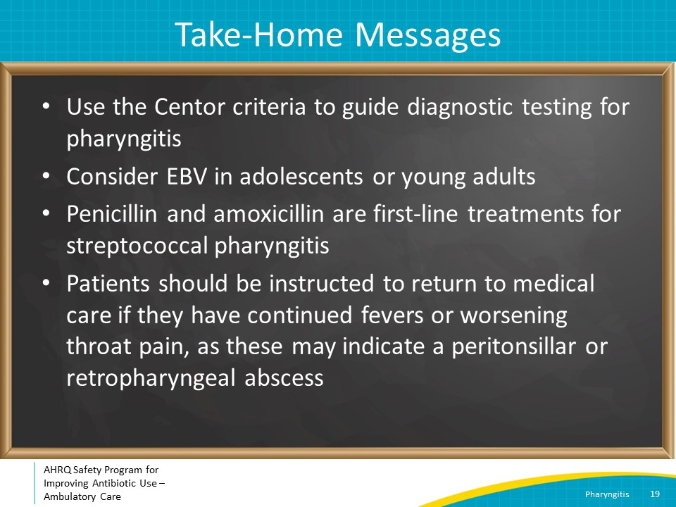
Additional Toolkit Resources  SAY:  For more resources on pharyngitis, please access tools listed below, available on the AHRQ Toolkit To Improve Antibiotic Use in Ambulatory Care Guide.  Refer to the Discussion Guide to help your practice develop a standardized approach to the diagnosis and management of patients with pharyngitis.  Refer to the One-Page document for a concise summary of the diagnosis and treatment of pharyngitis.  Share the Patient Handout with your patients. It explains the symptoms and symptomatic treatment of pharyngitis and emphasizes that antibiotics are not always needed. It is available in both English and Spanish. | Slide 20 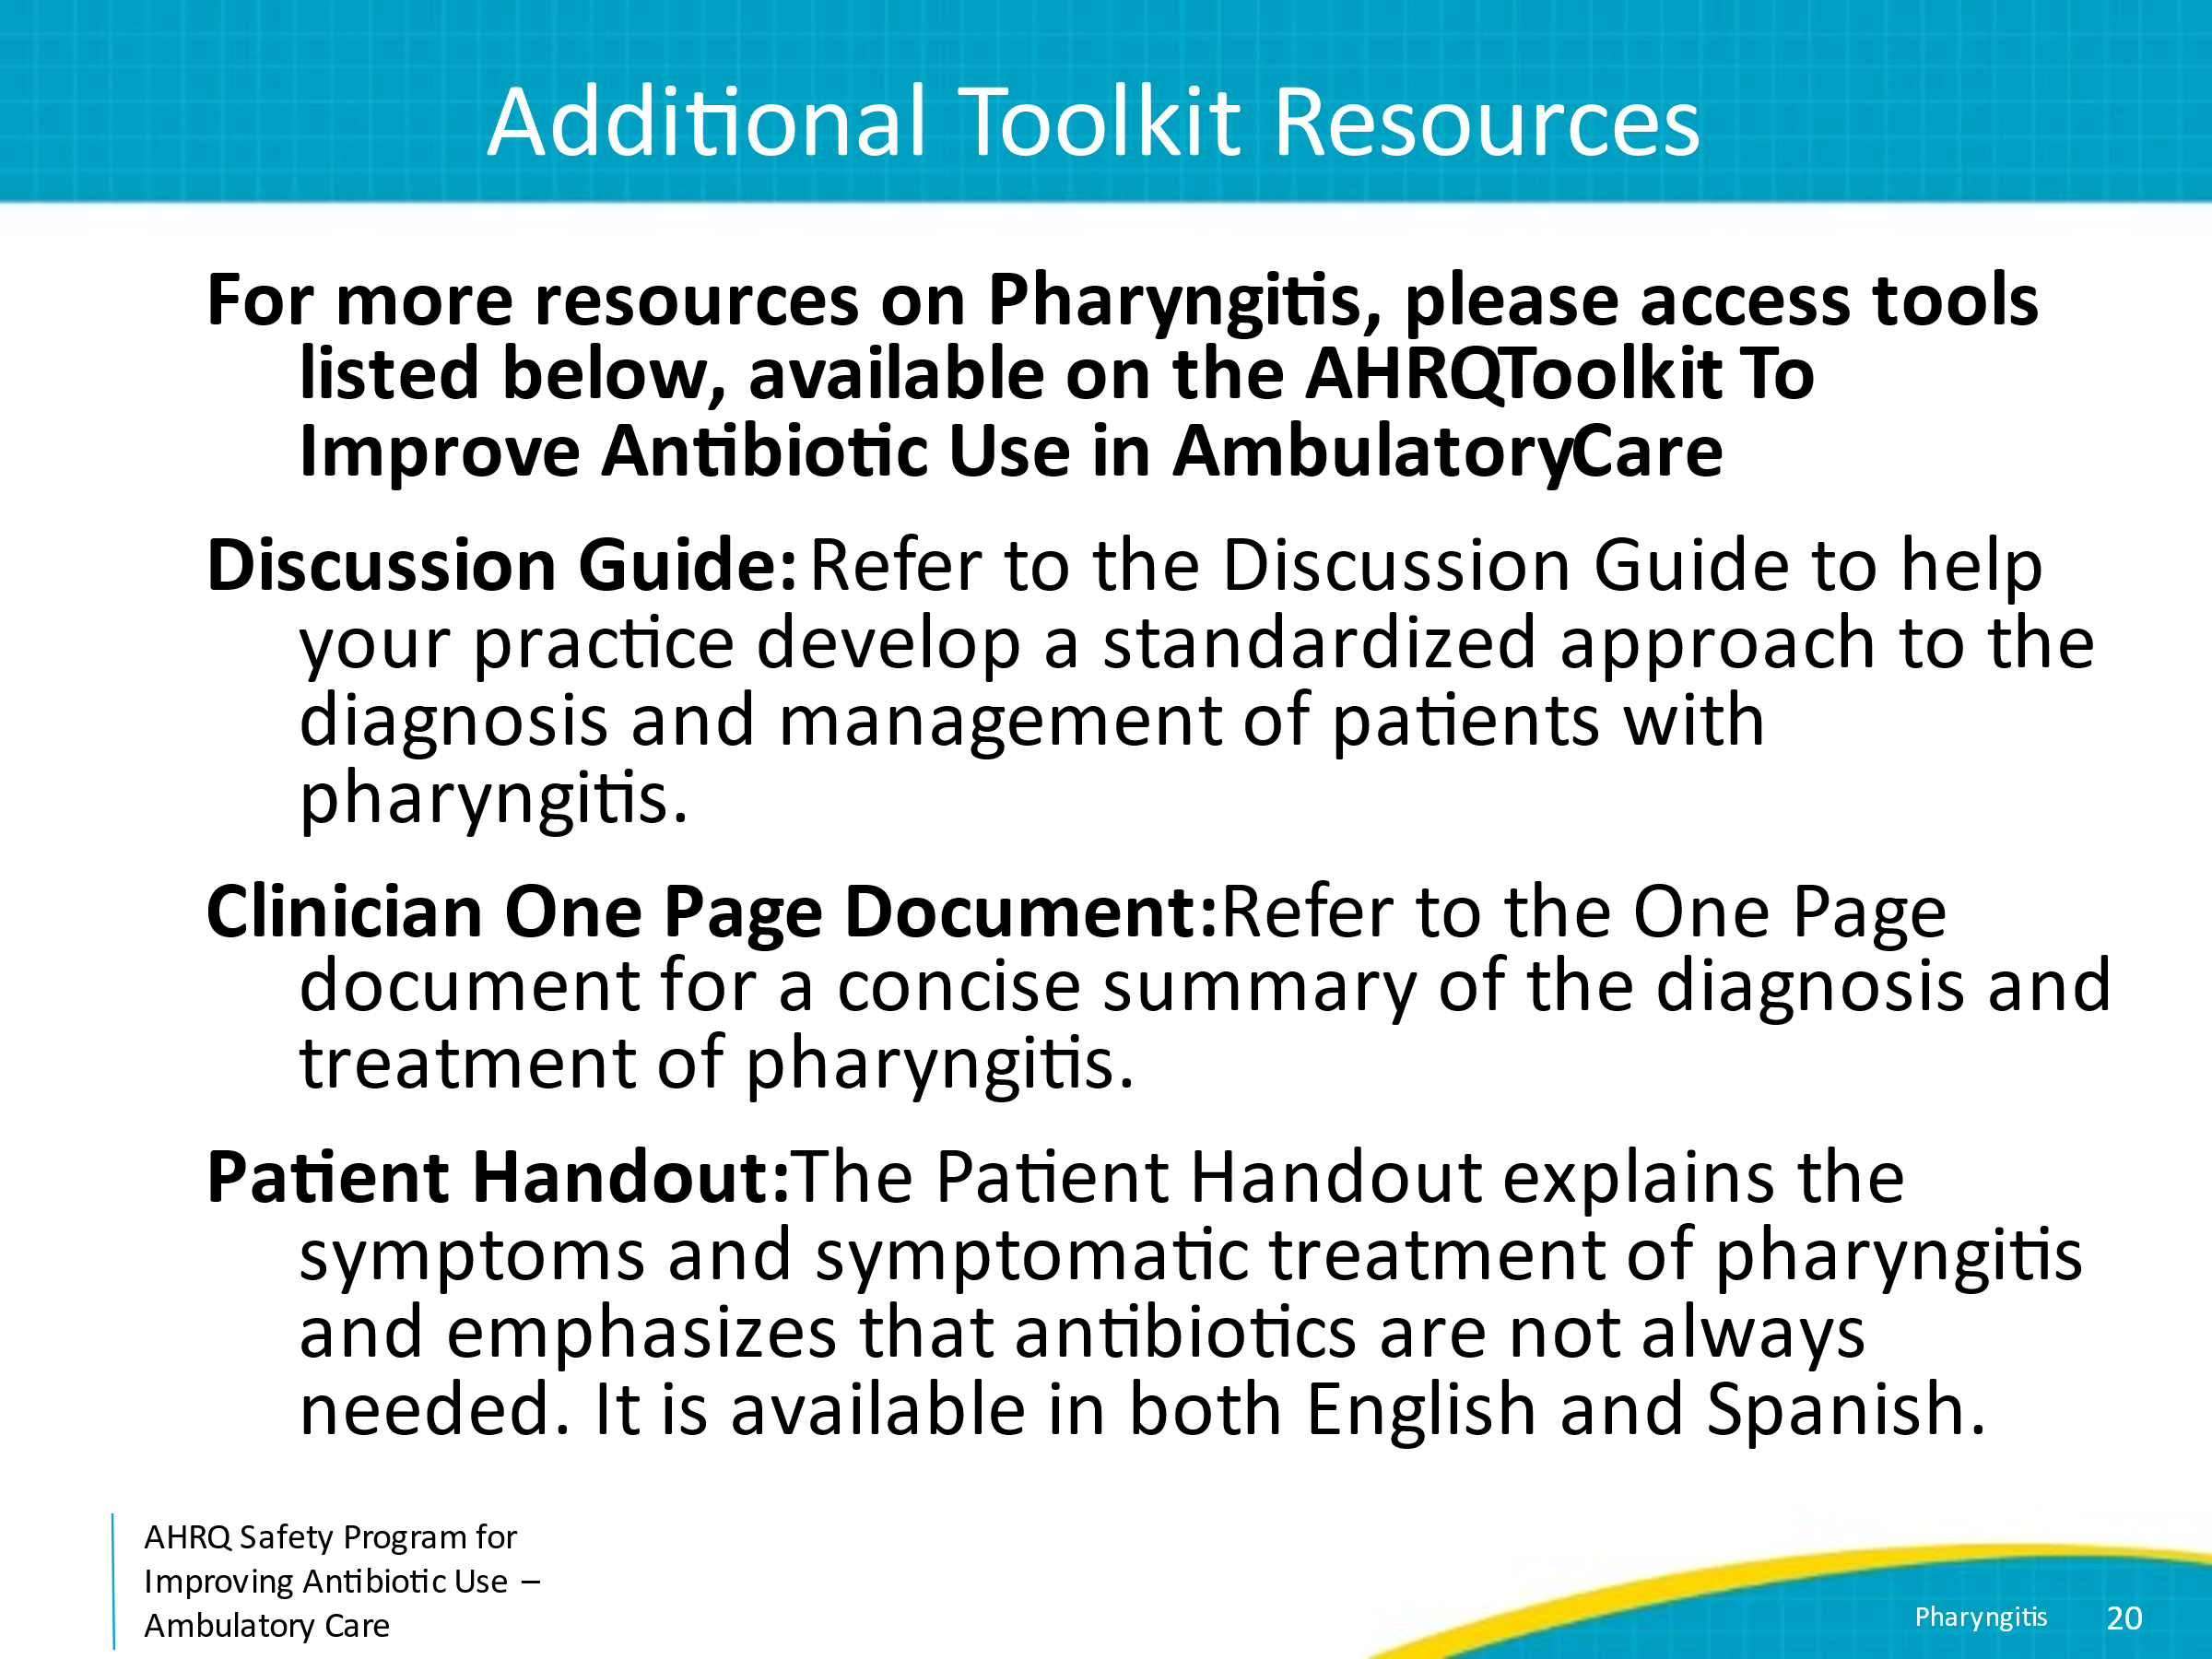
Disclaimer  SAY:  The findings and recommendations in this presentation are those of the authors, who are responsible for its content, and do not necessarily represent the views of AHRQ. No statement in this presentation should be construed as an official position of AHRQ or of the U.S. Department of Health and Human Services.  Any practice described in this presentation must be applied by healthcare practitioners in accordance with professional judgment and standards of care in regard to the unique circumstances that may apply in each situation they encounter. These practices are offered as helpful options for consideration by healthcare practitioners, not as guidelines. | Slide 21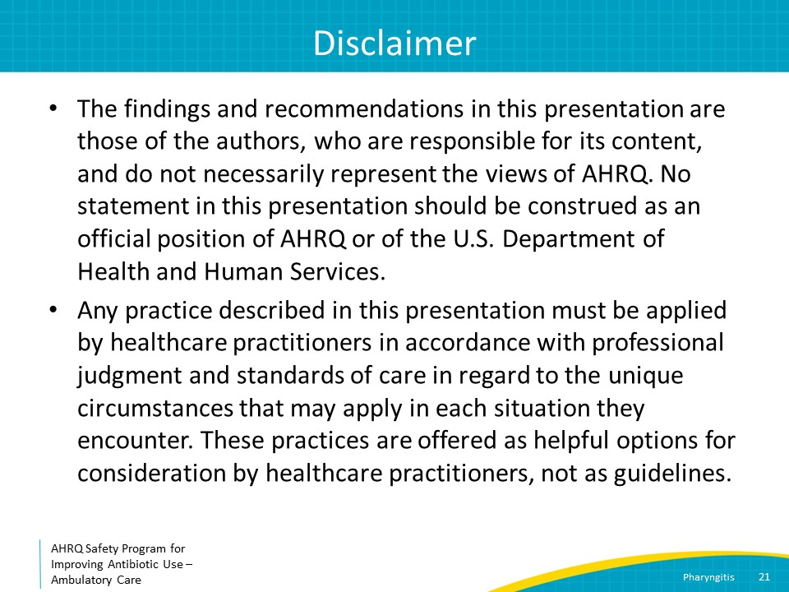
References  SAY:  Here are the references. | Slide 22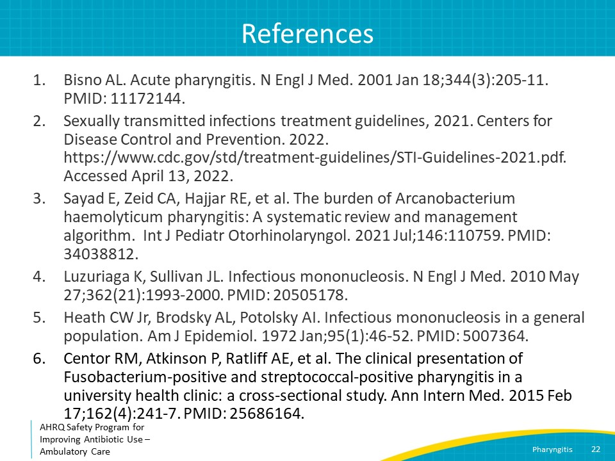
References | Slide 23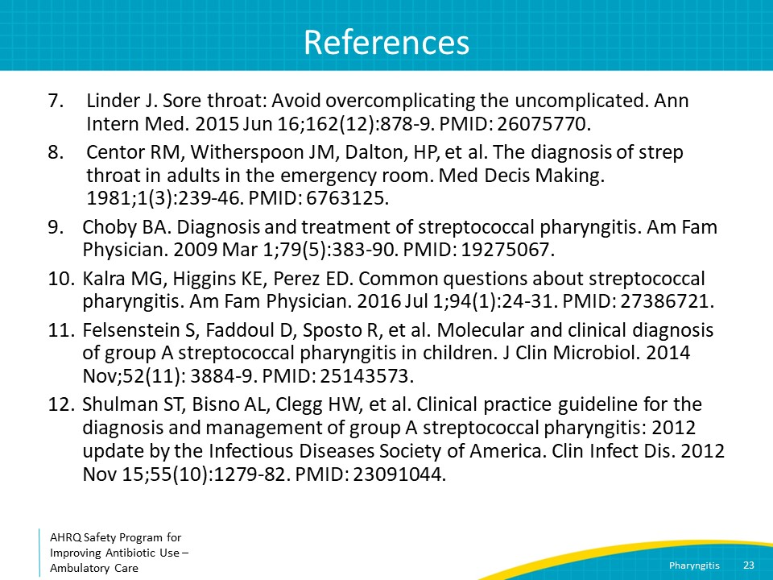
References | Slide 24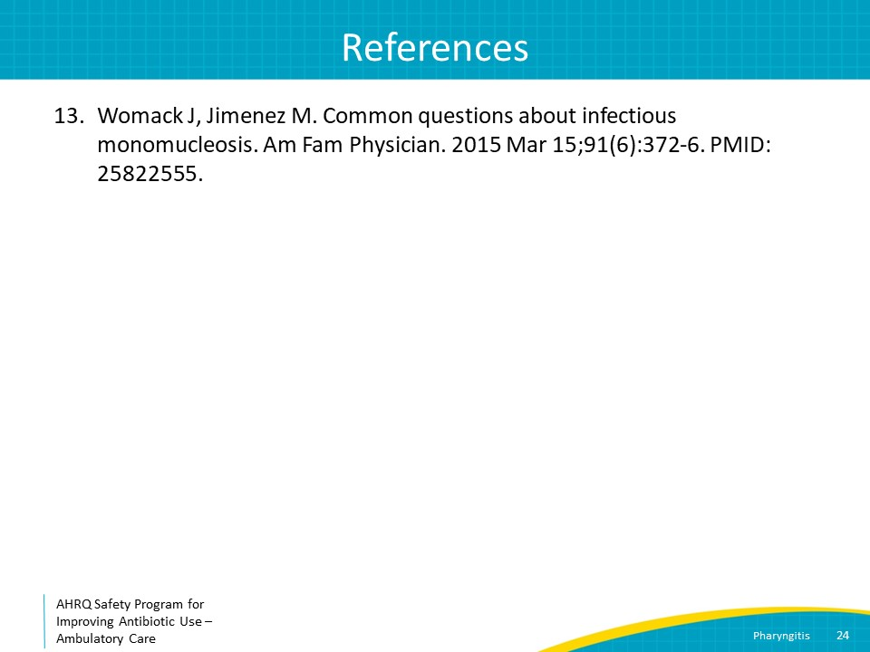
AHRQ Pub. No. 17(22)-0030
September 2022

