Assessment of the Resident With a
Suspected Urinary Tract Infection
Long-Term Care
Slide Title and Commentary | Slide Number and Slide
Assessment of the Resident With a Suspected Urinary Tract Infection  Long-Term Care  SAY:  Welcome to the presentation titled, “Assessment of the Resident With a Suspected Urinary Tract Infection.” | Slide 1
Objectives  SAY:  At the end of the presentation, you will be able to differentiate between the terms urinary tract infection (UTI) and asymptomatic bacteriuria. You also will be able to recognize the signs and symptoms of a suspected UTI that should be reported to and discussed with other members of the health care team.  Finally, you will be able to list common resident signs and symptoms that warrant collecting urine cultures to assess for infection. The goal of this presentation is to help you make better decisions about antibiotic prescribing and improve the care for your residents. | Slide 2  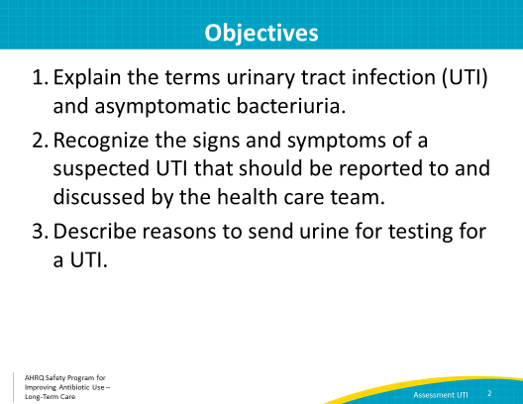
Case 1  SAY:  One of your colleagues is reviewing the case of Mary Ann, a resident who is about to be transferred to your long-term care facility from the hospital. He asks you about the urinalysis or UA and culture results he found in her chart. Your colleague looks at these laboratory results and thinks the resident has a UTI.  Take a moment to look at the results.  Note that she has an abnormally high white blood cell count and red blood cell count in her urine, as well as positive nitrites and large leukocyte esterase. She also has evidence of bacteria in her urine. | Slide 3  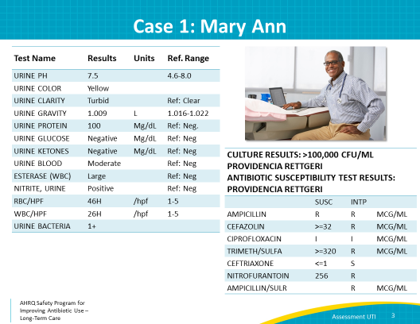
Case 1: Question 1  SAY:  Your colleague thinks Mary Ann has a UTI. Do you think she has a UTI?  Let’s explore all of the answers.  If you chose “yes,” you are incorrect. We can't use laboratory results in isolation to know whether the resident has an infection. We need to speak with the resident and determine if she has symptoms consistent with a UTI.  If you chose “no,” you are also incorrect, for the same reason.  If you chose “don’t know,” great job! We cannot know if the resident has a UTI without assessing her. | Slide 4  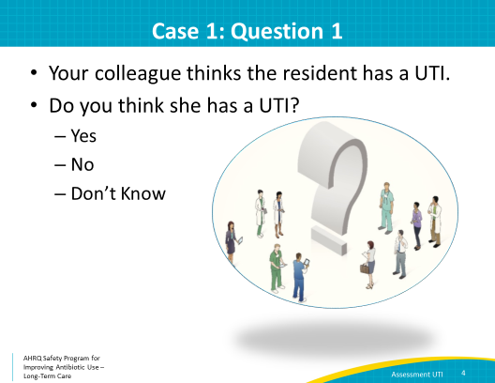
Diagnosing a UTI  SAY:  Let’s review the signs and symptoms of a UTI.  Dysuria, or a burning pain with urination, is a common symptom of a urinary tract infection. Bear in mind that urinary tract infections are not the only reason for dysuria.  A resident might also have a UTI if he or she has systemic signs such as fevers or chills AND one or more symptoms that localize to the genitourinary tract. These include urinary frequency, urgency, bladder pain, pelvic pain, hematuria, or worsening urinary incontinence.  Some older adults have urinary frequency or incontinence at baseline—this does not mean they have a UTI. Systemic signs combined with a change in frequency or incontinence might also indicate a UTI.  Notice that laboratory tests are missing from this list. Laboratory tests alone do not tell us if someone has a UTI. Instead, we use clinical signs and symptoms to decide if we should worry about the possibility of a UTI. The results of laboratory tests might help guide treatment decisions about whether a resident does or does not have a UTI. | Slide 5  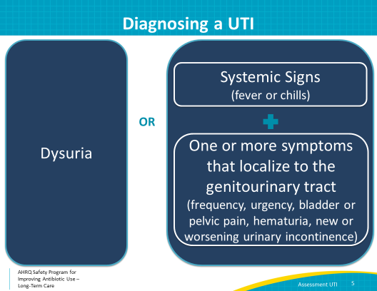
Asymptomatic Bacteriuria  SAY:  If a resident has a positive urinalysis OR a positive culture but does not have any symptoms suggestive of infection, he or she has asymptomatic bacteriuria. This means there is bacteria in the urine, but it does not need to be treated.  You talk with the resident and find out she does not have any urinary symptoms. So, she does not have a UTI. She has asymptomatic bacteriuria. A positive urinalysis or positive urine culture in the absence of symptoms is asymptomatic bacteriuria. | Slide 6  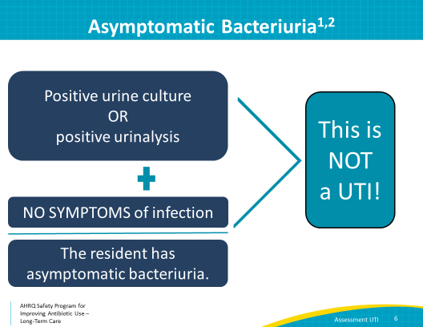
Asymptomatic Bacteriuria  SAY:  Asymptomatic bacteriuria is common among older adults, and can occur in 25 to 50 percent of women and 15 to 40 percent of men. It does not lead to increased risk of infection or death.  There are data indicating that treating asymptomatic bacteriuria can be harmful to residents as it increases the likelihood of future clinically relevant UTIs and also increases the chances of having future UTIs caused by drug resistant bacteria.  There are two exceptions regarding antibiotic therapy in asymptomatic bacteriuria—pregnant women and patients undergoing urologic procedures involving the mucosa. These two exceptions are uncommon in long-term care and are considered prophylaxis, not treatment. | Slide 7  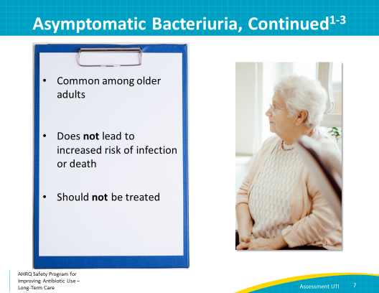
Case 1  SAY:  Let’s look more deeply into the case we just discussed.  When Mary Ann arrives to the floor, you and your colleague visit her. She appears fatigued, but is in good spirits and is asking if they are serving key lime pie for dessert tonight. Her vitals are as follows: temperature 99.2 degrees Fahrenheit, heart rate 85 beats per minute, blood pressure 110/72, and respiratory rate 16 breaths per minute. | Slide 8  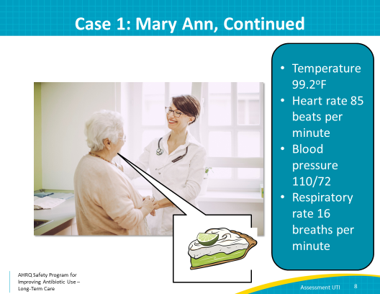
Case 1: Question 2  SAY:  Let's review Mary Ann’s case information. Based on this information, what would you do next?  Would you ask about urinary urgency, frequency, dysuria, chills, and pelvic or bladder pain? If so, that’s a good choice because these are all signs and symptoms that suggest a UTI.  Would you determine if she has an indwelling urinary catheter? Also a good choice. If she does have an indwelling catheter, find out why she has one and if she still needs it. If she does not need it, remove it as it puts her at risk for a UTI. If she still needs it, find out, when it was last changed.  Would you ask her about signs and symptoms of infection (other than a UTI)? Good choice. Mary Ann’s temperature of 99.2 degrees Fahrenheit may be a normal variation, an early sign of systemic illness, or an error.  Would you contact the health care practitioner with her vitals and symptoms and your assessment? As you might have guessed, this is also a good choice. Be sure to mention that you asked about signs and symptoms that could suggest a UTI. All of the options listed on the screen are important and are excellent next steps. | Slide 9  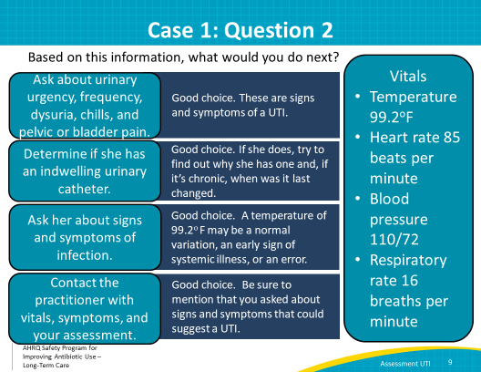
Case 1  SAY:  Upon assessing Mary Ann, you note that she has no urinary catheter and feels well. She does not have dysuria, urgency, hematuria, or new or increased frequency and incontinence. She also does not have suprapubic or back pain.  You communicate these findings to the medical provider using your Situation-Background-Assessment-Recommendation or SBAR tool and develop a plan to observe her overnight and alert the daytime staff and practitioners of any changes in her clinical status. | Slide 10  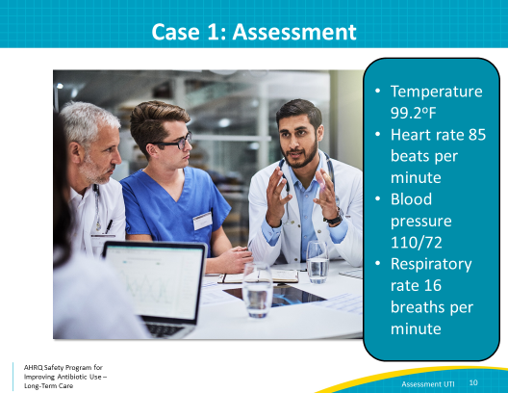
Case 1: Take-Home Message  SAY:  When you see Mary Ann the following evening, she is feeling well, and her temperature is 98.1 degrees Fahrenheit. She is happy that she was not exposed to any unnecessary antibiotics, and that she had a delicious piece of key lime pie for dessert last night.  The lesson learned here is to treat the patient, not lab values! | Slide 11  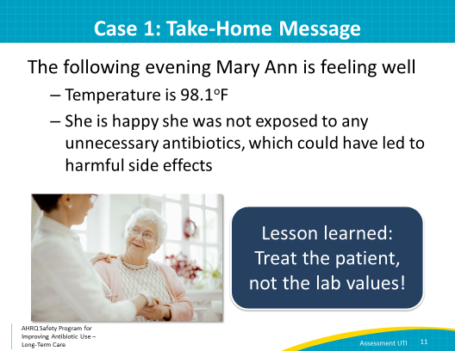
Case 2: Walter  SAY:  Let’s move on to a second case.  Walter’s daughter is visiting him in his long-term care facility. He has a chronic indwelling urinary catheter due to urinary retention. His daughter says his urine is cloudy, and she thinks it has an odor to it. She asks you to check his urine for infection.  Walter himself is not available. You find him in the common area singing an enthusiastic rendition of “Yellow Submarine” for karaoke hour. | Slide 12  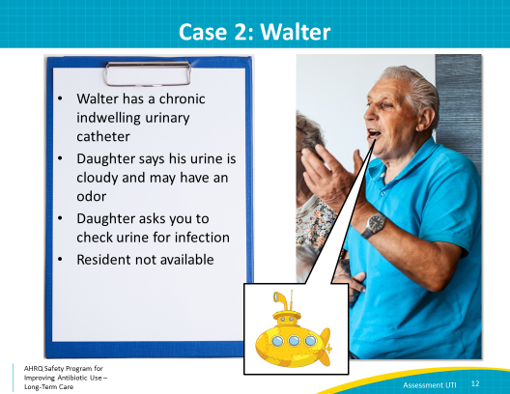
Case 2: Question 1  SAY:  Based on the information you just saw and heard, what would you tell Walter’s daughter?  If you choose, “He probably has a UTI because the urine is cloudy”, or “He probably has a UTI because his urine smells bad,” you are incorrect. Foul-smelling or cloudy urine is not an indication to send a urine culture.  If you choose, “He seems to be feeling well. Let’s ask him about symptoms when he’s finished singing,” you are correct! Residents with chronic indwelling urinary catheters are likely to have asymptomatic bacteriuria. | Slide 13  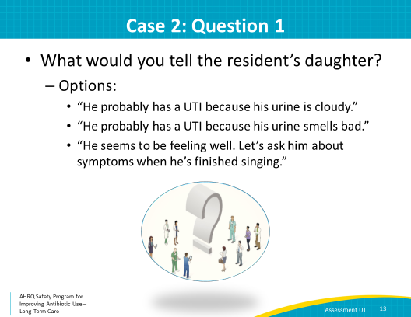
Case 2: Take-Home Messages  SAY:  It was good that you didn’t diagnose Walter with a UTI based on changes in the appearance or odor of his urine.  The lesson learned from case 2 is that cloudy or smelly urine is NOT an indication to send a urine culture. You must determine if the resident has symptoms before moving forward with a possible diagnosis. Urine in the drainage bag becomes a good place for bacteria to grow. Bacterial growth can lead to cloudy urine. Cultures taken from the drainage bag or from the proximal port of the catheter do not necessarily reflect what is happening in the bladder. For residents who have cloudy or dark urine, you should consider an increase in oral fluids. We recommend offering 4–8 ounces every 1–2 hours. | Slide 14
Urinary Catheters  SAY:  One common question that often comes up about urinary catheters is about the indications for replacing existing urinary catheters. While the ideal situation is to avoid them altogether, there will always be residents who will need urinary catheters.  Blocked or occluded urinary catheters should be removed.  If a resident has a true catheter-associated UTI, the catheter should be removed and, if still indicated, replaced.  Recall that a catheter-associated UTI is a diagnosis of exclusion. The resident should have signs or symptoms of a UTI without other identified sources of infection.  There are several signs and symptoms of a catheter-associated UTI. Specific signs include flank pain, costovertebral angle tenderness, acute hematuria, or pelvic discomfort. Nonspecific signs may include fever, rigors or shakes, change in mental status, malaise or lethargy without another identified cause. If a resident is only showing nonspecific signs, like a change in mental status, clinical staff need to consider the many reasons that this might occur. They include dehydration, pain, a change in medications, constipation, or a poor night’s sleep. Dehydration and medication changes may also cause urine to be dark and foul-smelling. Encouraging oral fluids is good supportive care.  Sometimes removing or changing the catheter is enough to help the resident feel better. Urine samples sent for culture should be collected from the new catheter.  Finally, there is not sufficient data to indicate that routinely changing the catheter every 2 to 4 weeks will reduce the risk of catheter-associated asymptomatic bacteriuria or urinary tract infection, therefore this practice is not recommended. | Slide 15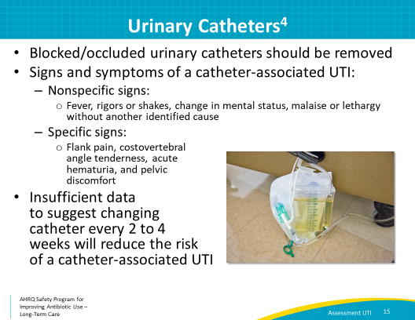
Case 3: Sally  SAY:  Let’s discuss a third case.  Sally, a resident in your facility, complains of burning with urination. We learned in case 1 that dysuria alone can suggest a UTI. After a bath, she received assistance with collecting a good quality urine specimen. Because of her symptoms, Sally was started on nitrofurantoin the same day.  Two days later, the urine culture came back growing E. coli susceptible to nitrofurantoin. This means she is on an effective medication.  When you talk to Sally, she states that her symptoms have not improved. | Slide 16  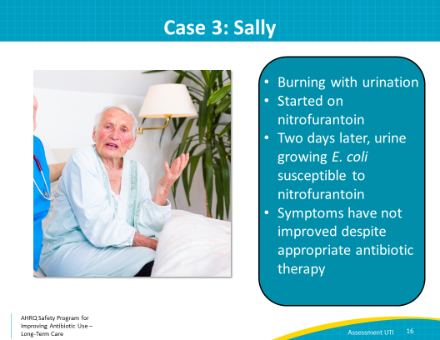
Case 3: Question 1  SAY:  What would you do next? Let’s walk through some possible options.  Send another urine culture.  This is a common reaction, but not the best first course of action in this situation. As discussed in the presentation “Appropriate Collection of Microbiologic Specimens,” collecting a good urine specimen has its challenges. The most common situation is that of a false positive—that is, a urine culture that grows bacteria in someone who does not have a UTI. In people who truly have a UTI, it is uncommon for a urine culture to not grow bacteria if they were not already receiving antibiotics before the urine culture was collected.  Start a different antibiotic.  This is also a common reaction, but still not the correct next step. We know that the bacteria recovered in the urine culture was susceptible to nitrofurantoin. There is no reason to doubt the microbiological results.  Send her to a urologist.  This is not completely unreasonable, but is a bit drastic without obtaining more information. Without first examining the resident and determining whether he or she has appropriate symptoms, an immediate referral to the urologist is unnecessary.  Examine the resident.  This is the best choice. This would be an opportunity to find out more about her symptoms. Is she having urinary frequency or urgency? Does she notice blood in her urine? What about incontinence? Does anything else feel off or wrong?  In addition to obtaining her vital signs, a physical exam should include an evaluation for abdominal pain, flank pain, tenderness over the bladder, and perhaps examination of her external genitalia. | Slide 17  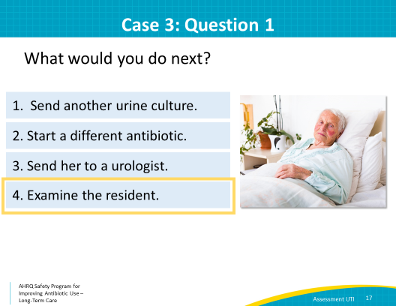
Case 3: Take-Home Message  SAY:  Sally shares that in addition to the burning with urination, she feels itchy and that her external genitalia hurt. These symptoms prompt an examination that reveals a yeast infection. This explains her dysuria.  The nitrofurantoin is stopped and continuing antibiotics is unnecessary and can worsen her yeast infection. Sally receives a single dose of fluconazole. When she is reassessed 3 days later, she indicates she is feeling much better.  An important take-home message from this case is that UTIs are not the only reason for dysuria, in women or in men. A second lesson is that if an antibiotic does not seem to be improving symptoms, rather than immediately repeating the workup or prescribing different antibiotics, consider other reasons for the resident’s signs and symptoms. | Slide 18  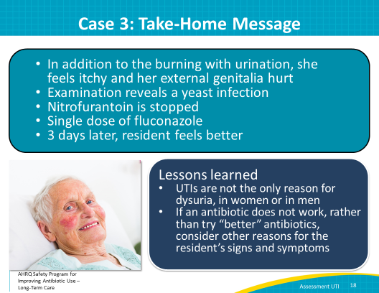
Do’s and Do Not’s: Pocket Cards  SAY:  On the screen you can see pocket cards that we have developed for the Safety Program that indicate when you should and should not send a urine culture (in 4x6 and 8x11 sizes).  You should consider sending a urine culture when a resident has—  - Dysuria;  - Flank pain or suprapubic tenderness AND a fever;  - Urgency, hematuria, AND a fever; or  - New or increased frequency or urinary incontinence AND fever  Do not send a resident’s urine culture—  - If the urine is foul-smelling or cloudy without other concerning clinical symptoms  - After a urethral catheter change  - Routinely upon admission  - After treatment to “document care” or for “test of cure” or  - For a change in a mental status in noncatheterized residents.  In residents with urinary catheters, if they have an acute change in mental status, you may consider sending a urine culture. These individuals also should be thoroughly evaluated for other possible reasons for a change in mental status. Pain, dehydration, a change in medications, or even constipation are all reasons older adults may have a change in mental status.  There are pocket cards (in 4x6 and 8x11 sizes) that you can use to help you remember how to assess a resident with a possible UTI. We recommend downloading these from the AHRQ toolkit Web site and distributing them to frontline staff or posting them in charting areas. They are located in the Assessment and Management of the Resident With A Suspected Urinary Tract Infection section of the toolkit. | Slide 19  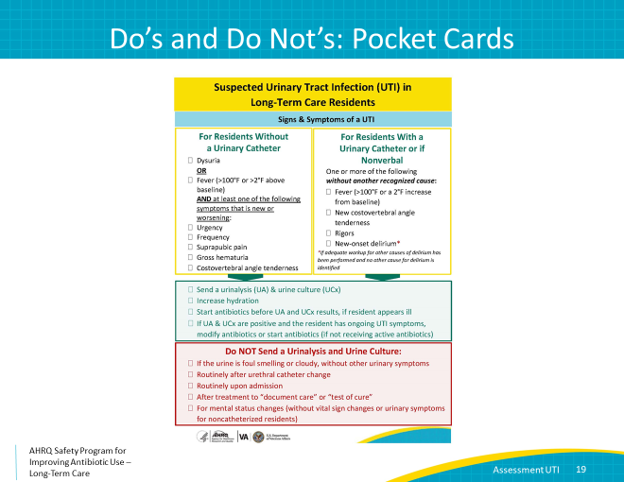
Overall: Take-Home Messages  SAY:  Based on the three cases reviewed in this presentation there are five main take-home messages. They are—  If you are worried about a urinalysis or urine culture result, talk to and examine the resident and determine if he or she has symptoms.  If the resident is asymptomatic, a positive urine culture might indicate asymptomatic bacteriuria rather than infection.  Treating a resident for asymptomatic bacteriuria can lead to harmful side effects.  Urinalysis and urine cultures should only be sent if the resident is symptomatic, NOT if urine appears cloudy, dark, or smelly.  Most importantly, we treat people, not their laboratory results! | Slide 20  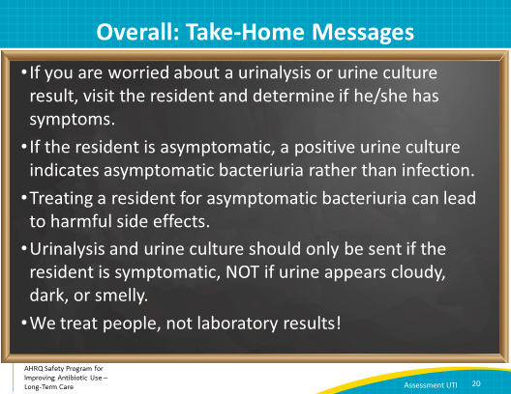
Activities to Complete  SAY:  These are the activities you may want to pair with this presentation, which are intended to help your team stay on track with the overall program.  The ASP team should continue to hold monthly meetings and gather data from any interventions.  Frontline providers should review the signs and symptoms of a UTI and discuss with the team when it is appropriate to send a urinalysis and urine culture.  The Do’s and Do Not’s pocket card and poster, called “Suspected Urinary Tract Infection in Long-Term Care Residents – Signs and Symptoms of a UTI,” can be found in the Assessment and Management of the Resident With A Suspected Urinary Tract Infection section of the toolkit. Download and distribute them to frontline staff or post them in charting areas. | Slide 21  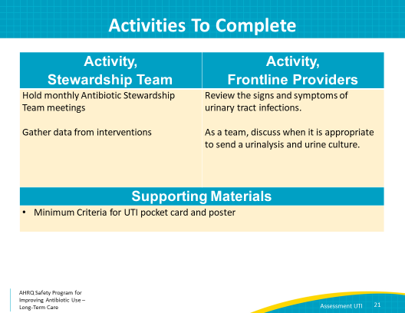
Narrated Presentation  SAY:  There is a narrated presentation available in the toolkit for your viewing. It covers the material for “Assessment of the Resident With a Suspected Urinary Tract Infection.” It can be used to train colleagues or orient new staff in your facility. | Slide 22
Disclaimer  SAY  The findings and recommendations in this presentation are those of the authors, who are responsible for its content, and do not necessarily represent the views of AHRQ. No statement in this presentation should be construed as an official position of AHRQ or of the U.S. Department of Health and Human Services.  Any practice described in this presentation must be applied by health care practitioners in accordance with professional judgment and standards of care in regard to the unique circumstances that may apply in each situation they encounter. These practices are offered as helpful options for consideration by health care practitioners, not as guidelines. | Slide 23  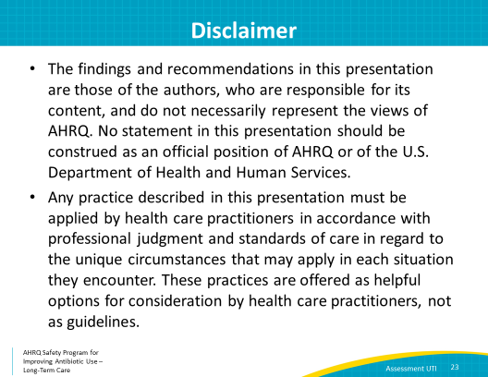
References | Slide 24  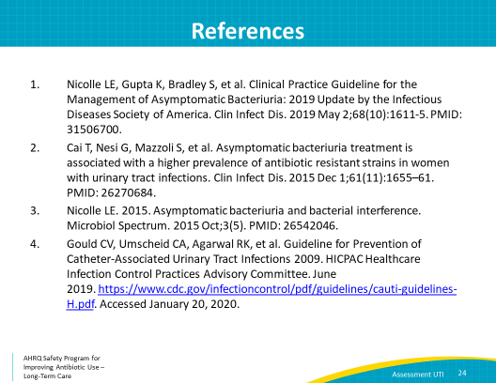
AHRQ Pub. No. 17(21)-0029
June 2021

