Improving Teamwork and Communication
Long-Term Care
Slide Title and Commentary | Slide Number and Slide
Improving Teamwork and Communication  Long-Term Care  SAY:  Welcome to this presentation, “Improving Teamwork and Communication.” | Slide 1  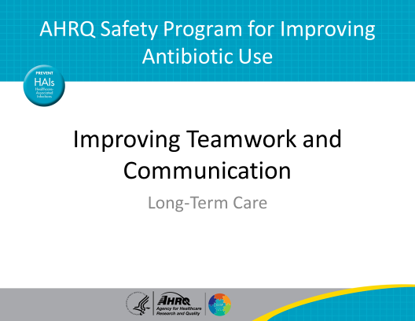
Objectives  SAY:  By the end of this presentation, you will be able to—  - Recognize the importance of seeking input from all team members, including residents and their family members, when making antibiotic prescribing decisions.  - Summarize how to use available AHRQ safety tools, such as SBAR (situation, background, assessment, recommendations), to improve communication related to antibiotic prescribing.  - Describe how to effectively communicate the potential harms of antibiotics to other health care providers and to residents and caregivers. | Slide 2  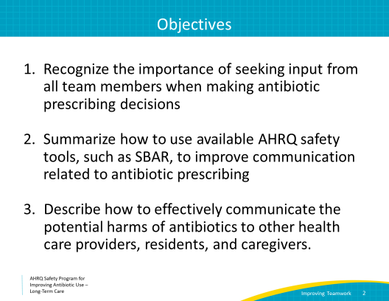
5 Steps for Improving the Culture of Patient Safety  SAY:  One of the goals of the AHRQ Safety Program for Improving Antibiotic Use is to improve the culture of safety. This includes giving frontline caregivers the tools and support they need to identify and tackle the hazards that threaten their residents. The long-term goal is to eliminate preventable harm.  This presentation will discuss how to improve teamwork and communication throughout the care team.  In brief, these steps are—  - Engage leadership for support and collaboration  - Understanding the science of safety  - Improve teamwork and communication  - Recognize current practices that may lead to patient harm  - Develop system-based solutions to improve patient safety | Slide 3  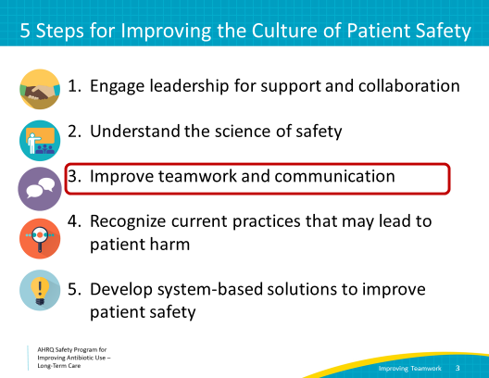
Improve Teamwork and Communication  SAY:  We often hear that teamwork and communication are important. Let’s go over what these terms mean.  Teams consist of two or more people who interact with a common goal. In patient care, team members need skills, tools, and strategies to ensure they can work together effectively and maximize the safety of residents.  An example of a team would be the people doing weekly wound care rounds. The wound care nurse and a nurse from the unit work together to assess a resident’s wounds, change the dressing, and update their findings and recommendations in the chart.  Communication is also a key factor for a strong culture of patient safety. Effective communication helps bring about proper use of antibiotics. This includes communication among the members of the health care team as well as with residents and families. | Slide 4  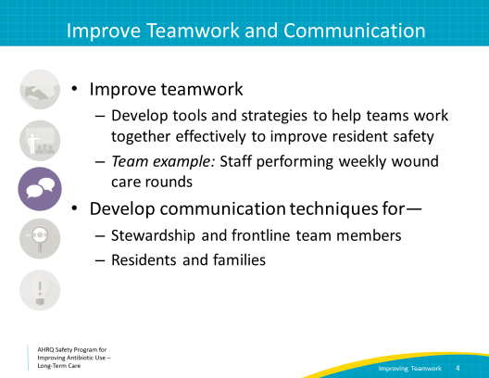
Four Key Characteristics of Effective Communication  SAY:  There are four characteristics of effective communication.  - First, effective communication is complete. It communicates all relevant messages but avoids unnecessary details that may cause confusion.  - Second, it is clear. When speaking with residents and families, effective communicators avoid technical terms and abbreviations. Instead, they use plain language that is more easily understood. When speaking with team members, effective communication includes the use of standard terminology rather than abbreviations or technical language that may cause confusion.  - Third, effective communication is brief and concise. It can be useful to ask the recipient of the information to repeat the message to verify that the message has been understood.  - And fourth, it is timely. It means relaying information about a change in a resident’s condition promptly. It also means noting times of observations and interventions in the medical record. It verifies the message communicated and the recipients of that message. It also validates or acknowledges that information was received. | Slide 5  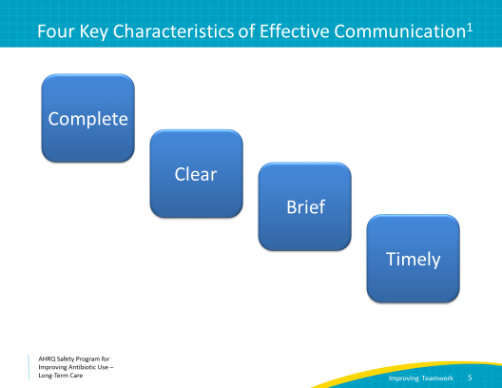
Process of Communication  SAY:  Communication in general can be viewed in this simple model.  When sending a message, you encode it. This message often passes through some busy environments, and the receiver is tasked to decode the message (whatever the sender is attempting to pass along). If the sender and receiver know each other well, it is less likely that there’ll be a translation error. However, in work atmospheres, sending and receiving messages can sometimes be problematic.  For example:  A daughter of one of the residents in your nursing home approaches a provider because she noticed her mom has a cough. She tells the provider she is worried about her mom’s cough, and she is afraid that she may have pneumonia.  The provider hears, “My mom has pneumonia; therefore, she needs an antibiotic.”  In reality, the family member may be looking for options to make her mother feel better (such as a cough suppressant), or simply reassurance that her mother does not have a serious infection. The provider may feel pressured to prescribe antibiotics. Listening to the resident’s daughter and then evaluating the resident may prevent an unnecessary antibiotic prescription and ensure the resident is being treated appropriately and safely. | Slide 6  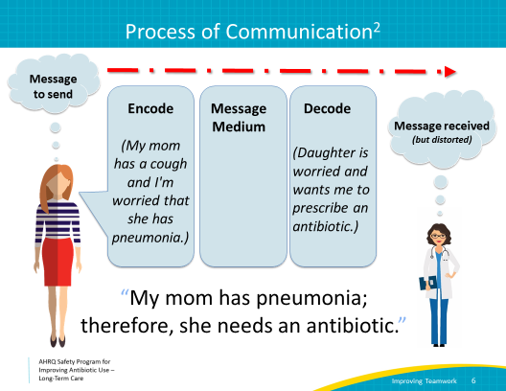
Process of Communication  SAY:  In the best communication methods, the receiver uses active listening techniques during which they repeat back the message to let the sender know that it was received and decoded correctly. In this case, it is important that the provider clarifies the daughter’s concerns. The receiver should also look directly at the speaker and use nonverbal signals such as nodding to show that they are listening.  After evaluating the resident and determining she likely has a common cold, the provider might say something like:  “I understand that you are worried about your mother’s cough. She has not had a fever, and all of her vital signs are stable. We will give her some cough medicine and some respiratory treatments to help her feel better and will continue to keep a close eye on her.  Most of the time upper respiratory infections or common colds are caused by viruses. I would like to hold off on starting antibiotics for now, because I don’t think she has a bacterial infection, so antibiotics will not be helpful, and antibiotics can cause unpleasant side effects.”  Listening and addressing the daughter’s concerns and then reassuring her that her mother looks stable helps acknowledge and initially alleviate the daughter’s concerns. Next, the provider gives some alternatives to make the resident feel better and describes the reasoning for avoiding antibiotics. All of these messages provide a clear message of resident safety and comfort as the top priority. | Slide 7  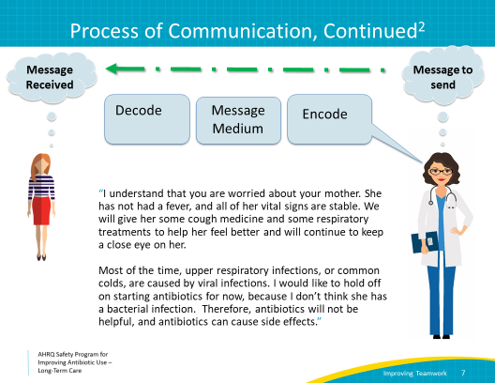
DESC for Conflict With Patients and Families  SAY:  Unfortunately, sometimes communication does not go as smoothly as the example we just discussed. Residents or family members may not agree with decisions or may be frustrated with the health care process.  This is often due to problems with communication. The shared goal of all team members is the well-being of the resident. This can sometimes get lost in translation. When this happens, consider using a structured communication tool to help resolve conflicts with patients and families.  The DESC script can be used to communicate effectively during difficult conversations or conflict.  DESC is a mnemonic for:  D = Describe the specific situation.  E = Express your concerns about the action.  S = Suggest other alternatives.  C = Consequences should be stated.  Ultimately, consensus should be reached.  We’ve probably all faced family members who insist on ordering a urine culture or antibiotic that we feel is not indicated. Gentle attempts to talk or reassure them fail, and they may become upset. Let’s try applying the DESC tool. In this scenario, a family member worries that her aunt has a urinary tract infection, or UTI.  Describe the specific situation.  - I understand you are worried about your aunt. She is not acting like herself today, and the last three times this happened, someone told you she had a urinary tract infection and gave her antibiotics, and she got better. We performed a history and a full physical exam and she is not having symptoms of a UTI, nor does she have any other signs of infection, such as a fever or increase in her white blood cell count.  Express your concerns about the action.  - I am concerned that the risks of prescribing another course of antibiotics outweigh the potential benefits. I worry about allergic reactions, antibiotic resistance, and the risk of her getting an infection caused by a bacteria called Clostridioides difficile. This can occur after someone has had antibiotics and can be devastating in nursing home residents. I don’t want to risk hurting her with a medicine that she very likely does not need.  Suggest other alternatives.  - Instead of giving her a medicine she may not need, I’d like to see if there is something else going on first. She may have had a bad night’s sleep. She might be in pain or a little dehydrated. She might be constipated. These are all things that we should consider first.  Consequences should be stated and consensus should be reached.  - I do not want to give her an antibiotic if she does not truly need it, because this could put her at risk for dangerous side effects.  - We both want to help her feel better. I would like to take a few minutes and review her medicines for any recent changes and talk with other people here who have taken care of her over the past few days. They may have some ideas. While I do that, would you please see if you can get her to drink some water or juice? Maybe you can also try to find out if anything is hurting her? Let’s talk in an hour or so. If you don’t see me, please ask someone at the nurse’s station to call my extension. | Slide 8  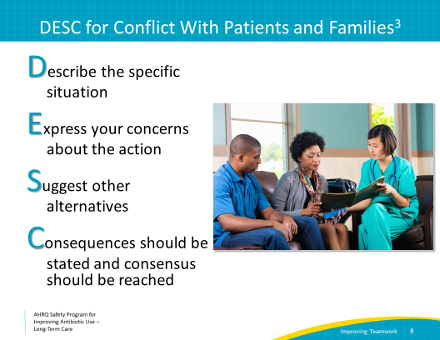
Case 1: Mr. W  SAY:  Learning how to communicate information effectively can make a huge difference in resident care and outcomes.  Here is an example:  A nurse notices that one of the residents in her facility, Mr. W, is acting strange. Mr. W refused his breakfast, and he has been sleepier than usual. He has a chronic, indwelling catheter due to urinary obstruction, but has not complained of any pain around the catheter. When the nurse walks in after her evening rounds, she notices that the resident is shivering in bed. She takes his temperature and it is 100.4 degrees Fahrenheit.  The nurse decides to call the on-call provider to relay the information.  She says “I think Mr. W has a UTI. He didn’t eat breakfast, and he is not acting like himself. We probably should put him on antibiotics.” | Slide 9  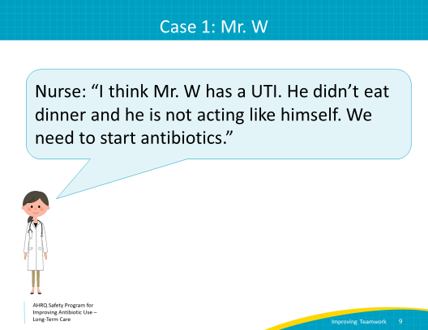
Case 1: Mr. W, Continued  SAY:  The nurse thinks that the resident has a UTI, and she may be right, but she has made some mistakes in her communication.  - As we will review in our UTI presentation, there are specific criteria that may suggest a resident has a UTI. These criteria need to be assessed and communicated to make the decision whether the resident has an infection and therefore would benefit from antibiotics.  The nurse is leaving out some important information here.  - First, the resident has a fever, which is suggestive of infection and is important information to pass on to the provider. In fact, for any residents with concern for an infection, all of the vital signs should be relayed to the provider.  - Next, the nurse should have evaluated the resident and communicated signs and symptoms to the provider. Simply saying the resident is “not acting like himself” is not enough information.  - Without reporting any symptoms, such as suprapubic or flank pain, cough, or headache, the provider is unable to determine a possible source of infection, and also cannot tell which, if any, infection to treat. | Slide 10  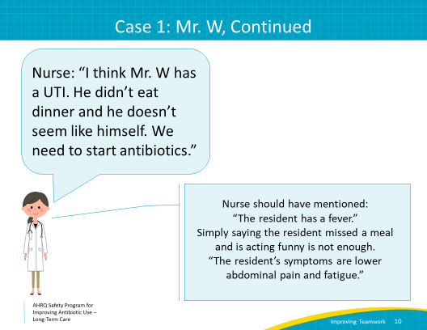
Case 1 — SBAR  SAY:  SBAR is a framework that can help guide the communication between medical professionals. SBAR stands for situation, background, assessment, and recommendations.  Using these cues, we can reframe how Mr. W’s information should be communicated. Consider this alternative communication from the nurse:  First, the Situation: Hi, I am calling about Mr. W. I am worried about him.  Next, the Background: He is a resident with a history of coronary artery disease and dementia. He didn’t eat his breakfast this morning and seems fatigued and confused, and when I walked in he was shaking in bed. He has a temperature of 100.4 degrees Fahrenheit. He has no cough or diarrhea, but he did have some suprapubic tenderness on exam. He has a urinary catheter in place.  Third, the Assessment: I am concerned that he may have a UTI. He seems very sick.  Finally, Recommendations: I think we need to get a urine culture and complete blood count as soon as possible. And I wonder if we should change the urinary catheter and start antibiotics.  Because of this excellent communication, the prescriber understands that the resident has a chronic indwelling Foley catheter, rigors, and a fever. This meets criteria for empiric treatment for a urinary tract infection while awaiting culture results.  The provider recommends that the nurse obtain a urine culture after placing a new urinary catheter and starts Mr. W on trimethoprim-sulfamethoxazole, based on the facility's local antibiogram. | Slide 11  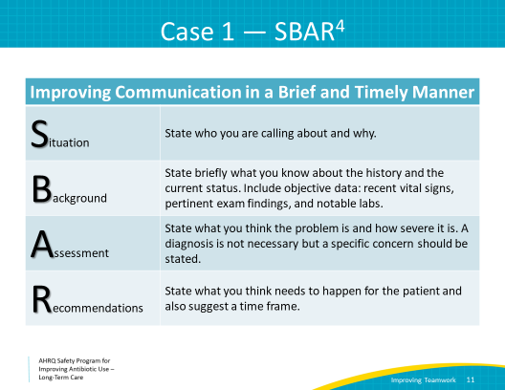
Case 2: Mrs. N  SAY:  Let’s walk through another case.  Mrs. N, a long-term care resident, was visited by her son over the holiday.  He hadn’t seen her in a while, but he noticed that when he helped her to the bathroom, her urine appeared very dark and smelled pungent.  The son let the nurse know and asked him, “Can we just check herurine?” The nurse had not yet reviewed the toolkit’s urine culture management presentation, so he went ahead and sent the urine and then paged the on-call provider to ask her to sign the order.  Mrs. N had no symptoms and was otherwise feeling well, so she was not started on any antibiotics by the on-call provider.  Two days later, however, her urine culture comes back with >100,000 colony forming units per milliliter of Gram-negative rods.  Her nurse calls the provider about the urine culture results. This provider is different from the on-call provider from 2 days ago.  The nurse says, “I’m the nurse for Mrs. N, a resident on ward B. I’m calling because her urine culture is growing >100,000 Gram-negative rods.” | Slide 12  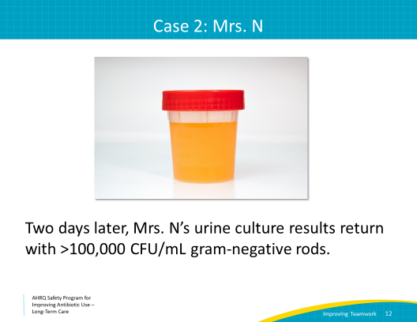
Case 2: Mrs. N, Continued  SAY:  Think of all of the possible decisions or responses the provider could make when she receives this information.  - The provider could hear that there is a positive urine culture and simply decide to start an antibiotic. This happens more than you might think. Many providers feel that they must give antibiotics if a resident has a positive urine culture, but a little more background and information from the nurse could help the provider understand that Mrs. N may have asymptomatic bacteriuria, and that antibiotics are not indicated.  - She could also ask the nurse how the resident is doing. This would be the best response and would open lines for positive communication.  - The provider could decide to simply do nothing and wait to give the culture results to the physician who knows the resident on Monday. This could be dangerous, however, if the resident is actually sick and needs antibiotics. The problem is, we don’t know unless we ask.  - Last, it’s possible the provider could respond aggressively, confronting the caller in a challenging manner, because she may not want to be bothered if she does not understand the context of the call. This type of communication should always be discouraged, but unfortunately it does happen. Sometimes, clear and open communication will help prevent this from happening.  As you can see here, good communication is key to good resident care and well-being. Effective communication can not only influence important safety decisions, but it can also help to ensure that the resident and their family members are comfortable and establish trust in your facility. It also helps strengthen the relationship among the health care team! | Slide 13  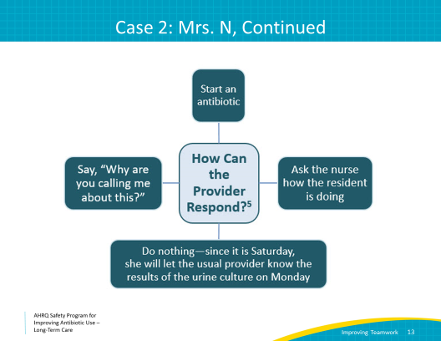
Case 3: Communication  SAY:  Let’s walk through a final case of communication errors that can occur on the resident care team.  A resident was admitted to the hospital for a fall. He required surgical repair of a broken hip, which was complicated by postoperative bleeding. After a long hospitalization, he is transferred to the long-term care facility for rehabilitation. He has been at the facility for 3 weeks, and is doing well.  On Saturday morning, the nurse dispensing medications notices that the resident is on ciprofloxacin for a UTI.  Reviewing further, she discovers that the resident was placed on the ciprofloxacin in the hospital 3 weeks earlier to treat a urinary tract infection. The medication was never stopped upon transfer to the long-term care facility because it was incorrectly listed as a home medicine.  She calls the covering physician to discuss further. It is a Saturday.  Using her SBAR tool, the nurses states:  “Hi Dr. K, I am calling about one of the residents. He was transferred here 3 weeks ago for rehabilitation following a broken hip. He’s doing well. It looks like Mr. T was mistakenly continued on ciprofloxacin after his hospital discharge. I think we need to stop the antibiotic now.” Dr. K responds: “Why are you calling me about this on a Saturday? We will get to the bottom of it on Monday. I’m sure the hospital put him on it for a reason.”  The nurse does not feel comfortable with this plan and knows that serious side effects can occur on antibiotics, even if they are extended 1–2 extra days. She is concerned about patient safety, but feels uncomfortable pushing the issue, and decides to wait until Monday.  This nurse usually works only on the weekends. She worries about the resident the rest of the weekend but feels like she can’t do anything other than pass her concerns along in report and hope those get passed to the provider on Monday.  Still worried, she calls the nursing home late Monday afternoon to find out if the regular provider stopped the ciprofloxacin. No one knew anything about her concerns—they were not passed along by the nurses or by the covering provider. The assistant director of nursing (DON) says she’ll discuss it with the team Tuesday morning. The nurse feels reassured because she knows the assistant DON will follow through. | Slide 14  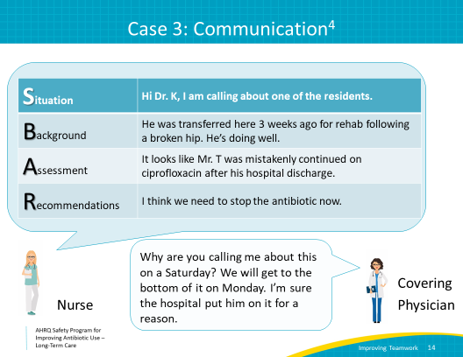
Use Assertiveness (Not Aggressiveness)  SAY:  In the case we just discussed, the nurse yielded to an inappropriateresponse from a covering physician, even though she had concerns about the welfare of the patient. Let’s consider how she could have responded differently by being assertive.  In communication, there is a difference between being assertive and being aggressive.  Assertiveness is an attitude and a way of positively relating to those around you. It is an approach that leads to effective communication. Aggressiveness, whether active or passive, occurs when someone attacks or ignores others' opinions in favor of their own.  Being appropriately assertive means:  - Seeing yourself as having “worth,”  - Valuing others equally by respecting their right to an opinion,  - Engaging in communication respectfully while also respecting your own opinions,  - Organizing your thoughts and subsequent communication,  - Speaking clearly and audibly,  - Saying “yes” when indicated, but “no” when you mean “no,”  - Using “I” when not speaking for the team,  - Respectfully defending your position, even if it provokes conflict, and  - Using a secure upright body language position in a relaxed manner while making eye contact when you are communicating in person.  It is important to be assertive when speaking with colleagues, especially when there is a real or perceived difference in roles. This lets that person know that you deserve to be given time and respect.  Being assertive does NOT mean being aggressive, hostile, confrontational, ambiguous, or condescending. These characteristics can be categorized as poor communication. Ineffective communication hinders teams and units as a whole. | Slide 15  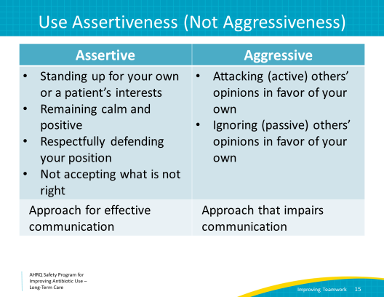
Elements of Appropriate Assertion  SAY:  Elements of appropriate assertion include the following:  - Focus on the common goals: the welfare of the resident and safety—it’s hard to disagree with safe, high-quality care.  - Avoid the issue of who’s right and who’s wrong. “Resident-centered care” is not about who is right or who is wrong. It is what is best for the resident.  - Depersonalize the conversation.  - And be hard on the problem, not the people.  Being assertive is a skill that all of us can learn. We encourage you to practice being assertive. You might want to consider some role-play activities with trusted colleagues or peers. | Slide 16
Case 3 — DESC Script  SAY:  Conflict can occur in teams, and it is important to know how to handle such situations when they occur.  Remember our DESC tool that we used to talk with a family member?  DESC also can be effective in resolving conflicts among team members.  Let’s look back at earlier conversation between the nurse and Dr. K, this time using DESC script.  D: Dr. K, it looks like there was a mistake in the discharge paperwork and this resident has been continued on ciprofloxacin. He should not be on this antibiotic. It was started in the hospital for a UTI, but he has been on it for 3 weeks in our facility, and that is way too long to treat a simple urinary tract infection.  E: I am concerned because he is also on several other drugs which can lead to harmful drug interactions. There is now a black box warning on fluoroquinolones, and there are many side effects associated with this medication.  S: I think we need to stop the ciprofloxacin today.  C: If we don’t stop the antibiotic today, he could suffer harmful side effects.  By providing the relevant information in a clear, concise, and organized manner, the nurse has made it easy for the physician to agree with her and stop the ciprofloxacin. Her actions helped to reduce further risk to the resident. | Slide 17  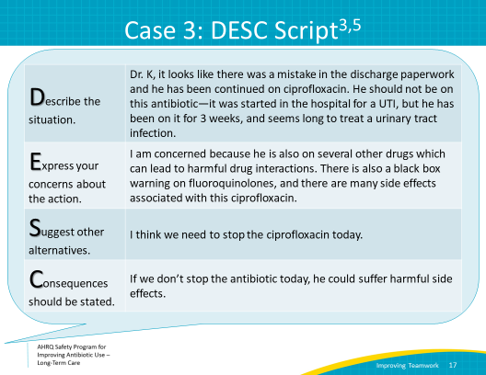
Summary  SAY:  Overall, efficient teamwork and effective communication play an integral role in the delivery of high-quality, resident-centered care that leads to improved outcomes for residents and the facility as a whole.  Research shows a connection between communication errors and problems with patient care delivery.  Health care teams can implement a variety of tools and strategies to improve the effectiveness of teamwork and communication in their clinical area. | Slide 18  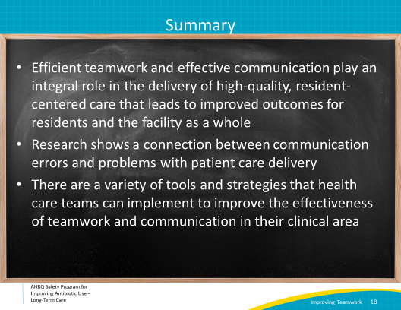
Activities To Complete  SAY:  These are the activities you may want to pair with this presentation. They are intended to help your team stay on track with the overall program.  You may consider asking frontline staff to apply the Four Moments of Antibiotic Decision Making Form to one resident. Continue to encourage them to complete and return their Staff Safety Assessment Form to evaluate problems with antibiotic prescribing in the facility. Also, consider posting the DESC Technique Poster and introduce frontline staff to that tool as well.  Supporting materials for the activities are listed on the slide and are available on the toolkit Web site. | Slide 19  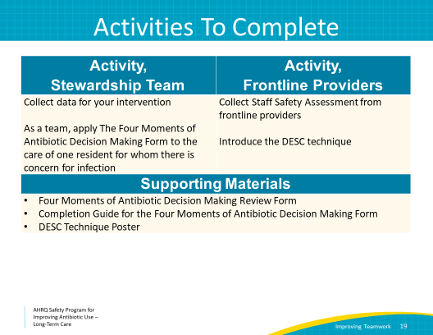
Disclaimer  SAY:  Disclaimer:  The findings and recommendations in this presentation are those of the authors, who are responsible for its content, and do not necessarily represent the views of AHRQ. No statement in this presentation should be construed as an official position of AHRQ or of the U.S. Department of Health and Human Services.  Any practice described in this presentation must be applied by health care practitioners in accordance with professional judgment and standards of care in regard to the unique circumstances that may apply in each situation they encounter. These practices are offered as helpful options for consideration by health care practitioners, not as guidelines. | Slide 20  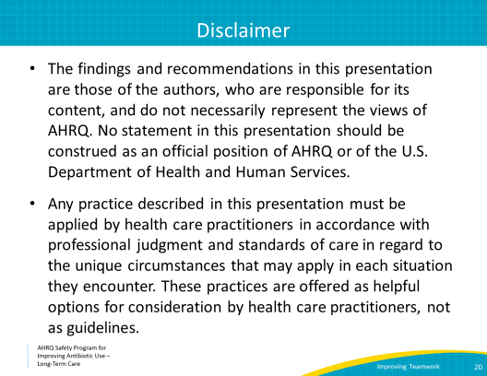
References | Slide 21  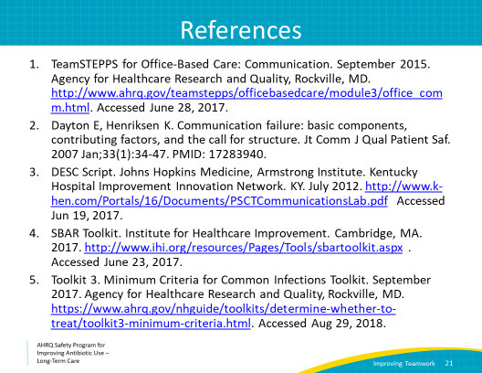
AHRQ Pub. No. 17(21)-0029
June 2021

