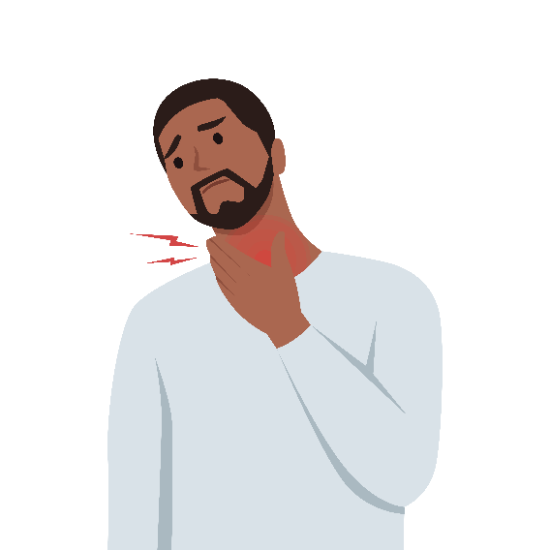
Pharyngitis

What Is Pharyngitis?
- Pharyngitis, or a sore throat, is commonly caused by viruses (>90%) and, less frequently, bacteria.
- Based on your telemedicine visit, your clinician decided if you need antibiotics or not.
- If there was concern for bacterial pharyngitis, antibiotics were prescribed.
- Since viral pharyngitis does not improve with antibiotics and may lead to unnecessary antibiotic-associated adverse events, antibiotics are not suggested for viral pharyngitis.

What Should I Do To Feel Better?
- Acetaminophen (commonly called Tylenol®) can help with pain and fever and ibuprofen (commonly called Advil® or Motrin®) can help reduce pain and inflammation; store brands (e.g., CVS brand) are just as good as name brands (e.g., Tylenol®).
- Try warm tea with or without honey, warm soup, throat sprays with benzocaine, cold or frozen desserts, or sucking on ice.
- For children over 5 years of age and adults, lozenges with menthol or benzocaine or hard candy may reduce throat pain.
- Consider gargling saltwater (which can be made by dissolving about half a teaspoon of salt in warm water).
- Hydration and rest always help.
- Avoid honey in children under 1 year of age because of the increased risk of botulism.
- Avoid cough and cold medications in children under 6 years of age as these can cause serious side effects (e.g., extreme sleepiness, difficulty breathing, seizures).
- Herbal remedies and dietary supplements have not been shown to be effective.

When Should I Contact a Clinician?
- Fever and sore throat typically improve within 3 days; however, mononucleosis (mono) or fatigue may take 1 month or longer to resolve. If diagnosed with mono, avoid contact sports for at least 3–6 weeks.
- If you were prescribed antibiotics for bacterial pharyngitis and have continued fevers after 3 days or worsening throat pain, you should seek an in-person visit.
- If you develop difficulty breathing or swallowing or confusion, or a bulging neck mass develops, you should go directly to an emergency department.
AHRQ Pub. No. 26(27)-0021
October 2026

Directions for Adding Your Logo to Your Document
If you choose to add a logo to this document, you can place it in the footer, below the article development content.
Steps:
- Open the footer section (either double click in the footer section of the document or go to the “Insert” tab → select the drop-down menu for “Footer”→ and click on “Edit Footer”).
- Make sure your cursor is below the bottom line (or wherever you want your logo).
- Go to the “Insert” tab.
- Click on “Pictures” from the “Insert” tab.
- A window will pop up so you can search your computer for the logo. Select your logo (.jpg or .png format) and click the insert button.
- Your logo will appear in your footer. If you are happy with the placement, skip step 7.
- ** If you want to move the logo image around, click on the logo → go to the
“Format” tab → click on the “Wrap Text” drop-down menu → and select “In front of text.” This formatting will allow you to move the logo freely around the screen.
- When you are satisfied with the placement of the logo, exit the footer section (either double click outside of the footer area or go to the “Design” tab → and click the “Close header and footer” button).

AHRQ Pub. No. 26(27)-0021
October 2026

