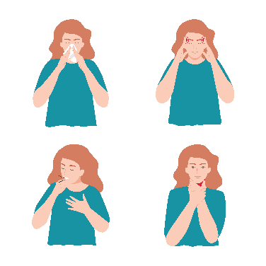
COVID-19

What Is COVID-19?
- The SARS-CoV-2 virus causes COVID-19.
- COVID-19 can make you feel tired or run down and can give you a fever, sore throat, headache, cough, muscle aches, loss of taste or smell, shortness of breath, or loss of taste or smell.
- COVID-19 spreads from person to person through the air.
- After you are exposed to COVID-19, it can take between 2 and 14 days to start feeling sick.
- You can spread COVID-19 to others between 1–2 days before you get ill and 8–10 days after symptoms begin. You are most likely to spread COVID-19 between 1–2 days before you get ill and 5 days after symptoms begin.
- You can limit the chance of spreading COVID-19 by—
  - Washing your hands often with soap/water or hand sanitizer.
  - Avoiding close contact with people who are sick.
  - Wearing a mask when you are sick and around other people.
  - Staying in well-ventilated areas.
  - Staying home from work, school, or daycare, if feasible.

What Should I Do To Feel Better?
- Some patients can take antiviral medicines to treat COVID-19. These work best if taken right after you begin to feel sick, but can be taken within 5 days of getting sick. Talk to your healthcare provider about whether you need antiviral medicines.
- Ask your healthcare provider what to do. They may tell you to—
  - Take acetaminophen (commonly called Tylenol®) or ibuprofen (commonly called Advil® or Motrin®) for symptoms; store brands (e.g., CVS brand) are just as good as name brands (e.g., Tylenol®).
  - Get plenty of rest, drink lots of water or other liquids, and avoid smoking.
  - To help a sore throat, gargle with warm water, take cough drops (generally wait until a child is at least 6 years old), take about half a teaspoon to 1 teaspoon of honey every 2 hours or so (do not give honey to children under 1 year of age), and/or drink warm tea.

What Is the Role of Antibiotics?
- Antibiotics do not help COVID-19. Antibiotics only kill bacteria, and bacteria do not cause COVID-19. If you use antibiotics to treat viruses, they won’t make you feel better, and they can do more harm than good. You will still feel sick, and the antibiotic may give you a skin rash, diarrhea, or a yeast infection.

When Will I Feel Better?
- Most people feel sick from COVID-19 for about a week.
- Getting a COVID-19 vaccine every year is the most effective way to prevent COVID-19. You can sometimes still get COVID-19 even if you get the COVID shot, but your illness will be less severe. Talk with your doctor.

When Should I Get More Medical Care?
- Contact your clinician immediately if you do not feel better after 2 weeks.
- Go to the emergency room if you develop difficulty breathing or shortness of breath, pain or pressure in the chest, dizziness, confusion, sleepiness, or severe or persistent vomiting.

AHRQ Pub. No. 26(27)-0021
October 2026

Directions for Adding Your Logo to Your Document
If you choose to add a logo to this document, you can place it in the footer, below the article development content.
Steps:
- Open the footer section (either double click in the footer section of the document or go to the “Insert” tab → select the drop-down menu for “Footer”→ and click on “Edit Footer”).
- Make sure your cursor is below the bottom line (or wherever you want your logo).
- Go to the “Insert” tab.
- Click on “Pictures” from the “Insert” tab.
- A window will pop up so you can search your computer for the logo. Select your logo (.jpg or .png format) and click the insert button.
- Your logo will appear in your footer. If you are happy with the placement, skip step 7.
- ** If you want to move the logo image around, click on the logo → go to the
“Format” tab → click on the “Wrap Text” drop-down menu → and select “In front of text.” This formatting will allow you to move the logo freely around the screen.
- When you are satisfied with the placement of the logo, exit the footer section (either double click outside of the footer area or go to the “Design” tab → and click the “Close header and footer” button).
AHRQ Pub. No. 26(27)-0021
October 2026

