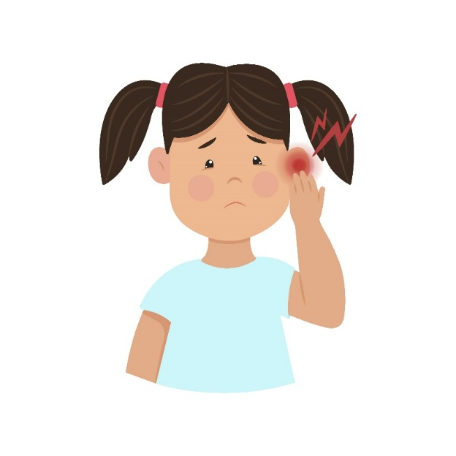
Ear Infection in Children (Acute Otitis Media)

What Is an Ear Infection or “Acute Otitis Media”?
- An ear infection is also called acute otitis media.
- Ear infections are most common in young children.
- Ear infections can cause fever, ear pain, poor sleep, irritability, and sometimes ear drainage.

What Should I Do To Help My Child Feel Better?
- Medicines like acetaminophen (commonly called Tylenol®) or ibuprofen (commonly called Advil® or Motrin®) can help with ear pain and fever; follow the instructions on the package based on your child’s age. Store brands are just as good as name brands.
- Avoid applying extreme heat or cold to the ear or putting any smoothing liquids in the ear as these can cause injury.

When Will My Child Feel Better?
- If a clinician determined that your child may have acute otitis media, your child should feel better within 3 days. It may take 1–2 days more to improve without antibiotics.
- Antibiotics can have side effects like diarrhea or rashes and make future ear infections harder to treat; a clinician weighs the risks and benefits of antibiotics when deciding if they make sense for your child.

When Should I Contact My Clinician?
- Seek medical attention if your child’s symptoms worsen or fail to demonstrate any improvement within 48–72 hours, regardless of whether antibiotics were prescribed or not.
- Seek immediate medical care if your child has a temperature ≥102 degrees Fahrenheit, is becoming confused, lethargic, develops persistent vomiting, is increasingly tired, or is ill appearing.
- If you notice that one ear is suddenly sticking out or there is redness behind one of the ears, you should seek immediate medical care for your child.
AHRQ Pub. No. 26(27)-0021
October 2026

Directions for Adding Your Logo to Your Document
If you choose to add a logo to this document, you can place it in the footer, below the article development content.
Steps:
- Open the footer section (either double click in the footer section of the document or go to the “Insert” tab → select the drop-down menu for “Footer”→ and click on “Edit Footer”).
- Make sure your cursor is below the bottom line (or wherever you want your logo).
- Go to the “Insert” tab.
- Click on “Pictures” from the “Insert” tab.
- A window will pop up so you can search your computer for the logo. Select your logo (.jpg or .png format) and click the insert button.
- Your logo will appear in your footer. If you are happy with the placement, skip step 7.
- ** If you want to move the logo image around, click on the logo → go to the
“Format” tab → click on the “Wrap Text” drop-down menu → and select “In front of text.” This formatting will allow you to move the logo freely around the screen.
- When you are satisfied with the placement of the logo, exit the footer section (either double click outside of the footer area or go to the “Design” tab → and click the “Close header and footer” button).

AHRQ Pub. No. 26(27)-0021
October 2026

