Decolonization of
Non-ICU Patients With Devices
Section 13-2 – Staff Huddle Reminder:
Device Cleaning With CHG
- Because of the results of a large clinical trial, we provide daily chlorhexidine gluconate (CHG) bathing/showering for non-ICU adult patients with medical devices for the duration of their hospital stay. This includes patients with devices such as central lines, midline catheters, and lumbar drains.
- For ALL devices (lines, tubes, drains) clean the 6 inches closest to the body.
- Patients feel uncomfortable cleaning devices. Staff HAVE TO HELP clean them.
- Staff: Use clean CHG cloths to clean patients’ devices during bed baths and after showering.
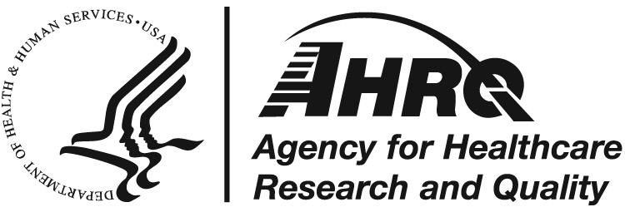
AHRQ Pub. No. 20(22)-0036
March 2022

Decolonization of
Non-ICU Patients With Devices
Section 13-2 – Staff Huddle Reminder:
Device Cleaning With CHG
- Because of the results of a large clinical trial, we provide daily chlorhexidine gluconate (CHG) bathing/showering for non-ICU adult patients with medical devices for the duration of their hospital stay. This includes patients with devices such as central lines, midline catheters, and lumbar drains.
- For ALL devices (lines, tubes, drains) clean the 6 inches closest to the body.
- Patients feel uncomfortable cleaning devices. Staff HAVE TO HELP clean them.
- Staff: Use clean CHG cloths to clean patients’ devices during bed baths and after showering.
AHRQ Pub. No. 20(22)-0036
March 2022

