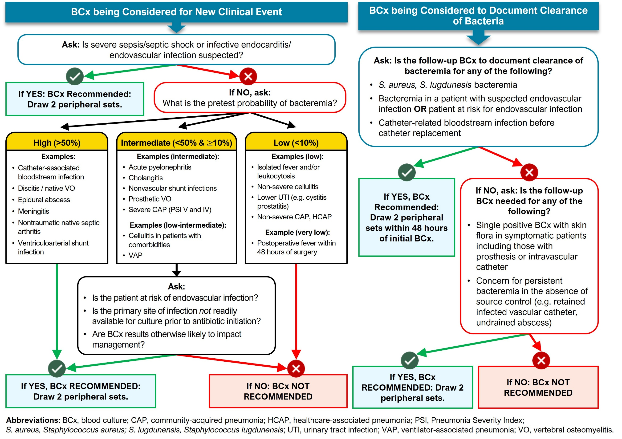
Originally published in “Does This Patient Need Blood Cultures? A Scoping Review of Indications for Blood Cultures in Adult Nonneutropenic Patients” by Fabre et al in Clinical Infectious Diseases, September 2020. Used with permission. Image is adapted.

Algorithm of Indications for Bacterial Blood Cultures
for Non-Neutropenic Adult Patients
- This algorithm is not a substitute for clinical judgment.
- Peripheral BCx are preferred over central lines blood cultures due to lower rate of false positives.
- Always draw 2 peripheral sets (i.e., 4 bottles with 8-10cc/bottle).
Avoid use of blood cultures when they are not clinically appropriate. The algorithm presented here is intended as a decision-making aid to assess when blood cultures are necessary.
The algorithm differentiates between initial indications for blood cultures in the setting of a new clinical event, and “follow up” blood cultures that are sometimes indicated to determine and document clearance of bacteremia.

Background
This algorithm was developed as part of the DISTRIBUTE Study and was informed by a scoping review examining the effectiveness of blood cultures across a range of clinical scenarios involving adult nonneutropenic inpatients. Development of the algorithm was led by a multidisciplinary team that included experts in antimicrobial stewardship, hospital epidemiology, critical care, hospital medicine, surgery, medical microbiology, and infectious diseases.
Additional details on the development of the algorithm and the design, implementation, and outcomes of the DISTRIBUTE Study are available in the following publications:
- Fabre V, Sharara SL, Salinas AB, et al. Does this patient need blood cultures? A scoping review of indications for blood cultures in adult nonneutropenic inpatients. Clin Infect Dis. 2020 Aug 22;71(5):1339-47. PMID: 31942949.
- Fabre V, Klein E, Salinas AB, et al. A diagnostic stewardship intervention to improve blood culture use among adult nonneutropenic inpatients: the DISTRIBUTE study. J Clin Microbiol. 2020 Sep 22;58(10):e01053-20. PMID: 32759354.

Subsequent Studies Using This Algorithm
This algorithm has since been adapted or implemented in multiple studies evaluating diagnostic stewardship interventions:
- Seidelman JL, Moehring R, Gettler E, et al. Implementation of a diagnostic stewardship intervention to improve blood-culture utilization in 2 surgical ICUs: time for a blood-culture change. Infect Control Hosp Epidemiol. 2024 Apr;45(4):452-458. PMID: 38073558.
- Theophanous R, Ramos J, Calland AR, et al. Blood culture algorithm implementation in emergency department patients as a diagnostic stewardship intervention. Am J Infect Control. 2024 Sep;52(9):985-991. PMID: 38719159.
- Wang MC, Zhou KJ, Shay SL, et al. The impact of a blood-culture diagnostic stewardship intervention on utilization rates and antimicrobial stewardship. Infect Control Hosp Epidemiol. 2024 May;45(5):670-673. PMID: 38088164.
AHRQ Pub. No. 25-0007
October 2024

