Implementation and Sustainability of Interventions To Improve Skin Care and Prevent MDRO Infections in Long-Term Care Facilities
AHRQ Safety Program for MRSA Prevention
Slide Title and Commentary | Slide Number and Slide
Implementation and Sustainability of Interventions to Improve Skin Care and Prevent MDRO Infections in Long-Term Care Facilities  SAY:  Welcome to the toolkit for the AHRQ Safety Program for MRSA Prevention—Improving Skin Care and MDRO Prevention in Long-Term Care. Providing good skin care helps to prevent skin tears and pressure injuries as well as infections associated with indwelling devices. This helps to reduce the prevalence of multidrug-resistant organisms or MDROs and helps prevent infections caused by these pathogens. Methicillin-resistant Staphylococcus aureus or MRSA is one of the most common MDROs and commonly causes infections by entering through broken skin. The toolkit includes content about skin assessment, keeping skin clean and safe, how healthcare personnel can help prevent the spread of MDROs, antibiotic stewardship, and environmental cleaning and disinfection. It also contains information about infection prevention strategies, and case studies that apply to long-term care facilities. | Slide 1  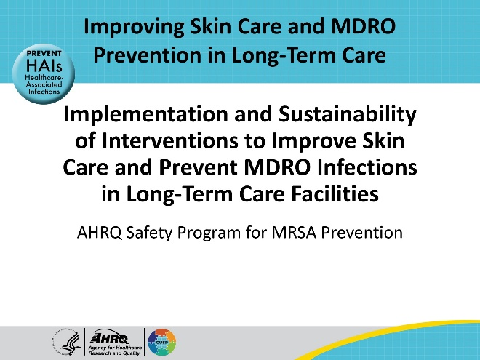
All Staff Support Resident Care and Safety  SAY:  The information provided in this presentation is important in the care of Long-Term Care (LTC) residents. In LTC facilities each member of the facility’s staff supports resident care and safety. Some actions described in these presentations may not be in your scope of practice, but it is important to learn how all staff contribute to resident care and safety. | Slide 2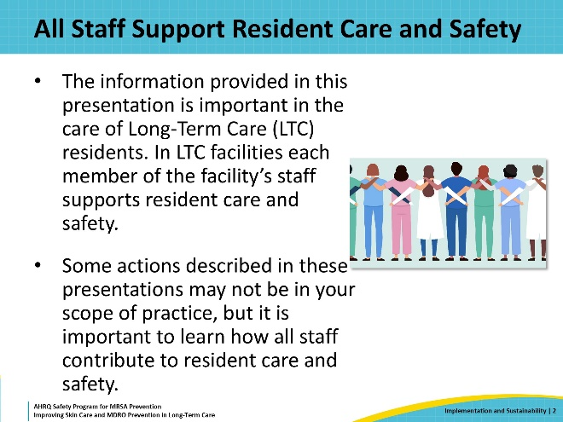
Educational Objectives  SAY:  The learning objectives of this presentation are to provide key principles and information about this toolkit, discuss a plan for implementing the suggested skin care and infection prevention strategies from this toolkit, offer a plan for ongoing evaluation and sustainability of efforts, and to describe data sources that can be used to inform the team of progress. | Slide 3  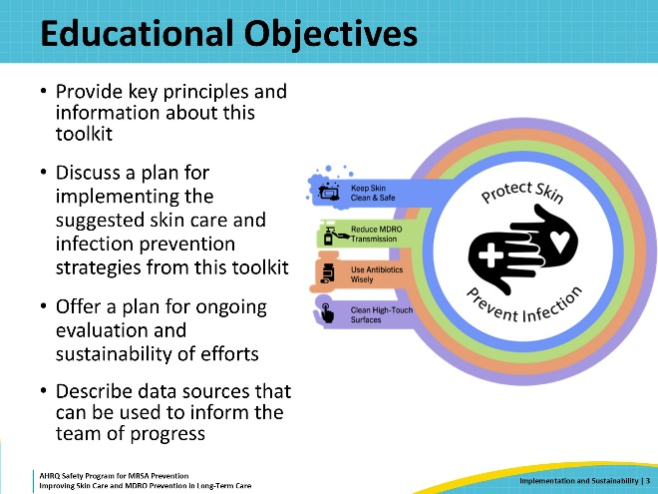
AHRQ Safety Program for MRSA Prevention—Improving Skin Care and MDRO Prevention in Long-Term Care  SAY:  The purpose of this AHRQ Safety Program for MRSA Prevention—Improving Skincare and MDRO Prevention in Long-Term Care is to promote quality skin care and infection prevention. This toolkit promotes skin integrity which means keeping skin clean, healthy, and safe and preventing skin tears and wounds. Skin that lacks integrity or is damaged creates a portal of entry in which pathogens, such as MDROs, can enter the body and cause infection. So, an additional focus of this toolkit is on infection prevention. | Slide 4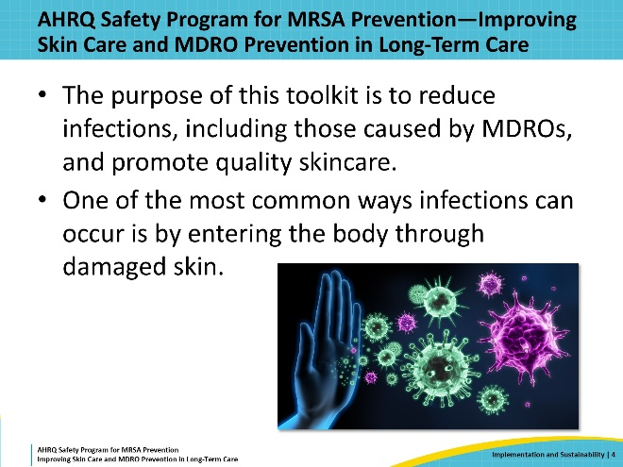
Four Key Strategies to Improve Skincare and Prevent Infection  SAY:  This toolkit focuses on four key strategies to protect skin and prevent infection. These key strategies are depicted in the program graphic and include Keep Skin Clean and Safe, Reduce MDRO Transmission, Use Antibiotics Wisely, and Clean High-Touch Surfaces. | Slide 5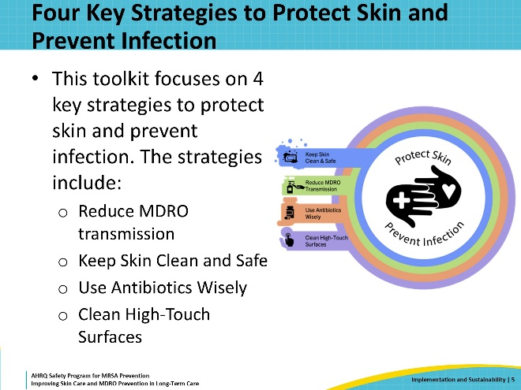
Triangle of Transmission  SAY:  This toolkit emphasizes tangible actions that long-term care staff can utilize to prevent pathogen transmission between direct care staff, residents, and the environment.  The presentations are case based, and stress topics such as the importance of skincare, appropriate bathing practices, and how to reduce the risk of pressure injuries and wounds.  The triangle of transmission is a theme that will be presented throughout the various presentations in the toolkit. This triangle shows how pathogens can be spread between direct care staff, residents, and the environment and how the interventions in the program can help stop that spread. The language on the outside of the triangle shows the interventions that can break the cycle of pathogen transmission. | Slide 6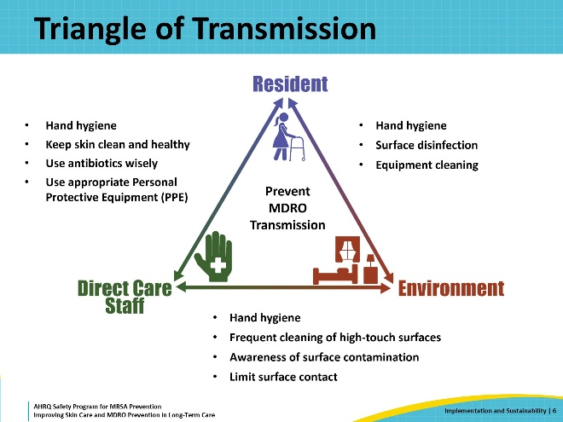
The 3 Cs of Healthcare  SAY:  The 3 Cs of healthcare: connection, communication, and collaboration, are a central concept of this toolkit. This concept encourages recognition that individuals who operate in a clinical environment within a healthcare organization are a team. This team is comprised of both clinical and non-clinical healthcare personnel who provide integral sets of skills and services to individuals seeking healthcare. This group is referred to as a team because it stresses the importance of working together to accomplish the shared goal of providing safe, quality care. It is essential to work together to accomplish this goal, as everyone’s role is important in accomplishing this task. To do this, it must be recognized that interpersonal relationships within the healthcare team can directly influence the care provided for residents.  To develop and strengthen the 3 Cs in your organization, there are two types of interventions.  The first are technical interventions, which are based on evidence-based recommendations. These include a focus on enhanced barrier precautions, hand hygiene, skin care and other actions that help prevent transmission of MDROs and skin breakdown. These are largely rooted in education, teachable moments, and supporting materials that share information.  The second type of intervention is adaptive interventions. These include improving teamwork and communication to create lasting change, sometimes by changing the system. Many of these changes involve direction and support from people in leadership as well as good ideas for implementation and improvements from staff. An important part of the safety culture is empowering staff to speak up when they notice a problem or even just the potential for a problem that affects patient safety. That voice, and the wisdom behind it, can help prevent future harms. | Slide 7  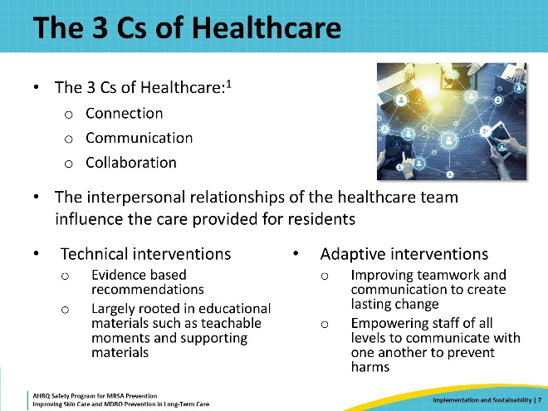
Presentation Structure and Content  SAY:  The presentations in this toolkit are designed to provide long-term care staff with important and actionable information to improve infection prevention and skin care practices throughout the facility.  Each presentation includes learning objectives and several slides that describe the evidence and rationale for the topic, including how it relates to the triangle of transmission.  This is followed by a brief case study that addresses common practices in the long-term care setting, such as bathing. Each case involves a challenge that disrupts the normal flow of activities. These challenges are real-world events, such as not having enough towels, or stool incontinence during a bed bath. The case study walks through common errors and solutions to the challenge or problem. The solutions are action items directed towards direct care staff and infection preventionists.  There are also points to address with senior executives which can help promote sustainable changes in the practice patterns and safety culture in your building.  The presentations use a “train the trainer” approach that makes it easy for core team members to distribute the applicable materials with each role of the direct care staff.  * Please be mindful that though the items in these presentations are often catered towards a specific member of the long-term care staff, these topics are educational for and can be shared with all members of the care team. | Slide 8  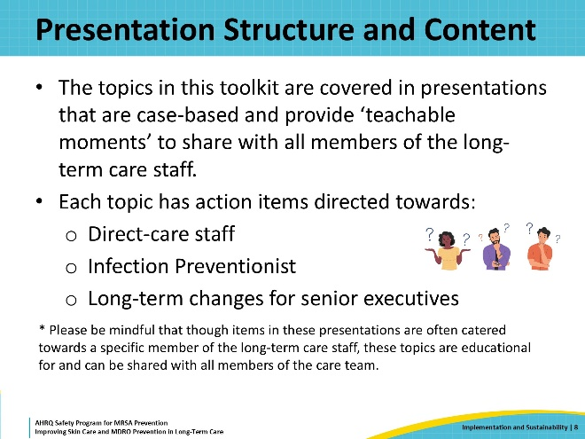
Teachable Moments and Supporting Materials  SAY:  The toolkit contains a series of “Teachable Moments” for each topic. These teachable moments are intended for direct care staff, that is, the nurses and nurse aides that provide the hands-on care to the residents. Though these materials were created with this audience in mind, any member of the staff that provides care to the resident or resident rooms may find these materials to be educational.  The Teachable Moments are handouts that provide a brief and focused lesson about topics such as skin care, infection prevention, patient safety and other information key to prevent infection. Most have one to two straightforward multiple-choice questions. The questions are not meant to be graded but simply to reinforce the material. The handouts are designed for staff to keep.  In addition to the Teachable Moments, most of the topics also have other supporting materials. These may include checklists, posters, or similar materials designed to reinforce the important messages from each presentation. These materials and the Teachable Moments handouts can all be found on the toolkit website. | Slide 9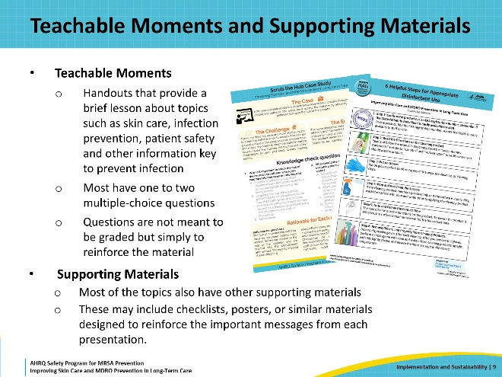
Honoring Resident Preferences  SAY:  Other important information in the toolkit focuses on the resident and the staff in nursing homes. There are often challenges with providing quality skin care and bathing to residents who may lack the autonomy that accompanies being dependent on caregivers for the first time.  To provide thorough and effective skin care, residents need to be regularly bathed in the nursing home. This may take some extra time and attention, particularly for resistant residents.  It is important to take the time to assess resident preferences around bathing so that they are as comfortable as possible with this process. This should be done on admission and at regular intervals, particularly if there is any hesitancy around bathing. The toolkit has a resident bathing preference menu, which can be reviewed with residents and their families. Residents can specify if there is a specific time of day that may make bathing more comfortable, or if they have bathing products they particularly enjoy.  It is also important to train staff on strategies to protect resident modesty and privacy, such as draping techniques, using low lighting, and trying to keep some consistency with staff bathing. | Slide 10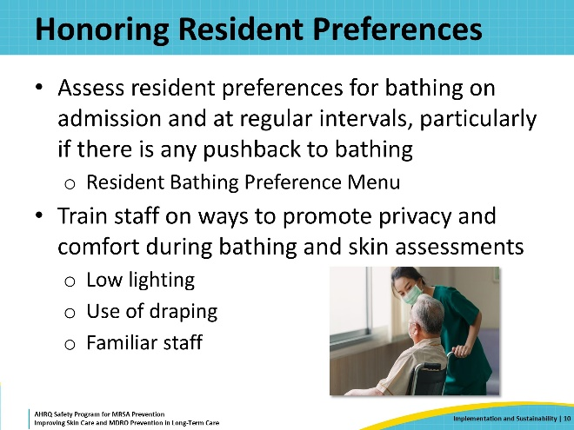
MDRO Infection Prevention Bundle  SAY:  An infection prevention intervention requires multiple layers of protection, and all staff have a role in making infection prevention effective. Because germs are invisible, it can be particularly challenging to notice the immediate impact of the efforts.  Core activities like proper hand hygiene, wearing PPE when indicated, regular skin assessments, attention to skin care, and frequent communication and documentation can go a long way in preventing infections.  Remember that staff members are there because they care for these residents, and re-centering the goals of infection prevention around the protection of the residents can really help to get the team on the same page and improve the culture in the facility. | Slide 11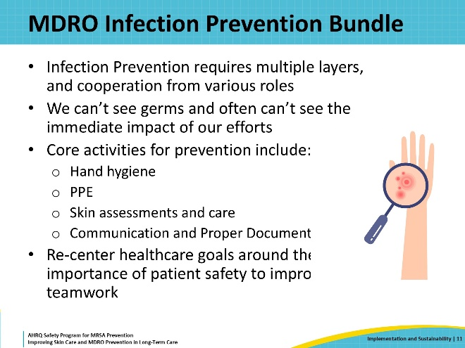
Sustainability: Keeping your Efforts Alive  SAY:  When implementing this infection prevention and skincare program at your facility it is important to consider sustainability during the planning and implementation process.  Get a pulse on your nursing home by checking the data and evaluating the staff culture of the facility. Get a sense of the facility’s culture, and how the staff works together by asking them about their communication practices. Take a walk around the different units of the facility and observe staff in action. Talk to the staff to learn what is working well and what is not. Walk rounds can help evaluate compliance levels for things like hand hygiene and enhanced barrier precautions. Look at bathing compliance rates. Are residents refusing baths often? Consider putting out a survey to residents about their thoughts on the bathing process and get feedback on how to improve it. Do the same for the staff to get their input on challenges. Share this information with each member of the staff to co-create solutions. You may discover it is helpful to monitor these different aspects about your facility during the program planning phase, as well as during and after implementation.  Truthfully, the process should never stop. Staff change, practices change, and training changes as time goes on. A once a month walk around the building can help ensure that everyone is up on their training, are compliant with current protocols, and, most important, that they are working together as a team.  These actions are all part of interconnected and sustainable practices into your implementation efforts to prevent infections and improve patient outcomes. | Slide 12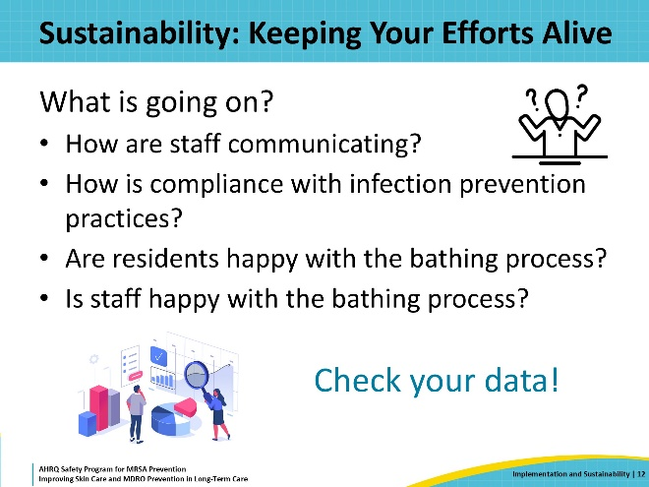
Defining Your Team  SAY:  To get started with the implementation of this toolkit, it is recommended to identify a core team who will be actively involved in implementing interventions and data collection.  The infection preventionist at the facility is a great person to involve, as this is a key focus of this program.  Consider involving one to two clinical leads, such as the director of nursing or assistant director of nursing, a Staff Champion, or a representative from the direct care staff, and anyone else that may be interested in this implementation work. This should include the certified nursing assistant (CNA), RN or LPN and someone from the environmental services team. Having several people engaged in the program means there are more people to help distribute the information to direct care staff and identify areas where interventions will improve resident care. | Slide 13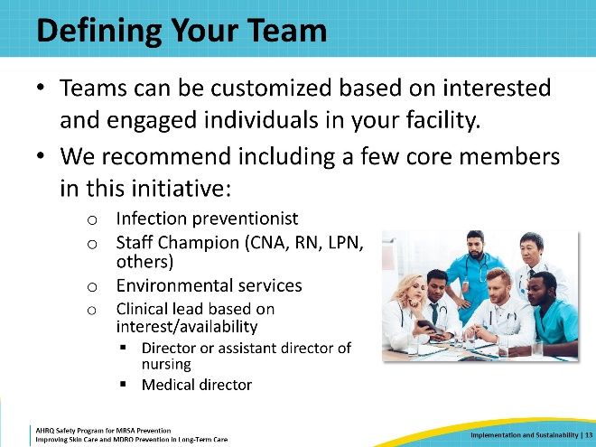
Delegation of Tasks  SAY:  Knowing who is responsible for what actions and delegating tasks in the work environment can be challenging when implementing infection prevention strategies. The toolkit contains case studies discussing the importance of understanding, and effectively communicating, the delegation of tasks in a facility. For example, there is often a lot of uncertainty about who is responsible for cleaning devices such as PEG tubes. The CNA may think that they are not allowed to touch the PEG tube, so they skip over this area completely during bathing.  Nursing may think the CNA has cleaned the hub of the tube during a bed bath, so they don’t do it. Unfortunately, these missed communications results in no one attending to this area and can certainly increase the risk of infection. Having clear conversations with members of the team, to make sure that each of these “nebulous” areas are addressed, can help to prevent gaps in care.  Teachable moments and training information about these issues are available in the materials of the toolkit. Using these in staff meetings or annual reviews can help garner good communication among staff and sustain your efforts at infection prevention. | Slide 14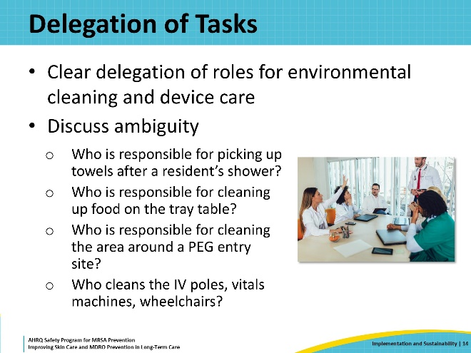
Consistent Monitoring and Feedback  SAY:  Use your data sources to track and promote change. Once you identify areas of concern, create a system to share the data, such as at a monthly or weekly QA meeting. Most importantly, share this data with the staff and leadership to make an impact and promote further change. This can be done on a facility or unit/neighborhood level, or directly to the individual. | Slide 15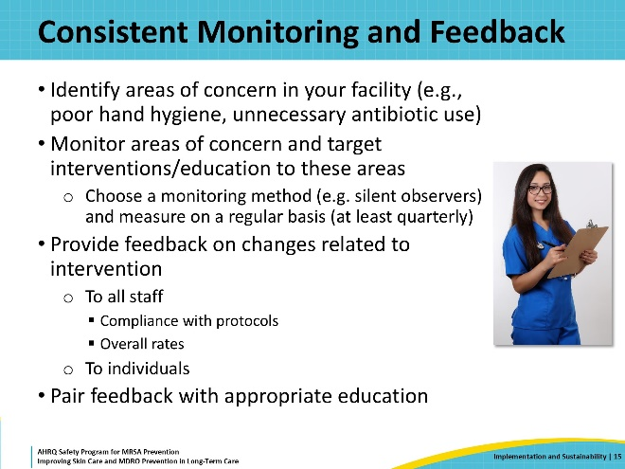
Data Sources  SAY:  There are many opportunities to track data to measure the impact of the interventions. Focus on areas where your facility has weak points. If hand hygiene is a particular problem, perform audits with secret observers on compliance and feed this data back to each unit monthly. If you have high antibiotic prescribing rates, track your antibiotic use, and focus on syndromes which may be of concern, such as urinary tract infections (UTIs).  You can also look at transfer rates to other facilities. To evaluate safety culture and teamwork in the facility, consider using the staff surveys located in the communication section to gauge staff opinions on their work. | Slide 16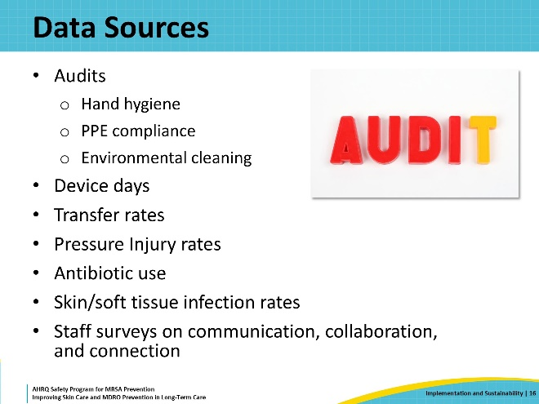
Audits and Feedback in LTC  SAY:  Audits and feedback are two of the most helpful ways to implement and sustain good practice when implementing infection prevention strategies. The toolkit contains information to help the long-term care facility implement a review of interventions.  For example:  Another staff member is in the hallway and happens to notice that the CNA forgot to perform hand hygiene before donning gloves. The nurse doesn’t feel comfortable reminding her to wash her hands in the moment—she isn’t familiar with this new CNA and doesn’t want to seem rude.  One way to mitigate this challenge is by using audits and feedback. Audits and feedback are two of the most helpful ways to cement and sustain good practice. This should be done both on a peer-to-peer level, as well as in a more formal process by leadership.  Facility leadership should make efforts to create a culture that fosters respectful communication. This should be emphasized in orientation, and this behavior should be modeled in interactions among facility staff.  While infection prevention policies can easily be written, implementing these practices, and ensuring they are followed is a whole separate challenge. A formal system to monitor compliance, either with secret observers or regular walk rounds by the IP, can help you provide real time feedback when you see a breach in practice. Foster a culture where peers can respectfully remind each other about missed opportunities for infection prevention, so that observation is continuous. | Slide 17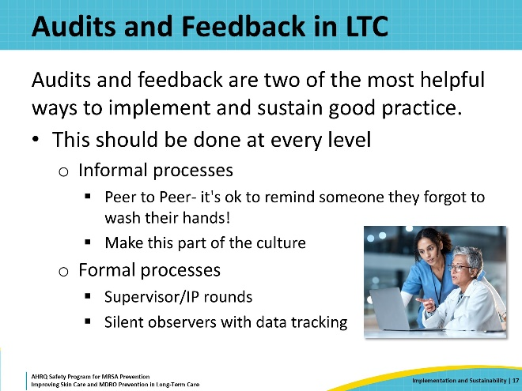
Share Successes and Incentivize Improvement!  SAY:  When you see improvement, celebrate it!  Incentivize staff by providing lunch to the units or neighborhoods with the highest compliance rates or highlight individual staff members who champion change as an employee of the month.  This helps to create a positive culture in the facility, and makes change rewarding, rather than focusing on penalties for lower rates, which can be discouraging for staff. | Slide 18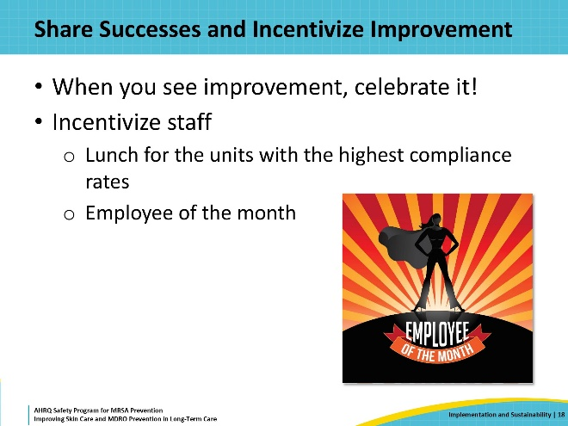
Time to “Reboot”  SAY:  Several strategies can keep the momentum going in infection prevention efforts to improve resident skin care and reduce MDRO infections.  Undoubtedly, you will see some lull in compliance or vigor for some of these activities as active interventions wear off over time.  This is when it is time to reboot. Remind staff of all they have learned and incorporate some fun activities to invigorate the team to re-dedicate themselves to infection prevention activities and improvements in skin care of the residents.  Consider using some of the materials available in the toolkit. Re-circulate old teachable moments to new staff members or staff who haven’t seen them in a while. Do the escape room activity over a lunch break one day or during a staff meeting. Remember to continue to empower the team and keep the message resident focused, so staff understand that infection prevention can have a real impact on the health of their patients. | Slide 19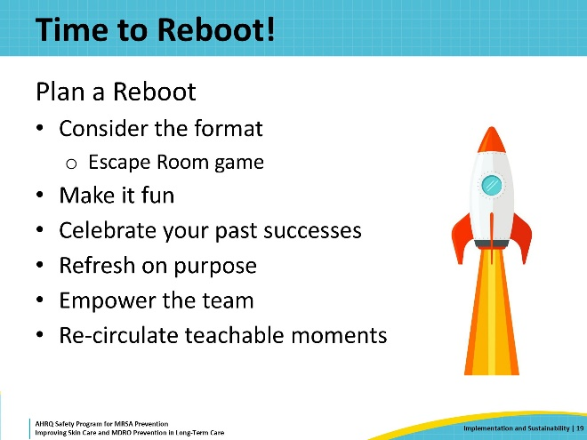
Supporting Materials  SAY:  Supporting materials for this toolkit include Teachable Moments: Communication, Collaboration, and Connection in Healthcare, Cutting Corners and Workarounds, Why We Wear Gloves, Mistakes Happen!, The Triangle of Transmission: Understanding Sources and Pathways of Germ Transmission. Other, additional materials include: The Four Key Strategies to Protect Skin and Prevent Infection, Multidrug-Resistant Organisms (MDROs): Education for Patients and Families, Centers for Disease Control and Prevention MDRO Prevention Strategies Webpage. | Slide 20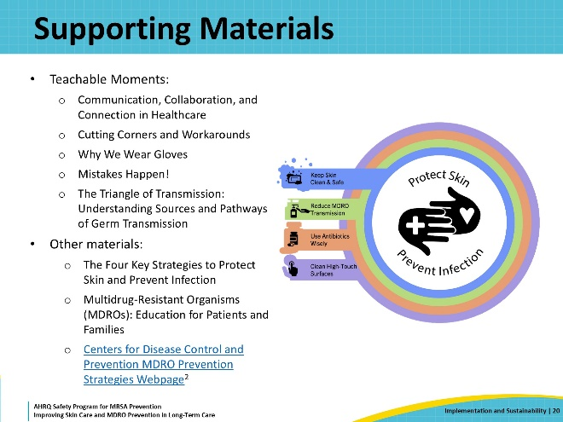
Key Takeaways  SAY:  This toolkit contains valuable information to reduce skin and soft tissue infections, pressure injuries, and skin tears among residents in long-term care facilities. This information, along with improvement in patient safety, will also improve team-based infection prevention practices and increase overall staff, resident, and family satisfaction. | Slide 21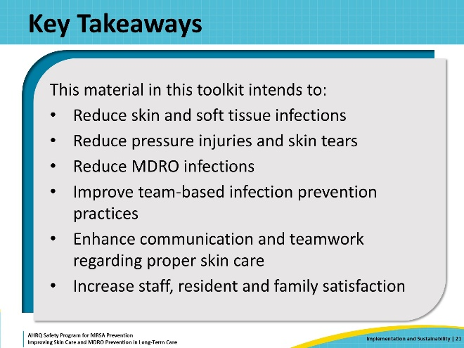
Disclaimer  SAY:  The findings and recommendations in this presentation are those of the authors, who are responsible for its content, and do not necessarily represent the views of AHRQ. No statement in this presentation should be construed as an official position of AHRQ or of the U.S. Department of Health and Human Services.  Any practice described in this presentation must be applied by healthcare practitioners in accordance with professional judgment and standards of care in regard to the unique circumstances that may apply in each situation they encounter. These practices are offered as helpful options for consideration by healthcare practitioners, not as guidelines. | Slide 22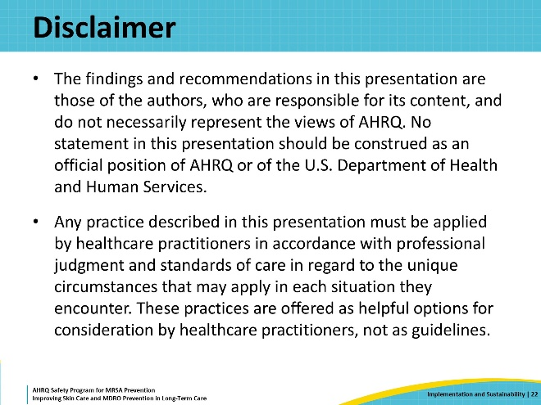
References  SAY:  Here are the references. | Slide 23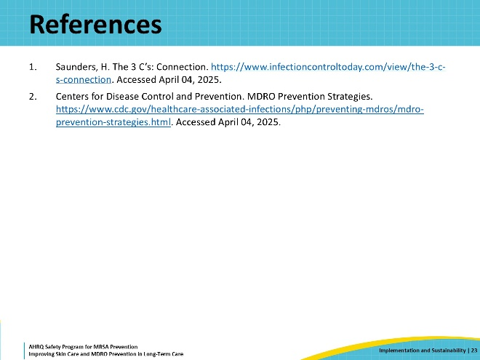
AHRQ Pub. No. 25(26)-0066
October 2025

