Aging Skin: The Importance of Care and Assessment
AHRQ Safety Program for MRSA Prevention
Slide Title and Commentary | Slide Number and Slide
Aging Skin: The Importance of Care and Assessment  SAY:  Welcome to this presentation on “Aging Skin: The Importance of Care and Assessment.” Caring for aging skin is part of an overall approach to improving skin care and in the process, improving prevention tactics against multidrug-resistant organism (MDRO) infection in long-term care. | Slide 1  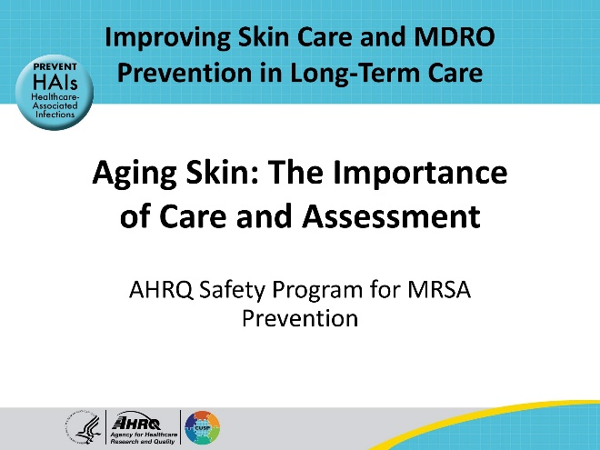
Educational Objectives  SAY:  This presentation is broken into two sections. The objectives for the first part of this presentation are to learn why aging skin is different and describe how to care for aging skin. The second part delves into skin assessment, which includes learning the importance of maintaining healthy skin and then how to perform a skin assessment. | Slide 2  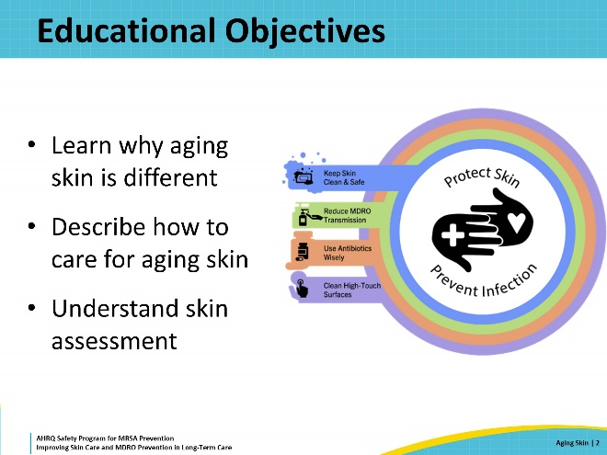
Why Is Our Skin Important?  SAY:  Skin is the largest human organ and is really amazing. It moves, stretching as the muscles and skeleton move. Skin helps the body stay warm or cool off. It also serves as a barrier of protection and helps sense the environment.  Skin has several layers. The visible, outside layer is the epidermis. Under this is the dermis, which contains fibers like collagen and elastin as well as blood vessels, nerves, hair follicles, sebaceous glands, and sweat glands. When a cut occurs, the dermis contains the nerves that sense pain and the blood vessels that bleed. Below the dermis is the hypodermis, which is mostly fat. Muscles are below these layers of skin.  Skin protects the body from germs and regulates body temperature. It also protects vital organs and prevents water loss. | Slide 3  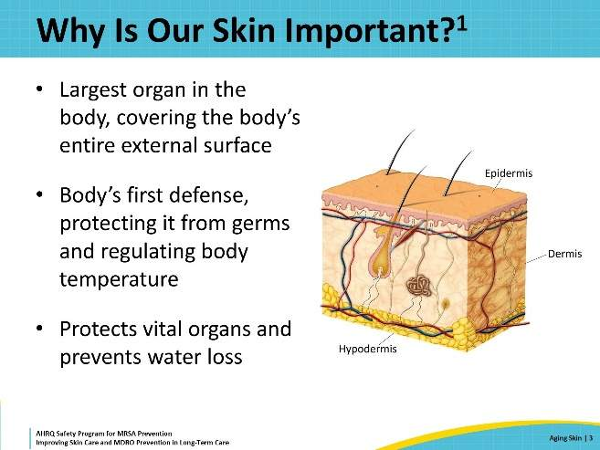
Aging Skin  SAY:  Skin changes as people age. A familiar change includes wrinkles, common to older people. Another change that is less obvious is the thinning of the dermis. Collagen and other skin fibers become less abundant and also break, leading to wrinkles. It also means that older skin can be damaged quite easily, and it takes longer to heal.  Skin reactions and conditions may vary in appearance depending on a person’s skin color. This toolkit uses pictures and diagrams depicting skin of a variety of colors/tones to give a broader view of how these conditions may manifest. However, all possibilities may not be represented. | Slide 4  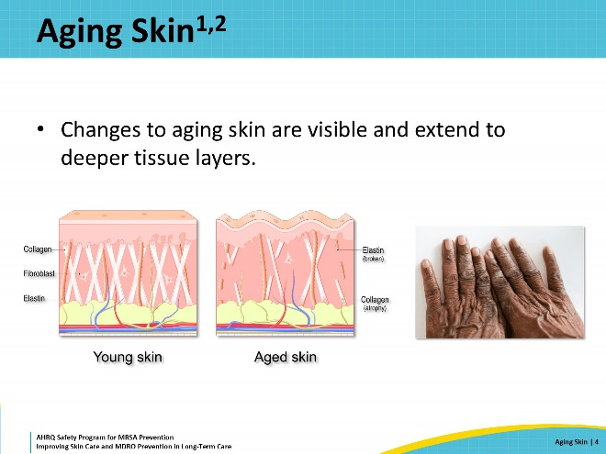
How Is Aging Skin Different?  SAY:  Skin changes with age, and there is no getting around it. While retinol creams, plastic surgery, and costly injections may provide temporary solutions, age eventually catches up and results in noticeable changes to the skin.  As caregivers for an aging population, it is important to understand the effect that age has on skin. Skin changes in older adults increase the risk for skin and soft-tissue injuries and infection.  Most people are aware of the cosmetic changes to aging skin, including sagging skin, wrinkles, and fine lines. However, skin also commonly becomes drier and itchier with age. In fact, 85 percent of older adults develop what is commonly known as winter itch due to the overheated, dry indoor air. Skin loses its elasticity as people age, resulting in thinner skin that loses water more easily and is prone to tears and injury. Finally, and the reason that skin is being highlighted in this toolkit, aging and wrinkled skin is more prone to injury and infection. | Slide 5  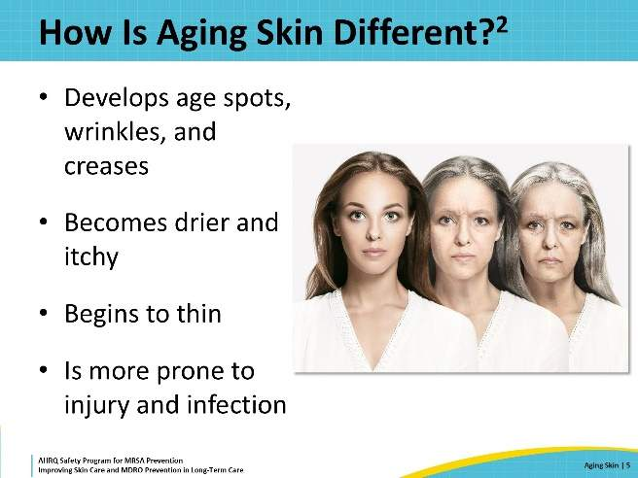
Key Ideas for Staff  SAY:  When caring for residents, there are many opportunities to bring them joy, including through care pathways. Taking the time to properly assess skin and provide comfort during bathing are two areas where personal attention and detailed care can have long-lasting impacts on a resident’s quality of life.  Individuals with immobility and or incontinence are at risk for developing an array of problems that lead to damaged skin. Especially for people with decreased mobility, pressure injuries are a major concern. For residents who need assistance with moving, especially moving around in bed, skin tears can easily occur. It is helpful to take note of which residents are immobile or have decreased mobility to help inform the care process, and ensure residents are getting the care they need, within the timeframe they need it.  Being incontinent of urine or feces also creates problems. A resident’s skin may be moist or damp for extended periods, which, in and of itself, is damaging to the skin. Also, the chemicals in urine and feces cause skin to become irritated, leading to swelling, pain, and skin breakdown. The bacteria from urine and especially feces that remain in prolonged contact with broken skin can cause further skin problems, including infections.  Moisture in skin folds can lead to intertrigo, an inflammatory skin condition. Many of us more commonly know this as diaper rash as it is often seen in infants. Intertrigo manifests as erythema or red skin that can also be painful or itchy. Yeast infections of the skin are commonly associated with intertrigo. Common locations for this problem include the inguinal folds where the leg meets the body, in gluteal folds, and under pendulous breasts and abdomens.  It is important for the care team to understand that these acts of service and care are low-hanging fruit on the tree of resident joy. These actions, when performed with attention and detail, seek to promote an increased quality of life for residents, while improving health outcomes in facilities. | Slide 6  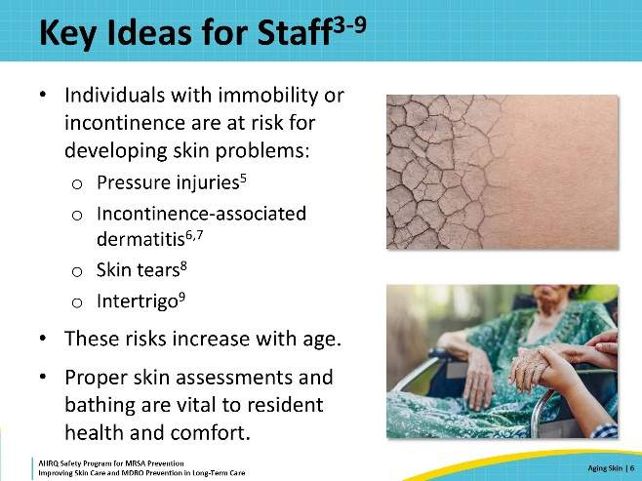
Additional Skin Care Interventions  SAY:  Scented soaps, lotions, and body sprays are very popular. Although the fragrances smell good, the chemicals that release those strong scents all work by evaporating from the skin. During this process, water is taken from the skin as well, leading to drier skin.  Older adults are also at risk of sunburn. It takes longer for them to heal from this damage, which can include dehydration, pain, swelling, and systemic inflammation followed by dry, peeling skin. When taking a resident outside, it is important to cover the resident’s skin with protective clothing, sunscreen, and shade to protect them from sunburn.  Having air humidifiers can help, especially in drier climates and during cold weather when heating systems tend to dry out the air in a building.  Finally, simply keeping residents hydrated can make a difference. For some, this means ensuring water is within easy reach. For others, this means offering water regularly and helping make sure the residents drink fluids throughout the day. | Slide 7  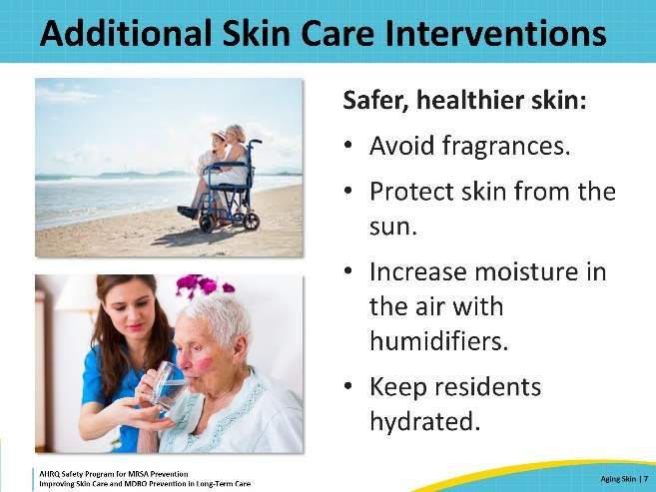
Good Bathing Practices: Taking Care of Residents’ Skin  SAY:  As skin becomes drier with age, regular bathing can help alleviate dry skin. However, if the wrong products, water temperature, or technique are used, bathing can result in drier skin that is more prone to itching, injury, and infection.  Good bathing practices for older adults include bathing regularly. Warm water, not hot, is better for the skin. Use a soft cloth or sponge. Moisturizing soap that is gentle and does not have added fragrances also helps prevent dry skin.  When drying skin after a bath or shower, it's important not to rub. Instead, gently pat the skin dry with a soft and absorbent towel. Make sure to include the creases and crevices where extra moisture may lie. This takes patience.  After a bath or shower is the best time to apply moisturizer. Gently rub it into the skin and remember that fragrance free is better. Creams and lotions are recommended over oils, as oils lead to slippery skin, which can increase the risk of falls. | Slide 8  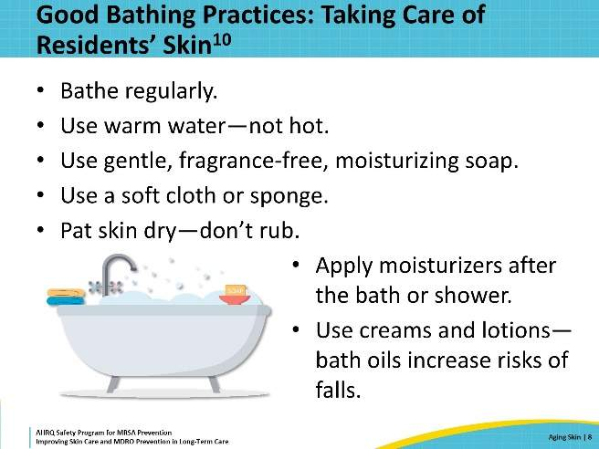
Aging Skin Damages Easily  SAY:  Aging skin is easily damaged. That damage can lead to small tears or wounds that then become infected.  Most skin and soft-tissue infections are caused by bacteria. A small cut or tear, even one that is not visible, can create a site of entry for bacteria to invade skin and soft tissue and cause an infection. For people living in nursing homes, the bacteria that cause skin and soft tissue infection often include multidrug-resistant pathogens (MDROs). Methicillin-resistant Staphylococcus aureus or MRSA is among these pathogens and is a common cause of skin and soft-tissue infections.  Skin and soft-tissue infections (SSTIs) are the third most common infections in nursing home residents nationally, affecting between 1 percent and 9 percent of residents. | Slide 9  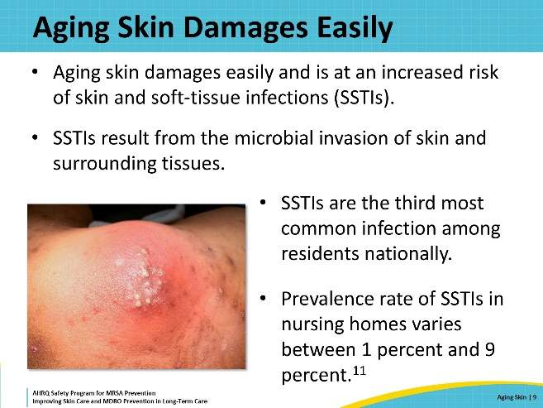
Prevent MDRO Transmission  SAY:  The Triangle of Transmission shows how germs, such as MDROs, can be spread among direct-care staff, residents, and the environment. Think of each side or leg of the triangle as a two-way street. The healthcare team works to disrupt or put a break in each leg of the triangle.  Consider how skin relates to the Triangle of Transmission. Skin that is dry, irritated, inflamed, itchy, swollen, or painful becomes a hazard for the resident. Broken or damaged skin becomes a point of entry for infections. Keeping skin clean and healthy is important to prevent infections by blocking the transmission pathway between direct care staff and residents.  Keeping skin safe and healthy is one of the most important ways to protect residents from infection.  Attention to and care of aging, wrinkled skin can prevent injury and infection! | Slide 10  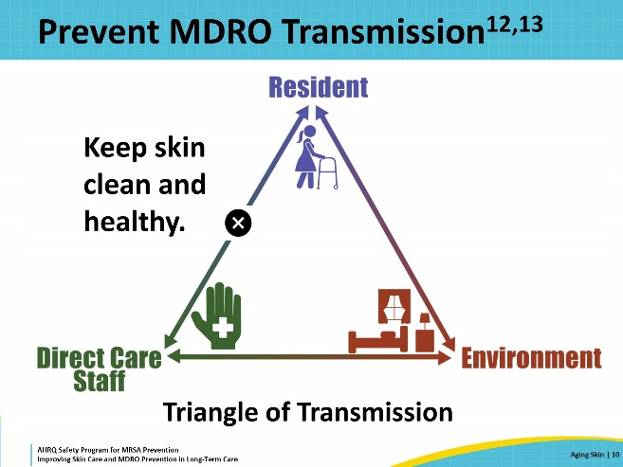
Skin Assessment | Slide 11  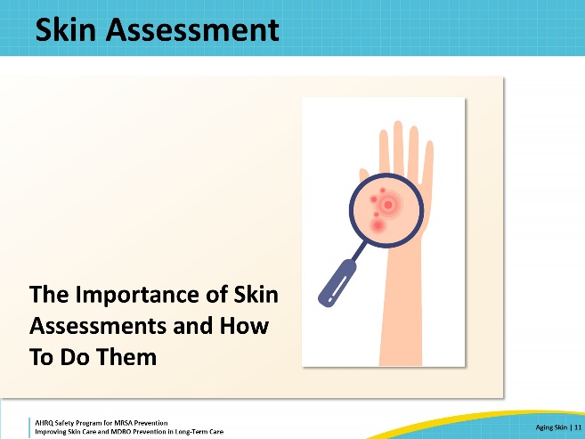
Objectives Of Skin Assessment  SAY:  The objectives of skin assessment are to determine how and when to perform a skin assessment, differentiate between skin that is dry and skin that is humid or moist, correctly assess and report the condition of medical device insertion sites and correctly identify and assess skin rashes. | Slide 12  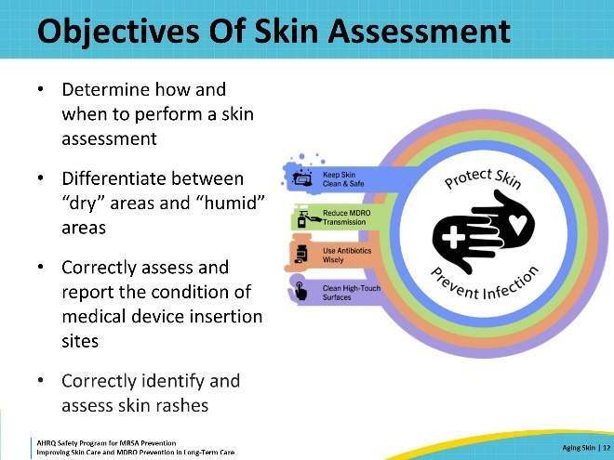
Basic Skin Assessment  SAY:  Early detection of skin problems can prevent a situation from getting worse. There are many opportunities for early detection of damaged or unhealthy skin during resident care. One of these is while helping someone bathe or dress. In addition to helping the resident dress, take the opportunity to assess the resident from head to toe to look for any signs of damaged or unhealthy skin. This process is also referred to as a skin assessment.  Another assessment opportunity is when bathing the resident or helping them prepare for bathing. There are several things that can be somewhat easily seen that indicate unhealthy skin.  Is there dry skin? Dry skin will have flaking or scaling or an ashy appearance.  Is there moist skin? Those areas are typically in areas that are already prone to moisture—like the inguinal folds or where the leg meets the torso. Are they more wet or moist than expected due to incontinence?  Are there skin color changes? In people with light skin, a stage 1 pressure injury appears as an area that is pink or red. If you press your finger to the area and it does not blanch—lose color briefly after you lift your finger—that indicates an injury. For darker skinned people, it’s harder to see color changes that are red or pink. Look for changes in color compared with the surrounding areas. There may be a purple or darker hue to the affected area.  Are there areas with swollen or painful skin? Some residents will notice this and tell their caregivers about it during the bathing process. Others may not notice or may not be able to communicate that information. Bathing is a chance to observe, ask, and note if an area is bothersome or painful.  Is there damaged skin? Any area that appears bruised, torn, or otherwise has broken skin needs attention. It may be tempting, especially for the resident, to dismiss a small tear, blister, or scratch as something that is not important. But even a small opening in a resident’s skin can be a warning sign of a deeper problem—like a pressure injury—or it can become a point of entry for infection.  Finally, does the resident have medical devices that go through the skin? What does the skin around those look like? Devices that go through the skin include central lines, peripheral intravenous lines, peripherally inserted central catheters, dialysis catheters, feeding tubes, and tracheostomies. Redness, swelling, bleeding, and crusting where the device goes through the skin are all important signs that indicate a deeper problem. | Slide 13  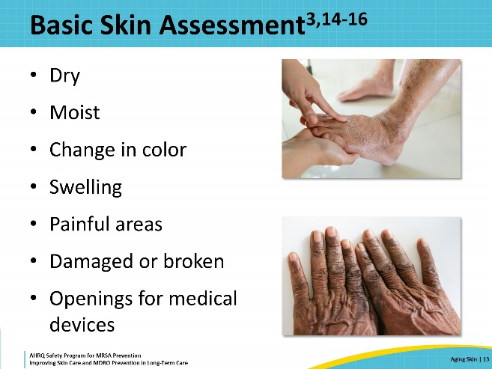
Skin Assessment Steps  SAY:  Skin assessment is an opportunity to provide extra attention to help residents feel cared for, and to identify health problems before they become more difficult to treat.  When performing a full skin assessment, it is important to first explain to the family that you will be assessing the resident’s skin from head to toe to identify and document any issues with the skin that may require particular attention or care. This is a great opportunity to provide a caring, educational, and enthusiastic environment by engaging the resident and their family in the care process.  It is important to make sure that this assessment is done in a private place, so the resident is comfortable and at ease.  Always remember to perform hand hygiene before touching the resident, and to change gloves and apply hand sanitizer again with any exposure to bodily fluids during the assessment.  One way to greatly reduce discomfort for the resident is by minimizing bodily exposure. Always cover areas of the body you are not actively examining with a towel or sheet. Remember if the resident cannot assist with turns, you need to get help to turn the resident to ensure a proper assessment.  Touch skin gently throughout the assessment to assess temperature changes, turgor, blanching, or any swelling that may signify skin breakdown or infection.  Finally, remember to document your findings in the moment so you do not miss anything and so you can track progress or changes on the next assessment.  Access the Skin Assessment Teachable Moment on the toolkit website. | Slide 14  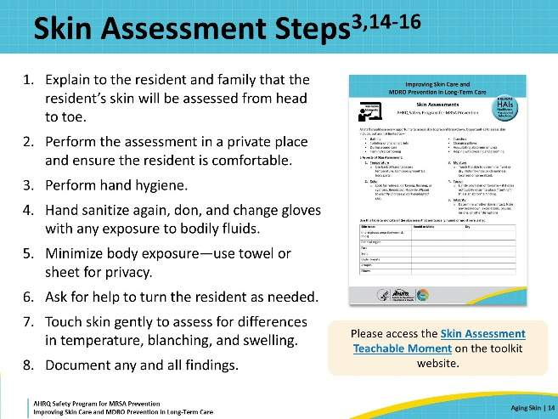
Dry Versus Humid Skin  SAY:  Dry skin is often found on the hands, feet, forearms, lower legs, elbows, knees, and sometimes the face and scalp. Watch for scaling itching, roughness, or cracks and fissures.  Humid skin can often be found in areas where skin rests on skin, in the anogenital area, and between the toes. When assessing for humid skin, look for areas that are moist to touch and those that might have a fungal rash.  Dry areas should be cleaned no more often than once a day. Use ointments to help alleviate the problem.  Humid areas need frequent cleansing. Use a mild soap and dry the skin carefully after washing. When drying skin, pat rather than rub. When possible, after patting the area dry, allow some extra time for the affected area to air-dry, to ensure no excess moisture remains. | Slide 15  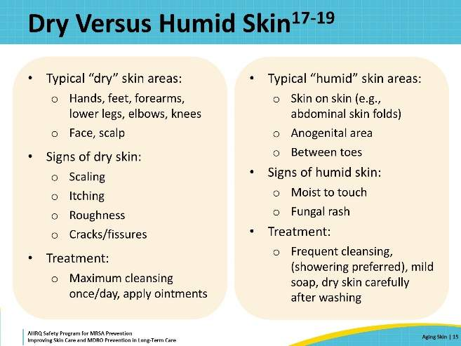
Identifying and Assessing Rashes  SAY:  Rashes are also common and can arise for a multitude of reasons. Being able to recognize and describe rashes is an important component of resident care.  Along with being a change to the skin’s appearance, a rash can also be itchy, which leads to scratching. Scratching in turn can lead to openings in skin. Bacteria that live on the skin can get in through those openings and cause an infection in deeper layers of skin and soft tissue. So, a rash that began because of dry skin or an allergic reaction can lead to skin infection.  It is important that staff can recognize and describe rashes. The skin pictured on this slide is an example of a rash caused by herpes zoster or shingles. Note that the skin is pink to red. The lesions are raised and clustered together and can often be itchy and painful. They also only occupy a narrow strip of skin. | Slide 16  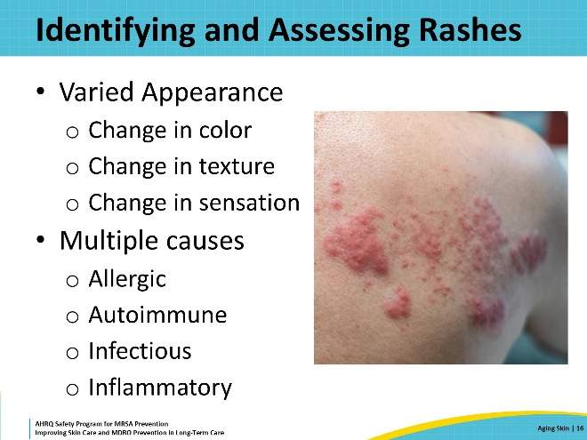
Medical Devices and Resident Skin  SAY:  Medical devices are rough on skin. Many of them involve going through the skin to enter deeper tissues. Nearly all of them also involve some way of attaching the skin to the adhesive of the device. Sometimes a device can rub against skin or make areas more prone to pressure injuries from the device. Aging skin is more vulnerable to these device-related problems.  Proper placement of medical devices as well as the cleaning and care of surrounding skin can help reduce the risk of injury and infection. Pay particular attention to changes in the skin around devices, especially those that involve a hole in the skin. Warning signs to look for include moisture under a dressing, crusting or weeping from the skin, skin that looks like it is swollen, and skin that is hot to the touch.  Some change in skin color is expected immediately around where devices go into the skin. If those color changes extend beyond the site of entry, this can be a sign of concern for infection of the skin. For people who are lighter skinned, look for red coloring around the device. For people who are darker skinned, look for a purple or sometimes darker, deeper pigment to the skin.  If changes in skin around a device are concerning, make the nurse or the wound care nurse aware of this concern, increasing the number of staff observing the area of concern. The wound care nurse may even have photographs of the area from before the device was inserted or the skin changed, or the nurse could take photographs so that changes can be noted over time. | Slide 17  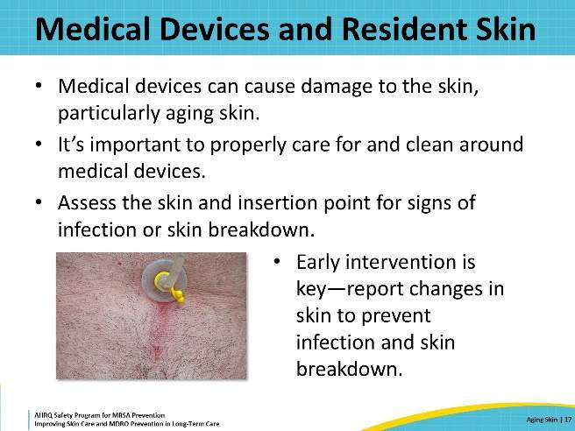
Find Opportunities to Assess Skin and Document  SAY:  Skin assessments should occur daily. There are many opportunities to assess the skin and identify changes that require attention. Empowering the entire care team, including CNAs, R.N.s, physical therapy, physicians, and others, by providing education on skin assessments, including what to take note of and who should be notified of any concerns.  Skin assessments are commonly performed during bathing, but also can be done anytime, such as when helping a resident with toileting or repositioning, when performing a physical exam, or when dressing the resident.  The entire team is responsible for proper resident care. Work together to constantly assess skin and share findings. It is the best way to prevent problems and protect resident skin integrity. | Slide 18  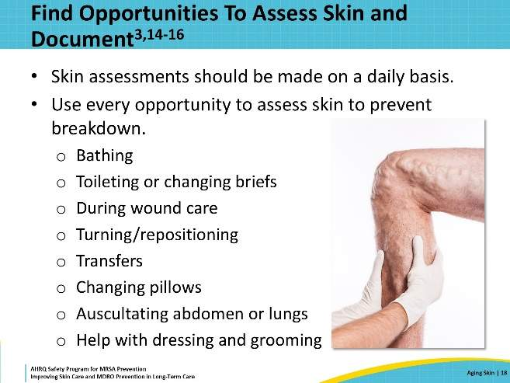
Remember: Regularly Assess Skin  SAY:  Most people have noticed a scrape, small cut, or bruise without remembering how it occurred. This also can happen in older adults. Not only are older adults at greater risk for skin injury, but older adults also require more assistance, particularly with cleaning in between the small, folded skin of wrinkles. Small slips or bumps, which often go unnoticed, can lead to damaged skin. This is one of the reasons why inspecting skin on admission and then daily is very important for the safety of nursing home residents.  Specific areas to check include pressure points such as heels, sacral areas, and elbows. The skin beneath and around medical devices and the skin that is under dressings should also be checked.  Good skin care for nursing home residents is everyone's responsibility. | Slide 19  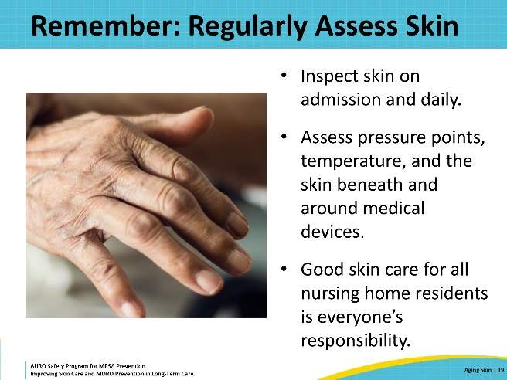
Teachable Moment  SAY:  For the Teachable Moment, this presentation will examine a case study. When going through the case, think about the following questions:  - How do insertion site assessments protect residents’ skin?  - How can all staff members protect residents' skin? | Slide 20  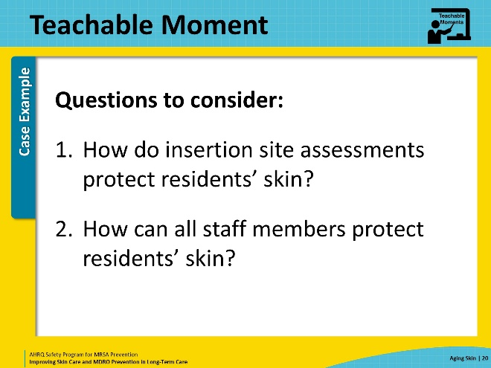
The Case  SAY:  Mrs. Michaels is a 79-year-old resident who just returned from the hospital following a percutaneous endoscopic gastrostomy (PEG) tube placement to assist with correcting malnutrition secondary to malignancy. The PEG tube has now been in place for just over 48 hours. Mrs. Michaels is a familiar resident to the certified nursing assistant (CNA) assigned to her care today. The CNA knows she always receives a shower on her bathing days, and today is her normally scheduled day for bathing. | Slide 21  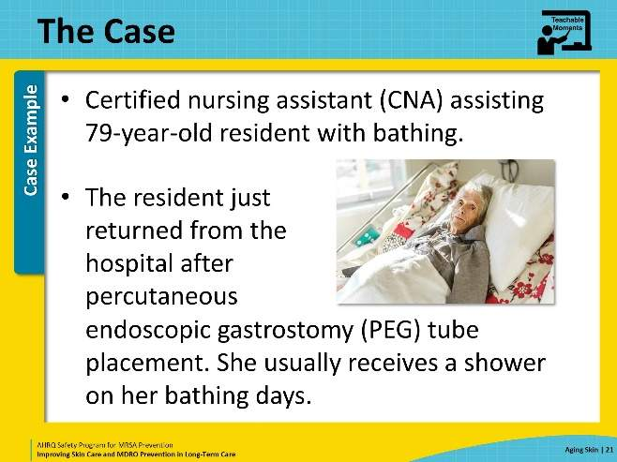
The Challenge  SAY:  Mrs. Michaels is still weak from her extended hospitalization. Although she is normally able to stand with the assistance of only one person, her recent hospitalization has atrophied her muscles. She is receiving physical therapy to help her regain some of her strength. Her PEG tube is also a new device to the facility. Most nurses and CNAs have not previously had to provide care to a resident with a PEG tube, so the nurses and CNAs are not aware that bathing practices must temporarily change following a new PEG tube placement. | Slide 22  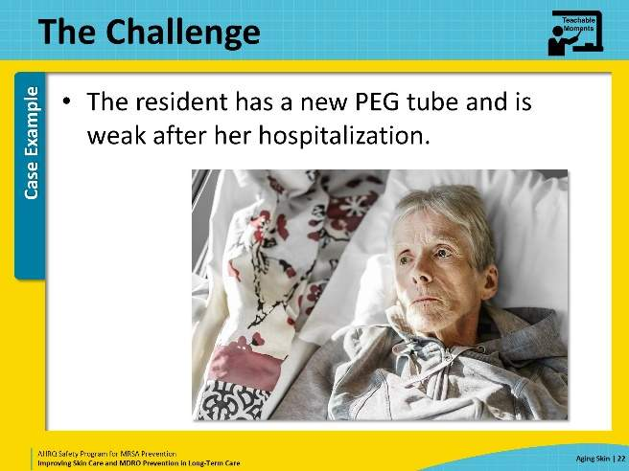
Knowledge Check  SAY:  Would it be more appropriate for Mrs. Michaels to receive a shower, bed bath, or a tub bath following his PEG tube placement?  After PEG tube placement, a resident should avoid taking a shower for 2 days and a tub bath for at least 2 weeks. Mrs. Michaels is also experiencing some acute weakness, which would make her transfer to the shower chair challenging, possibly resulting in a preventable fall. A bed bath would be more appropriate in this situation, while Mrs. Michaels is regaining her strength and healing from her recent PEG tube placement. | Slide 23  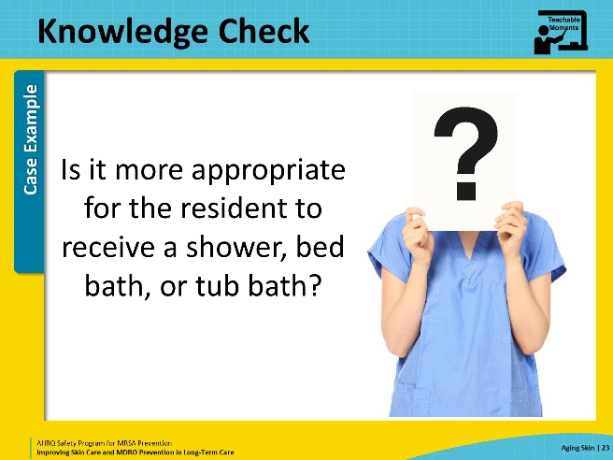
The Error  SAY:  The physician has placed an updated order for this reason, directing that the resident receive a bed bath for the first 2 weeks following her readmission, and has included directions for careful care of the PEG tube and surrounding skin.  The CNA misses this order and proceeds with a shower. The CNA avoids the PEG tube insertion site because of being unsure of how to care for the tube and the site. The resident is rubbed dry with a towel instead of being patted dry. The friction caused by rubbing her skin with a towel causes some of the paper-like layers of skin to separate, causing small skin tears. The CNA does not assess the PEG tube's insertion site and fails to notice the thick white drainage and red appearance of the surrounding skin. | Slide 24  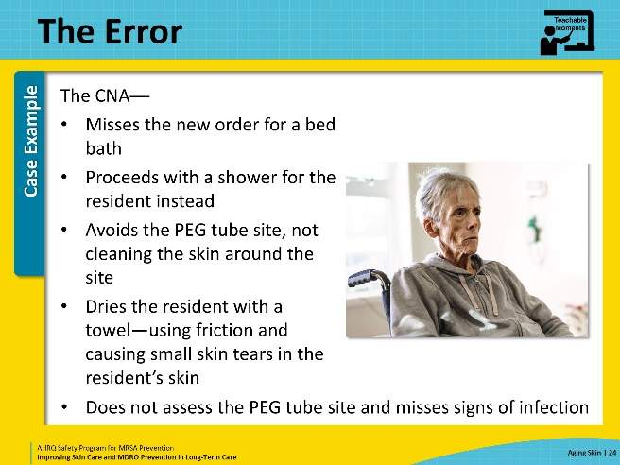
The Consequence  SAY:  The insertion site was already showing signs of infection, but the shower worsened the infection.  The resident develops MRSA peritonitis for which he is in the hospital for several days. His PEG tube has to be temporarily removed, and he falls further behind in his nutrition. | Slide 25  
Patient Safety in the Moment  SAY:  In the moment, the CNA should have checked the resident’s orders around bathing. Additionally, the CNA should have received education about avoiding tub baths and showers for people with recently placed devices.  As a refresher, the staff can refer to the facility's educational materials for nurses and CNAs on the care of medical devices to increase the comfort around caring for a resident with a PEG tube or other invasive medical devices. Even if the order about bathing had not been placed, with appropriate education about devices, the CNA could have initiated a discussion about bathing with nursing and potentially other people involved in the resident’s care.  Finally, had the CNA observed the point of entry for the PEG tube, the CNA would likely have noticed the signs of infection that were already present. This could have helped reduce the severity of what this resident went through. | Slide 26  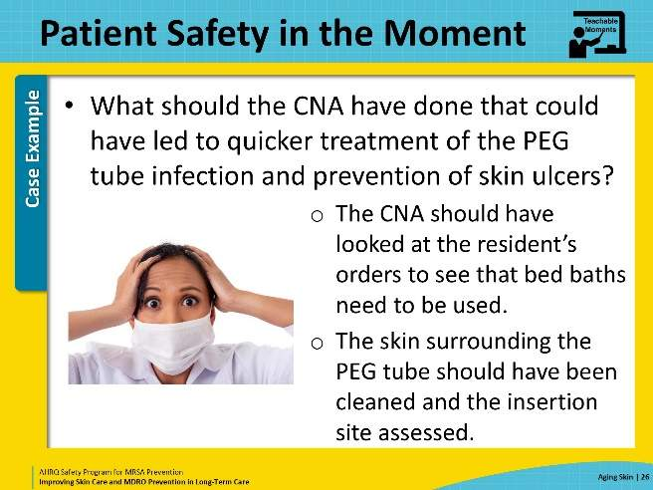
Preventing the Next Harm  SAY:  CNAs need to be empowered to make observations. CNAs can learn what to look for and how to communicate findings by observing from other staff who are licensed to perform skin assessments and to change dressings. This means that CNAs need to feel safe and comfortable asking other people at the nursing home to look at something of concern, even if the CNAs are not entirely sure that there is a problem. Good skin care and preventing skin injuries are “better safe than sorry” situations. | Slide 27  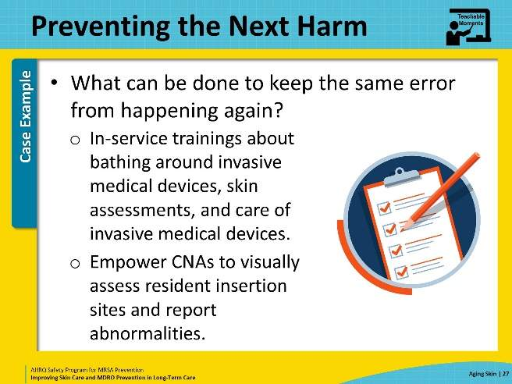
System-Based Safety Changes  SAY:  In thinking about the larger system of care in the nursing home, all clinical staff should have some education and training around skin assessment. This includes both nurses and CNAs, and also includes physical therapists, occupational therapists, phlebotomists, and other staff who interact with residents.  All staff members also need to be aware of and watch for skin changes around medical devices that can indicate problems, such as redness, moisture, and crusting. When those changes are noticed, the resident’s nurse, unit manager, or wound care nurse should be alerted.  Finally, the nursing home administration should work with staff to provide bathing supplies that are kind to aging skin. This includes soft towels and cloths, fragrance-free cleansing agents, and skin moisturizers for after bathing. While these products may cost more than alternatives, the improvements to resident care and safety and the prevention of skin injury are well worth the investment. | Slide 28  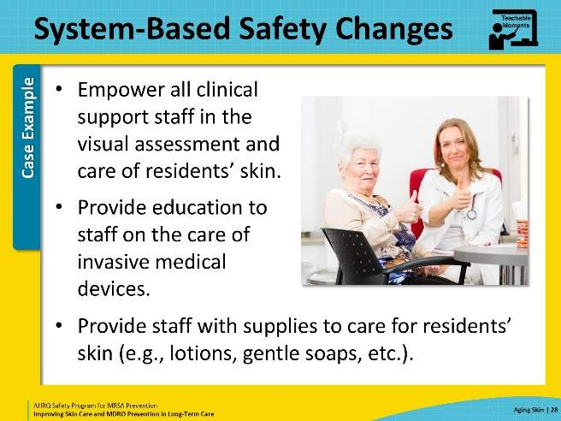
Supporting Materials  SAY:  Some supporting materials to use as a supplement to this presentation include—teachable moments: The Case of the Resident With A PEG Tube, and Enteral Tube Care and Management. Other materials for this presentation include AHRQ’s Safety Program for Nursing Homes: On-Time Pressure Ulcer Prevention and 3M’s Pressure Ulcer/Injury (PU/I) Staging Guide.  These supporting materials can also be accessed on the toolkit website. | Slide 29  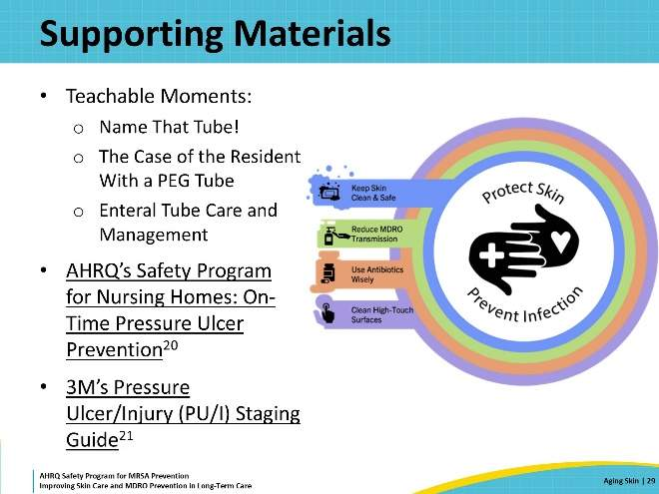
Key Takeaways  SAY:  Key takeaways from skin assessment stress the importance that all staff caring for residents should know how to care for and assess aging skin. Examining the skin and documenting proper skin assessment at least once daily is essential to resident care. Involving the entire care team to perform skin assessments at every opportunity can be a great preventative strategy to identify problems before issues worsen.  Dry skin should be cleaned less frequently, whereas humid areas, such as armpits, under the breasts, or perineal areas, should be cleaned more frequently to prevent SSTIs and injury.  Insertion sites of invasive medical devices are a greater risk factor in aging skin. Care and observation of these devices and the surrounding skin can prevent complications. | Slide 30  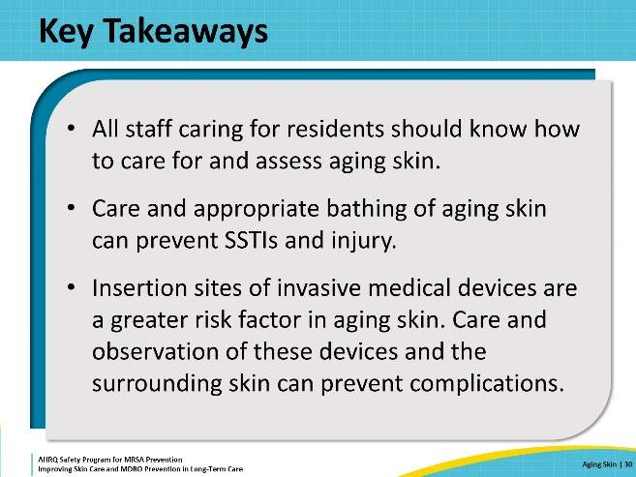
Disclaimer  SAY:  The findings and recommendations in this webinar are those of the authors, who are responsible for its content, and do not necessarily represent the views of AHRQ. No statement in this webinar should be construed as an official position of AHRQ or of the U.S. Department of Health and Human Services.  Any practice described in this webinar must be applied by healthcare practitioners in accordance with professional judgment and standards of care in regard to the unique circumstances that may apply in each situation they encounter. These practices are offered as helpful options for consideration by healthcare practitioners, not as guidelines. | Slide 31  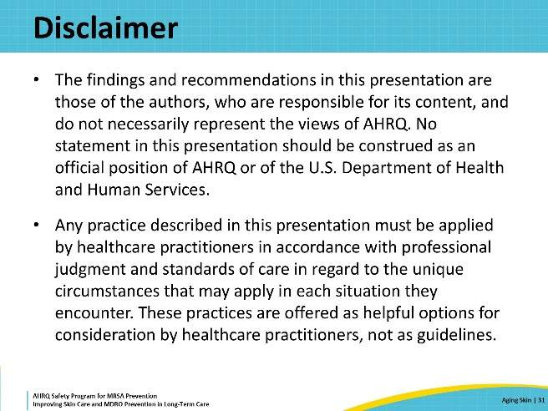
References–1  SAY:  Please take a moment to review the references. | Slide 32  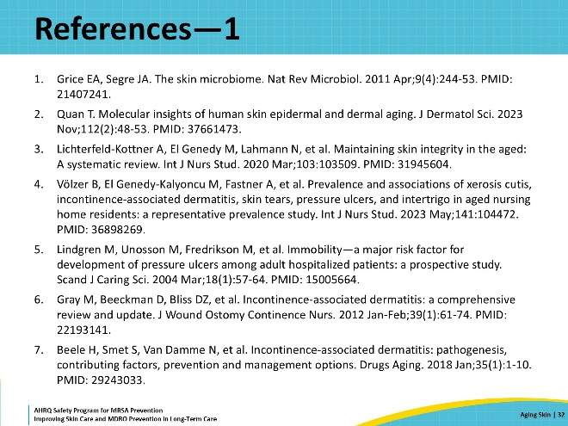
References–2 | Slide 33  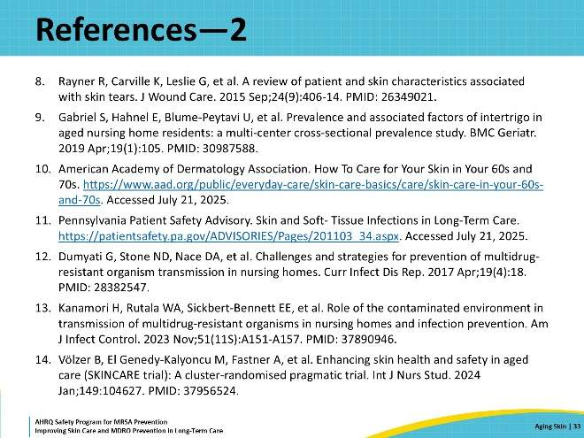
References–3 | Slide 34  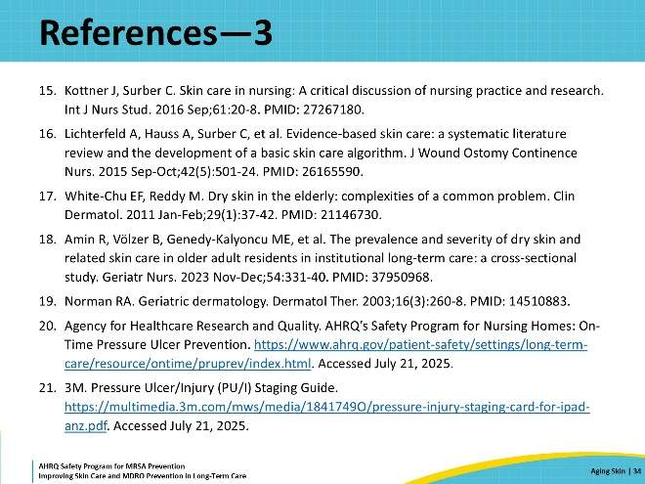
AHRQ Pub. No. 25(26)-0066
October 2025

