The Triangle of Transmission: Understanding Sources and Pathways of Germ Transmission
AHRQ Safety Program for MRSA Prevention
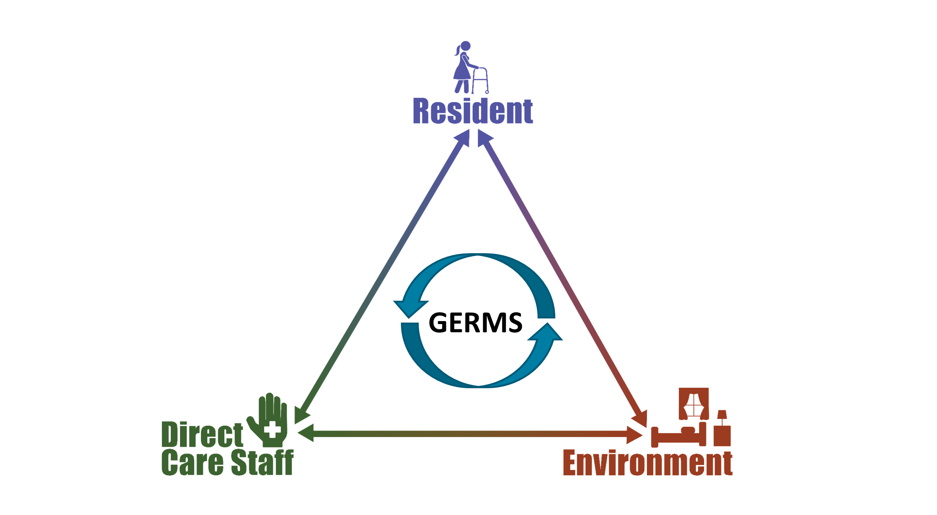
The Triangle of Transmission shows how germs can be spread between direct-care staff, residents, and the environment. Think of each side or leg of the triangle as a two-way street.

Germs can be bacteria, yeast, and viruses that live in and on us. They can travel in either direction on the triangle, spreading between residents, staff, and the environment.
- Germs can spread between residents and staff
- Germs can spread between residents and the environment
- Germs can spread between staff and the environment
When germs move along the sides of the triangle, people can get sick. The more a germ (e.g., bacteria, yeast, or viruses) can move along the different sides of the triangle, the greater the risk of spreading that germ.
Interventions such as hand hygiene, personal protective equipment, and environmental cleaning can disrupt movement along the triangle and break the chain of transmission.

AHRQ Pub. No. 25(26)-0066
October 2025

