Triangle of Transmission:
Residents as Reservoirs for MDROs
AHRQ Safety Program for MRSA Prevention
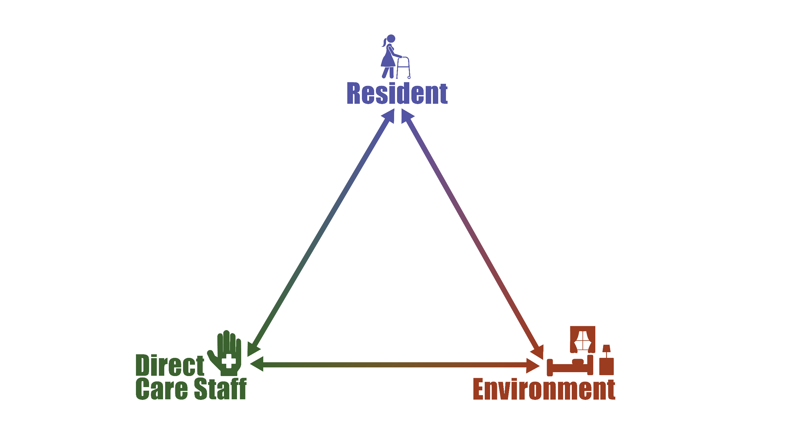
Residents who are infected or colonized with multidrug-resistant organisms (MDROs) or Clostridioides difficile are reservoirs for these organisms. These germs are found on their skin and in their stool, urine, sputum, and wounds. Residents may harbor MDROs for weeks or months, even years. Even after treatment for an infection, the organism causing the infection is likely not gone. Repeated testing for these organisms is laborious and can have false negatives.
Direct care staff should wear a gown and gloves when performing high-contact activities in the room of a resident who is known to have an MDRO or is at increased risk of being on enhanced barrier precautions. Some examples of risk factors for MDRO acquisition include C. difficile infection, acute diarrhea, excretions, draining wound, recent hospitalization or antibiotic use, such precautions should be implemented to further prevent the spread of MDROs and other pathogens.
Once a resident is known to have an MDRO, even if it is not making them sick, they still have the potential to spread the germ into the environment, to healthcare workers providing care, or to other residents. The environment around individuals harboring MDROs or C. difficile is often contaminated by these germs. Cleaning the environment appropriately is an important way to control the spread of the bacteria and other infectious pathogens.

