Triangle of Transmission: Norovirus
AHRQ Safety Program for MRSA Prevention

This teachable moment explores a virus that is common to nursing homes—norovirus. This virus causes vomiting and diarrhea. It moves easily in all directions on the triangle, which makes its spread difficult to control. The infection usually only lasts a few days, but norovirus can make people very sick.
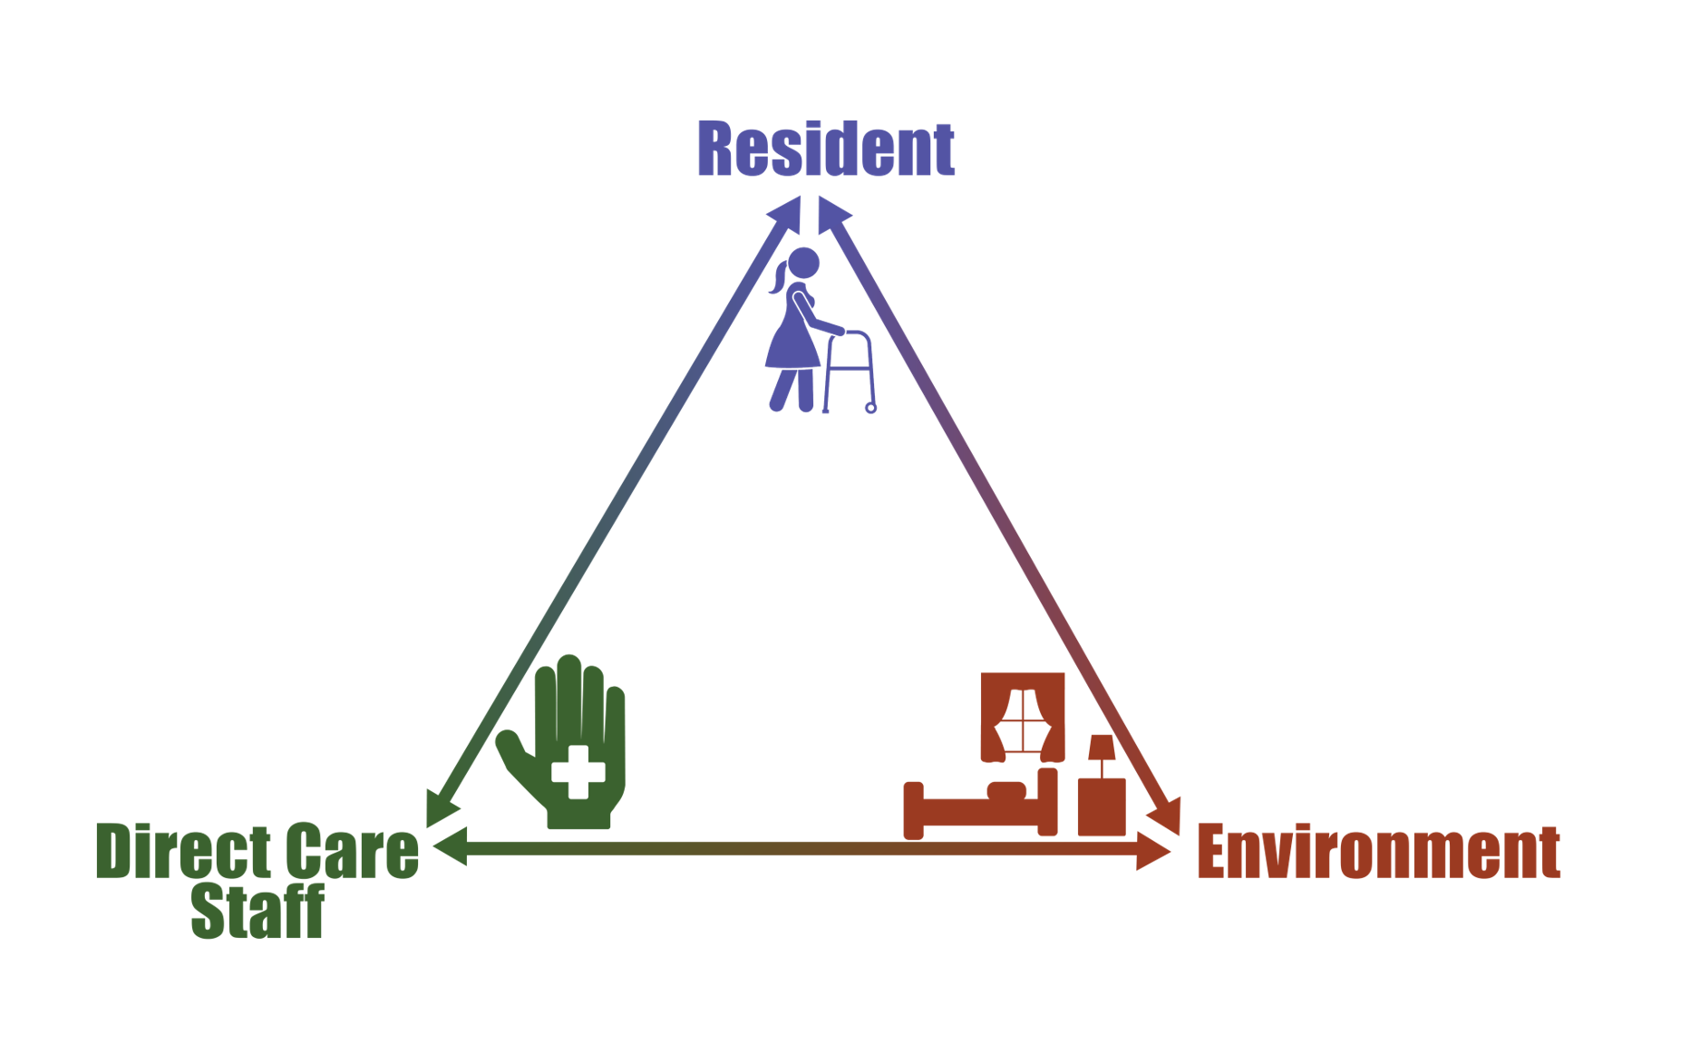
Individuals infected with norovirus shed virus particles in their vomit and stool. People can get sick by either eating contaminated food or touching their face and mouth with their hands after touching contaminated environmental surfaces, like the break room door handle.

Interventions To Control a Norovirus Outbreak
- Staff who are not feeling well are sent home and should not return to work until 2 days after their symptoms resolve.
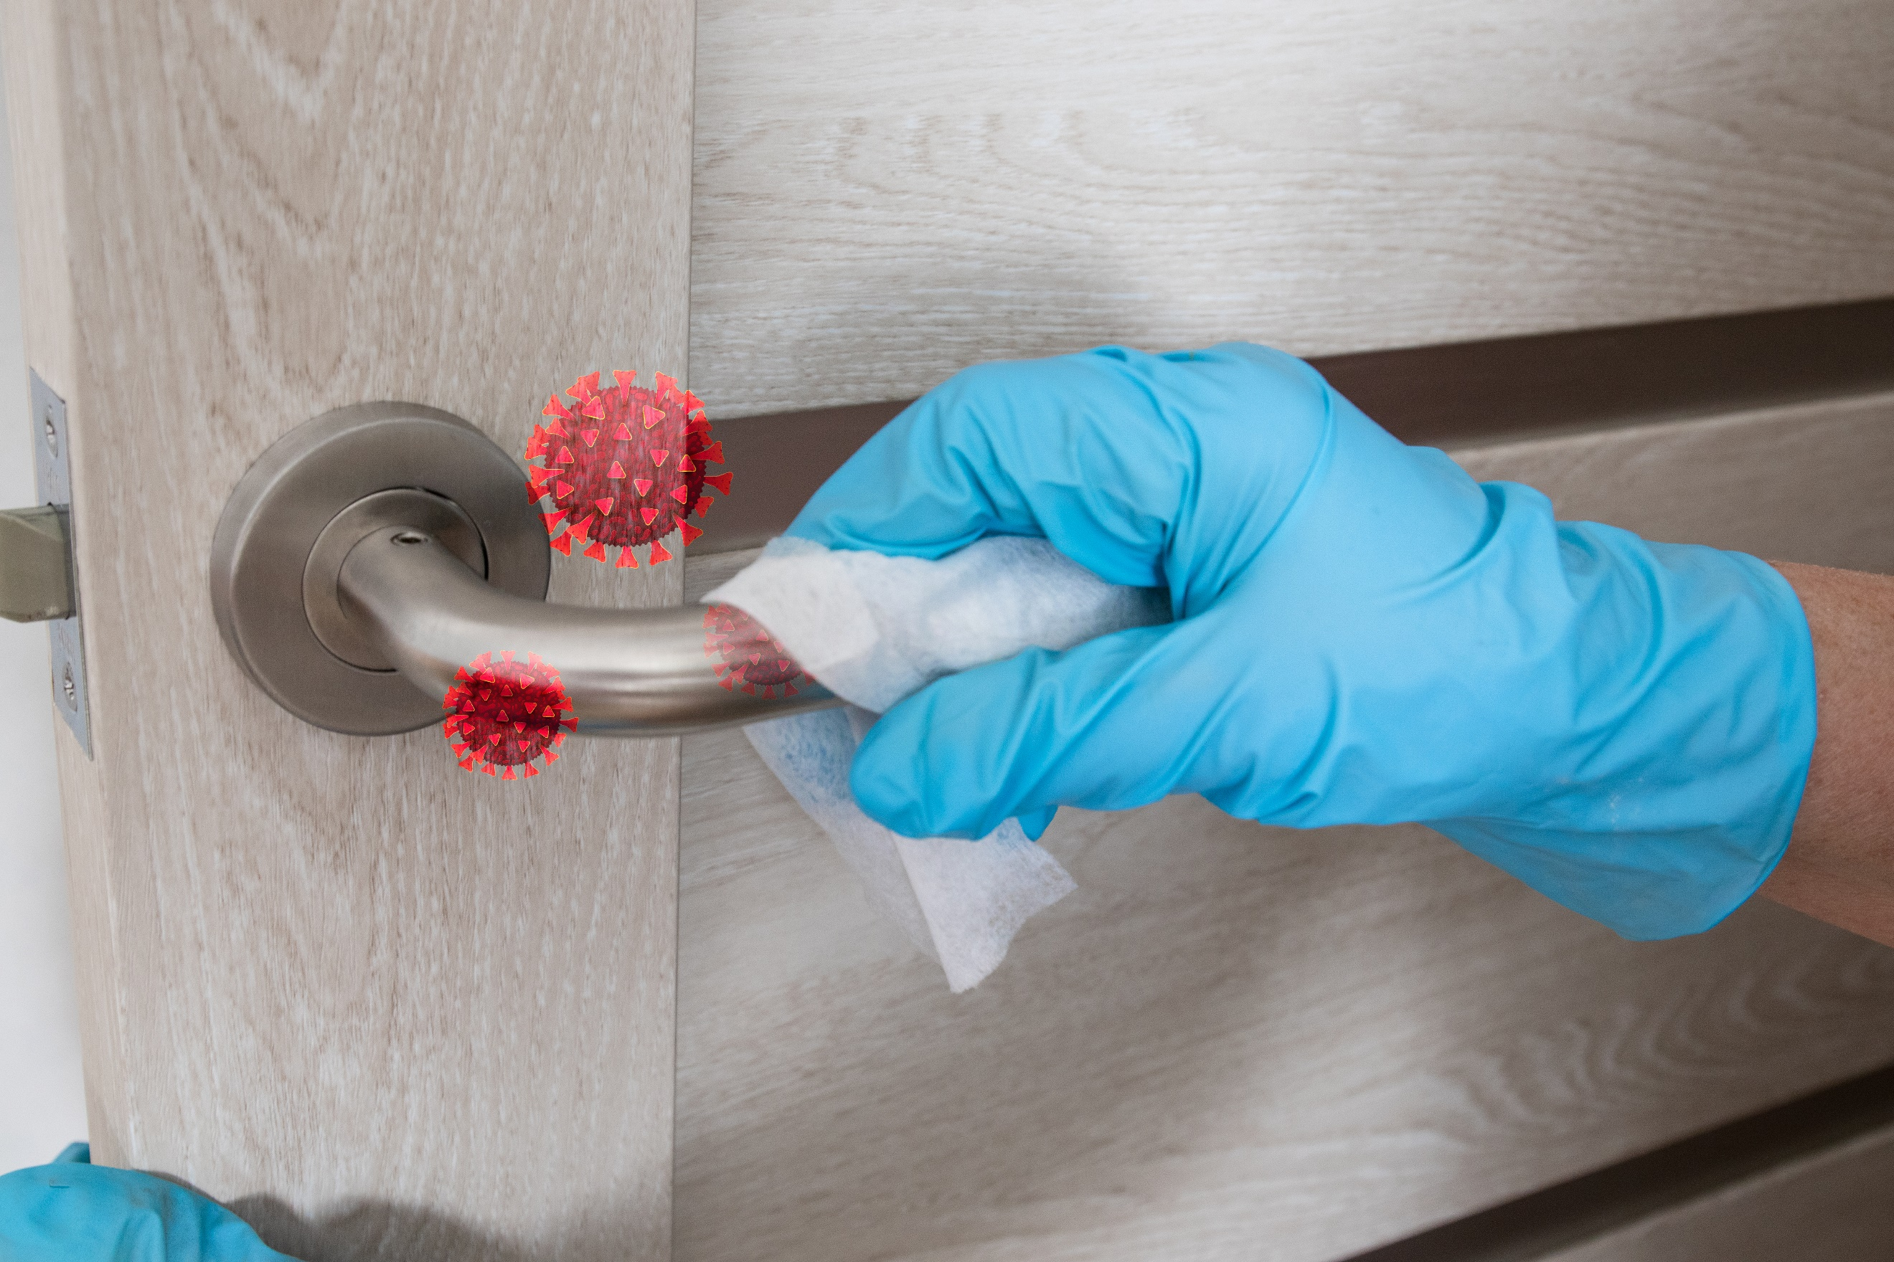
- Residents who are sick are put on contact precautions, which include having them stay in their rooms and requiring staff who enter the room to wear a gown and gloves.
- Environmental services staff members should perform extra cleaning and may use different cleaning agents and techniques.
- Hand hygiene should be emphasized to reduce the spread of norovirus from contaminated hands.

AHRQ Pub. No. 25(26)-0066
October 2025

