“This Is the Way We Wash Our Hands”

Hand Hygiene
AHRQ Safety Program for MRSA Prevention
Slide Title and Commentary | Slide Number and Slide
“This Is the Way We Wash Our Hands” Hand Hygiene  SAY:  Welcome to this presentation on Hand Hygiene, “This Is the Way We Wash Our Hands.” This webinar will review hand hygiene with an emphasis on helping to ingrain this important task into the culture of your workplace. | Slide 1  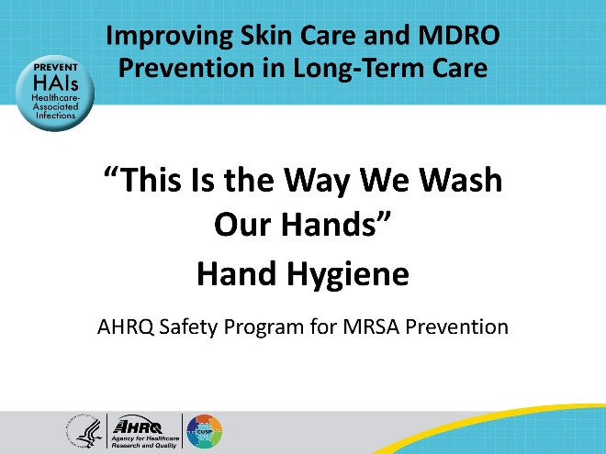
All Staff Support Resident Care and Safety  SAY:  The information provided in this presentation is important in the care of long-term care (LTC) residents. In LTC facilities each member of the facility’s staff supports resident care and safety. Some actions described in these presentations may not be in your scope of practice, but it is important to learn how all staff contribute to resident care and safety. | Slide 2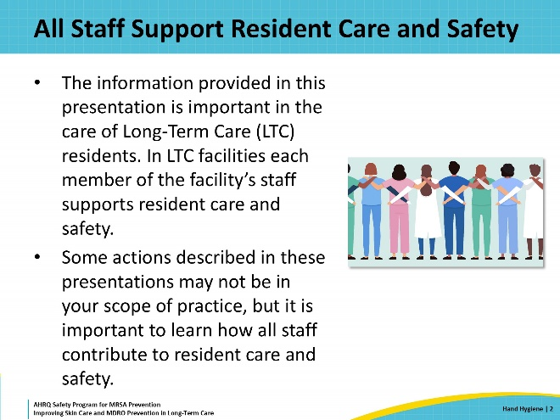
Educational Objectives  SAY:  At the end of this presentation, viewers will be able to describe when to perform hand hygiene using alcohol-based hand rub or using soap and water. They will also recognize the 5 Moments for Hand Hygiene during resident care, and they will be able to discuss system-based solutions for improving hand hygiene in their facility.  Hand hygiene is part of the focus of this program to protect skin and prevent infection. It fits into the section on “Reduce MDRO Transmission” on this graphic. The other sections include: “Keep Skin Clean and Safe,” “Use Antibiotics Wisely,” and “Clean High-Touch Surfaces.” Topics related to these sections are covered in other presentations. | Slide 3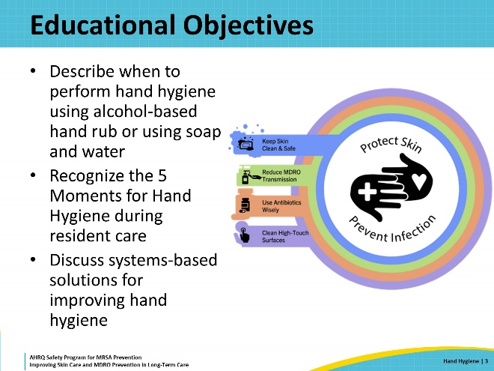
Poor Hand Hygiene in Nursing Homes  SAY:  What is going on with hand hygiene in long-term care facilities? A study conducted in eight U.S. Department of Veterans Affairs (VA) nursing homes examined general infection prevention practices performed by direct care staff. The study examined 4,325 visits into the rooms of nursing home residents. Overall compliance for hand hygiene upon entry into the residents’ rooms was less than half of the visits. Direct care staff did better when leaving residents’ rooms, performing hand hygiene about two-thirds of the time. Even so, this is an alarmingly low rate for something so important to patient safety. The study did not evaluate how well staff performed hand hygiene during resident care within the room.  We should note that VA nursing homes are well-stocked and well-staffed. Compared with community nursing homes, where staff turnover is common, staff at VA nursing homes typically stay for a long time, which means there is strong institutional memory and consistency on performing tasks. Simply stated, these numbers describing compliance with hand hygiene are likely better in VA nursing homes when compared with many non-VA nursing homes. | Slide 4  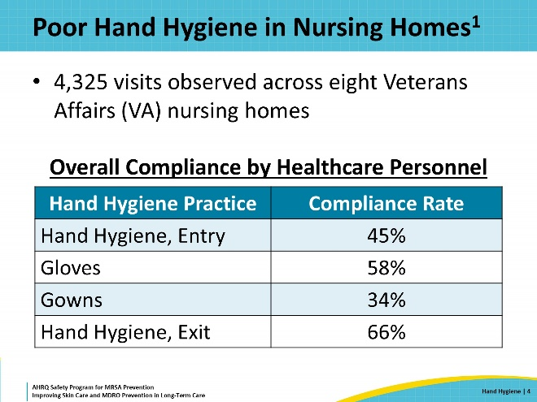
Key Ideas for Staff  SAY:  The importance of hand hygiene for patient and resident safety cannot be overstated. Clean hands save lives.  The next several slides discuss important aspects of hand hygiene for direct care staff working in the long-term care setting. Specific slides have a triangle in the lower right corner, indicating that they can be shared with direct care staff during in-service meetings, morning reports, daily huddles, or similar events. | Slide 5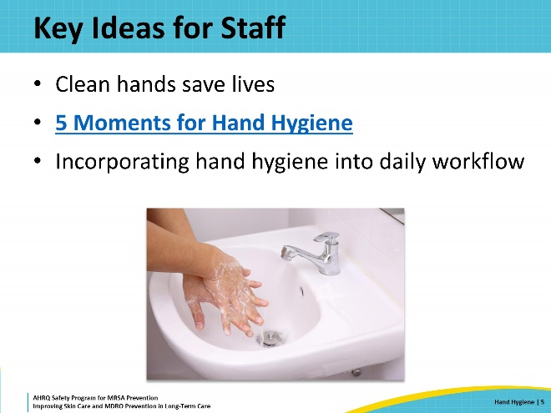
Triangle of Transmission  SAY:  First, let’s review the Triangle of Transmission. The triangle is a model that shows how pathogens that cause infection are spread and transferred among healthcare personnel, residents, and the environment. It also shows important prevention practices that can help prevent the spread of pathogens within long-term care facilities. Hand hygiene helps prevent the spread of pathogens in all three areas: between residents and healthcare personnel, between residents and the environment, and between the environment and healthcare personnel.  Hand hygiene is the single most important method to prevent the spread of infection. Hands can pick up pathogens from other people and from any number of surfaces in the environment. Healthcare personnel can then unknowingly spread those pathogens directly to other residents when touching them during care activities or even when just shaking hands. The hands of healthcare personnel can also spread pathogens to other places in the nursing home, just by touching. The next person that touches that surface is at risk for pathogens being transferred onto their hands. Some commonly touched surfaces are light switches, doorknobs, bedside tables, water faucets on sinks, the keypad to enter utility rooms, and handles on wheelchairs. Office equipment can also be a place where healthcare personnel leave and pick up pathogens. These include keyboards, computer mice, drawer handles, pens, and staplers.  Hand hygiene effectively removes pathogens from hands, and clean hands do not spread pathogens to residents or to the environment. | Slide 6  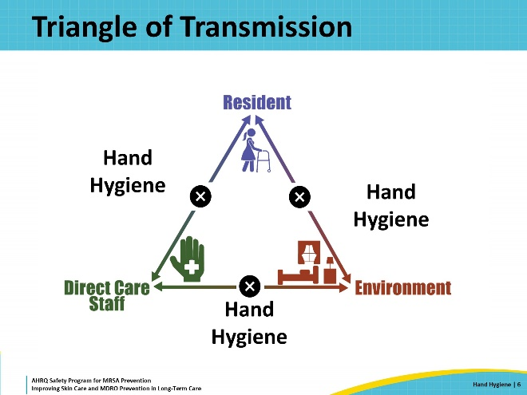
Who Does Hand Hygiene Protect?  SAY:  Hand hygiene protects residents during direct care, other residents in the building, visitors, and healthcare personnel. You are also protecting yourself, which helps you avoid bringing pathogens home to your family and friends. Good hand hygiene removes pathogens and prevents them from spreading and potentially causing an infection. Clean hands care. And, in healthcare settings, clean hands save lives. | Slide 7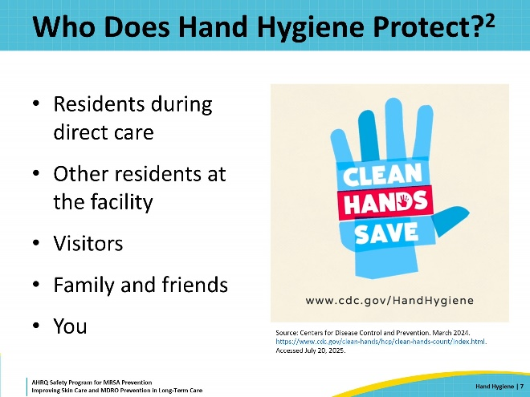
Moments for Hand Hygiene in Everyday Life  SAY:  Because germs are everywhere, there are many moments for hand hygiene in everyday life. Many of these moments, such as before, during, and after preparing food and before and after eating, were learned in childhood.  Other well-known moments for hand hygiene include after using the toilet and after blowing your nose, coughing, or sneezing.  Additionally, hand hygiene should be performed after touching an animal or animal waste, and after touching garbage. These moments of hand hygiene are second nature because we grew up practicing them. In healthcare settings, there are additional moments for hand hygiene. | Slide 8  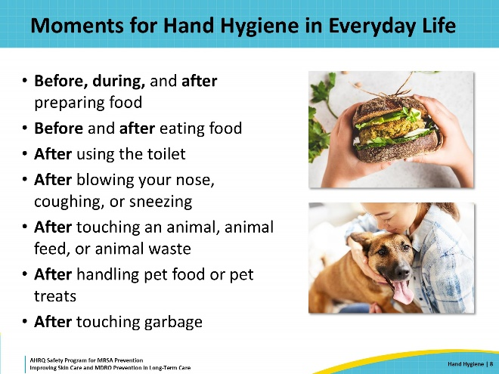
5 Moments for Hand Hygiene in Healthcare  SAY:  Hand hygiene is performed when providing resident care to ensure that pathogens are not accidentally spread in the healthcare environment. Remembering these 5 Moments for Hand Hygiene can help healthcare personnel reduce the opportunity to infection in residents, visitors, and their families.  The first moment is before the healthcare worker touches a resident, to prevent the transfer of pathogens on their hands to the resident. This is commonly performed either immediately before or on the way into a resident’s room. If there is more than one resident in a room, hand hygiene should be performed when the care is completed for one resident and before starting the care for the next person.  The second moment is before performing a clean or aseptic procedure. This means performing hand hygiene before handling indwelling medical devices like feeding tubes or changing dressings.  The third moment is after exposure to bodily fluids, such as after emptying a urinal or bed pan. It also means performing hand hygiene after handling a urine collection bag or after changing a dressing.  The fourth moment is after touching a resident. This means after assessing or checking vitals or helping residents with activities of daily living, such as dressing or brushing teeth.  The fifth moment is after touching a resident’s surroundings or environment. Germs from the resident are on the environment surrounding the resident. These germs are spread by residents when they touch something or when they cough or sneeze.  Germs are also shed from people’s skin into their environment. So, even if the resident was not in the room and all the staff members did was to change linens or fluff a pillow, they should still perform hand hygiene. This fifth moment is usually performed as the staff member leaves the room. | Slide 9  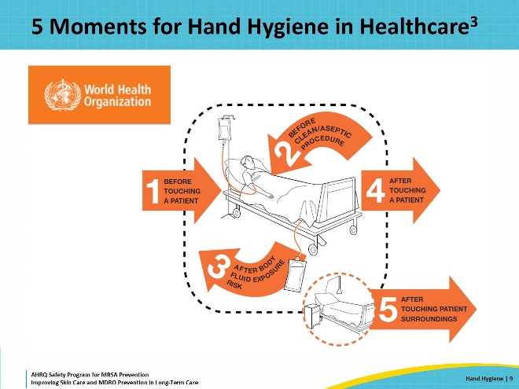
What Do I Use To Clean My Hands?  SAY:  Hand hygiene may need to be performed several times during each resident encounter, even during the care of just one resident.  Sinks are not always convenient to use. For this reason, the Centers for Disease Control and Prevention prefers using alcohol-based hand rub for nearly all hand hygiene moments in healthcare settings. Alcohol-based hand rub, which can also be called hand sanitizer, is more effective at killing pathogens than soap.  Alcohol-based hand rub dispensers can be placed in hallways and within resident rooms, so they are easy to locate and use. This makes it convenient to use alcohol-based hand rub when caring for a resident, especially when moving from a soiled to a clean task or when going from the care of one resident to another in the same room. Alcohol-based hand rub also has ingredients that cause less irritation and less drying of skin when compared to soap.  There are times when hand hygiene should be performed with soap and water. The most important time is when hands are visibly dirty. Alcohol-based hand rub kills most bacteria and viruses on hands, but it is not effective at removing things like dirt, food, or body fluids. Removing these things requires soap and running water to wash them off and down the drain. Other times hand washing with soap and water is preferred include after using the restroom, before eating, and after caring for a resident with infectious diarrhea or vomiting. These residents may have an infection with C. difficile or norovirus.  For all other times when hand hygiene is indicated in the healthcare setting, please use alcohol-based hand rub. Rub hands together with hand sanitizer for hand hygiene. Wash them with soap and water when they are visibly dirty. | Slide 10  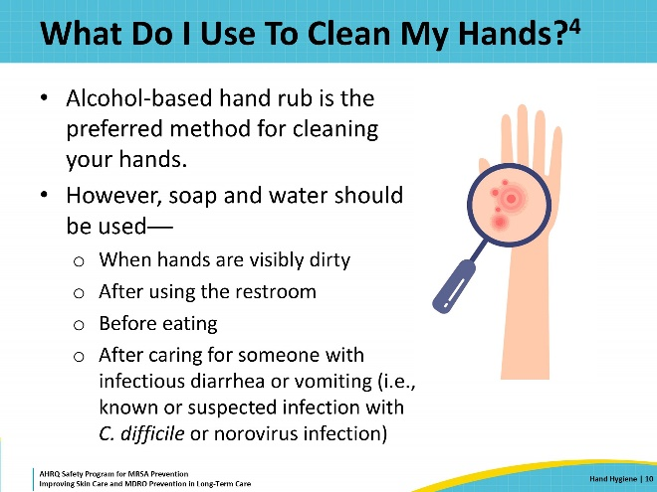
Is There an Easy Rule?  SAY:  One more time: How do I know which way to clean my hands?  Look at it this way. You wash your hands with soap and water if they are visibly dirty. Otherwise, use the alcohol-based hand rub. | Slide 11  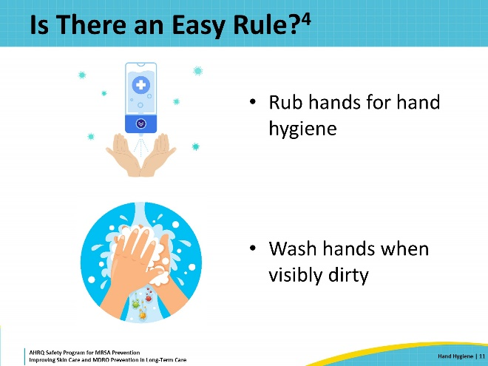
How To Use Alcohol-Based Hand Rub  SAY:  When using hand sanitizer, use enough product to ensure hands are fully covered. Rub hands together, covering all surfaces of the hands and fingers until the hands feel dry. Don’t forget to rub the product between the fingers and on the backs of the hands. Generally, this takes approximately 20 seconds when performed correctly. | Slide 12  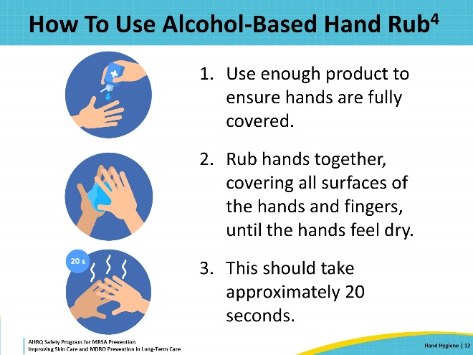
How To Wash With Soap and Water  SAY:  - Wet your hands with clean, running water (warm or cold).  - Apply soap.  - Scrub your hands by rubbing them together with the soap. Lather the backs of your hands, between your fingers, and under your nails. Scrub for at least 20 seconds. Need a timer? Hum the “Happy Birthday” song from beginning to end two times.  - Rinse your hands well under clean, running water.  - Dry your hands using a clean paper towel and then use that towel to turn off the faucet. | Slide 13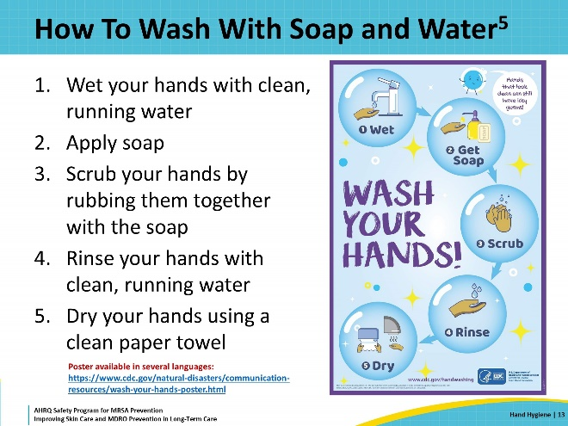
Correct Glove Use Saves Lives  SAY:  Gloves are required when anticipating contact with blood or bodily fluids and for enhanced barrier precautions (EBP) and contact precautions. The purpose of gloves is to reduce the risk of direct care personnel becoming contaminated with a pathogen when caring for a resident. Glove use can also help reduce the spread of pathogens or germs that cause disease, but only when used alongside good hand hygiene. Gloves never replace hand hygiene.  Always perform hand hygiene before putting on gloves. When removing gloves, it’s easy to contaminate your hands with whatever is on the outside of the gloves. So, always perform hand hygiene immediately after taking off your gloves, too.  Just like your hands, gloves can become contaminated with germs. It’s common to have to change gloves during routine tasks when caring for a resident. If a glove becomes damaged, such as if there is a hole in your glove, remove the gloves and perform hand hygiene before putting on a new pair of gloves. If your gloves are visibly soiled or dirty after a task, like cleaning up stool or changing a dressing, remove the gloves, perform hand hygiene, and then put on a new pair of gloves before moving on to the next task. Finally, if you are moving from a “dirty” task to a “clean” task, that’s another time you should remove your gloves and perform hand hygiene before putting on a new pair of gloves.  Examples of going from a soiled site to a clean task are: helping someone change a soiled brief before helping them get dressed or going from changing the dressing on a pressure ulcer to addressing an alarm on an intravenous pump. In both of those cases, the person providing care should remove their gloves and perform hand hygiene with alcohol-based hand rub or soap and water before putting on new gloves for the next task.  Finally, never wear the same gloves in the care of more than one resident. | Slide 14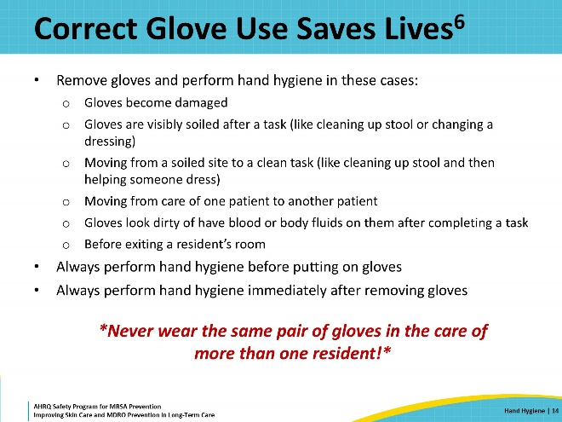
Teachable Moment  SAY:  This Teachable Moment will look at a case in which hand hygiene was forgotten. Hand hygiene sounds simple at first, but it can become complicated and easily be dropped when trying to integrate into a series of busy, everyday tasks. Therefore, it is important to look at hand hygiene as a part of normal workflow.  When reviewing this Teachable Moment, try to keep the following questions in mind:  - Is it OK to leave a resident’s room without removing gloves and performing hand hygiene?  - What are some of the consequences of not removing gloves nor performing hand hygiene when you leave a resident’s room? | Slide 15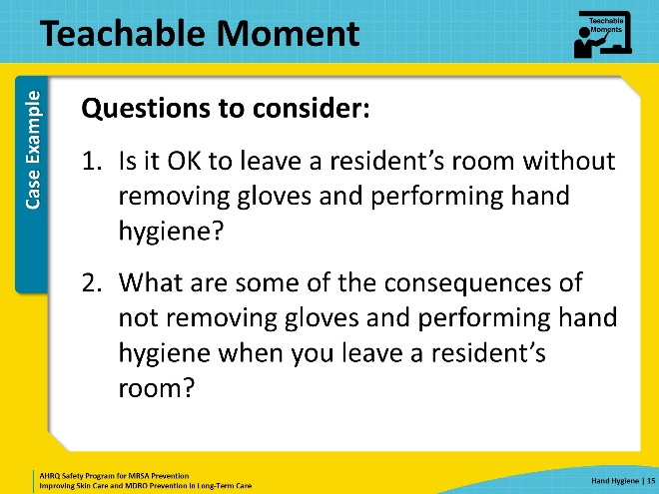
The Case: The Bed Bath Interruption  SAY:  This case involves a resident receiving a bed bath. Mr. Castille is a 74-year-old male resident who is quadriplegic. He relies on nursing aides to help him complete his bed baths. He is also colonized with methicillin-resistant Staphylococcus aureus or MRSA.  The nurse gathers all the supplies for the bed bath before entering the resident’s room. He performs hand hygiene and puts on a gown and gloves before beginning the bed bath. Partway through the bed bath, the nurse realizes he has forgotten the towels needed for drying the resident. To avoid making the resident cold, he quickly leaves the room, grabs the towels from the laundry cart down the hall, and comes back into the room to finish Mr. Castille’s bed bath. | Slide 16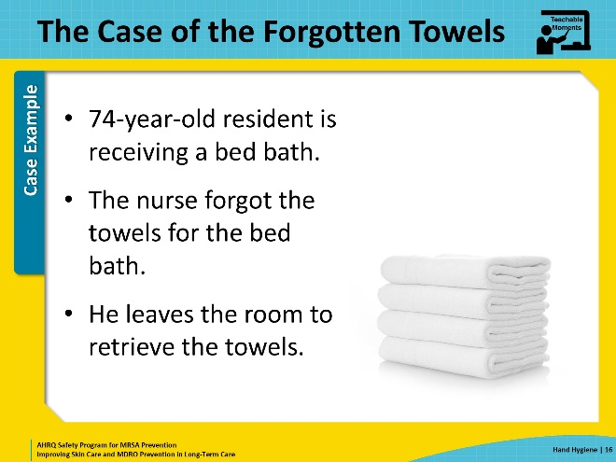
The Error  SAY:  Unfortunately, the nurse did not remove his gloves or gown before leaving the room. He had already touched the resident and started the bed bath when he realized that he had forgotten about the towels. In that short time, his gloves had already become contaminated with bacteria from Mr. Castille’s skin, including the MRSA. When the nurse did not remove his gloves or gown, the MRSA went with him to the laundry cart. He spread the bacteria to the flip-up cover and to the top of the laundry cart. Then, while collecting the towels from the bottom level of the cart, he lost his balance and touched the floor. Germs from the floor joined the others already on the gloves. The nurse re-entered the resident’s room with the towels, still wearing the same gloves and gown. When he continued with Mr. Castille’s bath, the nurse exposed him to new pathogens.  A few minutes later, another staff member used the same laundry cart to get fresh sheets. That staff member got MRSA on her hands when she touched the same places on the cart the first nurse had touched. And now, that MRSA is on the sheets being used to make up another resident’s bed. | Slide 17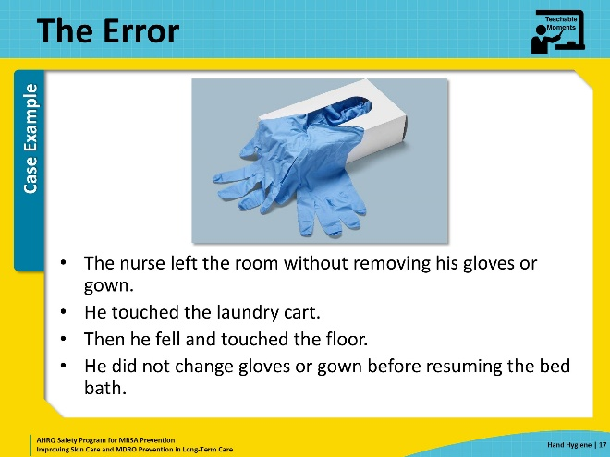
Potential for Patient Harm  SAY:  When someone is in a hurry, the importance of taking the steps that help prevent the spread of pathogens may easily be forgotten. The nurse forgot the towels and wanted to get them quickly to keep the resident warm. Unfortunately, this led to the nurse cutting corners, which can have negative consequences for resident safety.  In this case, MRSA from Mr. Castille’s skin and linens got onto the nurse’s gloves. The nurse did not remove those gloves and perform hand hygiene before he left the room. He then touched surfaces in the environment, including the laundry cart. The transmission of MRSA to the cart led to MRSA-contaminated sheets being used to make up another resident’s bed. That resident got MRSA on her skin and developed an abscess on her thigh over the next week. The abscess grew large enough that she was transferred to the hospital for intravenous antibiotics and needed to have the abscess drained. Due to the pain from the abscess and then the incision and drainage of the abscess, she stayed in bed more and developed a pressure injury over her sacrum. Not surprisingly, that wound became colonized with MRSA.  Looking back at the nurse originally taking care of Mr. Castille, he had picked up resistant Gram-negative bacteria from the floor by the laundry cart when he fell. When he resumed the bed bath, the resistant bacteria were transmitted to Mr. Castille. Two months later, Mr. Castille developed a catheter-associated urinary tract infection with those same resistant bacteria. Because the bacteria are resistant to many medications, he does not get better with the first antibiotic selected for him. He gets sicker and must go to the hospital. | Slide 18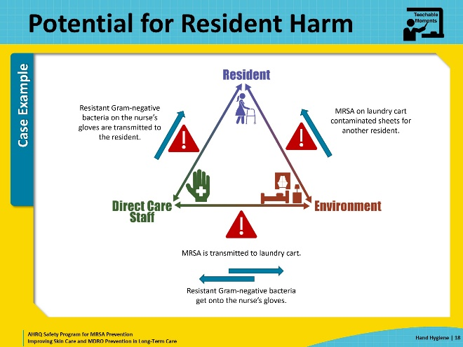
Patient Safety in the Moment  SAY:  The nurse actually missed two opportunities for hand hygiene.  First, he did not remove his gown and gloves and perform hand hygiene after touching the resident and his surroundings. These are Moments 4 and 5 on this graphic.  Second, he should have performed hand hygiene and put on new gloves before resuming Mr. Castille’s bed bath. This is Moment 1.  The nurse should have removed his gown and gloves and then performed hand hygiene before leaving the room. When the nurse lost his balance and touched the floor, he should have recognized the potential for contamination and performed hand hygiene at that point, before handling the clean linens. Then, he should have brought the towels into Mr. Castille’s room, performed hand hygiene, and put on a new gown and gloves. Then he could resume the bed bath. This would have likely added two minutes to the time required to complete the tasks and significantly reduced contamination on the hands.  Another option, and perhaps a better one, would have been to ask for help. The nurse could have asked a co-worker to bring in the towels and place them within easy reach of the nurse. This is probably a better solution as the nurse would not have to leave the resident’s bedside. | Slide 19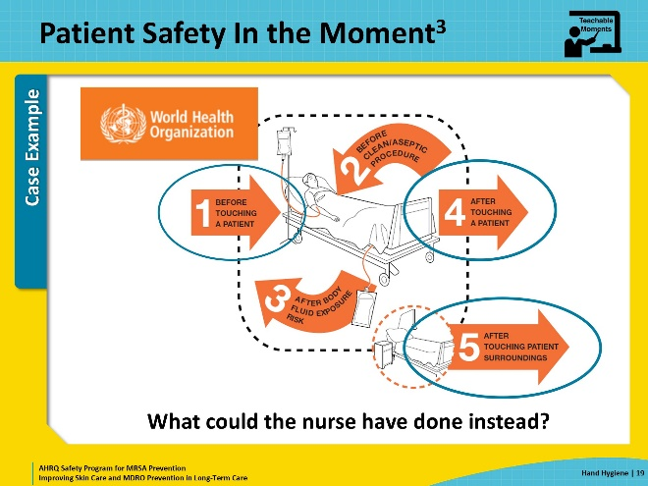
Preventing the Next Harm  SAY:  A key part of resident and patient safety is to think ahead on how to prevent harm to a patient or resident. Once an error or mistake has been identified, what can be done to avoid that same or a similar error in the future? In this example, one unintentional error was forgetting towels, which is perfectly understandable. So, what could be done to prevent such an error in the future? Here are a few approaches.  Checklists are a great way to remember what is needed for routine tasks. Post a bathing supply checklist in the same room there the materials for bathing are kept. If the items needed cannot be stored in the same location, then indicate that on the list. For example, move the towels to the bottom of the list and indicate that they must be picked up from the laundry cart before going into the resident’s room. Thinking about what is on the list and where those items are located may lead to discussions about moving some items into a common area. Preparing for a bed bath will prevent you from having to go on a scavenger hunt later. The supporting materials for this webinar include a sample checklist that can be modified for your building.  Another error in this case study involved hand hygiene. The nurse did not remove his gloves or perform hand hygiene prior to leaving the room to fetch the towels. Perhaps it was not part of his typical workflow, or he didn’t understand the importance of always performing hand hygiene when he leaves a resident’s room. There are several ways to support hand hygiene among staff.  One is to put up posters reminding people about the importance of hand hygiene. Links to material from the Centers from Disease Control and Prevention and the World Health Organization are in the supporting materials. This same content is included in the Teachable Moments tools for this presentation.  The supporting materials also contain a hand hygiene observation tool. That tool can be used to monitor the hand hygiene of staff and ensure that practices are being performed as they’ve been taught. Ongoing feedback should be encouraging and positive. For staff that need remediation, try to learn more about what barriers they are facing. What can be done to make it easier for them to perform hand hygiene?  The approaches described here are largely based on a technical approach that can be implemented by the infection preventionist, nurse managers, or nursing leadership. | Slide 20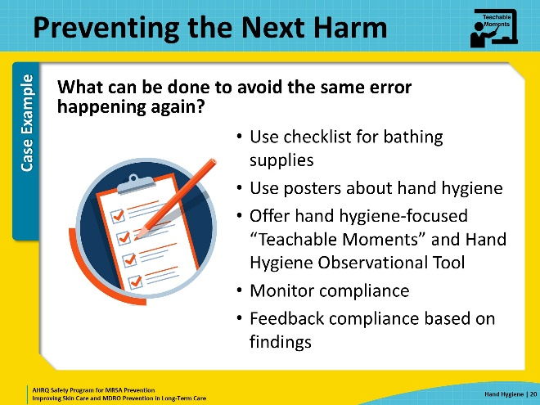
System-Based Safety Changes  SAY:  Some changes require more of a team approach, usually with the support and guidance of leadership. These may involve changes to the culture and even the structure of an institution. These are considered adaptive approaches.  In this case study, the nurse most likely wanted to get back to the resident right away and wound up cutting corners to solve the problem of the forgotten towels.  Perhaps gowns and gloves were in short supply, and the nurse believed he would have been wasting personal protective equipment (PPE).  Maybe the building has only a few alcohol hand rub dispensers, none of which were close to this resident’s room. The physical layout of the building may be such that sinks are not easy to get to because they are far away and can only be accessed by opening a door that is always kept shut or using a keypad entry.  The nurse may not have thought to ask a coworker for help. Or they may have known that the building is very short-staffed and that no one has time to help in situations like this. The nurse may have been behind on their own tasks and may have felt pressure to just complete the bed bath as quickly as possible because he had other tasks to complete during his shift.  These problems are harder for one person to address and require system-based solutions. Leadership may need to communicate that PPE is no longer in short supply. Also, staff need to be empowered to talk with their supervisors about events like this without fear of reprimand. They need to learn to report problems that can be addressed and lead to improved patient and resident safety, while feeling safe doing so.  Leadership may also be useful in setting up the environment to support high hand hygiene compliance. The more available and accessible hand hygiene products are, the easier it will be for healthcare workers to comply with the many moments of hand hygiene. Ideally, alcohol-based hand rub dispensers should be placed outside the door of every resident room, as well as near the dining area, day rooms, therapy areas, workstations, and anywhere else people gather.  Additionally, the nursing home needs to have a staff member who is responsible for both regularly checking and refilling alcohol-based hand rub dispensers and making sure the sinks have enough soap and towels. | Slide 21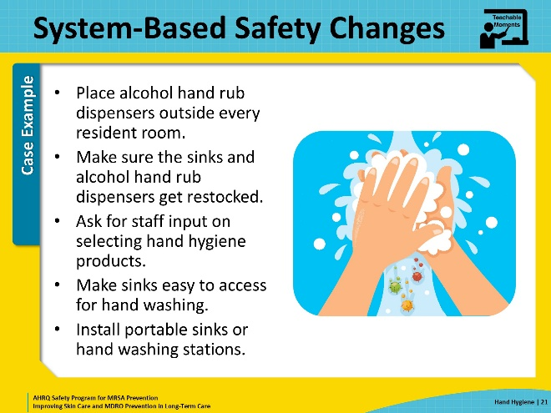
Key Takeaways  SAY:  There are three key takeaway messages from this presentation.  First, good hand hygiene is essential to preventing the spread of pathogens.  Second, where there are errors or problems, stop and think about solutions that can help prevent the situation from happening again, or, to prevent the next harm. Then implement those solutions.  Some of the solutions are technical, like checklists and posters. Other solutions may call for a change in the status quo or the current process at your building. Changes include having more alcohol-based hand rub dispensers and adjusting work assignments to have more staff available during bathing. | Slide 22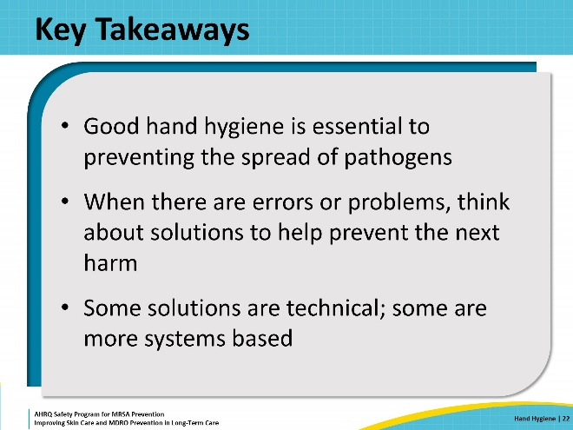
Supporting Materials  SAY:  Additional materials go with this webinar. They can be found on the Hand Hygiene web page. The materials include Teachable Moments: When To Perform Hand Hygiene, Catch Me if You Can!, The Case of the Forgotten Towels, and When You should Use Alcohol-Based Hand Rub or Soap and Water. Other supporting materials include a checklist of supplies needed for a bed bath, a poster regarding the World Health Organization’s 5 Moments for Hand Hygiene, a link to the Clean Hands Count campaign at the Centers for Disease Control and Prevention, and a Hand Hygiene Observational Tool. | Slide 23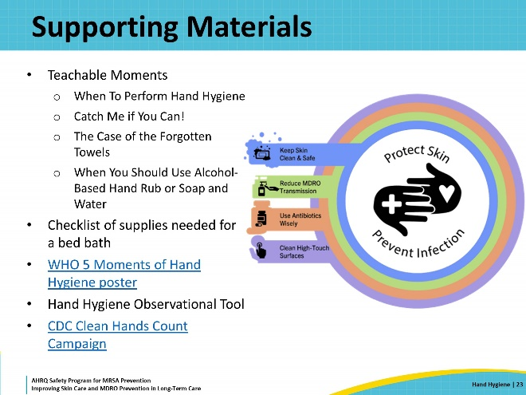
Disclaimer  SAY:  The findings and recommendations in this webinar are those of the authors, who are responsible for its content, and do not necessarily represent the views of AHRQ. No statement in this webinar should be construed as an official position of AHRQ or of the U.S. Department of Health and Human Services.  Any practice described in this webinar must be applied by healthcare practitioners in accordance with professional judgment and standards of care in regard to the unique circumstances that may apply in each situation they encounter. These practices are offered as helpful options for consideration by healthcare practitioners, not as guidelines. | Slide 24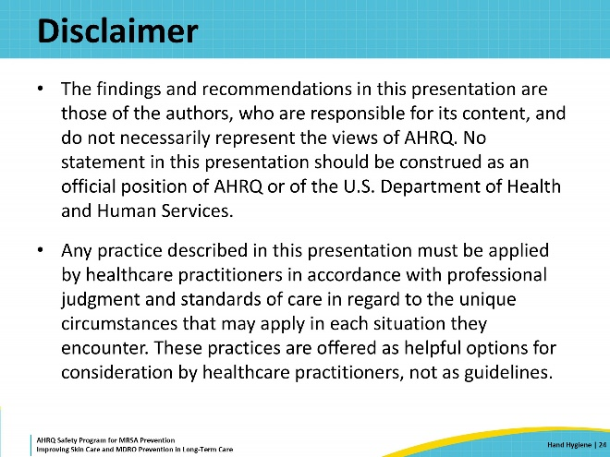
References | Slide 25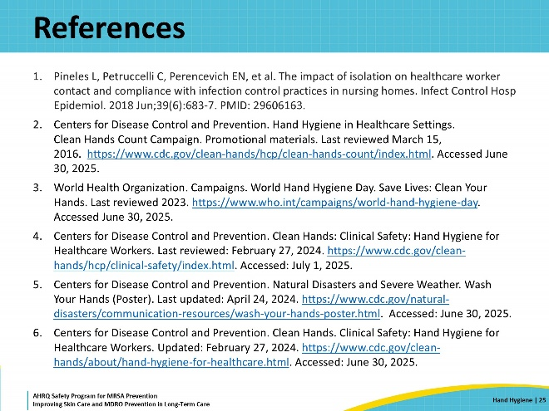
AHRQ Pub. No. 25(26)-0066
October 2025

