Bed Bath Required Supplies
AHRQ Safety Program for MRSA Prevention

This document lists the supplies needed to provide a bed bath. The boxes to the left of the bed bath items provide a way to verify you have all necessary items before entering a resident’s room. Check off each item either in your head or with a pen.
- Four or more soft washcloths or bath sponges
- Three or more towels
- Two wash basins (one for soapy water, one for rinsing)
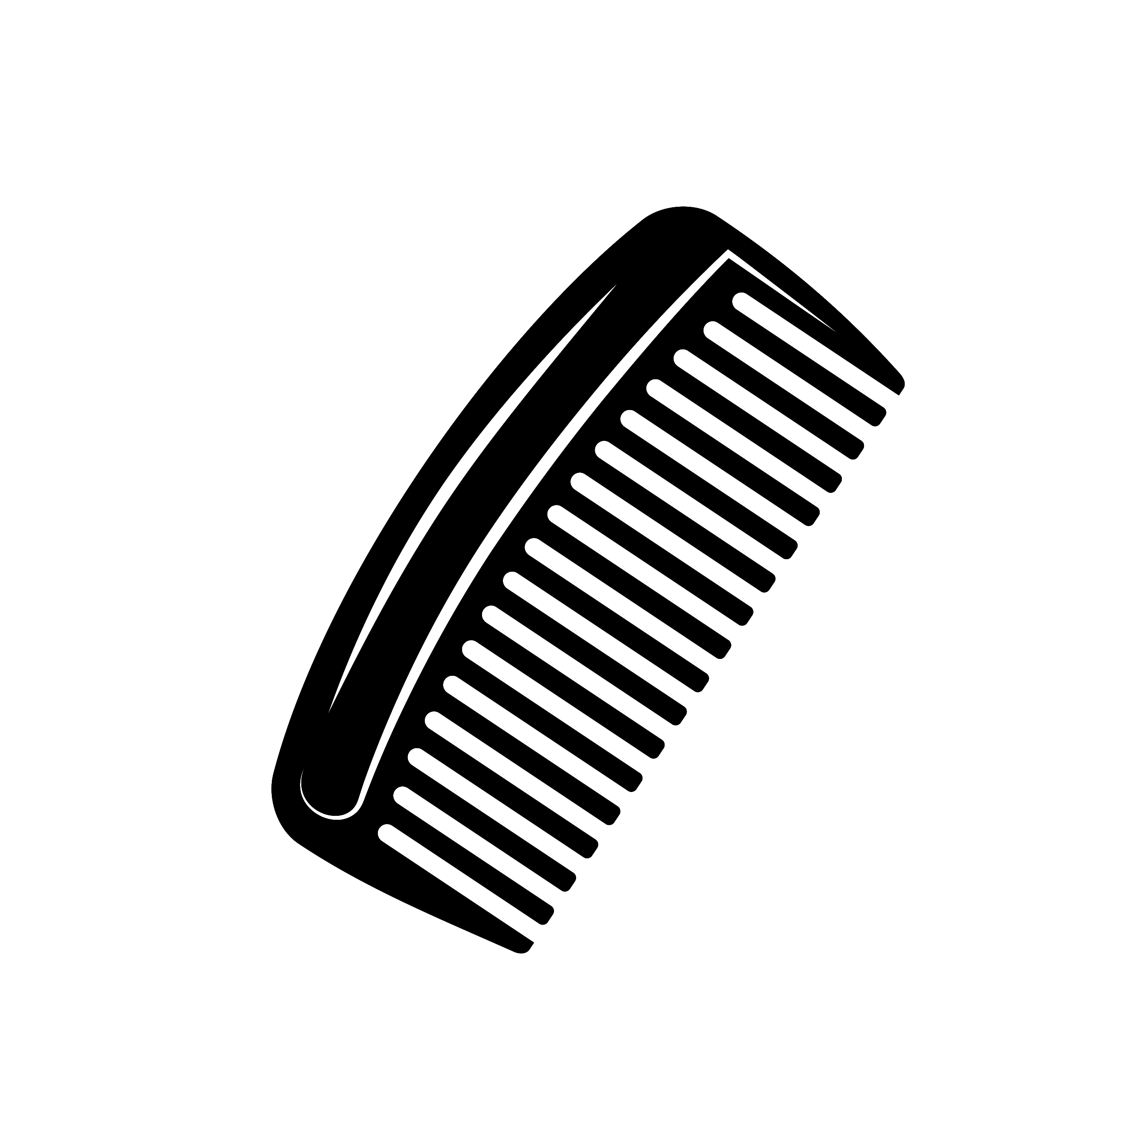
- Soap or a gentle, non-irritating cleanser (a bar of soap, liquid soap, or wipes)
- "No-tears" or no-rinse shampoo
- Body lotion
- Deodorant
- Shaving supplies (if you are planning to shave the patient)
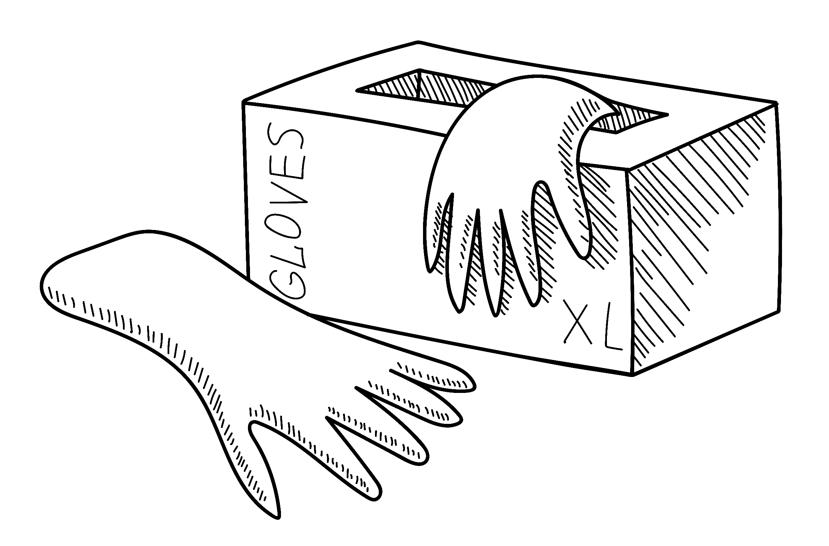
- Comb or other hair care products
- A lightweight blanket
- A waterproof mat or sheet to keep the bed dry
- A table or stand to hold the materials
- Disposable gloves
AHRQ Pub. No. 25(26)-0066
October 2025

