Enhanced Barrier Precautions and Multidrug-Resistant Organism Prevention in Long-Term Care
AHRQ Safety Program for MRSA Prevention
Slide Title and Commentary | Slide Number and Slide
Enhanced Barrier Precautions and Multidrug-Resistant Organism Prevention in Long-Term Care  SAY:  Welcome to the presentation on Enhanced Barrier Precautions, or EBP, and Multidrug-Resistant Organism Prevention in Long-Term Care. | Slide 1  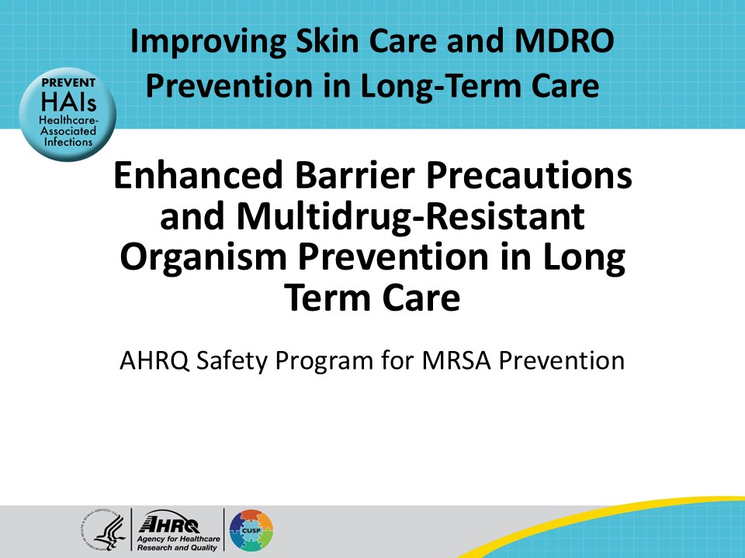
Educational Objectives  SAY:  The objectives of this presentation are to differentiate between colonization and infection; identify novel and emerging multidrug-resistant organisms, also known as MDROs; describe enhanced barrier precautions; and review strategies to prevent the spread of MDROs, such as MRSA. | Slide 2  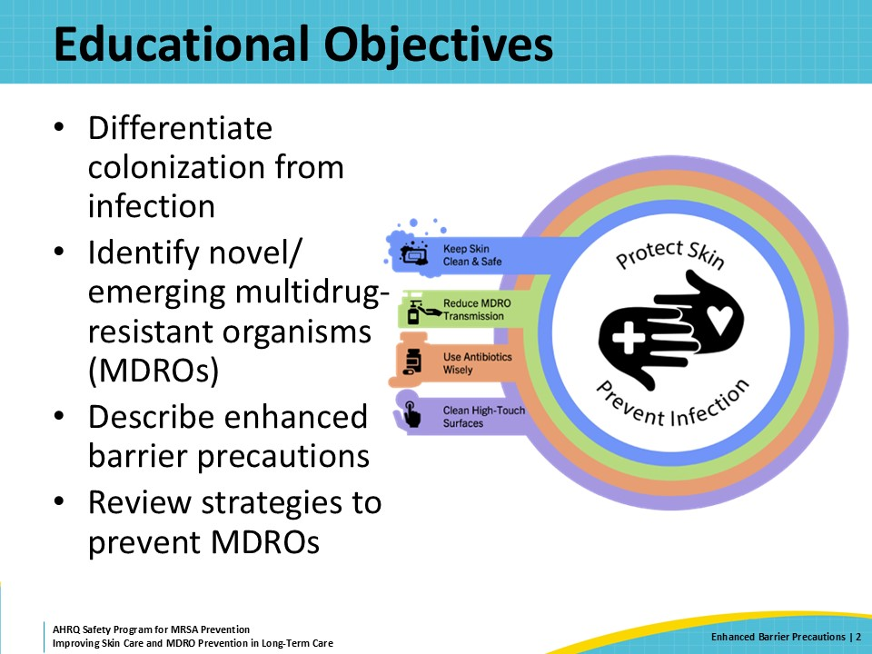
Infection Versus Colonization  SAY:  This slide reviews the difference between infection and colonization.  Infection means someone has a pathogen on their skin or in their body and that pathogen is making them sick. Sometimes people refer to this as an active infection, or an infected wound. A resident with an active infection should get treatment for that infection.  Colonization means that someone has a pathogen on their skin or in their body that is not making them sick. This means that they do not have an infection from these organisms that requires treatment. However, people colonized with organisms can spread these pathogens to others, even though they are not sick. If a colonized person develops an infection, it is likely to be caused by the MDRO they are colonized with. | Slide 3  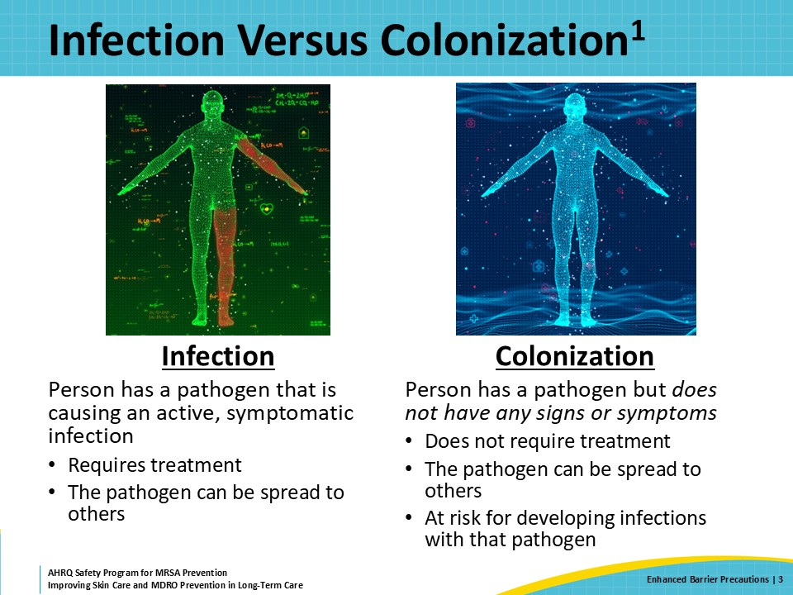
Tip of the Iceberg  SAY:  When a person is sick from an infection, samples of urine, blood, sputum, or wound drainage are collected to isolate the causative organism(s). If the culture grows a bacteria or yeast, further testing is done to identify the pathogen(s) and determine if the pathogen(s) is/are resistant to treatment with specific antibiotics. Once the provider knows which organism(s) is/are causing the infection, the proper antibiotics can be given to the person. Pathogens resistant to several antibiotics are MDROs.  However, infections are just the tip of the iceberg when it comes to MDROs. More than 50 percent of nursing home residents may be colonized with an MDRO. Reviewing the medical record from the hospital or other healthcare facility is an important step to determine if a resident is colonized. Additionally, if the resident had a previous infection with an MDRO it is likely that they are also colonized with that same organism. Some residents may carry an MDRO without knowing it, because testing for these pathogens is typically only done when a person becomes sick.  Unfortunately, people who are colonized with a resistant organism can remain colonized for a long time. People with resistant Gram-positive bacteria may be colonized for weeks to months. People with resistant Gram-negative bacteria may be colonized for years. It is for this reason that infection prevention measures are a vital part of resident care.  It is important to remember that we do not always know which patients are colonized. | Slide 4  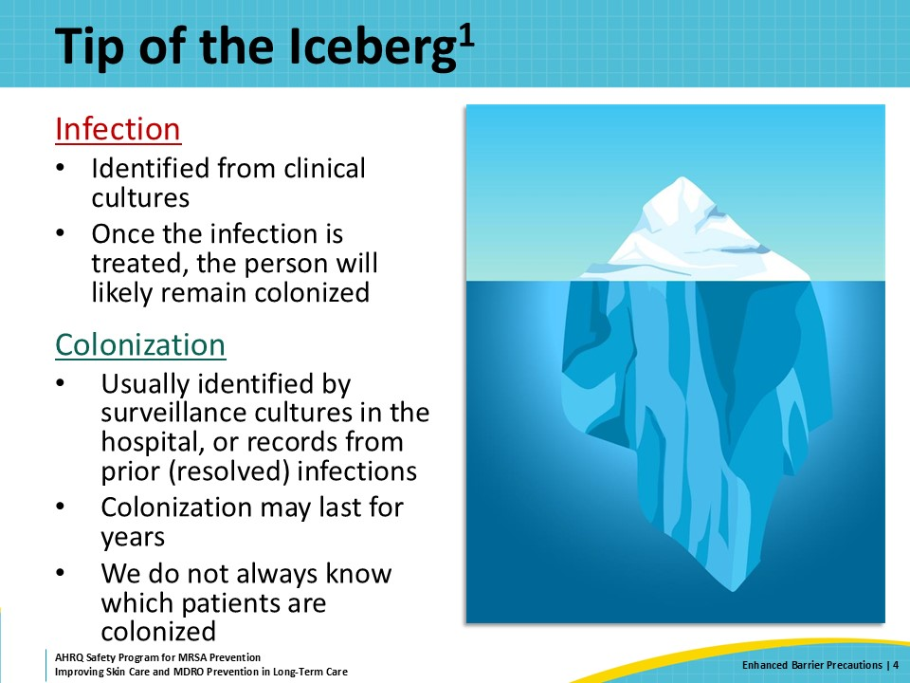
MDROs in Nursing Homes  SAY:  MDROs are organisms resistant to one or more classes of antimicrobial agents that are typically used to treat that organism. If a resident develops an infection from an MDRO, there are limited options to treat the infection. This is why it is important to prevent the spread of MDROs.  Examples of MDROs include methicillin-resistant Staphylococcus aureus (MRSA), vancomycin-resistant Enterococci (VRE), Extended-spectrum beta-lactamase (ESBL-producing bacteria), carbapenem-resistant Enterobacteriaceae (CRE) and some Candida species.  Unfortunately, transmission of multidrug-resistant organisms is common in long-term care facilities. Over 50 percent of nursing home residents are infected or colonized with MDROs.  Because MDRO infections can be difficult to treat, there is an increase in morbidity and mortality of residents and an increase in healthcare costs associated with treating residents with these complicated infections. | Slide 5  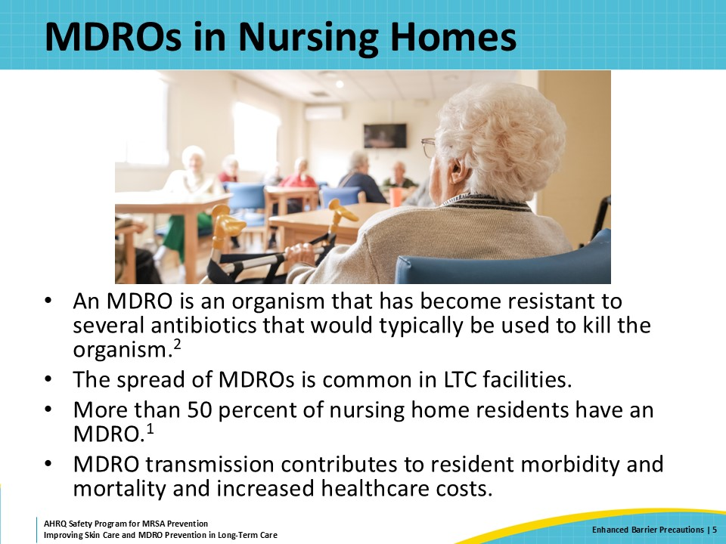
Challenges With Detection of MDROs  SAY:  Colonization does not always need to be treated, but it is helpful to understand who is or might be colonized with resistant organisms.  Like this iceberg, if only what is visible is considered, the prevalence of MDRO-colonized residents in the building will be grossly underestimated. Accurately tracking the MDRO carriage status of residents is a significant challenge for nursing homes. Much of the information about colonization status is lost during transfer to and from the hospital or other facilities. This is why communication is so important across the healthcare spectrum. | Slide 6  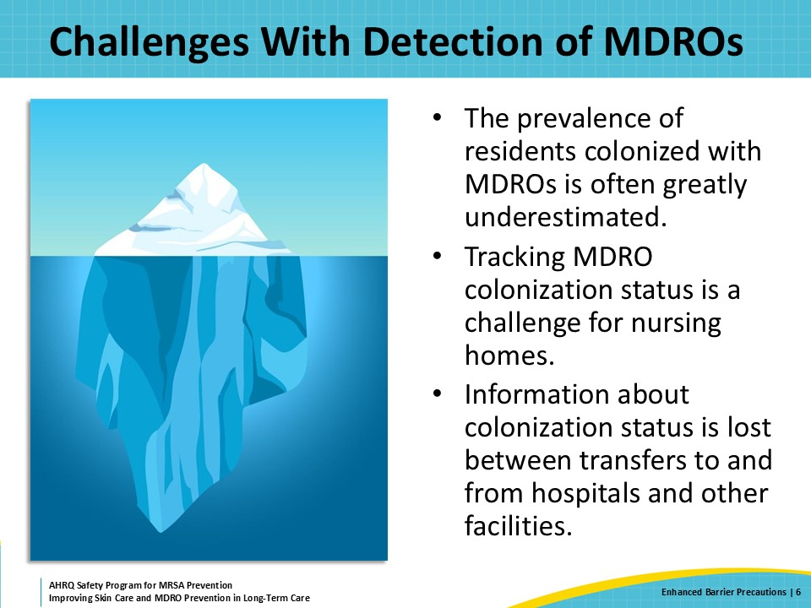
Risks for MDRO Colonization and Acquisition  SAY:  There is an increase in medical acuity and care needs among residents coming to long-term care facilities, especially those requiring postacute nursing and rehabilitation care. Residents with more complex care needs may be at more risk for spreading or acquiring an MDRO. Several risks factors for colonization of an MDRO or acquisition of an MDRO include—  - Inadequate infection control practices such as poor hand hygiene, poor use of isolation precautions, inadequate use of PPE, and poor cleaning of surfaces and equipment used to take care of residents.  - In addition, medical devices, wounds, inappropriate antibiotic use, recent hospitalization, and prolonged length of stay in an acute care facility all contribute. | Slide 7  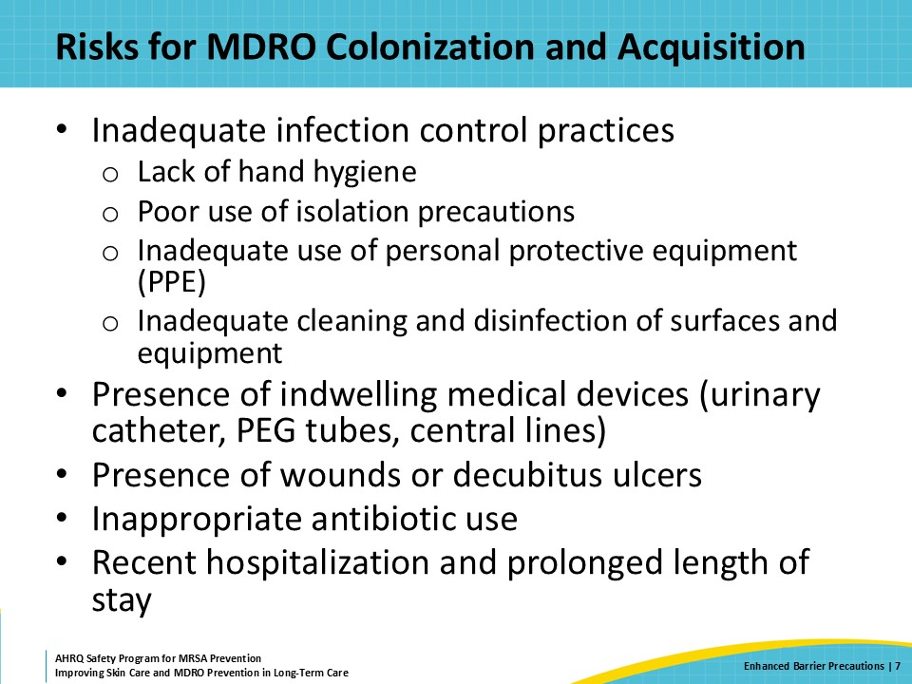
MDRO Prevention: Novel and Core Strategies  SAY:  MDRO prevention is not one single intervention or focus. That’s what makes prevention challenging. It’s the consistent application of all these practices to reduce the risk of transmission for residents with or without MDRO colonization.  These include meticulous hand hygiene, disinfection of shared equipment, antibiotic stewardship, improved interfacility communication on colonization or infection status, environmental cleaning, appropriate PPE and transmission-based precautions, and, potentially, decolonization. | Slide 8  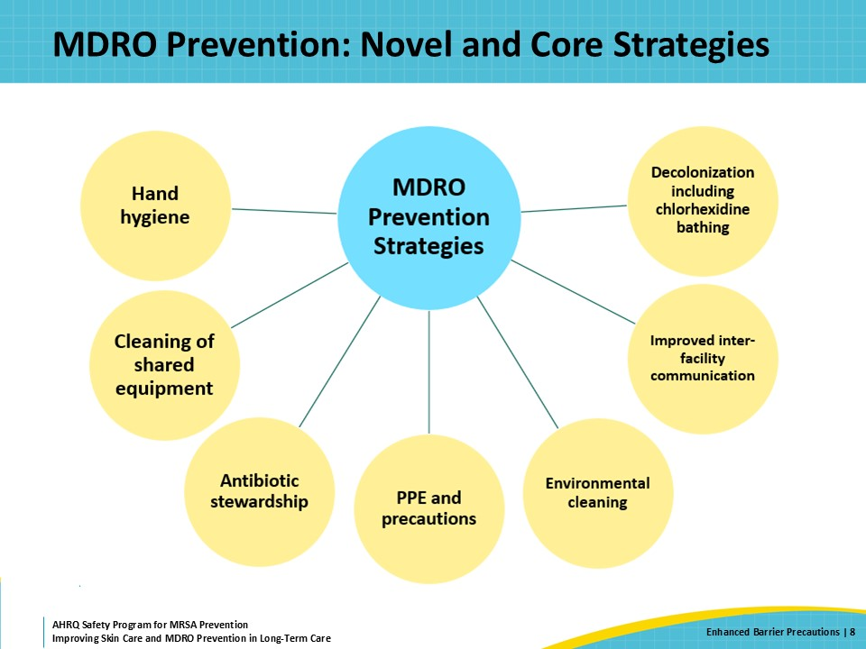
Triangle of Transmission  SAY:  PPE can prevent the transmission of pathogens between residents and direct care staff. PPE may include gowns, gloves, masks, and/or eye protection. PPE protects against the contamination of hands and clothing. Knowing when and how to use PPE is as important as hand hygiene in preventing the transmission of pathogens. Wearing PPE when providing direct care to residents infected or colonized with MDROs is a key factor in the prevention of spread to others. | Slide 9  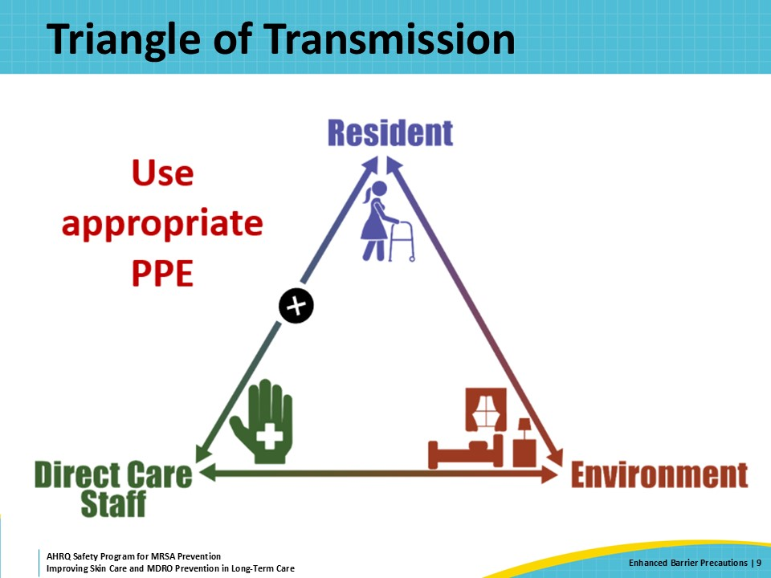
Spectrum of Precautions  SAY:  Recommendations for PPE precautions follow a spectrum based on the risk of transmission. Each has specific actions to prevent the spread of infection. It is important to remember to perform proper hand hygiene prior to entering the resident’s room and after leaving no matter what type of precautions are in place.  Standard precautions are the least stringent on the PPE precautions spectrum. These used to be called universal precautions and are the precautions that direct care staff use with anyone.  Standard precautions are for residents—  - Who have no history of MDRO colonization  - Who do not have open wounds or indwelling devices  The most basic of the standard precautions is to perform proper hand hygiene before entering the resident’s room and after leaving, and wear gloves if there is any risk of encountering blood, other bodily fluids, or skin that is chapped, abraded, has dermatitis, or is otherwise not intact.  Contact precautions are the most stringent and are reserved for residents with active infections such as diarrhea or uncontained draining wounds. When providing care for a patient on contact precautions, first perform proper hand hygiene. Then at a minimum, staff should wear a gown and gloves when entering the room of a resident on contact precautions. When a resident is on contact precautions, they are isolated in their room so that they do not transmit their infection to others.  Contact precautions are for residents infected or colonized with an MDRO who also have either of these conditions:  - active infectious diarrhea  - an uncontained (unable to be covered) or draining wound  Contact precautions also can be recommended by public health authorities in the event of a suspected or confirmed MDRO outbreak.  Contact precautions can typically be removed when an infection resolves, so the resident is not isolated for a prolonged or indeterminate period.  A resident also may be placed on transmission-based precautions known as enhanced barrier precautions. This is usually done for residents who are infected or colonized with an MDRO or have an indwelling medical device.  Enhanced barrier precautions falls between standard and contact precautions. Enhanced barrier precautions were created for the long-term care setting, where residents are expected to stay for prolonged periods but remain at high risk of being colonized with MDROs and developing complications from these organisms. With enhanced barrier precautions, residents are not isolated to their room and can continue to participate in group activities.  Enhanced barrier precautions recommends gown and glove use when performing direct care activities for residents who are at high risk of having or getting an MDRO.  Direct care activities include anything that requires close, personal contact with the resident, or their belongings, such as transfers, toileting, or linen changes.  Residents at high risk for having and getting an MDRO are anyone with an indwelling device or an open (but contained) wound. In-dwelling devices include urinary catheters and central lines—such as peripherally inserted central catheters or PICC lines, and many others. Residents with a previous infection due to an MDRO are also considered high risk for colonization with an MDRO. | Slide 10  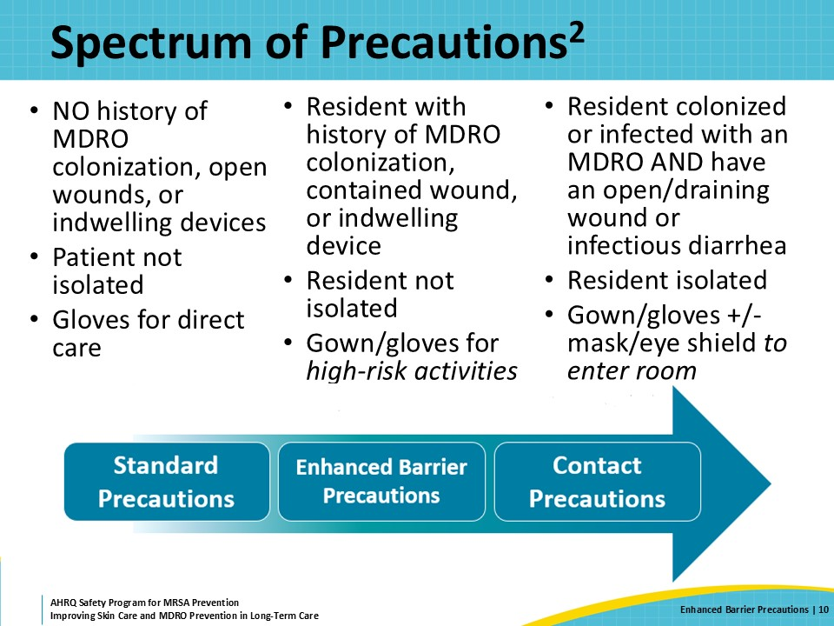
Enhanced Barrier Precautions  SAY:  Enhanced barrier precautions were created specifically for the long-term care setting to balance preventing the spread of resistant organisms with the resident's quality of life.  A key part of enhanced barrier precautions is understanding that a resident's MDRO status may not always be known. Therefore, any resident at risk for having or acquiring an MDRO is placed on enhanced barrier precautions. Residents with indwelling devices and wounds are at high risk of being infected or colonized with an MDRO. If they are colonized, using enhanced barrier precautions helps prevent that MDRO from being spread to others. It is also important to note that if the resident is NOT colonized with an MRDO but is at risk of acquiring one, using enhanced barrier precautions can prevent them from acquiring one.  It is still important to know a resident’s microbiological history as this is part of their medical history. But enhanced barrier precautions means that we don’t need to keep in mind each resident’s microbiological history when they need help brushing their teeth or getting dressed. Rather, we know that using gowns and gloves during close contact with residents at high risk for having or getting an MDRO helps prevent MDRO transmission. | Slide 11  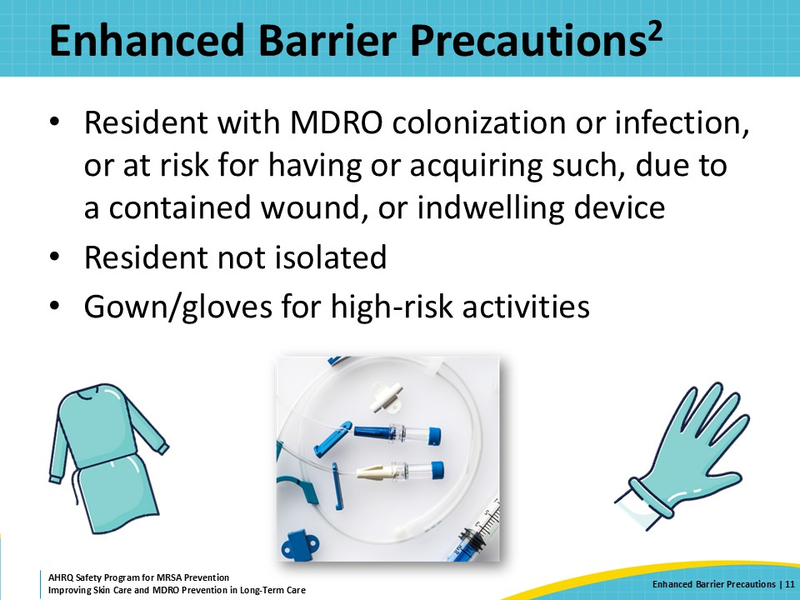
Why Are Enhanced Barrier Precautions Important?  SAY:  Enhanced barrier precautions are less stringent than contact precautions. Residents on enhanced barrier precautions may continue to socialize with others outside of their rooms. This reduces the social isolation and the stigma that residents may experience when placed on contact precautions.  When residents are in their room and receiving personal or direct care, staff should wear PPE. The rationale for this comes from studies showing that direct care activities, such as helping someone dress or bathe, are associated with the transfer of pathogenic bacteria to healthcare workers. | Slide 12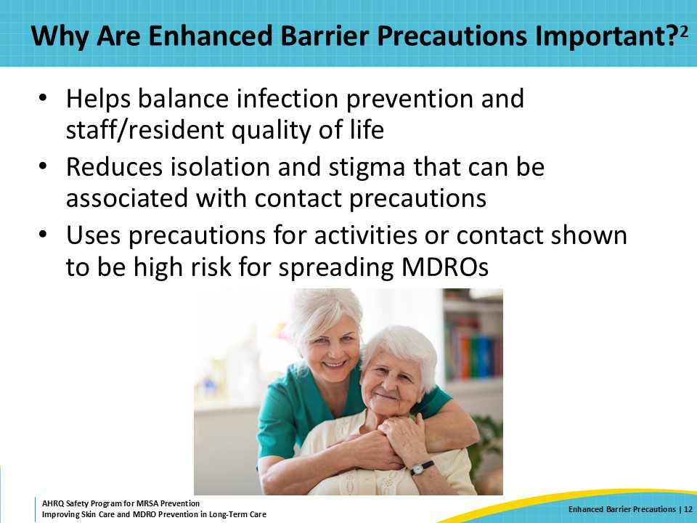
Activities With a High Risk for MDRO Transmission  SAY:  With enhanced barrier precautions, PPE should be used during activities that pose a high risk for MDRO transmission. These are activities that generally have a higher likelihood of bodily contact with the resident.  Some of these are obvious. Healthcare workers should wear gowns and gloves when they provide wound care—which refers to any skin that has a dressing. It is also important to wear gowns and gloves when providing device care, which includes urinary catheters, feeding tubes, and central lines.  Enhanced barrier precautions also call for healthcare workers to wear gowns and gloves when helping residents with personal care activities.  These include such activities as—  - Dressing  - Bathing or showering  - Transferring  - Providing hygiene—like helping someone brush their hair, brush their teeth, or apply deodorant or lotions  - Changing briefs  - Assisting with toileting  What may not be obvious—but is important—is that changing linens is also an activity that poses a high risk of MDRO transmission. A gown and gloves should be worn when making beds or putting fresh linens on beds.  When anticipating participation in any of these activities, staff should don a gown and gloves before entering the resident room. If a staff member is in a resident’s room for another reasons, such as giving medication, and they find that an activity with close contact is needed, such as toileting, they must exit the room and don PPE prior to assisting the resident. | Slide 13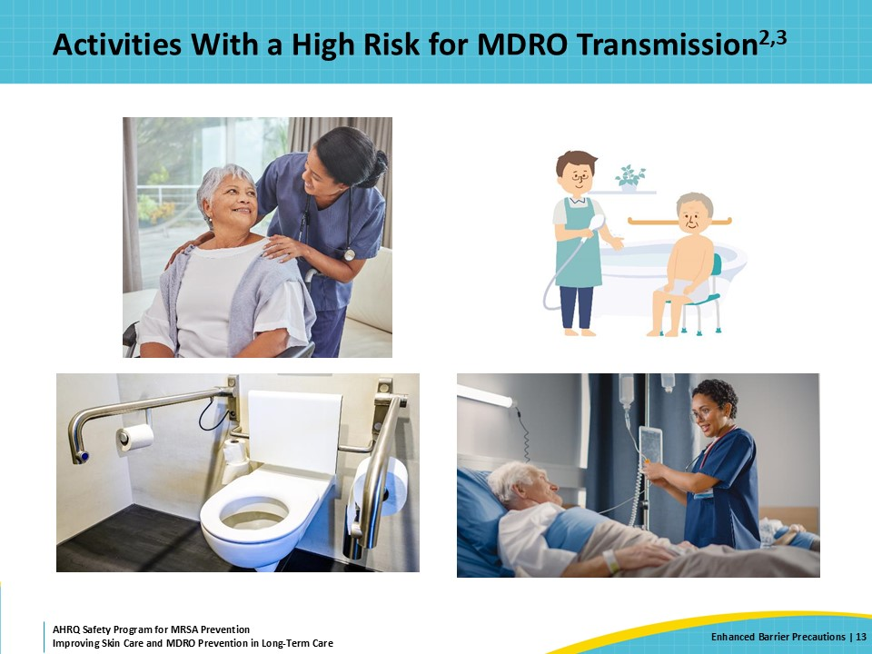
Teachable Moment  SAY:  This teachable moment will be about a resident, Mr. Gonzalez, who is recovering from a prosthetic joint infection caused by MRSA. In reviewing the case study, think about the following questions:  - What type of precautions should the resident be on?  - What PPE should the certified nursing assistant or CNA wear?  - And what were the consequences of not wearing a gown in this case? | Slide 14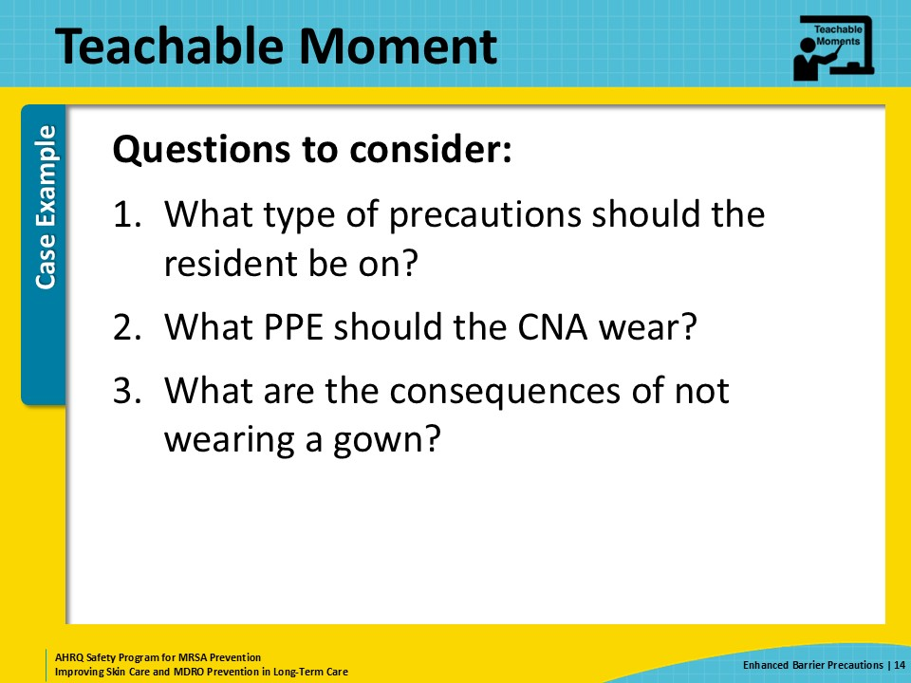
The Case  SAY:  In this case, Mr. Gonzalez is a 65-year-old resident who was admitted to the short-term stay unit of a nursing home for the treatment of a prosthetic joint infection caused by methicillin-resistant Staphylococcus aureus (or MRSA). Mr. Gonzalez has a PICC line for infusion of his antibiotic, vancomycin, and has a healing wound that is covered with a bandage after a recent washout. | Slide 15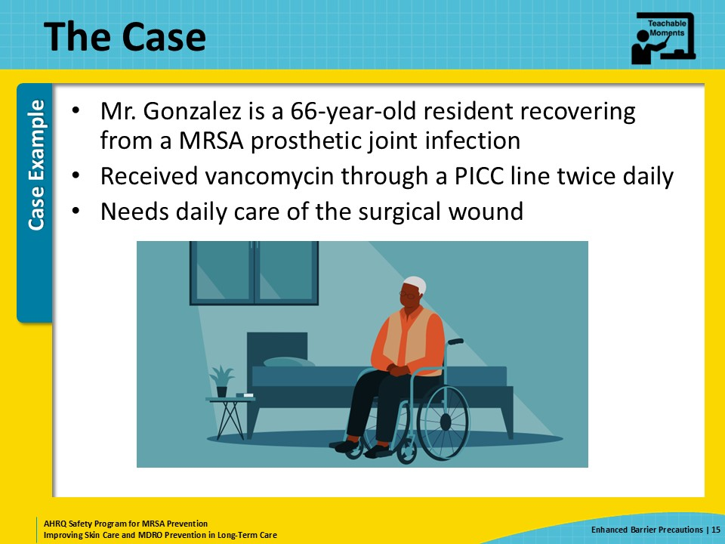
Knowledge Check  SAY:  With the information provided in the previous slide, what is the best type of precautions for Mr. Gonzalez?  Your choices are—  - Standard precautions (which used to be called universal precautions)  - Enhanced barrier precautions  - Contact precautions | Slide 16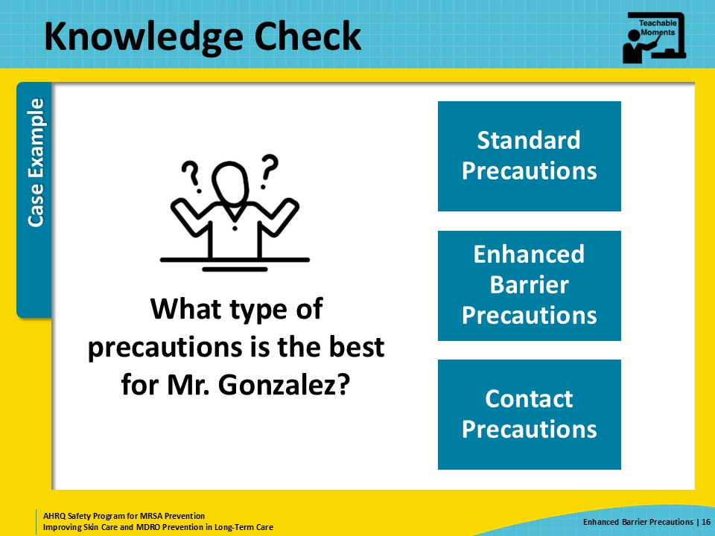
Knowledge Check: Answer  SAY:  In this case, enhanced barrier precautions is the correct choice.  Mr. Gonzalez is being treated for an infection caused by MRSA, which is an MDRO. He also has an indwelling device—the PICC line—and a contained wound. He has multiple reasons for requiring enhanced barrier precautions.  Notably, his wound is contained and covered in a dressing, so he does not require contact precautions at this time. | Slide 17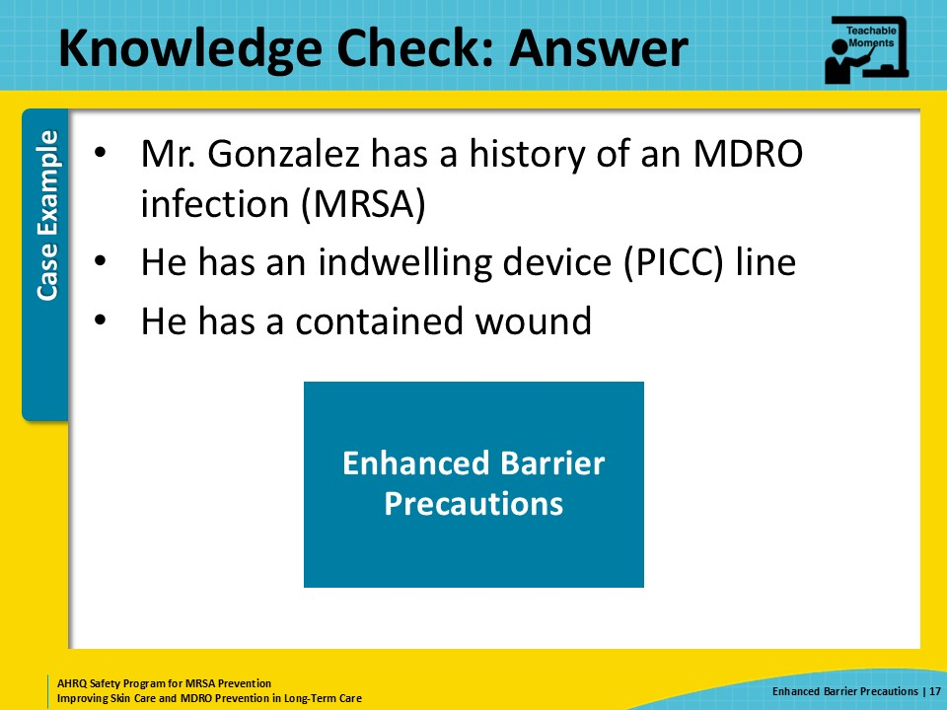
The Choice of PPE  SAY:  A CNA is preparing to enter Mr. Gonzalez’s room to flush the central line and then to change the dressing on his surgical wound.  What PPE should the CNA put on before entering his room?  The CNA should perform hand hygiene, then don a gown and gloves prior to entering Mr. Gonzalez’s room. The CNA is going to be performing two activities with a high risk for MDRO transmission: flushing the central line and changing the dressing on a wound. The CNA should complete the device care first before changing the wound dressing to move from a clean to a dirty task.  Residents at high risk for having and getting an MDRO are anyone with an indwelling device or an open (but contained) wound. In-dwelling devices include urinary catheters and central lines—such as peripherally inserted central catheters or PICC lines. Residents with a previous infection due to an MDRO are also considered high risk for colonization with an MDRO. | Slide 18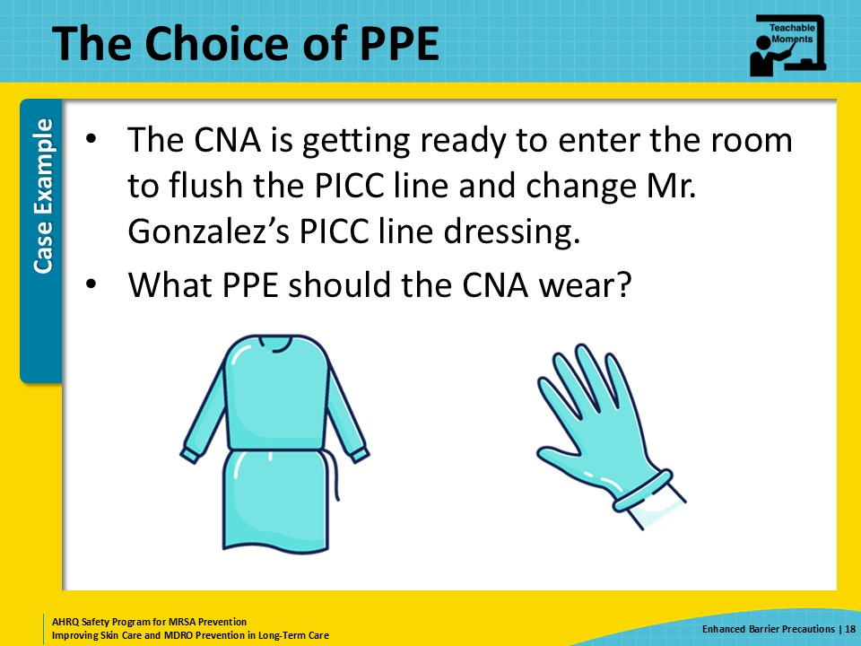
The Error  SAY:  Although the CNA remembers that a gown and gloves are required for these two high-risk activities, there are no gowns located outside of the resident's room. There is an isolation cart, but no gowns are inside. The CNA pauses outside of the room, uses the hand sanitizer dispenser, puts on gloves, and heads into the room. The CNA is behind in work and doesn’t want to take more time to look for an isolation gown. The CNA rationalizes that hand hygiene and gloves will be enough to prevent contamination during these two activities. | Slide 19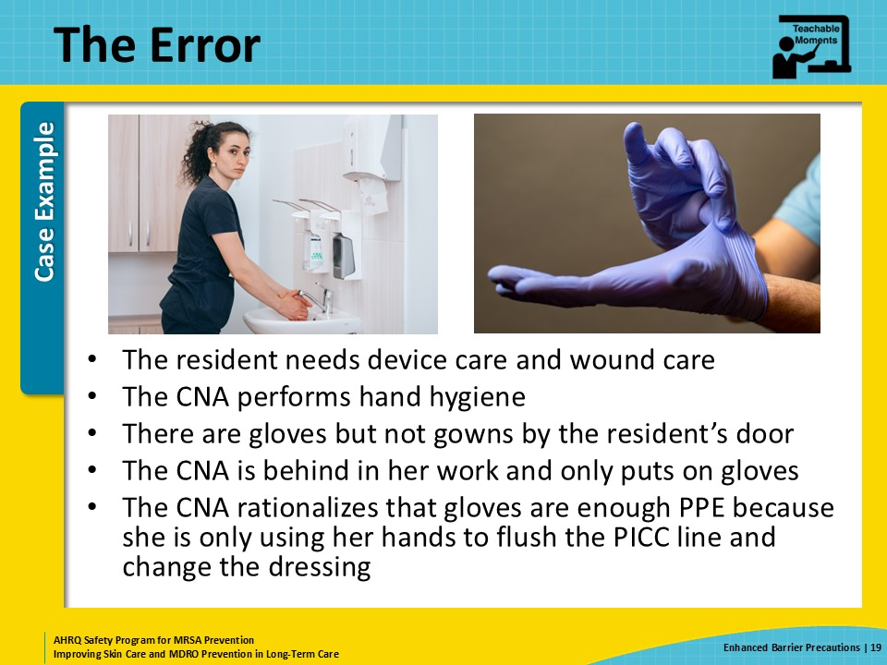
Potential for Patient Harm  SAY:  Unfortunately, when the CNA flushes Mr. Gonzalez’s PICC line, she leans against the side of his bed and gets MRSA on her clothes, right around her right hip where her pockets are. She also comes into contact with the bed linens when she changes the dressing on his wound. She leans against the bed, and more MRSA is transferred to the front of her scrub top.  Later during her shift, the CNA has to flush the PICC line of another resident. She uses a prepackaged syringe that was in her pocket. When she moves aside her gown and reaches into her pocket to grab the flushing solution, the MRSA on her clothes contaminates her gloves. She then contaminates the syringe before proceeding to flush the central line. A few days later, this other resident develops a fever and low blood pressure. He is transferred to the hospital with sepsis and is eventually found to have a bloodstream infection caused by MRSA. He is diagnosed with a central-line associated bloodstream infection (or CLABSI) because the PICC line was the likely source of his infection.  The CNA is now preparing to leave her shift for the day. She rests her hands in her lap for a moment while chatting with a coworker. The MRSA that was on the front of her top is now on her hands and, when she goes to write her notes for the day, the MRSA is transferred to the keyboard. The next person to use that keyboard gets MRSA on their hands. Thanks to good hand hygiene, however, that person does not transmit MRSA to any more residents.  Because bacteria are invisible to the naked eye, the importance of adhering to each and every step of transmission precautions too often gets overlooked. It’s essential to recognize the connection between every infection prevention activity and reduction in patient harm. The potential consequences are very real for residents. | Slide 20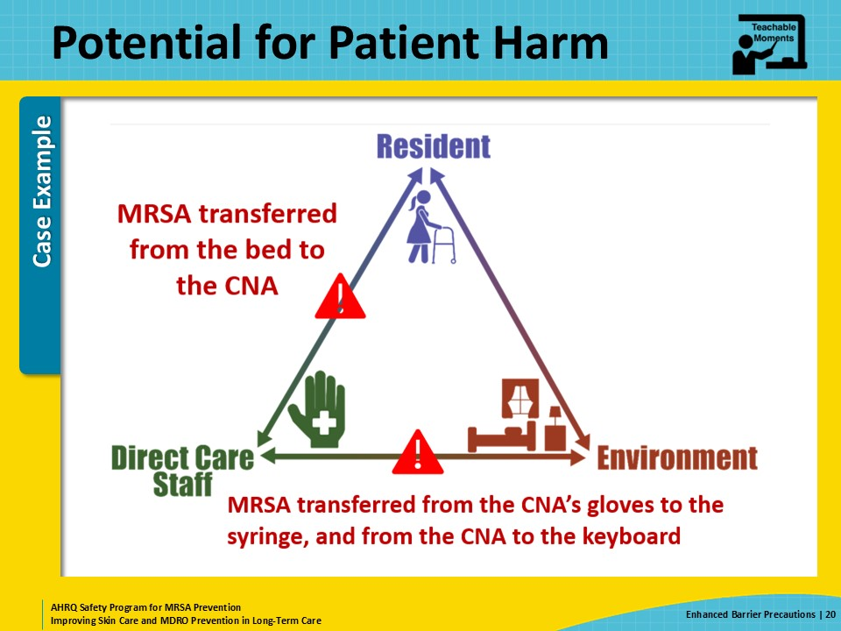
Patient Safety in the Moment  SAY:  Consider this case study and what the CNA should have done instead.  She should have stopped what she was doing and found an isolation gown to don prior to entering the resident's room. She could have either restocked the gowns from clean supply or taken a gown from a nearby room while asking for assistance with restocking the isolation gowns. This would not have taken long and would have prevented accidental contamination of her clothes and prevented another resident experiencing real harm.  Simply stated, the CNA should have taken the time to responsibly practice infection prevention and don the proper PPE. | Slide 21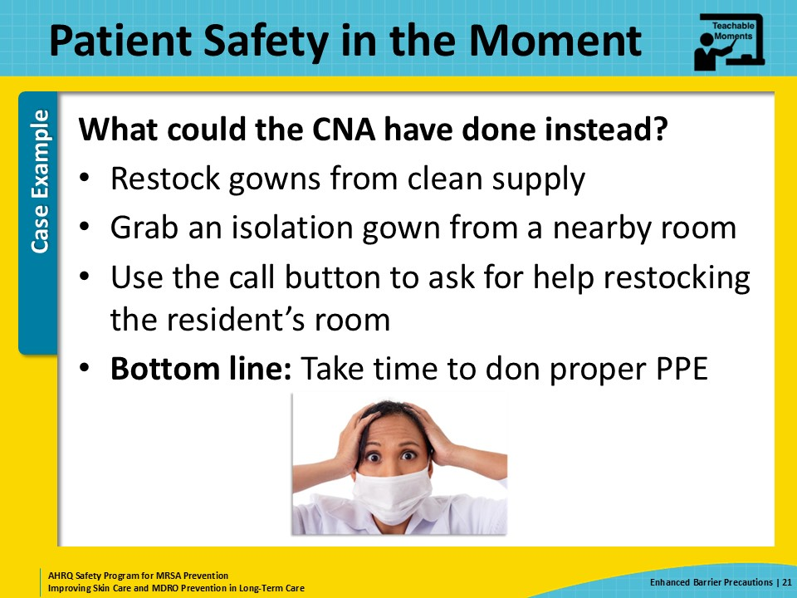
Preventing the Next Harm  SAY:  What steps can be taken to prevent this situation from occurring in the future?  On every shift, one person can be designated to stock and refill PPE. The best way to prevent PPE from running out on the unit is to specifically assign a staff member to ensure that PPE stays stocked on the unit.  In addition to having a primary person assigned to this responsibility, a second staff member should serve as a backup in case the first person is out or otherwise occupied.  Lastly, all staff should take personal responsibility for infection prevention, ensuring that the correct PPE is worn for every interaction. Safety and prevention should always come first. | Slide 22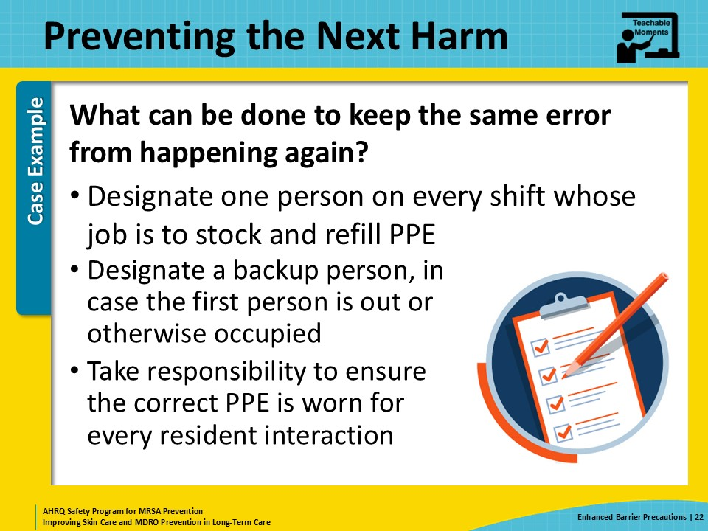
System-Based Safety Changes  SAY:  Thinking about this a little more, part of the problem is that the CNA was already behind in her work. Why was that? Is there too much work to go around for too few staff? Did she lose time earlier in her shift due to a long meeting or because she helped a new staff member pass medication? Or did she need help with another aspect of her job—like having to figure out a new note template in the electronic medical record? How often are staff feeling time-pressured?  The administration, director of nursing, and nurse managers may need to reconsider workloads for their staff. If there have been recent changes, staff may need more time and education until new routines become familiar. Or perhaps there should be one to two additional people available during especially busy times, such as medication passes, that serve as floating helpers.  Their duties can include restocking PPE as well as becoming a ready set of hands for colleagues who need help but are unable to leave the bedside or interrupt other tasks. To ensure that safety and prevention is prioritized, the facility should support organizing workflow so staff can work efficiently without feeling rushed. Additionally, facility administration may need to consider overall staffing levels relative to occupancy in order to have adequate staffing to support facility responsibilities. | Slide 23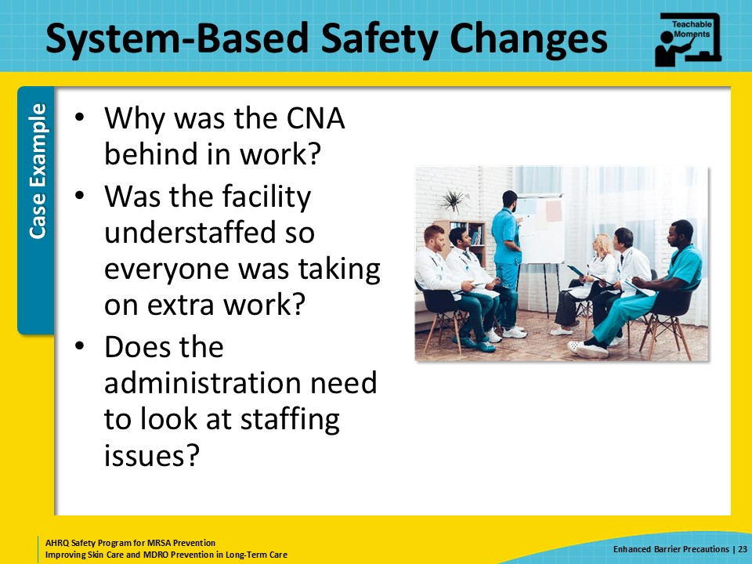
Key Takeaways  SAY:  To recap, MDROs are a problem in nursing homes. Nursing home residents can be colonized with an MDRO for months or years. Residents with an MDRO or those who are at high risk of acquiring/having an MDRO should be on enhanced barrier precautions. Enhanced barrier precautions prioritize high-risk activities for the use of PPE and allow residents to leave their rooms. It's important to take the time to practice important infection prevention measures, such as donning appropriate PPE. These actions help keep the residents safe from harm. | Slide 24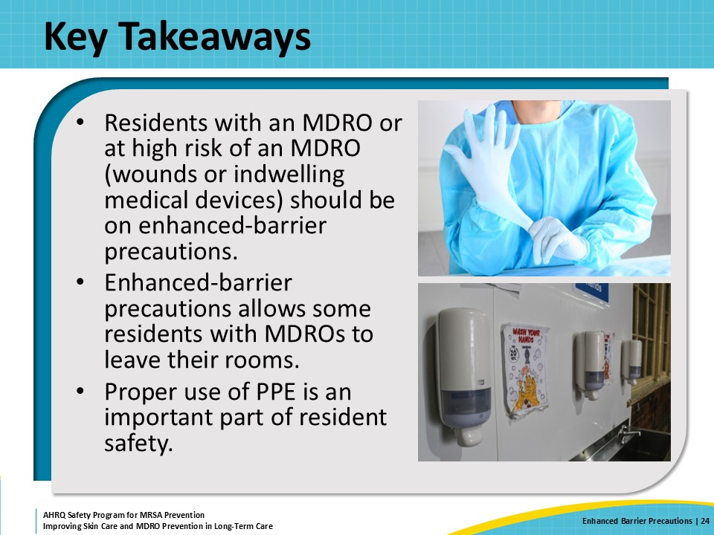
Supporting Materials  SAY:  There are a few supporting materials for this presentation. These materials include teachable moments: Implementing Enhanced Barrier Precautions, The Triangle of Transmission: Residents as Reservoirs for MDROs, The Triangle of Transmission: Norovirus, Clinical Criteria and Surveillance Definitions of Infections in Nursing Home Residents, Comparing Clinical and Surveillance Definitions of Urinary Tract Infections in Nursing Homes, The Case of Insufficient PPE, and The Case of EBP and the Laundry Bag. Internally created supporting materials include an Enhanced Barrier Precautions Tracker Tool. External supporting materials include several resources from the Centers for Disease Control and Prevention. | Slide 25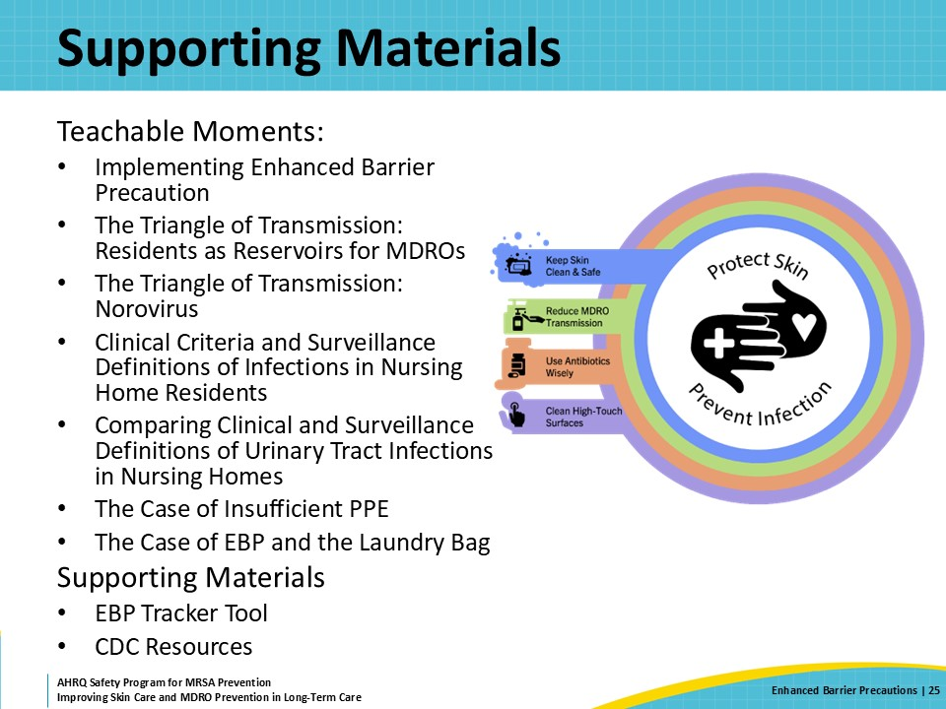
Disclaimer  SAY:  The findings and recommendations in this presentation are those of the authors, who are responsible for its content, and do not necessarily represent the views of AHRQ. No statement in this presentation should be construed as an official position of AHRQ or of the U.S. Department of Health and Human Services.  Any practice described in this presentation must be applied by healthcare practitioners in accordance with professional judgment and standards of care in regard to the unique circumstances that may apply in each situation they encounter. These practices are offered as helpful options for consideration by healthcare practitioners, not as guidelines. | Slide 26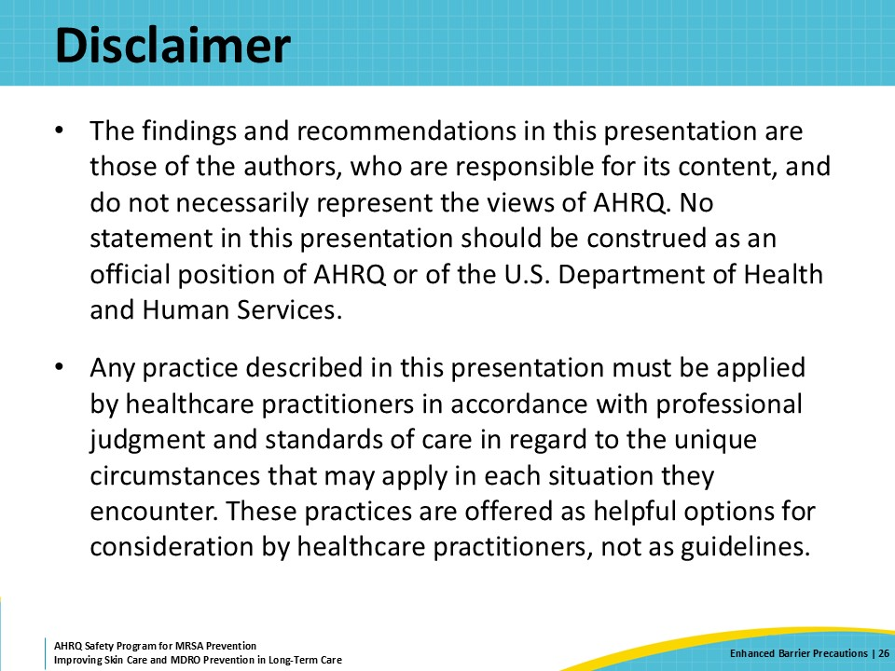
References | Slide 27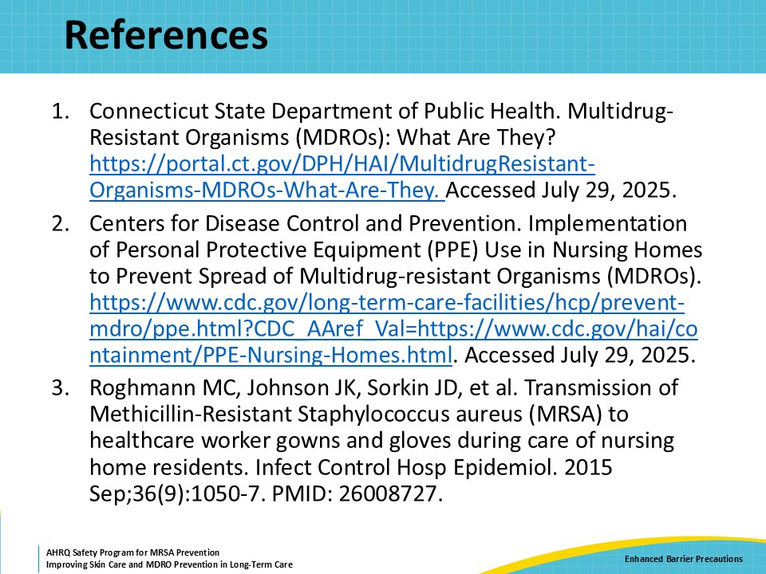
AHRQ Pub. No. 25(26)-0066
October 2025

