Down and Dirty With Stool:

Enteric Pathogens
AHRQ Safety Program for MRSA Prevention
Slide Title and Commentary | Slide Number and Slide
Down and Dirty With Stool: Enteric Pathogens  SAY:  Hello, and welcome to this presentation, Down and Dirty With Stool. This presentation will discuss enteric pathogens, common bacteria that can be found in stool and how to prevent transmission of these bacteria between residents, the environment, and healthcare personnel. | Slide 1  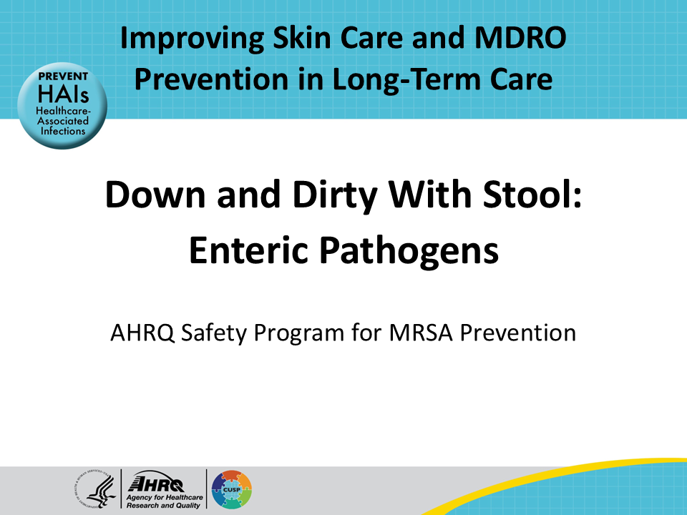
All Staff Support Resident Care and Safety  SAY:  The information provided in this presentation is important in the care of long-term care (LTC) residents. In LTC facilities each member of the facility’s staff supports resident care and safety. Some actions described in these presentations may not be in your scope of practice, but it is important to learn how all staff contribute to resident care and safety. | Slide 2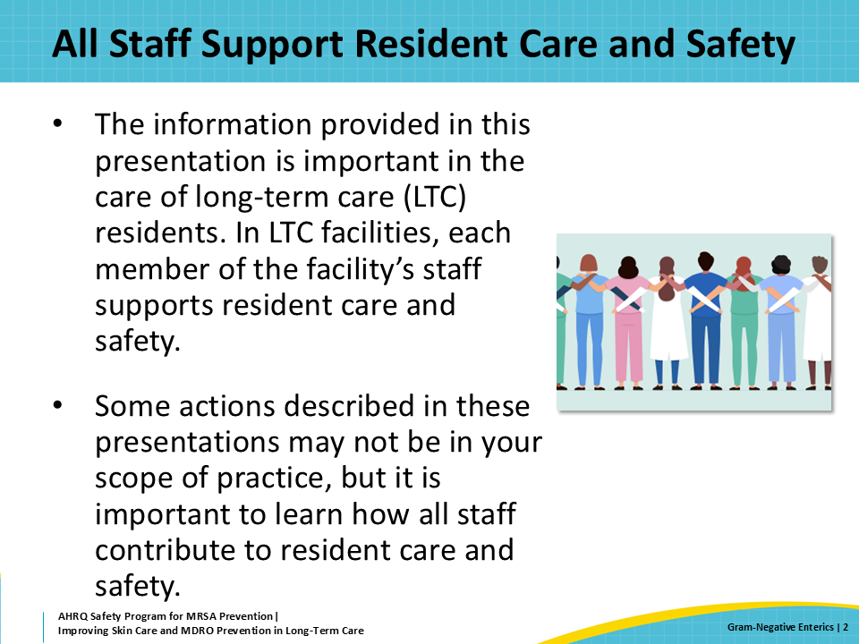
Educational Objectives  SAY:  The first objective of this webinar is to discuss the bacteria commonly seen in the stool, including the resistant organisms that can be spread through stool. The next objective is to review how bacteria in the stool can be spread to others and can cause infections in other parts of the body. Finally, this presentation will cover the precautions necessary to control the spread of pathogenic stool bacteria. | Slide 3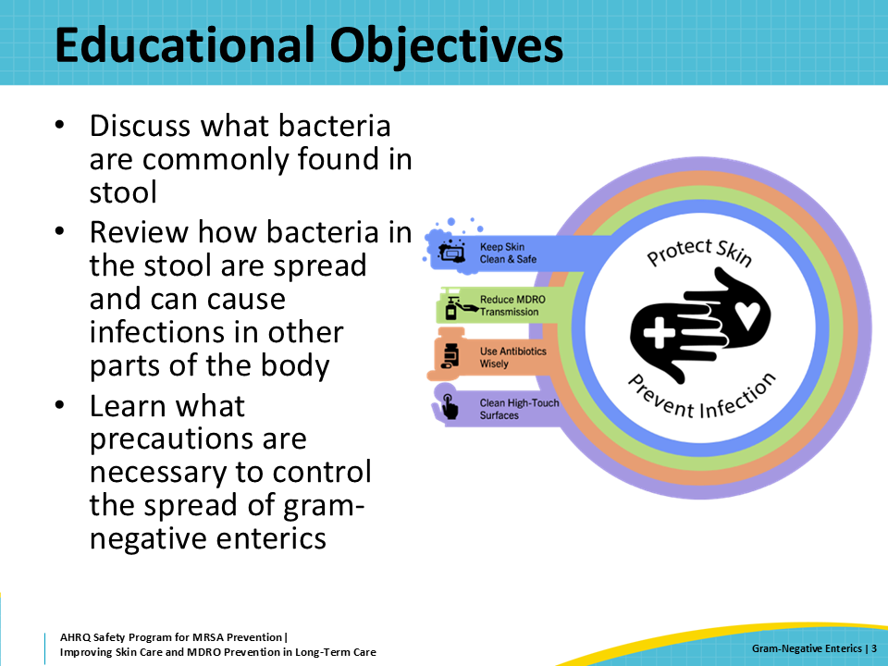
Normal Human Poop  SAY:  Believe it or not, more than HALF of the dry weight of stool is made up of bacteria alone!  There are several hundred different species of bacteria in our normal stool. In healthcare settings, the most common stool bacteria are part of a group called Enterobacterales. These are sometimes also called Gram-negative enteric bacteria. Some of the more common species are listed on the slide. E. coli, which many people have heard of before, is part of the Enterobacterales group. Some other common bacteria present in normal stool are Enterococcus faecium and Enterococcus faecalis. These are Gram-positive bacteria. | Slide 4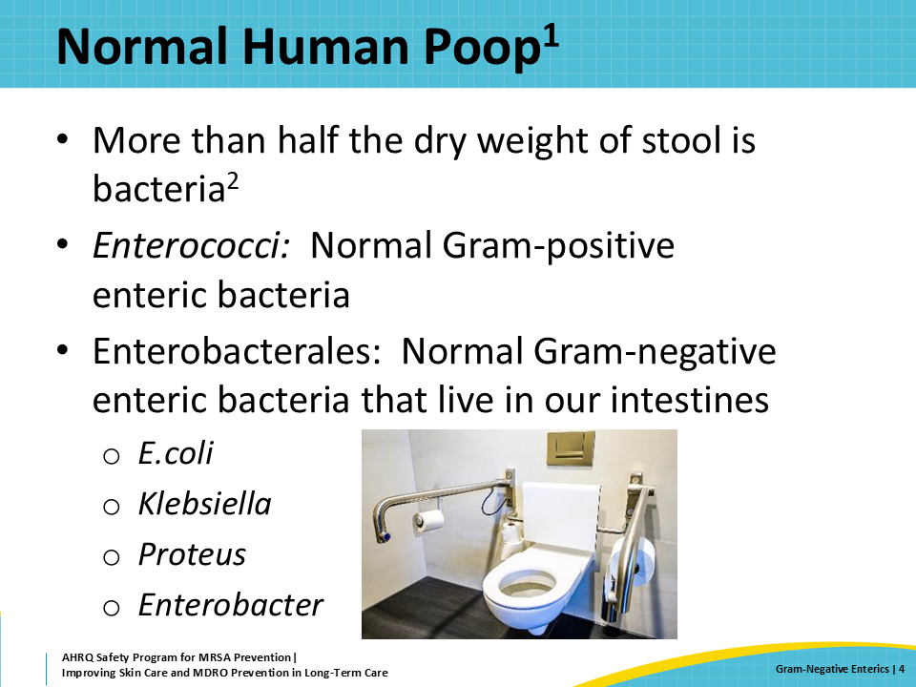
Pathogens in Our Poop  SAY:  There are several bacterial species that can cause gastritis—which usually means diarrhea and sometimes an upset stomach. These bacteria are not part of our normal stool. These are pathogens that people most commonly get by eating contaminated food.  The last bacteria on this list is Clostridioides difficile, more commonly known as C diff. This is the most common cause of healthcare-associated diarrhea, and it can cause people to be sick for weeks to months. Older adults may die from a C. diff infection. People who have had antibiotics in the last 3 months are at the biggest risk for getting a C. difficile infection. | Slide 5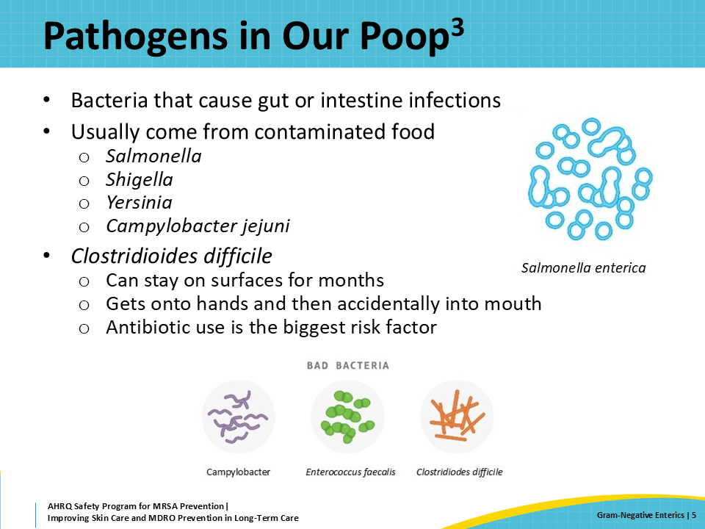
Resistant Bacteria in the Stool  SAY:  The bacteria in our intestines are part of us. Healthy people have healthy bacteria in their poop. People who are not healthy can have problems caused by normal gut bacteria that spread to other parts of their body, like blood, urine, wounds, or lungs.  People who are sick often get treated with antibiotics, which can change the bacteria that live in their intestine. Sometimes the prescribed antibiotics are not appropriate or not necessary. Antibiotics kill healthy bacteria and allow for the selection and growth of MDROs. The more antibiotics someone is exposed to, the more likely they are to have MDROs. Frequent exposure to healthcare settings is where people can pick up these bacteria. This includes nursing home residents, who are exposed to many rounds of different antibiotics and many different MDROs.  Another note—the resistant bacteria do not develop in one person's intestine. Instead, they are transmitted from person to person. Most people who work in healthcare settings, including long-term care, do not have MDROs. The healthy bacteria in their intestines keep the MDROs from becoming established.  Transmission of these MDROs is particularly challenging to control in nursing homes and other long-term care facilities. This is because many residents can be incontinent, and therefore they rely on others to clean their stool, which leads to more potential for spread. This is made worse by problems with infection prevention in this setting, such as poor hand hygiene and adherence to transmission-based precautions, and challenges with environmental cleaning. Shared bathrooms can also lead to transmission to roommates.  The most common resistant bacteria from the stool that we see in nursing home residents are resistant to oral antibiotics, including fluoroquinolones. Some bacteria become resistant to broad-spectrum intravenous antibiotics as well. These include extended-spectrum beta-lactamase producing bacteria (ESBL), which are resistant to penicillins and cephalosporins. Nursing home residents may also have carbapenem-resistant Enterobacteriaceae, or CRE. All of these bacteria are very difficult to treat if they cause a wound infection or another type of infection, so preventing transmission is incredibly important.  Remember the Enterococci from a few slides back? These can also become resistant, which is most commonly described as vancomycin-resistant Enterococcus or VRE. | Slide 6  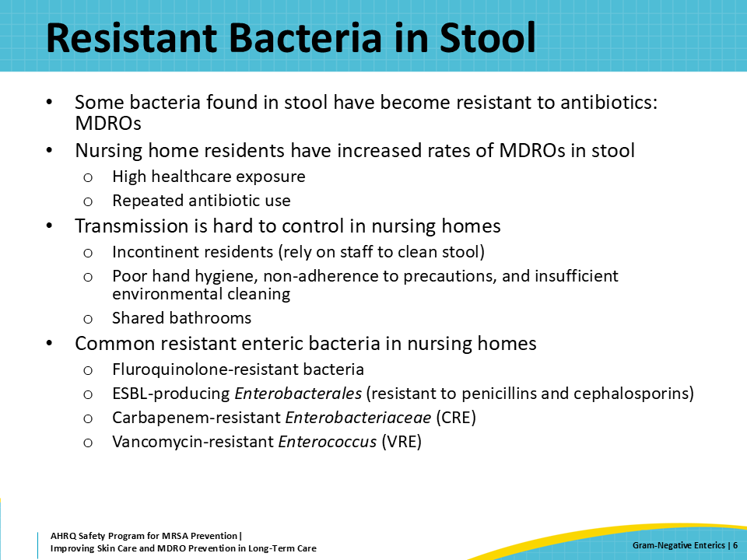
Transmission of Enteric Bacteria  SAY:  One way enteric bacteria can make people sick is if someone swallows them. Imagine a resident is incontinent of stool and a staff member assists with cleaning him or her up. Unfortunately, after the staff member cleans the stool, they may perform inadequate hand hygiene and not completely clean residual bacteria from their hands. They can then touch something in the environment with the bacteria still on their hands. These bacteria can remain in the environment for prolonged periods, and if someone else touches it, their hands are subsequently contaminated. Then they may touch their mouth or go eat without washing their hands, and this can make them sick. This is how C. diff spreads. This is also why cleaning and disinfecting surfaces—like doorknobs and bed rails—is so important.  Another example is contamination of a wound. If a resident with breakdown of the skin on his or her backside is incontinent and the stool is not cleaned quickly, the bacteria can seep into the broken skin. This can lead to an infection. In nursing home residents, bacteria from stool can infect sacral wounds that developed due to a pressure injury. These can be dangerous, and difficult to treat, particularly if the organism is resistant to antibiotics. | Slide 7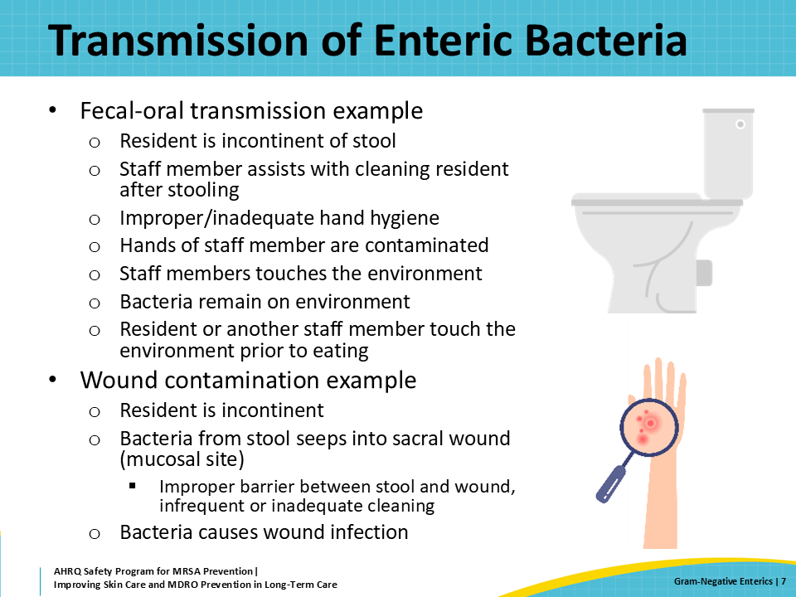
Triangle of Transmission  SAY:  This slide applies the knowledge of stool bacteria to the triangle of transmission and illustrates how to break the chain of transmission through healthcare actions.  Stool bacteria can contaminate the environment, our hands, and the gowns and gloves of healthcare personnel helping residents with toileting or getting cleaned up.  This is why hand hygiene is so important for every side of the triangle. Personal protective equipment or PPE, like gowns and gloves, helps prevent transmission to and from the healthcare workers' clothes. Environmental cleaning and disinfection help remove stool that could be transmitted through touching the environment.  Finally, protecting resident skin is important. It is much easier to prevent infections among people who have skin that is safe and intact. For people who have wounds and pressure injuries, protecting skin from exposure to stool is also important for them to not only avoid infection but to also heal the wound. | Slide 8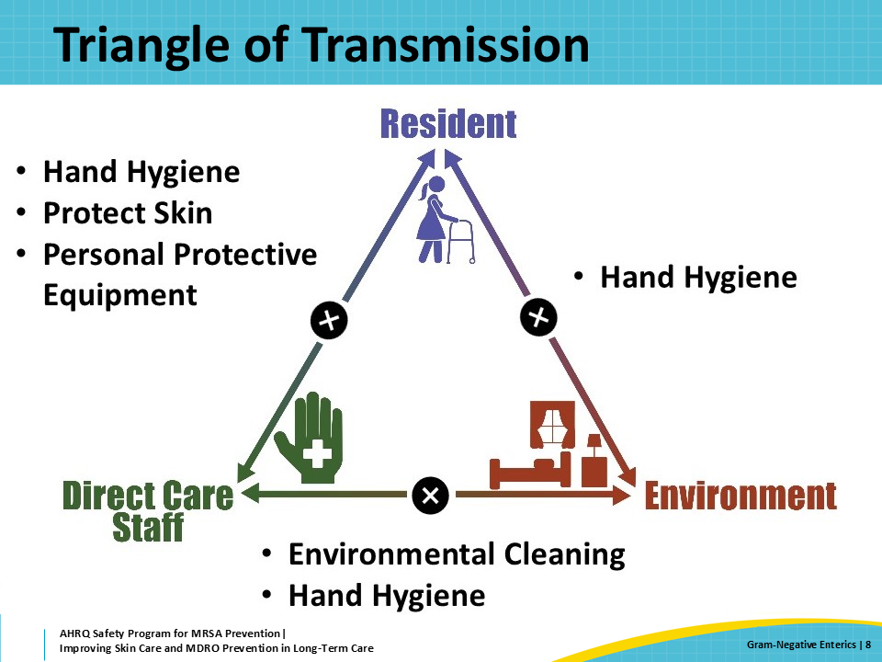
Key Infection Prevention Knowledge for Staff  SAY:  There are some key steps to consider when discussing the importance of reducing transmission of stool bacteria with staff.  First, as previously discussed, hand hygiene after dealing with any stool is essential. This means performing hand hygiene before donning and again after removing gloves. Gloves alone are not enough to prevent transmission.  Residents can remain colonized with MDROs, which means they may harbor resistant bacteria in their gut without symptoms for months to years! This is a big reason why enhanced barrier precautions are recommended. They help prevent transmission of resistant organisms to residents who are at high risk of being colonized.  Bacteria in stool can contaminate sacral pressure injuries and other wounds, which can lead to severe infections. Barrier precautions and prompt cleaning are essential for residents who are incontinent and who have sacral wounds.  Finally, while enhanced barrier precautions (EBP) are appropriate for residents who are colonized or at high risk for being colonized with resistant organisms, any resident who has new onset diarrhea should be placed on contact precautions. Contact precautions are needed in this scenario because it is possible they have an infectious diarrheal infection. Staff need to wear a gown and gloves upon entry to the room, regardless of the planned task, when caring for a resident with new onset diarrhea. | Slide 9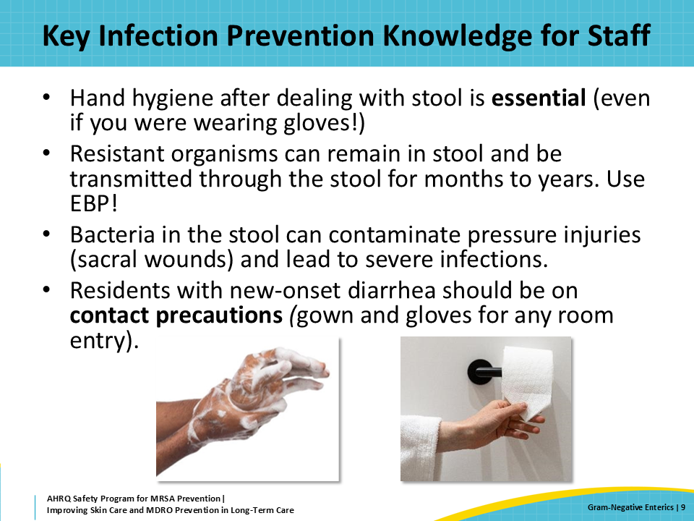
Contact Precautions  SAY:  This slide will review contact precautions.  The presentation “The ABCs of EBP” reviewed enhanced barrier precautions. Remember, enhanced barrier precautions should be reserved for residents who do not have new onset diarrhea, draining wounds, or conditions requiring contact precautions (e.g., C. diff).  A resident with an MDRO infection or colonization should be placed on contact precautions when he or she has an open/draining wound or in the presence of acute diarrhea. Contact precautions should also be implemented for residents with a suspected or confirmed infection that has a high risk for spread by touching the resident or their environment (e.g., scabies, C. diff).  Diarrhea due to infections, such as C. diff or norovirus, are easily spread from person to person. Putting someone with new onset diarrhea on contact precautions before knowing the cause is a “better safe than sorry” approach. It’s better to prevent the spread of pathogens that can cause diarrhea than to risk the spread of those pathogens while waiting for a diagnosis.  Contact precautions requires both a gown and gloves upon room entry (not only if you are touching the resident). This is because even touching the environment in the resident's room could result in transmission. | Slide 10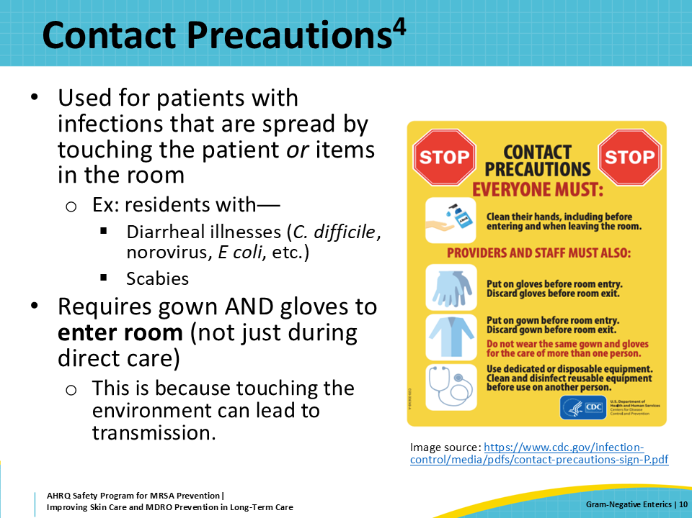
Teachable Moment  SAY:  This presentation’s Teachable Moment will look at a case where a resident has a sacral wound and new stool incontinence. Think about the following questions as the case study progresses:  - What problems would have been avoided with proper PPE use?  - How can your facility make sure hand hygiene products are easily accessible? | Slide 11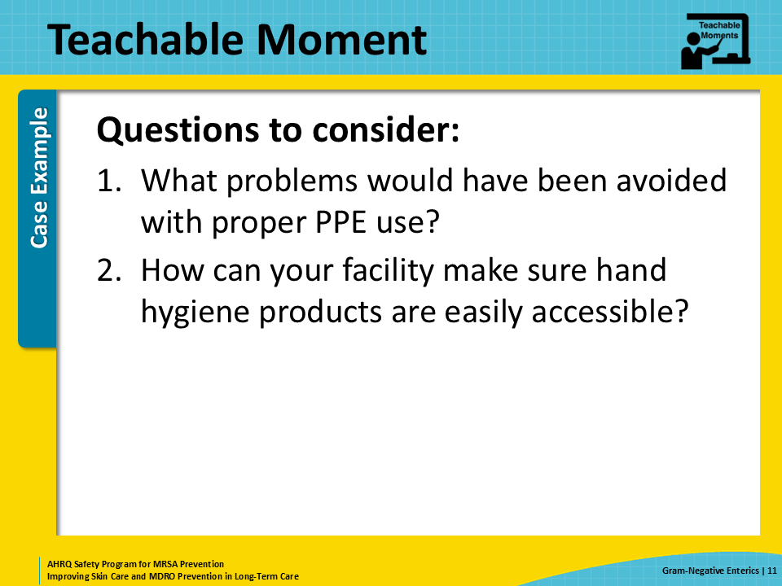
Wound Care and the Incontinent Resident  SAY:  Mr. Jones is an 82-year-old man with a history of stroke, resulting in limited mobility and dependence on staff for his activities of daily living. He has a chronic stage 2 sacral decubitus wound.  Unfortunately, he develops new onset diarrhea, and becomes incontinent of stool, with about four to eight bowel movements a day. | Slide 12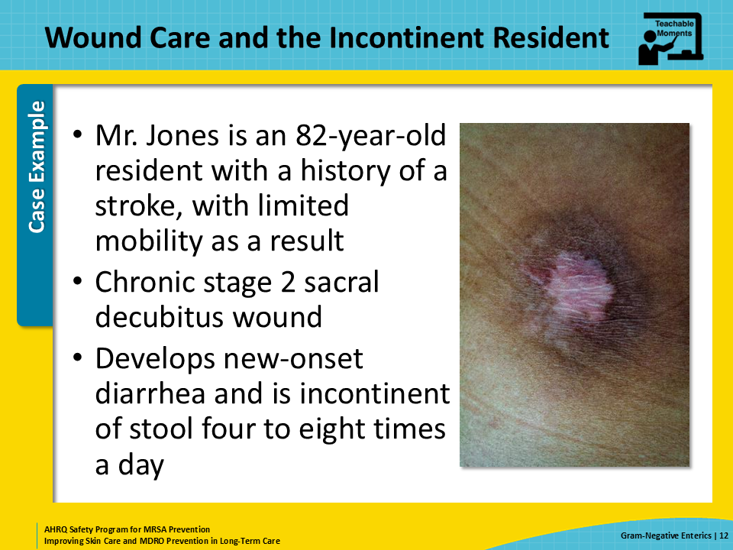
The Challenge  SAY:  The nurse goes in to perform a dressing change on his sacral wound and realizes that he has had another episode of diarrhea.  She asks the certified nursing assistant or CNA for assistance with cleaning him up and performing the dressing change. Neither of them wears a gown, but they both wear gloves.  After they clean him up, the nurse removes her gloves but does not perform hand hygiene. Even though she can’t see them, some of the bacteria from the stool are still on her hands. Some of these bacteria are resistant to antibiotics. | Slide 13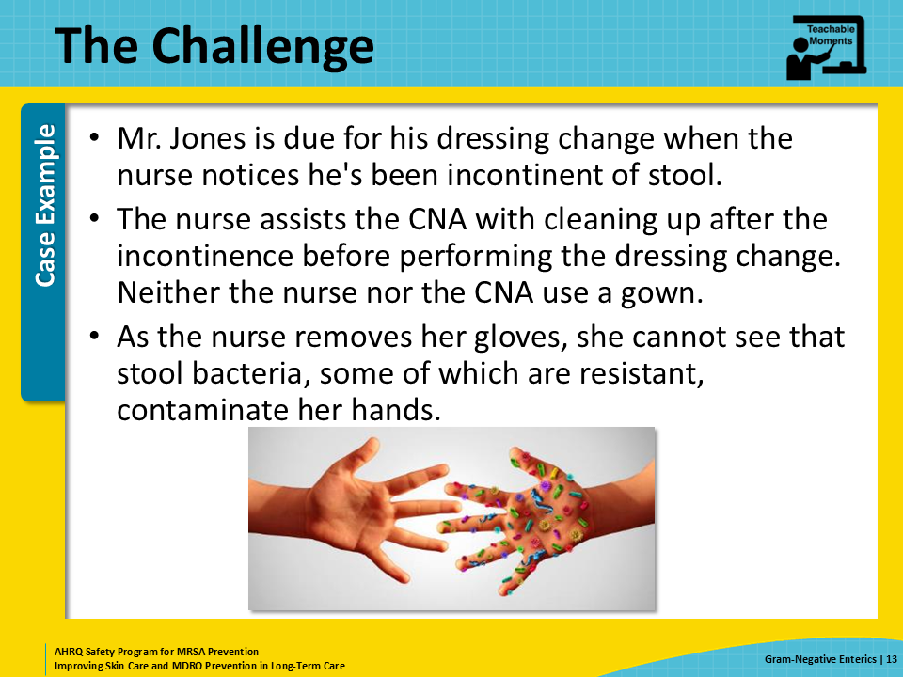
The Error  SAY:  The nurse did not perform hand hygiene after cleaning up the stool or before placing a clean dressing. Because of this, some of the resistant bacteria were transferred from her hands to the clean dressing.  About a week later, Mr. Jones’ diarrhea has resolved but he is noted to have new purulent discharge with a foul odor coming from his wound. A wound culture is performed that grows E. coli resistant to several antibiotics.  As if this wasn't enough, some of the wound care supplies were contaminated by the nurse. The bacteria from her clothes and hands contaminated the cart as she leaned against it. All of this because she did not wear a gown or perform proper hand hygiene after removing her gloves and before putting on a clean dressing.  Over the next 2 months, three other residents with wounds develop infections with the same drug-resistant E. coli. They were exposed to the bacteria on the outside of the dressing supplies contained in the wound care cart. One of the residents had a diabetic foot infection that progressed to a level of such severity that he had to proceed to an amputation. | Slide 14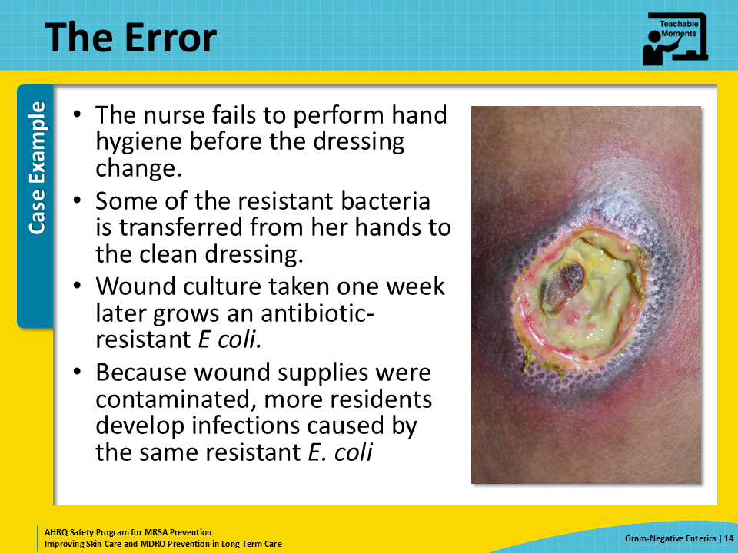
Potential for Patient Harm  SAY:  Small mistakes can lead to major potentials for patient harm, and being aware of the potential for bacterial contamination, particularly when dealing with stool, is very important.  Because staff did not wear appropriate PPE while cleaning up an incontinent resident, enteric bacteria was transmitted to their clothes. Wearing a gown and gloves when performing wound care and helping a resident with toileting (and properly disposing of them afterwards) helps to break this triangle of transmission.  Further, improper hand hygiene led to contamination of the resident's wound. This had downstream effects because the wound care supplies were contaminated, which led to transfer of these bacteria to many other residents who were getting wound care. Some of these resistant bacteria can persist on surfaces and objects for a prolonged period of time. Proper hand hygiene and frequent disinfection is important to breaking the triangle of transmission. | Slide 15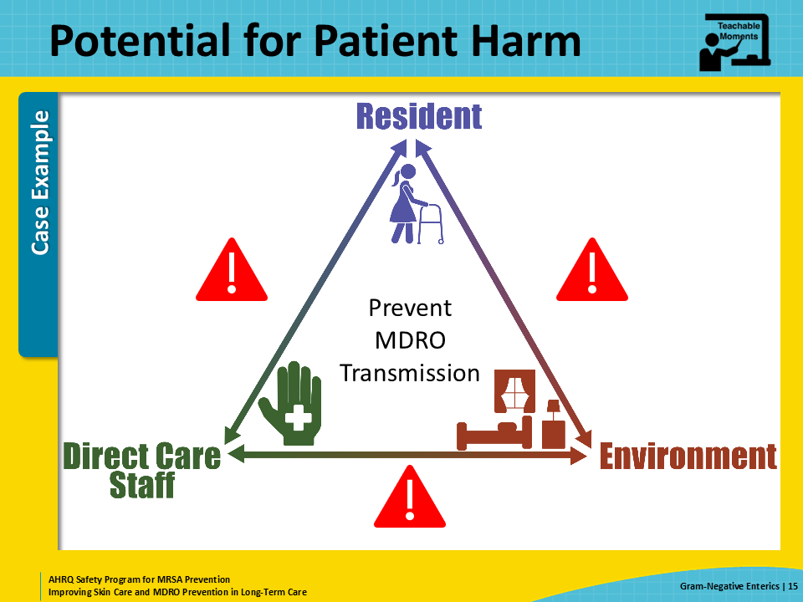
Patient Safety in the Moment  SAY:  Some of the problems Mr. Jones experienced could have been avoided if proper PPE was worn.  In this teachable moment, gowns and gloves should be worn during stool cleanup and wound care. Also, Mr. Jones should have been placed on contact precautions because he had a new diarrheal illness. His C. diff test came back negative, and his diarrhea resolved once orders for laxatives were changed from scheduled to as needed.  Making sure to perform hand hygiene and change gloves between stool cleanup and wound care helps to prevent infection of existing wounds with enteric bacteria.  Another key feature of this case is that the nurse’s errors were not immediately noticed or even something that could be traced back to this episode of stool incontinence. Because the causes of healthcare-associated infections are invisible and the infections take time to show up after the exposure, consequences of small lapses in infections prevention may be overlooked, and nobody realizes the true harm those errors may cause. Thus, it is important to be vigilant with hand hygiene and think about preventing harm. | Slide 16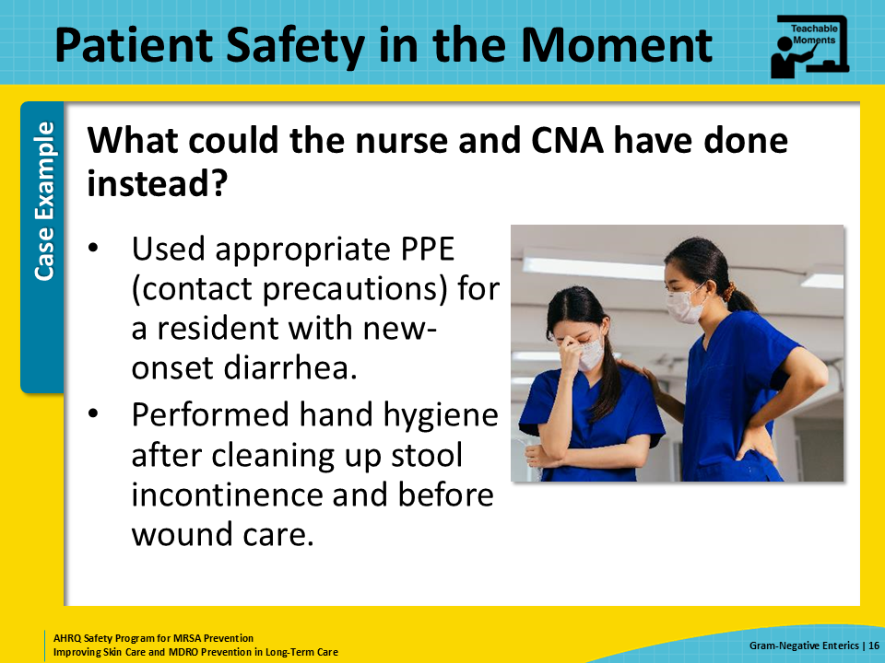
Preventing the Next Harm  SAY:  The infection preventionist can ensure that supplies, such as hand sanitizer, gloves, and gowns, are available and frequently stocked to help direct care staff make good decisions about infection prevention and remain efficient. In a hurry, searching for a gown can certainly impede workflow. It is much easier to remember to wear PPE if it is available and accessible.  Furthermore, the infection preventionist should stay on top of placing appropriate signage on the resident door to tell the staff exactly what they should be wearing to walk in the room. It helps to have pictures of the appropriate PPE on the sign, to reduce ambiguity. Educating staff to think about residents with new onset diarrhea as potentially having an infection can also help to promptly place patients on the appropriate transmission-based precautions. | Slide 17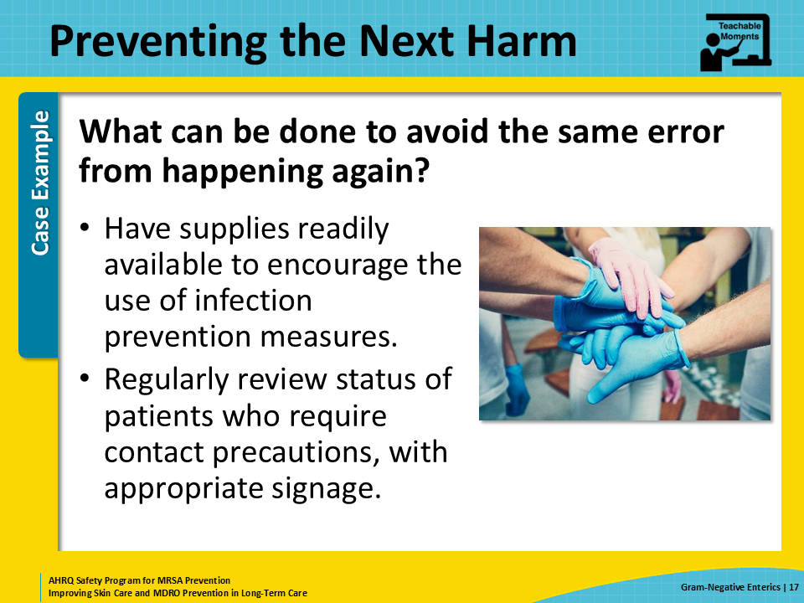
System-Based Safety Changes  SAY:  Consider other system-based safety changes to propose to senior executives, such as over-the-door PPE holders—these help make PPE easily visible and accessible. PPE holders make it easier to identify if supplies are running low, so you are more likely to restock them before you run out.  The same goes for alcohol-based hand rub dispensers. There is a much greater uptake of hand hygiene compliance when dispensers are installed both inside and outside every resident door. This placement both reminds staff to perform hand hygiene often and makes it easier to do so. The nurse in the case may have been more likely to perform hand hygiene after taking off her gloves if there was an alcohol-based hand sanitizer dispenser next to the trash bin or on the cart with the dressing supplies.  And just as a quick reminder, in most situations, hand hygiene can be achieved with either alcohol-based hand rub or washing with soap and water. For people known or even just suspected of having C. diff, washing with soap and water is recommended.  Finally, communal wound care carts and supplies can easily become contaminated and lead to outbreaks if not managed properly. Consider removing communal wound carts and getting fresh supplies for each resident to avoid contamination or ensuring the wound care cart and all the dressings are disinfected regularly. | Slide 18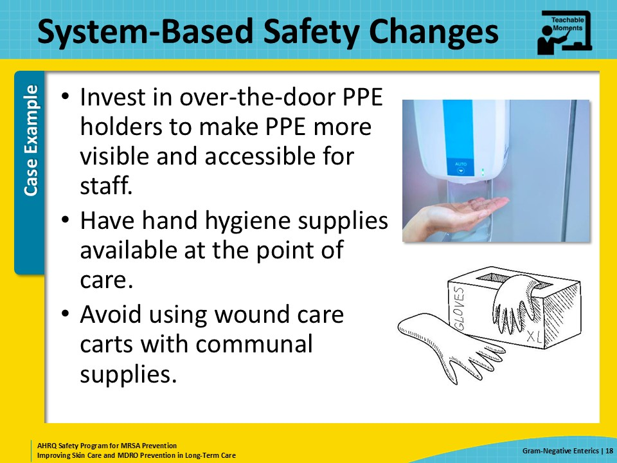
Key Takeaways  SAY:  Here are some take-home messages from getting down and dirty with stool and its contents.  Resistant organisms can live in the stool and survive in the environment for prolonged periods.  Contact precautions, including putting on a gown and gloves upon room entry, should be used for all residents with active infections, and for those with new-onset diarrhea until infectious diarrhea is ruled out.  Finally, proper PPE, hand hygiene, and environmental disinfection are key infection prevention measures to reduce transmission of bacteria in stool. | Slide 19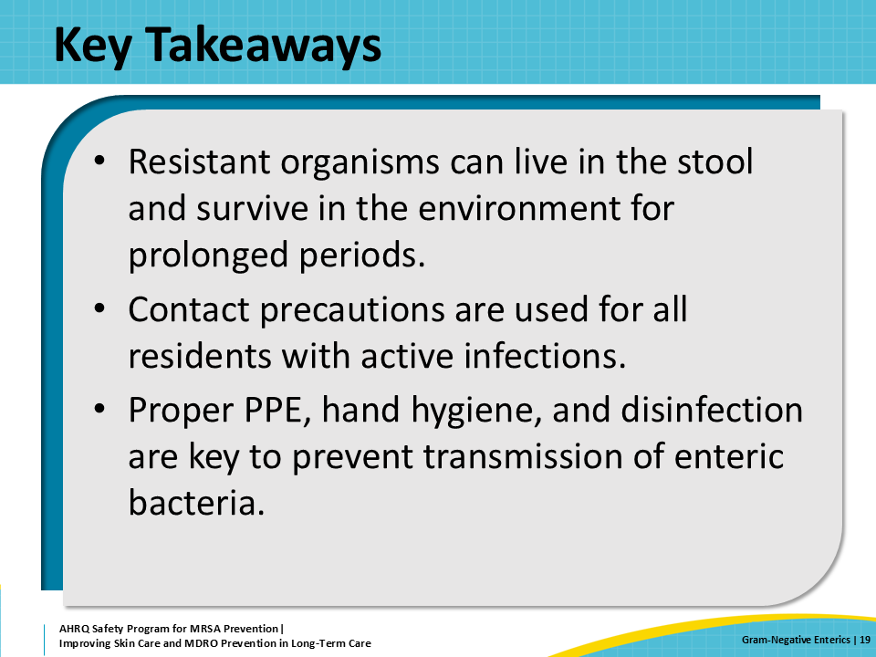
Supporting Materials  SAY:  There are a few supporting materials for this presentation. These materials include teachable moments: Contact Precautions Quiz and The Case of the Resident With a Chronic Wound and Diarrhea, in addition to an external supporting material: a C. difficile informational poster from the U.S. Centers for Disease Control and Prevention | Slide 20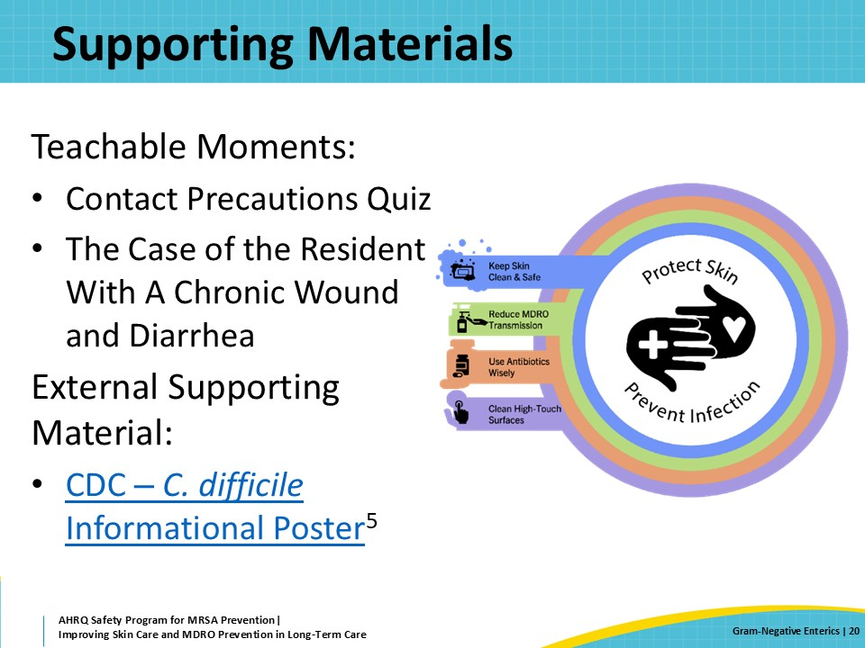
Disclaimer  SAY:  The findings and recommendations in this presentation are those of the authors, who are responsible for its content, and do not necessarily represent the views of AHRQ. No statement in this webinar should be construed as an official position of AHRQ or of the U.S. Department of Health and Human Services.  Any practice described in this presentation must be applied by healthcare practitioners in accordance with professional judgment and standards of care in regard to the unique circumstances that may apply in each situation they encounter. These practices are offered as helpful options for consideration by healthcare practitioners, not as guidelines. | Slide 21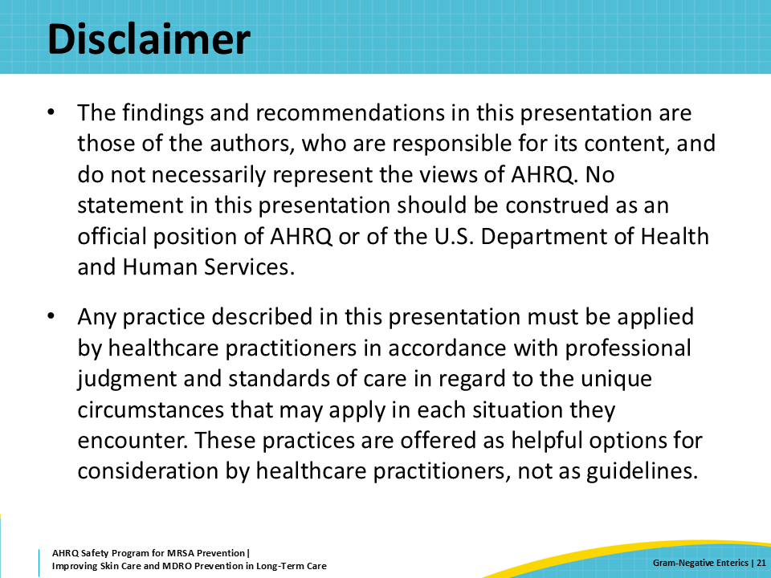
References—1  SAY:  Here are the references for this presentation. | Slide 22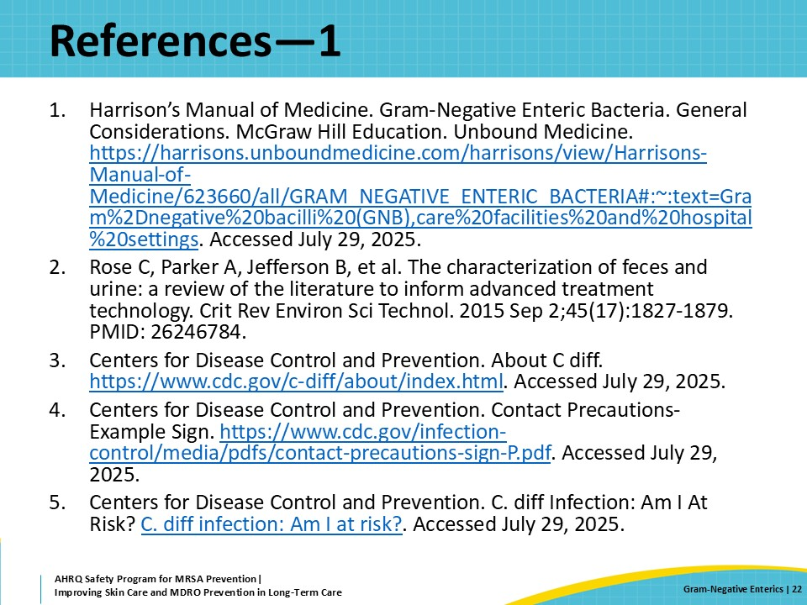
AHRQ Pub. No. 25(26)-0066
October 2025

