Where Do Germs Live?

Environmental Cleaning
AHRQ Safety Program for MRSA Prevention

Slide Title and Commentary | Slide Number and Slide
Environmental Cleaning  SAY:  Welcome to this presentation on “Where Do Germs Live: Environmental Cleaning,” part of the AHRQ Safety Program for MRSA Prevention: Improving Skin Care and MDRO Prevention in Long-Term Care. | Slide 1  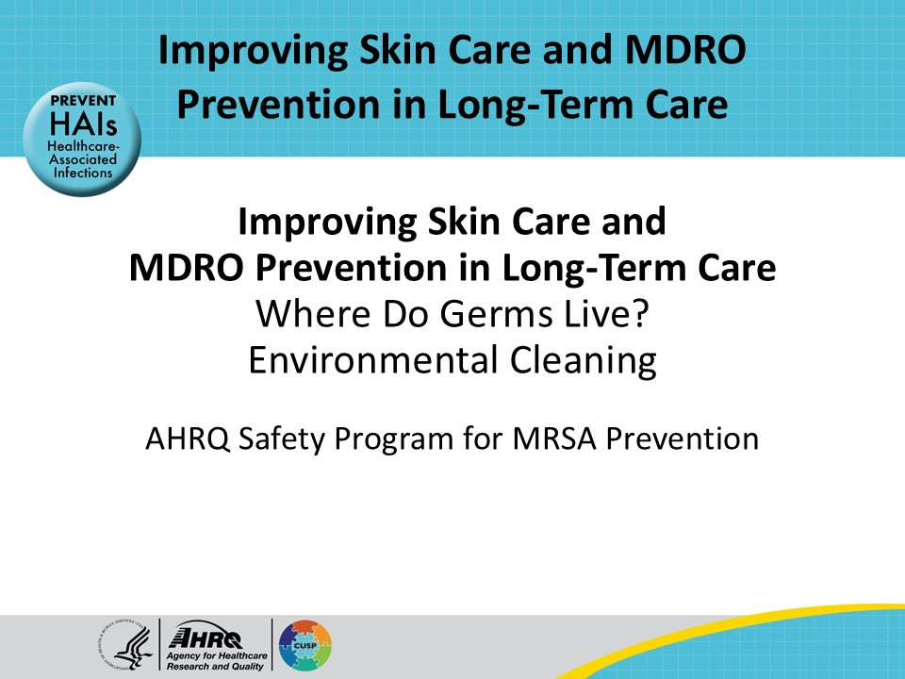
All Staff Support Resident Care and Safety  SAY:  The information provided in this presentation is important in the care of long-term care (LTC) residents. In LTC facilities each member of the facility’s staff supports resident care and safety. Some actions described in these presentations may not be in your scope of practice, but it is important to learn how all staff contribute to resident care and safety. | Slide 2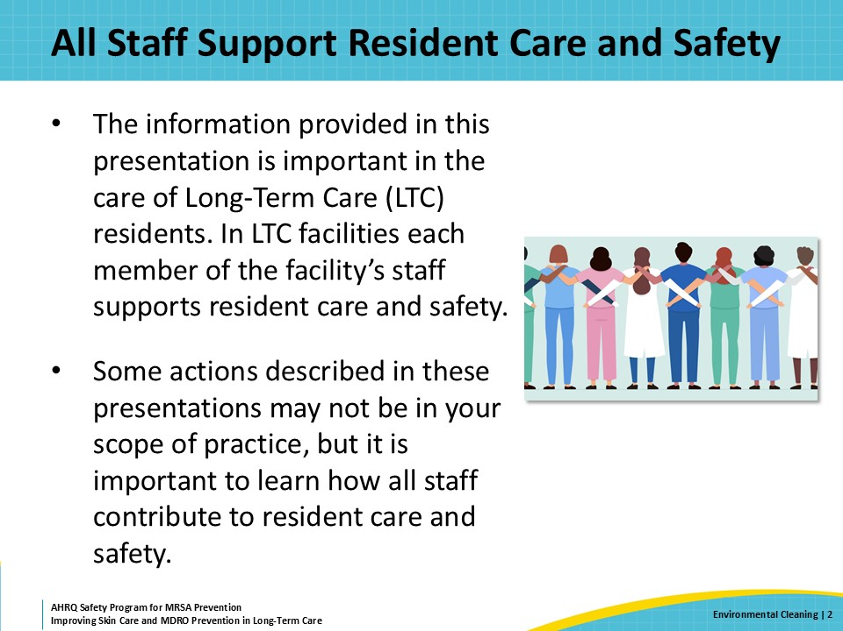
Educational Objectives  SAY:  Viewers of this presentation will be able to recognize the important role of cleaning and disinfecting the environment to prevent and control infections. They will be able to discuss barriers to proper cleaning that are unique to the long-term care setting and will be prepared with some concrete strategies that any member of the healthcare team can use to improve cleaning and help protect residents from infection. | Slide 3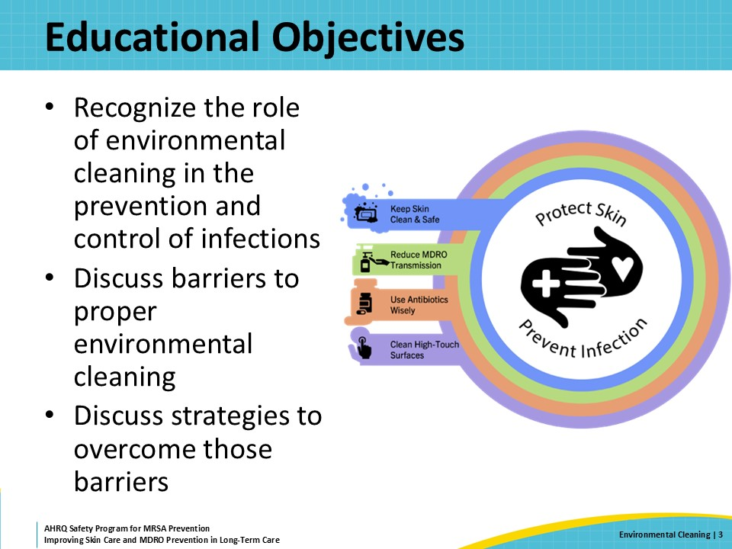
MDRO Contamination of the Environment in LTC  SAY:  In long-term care, contamination of the environment with MDROs is common. This means that major gaps remain in environmental cleaning practices.  A recent study sampled high-touch surfaces across 28 nursing homes in California. The research team found MDROs on surfaces of 74 percent of resident rooms and in 94 percent of common areas. You can see the breakdown of the organisms here, with MRSA being the most common organism recovered.  Long-term care settings can make environmental cleaning particularly challenging for several reasons. Residents live in these settings for a long time, and they often interact, either in the dining room or in common areas during group activities. Consequently, there is contamination of the shared environment by multiple individuals, and therefore environmental cleaning takes on great importance.  Housekeeping staff, however, may not feel comfortable moving personal belongings to clean resident rooms, particularly if a resident has a lot of belongings. They may also not want to disturb the resident in their room, which is effectively their home. | Slide 4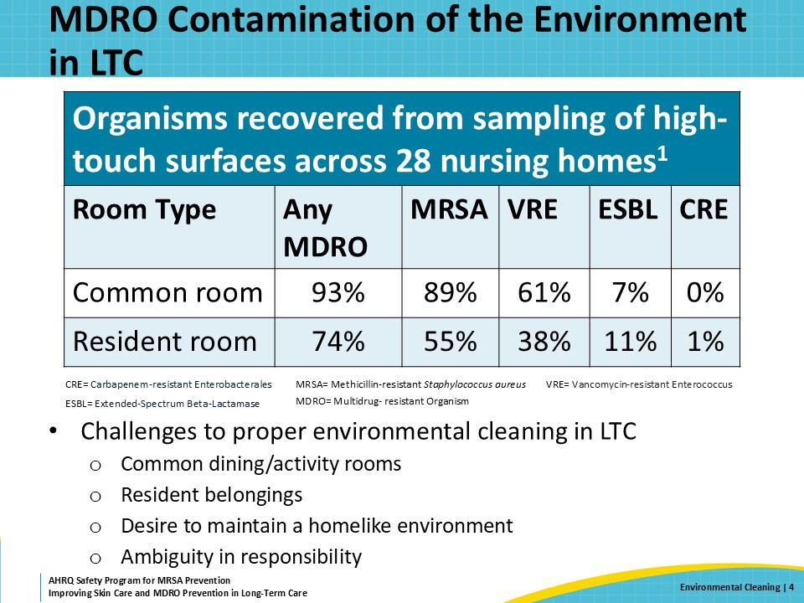
Key Ideas for Staff  SAY:  Numerous studies show enhanced environmental disinfection of high-touch surfaces is associated with a reduction in healthcare-associated infections. High-touch surfaces are where most of the germs are. People touch these surfaces with contaminated fingers, leaving germs behind. Simply stated, cleaning and disinfection improve patient safety.  One of the key ideas in this presentation, which should be emphasized with direct care staff, is their role in protecting the residents by cleaning the environment. In healthcare settings, cleaning is not done just to make an area “look nice.” There must be an emphasis on proper disinfection to kill the pathogens on the surfaces so they cannot be transmitted to others. This means knowing who is responsible for cleaning and disinfecting each of those high-touch surfaces. It also means using the appropriate cleaning supplies, which can change depending on the pathogen.  Several methods can be used to improve environmental cleaning processes. One is to use a list or checklist to emphasize high-touch surfaces that may need more frequent cleaning. A second method is to reduce ambiguity about which staff members are responsible for cleaning and disinfecting which areas. Do the same people that clean the floors also clean the portable medical equipment?  Finally, education on how environmental cleaning may impact resident outcomes is important because it gives healthcare staff a sense of purpose for doing the job correctly. | Slide 5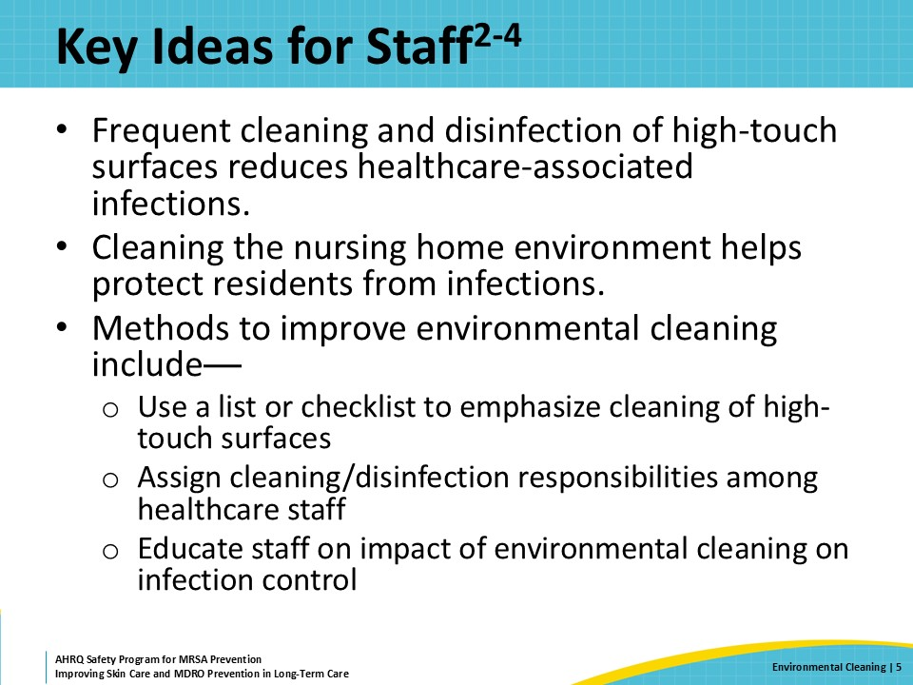
Triangle of Transmission  SAY:  In the triangle of transmission, you can see specific actions that can be taken to prevent the spread of pathogens in and from the environment. Cleaning and disinfecting surfaces and equipment removes pathogens from the environment. This prevents the spread of pathogens to healthcare workers and residents when they touch these surfaces.  Since pathogens contaminate the environment, it’s important to be mindful of the surfaces that are touched during day-to-day tasks. This mindfulness helps us to recognize when a surface may be contaminated. Frequently touched surfaces, such as doorknobs and call buttons, have a higher likelihood of contamination and represent another moment for hand hygiene. These are also surfaces that should be cleaned and disinfected regularly. | Slide 6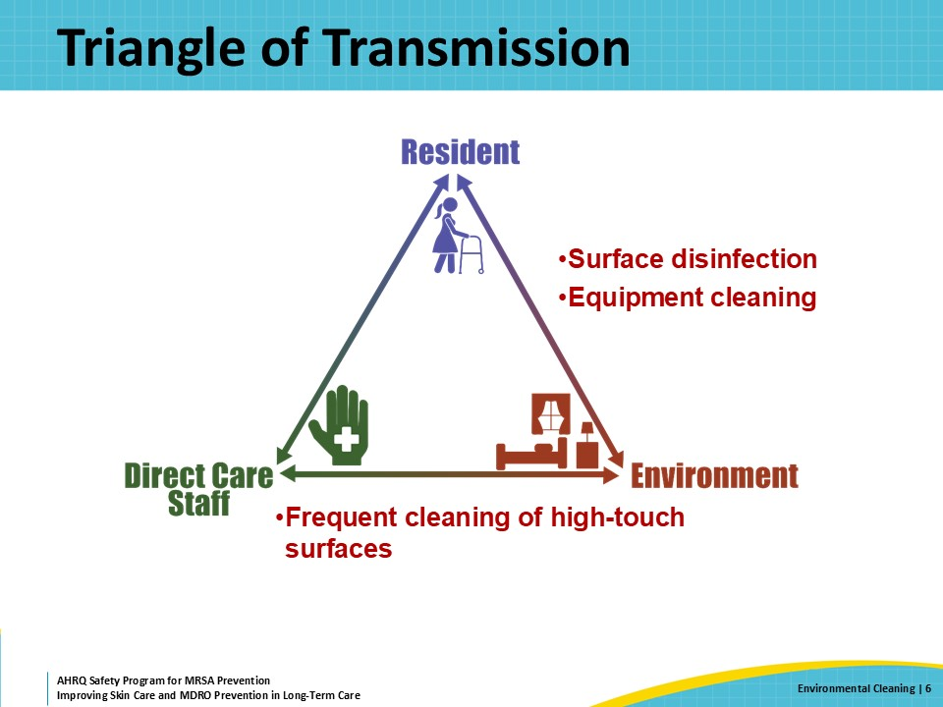
Why Is Environmental Cleaning Important?  SAY:  Helping direct care staff understand the role of the environment in the transmission of pathogens is key to ensuring proper cleaning and disinfection. Terms like “contact times” or “dwell times” don’t make a lot of sense if there is no understanding of the potential threat of contamination on surfaces and the need to kill the organisms on those surfaces.  Some pathogens can survive on surfaces for hours to months. Those pathogens can be picked up by a healthcare worker’s hand and spread to other people or surfaces. Cleaning and disinfecting the environment physically removes and kills those pathogens. When cleaning and disinfection is not done well, then the pathogens can stay on surfaces in the environment.  Poor cleaning and disinfection include improper techniques, such as wiping a disinfectant solution off a surface too soon—before the product has had enough time to kill the pathogens. Other mistakes can include using the wrong agent, not making fresh solutions daily, or mixing products. Another problem is when cleaning and disinfection does not actually happen or does not happen frequently enough.  Poor cleaning and disinfection have contributed to outbreaks and transmission of healthcare-associated infections. | Slide 7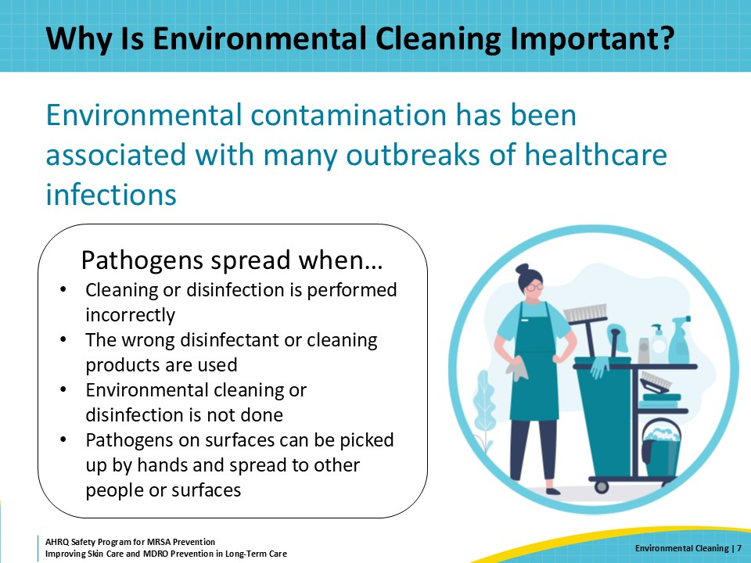
Cleaning Versus Disinfection  SAY:  Cleaning and disinfection are different processes. Cleaning is the physical removal of visible soil in the environment. For example, if a resident is incontinent of urine on the way to the bathroom, cleaning the floor means wiping up urine and making the area dry. This is a necessary step before disinfection. Cleaning includes several different methods, such as mopping, vacuuming, scrubbing, and wiping surfaces.  Disinfection kills pathogens on surfaces and occurs after the cleaning step is complete. Just as there are different ways to clean, there are also different ways to disinfect. For most surfaces, disinfection requires a disinfectant solution that remains wet on a surface for a specific period to kill pathogens. This is what is referred to as contact time. Some disinfectants, such as those used to kill spores, like Clostridioides difficile or C. difficile, require a contact time of 10 minutes. If no physical soil is present, then cleaning and disinfection can take place simultaneously.  Reusable equipment also needs to be disinfected before being used in the care of a different resident. While this is readily achievable for some equipment, like the poles used to hang bags of intravenous fluids, it may be challenging for other equipment, such as wheelchairs or the equipment used during physical or occupational therapy. It is important that everyone in the facility knows exactly what they are responsible for disinfecting, so that these materials are not missed. | Slide 8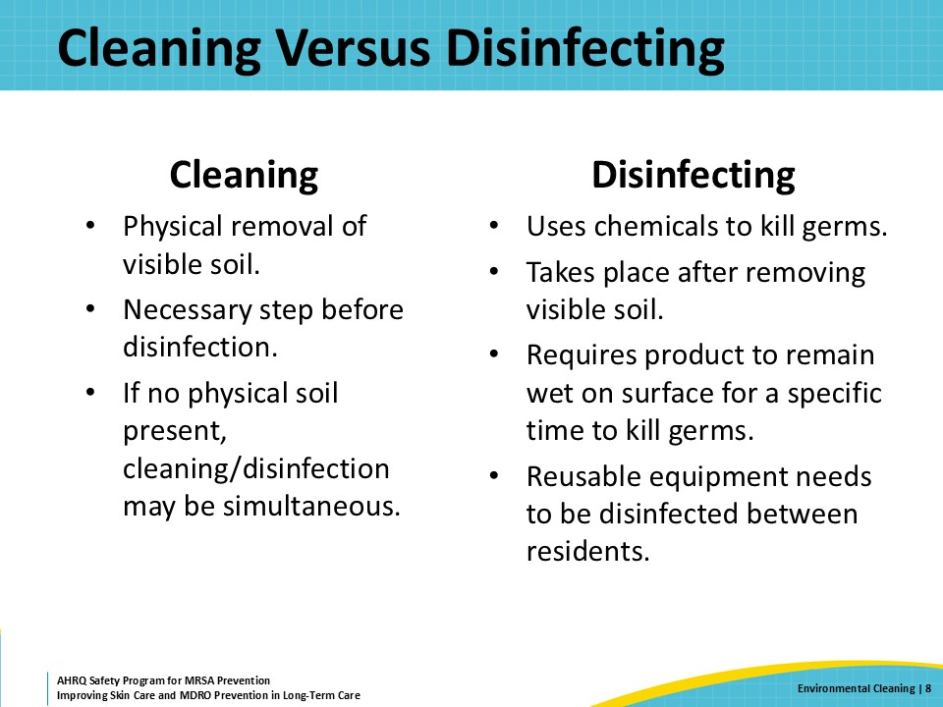
Cleaning and Disinfection Challenges  SAY:  There are many challenges to effective cleaning and disinfection in the long-term care setting.  The physical surfaces themselves can be challenging. Achieving 3 to 10 minutes of contact time for a cleaning and disinfection agent on the floor is feasible. Doing the same for other surfaces, such as a toilet seat, bedrail, or the handle and underside of a bedside table, is not always readily accomplished. Yet these are all surfaces that are touched frequently by residents and direct care staff.  The cleaning agents also present challenges. People working in environmental services or EVS may have been told to avoid applying cleaning products to specific surfaces due to the corrosive effects of some cleaning agents over time, while direct care staff may not have received this kind of training. This means that there are places that people touch frequently that may go uncleaned. In a resident’s room, these high-touch surfaces include handles to drawers or wardrobes, soap dispensers, dividing curtains, and the buttons used to raise and lower beds.  The presence of personal belongings can make it challenging to clean. If a sink area is cluttered with personal hygiene products, cleaning the sink may be challenging. A bathroom shared by two or more residents makes this even more difficult. If a bedside table has magazines, a cell phone, tissues, and snacks—that also becomes a cleaning problem.  Additionally, some facilities may have written or unwritten rules about who is permitted to touch residents’ belongings, and therefore, who is permitted to clean the surfaces on which those belongings are placed. If EVS workers do not touch or move resident belongings, then someone else may have to do the cleaning. This could fall to nurses or nurse aides, who already have an array of other responsibilities and are generally not trained in the use of cleaning or disinfecting in healthcare settings. Or it might become the task of the resident themselves or their family members—this ambiguity in delegation of responsibilities can often lead to missed steps. | Slide 9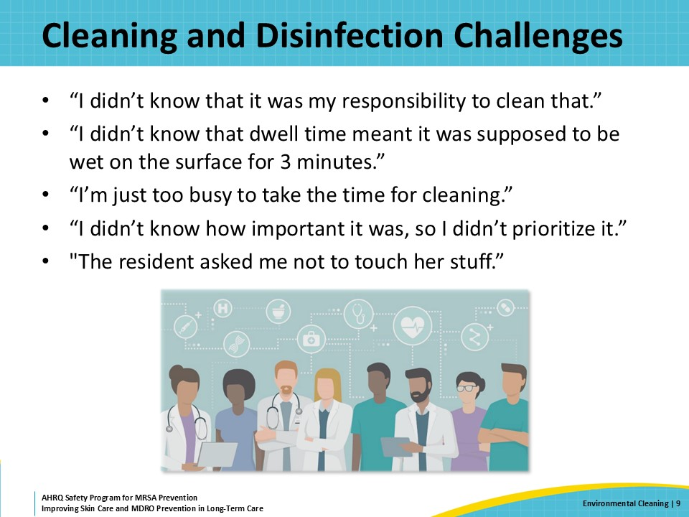
Who Is Responsible?  SAY:  Cleaning and disinfection are part of how residents are kept safe by their facilities. Everyone is responsible for resident safety.  As mentioned above, housekeeping or environmental services is responsible for the cleaning and disinfection of many areas within the healthcare environment. Cleaning and disinfection are also part of the responsibilities of people working in other roles.  Clinical staff clean and disinfect medical devices, such as blood glucose monitors or vital machine carts between residents. Nurse aides change bed linens. Hoyer lift pads must get laundered periodically.  Yet, there may be many surfaces that are used every day that do not get cleaned or only get cleaned periodically. These include medication carts, computer keyboards and mice, telephone handsets, remote controls, keypads, and doorknobs for entry into medication and supply rooms.  Clear delegation on who is responsible for cleaning what ensures that surfaces and items are not overlooked. | Slide 10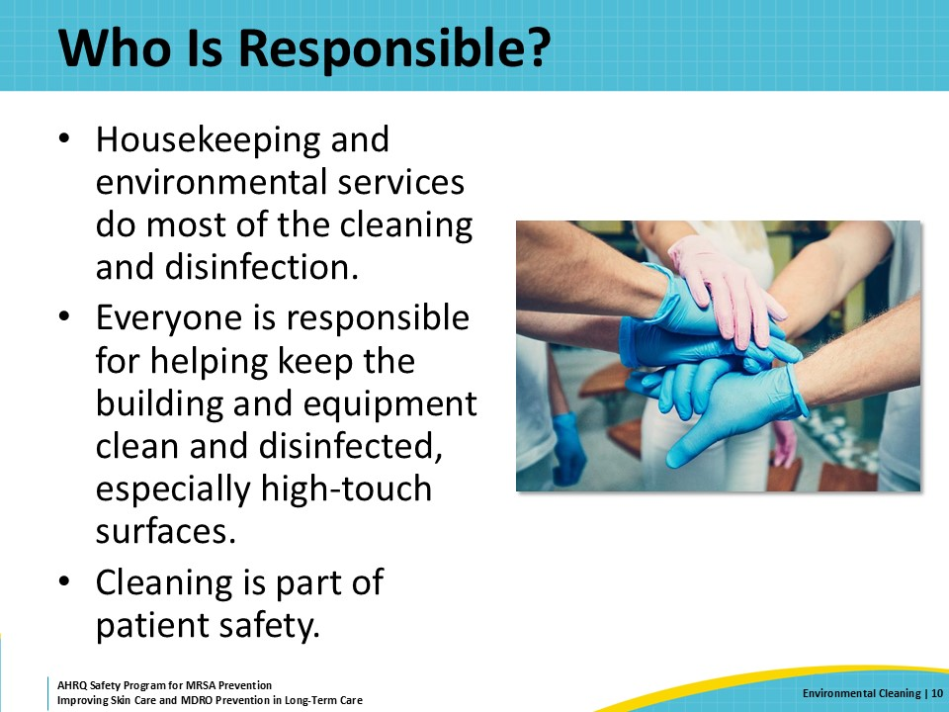
How Do We Clean or Disinfect?  SAY:  As previously mentioned, cleaning must take place before disinfection, when visible soil is present. We must remove dirt, bodily fluids, and other forms of visible soil from a surface before disinfecting it to kill the germs. In addition to knowing what disinfectant to use, we must know how to correctly use it. Disinfectants all have a dwell time, otherwise known as the contact time or a wet time. This is the amount of time that a surface needs to remain wet with the disinfectant for it to kill germs. Contact times range from 1 to 10 minutes. It is important to know the contact times for the disinfectants that your facility is carrying. It helps to have a list and clearly display the contact times on a sticker on each cleaning product.  When rooms are being cleaned, clean those areas or rooms for residents on isolation for an infectious organism last. This helps prevent transmission.  Also, some germs are more difficult to remove and disinfect than others. Pay attention to these requirements. For instance, C. difficile requires friction and a sporicidal product. Handwashing with soap and water is required after cleaning a room where the resident is on isolation precautions for this bacterium. | Slide 11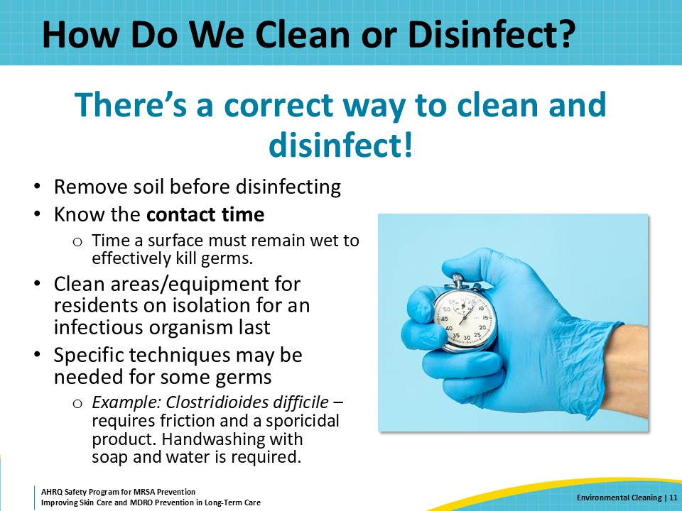
Standardize the Cleaning Process  SAY:  There are a few basic steps to help improve and standardize the cleaning process.  The first is that when cleaning an area, you should always work from clean to dirty areas. This means cleaning the bathroom last.  In general, when cleaning it is best to work from top to bottom, cleaning higher areas first and floors last—this is because higher areas are usually cleaner than the floors.  It is particularly important for nurses, physical therapists, and other non-EVS staff to know which shared equipment they are responsible for cleaning. Nurses are responsible for cleaning glucometers and blood pressure cuffs after each use. Physical therapy is responsible for wiping down equipment after use, and so on.  Finally, change cleaning materials frequently to prevent recontamination. Cleaning efforts will be futile if a dirty cloth is used to wipe down a relatively clean surface. The use of disposable wipes can be helpful, particularly for things like computer keyboards or phone receivers. | Slide 12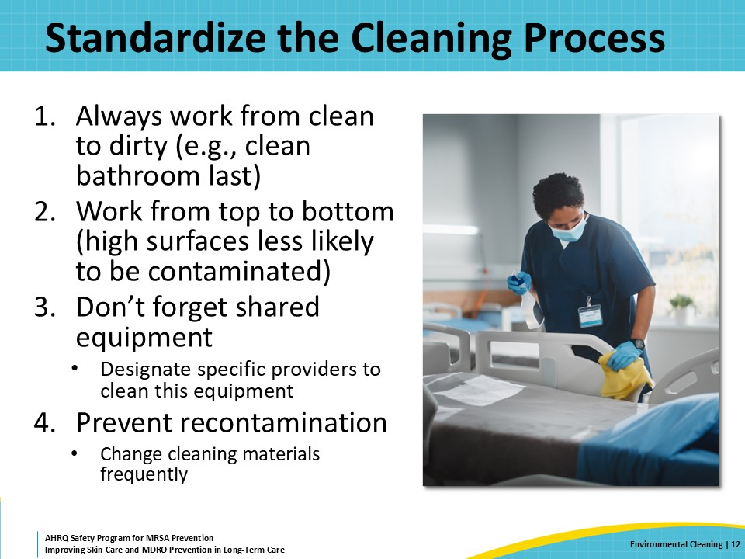
Teachable Moment  SAY:  This Teachable Moment will look at a case with a resident who has dementia, who is on contact precautions for C. difficile, and who also needs a bath.  Please keep the following questions in mind during the presentation:  - What should the certified nursing assistant or CNA do before entering a room with a resident who has an active C. difficile infection?  - What steps should the CNA follow before leaving the room?  The next few slides will review some of the challenges the CNA encounters, and errors that happen during the process. | Slide 13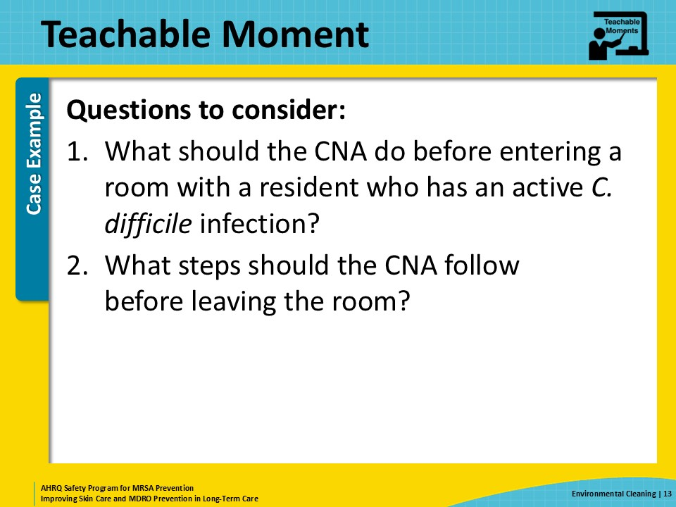
The Case  SAY:  Mr. Lee is an 82-year-old resident with dementia. He was recently treated with a broad-spectrum antibiotic for concerns about an aspiration event. Unfortunately, he then developed a C. difficile infection. His diarrhea has finally slowed down. It’s time to get a bed bath and get cleaned up.  The CNA who is preparing to give Mr. Lee a bed bath gathers the necessary materials, including a towel and a wash basin, pauses outside his door. | Slide 14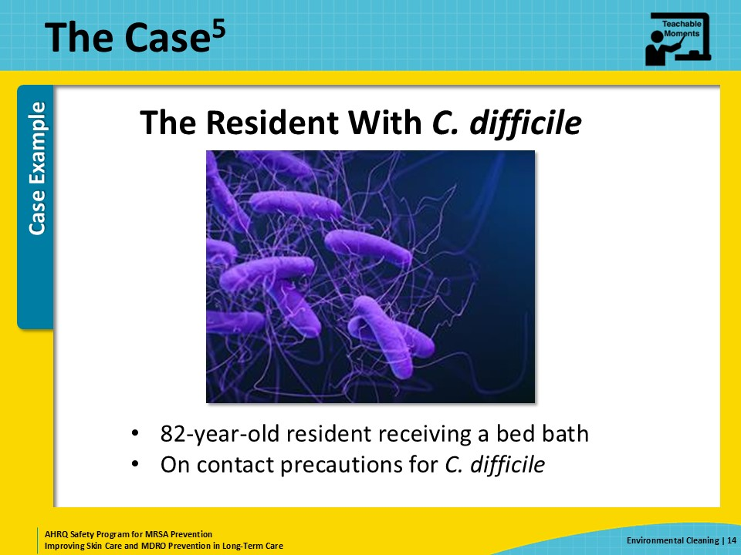
Knowledge Check–1  SAY:  Let’s pause with the CNA. This resident has an active C. difficile infection and is on contact precautions. What should the CNA do before entering the room to bathe Mr. Lee?  The CNA needs to perform hand hygiene, put on a gown, and last, put on gloves.  Everyone entering the room should perform hand hygiene, then don a gown and gloves, regardless of what task they are going to perform in the room. For room entry, hand hygiene can be either alcohol-based hand sanitizer or soap and water. The gown helps prevent C. difficile spores in the environment from getting on the clothes of healthcare workers while they are in the room.  When she’s ready to leave the room, the CNA should remove her gown first. She should do this by pulling the gown off from the front—strong person style—and then continue to remove the gown while avoiding touching her gloves on her clothes. Once the gown and gloves are off, the CNA then needs to perform hand hygiene and perform vigorous handwashing with soap and water. This is one instance where alcohol-based hand sanitizer will not be sufficient after providing care. Hand sanitizer is not effective against C. difficile spores. Washing hands with soap and water washes the C. difficile spores off skin and down the drain. | Slide 15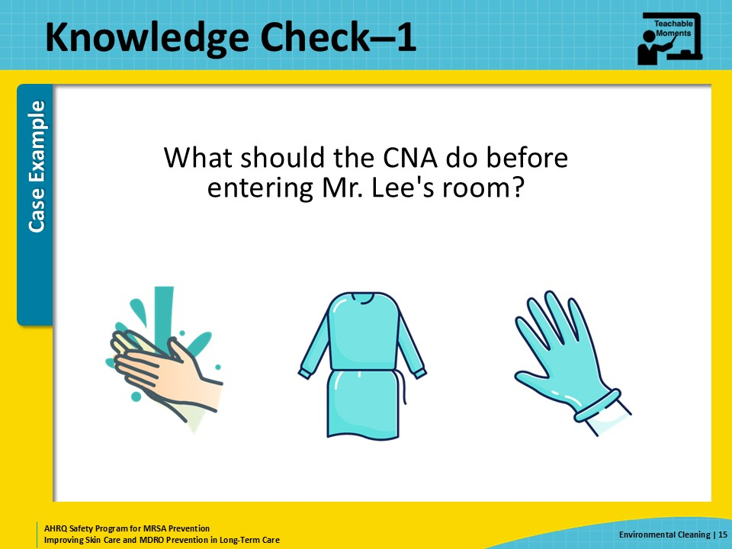
The Challenge  SAY:  Unfortunately, during the bed bath, Mr. Lee becomes incontinent of stool. Because he is confused, he doesn’t know how to avoid touching the stool with his hands. Before the CNA can prevent him from doing so, Mr. Lee touches the bedside table with his hands that are now covered in stool. Now, both Mr. Lee and the bedside table are contaminated with stool containing C. difficile. | Slide 16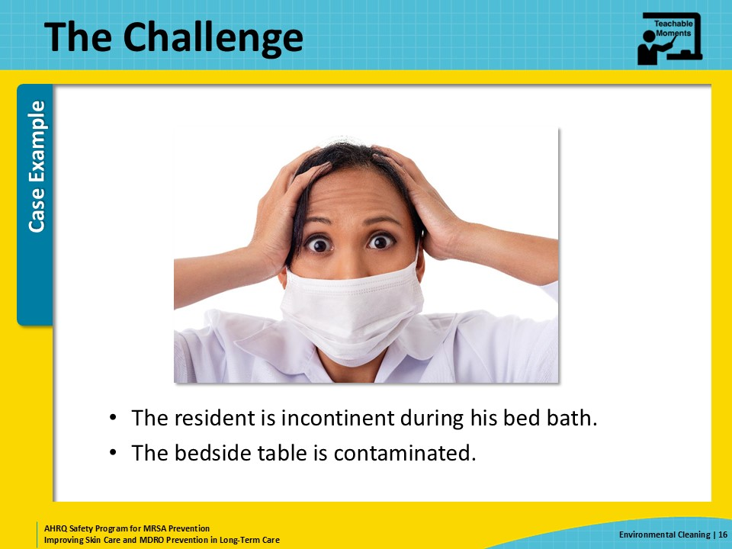
Knowledge Check–2  SAY:  Let’s pause again. The CNA is alone in the room, trying to bathe the resident, and now there is infectious stool on the resident as well as the bedside table. Who is responsible for cleaning this up?  The answer is the CNA. In this instance, the CNA needs to clean the feces off the table and off the hands of the resident, after moving the table out of the reach of the resident.  There are often issues with delegation of tasks between nurses and environmental services. Making sure that there is open dialogue between different teams with clear delegation of tasks helps ensure that vital cleaning practices are not missed.  If the CNA does not have the proper materials or does not know which materials are appropriate to clean the bedside table after it is clean, she should pause and get help from EVS or her supervisor. | Slide 17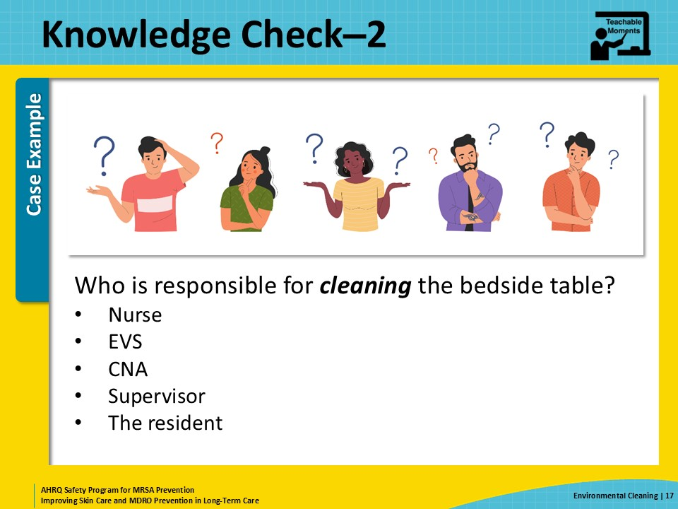
Steps for Cleaning the Table  SAY:  What are the steps the CNA should take after the table and resident have become contaminated with stool?  First, the CNA should move the table out of the reach of the resident.  Next, she should clean the resident’s hands and address the stool incontinence.  After the resident has been cleaned up and is settled safely in his bed, the CNA can turn her attention to the bedside table.  First, the visible soil on the table will need to be removed. This is the cleaning step. This can be accomplished using several different options, such as a wet wipe or a wet cloth.  After cleaning, the table needs to be disinfected. Most bacteria on an environmental surface will dry out and die in a day or so, but unfortunately, C. difficile forms spores, which are like hard microscopic balls. Spores can stay on surfaces for months and, if picked up on someone’s hands, can get ingested and potentially lead to a new infection.  The CNA uses bleach wipes provided by the facility to disinfect the bedside table. The bleach wipes have a 5-minute contact time, but the CNA only allows the surface to remain wet for 1 minute. Also, she did not remove her gloves after removing the visible soil from the table. She continues to use the same pair of gloves after cleaning the resident and bedside table. | Slide 18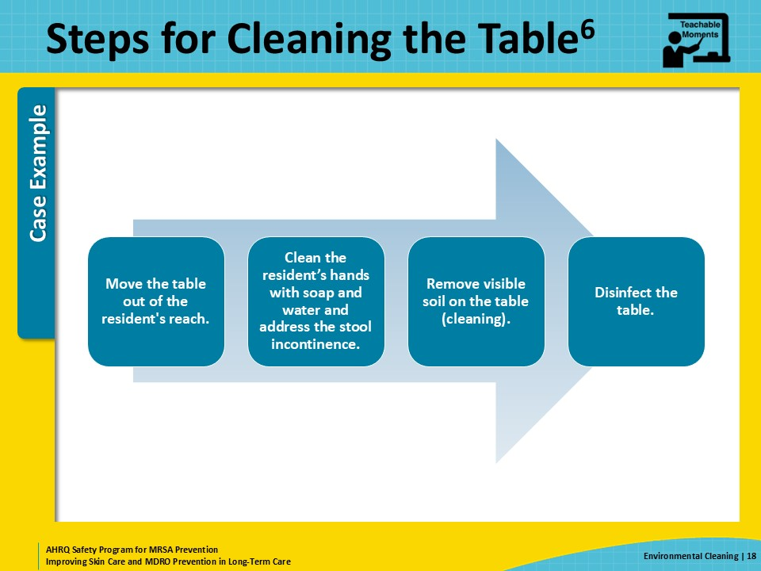
The Error  SAY:  What errors were made?  After removing the feces from the table, the CNA uses bleach wipes to disinfect the table. As part of the building’s infection prevention protocol for residents with C. difficile infection, the wipes in the room are sporicidal, so this was a good choice. However, to be effective, the information on the wipes states a contact time of 5 minutes. The CNA did not know this and assumed that 1 minute would be plenty of time for the product to work.  Unfortunately, the bedside table still has C. difficile spores on it.  A second error is that she did not remove her gloves until after she was done in the room and ready to doff all her PPE. Even though her gloves were not visibly soiled, there were still C. difficile spores on them, which can be transferred to every surface in the room she touches. That includes the outside of the wipes container, the bedside table, the bedrail, the call button she put within the resident’s reach, and the water jug she placed back on his bedside table after she finished wiping it off. | Slide 19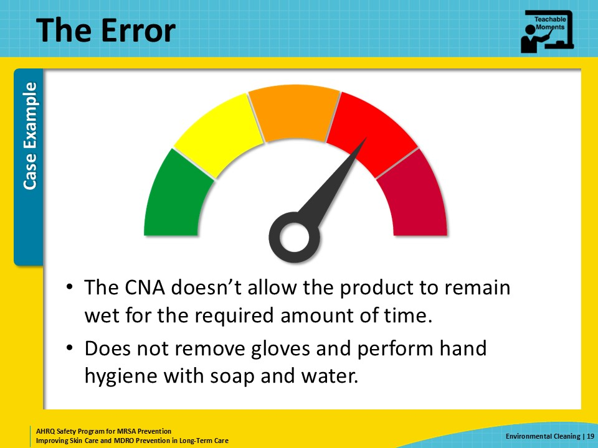
Potential for Patient Harm  SAY:  Later that day, the CNA comes back into Mr. Lee’s room. She wears appropriate PPE and gloves as she brings in fresh linens and does some straightening up. One task is to refill his water jug, but she doesn’t realize it is contaminated with C. difficile spores. She hands the jug to a colleague who refills the jug from a pitcher on a cart just outside the room. That person wears gloves while handling the water jug and pitcher. He does not change those gloves or wipe down the pitcher before moving on to the next resident’s room. When he helps refill the water jug for that next person, C. difficile spores contaminate the outside of their water jug. Two days later, that resident, who was recently on antibiotics for pneumonia, develops a C. difficile infection. | Slide 20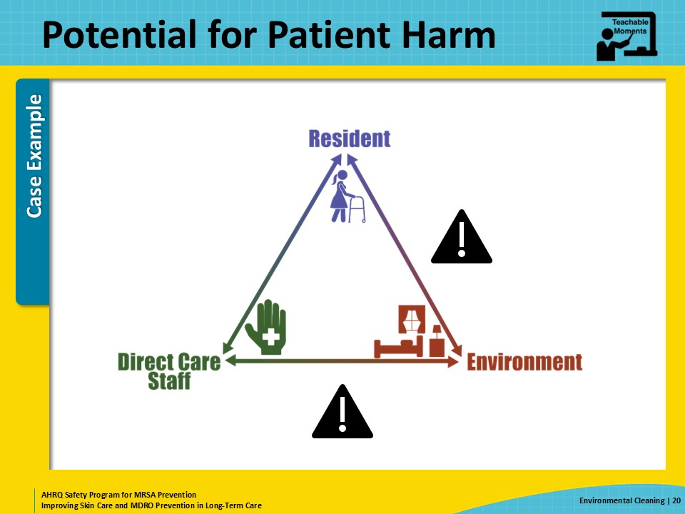
Patient Safety in the Moment  SAY:  What should the CNA have done instead?  - After cleaning up the feces, she should have removed her gloves and washed her hands with soap and water.  - If she could not wash her hands well because the gown had thumbholes and these were covering part of her hands, she should have removed the gown, washed, and then donned a new gown and gloves.  - If she did not know how to disinfect the surface for C. difficile, she should have gotten help from a supervisor of someone from EVS staff.  - She should have allowed the solution from the wipe to remain on the bedside table for 5 minutes. This information is usually on the outside of the container, but she may not have known to consider contact time for products or that disinfecting for C. difficile is different from disinfecting for most other pathogens. | Slide 21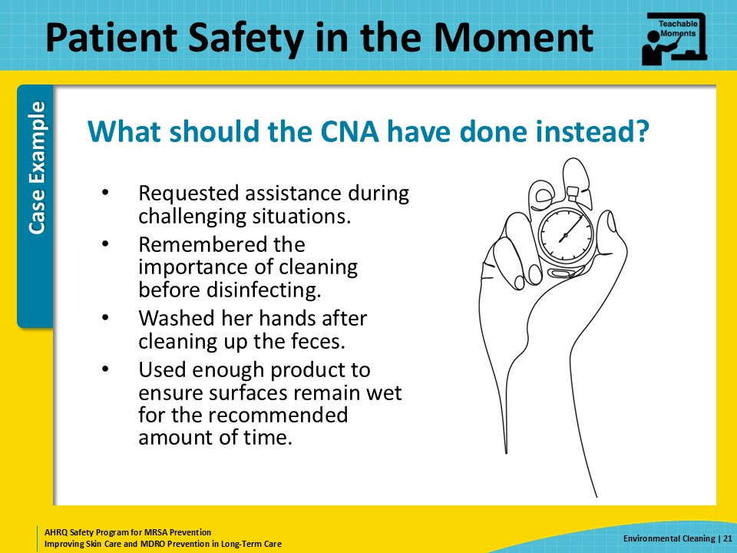
Preventing the Next Harm  SAY:  Unless the CNA is specifically taught about contact times for various products and different pathogens, it’s not reasonable to expect her to know how to use them in the moment. When there are residents with a C. difficile infection, the staff caring for them should get targeted education. Staff members needing this education should include nurses, housekeeping, environmental services workers, and anyone else who will have direct contact with the resident or their room. Educational topics should include: how C. difficile spreads, signs and symptoms of C. difficile infections, the importance of hand hygiene with soap and water, and the correct use of sporicidal agents, including wipes.  Developing and implementing this kind of educational program takes leadership support. This program should be ready to go when there is a resident identified with a pathogen for which typical cleaning agents and standard precautions are not sufficient, especially when this is not a common occurrence in a facility. While it may seem repetitive to have to continually provide this kind of education, this is also necessary to support long-term change to the culture of the institution.  A relatively easy and effective intervention is adding large and bright stickers on the outside of containers of disinfectant denoting the contact times. The stickers serve as a reminder to staff that contact time is important when disinfecting, and keep them from having to memorize this information, particularly if disinfection agents change frequently. | Slide 22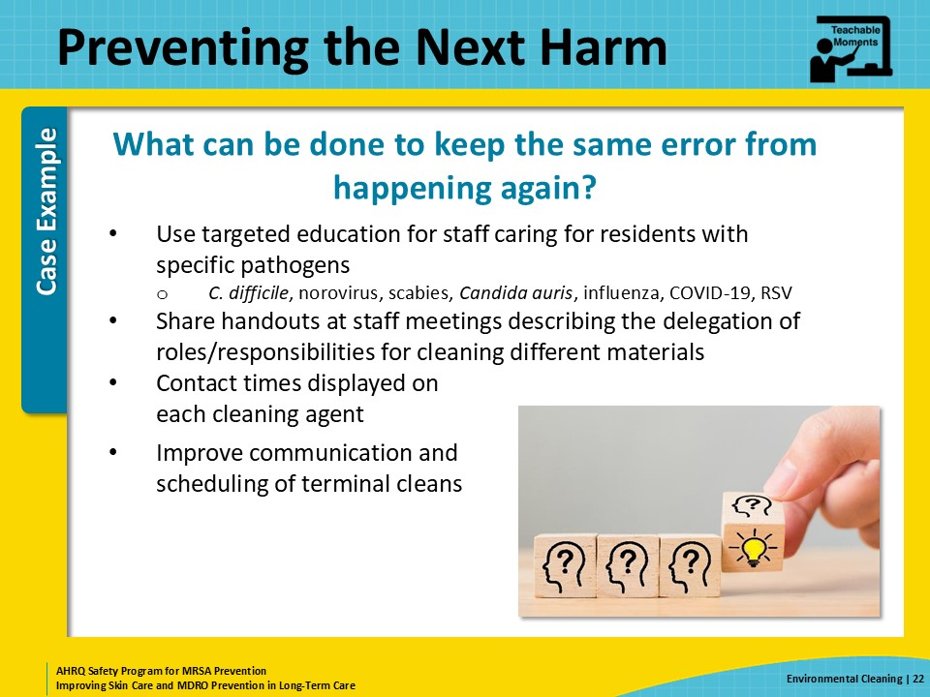
System-Based Safety Challenges  SAY:  A few interventions can be brought to senior executives that could make a difference in the effectiveness of cleaning and improve the efficiency of staff responsible for environmental cleaning.  Investing in solutions that have shorter contact times but comparable efficacy can have a huge effect on efficiency for staff. Waiting 10 minutes and remembering to come back to the surface can be really challenging.  Microfiber cloths and mops help trap harmful germs and debris. Consider switching to microfiber for cleaning and disinfection practices in your building.  Finally, make sure there is a process for communication and scheduling of terminal cleans. Terminal clean timing can affect all levels of staff. With more notice and understanding of the process, staff can arrange their day to help improve their ability to do an effective job on this important task. | Slide 23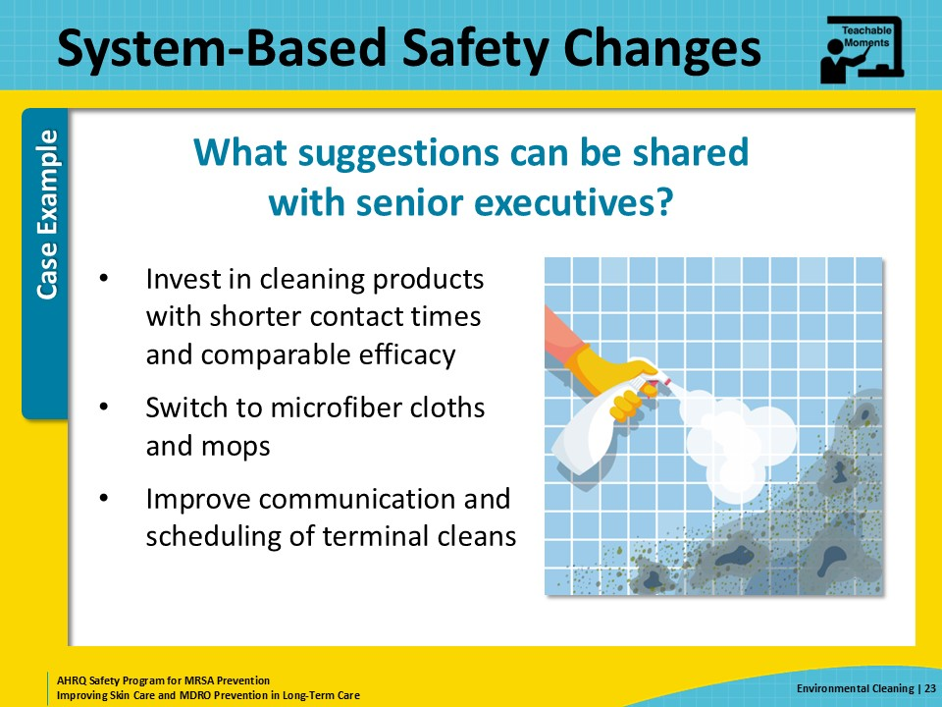
Key Takeaways  SAY:  There are four key takeaways from this webinar.  - Everyone is responsible for helping to keep the building and equipment clean and disinfected.  - Cleaning involves removing dirt and visible soil from surfaces. Disinfection is about removing and killing microscopic pathogens—which are invisible to our naked eyes—from surfaces.  - When cleaning, work from clean to dirty areas, and top to bottom. Change the cloths, mop heads, and other materials used for cleaning frequently.  - Some pathogens, like C. difficile, need special cleaning and disinfection products. | Slide 24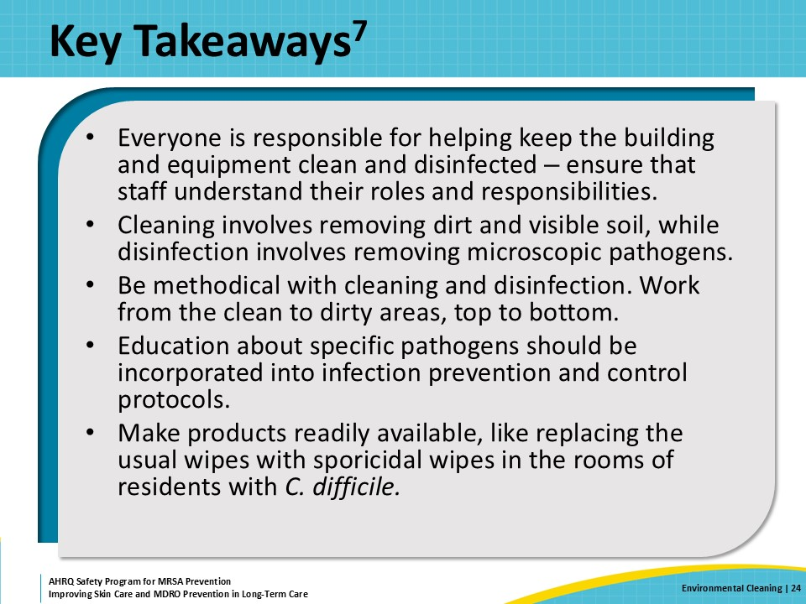
Supporting Materials  SAY:  Additional materials that coordinate with this presentation can be found in this toolkit. The materials include—  - Teachable Moments based on the content from this webinar, including—  - The Case of the Resident With a Chronic Wound and Diarrhea  - Cleaning and Disinfection Teachable Moment  - Environmental Cleaning of High-Touch Surfaces  - Disinfection at the Bedside  - How Long Do Pathogens Live on Environmental Surfaces?  - Supporting materials based on the content from this webinar  - Six Steps for Safe and Effective Disinfectant Use  - Links to the following external sources  - Environmental Cleaning in Global Healthcare Facilities with Limited Resources (Centers for Disease Control and Prevention)  - Implementation manual to prevent and control the spread of carbapenem-resistant organisms at the national and health care facility level (World Health Organization)  - Cleaning Chemicals (in four languages) (Occupational Safety and Health Administration)  - Environmental Cleaning and Disinfecting Basics for Health (AHRQ) | Slide 25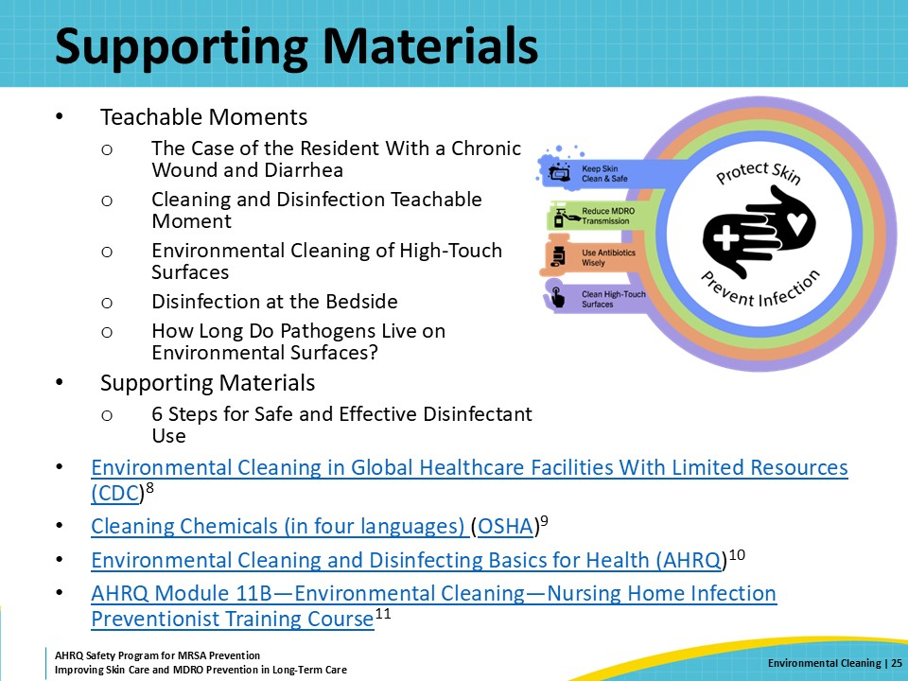
Disclaimer  SAY:  The findings and recommendations in this presentation are those of the authors, who are responsible for its content, and do not necessarily represent the views of AHRQ. No statement in this presentation should be construed as an official position of AHRQ or of the U.S. Department of Health and Human Services.  Any practice described in this presentation must be applied by healthcare practitioners in accordance with professional judgment and standards of care in regard to the unique circumstances that may apply in each situation they encounter. These practices are offered as helpful options for consideration by healthcare practitioners, not as guidelines. | Slide 26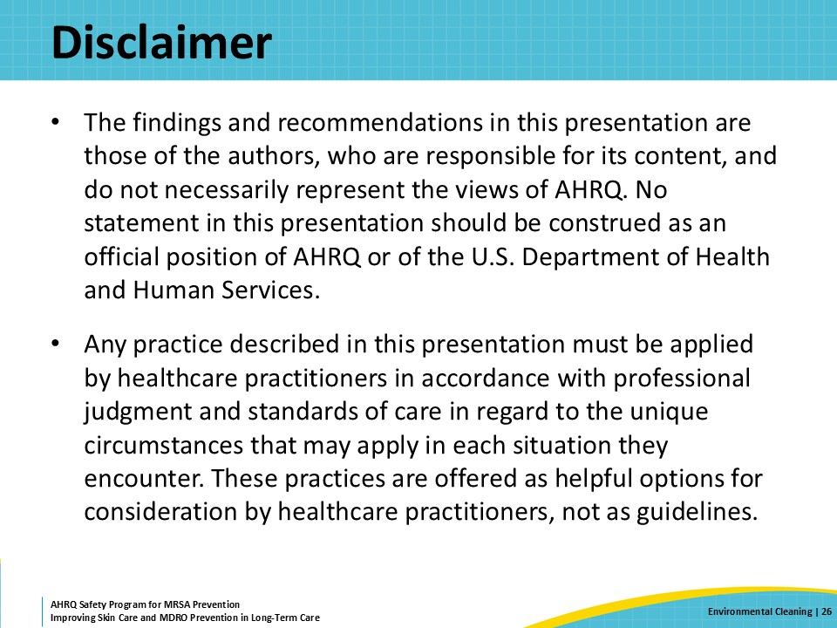
References—1  Here are the references for this presentation. | Slide 27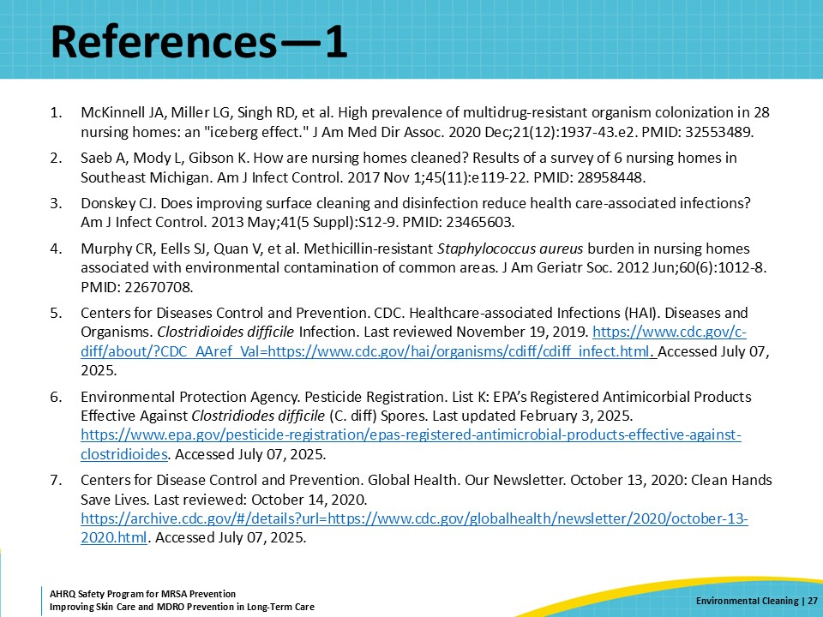
References—2 | Slide 28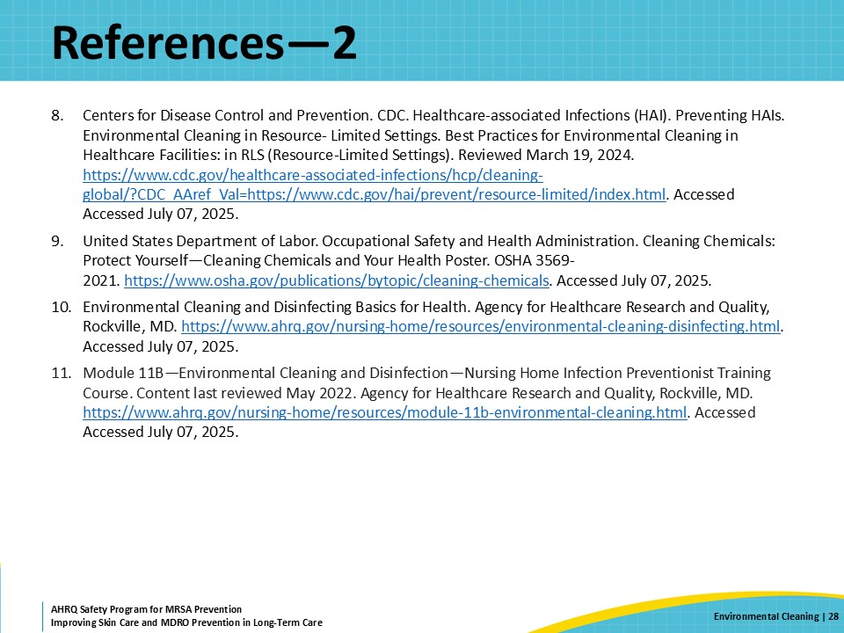
AHRQ Pub. No. 25(26)-0066
October 2025

