Cleaning and Disinfection
AHRQ Safety Program for MRSA Prevention

Cleaning: removing visible soil from surfaces. 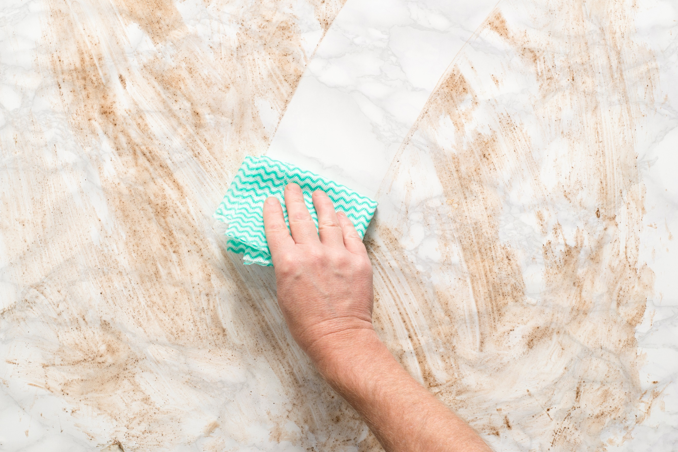
Disinfection: using a chemical solution to kill pathogens. 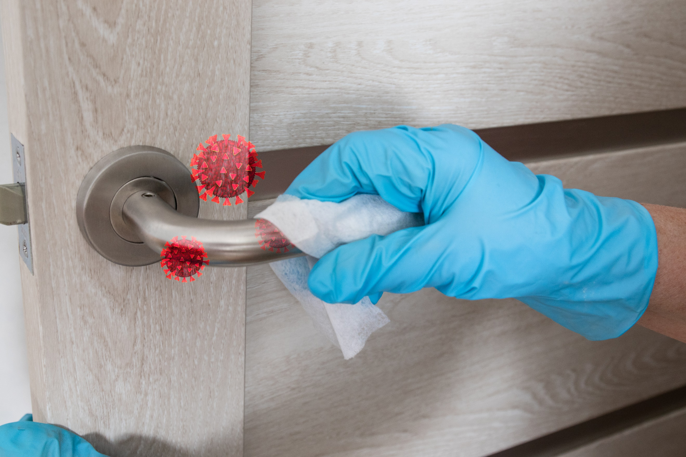

Always refer to product checklists showing contact/dwell times for each disinfectant. If contact/dwell times are not followed, the disinfectant will not kill the pathogen on the surface. Contact times can range from as little as 15 seconds (for hand sanitizer) to as long as 30 minutes for chlorine oxides used in laboratories.

Knowledge Check
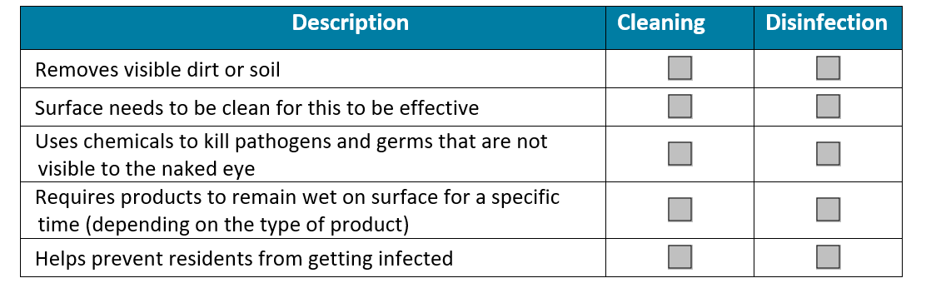
- For each row, check the box if the phrase applies to cleaning or disinfection or both.
- What is the correct order for cleaning and disinfection?
- Clean first, then disinfect. Surfaces need to be clean before they can be effectively disinfected.
- Disinfect first, then clean. Surfaces need to be disinfected before they can be cleaned.
- It does not matter. Do whatever is easiest to get the job done.
- What is a contact or dwell time?
- The amount of time spent wiping down a surface.
- The amount of time spent in the room with the resident.
- The amount of time disinfectant needs to sit on the surface, without being wiped away or disturbed, to kill pathogens.

Answers
- For each row, check the box if the phrase applies to cleaning or disinfection or both.
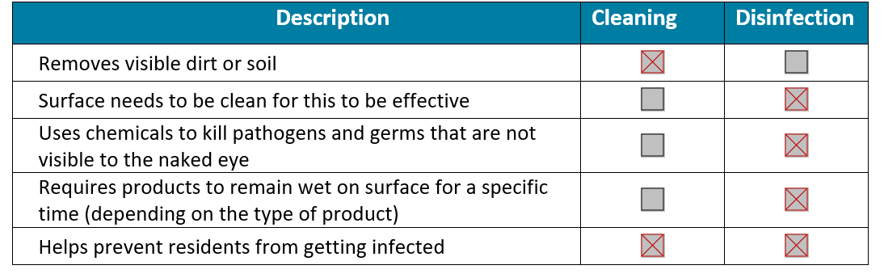

- What is the correct order for cleaning and disinfection?
a. Clean first, then disinfect. Surfaces need to be clean before they can be effectively disinfected.
- What is a contact, or dwell time?
c. The amount of time disinfectant needs to sit on the surface, without being wiped away or disturbed, to kill pathogens.

AHRQ Pub. No. 25(26)-0066
October 2025

