Environmental Cleaning of High-Touch Surfaces
AHRQ Safety Program for MRSA Prevention

*CLEAN FROM CLEAN TO DIRTY/TOP TO BOTTOM*
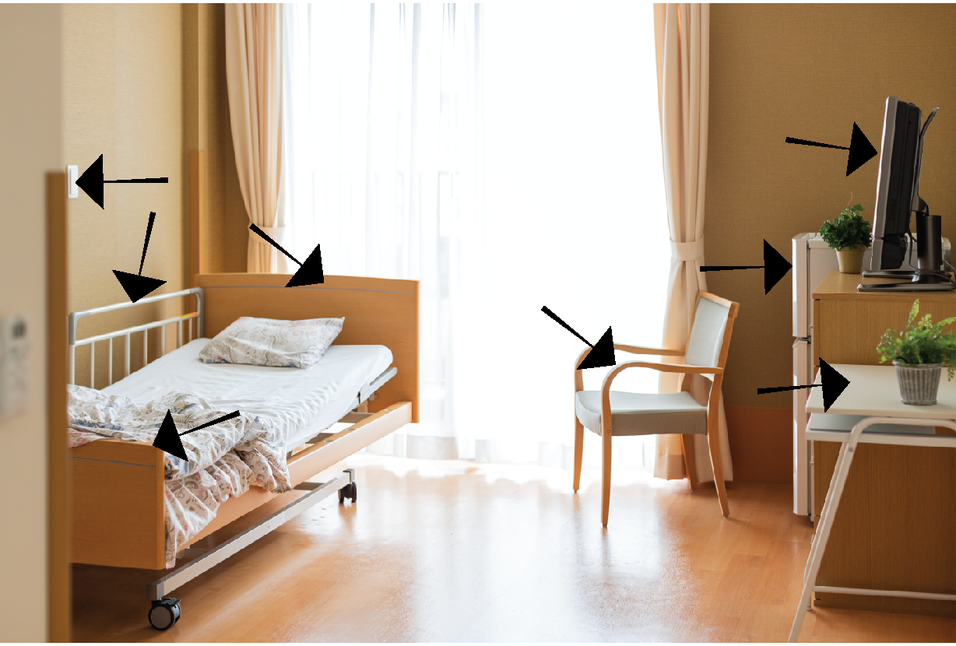
Common high-touch surfaces in resident rooms include:
- Bedrails
- Intravenous poles
- Bedside/tray tables
- Edges of privacy curtains
- Call buttons
- Drawer handles
- Doorknobs
- Light switches
- Sink handles

Common high-touch surfaces other places in the building include:
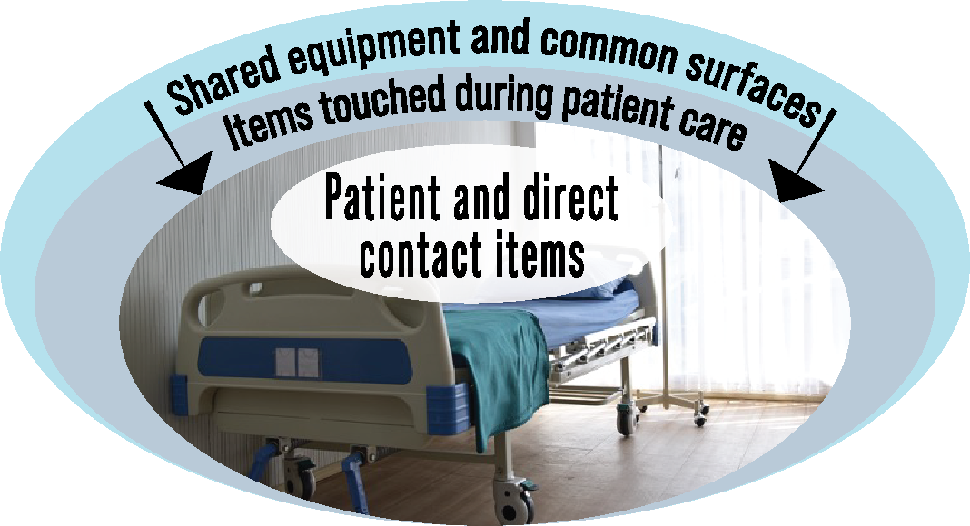
- Sink handles
- Counters where medications and supplies are prepared
- Transport equipment (e.g., wheelchair handles)
- Doorknobs
- Keypads for entry into rooms
- Elevator buttons
- Office equipment (e.g., keyboards, telephones, staplers)

*CLEAN FROM CLEAN TO DIRTY/TOP TO BOTTOM*

Discussion Questions
- Who is responsible for cleaning and disinfecting high-touch surfaces in work areas and break rooms in your building?
- What products are used to clean high-touch surfaces in resident rooms?
- Who is responsible for cleaning residents’ personal belongings in your facility?

