How Long Do Pathogens Live on Environmental Surfaces?
AHRQ Safety Program for MRSA Prevention

Studies have shown pathogens can survive for long periods of time on environmental surfaces. It is important to perform thorough routine cleaning and disinfection. Use this document to help inform staff about how long pathogens live on environmental surfaces.

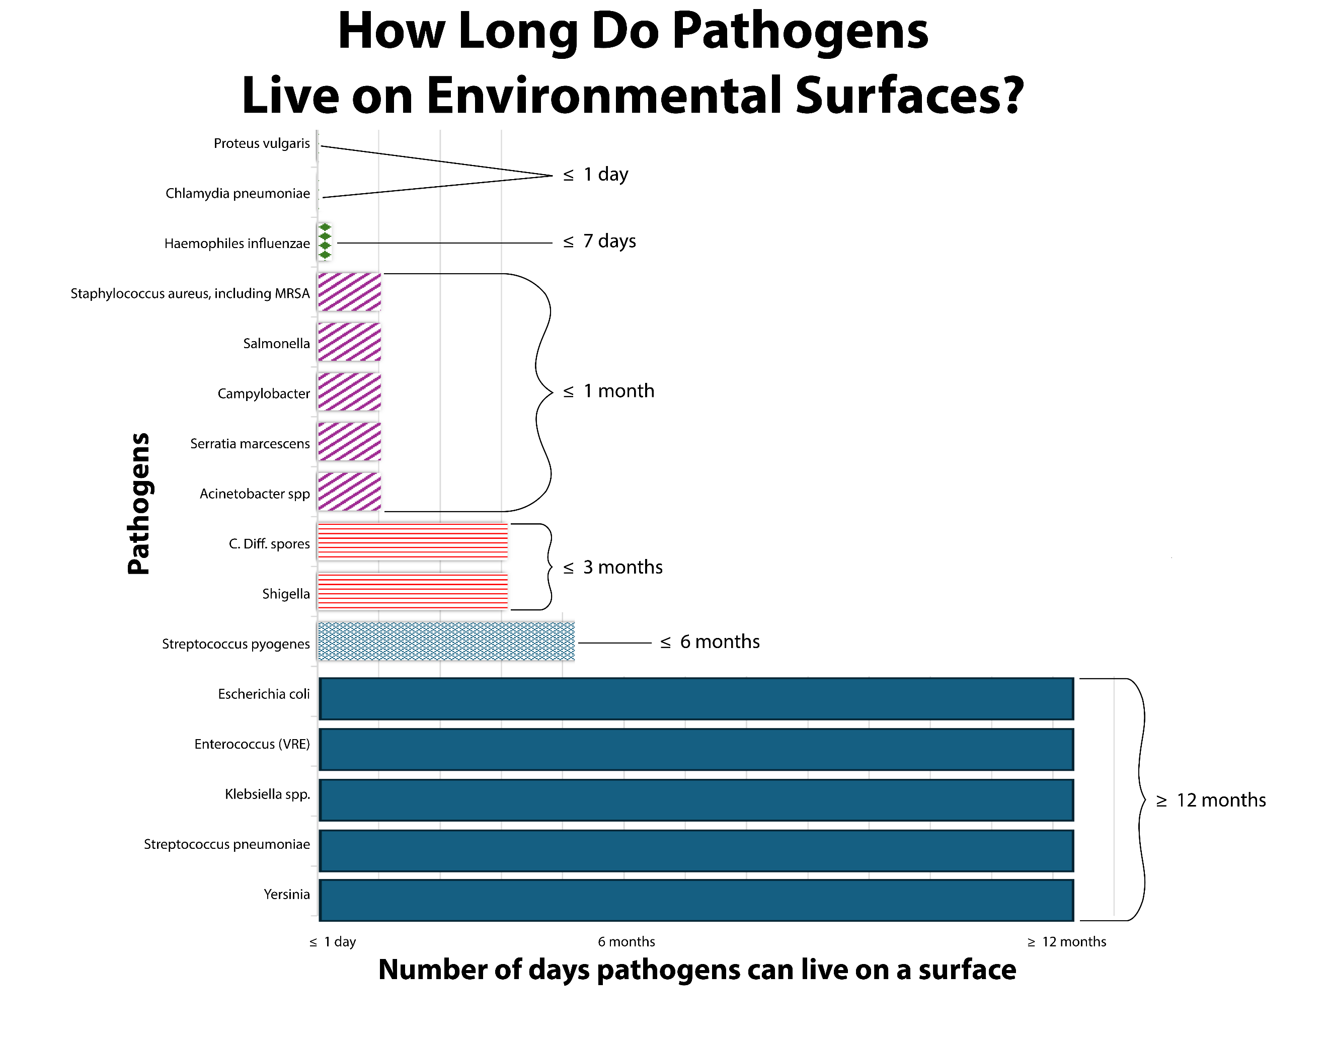

Reference
Kramer A, Assadian O. Survival of microorganisms on inanimate surfaces. In: Borkow G, ed. Use of Biocidal Surfaces for Reduction of Healthcare Acquired Infections. Cham: Springer International. 2014 p. 7–26. https://doi.org/10.1007/978-3-319-08057-4_2. Accessed July 31, 2025.
AHRQ Pub. No. 25(26)-0066|October 2025

