Caring for Residents With Central Lines: Preventing CLABSI
AHRQ Safety Program for MRSA Prevention
Slide Title and Commentary | Slide Number and Slide
Caring for Residents With Central Lines: Preventing CLABSI  SAY:  Hello. Welcome to this Improving Skin Care and MDRO Prevention in Long-Term Care presentation on Preventing CLABSI. This presentation will review the most important measures of prevention for reducing CLABSI in long-term care, including best practices in inserting and caring for central lines. | Slide 1  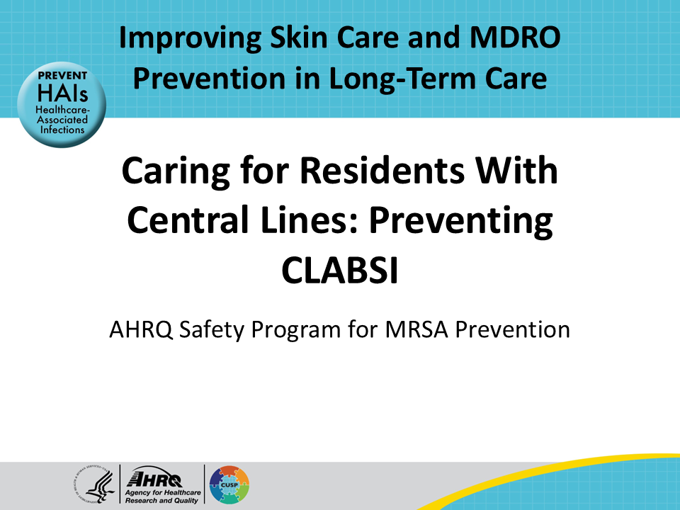
All Staff Support Resident Care and Safety  SAY:  The information provided in this presentation is important in the care of long-term care (LTC) residents. In LTC facilities, each member of the facility’s staff supports resident care and safety. Some actions described in these presentations may not be in your scope of practice, but it is important to learn how all staff contribute to resident care and safety. | Slide 2  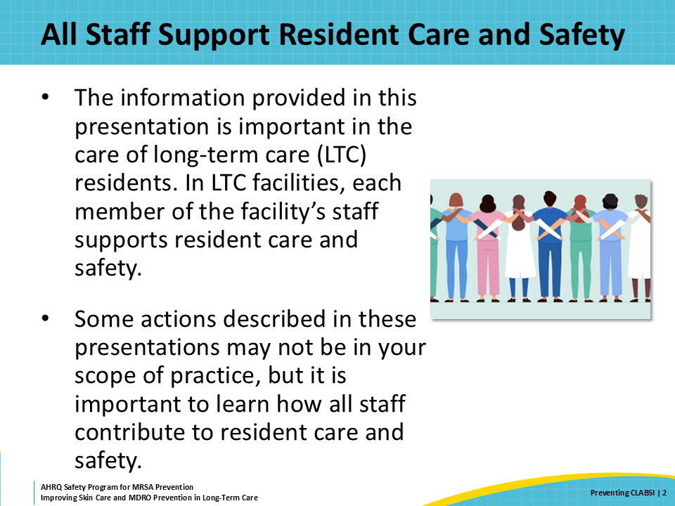
Educational Objectives  SAY:  This presentation will discuss the role of proper central line care in preventing bloodstream infections, best practices in the care of central lines, and challenges that may occur with bathing and central line care. | Slide 3  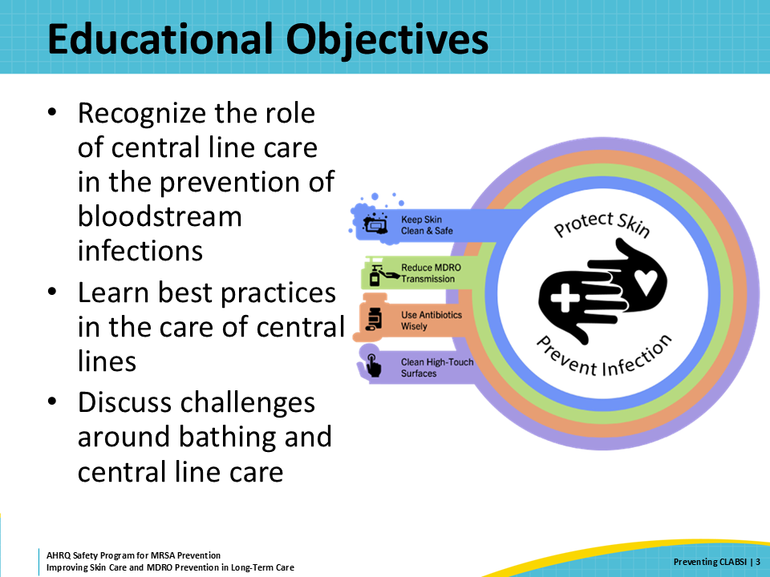
What Are Central Lines?  SAY:  To begin, what is a central line?  A central line or central venous catheter is a device that is inserted through the skin and ends in large, central veins. The end of the device is usually in the large veins that go directly into the heart.  The most common reasons people in nursing homes have central lines are for—  • Dialysis  • Medications, including antibiotics and chemotherapy  • Total parenteral nutrition or TPN. Sometimes this is called complete parental nutrition or CPN.  There are many kinds of central lines. The most common types of central lines in nursing home residents are dialysis catheters and PICC lines. PICC stands for peripherally inserted central catheter. Others include Hickman, port-a-cath or subcutaneous port, and triple-lumen catheter or central line. | Slide 4  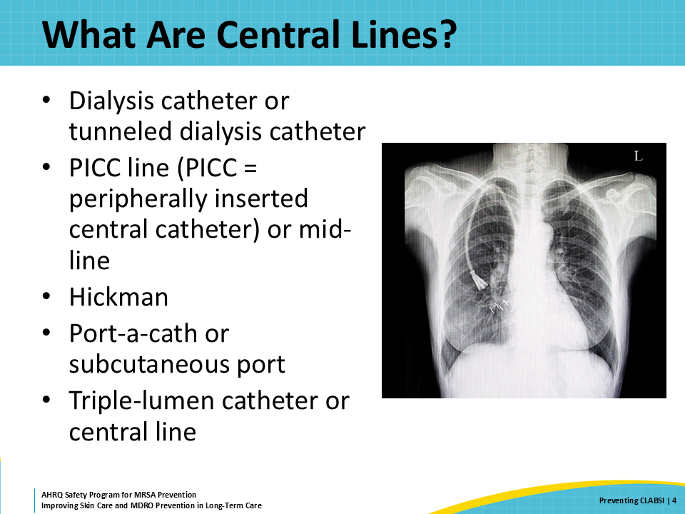
What Is CLABSI?  SAY:  What is CLABSI?  The acronym CLABSI stands for central line-associated bloodstream infection. Essentially, CLABSI is a bloodstream infection commonly caused by improper insertion or maintenance of a central line. The improper insertion or maintenance of the line allows the introduction of germs into the bloodstream.  The first step in diagnosing a CLABSI is the presence of a bloodstream infection. Clinical signs of a bloodstream infection, otherwise known as bacteremia, include fever, acute delirium, low blood pressure, fast heart rate, and chills. With these initial signs of infection, providers will run laboratory tests, which include blood cultures, to look for the presence of germs in the bloodstream. With positive blood cultures and no alternative source of infection, a provider will conclude that the source of the bloodstream infection is likely to be the central line. | Slide 5  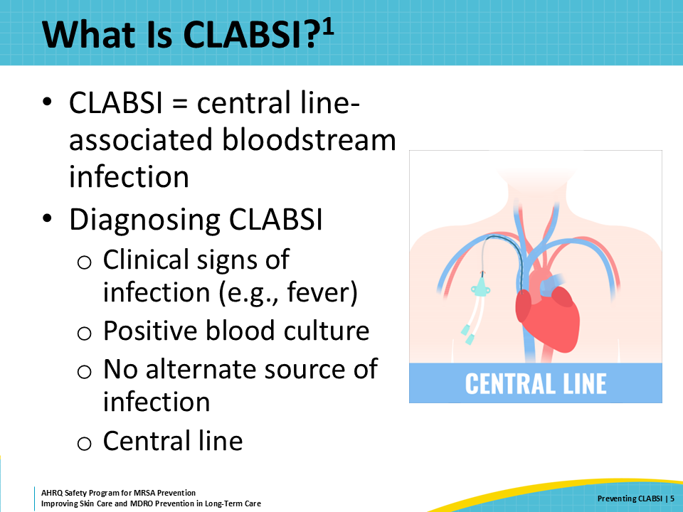
Why Is CLABSI Prevention Important?  SAY:  CLABSIs are a significant source of morbidity and mortality in healthcare. In fact, 15–20 percent of people with CLABSI die because of the CLABSI. For patients with a bloodstream infection caused by MRSA, the mortality rises to 15–60 percent. CLABSIs are unfortunately not a rare occurrence. The Centers for Disease Control and Prevention (CDC) estimates that approximately 30,000 CLABSIs are diagnosed each year. Most of these patients will be hospitalized, leading to an increased number of and prolonged hospital stays, in addition to increased healthcare costs.  Due to the advanced state of surveillance in hospitals, there is a wealth of data on hospital-associated CLABSIs, where patients acquire bloodstream infections from their central lines during a hospital stay. However, data on long-term care–associated CLABSIs is scarce due to the lack of widespread surveillance for this type of healthcare-associated infection. Nursing homes care for many residents with central lines, and the numbers continue to increase, so CLABSI prevention and surveillance is extremely importance for long-term care facilities. | Slide 6  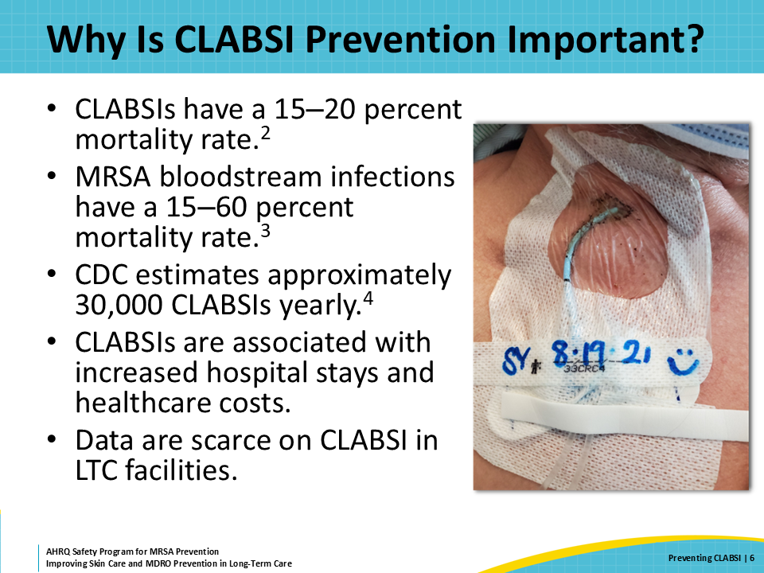
Triangle of Transmission  SAY:  This slide uses the triangle of transmission to illustrate how to reduce the development of CLABSI in nursing home residents with central lines. Central line–associated infections are acquired when germs enter the bloodstream through the entry site of central lines, through the hub and tubing of the central line, and during insertion of the central line.  Staff members in the nursing home can disrupt this process through meticulous care of the central line. Everyone is responsible for ensuring that the central line is protected from infection, including the certified nursing assistants or CNAs who are assisting with resident hygiene and skin care. | Slide 7  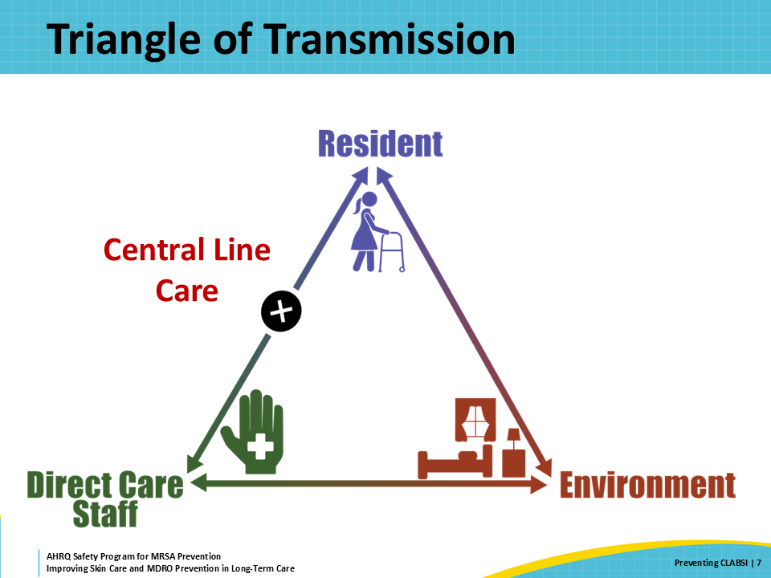
How Do CLABSIs Develop?  SAY:  This slide explores some ways that CLABSIs develop in healthcare settings. The first opportunity for infection comes with the insertion of the central line. Insertion-related blood stream infections will occur shortly after insertion of the central line, usually within 3–7 days of insertion. Poor insertion-related practices can contribute to the introduction of germs to the bloodstream during central line insertion. These poor insertion techniques include poor sterile techniques, poor skin prep, and poor choice of insertion site, such as choosing a femoral site over subclavian. Sometimes, patients are at a higher risk of CLABSI due to their own unique characteristics, such as an immunocompromised state.  In the nursing home, central line infections are more likely to develop because of poor maintenance techniques of the central line or lack of adequate central line care. One example of poor maintenance of the central line is not scrubbing the hub of the central line catheter prior to access. A second example is lapses in dressing maintenance and changes, such as not keeping a central line dressing clean, dry, and intact. A third example is the failure to remove central lines when they are no longer needed. Sometimes, the reason the resident has the central line can put a patient at a higher risk of CLABSIs, such as patients receiving total parenteral nutrition or TPN through their central line. | Slide 8  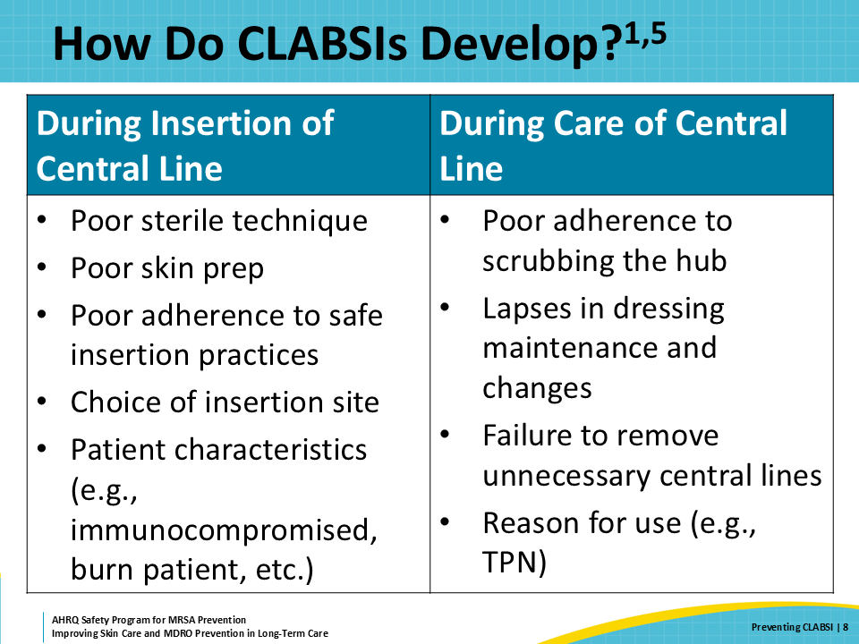
How Can Long-Term Care Professionals Prevent CLABSI?  SAY:  Nursing home staff have a significant opportunity to improve the prevention of CLABSIs. Through careful adherence to the best practices in central line care, the majority of CLABSIs are able to be prevented. To ensure best practices, all clinical staff should be educated on the importance of CLABSI prevention and key CLABSI prevention techniques. Then, follow up education with periodic audits, and provide feedback to frontline staff on best practices for CLABSI prevention. | Slide 9  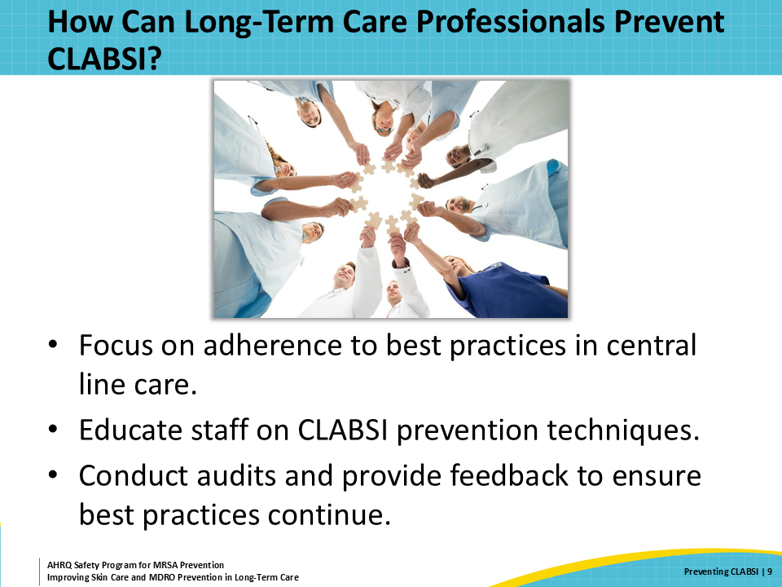
Focusing on Central Line Care  SAY:  Because the insertion of a central line primarily occurs in hospitals and other healthcare settings, nursing home staff should focus their efforts in CLABSI prevention on the best practices for the care or maintenance of central lines. Six central line care practices have previously been shown to decrease the number of CLABSIs in health care settings.  First, hand hygiene should always be performed immediately before handling central lines to ensure germs are not transferred from the hands of healthcare workers to central lines.  Second, it’s important that central line dressing sites are kept clean, dry, and intact. Wet dressings promote bacterial growth, and nonintact dressings expose insertion sites, putting them at risk for germ entry.  Third, it’s important to practice good technique for all central line dressing changes. Sterile technique is clearly preferred, but clean technique can be an acceptable practice if necessary. Only trained staff should perform dressing changes, and dressing supplies should be kept sterile, for single use only.  Fourth, the hub of the central line catheter is a primary source of entry into the bloodstream during central line access. The hub of the central line catheter should always be scrubbed with 70 percent alcohol or Chlorascrub™ for at least 10 seconds prior to access. It’s important to ensure that contact with the tip of the hub and the side of the hub is made during scrubbing. Visual examples of scrubbing the hub of a central line catheter can be found in the supporting material “Scrub the Hub Case Study.”  Fifth, it’s important that central line tubing is appropriately handled, and changed according to best practices. Tubing should be labeled with the date of next change and changed when tubing changes are due.  Finally, all unnecessary central lines should be scheduled for immediate removal. | Slide 10  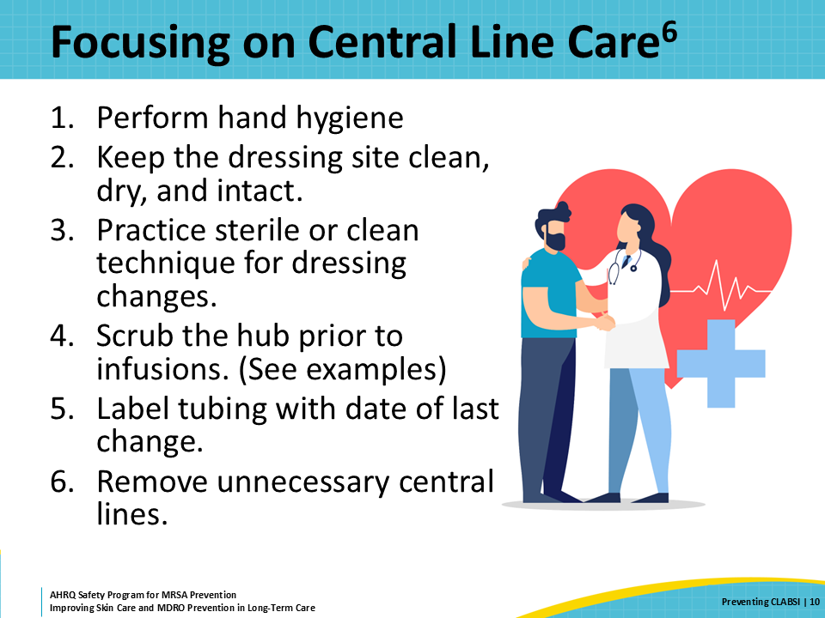
Educate Staff on Central Line Care  SAY:  All clinical staff should have role-specific education on the care and maintenance of central line catheters. It is important for all clinical staff to be educated on these devices, even when they are not responsible for the access or maintenance of central lines.  For example, nurses and CNAs should be trained to look for wet or peeling central line catheter dressings and notify the appropriate clinical staff member when compromised dressings are observed. CNAs frequently provide hygiene care to residents, including bathing or showering. It is important for them to be trained in the method of keeping a central line catheter clean, dry, and intact. This training should include the appropriate technique for protecting a central line during bathing, such as the use of recommended products that keep central line dressing sites dry.  Education of clinical staff should be hands on and allow for opportunities to practice dressing changes and central line care. Education should focus on the best practices in central line maintenance such as scrubbing the hub, properly changing dressings, and properly bathing residents with central lines. | Slide 11  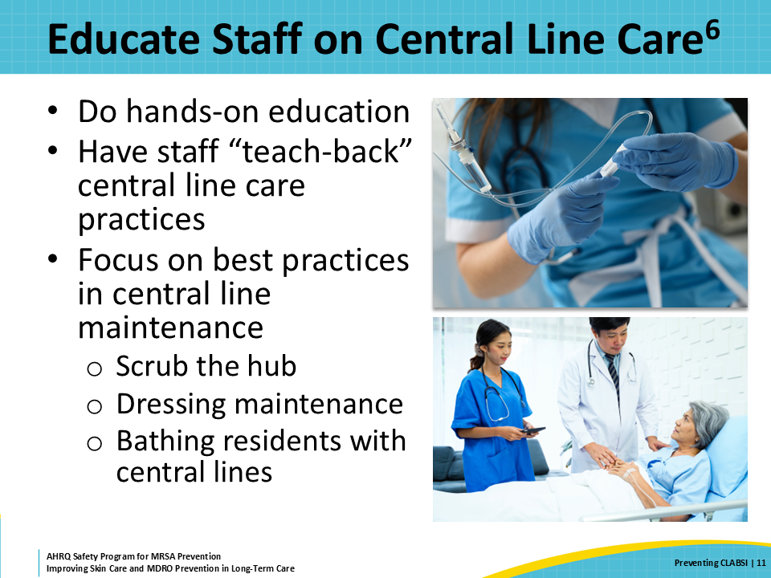
Central Line Care Checks  SAY:  Although education is crucial to ensuring safe central line care practices for residents, following up on education through careful observation of clinical practice is equally as important. Nursing home leadership, especially infection prevention, should observe central line care practices to ensure staff are adhering to the best practices in the maintenance of central lines. This includes observation of dressing changes, central line access, and central line care during bathing or showering.  Observation of clinical practice gives clinical leaders the opportunity to give frontline staff direct feedback on opportunities to improve the quality of central line care practices. Observations should be conducted regularly. One option would be for leadership to observe one to two dressing changes per month, making sure to observe all staff members who perform these changes every quarter. Similar observations can be conducted for accessing lines and care during bathing. Using checklists during these observations can help reinforce best practices. Feedback should never be punitive but rather an opportunity to observe corrective action through additional education of individuals within a unit.  Always seek feedback from frontline staff in addition to providing feedback. Sometimes, a systems-level problem is driving an inadequate amount of attention to central line care. For example, alcohol prep swabs may not be available on the unit, which forces staff to travel to the storeroom to retrieve alcohol prep swabs. This extra work may lead to staff not scrubbing the hub prior to accessing a central line. Receiving feedback from staff is a great way to identify and correct system-level problems in an organization. | Slide 12  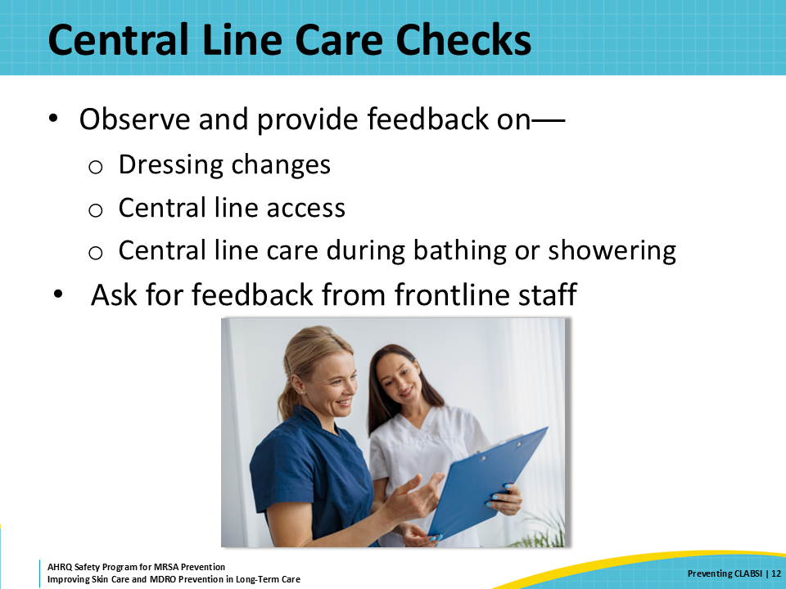
Teachable Moment  SAY:  This presentation’s teachable moment will walk through a challenge where a nurse needs to keep a resident’s PICC line dry during their routine shower. Consider the following questions regarding this case study:  - How should the CNA keep the PICC line dry during the shower?  - What steps should the nurse follow if the dressing is compromised during the shower? | Slide 13  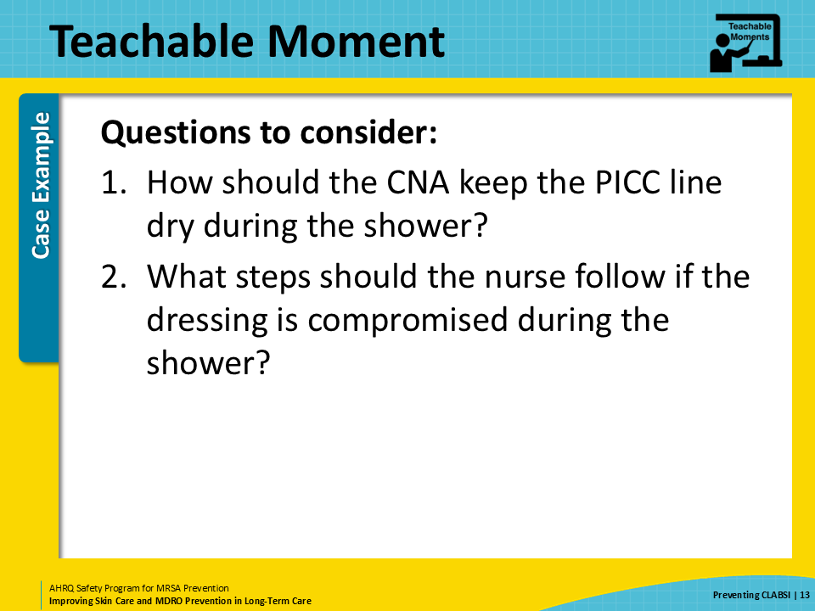
The Case  SAY:  In this scenario, a CNA is assisting a 69-year-old resident with their routine shower. The resident was recently discharged from the hospital with a PICC line for the receipt of long-term antibiotic therapy. | Slide 14  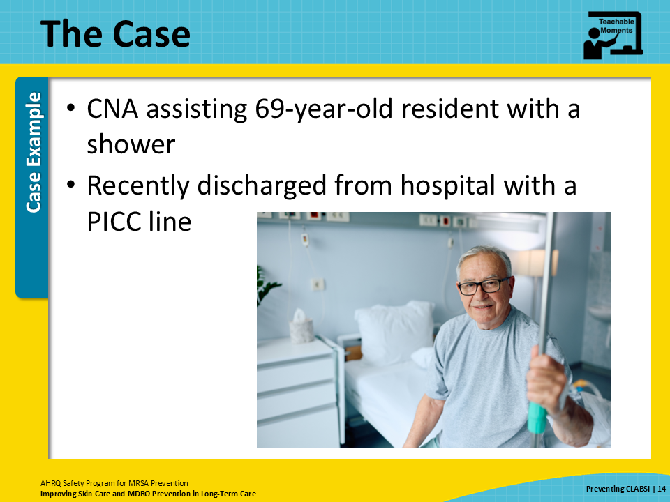
The Challenge  SAY:  The CNA knows they need to keep the PICC line dressing dry during the resident’s shower, but the facility doesn’t carry any approved products for keeping central line dressings clean, dry, and intact. The CNA, having received no prior training in central line care, begins to look for ways to keep the dressing dry while completing the resident’s routine shower. | Slide 15  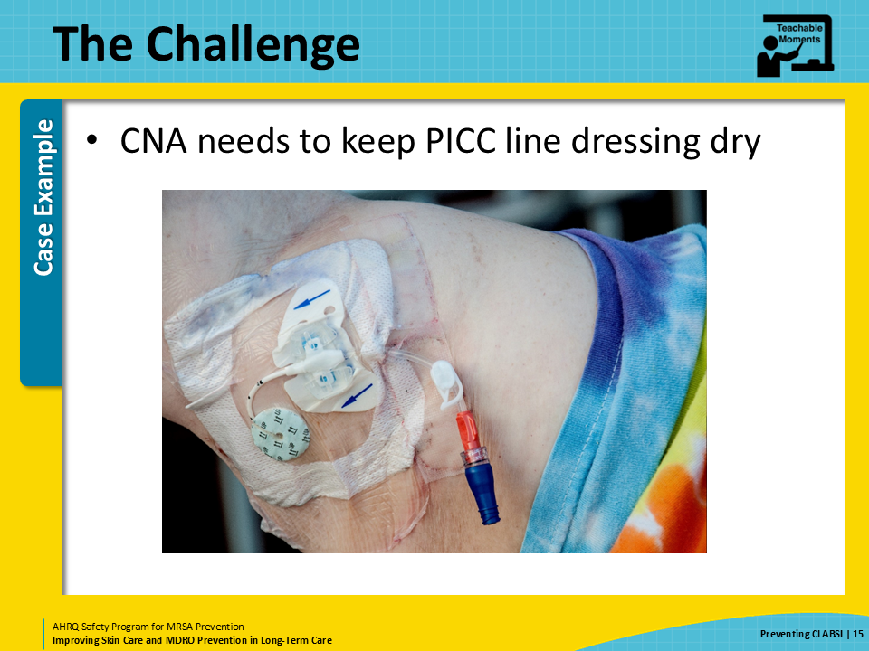
Knowledge Check  SAY:  Pause and think of some ways to keep the resident’s dressing dry. What are some options the CNA might have available in this situation? Having received no education on central line care, what should they do when faced with this dilemma? | Slide 16  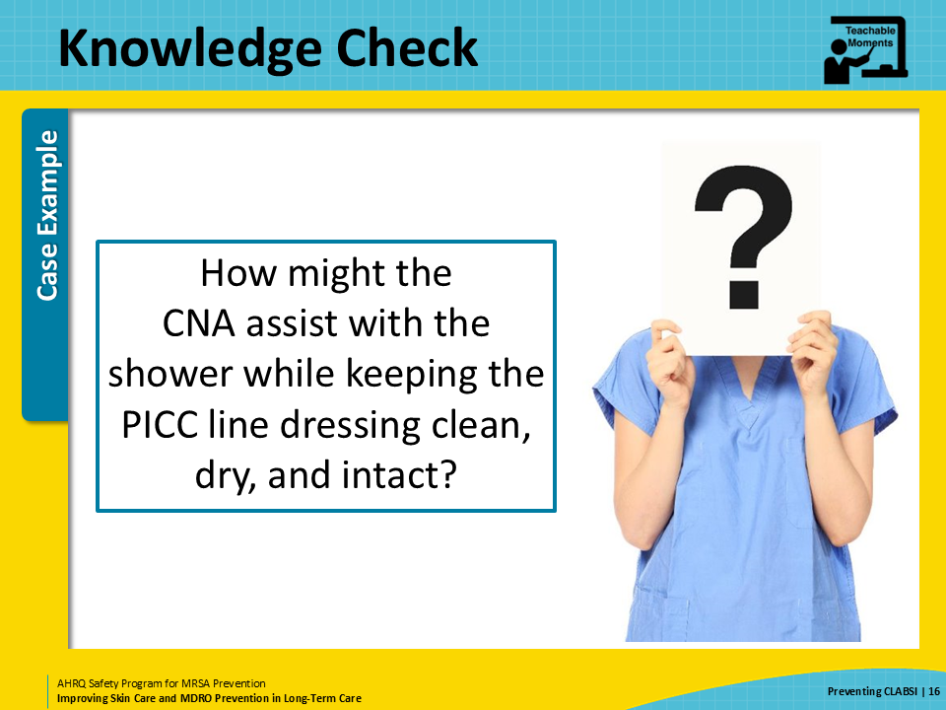
The Error  SAY:  The CNA looks around for an acceptable method for keeping the resident’s PICC line dressing dry, but unfortunately all they find is a plastic grocery bag at the nurse’s station. They decide to try tying the grocery bag around the PICC line dressing to keep the dressing and the PICC line dry. Not surprisingly, the plastic bag begins to fall off during the shower and the PICC line dressing becomes drenched.  By the time the shower is complete, the dressing is extremely wet and beginning to peel off. The CNA dries the dressing with a towel and reinforces the dressing with some medical tape. The resident is assisted with dressing and wheeled to the activities center for some evening entertainment. The CNA moves on to the next resident in need of bathing assistance. | Slide 17  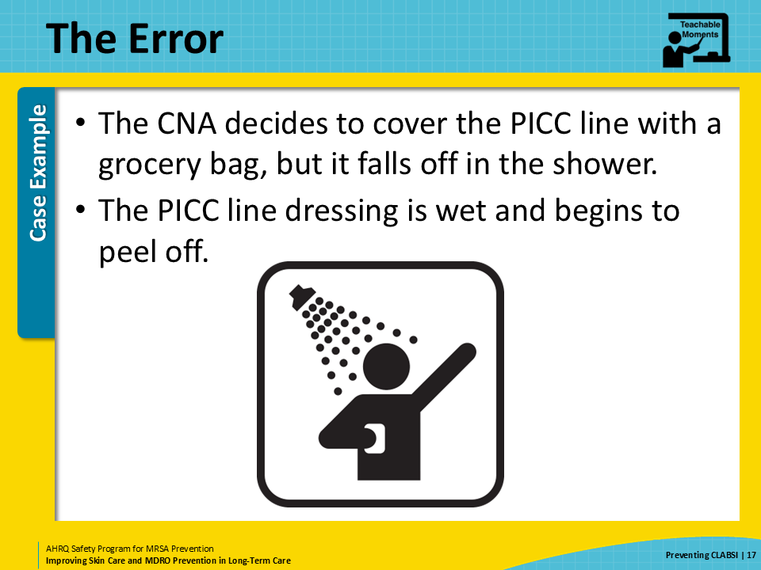
The Consequence  SAY:  The CNA has not received education in central line care and did not know the potential dangers of leaving a dressing damp and not intact. By the end of the day, the tape had fallen off and the dressing had peeled back far enough to expose the insertion site. Germs from the skin enter the bloodstream through the exposed insertion site and the resident begins to show signs and symptoms of bloodstream infection a few days later.  The CNA should have let the resident’s nurse know that the central line dressing was wet, would not stay intact, and needed to be changed. Without education, the CNA is at risk of repeating this error in the future. | Slide 18  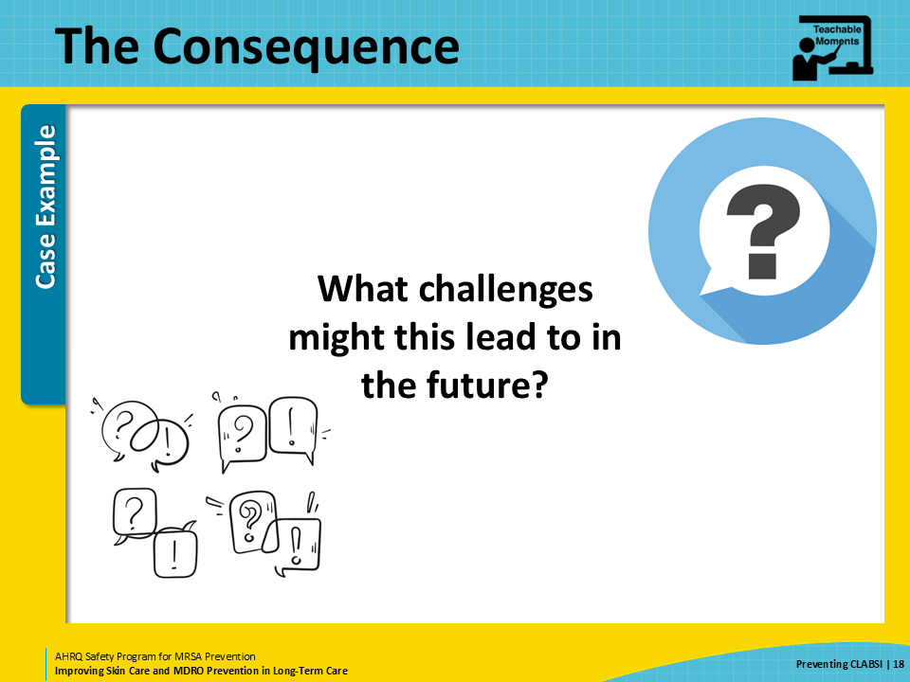
Preventing the Next Harm  SAY:  A key part of patient safety is to think ahead about how to prevent the next potential harm to a patient or resident. Once an error or mistake is identified, consider what can be done to avoid that same error from happening in the future. In this example, the CNA was unable to keep a central line dressing dry because they did not have access to products for doing so. Additionally, the CNA failed to inform the nurse of a compromised dressing. A strong contributing factor here is that the CNA was not taught how to care for a central line during bathing or showering. They also did not know how to respond to a compromised dressing.  The error here is not simply remedied by addressing the CNA’s knowledge gap. The facility needs to recognize that system-level changes need to be made to prevent this error from occurring again. First, the facility should make sure to stock products for protecting central lines during bathing or showering. Once a product has been obtained, all clinical staff members responsible for the care and observation of central lines should be educated on the use of these products. Next, all clinical staff members should be educated on the care or maintenance of central line catheters. CNAs need to be educated on the importance of keeping dressings clean, dry, and intact, and how to respond to a compromised dressing that is wet, soiled, or peeling. | Slide 19  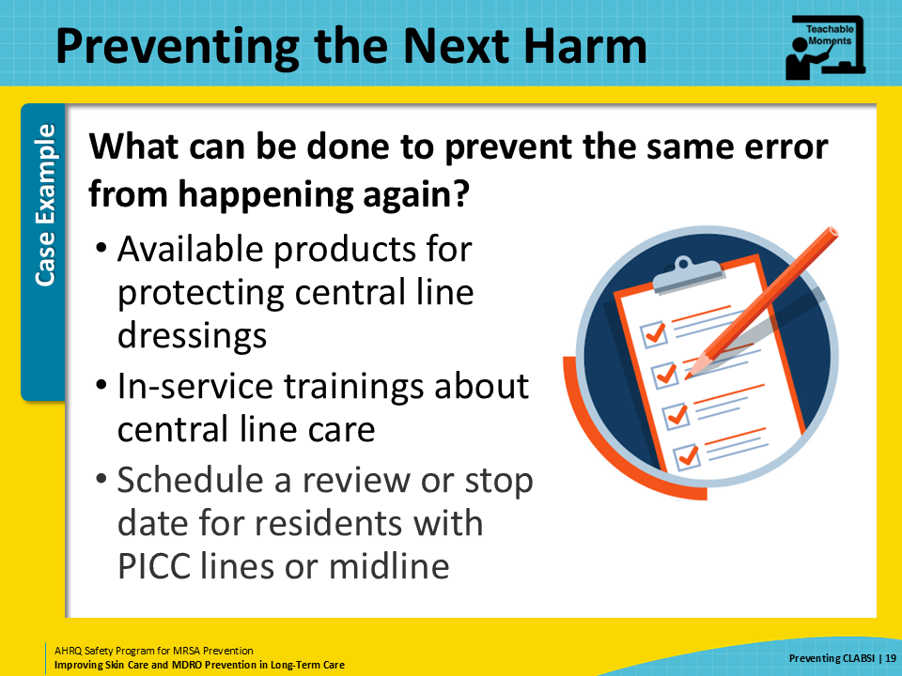
System-Based Safety Challenges  SAY:  Central line maintenance audits can allow the facility to assess and identify ongoing problems with the maintenance of central lines.  Some changes require more of a team approach, usually with the support and guidance from leadership. These may involve changes to the culture and even the structure of an institution. These are considered adaptive approaches.  Leadership can ensure that there are adequate supplies of appropriate products available to cover dressings during bathing. These can be ordered in different sizes or types to address the varying types of catheters and catheter placement. Direct-care staff should be empowered to let leadership know if the products they have are not working to keep dressings dry during bathing or if additional sizes or types of products are needed.  Leadership may also need to implement a process to make sure central lines are removed once they are no longer needed. Line removal usually requires an order from a medical provider. These orders can be included in order sets or communications with medical providers, particularly for residents who are on antibiotics. Central line care should also be scheduled. Some facilities find that having a “dressing change day,” such as every Monday, where all nurses can expect to change the dressing on their patient’s central lines, helps nurses to be prepared to perform that activity and allot the necessary time to perform this important task.  CNAs and nurses may be the only people who are aware that a resident has a central line—and they may also be aware that it is not being used anymore. They should feel comfortable asking the resident’s medical provider at the nursing home if a central line is still needed. | Slide 20  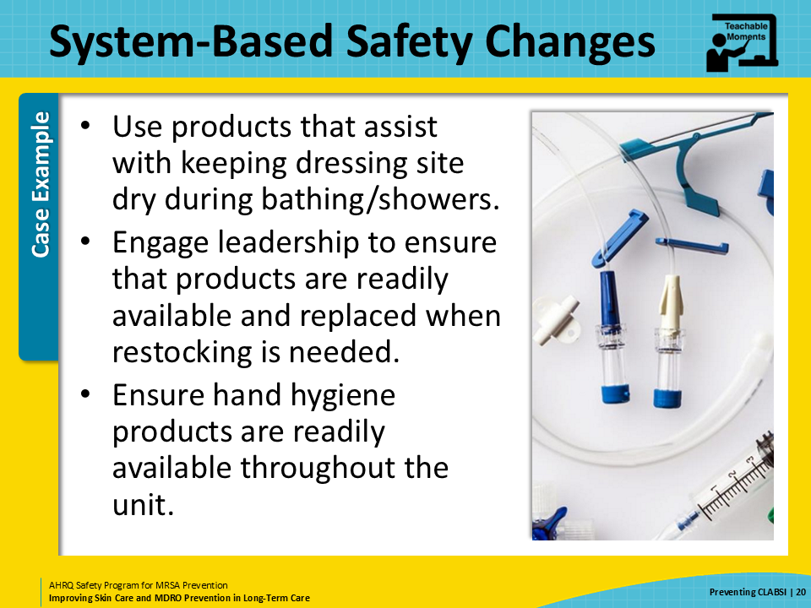
Key Takeaways  SAY:  In summary, central line catheters are a significant source of infection in nursing homes, including infections with multidrug-resistant organisms. Careful central line care or maintenance helps prevent infections caused by central line catheters.  When errors occur in healthcare, such as lapses in central line care, healthcare teams must think through these errors or problems to find solutions to prevent the next harm. The goal is to end repeated harms by intervening before the next error.  Healthcare teams should also look for systems-based opportunities to improve care, such as stocking products that are approved for keeping central line catheters dry during bathing or showering. | Slide 21  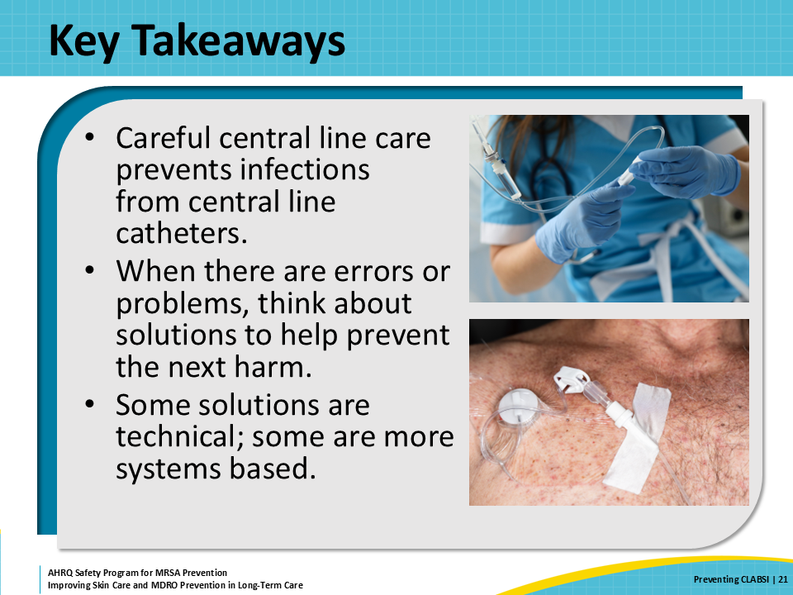
Supporting Materials  SAY:  Additional materials go with this presentation. These materials include a Hand Hygiene Observational Tool, and teachable moments including Name That Tube!, Interactive Scrub the Hub Activity, The Case of the Resident With a PICC Line, and The Case of an Inappropriate Scrub of the Hub. These complement the material from the presentation, with the overall goal being to reduce MDRO transmission and support resident safety. | Slide 22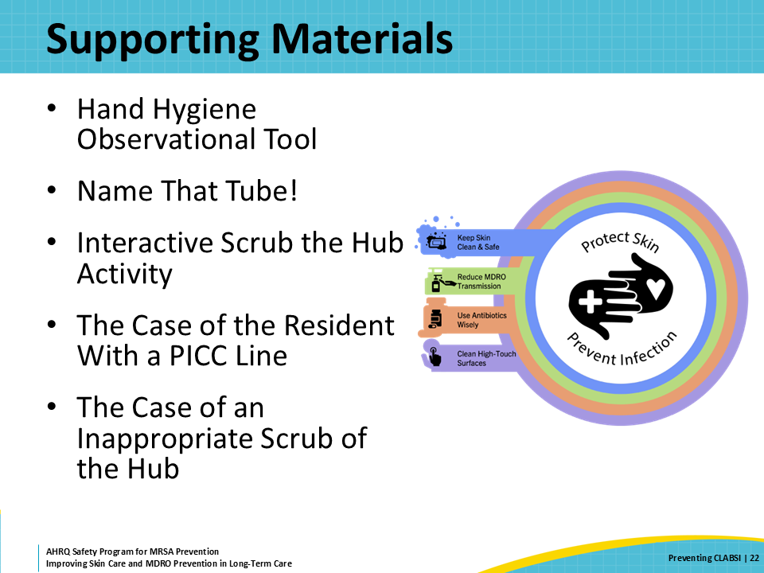
Disclaimer  SAY:  The findings and recommendations in this presentation are those of the authors, who are responsible for its content, and do not necessarily represent the views of AHRQ. No statement in this presentation should be construed as an official position of AHRQ or of the U.S. Department of Health and Human Services.  Any practice described in this presentation must be applied by healthcare practitioners in accordance with professional judgment and standards of care in regard to the unique circumstances that may apply in each situation they encounter. These practices are offered as helpful options for consideration by healthcare practitioners, not as guidelines. | Slide 23  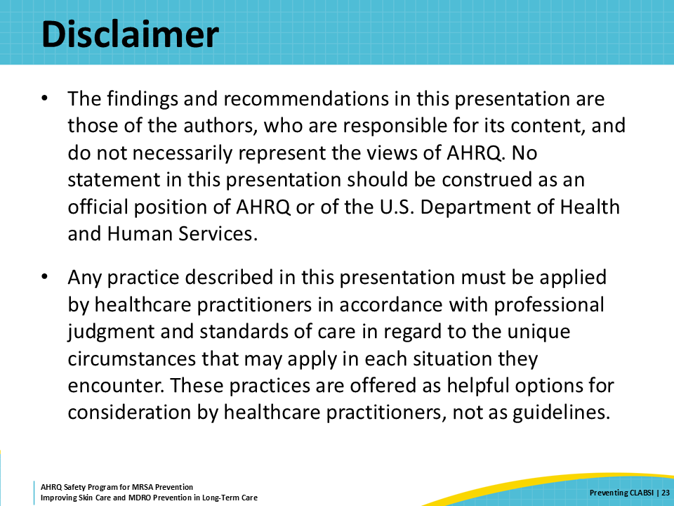
References | Slide 24  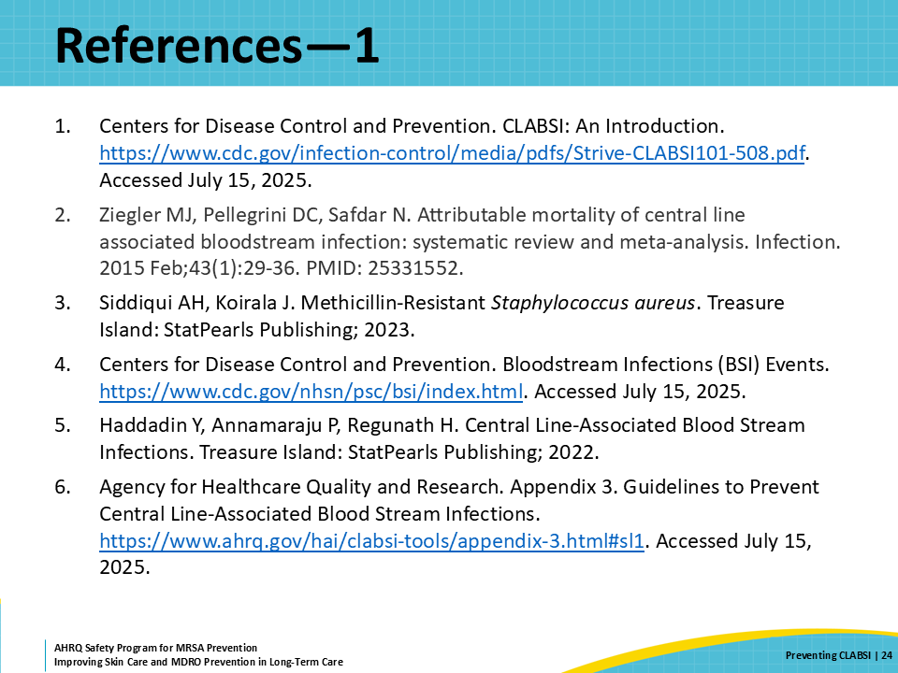
AHRQ Pub. No. 25(26)-0066
October 2025

