Go With the Flow: Preventing Urinary Tract Infections
AHRQ Safety Program for MRSA Prevention
Slide Title and Commentary | Slide Number and Slide
Go With the Flow: Preventing Urinary Tract Infections  SAY:  Welcome to this presentation on “Go With the Flow: Preventing Urinary Tract Infections,” part of the AHRQ Safety Program for MRSA Prevention: Improving Skin Care and MDRO Prevention in Long-Term Care. | Slide 1  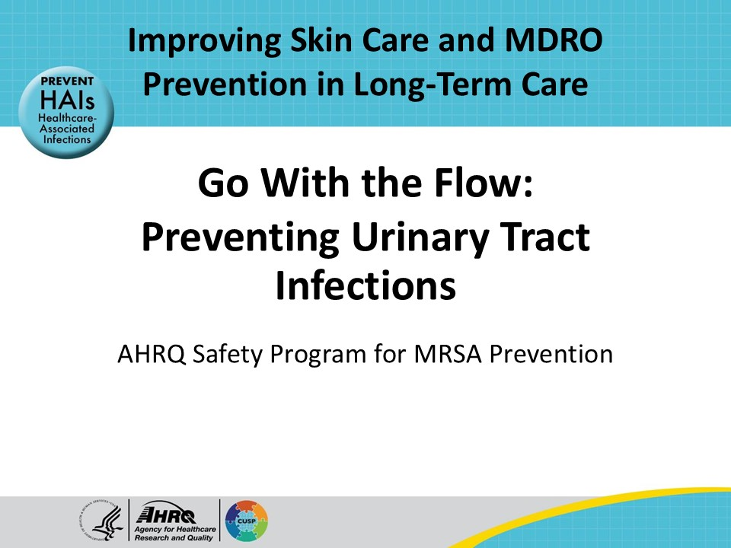
All Staff Support Resident Care and Safety  SAY:  The information provided in this presentation is important in the care of long-term care (LTC) residents. In LTC facilities, each member of the facility’s staff supports resident care and safety. Some actions described in these presentations may not be in your scope of practice, but it is important to learn how all staff contribute to resident care and safety. | Slide 2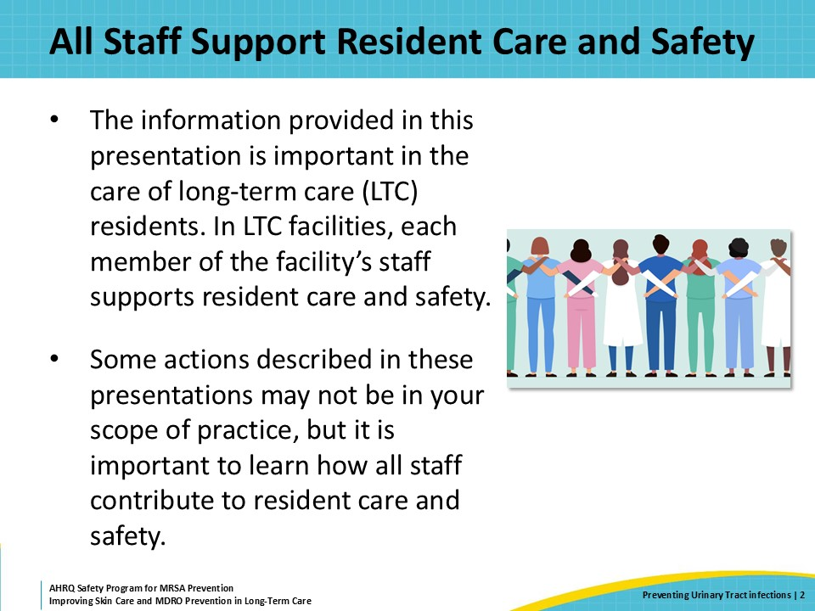
Educational Objectives  SAY:  After viewing this presentation, viewers will be able discuss the importance of preventing urinary tract infections or UTIs in long-term care facilities, learn the best practices for UTI prevention in long-term care, and discuss challenges around bathing for people who have indwelling urinary catheters. | Slide 3  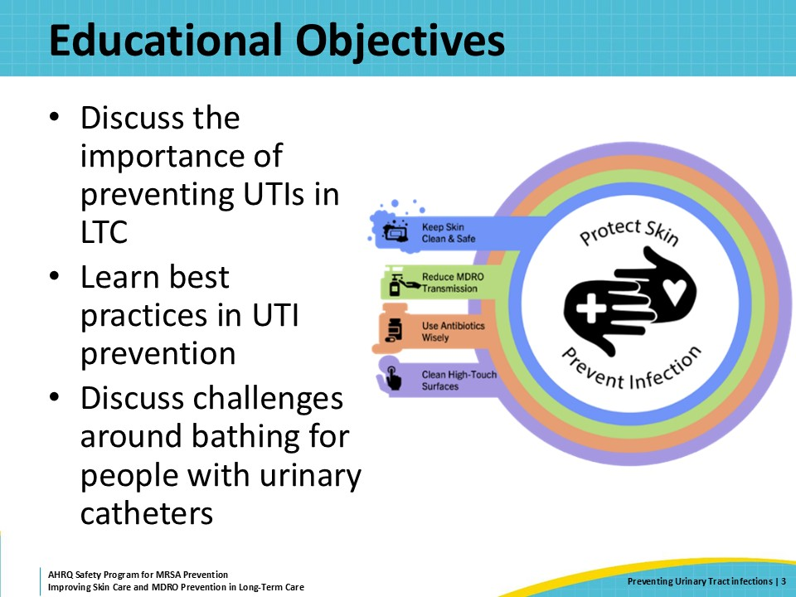
Triangle of Transmission  SAY:  The triangle of transmission is important in preventing urinary tract infections. This slide illustrates how to disrupt the transmission of infection to reduce the development of UTIs in nursing home residents. Catheter-associated UTIs (CAUTIs) among residents with indwelling urinary catheters are a common problem in these facilities, so the triangle of transmission also comes into play when protecting these patients from CAUTIs.  UTIs can happen when germs enter the urinary tract and/ or bladder. Direct care staff have a significant role in preventing germs from gaining access to the urinary tract through their care of the resident and their care of resident urinary catheters. The best way to prevent UTIs is for direct care staff to use best practices for perineal care, catheter insertion, and catheter maintenance.  Additionally, ensuring a clean environment reduces the opportunity for germs in the environment to transfer to residents, which can potentially lead to urinary tract infections or CAUTI. | Slide 4  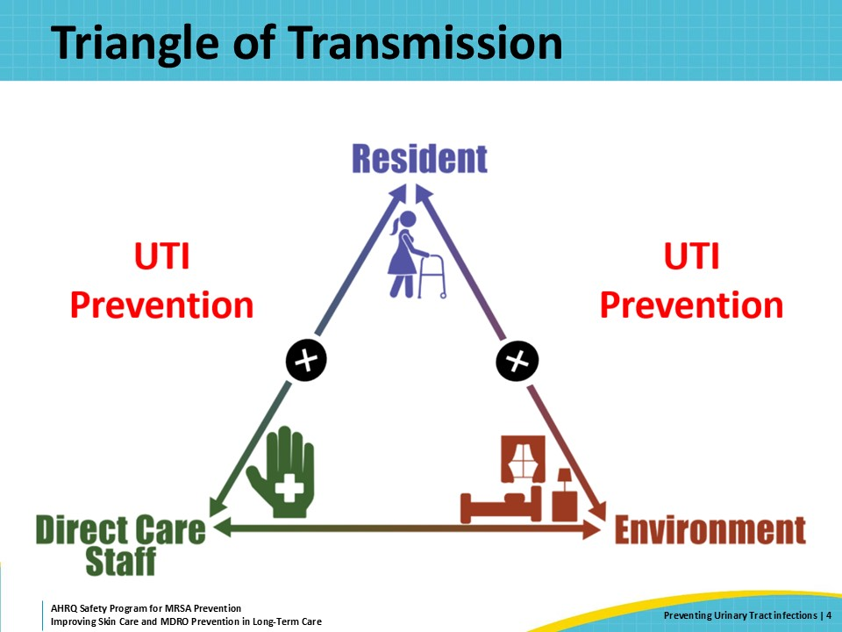
What Are UTIs and CAUTIs?  SAY:  Technically, a UTI is an infection involving the bladder, kidneys, or both. When people mention a UTI, they usually mean acute cystitis, which is an infection in the bladder. CAUTIs are urinary tract infections associated with the presence of a urinary catheter. This slide describes the diagnostic criteria for UTIs and CAUTIs.  On the left of the slide, you can see that for residents without a urinary catheter, the presence of dysuria alone is enough. Dysuria refers to pain or discomfort with urination, often described as a burning sensation.  Residents without dysuria may have a UTI if they have two or more other signs and symptoms that are specific to the genitourinary tract.  Residents with a urinary catheter may not report dysuria, frequency, or urgency. For these individuals, a diagnosis of CAUTI can be considered once other reasons for the signs and symptoms are ruled out. This is also a reasonable way to approach the diagnosis of UTI among residents who are not verbal.  Please note that these are clinical indications to send a urinalysis and urine culture. Depending on the clinical circumstances, starting an antibiotic while waiting for those test results may also be indicated. | Slide 5  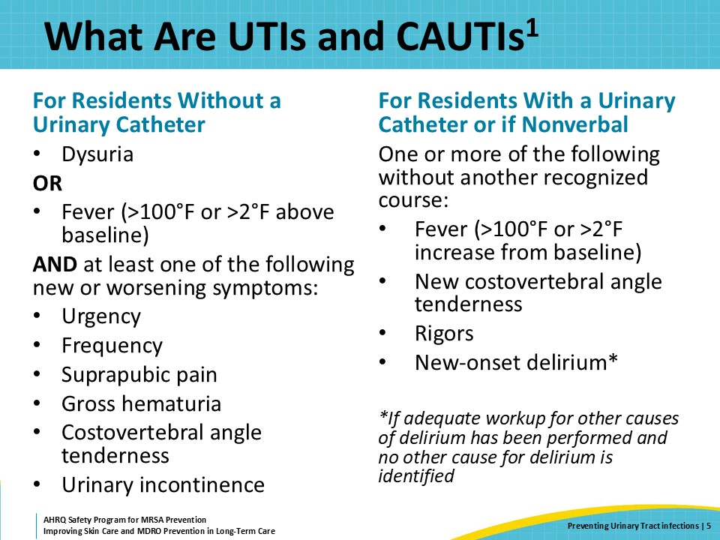
Asymptomatic Bacteriuria Versus UTI  SAY:  The Enhanced Barrier Precautions presentation reviewed the difference between infection and colonization.  Infection means a pathogen is making someone sick. Colonization means someone has a pathogen, but it is NOT making them sick.  Many nursing home residents have bacteria in their bladder that do not make them sick, known as asymptomatic bacteriuria. This is a form of colonization. People who have asymptomatic bacteriuria do not have an increased risk of illness or death compared to those who do not. People may also have catheter-associated asymptomatic bacteriuria. | Slide 6  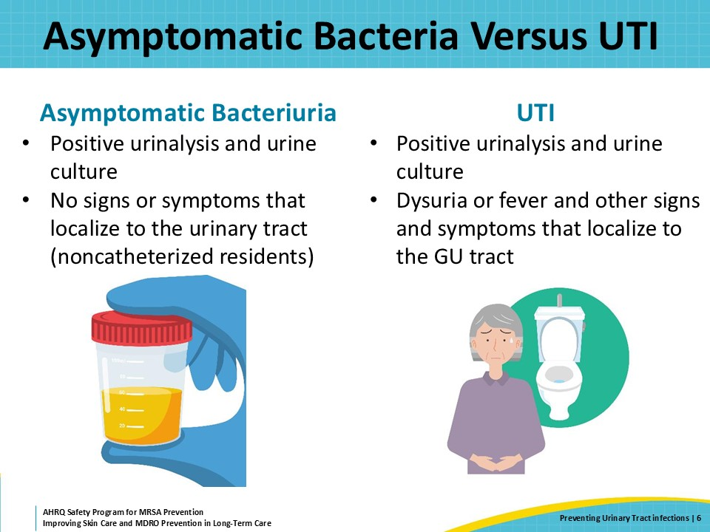
When NOT To Send Urine Culture  SAY:  Sending a urine culture for a resident who is not having signs and symptoms of a UTI or CAUTI can lead to unnecessary antibiotic use, which in turn increases the risk of multidrug-resistant organism or MDRO acquisition and other adverse drug events.  People who care for nursing home residents, including family members, often need ongoing education about when a urine culture should and should not be sent. Please see the resources associated with this presentation for one-page tools and similar educational materials about UTI and CAUTI.  If someone is having the signs and symptoms of a UTI or CAUTI as discussed above, a urinalysis and urine culture is indicated.  Do not check a urinalysis or send a culture for any of the following reasons:  - Dark, foul smelling, or cloudy urine in the absence of symptoms  - Routinely, such as upon admission or after placing or removing a urinary catheter  - As a “test of cure”  - People with urinary catheters who have mental status changes, unless there are changes in their vital signs or clear indications of delirium | Slide 7  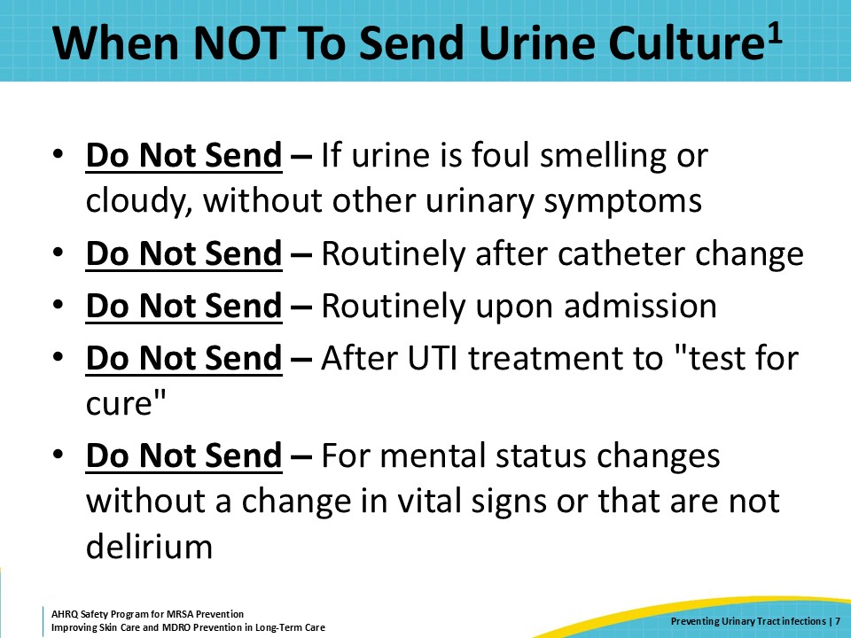
Why Is UTI Prevention Important?  SAY:  Even taking into consideration the prevalence of asymptomatic bacteriuria, UTIs remain the most common infection in long- term care. UTIs account for 20–30 percent of all infections reported from long-term care facilities. UTIs are also the most frequent reason that long-term care residents are hospitalized for an infection.  Urinary catheters further complicate the prevention of UTIs. In nursing homes, 75 percent of UTIs are associated with a urinary catheter, which are CAUTIs. Among residents with a urinary catheter, about half will develop a symptomatic UTI. | Slide 8  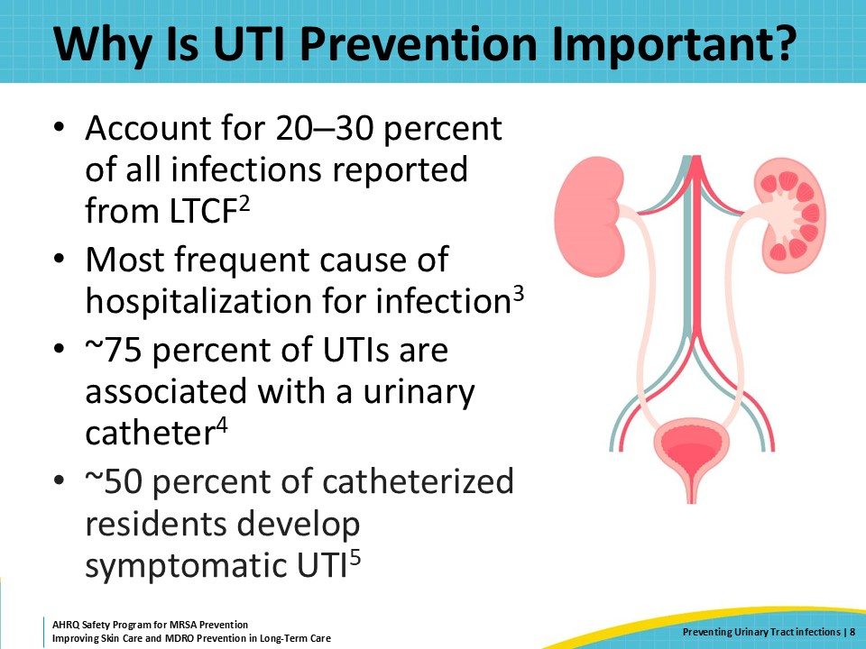
Risk Factors for UTIs  SAY:  Why are UTIs common among nursing home residents?  With age, our immune systems become less robust, meaning that older adults are at greater risk for many infections, including UTIs. Chronic medical conditions, such as diabetes, can affect bladder function, as do the side effects of medications used for other conditions.  As men age, their prostates can get bigger, which can make it more difficult to empty their bladder. This is frequently why older men sometimes need an indwelling urinary catheter.  For women, the hormonal changes that happen after menopause can lead to changes, including some dryness and thinning of genital tissues. These changes make it easier for bacteria to travel up the urethra into the bladder.  Other changes that happen with aging include a decreased thirst response, meaning that older adults are less hydrated and therefore urinating less frequently. This can also increase the risk of UTI.  Finally, the need for assistance with activities of daily living or ADLs, poor bathing technique, and missed perineal care are also associated with an increased UTI risk. | Slide 9  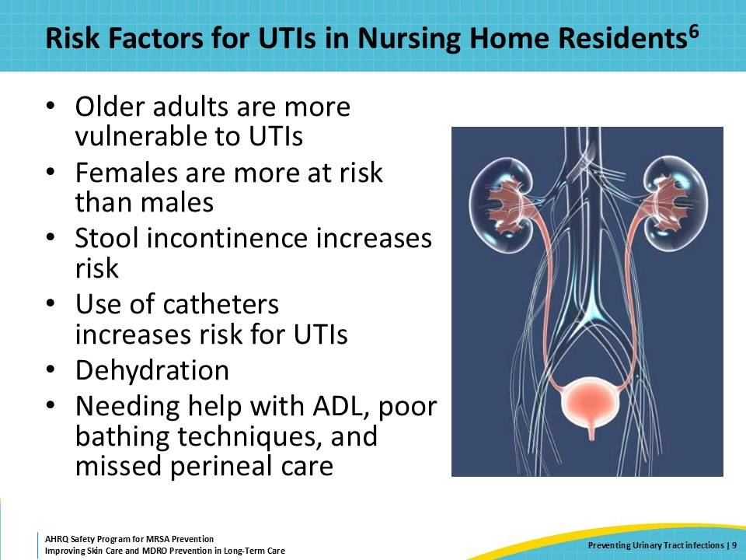
Best Practices in Urinary Catheter Insertion  SAY:  This slide reviews the best practices for urinary catheter insertion that will help prevent CAUTI.  First, catheters should only be inserted when absolutely necessary.  Second, staff need to have completed education and hands-on training before they can insert urinary catheters. People with limited experience in placing urinary catheters should be paired with someone who can coach them through the process.  Third, two or more people working together to place a urinary catheter should be routine practice. Even if they are not yet able to place a catheter themselves, the assistant should understand the best practices in urinary catheter insertion.  Fourth, perform perineal care prior to insertion and then perform hand hygiene immediately before placing the catheter.  It is also important to check the urine flow before inflating the catheter balloon. This confirms that the catheter is in place and reduces the risk of urethral trauma, which is a risk factor for UTIs. Having a catheter of the right length is important.  Finally, staff should secure the catheter to prevent tugging, which can lead to balloon dislodgement or urethral trauma. The catheter bag should be placed below the level of the bladder but off the floor to prevent the backflow of urine. | Slide 10  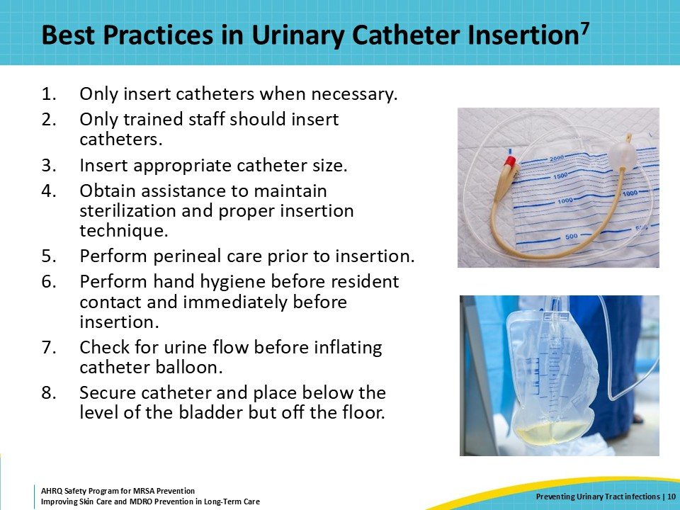
Best Practices in Urinary Catheter Care  SAY:  Once a catheter is in place, staff must maintain best practices in catheter maintenance by providing care according to evidence-based practice. Hand hygiene must be performed prior to care or manipulation of the urinary catheter.  The drainage bag should be kept below the level of the bladder but off the floor. The drainage bag should not become full as this could lead to the backflow of urine, increasing the risk of infection.  Residents should receive regular, routine bathing and perineal care. Regular bathing and perineal care remove germs from the skin and perineal region that could increase the risk of UTIs. It is particularly important to ensure that no stool comes into contact with the catheter if a resident is incontinent. This is a common error that can introduce resistant bacteria from stool into the urinary tract.  It is also important to ensure that the urinary catheter system stays closed. Never open the system to obtain a urine sample, for example. If the catheter system is opened, the catheter should be changed.  Ideally, if a urine sample is needed from a urinary catheter that has been in place for more than 14 days, a new catheter should be placed prior to obtaining the sample. This helps distinguish between the organisms that have formed a biofilm on the device from organisms that may be causing a problem in the bladder. If the catheter has been in place less than 14 days, a urine sample intended for microbiological culture may be collected aseptically from the urine collection port to help ensure the collection of an uncontaminated sample.  Dehydration is a risk factor for UTI. Encourage healthy intake of fluids to avoid dehydration.  Most importantly, continue to question whether the catheter is still necessary. Remove all unnecessary catheters as soon as there is no longer a need for one to reduce the risk of catheter-associated UTIs. | Slide 11  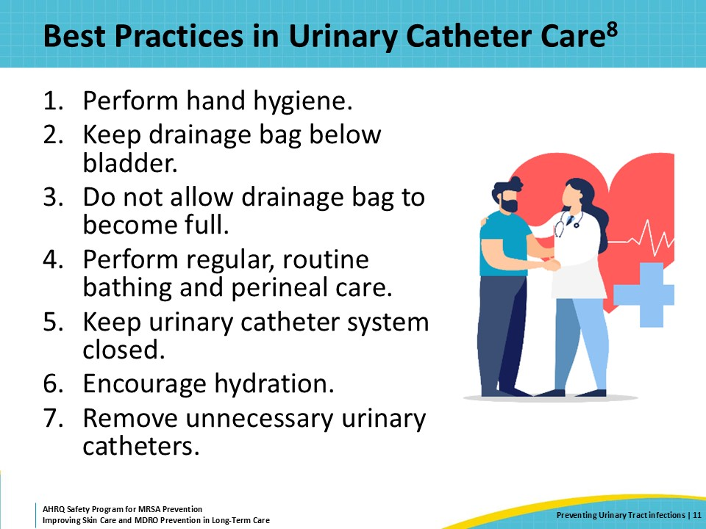
Urinary Catheter Checklists  SAY:  Staff members need to maintain their skills with placing and caring for urinary catheters. The same process of education, hands-on training, and observation used for people learning skills for the first time should continue for clinical staff who insert and work with urinary catheters. This helps ensure all staff are adhering to best practices.  Frequent observation of clinical practice gives facility leadership the opportunity to provide frontline staff direct feedback on opportunities to improve the prevention of CAUTI. Observations should be conducted regularly—at least quarterly and more frequently as time allows. Using a checklist during the observation process provides objective criteria and helps ensure consistency. It also serves to remind staff about exactly what they should do when inserting catheters and when providing care to residents with indwelling catheters.  The feedback process should be positive. Note what the person did well—even if it is not on the checklist—and be specific. Perhaps state, “I like how you put the resident at ease by talking them through each step.” Or “Once you realized you needed help with opening the wipes, you asked for help. That’s exactly what you should do!” Aim to give more positive feedback to staff. For opportunities for improvement, talk through how to avoid the same error from occurring next time. This is a chance for education to lead to better practice and support resident safety. Again, providing specific examples will help. Perhaps say, “I noticed that you did not perform hand hygiene between cleaning the perineum and inserting the catheter. Germs from those gloves can get onto the catheter during insertion, which can lead to an infection. Next time, change your gloves and clean your hands before opening the packaging around the catheter. What would help make that easier? Would it help to including alcohol-based hand rub in the supplies at the bedside?”  Always seek to receive feedback from frontline staff. It may be surprising to learn that a systems-level problem is driving an inadequate amount of attention to catheter care. Receiving feedback from staff is a fantastic way to identify and correct system-level problems in an organization. It can also be a way to bring improvements into the process at the nursing home. Picking up tips and tricks from observing others’ feedback is always useful. | Slide 12  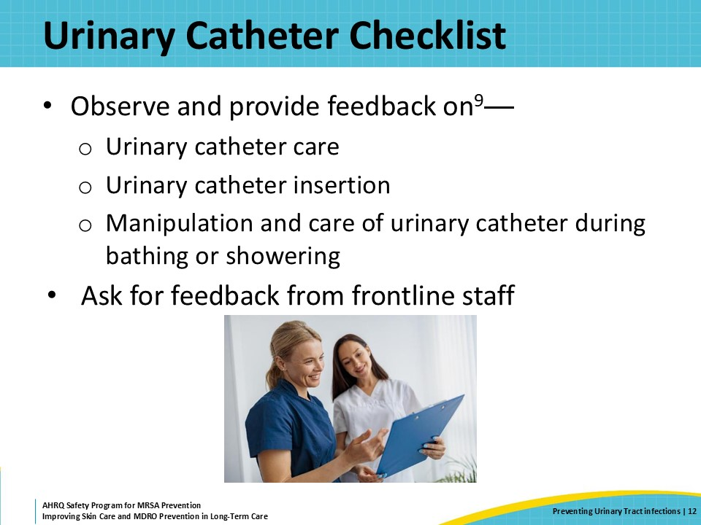
Teachable Moment  SAY:  The following slides will walk through a case study where a CNA is challenged with keeping an indwelling catheter clean for a resident with fecal incontinence. Consider the following questions:  - Does the resident need the catheter?  - How might the CNA prevent the loose stool from reaching the catheter? | Slide 13  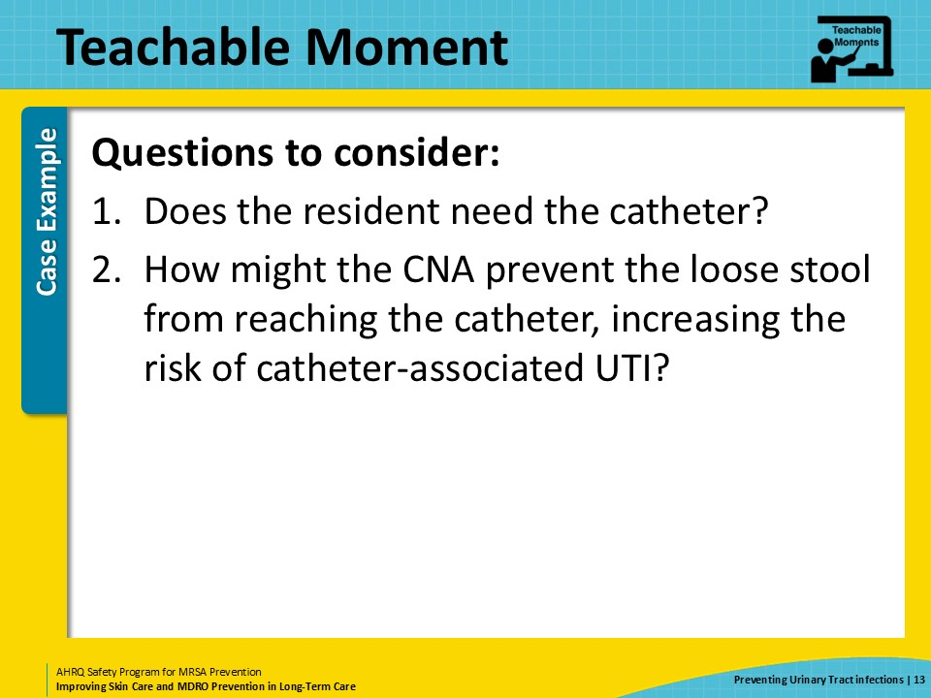
The Case  SAY:  A 69-year-old female resident is scheduled to receive a bed bath. The resident recently had a urinary catheter placed after the family requested its placement due to urinary incontinence. While preparing for the bed bath, the CNA notices that the resident has had a bowel movement sometime within the last hour. | Slide 14  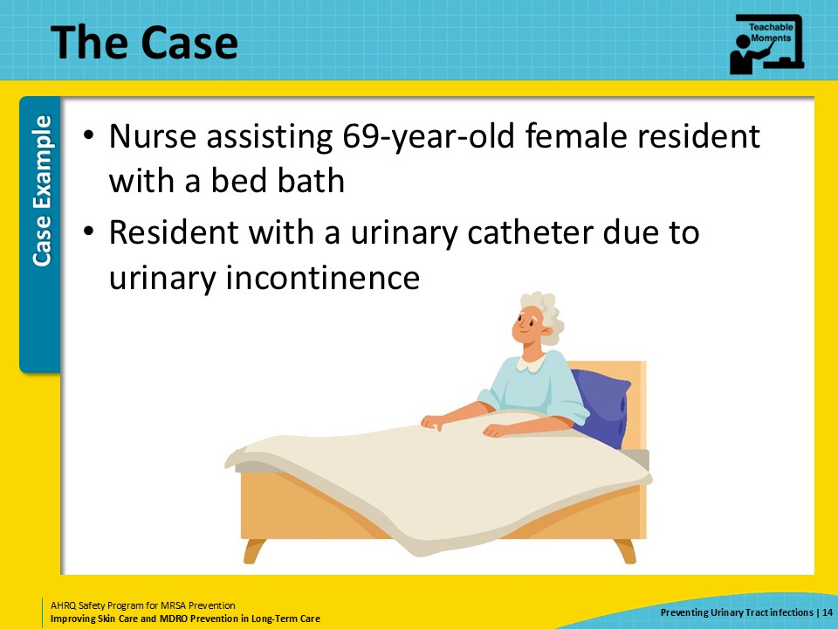
The Challenge  SAY:  The CNA must assist the resident with perineal care after stool incontinence, ensuring the catheter and the resident’s skin are appropriately cared for. The stool is already present on the catheter tubing and throughout the perineum. The resident is also contractured, making it difficult to position the resident for cleaning. | Slide 15  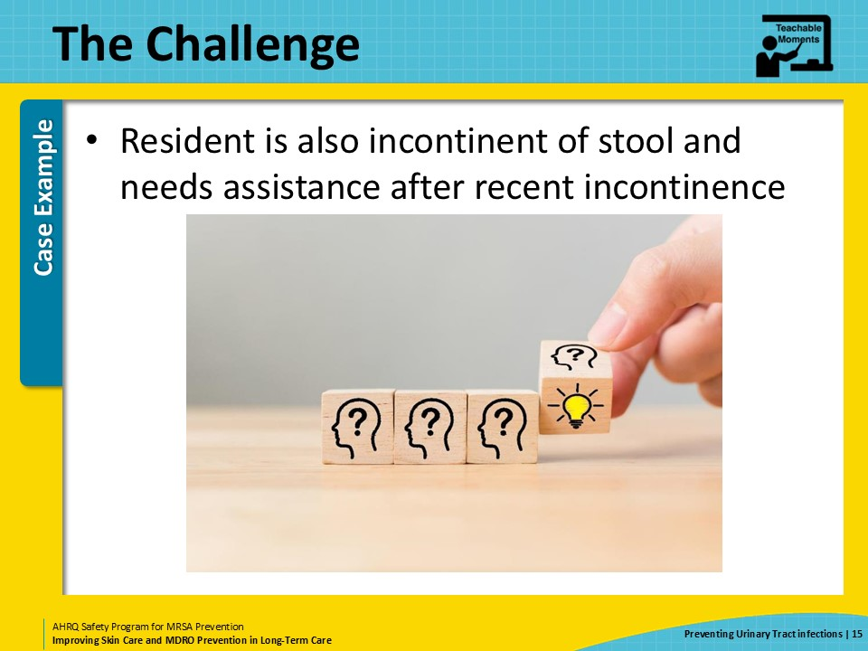
Knowledge Check  SAY:  Before the CNA begins perineal care, they should collect all necessary supplies to complete the task. They should remove any gloves they were previously wearing, perform hand hygiene, and don a new pair of gloves. The CNA will need to be careful not to wipe stool toward the catheter or the meatus during cleaning, to avoid pushing stool into the urethra. The CNA may need several washcloths and soapy water to effectively clean the perineum of stool. | Slide 16  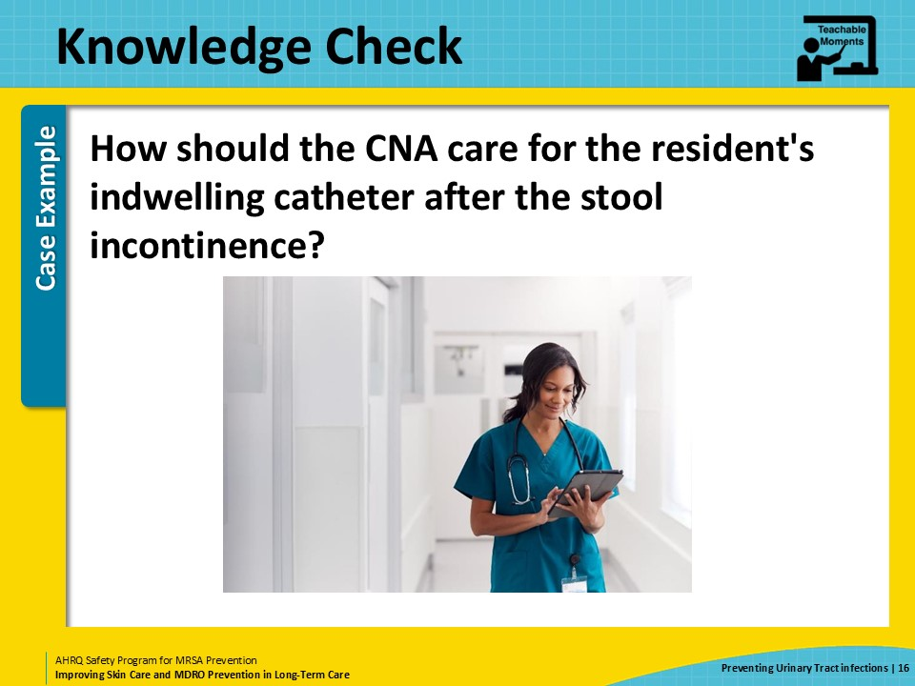
The Error  SAY:  During the cleanup process, the CNA wipes stool from the resident’s genitals from back to front or from bottom to top, which has the effect of pushing stool towards where the catheter enters the body—at the meatus of the urethra.  To avoid tugging on the catheter, the CNA also wipes stool up the catheter—toward the body—which pushes stool toward where the catheter enters the body.  Later, the family member mentions to the CNA that the resident had the catheter placed due to urinary incontinence. The CNA knows that this is not an appropriate indication for urinary catheter use but is hesitant to speak up to the nurse or provider about their concerns. | Slide 17  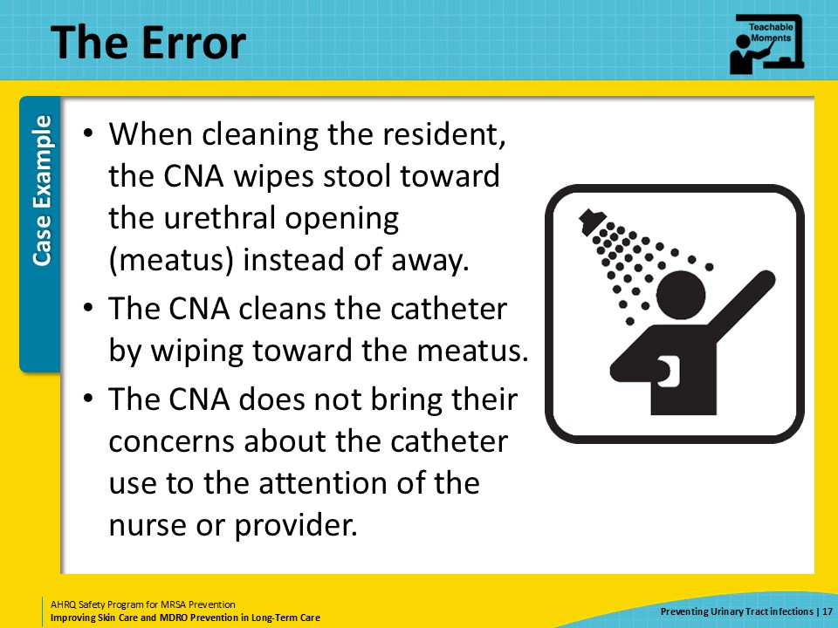
The Consequence  SAY:  The stool that was wiped toward the urethral opening was pushed into the urethra and traveled into the bladder.  Three days after the CNA assisted the resident with her bed bath, the resident presented with fevers and lower abdominal pain. The urine sample that was collected from the resident’s urine sample collection port was positive for a resistant E. coli, requiring IV antibiotics. Because the indication for the resident’s catheter was not questioned, the catheter remained in place for an additional week. | Slide 18  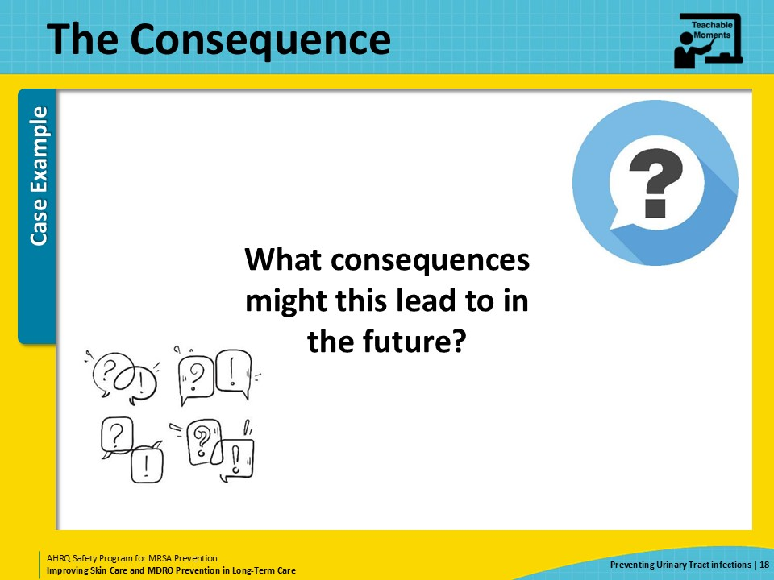
Preventing the Next Harm  SAY:  A key part of patient safety is to think ahead to how to prevent the next potential harm to a patient or resident. Once an error or mistake is identified, think about what can be done to avoid that same error from repeating in the future.  First, training and properly overseeing direct care staff on appropriate perineal care, including how to keep stool away from the urethra, is a fantastic way to prevent other staff from making the same mistake. Ensure that staff who are responsible for training, or are being shadowed, are following the facilities’ policies and procedures; having a trainer who does not follow policy can lead to more downstream mistakes.  Second, offering regular in-service training can help ensure that new staff are getting the correct education, particularly if the facility has high staff turnover rates, which is common in long-term care.  Third, using products to protect urinary catheters from stool, such as fecal collection devices, can help prevent contamination.  Most importantly, avoid urinary catheter use when it is not indicated. This is by far the best way to prevent catheter-associated urinary tract infections. Regular reviews of the indications for urinary catheters should be incorporated into resident care plans and revisited daily. | Slide 19  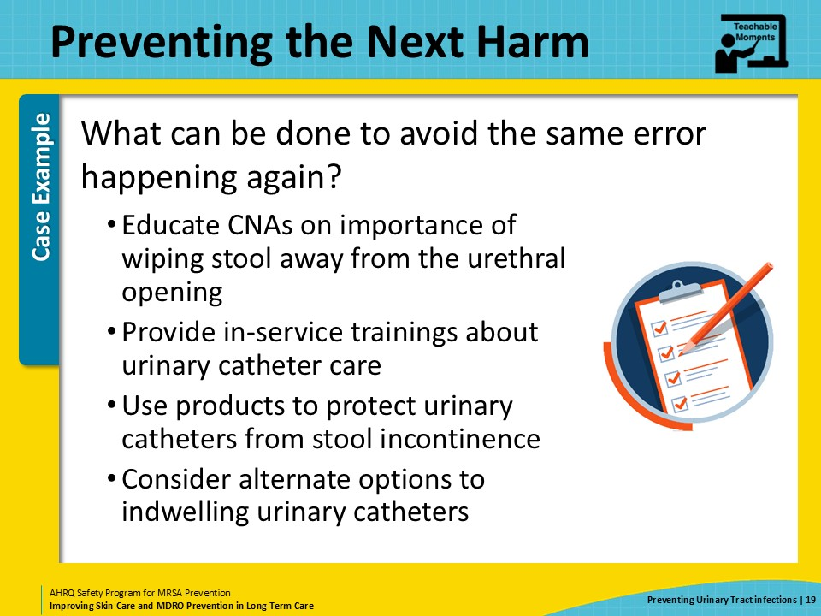
System-Based Safety Changes  SAY:  From the system level, senior executives can help ensure that the reasons for catheter placement are getting adequate attention. If a catheter is necessary, senior executives can also ensure best practices around urinary catheter insertion and maintenance are being implemented.  Remember, there are few indications for urinary catheters in the long-term care setting. Urinary incontinence alone is not an indication for an indwelling urinary catheter. Empowering all levels of staff to recognize potential risks to the resident, including prolonged catheter use that may not be indicated, and speaking up about these errors, is an essential element of good safety culture and should be encouraged.  Technical checklists and education are among the many tools that coaches—or people in leadership—can use to support a culture of safety.  Direct care staff in long-term care settings are there because they care about the residents. Helping direct care staff understand how their actions impact resident outcomes can be incredibly rewarding. Further, fostering an environment in which staff work together to educate each other and receive constructive feedback with grace can significantly improve the work environment for all levels of staff. | Slide 20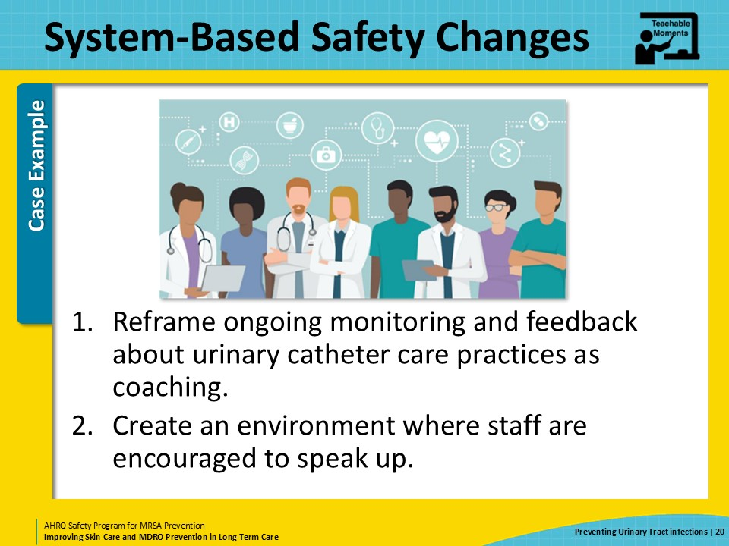
Key Takeaways  SAY:  In summary, urinary catheters are a significant source of infection in nursing homes, including infections with multidrug-resistant organisms. Careful catheter care or maintenance and frequent evaluation of the need for the catheter helps prevent infections caused by urinary catheters. When errors occur in healthcare, such as prolonged catheter use when it is not indicated, healthcare teams must think through these errors or problems to find solutions to prevent the next harm. The goal is to end repeated harms by intervening before the next error.  Although some solutions are technical, healthcare teams should also look for system-based opportunities to improve care, such as empowering all levels of staff to review indications for catheter use and speak up about removing the catheter when it is not indicated. | Slide 21  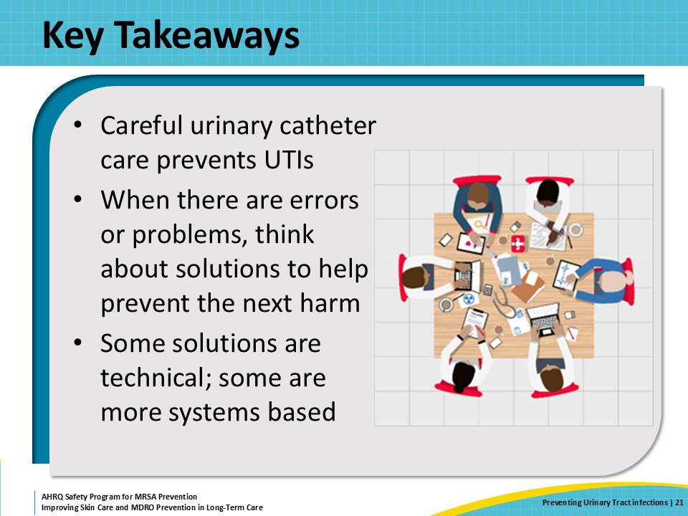
Supporting Materials  SAY:  Additional materials go with this presentation. These materials include Teachable Moments: Indications for Indwelling Urinary Catheters, The Case of the Resident With a Foley Catheter Who Had a Bowel Movement, and Preventing CAUTI. External supporting materials include AHRQ urinary catheter maintenance checklist tool, an AHRQ urinary catheter insertion checklist tool, and one-pagers, and pocket cards from the AHRQ Antibiotic Stewardship toolkit. The final material is an internally created supporting material— an LTC Urinary Catheter Maintenance checklist. | Slide 22  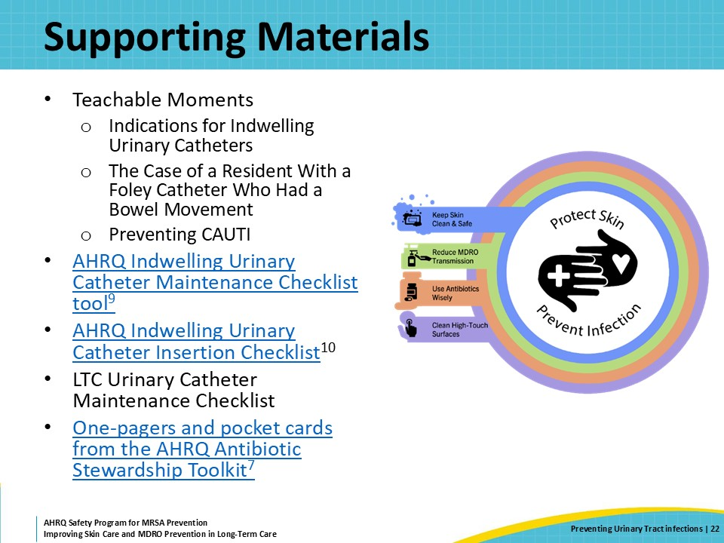
Disclaimer  SAY:  The findings and recommendations in this presentation are those of the authors, who are responsible for its content, and do not necessarily represent the views of AHRQ. No statement in this presentation should be construed as an official position of AHRQ or of the U.S. Department of Health and Human Services.  Any practice described in this presentation must be applied by healthcare practitioners in accordance with professional judgment and standards of care in regard to the unique circumstances that may apply in each situation they encounter. These practices are offered as helpful options for consideration by healthcare practitioners, not as guidelines. | Slide 23  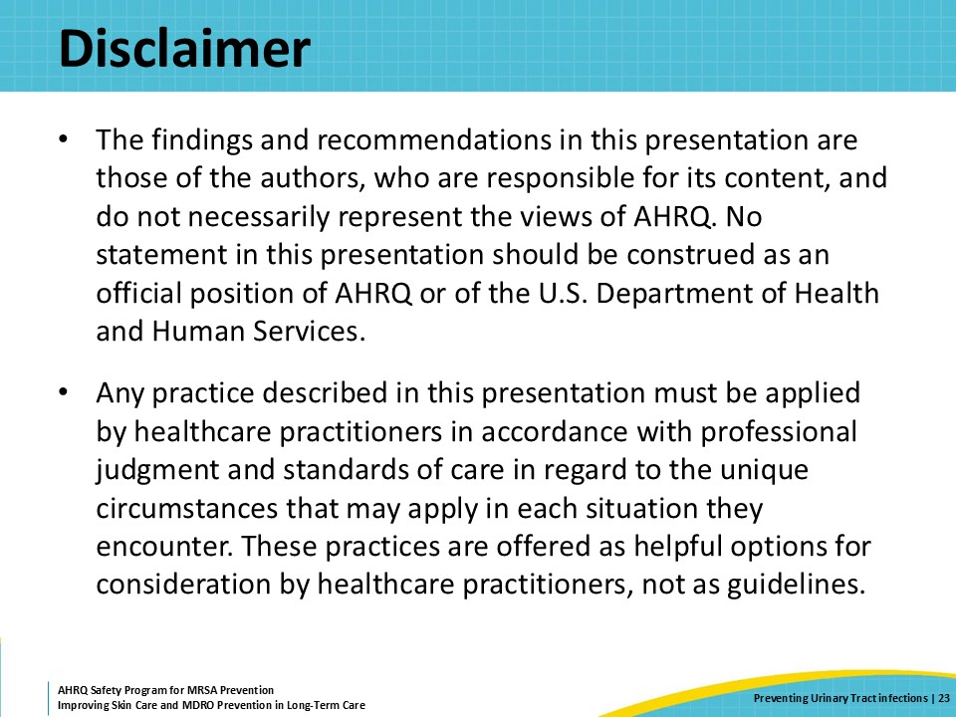
References—1  Here are the references for the presentation. | Slide 24  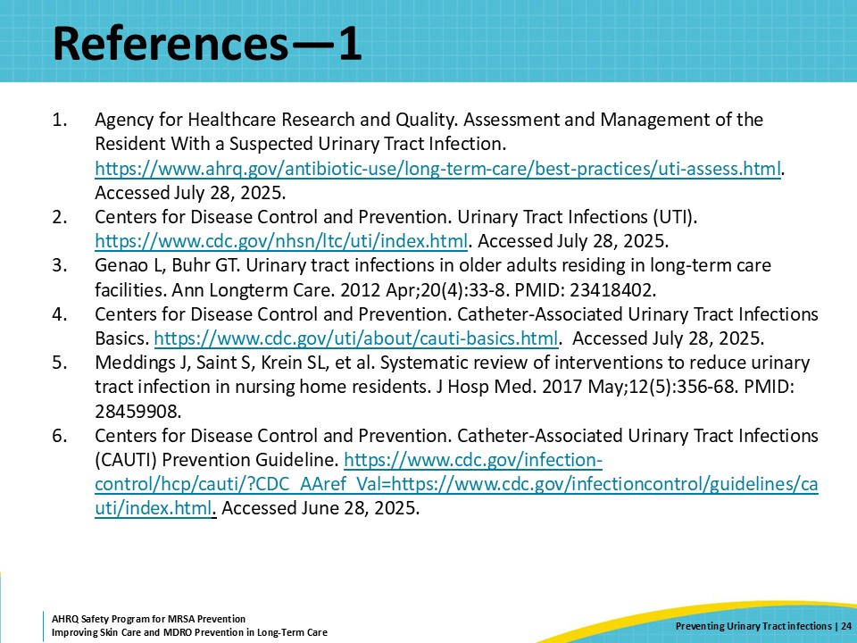
References—2 | Slide 25  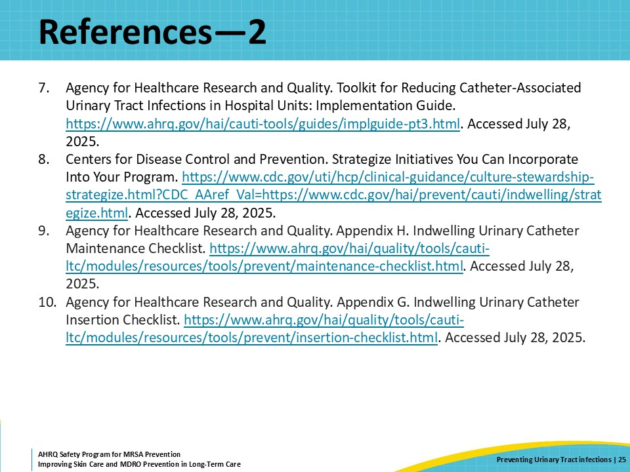
AHRQ Pub. No. 25(26)-0066
October 2025

