Indications for Indwelling Urinary Catheters
AHRQ Safety Program for MRSA Prevention
It’s not always easy to tell when it’s appropriate to use an indwelling catheter. The table below lists some situations you might run into and indicates whether it is appropriate to use an indwelling catheter or an alternative, such as intermittent catheterization or a condom catheter.
Always consider intermittent catheterization as an alternative before inserting an indwelling urinary catheter.
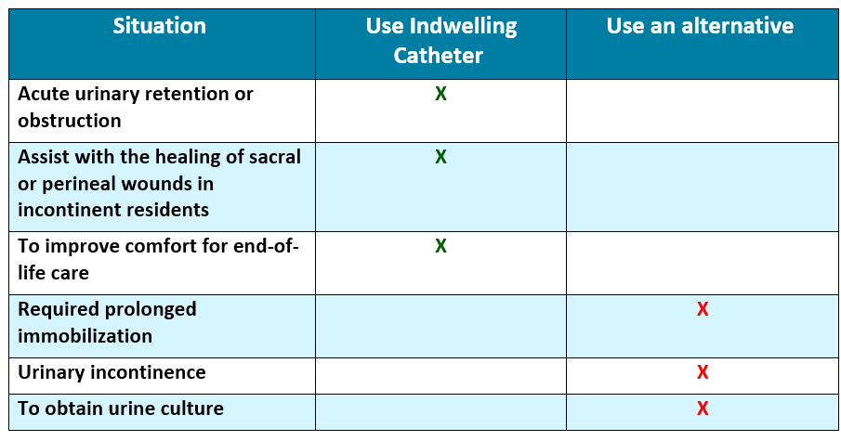

Knowledge Check
- A resident’s physician has asked the certified nursing assistant (CNA) to place an indwelling urinary catheter for urinary incontinence. The resident does not have any sacral or perineal wounds. How should the CNA respond to this request?
- “What size catheter would you like placed?”
- “I’ll take care of that order as soon as I’m finished with this bed bath.”
- “We are trying not to catheterize our residents for incontinence because of the risk of infection. I will need to consult my manager first before doing that.”
- A family member requests a catheter for a resident to increase his comfort due to his prolonged immobilization and urinary incontinence. Which catheter would be most appropriate in this situation?
- Intermittent catheterization
- Indwelling urinary catheter
- Condom catheter

Knowledge Check Answers
- A resident’s physician has asked the certified nursing assistant (CNA) to place an indwelling urinary catheter due to urinary incontinence. The resident does not have any sacral or perineal wounds. How should the CNA respond to this request?
- “What size catheter would you like placed?”
- “I’ll take care of that order as soon as I’m finished with this bed bath.”
- “We are trying not to catheterize our residents for incontinence because of the risk of infection. I will need to consult my manager first before doing that.”
- A family member requests a catheter for a resident to increase his comfort due to his prolonged immobilization and urinary incontinence. Which catheter would be most appropriate in this situation?
- Intermittent catheterization
- Indwelling urinary catheter
- Condom catheter

References
- Centers for Disease Control and Prevention. Infection Control. Catheter- Associated Urinary Tract Infections (CAUTI). Guideline for Prevention of Catheter- Associated Urinary Tract Infections. Last reviewed April 12, 2024. Catheter-Associated Urinary Tract Infections (CAUTI) Prevention Guideline | Infection Control | CDC. Accessed March 18, 2025.
AHRQ Pub. No. 25(26)-0066
October 2025

