Skin Under Pressure:

Preventing Pressure Injury
AHRQ Safety Program for MRSA Prevention
Slide Title and Commentary | Slide Number and Slide
Skin Under Pressure: Preventing Pressure Injury  SAY:  Welcome to this presentation on “Skin Under Pressure: Preventing Pressure Injury,” part of the AHRQ Safety Program for MRSA Prevention: Improving Skin Care and MDRO Prevention in Long-Term Care. The aims of this presentation are to identify, stage, and prevent pressure injuries in residents of long-term care facilities. | Slide 1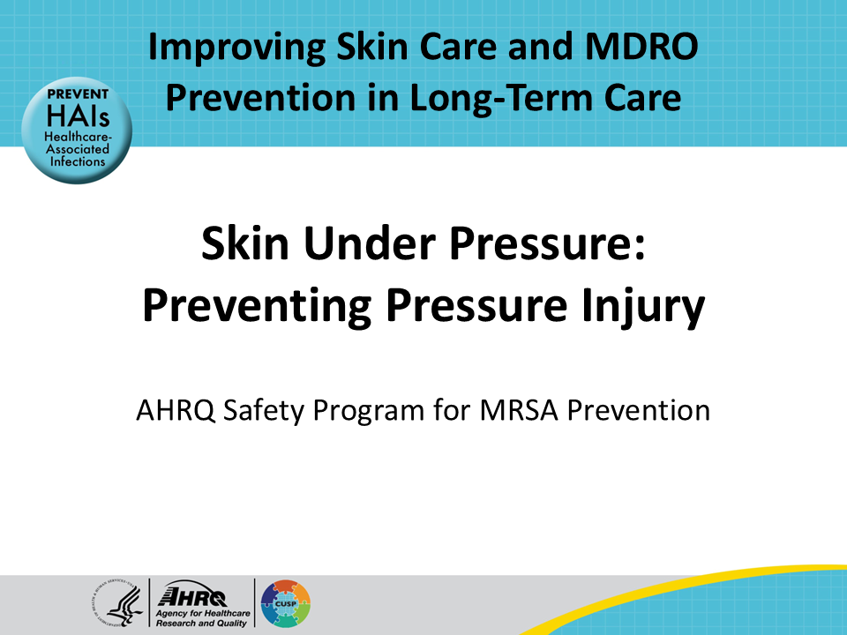
All Staff Support Resident Care and Safety  SAY:  The information provided in this presentation is important in the care of long-term care (LTC) residents. In LTC facilities, each member of the facility’s staff supports resident care and safety. Some actions described in these presentations may not be in your scope of practice, but it is important to learn how all staff contribute to resident care and safety. | Slide 2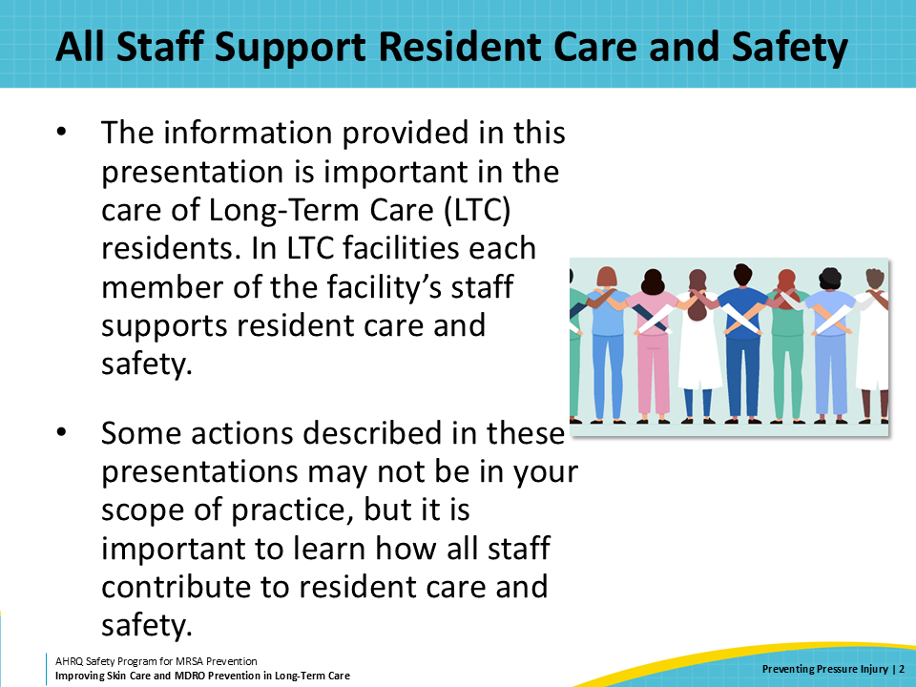
Educational Objectives  SAY:  The objectives of this presentation are to learn what pressure injuries are and how to prevent them, review how to stage different pressure injuries, and discuss how pressure injuries can lead to skin and soft tissue infections. | Slide 3  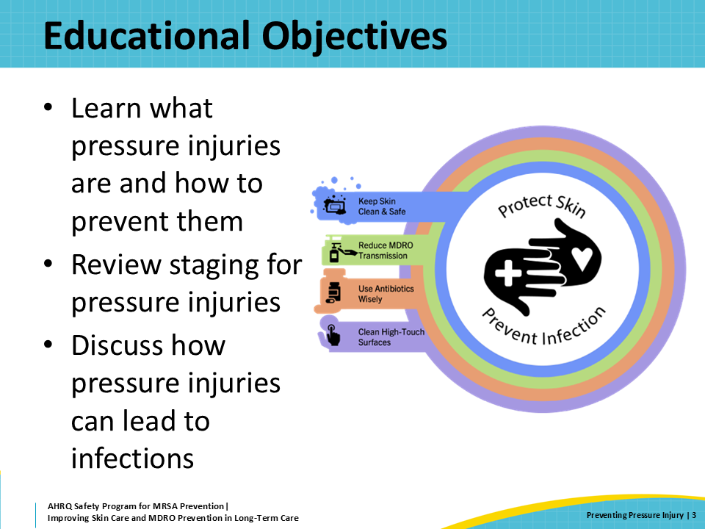
What Are Pressure Injuries?  SAY:  Pressure injuries were previously referred to as "pressure ulcers" or "bedsores." ”Pressure injury” is now the desired terminology, as it more accurately describes injury to both intact and ulcerated skin.  Pressure injuries develop due to a combination of factors that include pressure—causing a lack of adequate blood flow, friction, and shear to an area of the skin, which leads to breakdown of the skin.  There are four stages of pressure injuries that will be described in more detail in this presentation. These stages range from early warning, when the skin is red but remains intact, to severe, when the pressure injury is so deep it extends to underlying bone. | Slide 4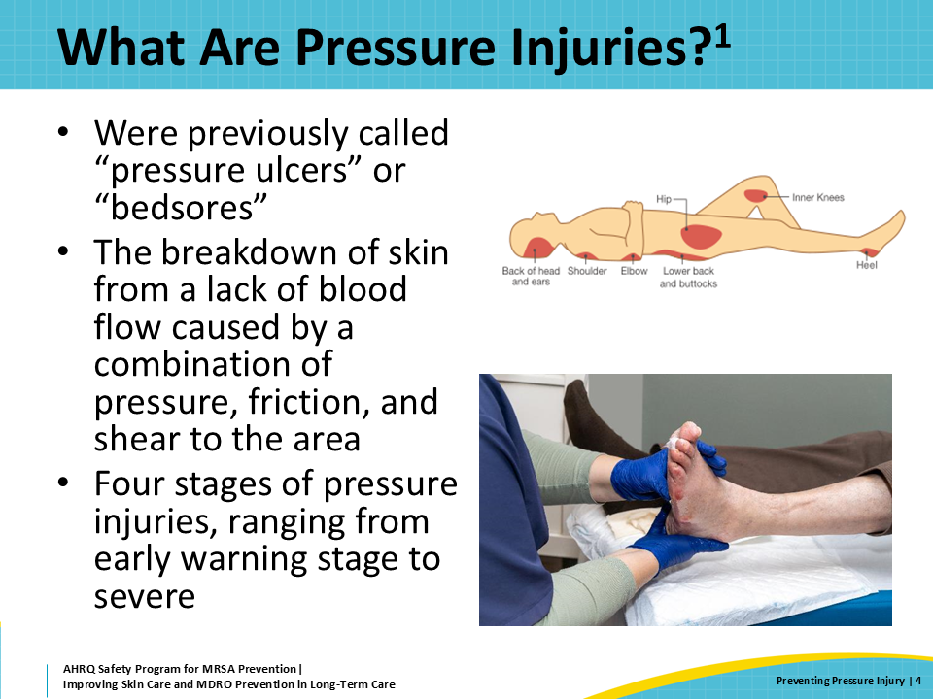
Pressure Injuries in Long-Term Care  SAY:  Pressure injuries are unfortunately quite common in nursing home residents. At any given time, approximately 11 percent of nursing home residents have a pressure injury.  Preventing pressure injuries is incredibly important. Not only do they cost the health system over $33 billion per year in associated complications, but they also predispose residents to wound infections and sepsis. When skin is not intact, there is a potential entry point for bacteria. These bacteria can cause infection in the wound, or worse, progress to bloodstream infections, bone infections, and sepsis, which can be fatal. | Slide 5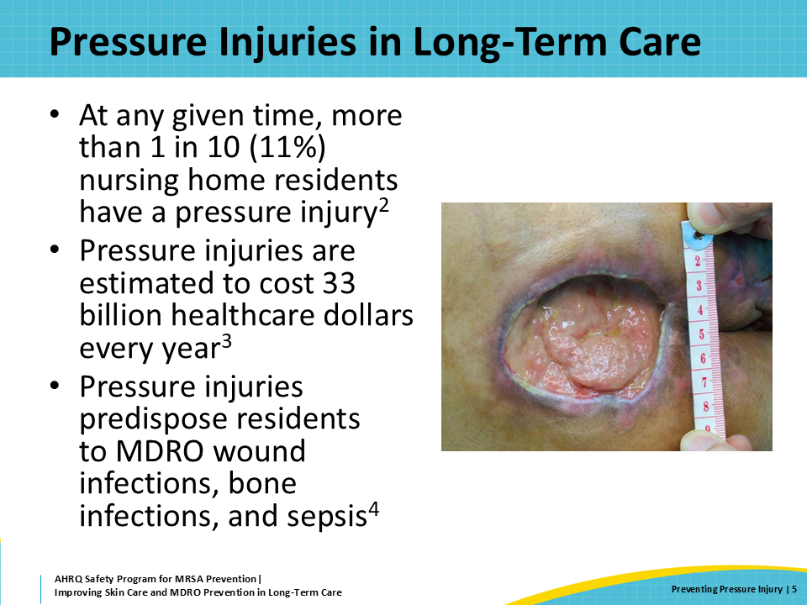
Triangle of Transmission  SAY:  The triangle of transmission illustrates where staff can have an impact in preventing the transmission of resistant organisms. Remember, pressure injury prevention helps residents maintain intact skin. By maintaining intact, healthy skin through pressure injury prevention, staff can prevent entry of resistant organisms into wounds.  Residents that are immobile are often completely reliant on direct care staff to reduce pressure on bony prominences, such as the resident’s coccyx or heels, both of which are common locations for pressure injuries to develop. Staff need to remain vigilant about residents at risk for prolonged immobilization so they can help reduce wear and tear on these pressure points. | Slide 6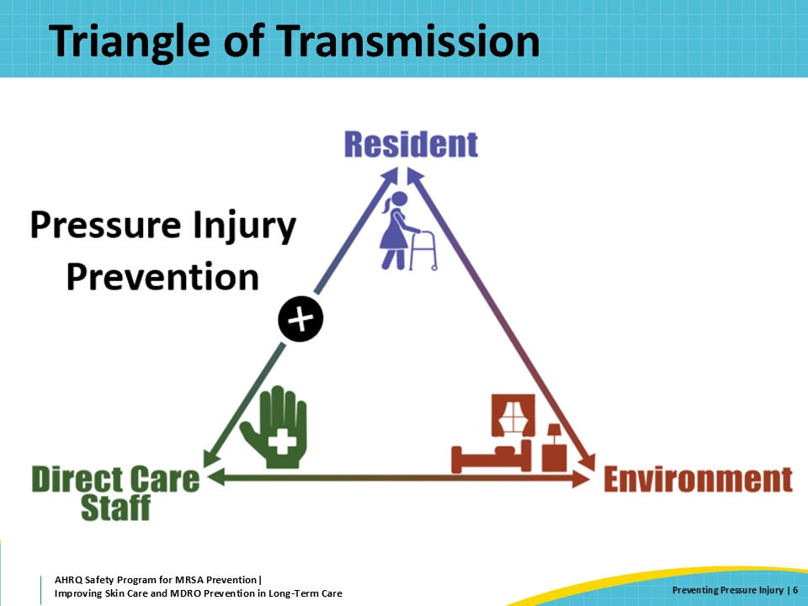
How Do Pressure Injuries Develop?  SAY:  Before discussing pressure injury prevention, let’s get a deeper understanding of how pressure injuries develop.  Previous thought was that pressure injuries develop due to a lack of blood flow to the skin and underlying tissues. That is partially true. But the development of pressure injuries is a much more complex problem. Despite the speed at which they can develop and progress, pressure injuries form due to a combination of these factors: direct sustained pressure, friction, and shear. | Slide 7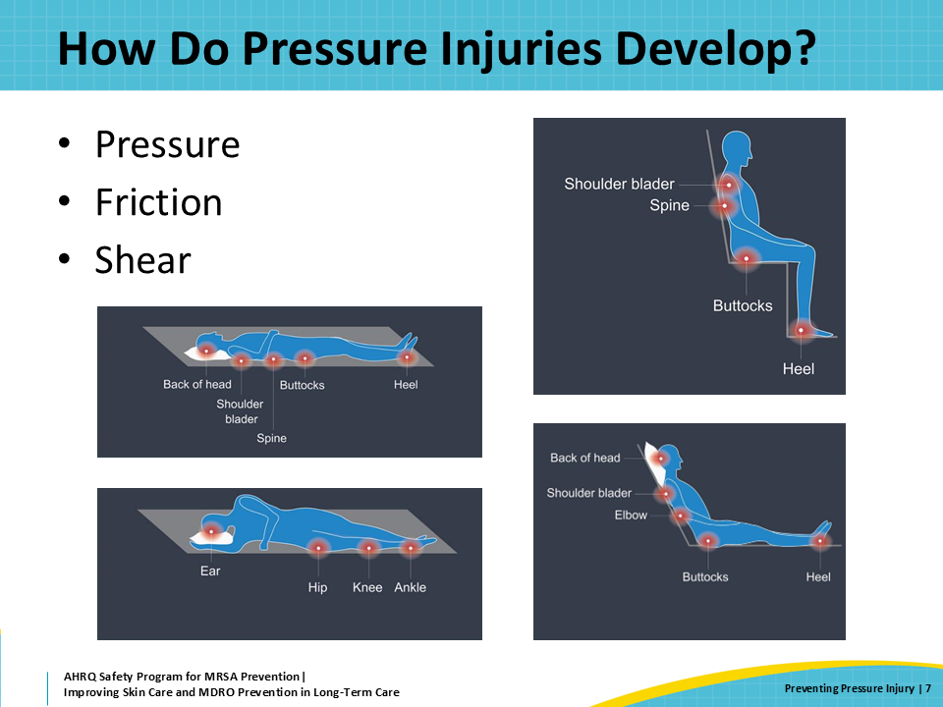
Pressure, Friction, and Shear  SAY:  Sustained pressure usually occurs when mobility is an issue. Residents with mobility challenges will have sustained pressure injuries from body weight in the areas where the body is encountering a surface, usually a chair or a bed. This sustained pressure is especially problematic along bony prominences of the body such as the heels, sacrum, coccyx, elbows, and shoulders.  Friction occurs when the body is moved back and forth along a surface. Friction causes the top layer of skin or epidermis to separate from the lower layer or dermis. This causes damage to the skin surface that can look red, purple, or denuded—like after the top comes off a blister.  Shear involves both pressure and friction. Shear causes damage to both layers of skin—the epidermis and dermis—and causes damage to deeper tissues underneath the skin. This combination of pressure and friction can disrupt blood flow to the skin and tissues, resulting in skin breakdown and ulcer formation. | Slide 8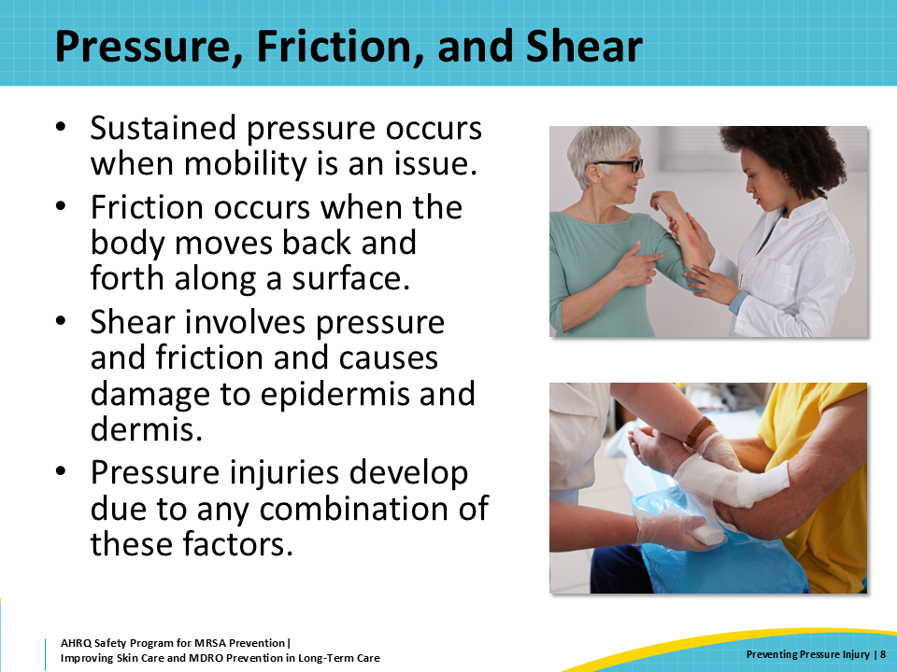
The Stages of Pressure Injuries  SAY:  Pressure injuries fall into four main categories or stages.  Stage 1 pressure injuries can be identified as intact skin that is discolored; this can be red, blue, purple, or violet, depending on the resident's skin tone. For people with darker skin, color changes can be hard to see. Sometimes it helps to look for violet hues or skin that is darker than surrounding areas. Having good lighting also makes it easier to see changes in skin color.  One way to identify stage 1 pressure injuries is to see if the skin blanches. If you press on the skin and it does not turn lighter after you lift your finger, this is considered "nonblanchable" and signifies a pressure injury. It may also feel warm to the touch and even a little boggy. The resident may tell you that skin area burns or itches.  In stage 2 pressure injuries, you begin to see some skin breakdown. This looks like an open sore that resembles an abrasion or blister. The skin around the wound can be discolored and the area is painful. | Slide 9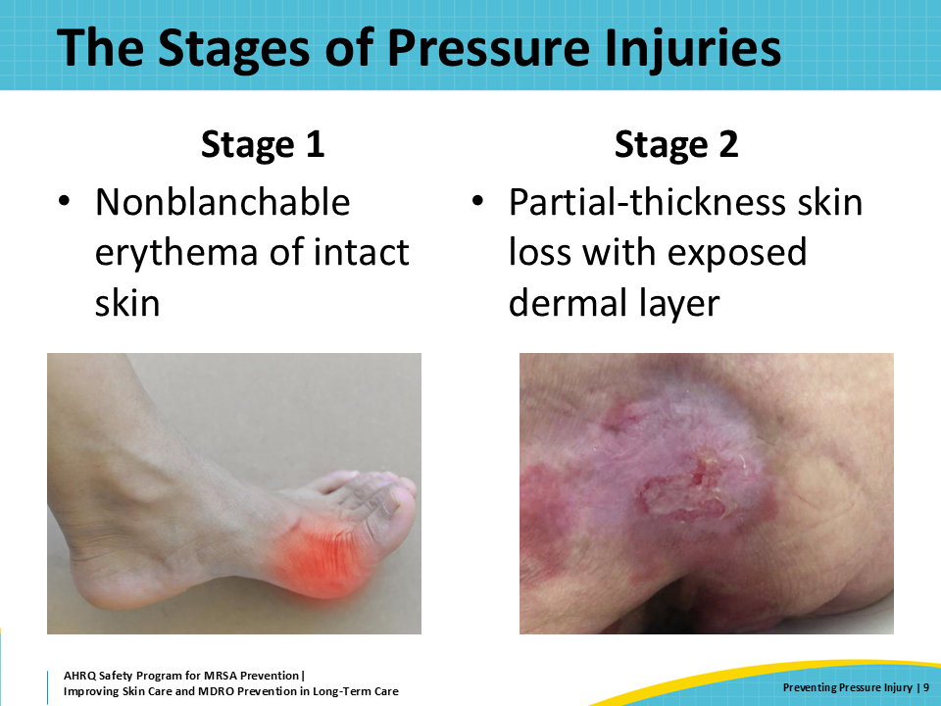
The Stages of Pressure Injuries (continued)  SAY:  Stage 3 pressure injuries involve full-thickness skin loss. The sore deepens and looks like a crater, often with darker patches of skin around the edges.  Stage 4 pressure injuries include full-thickness skin and tissue loss. The injury extends to muscle, tendons, and bone. Stage 4 injuries can cause infection of the bone, known as osteomyelitis. Whenever bone is exposed or the injury can track to the bone, the bone is considered infected. Bone infections are quite serious and can lead to major downstream complications for the resident. The treatment of osteomyelitis may involve surgical debridement in the operating room and nearly always requires several weeks of intravenous antibiotics, which are typically administered through a central line.  If the underlying causes that led to the pressure injury cannot be relieved, these wounds are often almost impossible to heal. It can also lead to a potentially life-threatening infection of the blood called sepsis, which has high mortality rates.  Some pressure injuries may be covered by a thick layer of dead skin that is still attached to the living tissue below. This is often dark brown or black in color and is called an eschar. Pressure injuries with an eschar are described as unstageable. | Slide 10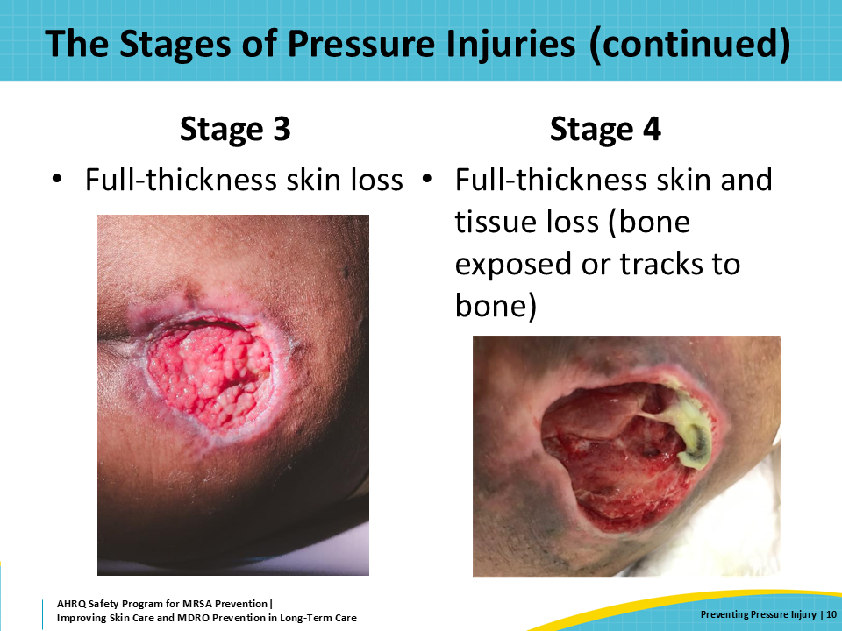
How Can We Prevent Pressure Injuries?  SAY:  After reviewing the devastating causes of pressure injuries, the next step is determining how to prevent them.  Pressure injuries have multifactorial causes. Therefore, prevention of pressure injuries must be approached through a multimodal strategy, addressing multiple factors at once.  First, identify and continuously reassess a resident's risk for pressure injuries. Identifying residents who may develop pressure injuries is the first step to putting proper prevention points in place so that pressure injuries do not develop.  Next, focus on proper skin care with frequent skin assessments. Good skin care includes using skin assessment skills when providing care to the residents. All staff members can look for potential skin problems and pressure injuries during bathing or assistance with toileting, or when helping someone dress.  Many residents in long-term care facilities have nutritional deficiencies that put them at risk for skin injury and delayed healing if they develop an injury. Frequent evaluations of nutritional status can help prevent the development and worsening of pressure injuries.  Obviously, the position and mobilization of the resident, when possible, helps to reduce breakdown of pressure points. Ensure residents are frequently turned or moved to the chair. Use cushioning, like pillows and soft arm rests, and barriers, such as heel protectors, to help protect the skin of residents who cannot mobilize on their own.  Finally, all of these prevention steps must be overseen and supported by leadership, including charge nurses, administrators, and senior executives. Preventing pressure injuries is multimodal and nursing assistants will not be successful if they do not have the staffing or other support needed. Examples of resources that nursing assistants may need include air mattresses and nutrition specialists. | Slide 11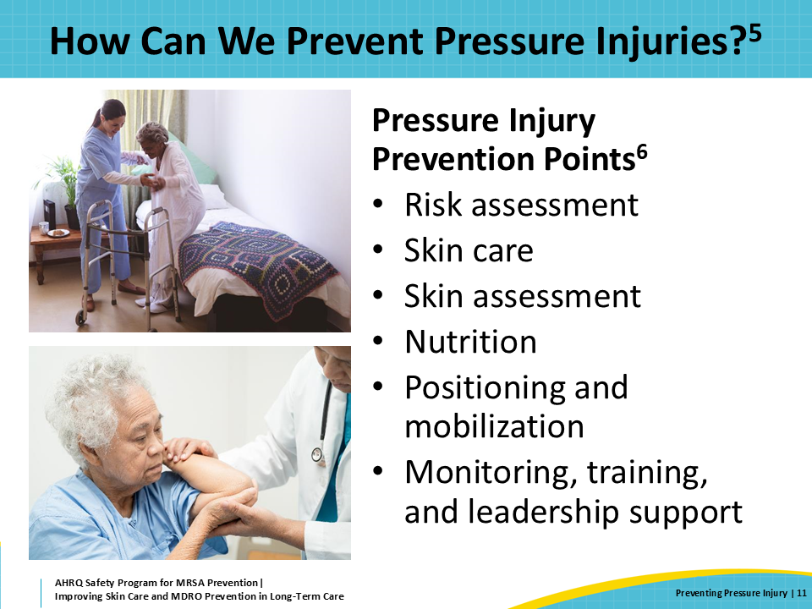
Assessing the Risk for Pressure Injuries  SAY:  A standardized, ongoing risk assessment is necessary to implement any evidence-based pressure injury prevention protocol.  Risk assessments should be performed on admission, preferably within 8 hours of admission, and reassessed on a regular basis, depending on the patient's acuity and with any significant change in clinical status.  Several risk assessment scales are commonly used in the long-term care setting to assess pressure injury risk. The three most common are the Norton Scale, the Braden Scale, and the Waterlow Scale. It is important to note that assessment scales are not perfect—even if a resident qualifies at low risk on the assessment scale, measures should still be put in place to reduce pressure injury risk.  Factors such as skin temperature, corticosteroid use, and underlying health may impact a resident's risk for pressure injury and not be incorporated in a risk assessment score. Therefore, clinical judgement is always important to guide interventions. | Slide 12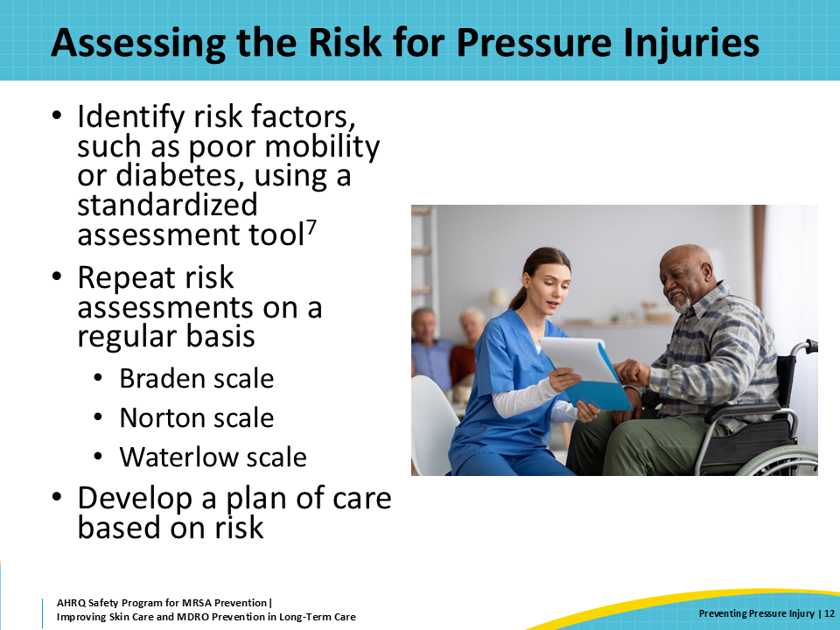
Caring for At-Risk Skin  SAY:  One of the best ways to prevent pressure injuries from progressing to later stages is to regularly inspect skin and intervene early. Skin that is discolored, particularly along pressure points like the heels, sacrum, elbows, or beneath or around medical devices may be developing a stage 1 pressure injury.  Broken skin serves as a point of entry for bacteria to enter and cause an infection. Identifying a stage 1 pressure injury—when the skin is still intact—can help prevent skin breakdown. Specific interventions include using pressure-relieving devices and avoiding positioning the patient on an area where there is a pressure injury. | Slide 13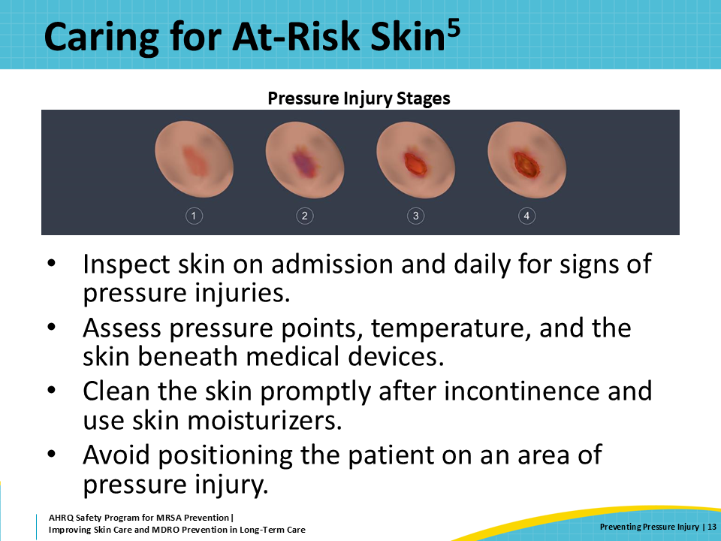
Positioning and Mobility  SAY:  Finally, focus on position and mobility to ensure residents do not have extended periods of pressure on bony prominences. Turning must be done with care—skin tears and shearing can occur if appropriate assistance is not provided, particularly with residents who cannot assist with movement or who have a larger body habitus.  Remember that some of these residents are completely dependent on caregivers for their mobility. Even when you may be overworked, take care to keep up with repositioning residents who rely on staff to move them. This is a difficult situation for anyone. Remember that you would not want your loved one feeling helpless or unable to clean themselves if they are incontinent.  It is OK to ask for help if you get behind. Fostering a culture in which staff members can help each other, even if it is not their responsibility, can improve resident outcomes and staff satisfaction. Helping someone find a comfortable position that also prevents injury is an act of kindness that everyone can relate to and appreciate. | Slide 14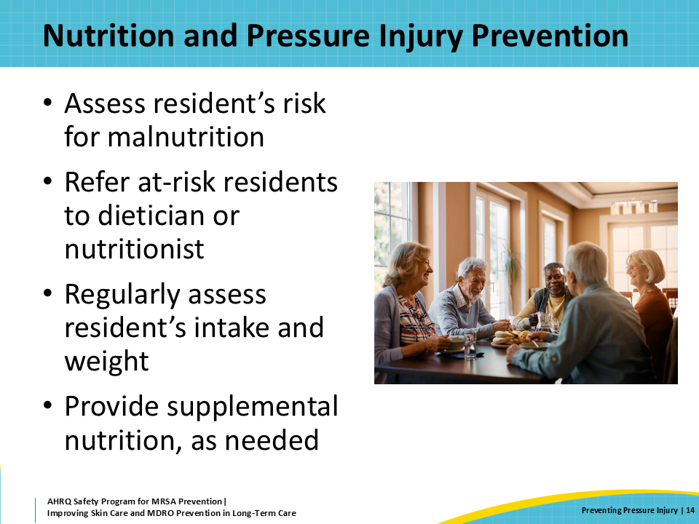
Nutrition and Pressure Injury Prevention  SAY:  Malnutrition can also place residents at risk for skin breakdown and poor wound healing. Take care to monitor a resident's intake and obtain (accurate) weekly weights to help identify residents who may be at risk for malnutrition.  Dieticians or nutritionists can be incredibly helpful to assess a resident's specific needs and tailor supplements or diet to improve the resident's chance of recovering from malnutrition. | Slide 15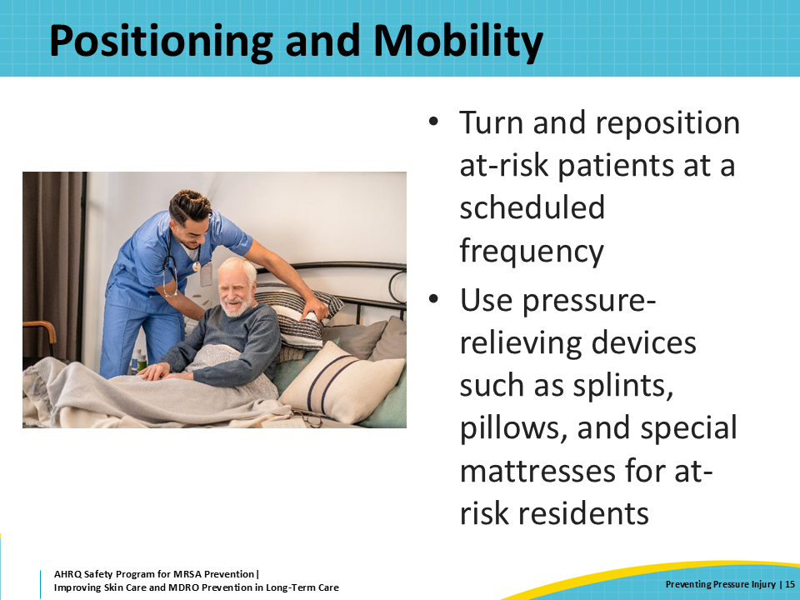
Teachable Moment  SAY:  The following case will touch on two important questions:  First, how does pressure injury prevention help to prevent skin and soft tissue infections?  Second, how can all staff members help prevent pressure injuries? | Slide 16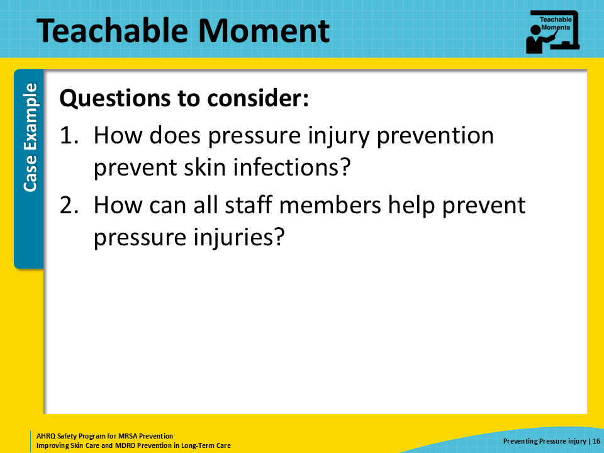
The Case  SAY:  In this case, a CNA has recently started caring for a 54-year-old with a spinal cord injury. Although he has limited use of his arms, he remains dependent on staff members for his mobility. | Slide 17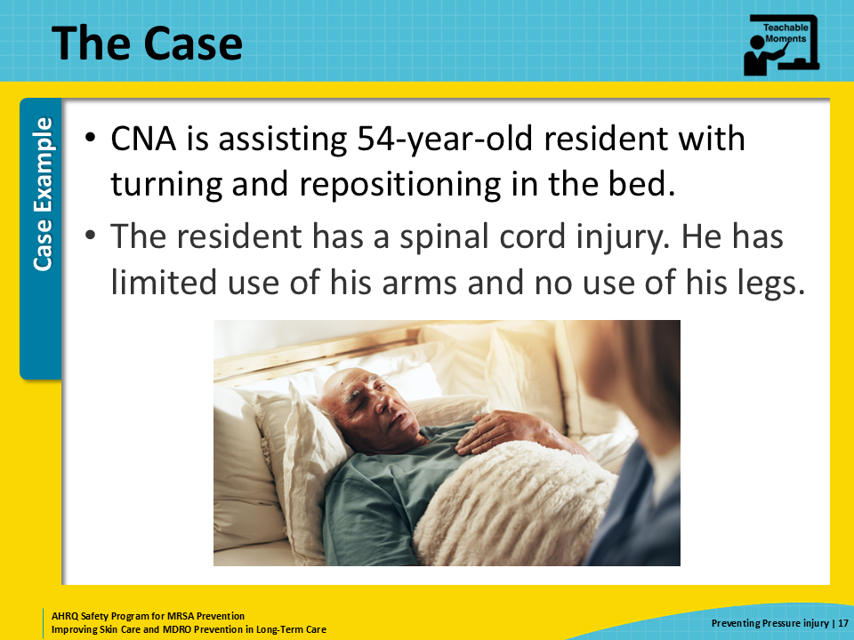
The Challenge  SAY:  The CNA does not usually work on this unit. She was assigned here after two other staff members called in sick.  The CNA uses a Hoyer lift to help the resident move into a chair. This should be a two-person assist, but there is no one in the hall who can help. Two nurses are nearby, but they are both administering medication. The CNA doesn’t feel comfortable asking for others to help or waiting until help was available. | Slide 18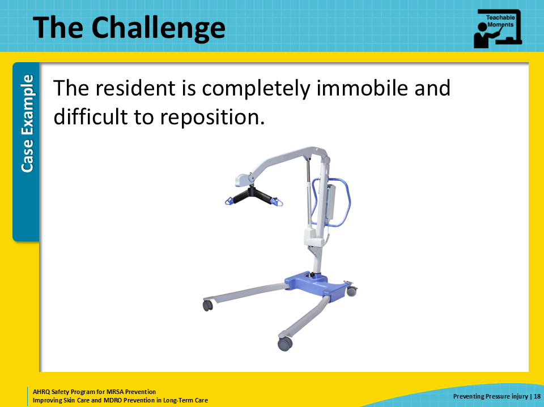
Knowledge Check  SAY:  This slide provides a knowledge check about repositioning the resident.  The most important way to minimize friction and shearing in a resident who cannot assist with movement is to get assistance.  She knows that the Hoyer lift is a two-person task but is too intimidated to ask the nurses for help because they are busy administering medication. | Slide 19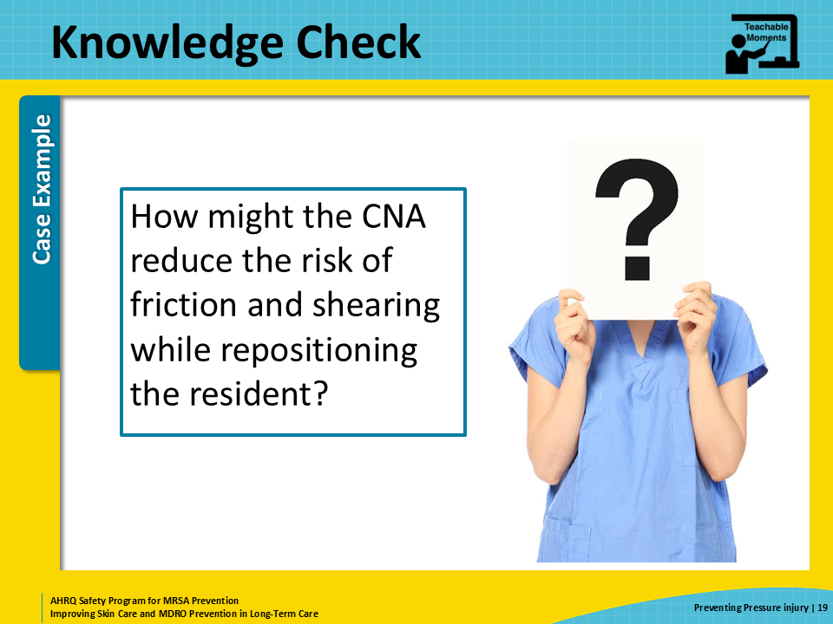
The Error  SAY:  The CNA decides she can move the resident into the sling on her own. She gets the Hoyer lift from the shower room and forgets to wipe it down before she transfers the patient.  Unfortunately, the Hoyer lift had been used earlier that day for a resident colonized with MRSA, and the CNA using the device forgot to wipe it down with the approved disinfectant after use.  The CNA and resident work together to get him into the sling. During that process, the resident’s leg falls against the side of the lift, resulting in a small skin tear on his leg. Once he is in the chair, he begins to slide down. The resident and the CNA work together to get him better situated. During this process, the pads placed on the chair get bunched up behind the resident. Neither the resident nor the CNA are aware of the bunched-up material that is putting pressure on his sacral region.  The nurse and CNA helping with bowel care the following night do not notice the darker skin over his sacral area. The skin looks intact, so they do not make anything of it. | Slide 20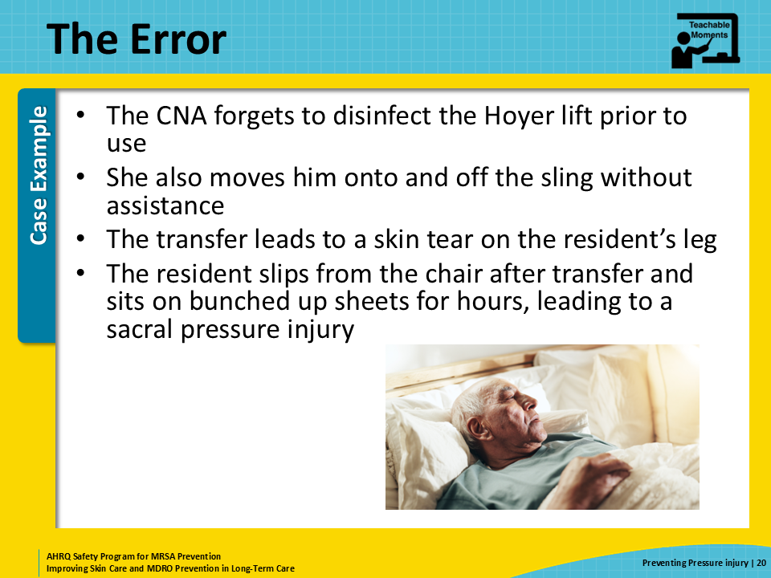
The Consequence  SAY:  Because the Hoyer lift was not properly disinfected and the CNA’s gloves became contaminated, the skin tear on the resident’s leg becomes infected. About 3 days later, the nurse notices purulent fluid draining from the wound.  This prompted a full skin assessment. The resident is now noted to have a stage 2 pressure injury over his sacral region that was not documented when they noticed the skin changes 3 days prior. The pressure injury developed after the resident sat on bunched up sheet in a chair for several hours.  Culture of the fluid from the leg wound grows MRSA. The resident requires several days of antibiotics. He is on enhanced barrier precautions for the rest of his stay in the facility.  The stage 2 pressure injury on his sacral area takes several weeks to heal. | Slide 21  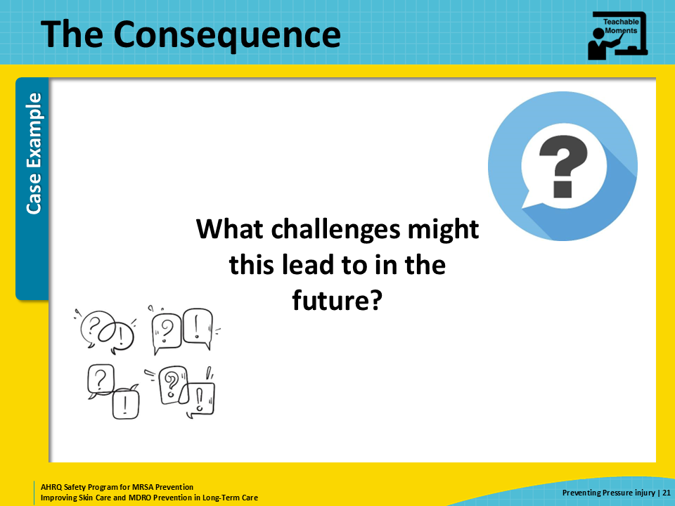
Patient Safety in the Moment  SAY:  What could the CNA have done to prevent skin tear leading to a MRSA infection? And, what could the CAN have done to prevent the resident slipping in the chair and sitting in bunched up sheets, leading to a pressure injury?  Both skin injuries could have been avoided if the CNA had assistance when she transferred the resident to his chair. | Slide 22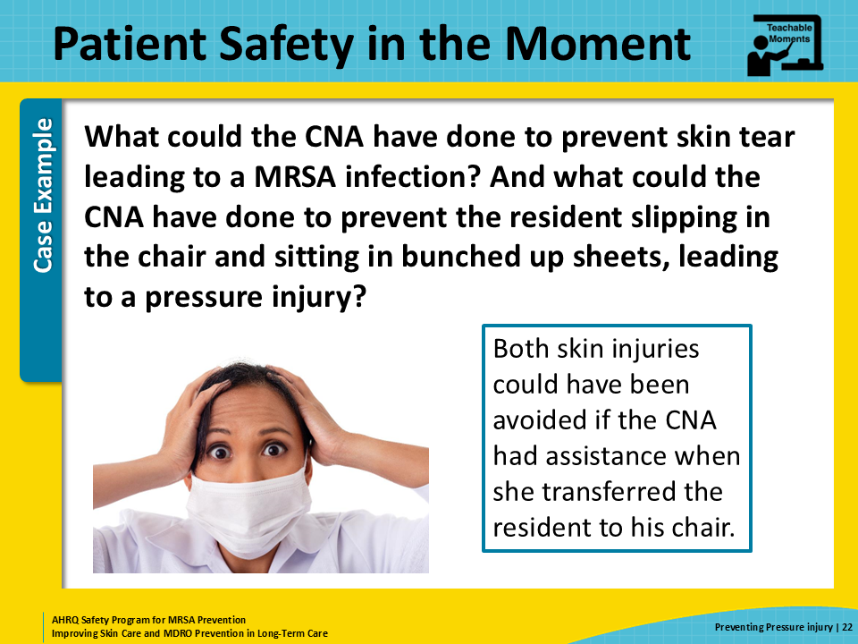
Preventing the Next Harm  SAY:  How can these unfortunate events be prevented for other residents?  First, there must be proper training and delegation regarding who is responsible for disinfecting shared equipment. Disinfection of the Hoyer lift after its last use would have prevented the MRSA infection. The CNA assumed that the Hoyer lift had already been disinfected, but because there was no system in place to document whether the equipment was clean or not, she ended up using contaminated medical equipment.  Second, the CNA should be empowered to ask for help. In this case, she felt too intimidated to ask the nurses while they were administering medication, and because she was already behind schedule, she did not feel comfortable taking more time to go find another person to help her. She was worried it would seem like she could not do her job. These fears contributed to patient harm.  Third, all staff should be trained on the importance of noticing changes in skin as these changes can indicate skin damage or pressure injuries. This training should be part of orientation for new employees and reinforced on a regular basis among all clinical staff who provide direct care to residents. | Slide 23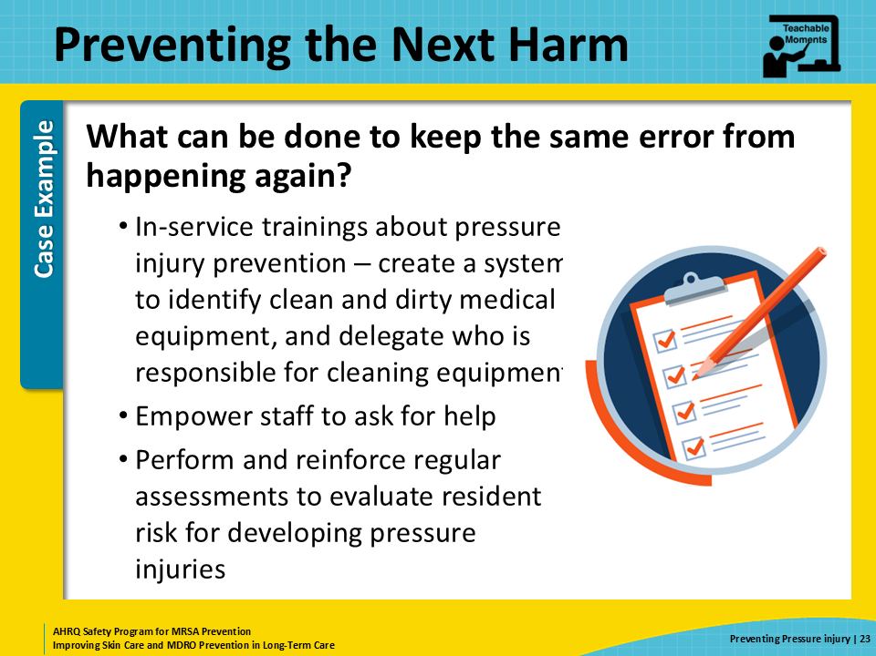
System-Based Safety Challenges  SAY:  Senior executives also need to be engaged in creating a culture where staff of all roles are willing to pitch in to support a resident’s needs. The CNA felt uncomfortable asking the nurses for help because they were busy with other tasks. She also did not want to ask for help from other CNAs because she feared she would look bad—and it could impact her performance evaluation.  Senior executives can foster a collaborative environment with shared goals, expectations, and open lines of communication. Direct care staff in long-term care are there because they care about the residents, and rewarding collaborative, multidisciplinary efforts can help to bridge the gaps highlighted in this case. Leadership can model these efforts with willingness to pitch in and help for jobs that may not be their responsibility if needed. This can include helping clean up a resident’s room if environmental services staff needs support or wheeling a resident to dialysis if no one else is available.  Leadership also should ensure adequate staffing is in place to support two-person assists. Leadership also should invest in products that help to assist with turning and repositioning or reduce pressure on bony prominences, such as air mattresses and heel protectors. | Slide 24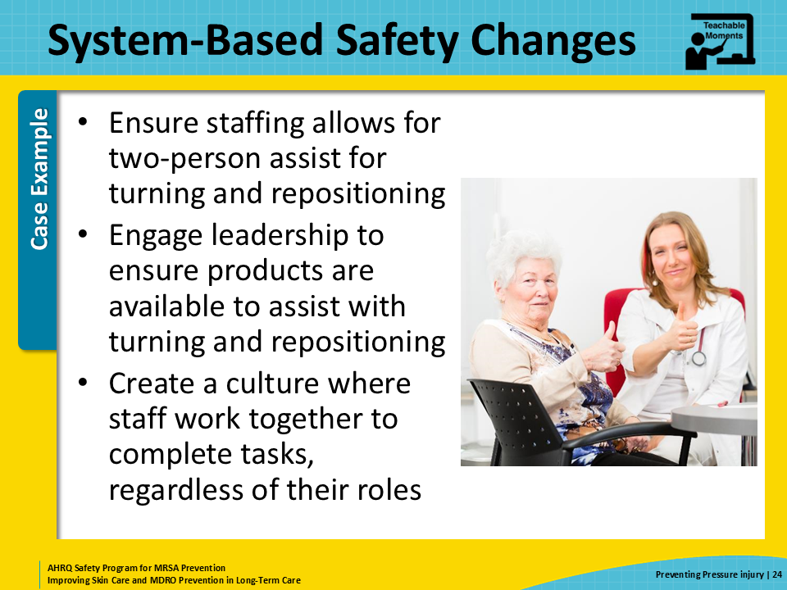
Key Takeaways  SAY:  Here are some final take-home messages from this presentation.  First, residents should regularly be assessed for the risk of developing pressure injuries, and proper precautions should be put in place before residents develop any sign of injury.  Second, any break in the skin can lead to infection and worsening of pressure injuries, which can have severe downstream effects. | Slide 25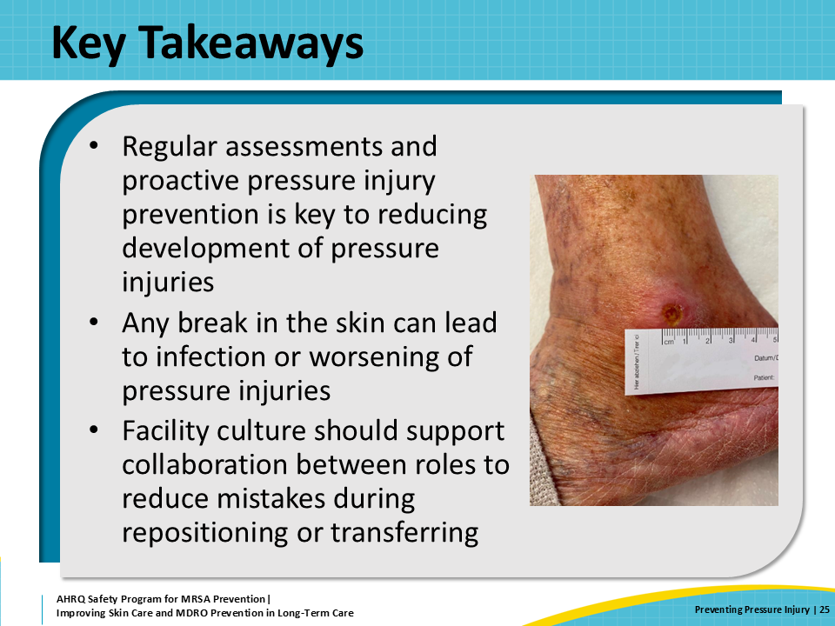
Supporting Materials  SAY:  Several supporting materials are paired with this presentation and can be distributed to direct care staff for pressure injury prevention. Teachable Moments for this presentation include: The Case of the Resident Who Needs To Be Repositioned, The Case of the Hoyer That Was Not Disinfected, and Pressure Injury Prevention—Fill in the Blank. There are two additional supporting materials: an AHRQ On-Time Pressure Ulcer Prevention, and a Pressure Injury Staging Guide. | Slide 26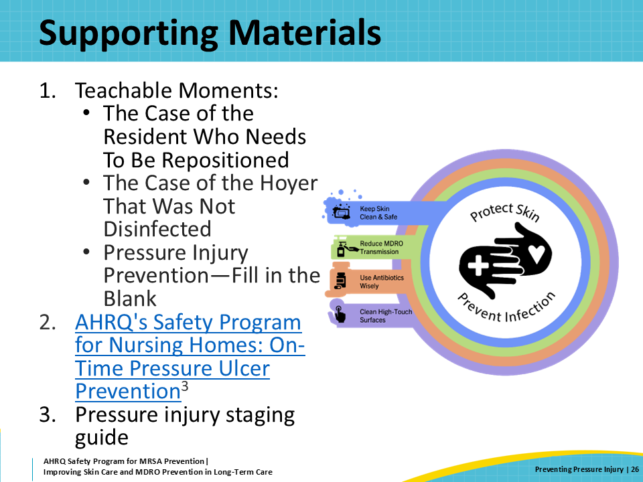
Disclaimer  SAY:  The findings and recommendations in this presentation are those of the authors, who are responsible for its content, and do not necessarily represent the views of AHRQ. No statement in this presentation should be construed as an official position of AHRQ or of the U.S. Department of Health and Human Services.  Any practice described in this presentation must be applied by healthcare practitioners in accordance with professional judgment and standards of care in regard to the unique circumstances that may apply in each situation they encounter. These practices are offered as helpful options for consideration by healthcare practitioners, not as guidelines. | Slide 27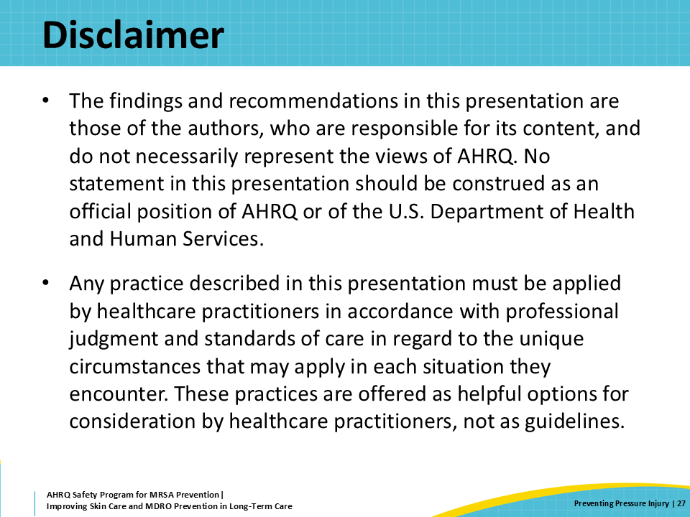
References—1  SAY:  Here are the references for this presentation. | Slide 28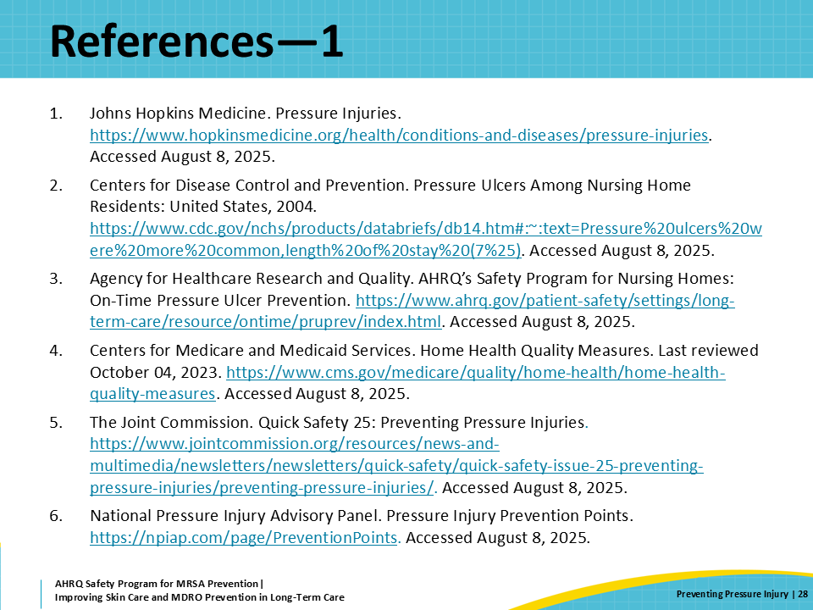
References—2 | Slide 29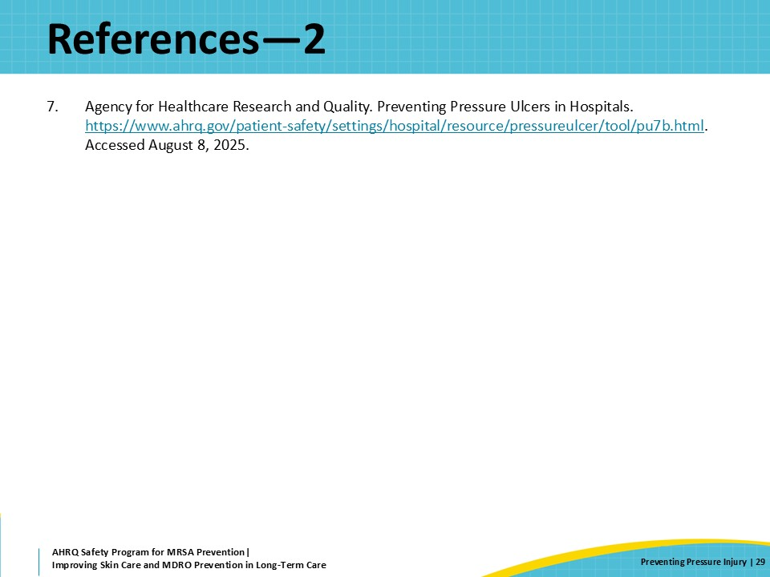
AHRQ Pub. No. 25(26)-0066
October 2025

