Name That Stage!
AHRQ Safety Program for MRSA Prevention
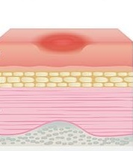
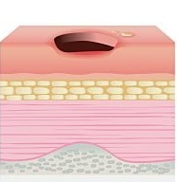
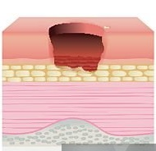
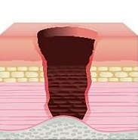
Draw a line between the pressure injury and its correct stage.

Stage 3

Stage 1

Stage 2

Stage 4

Answer Key
Stage 3
Stage 1
Stage 2
Stage 4

AHRQ Pub. No. 25(26)-0066
October 2025

