Quick Pressure Injury Guide
AHRQ Safety Program for MRSA Prevention
This document provides a guide for classifying the stage of pressure injuries.
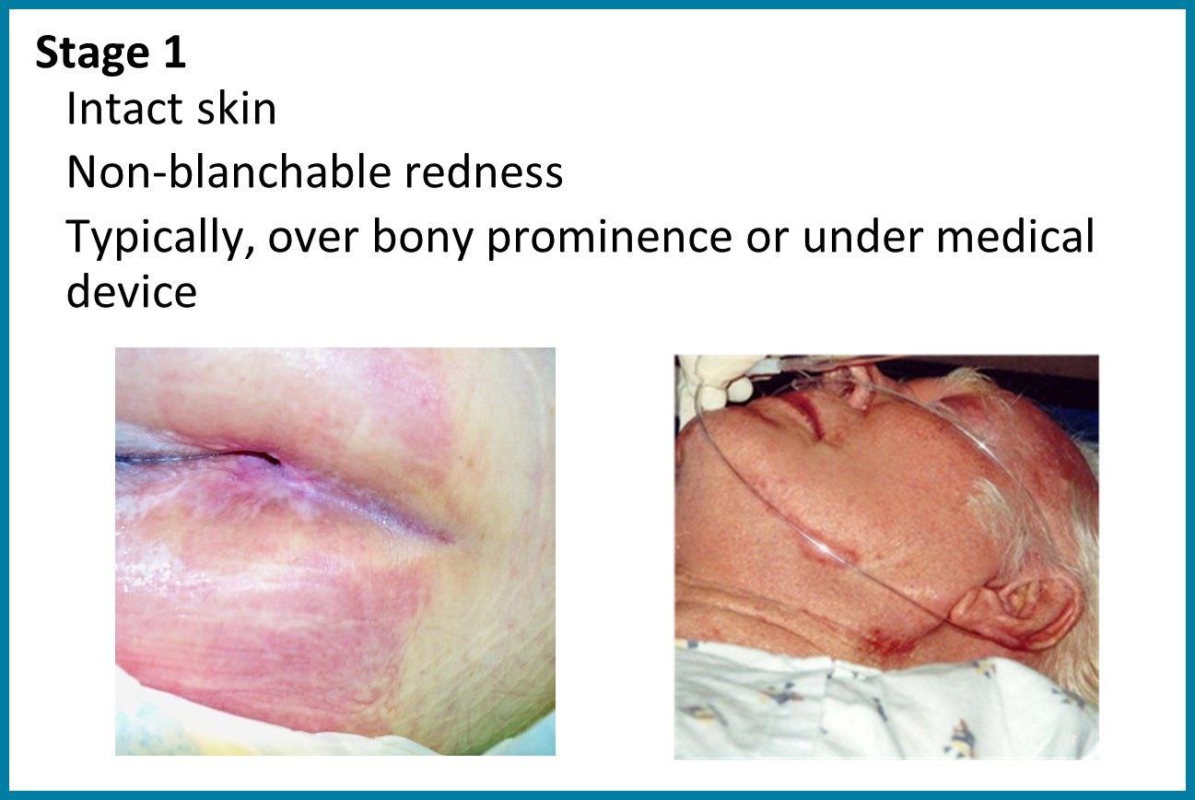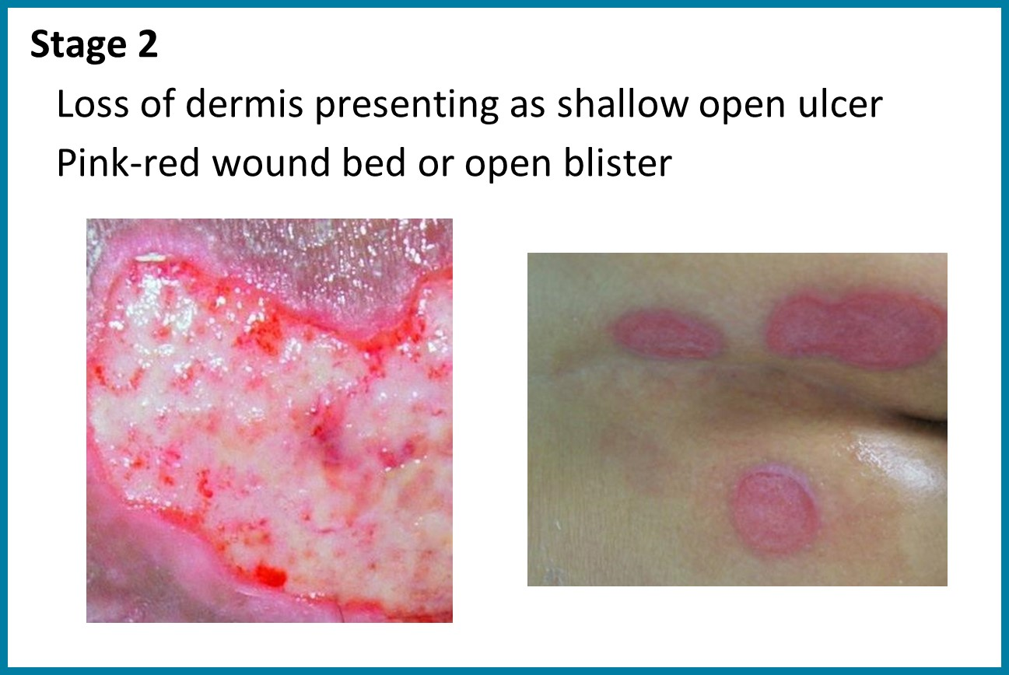
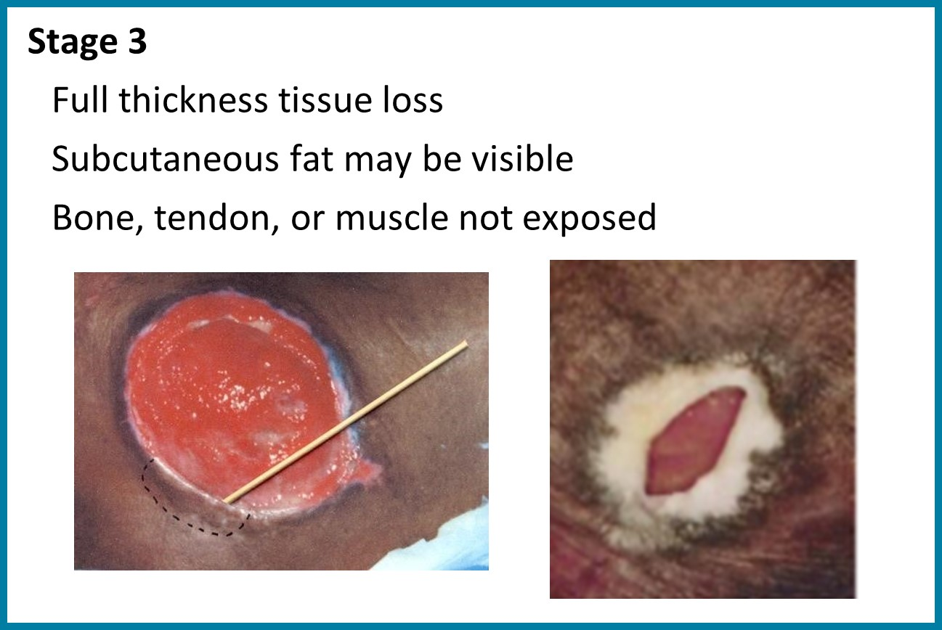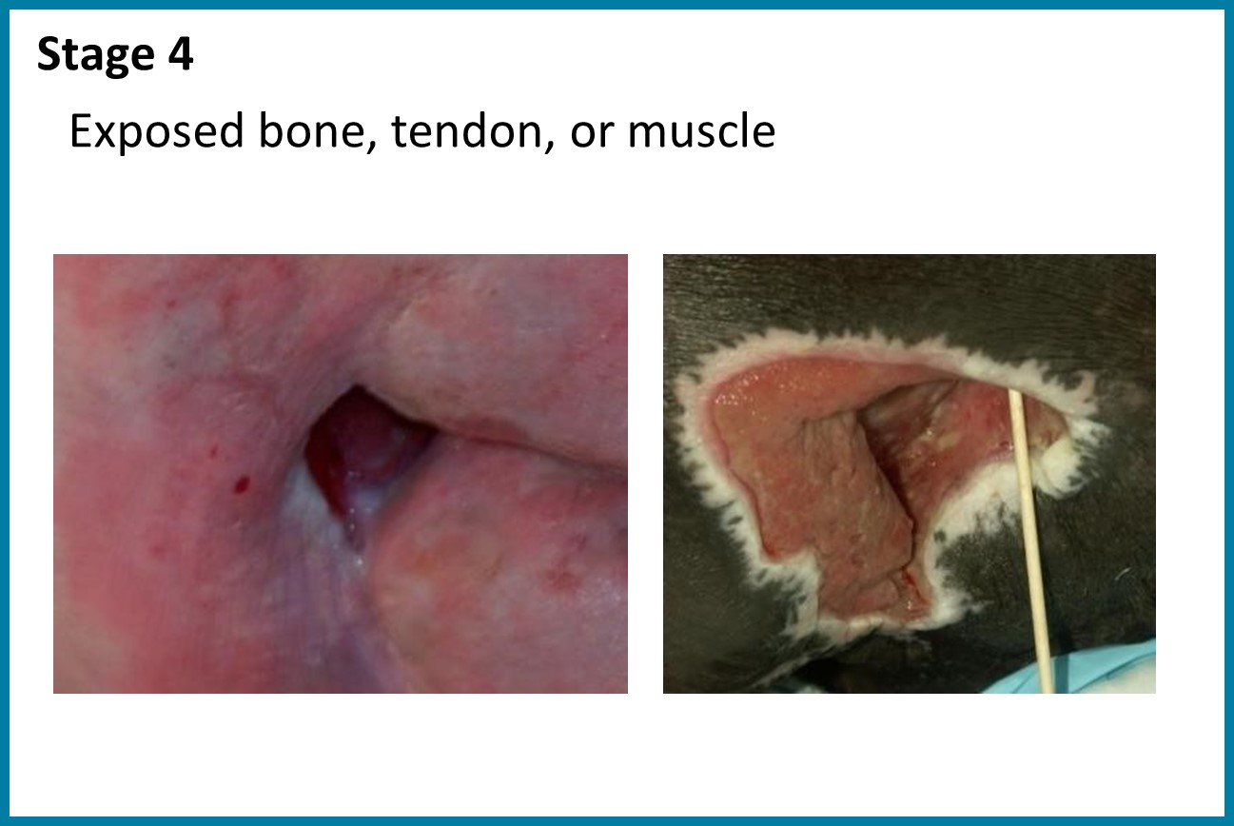
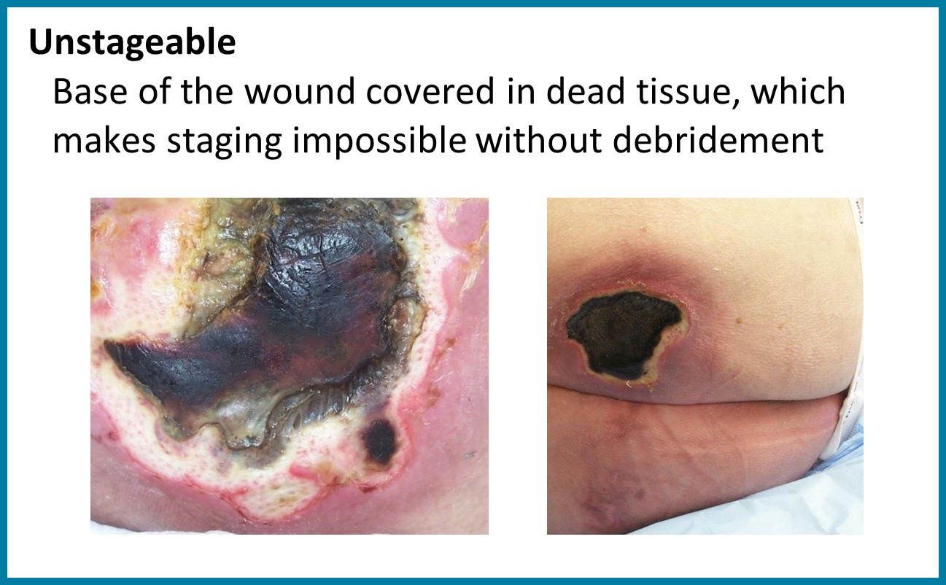
All images courtesy of Dr. Karen Zulkowski, D.N.S., RN.

Karen Zulkowski, D.N.S., R.N. Wound Classification. Agency for Healthcare Research and Quality. https://www.ahrq.gov/sites/default/files/wysiwyg/professionals/systems/hospital/pressure_ulcer_prevention/webinars/webinar6_pu_woundassesst.pdf. Accessed August 5, 2025.

