A Rash of Words
AHRQ Safety Program for MRSA Prevention
Even for experienced clinicians, describing changes in skin is challenging. Having a general approach and some words to use can make it easier to describe changes in skin. Because some rashes can change quickly, clear descriptions are important for observers to assess and compare.
In the table below, the first column has general categories to use when describing skin changes. The second column has some words to help describe skin changes. These are just suggestions and only a partial list.
Categories | Descriptions
Location | Trunk, chest, abdomen, hand, palm, foot, between toes, buttock, inguinal fold (where the leg meets the body), gluteal fold (crack between buttocks), cheek, neck, scalp, hairline, around the eye, ankle to just below knee
Estimated Size | Pea, quarter, playing cards
Color | Pink, red, violet, gray/silver, yellow, red pinpricks on pink background, darker or lighter than surrounding skin
Grouping | Flat, raised, swollen, nodule, lump, contiguous, patchy, pimples, macules, blisters or vesicles
Borders | Sharp borders, gradual change, geographic
Surface | Scaly, thickened, callous, fissure, erosion, ulcer, wet, moist, dry, crusty, warm, hot
Symptoms | Painful, itching, burning, tingling, numb, stiff, swollen

Examples
Here is an example of words that can help describe the rash on this woman’s face. Note that some of the description says what is not there as well.
Categories | Descriptions
Location | Face—cheeks, nose, chin, lower forehead
Estimated size | Largest area is on cheeks, about the size of half of a playing card
Color | Red
Grouping | Flat
Borders | Borders that fade
Surface | Some areas that are redder like blood vessels, mostly smooth surface, no temperature changes, not moist or dry
Symptoms | Slightly itchy, not painful
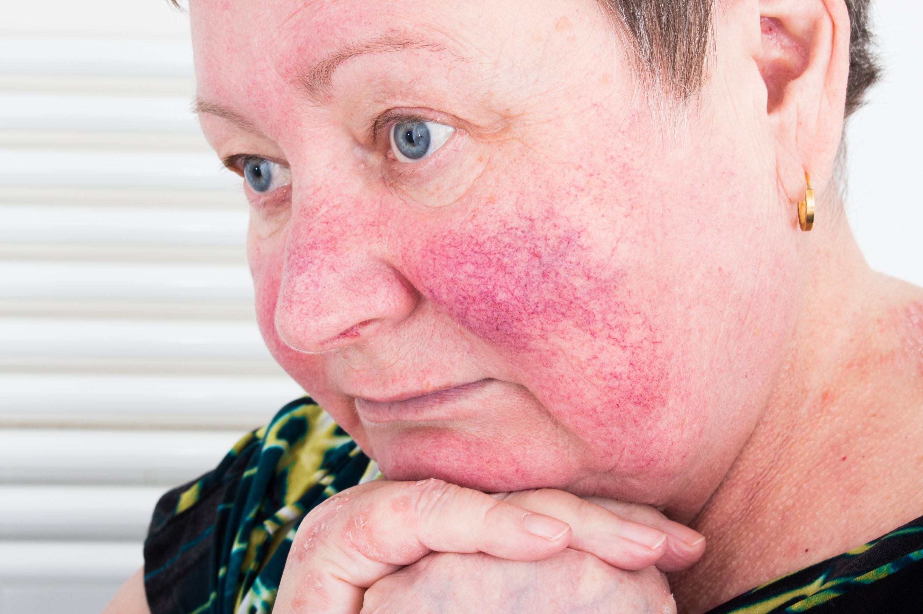

Here are three other pictures of skin changes. To describe the lesions, fill in the table below each picture with the words above or your own words. Keep in mind—a variety of words can be used to describe the same thing; this activity is intended to facilitate conversation about describing wounds. The answer key below serves as a guide and is not intended to cover all possible answers.
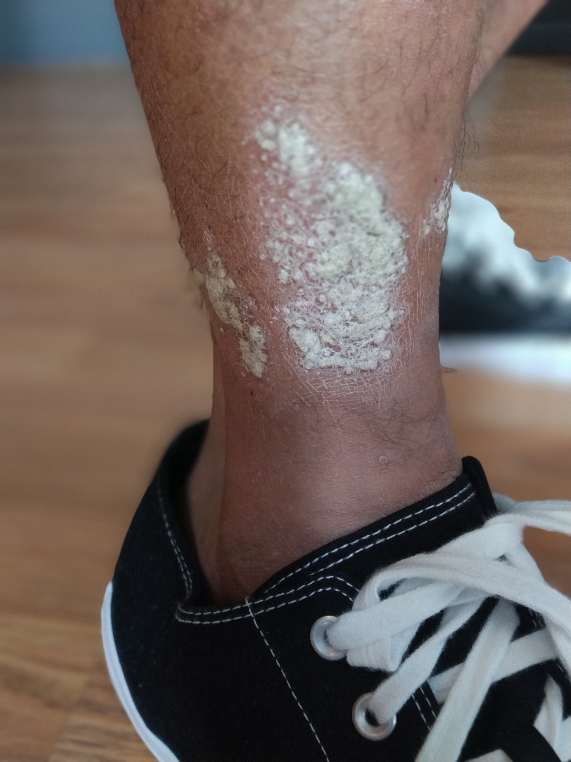
1.

Categories | Descriptions
Location
Estimated size
Color
Grouping
Borders
Surface
Symptoms

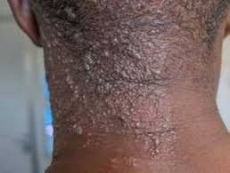
2.

Categories | Descriptions
Location
Estimated size
Color
Grouping
Borders
Surface
Symptoms

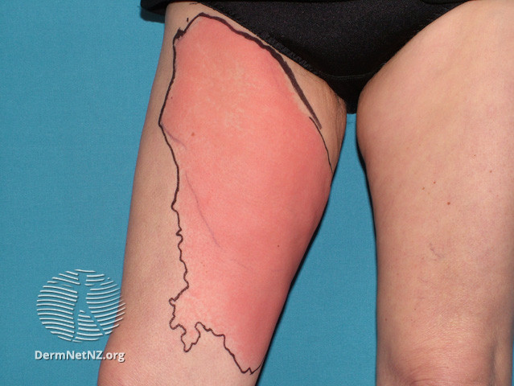
3.

Categories | Descriptions
Location
Estimated size
Color
Grouping
Borders
Surface
Symptoms

ANSWER KEY
Categories | Descriptions
Location | Right leg, above ankle
Estimated size | About the size of a hand
Color | White to gray
Grouping | Several patches, small lesions that group together
Borders | Distinct, geographic borders
Surface | Raised, bumpy, some flaking, no redness
Symptoms | Itchy, a little painful
1.

Categories | Descriptions
Location | Only on the left side of neck; right side unaffected
Estimated size | Back of neck from hairline to top of neck
Color | Red and violet/darker
Grouping | Fairly sharp demarcation on back of neck; wraps around and fades toward front of neck
Borders | Most skin involved
Surface | Vesicles, raised, moist
Symptoms | Painful, stings and electrical
2.

Categories | Descriptions
Location | Right leg, thigh
Estimated Size | From above the knee to just below the perineal area, extending toward the inside of the leg
Color | Red with some lighter areas toward the knee
Grouping | Flat
Borders | Geographic
Surface | Hot, no weeping fluid or blisters
Symptoms | Area painful; resident states she feels sick
3.
AHRQ Pub. No. 25(26)-0066
October 2025

