How Dirty Are My Gloves?
AHRQ Safety Program for MRSA Prevention
You are about to go into a resident’s room to help with a dressing change that requires the resident to lie down. The chart below includes the activities you will perform while in the resident’s room. Before you enter the room, you begin to think about how dirty (with germs) or contaminated your gloves will be after performing each activity, which order you should perform the activities, and which activities will require you to change gloves and perform hand hygiene before moving to the next task. The heaviest burden of germs is from bodily fluids and secretions from residents. These include stool and respiratory secretions as well as soiled dressings. Residents’ skin can also have a heavy burden of bacteria. Moist body parts have the most germs—which includes the perineal area, armpits, nose, and mouth—as well as hands and feet, because we use those to touch things.

Part 1: Just How Dirty Are the Gloves?
Instructions: For each of the activities below, place a check in the column to indicate the burden of germs on your gloves after the activity.
Activity | 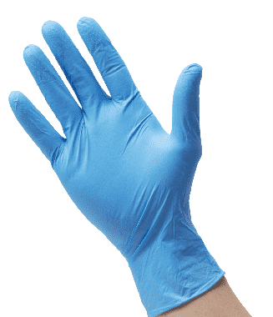 | 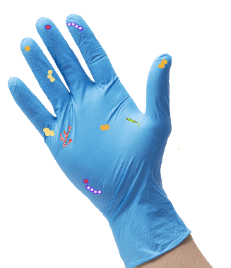 | 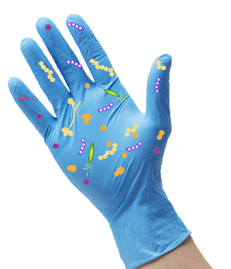 | 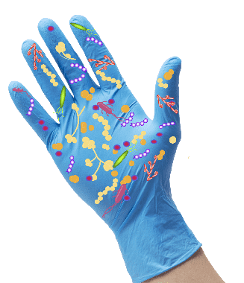
Move the intravenous (IV) pole back
Cleanse the surrounding skin
Help the resident sit up in bed
Apply clean dressings
Remove the dirty dressings
Enter the room
Empty the bedside urinal
Bring in dressing supplies

Part 1 Answers
Activity
Move the IV pole back |  | 
Cleanse the surrounding skin
Help the resident sit up in bed
Apply clean dressings
Remove the dirty dressings
Enter the room
Empty the bedside urinal
Bring in dressing supplies

Part 2: What Order Should the Activities Be Completed In?
Instructions: Using the answers from the chart in Part 1, order the items from the activity column, to represent the order in which the activities should be performed.

Part 2 Answers
- Enter the room
- Bring in dressing supplies
- Move the IV pole back
- Remove the dirty dressings
- Cleanse the surrounding skin
- Apply clean dressings
- Empty the bedside urinal
- Help the resident sit up in bed

Part 3: When Do I Need To Change My Gloves?
Part 3 contains a completed chart with the activities listed in the order they should be performed and the contamination level of the gloves after those activities have been performed. If you go from completing a very germy or dirty activity and then move to a clean one without changing gloves and performing hand hygiene first, the germs on your gloves contaminate what you touch for that clean activity. Changing a dressing is a dirty or germ-heavy activity. Once the dirty dressings are taken away, remove those yucky gloves, perform hand hygiene, and move on to the next task.
Think about what else you do during the care of a resident. What are some of those activities that will lead to a LOT of germs getting on gloves? Those are also times when you should change your gloves before moving on to a task that has fewer germs. Think about how you can bring this idea of ordering tasks from clean to dirty into your workflow. Think about when you should change gloves (which includes hand hygiene before putting on new gloves), so that you are not bringing dirty gloves or hands to a clean task.
Instructions: Now, circle the activities that will require you to change gloves and perform hand hygiene before moving to the next task. These are also the step(s) that have a heavy burden of germs.
Activity
Enter the room
Bring in dressing supplies
Move the IV pole back
Remove the dirty dressings
Cleanse the surrounding skin
Apply clean dressings
Empty the bedside urinal
Help the resident sit up in bed

Part 3 Answers
Activity
Enter the room
Bring in dressing supplies
Move the IV pole back
Remove the dirty dressings
Cleanse the surrounding skin
Apply clean dressings
Empty the bedside urinal
Help the resident sit up in bed
AHRQ Pub. No. 25(26)-0066
October 2025

