Keep the Bugs Out!

Preventing Surgical Site Infection
AHRQ Safety Program for MRSA Prevention
Slide Title and Commentary | Slide Number and Slide
Keep the Bugs Out! Preventing Surgical Site Infections  SAY:  Welcome to this presentation on “Skin Under Pressure: Preventing Pressure Injury,” part of the AHRQ Safety Program for MRSA Prevention: Improving Skin Care and MDRO Prevention in Long-Term Care. | Slide 1  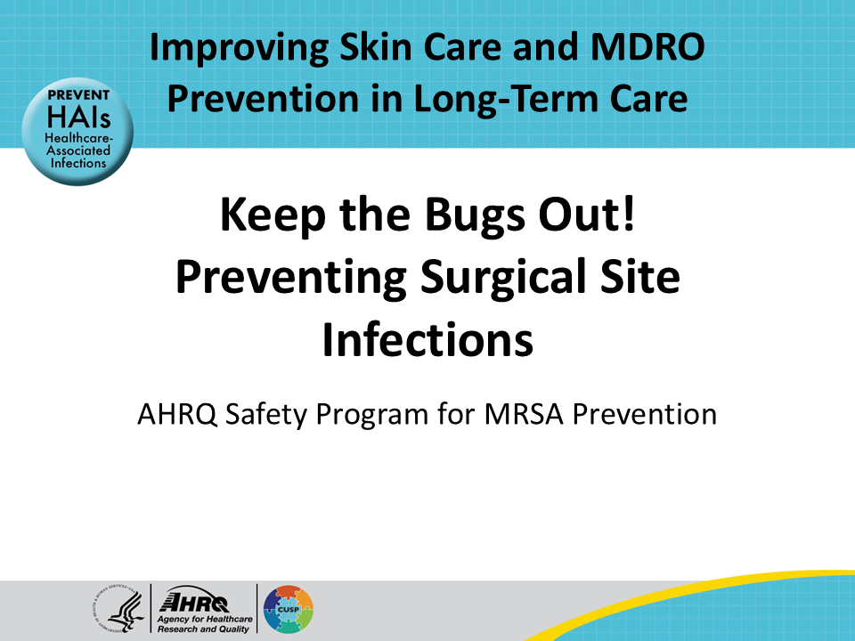
All Staff Support Resident Care and Safety  SAY:  The information provided in this presentation is important in the care of long-term care (LTC) residents. In LTC facilities, each member of the facility’s staff supports resident care and safety. Some actions described in these presentations may not be in your scope of practice, but it is important to learn how all staff contribute to resident care and safety. | Slide 2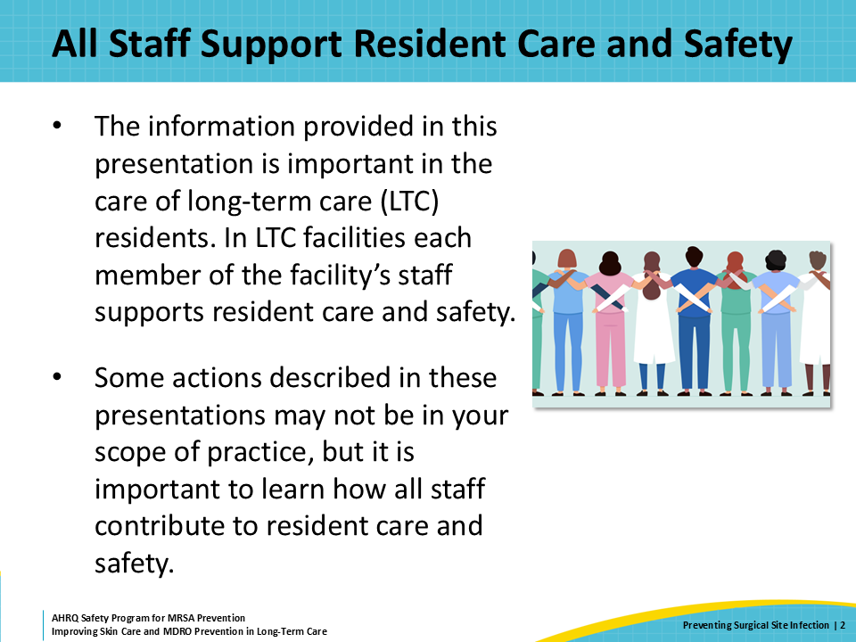
Educational Objectives  SAY:  The learning objectives for this presentation include how to care for surgical wounds, how to correctly assess and document surgical wounds, and how to culture surgical wounds, as well as strategies to prevent surgical site infections in long-term care facilities. | Slide 3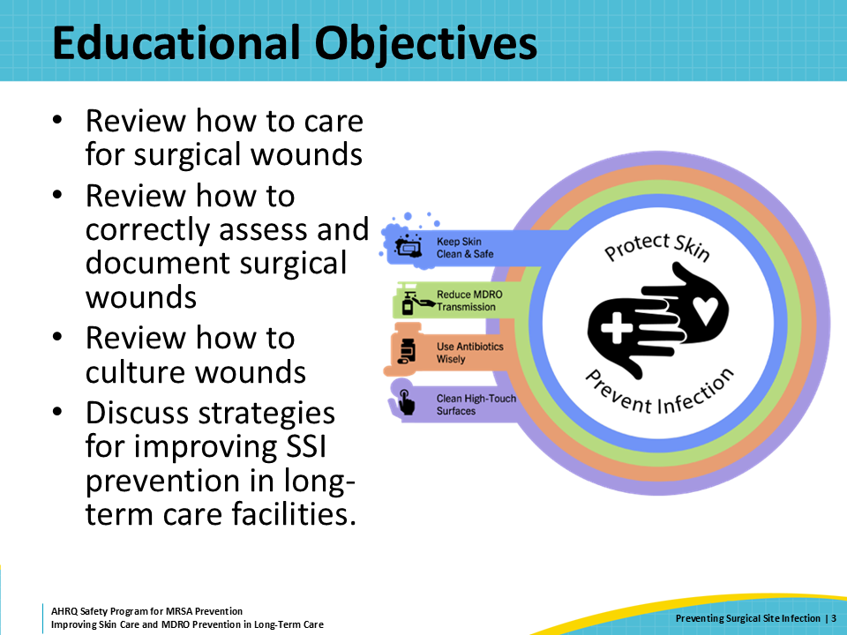
What Are Surgical Site Infections?  SAY:  Surgical site infections are any infection that takes place where there was a surgery in the previous 30–90 days.  There are three types of surgical site infections or SSIs. These include superficial incisional SSI, deep incisional SSI, and organ space SSI.  The most common surgical site infections are superficial incisional SSI, which affects only the upper layers of skin. With superficial infections, the skin around the wound becomes red, swollen, and usually warm. This inflammation can extend beyond the immediate margins of the wound, and sometimes the wound edges will remain partially or totally separated. This is called wound dehiscence. Pain, pus, and drainage are additional signs of superficial surgical site infections.  The picture shown here is one of a superficial surgical site infection. Note that the skin is red, and this redness extends beyond the edges of the wound by several millimeters. The skin underneath the sutures is also swollen. | Slide 4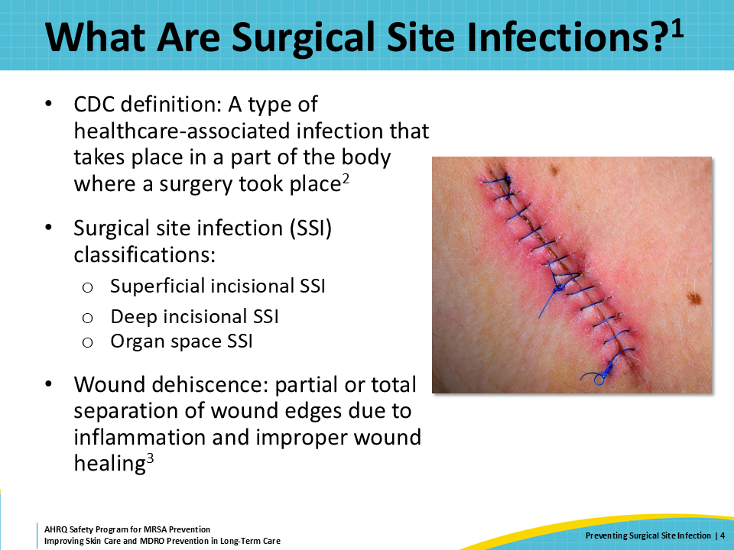
Surgical Site Infection Classification  SAY:  Superficial incisional SSIs only affect the upper layers of the skin. They extend from the skin down into the subcutaneous tissue, including the fatty tissue underneath the skin.  Deep incisional SSIs extend below the skin and down into muscle and fascia. These deeper infections can have all the signs and symptoms of a superficial surgical site infection, but there is usually more pain and sometimes variation around these infections. Fever, elevated white count, and other systemic signs of inflammation are also indicators of deep incisional SSI. These wounds tend to need imaging or ultrasound as part of their evaluation and the treatment involves wound exploration or debridement.  Organ space SSIs are wound infections that occur deep within the organ spaces. When this happens, the patient is usually sick with fever, has an elevated white blood cell count, and has pain in the area where the surgery was. It is important to note that sometimes the overlying skin does not show the infection. An example of this type of infection might be a deep-space infection following an abdominal surgery. These types of infections need to be addressed in the hospital. | Slide 5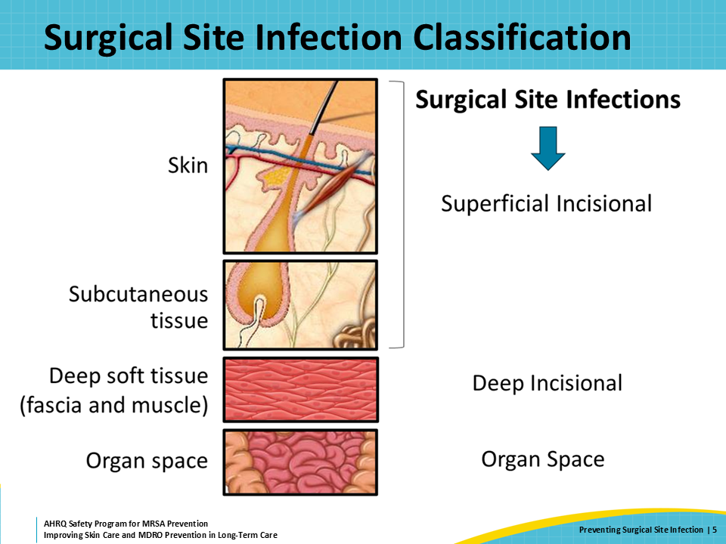
Impact of Surgical Site Infections  SAY:  Surgical site infections account for 20 percent of healthcare-associated infections. The Centers for Disease Control and Prevention estimates that in 2015 there were 110,800 surgical site infections associated with an inpatient surgery. These are the most expensive type of healthcare-associated infections with an estimated cost of $3.3 billion annually.  Surgical site infections are also associated with a 2- to 11-fold increase in risk of mortality following the surgery, making it even more important to reduce the risk of surgical site infection post-surgery. | Slide 6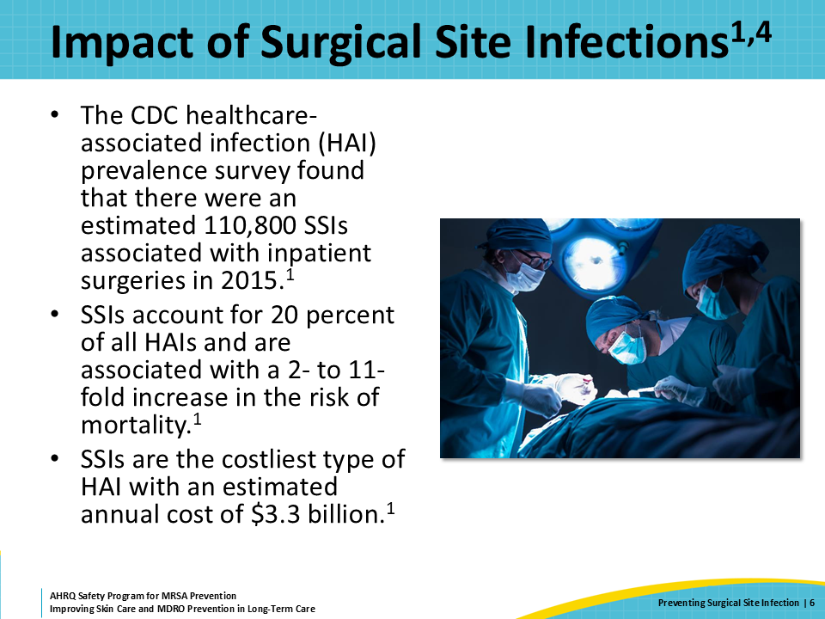
Triangle of Transmission  SAY:  Prevention of SSIs is multifactorial. All the basic measures of infection prevention must be in place to reduce the risk of a resident acquiring a surgical site infection. Maintain proper hand hygiene, environmental cleaning, personal protective equipment (PPE) use, and more. In today’s presentation, we will discuss the importance of caring for surgical wounds in order to prevent infection and encourage wound healing. | Slide 7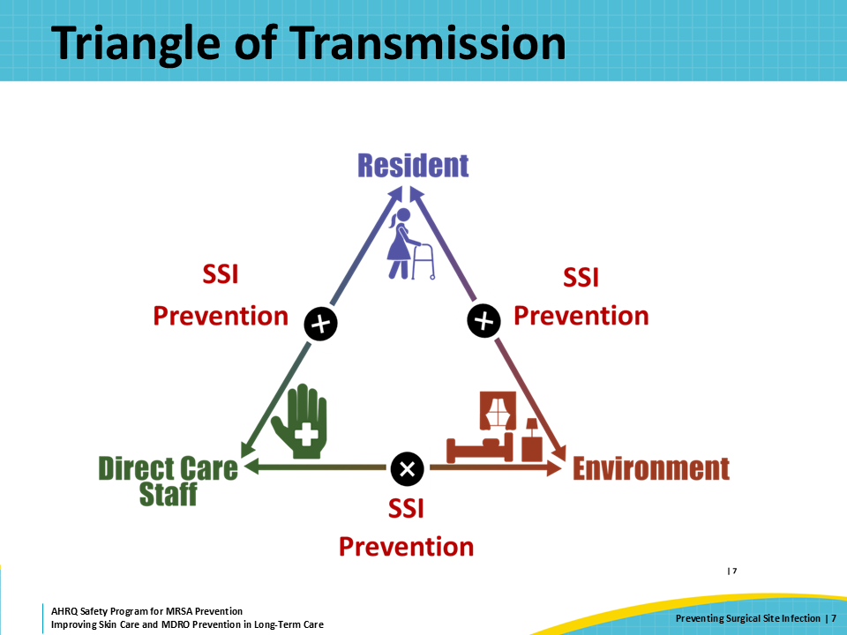
Understanding Surgical Wounds  SAY:  The type of wound is an important part of understanding the risk of developing a surgical site infection. So, what is a surgical wound? A surgical wound is a cut or incision through the skin that is made during surgery.  Surgical wound classifications help identify which patients are at risk for surgical site infections. These classifications describe the degree of contamination of a surgical wound that took place during a procedure.  Clean wounds are surgical wounds in which the incision involves going through skin. There is no entry into parts of the body that normally have germs living in or on them.  Controlled and planned operations involving parts of the body that normally have bacteria are clean-contaminated wounds. These are surgical wounds in which the respiratory, genital, or urinary tracts are entered. Any surgical involvement of the digestive tract of the body are also clean-contaminated wounds. This means a surgery anywhere from the mouth to the biliary tracts to the intestine or the anus.  Contaminated wounds are often open, fresh, accidental wounds. These can also come from a surgery in which there was a major break in sterile technique. Sometimes this happens when there is gross spillage from the contents of the gastrointestinal tract into the peritoneal space.  Finally, dirty wounds are those in which there is already an existing infection. This means a wound that goes through a known infection, such as an abscess, or into the abdomen of someone who, for example, has a burst appendix. | Slide 8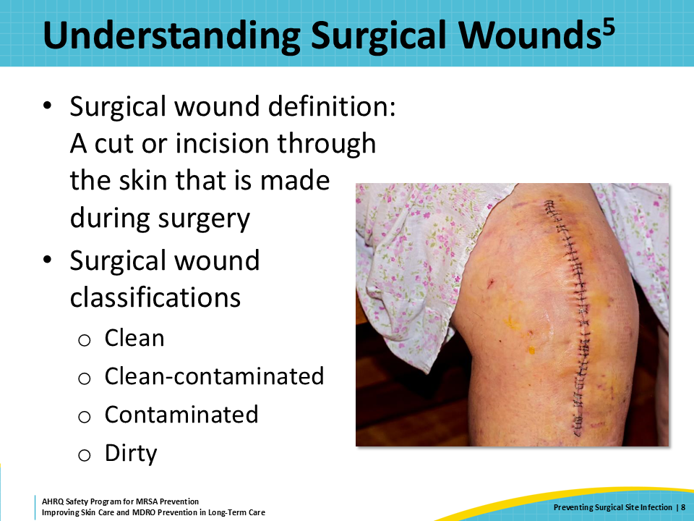
Stages of Wound Healing  SAY:  Many other factors specific to the surgery can influence the risk of infection, which can include anything from how the skin and surgical site were cleaned and prepared, to the length of the operation and placement of surgical drains.  Resident characteristics also influence wound healing. These characteristics include age and nutritional status in addition to lifestyle factors such as, diabetes, smoking, and obesity. One other important note that can contribute to wound healing is whether the individual is colonized or infected with bacteria or fungi. Bacteria and fungi that are drug resistant can exacerbate and prolong the wound healing process.  Wound healing begins after the wound is closed and all bleeding has stopped. Wound healing has three phases.  The first wound healing phase is inflammation. This is indicated by redness, heat, swelling, and pain around the surgical site. Inflammation can last from a few days to 2 weeks.  The next phase is called proliferation. This happens with new connective tissue being laid down to restore structure and function. New capillaries also develop, bringing blood to the area to get the tissue back to normal. A wound that is moving to the proliferative stage is described as a wound with granular tissue and epithelialization.  The final stage of wound healing is called remodeling. During this phase, the granulation tissue forms into a scar. This process can take weeks to months. There are subtle changes that happen as the tissue continues to repair, and a scar is never as strong as the original tissue that was there. At best, it has about 80 percent of the strength of the original tissue. | Slide 9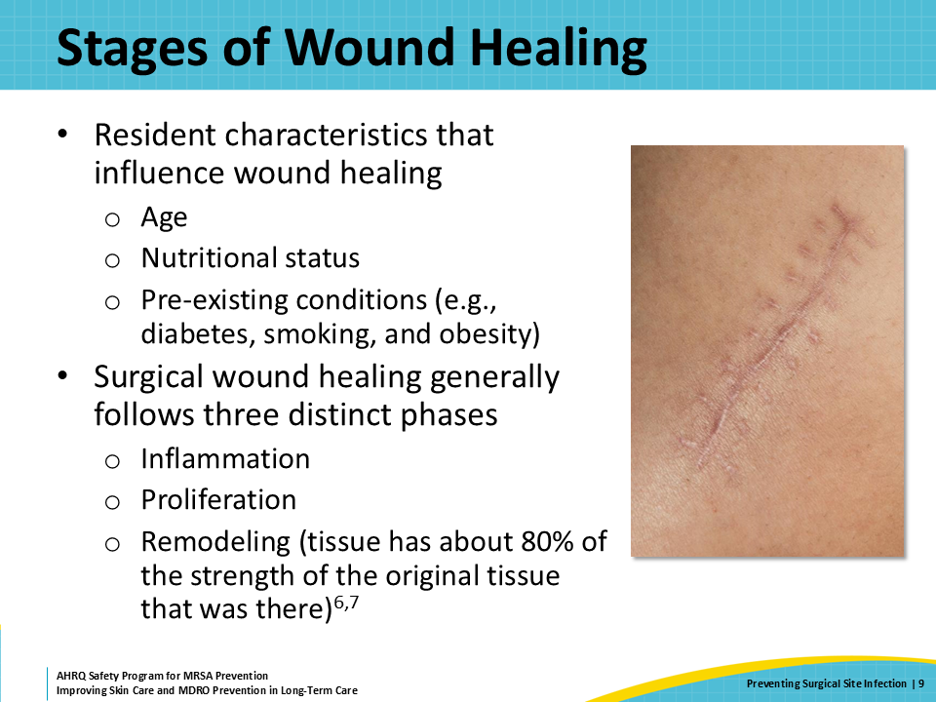
Signs and Symptoms of SSI  SAY:  The most common types of surgical site infections in nursing home residents are superficial with the occasional deep wound.  Wound infections appear as redness around the surgical site. For people with darker skin, redness may be harder to notice—the skin may look darker with a purple tone to it. Changes that are not dependent on skin color include pain, swelling, and warmth around the incision. There may also be excessive drainage and even frank pus that is coming from the wound. | Slide 10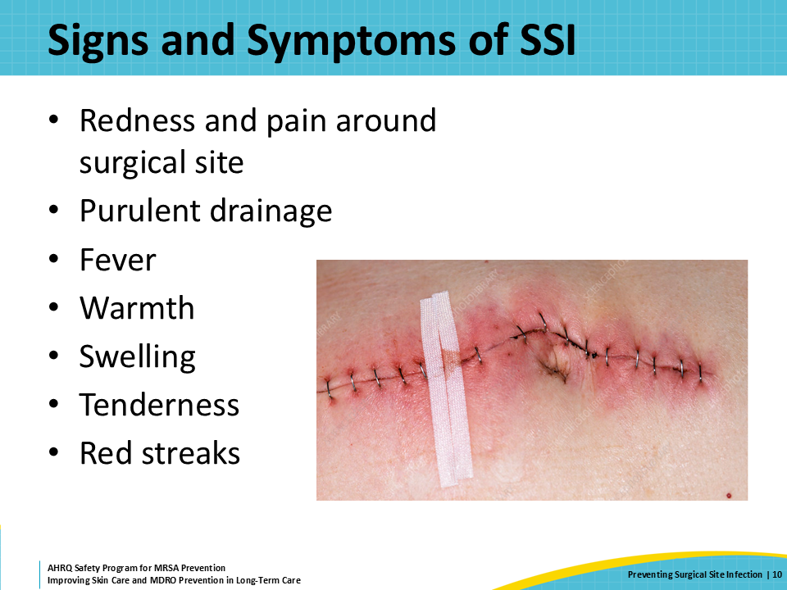
Assigning and Documenting Surgical Wounds  SAY:  Wounds should be assessed each time there is a dressing change, by the individual performing the dressing change. Staff should operate within their scope of practice and receive the proper training to assess and manage wounds. Frequent wound assessment is the best way to detect a wound infection early. Consistent and objective documentation is important to know if a wound is getting better or worse. Documentation allows comparisons to be made over time, to determine if a wound is getting better or worse.  While photos of wounds are helpful, they can sometimes be challenging to access. For this reason, good, written documentation is recommended as a consistent approach to wound documentation.  To assess and document surgical wounds, begin by describing the location. For example, the right heel or the right lower quadrant approximately 4 inches above the inguinal fold.  Next describe the size of the wound. The best practice for this is to use a ruler to measure the length of a closed wound and note the type of closure, which may be steri-strips and glue, staples, or sutures. For open wounds, measure and record the largest aspects of the wound in two dimensions. For some open wounds, the depth is also important to note. This may require probing with a sterile cotton swab.  After describing the size of the wound, note the appearance of the wound. What color is the skin around the wound? Is the skin swollen? Is there crusting or fluid coming from this site? Are there blisters or black edges to the skin? Some questions that are specific to open wounds include:  - What does the wound bed look like?  - Is the wound bed gray or yellow and does it include fibrinous material?  - Is it more beefy and red looking with granulation tissue forming?  Some wounds can have a mixture of these appearances. If this is the case, try to estimate how much of the wound looks like granulation tissue. Sometimes people describe wounds as less than 25 percent or more than 90 percent granulation tissue.  After noting the appearance, also consider how the wound feels and smells. Is the skin around the wound warm or is it hot to touch? Does the wound seem especially painful to the resident? Is there a foul odor coming from the wound?  Finally, note what is on the dressings that were removed. Are the dressings mostly dry with just a little bit of yellow to brown remnant? Or is the dressing wet with drainage? If the dressing is wet with drainage, what color is that drainage? Is there blood or is it more dishwater colored? Do the dressings have a foul odor? | Slide 11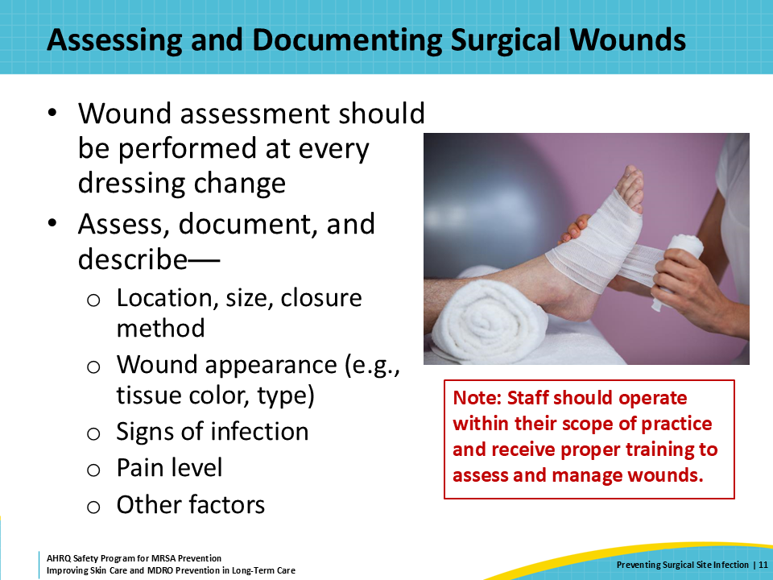
A Note on Dressing Changes  SAY:  Care must be taken when performing dressing changes to not contaminate the surgical site. Good, sterile technique around dressing changes helps to reduce the risk of infection. A poorly performed dressing change increases the risk for surgical site infection.  Dressings should cover and adhere to the skin around the wound. Loose and shifting dressings provide an opportunity for bacteria to invade the surgical site.  Dressings should be kept clean, dry, and intact. Wet dressings are a breeding ground for bacteria and increase the risk of infection to the surgical site. This can be very challenging for some wounds, depending on the anatomical site and an array of host factors. Some wounds may need frequent assessment to make sure the dressings are not soiled, and some dressings may need to be changed before the originally scheduled time.  Note: If dressings are becoming wet or soiling frequently, this may also be an early sign of a surgical site infection. | Slide 12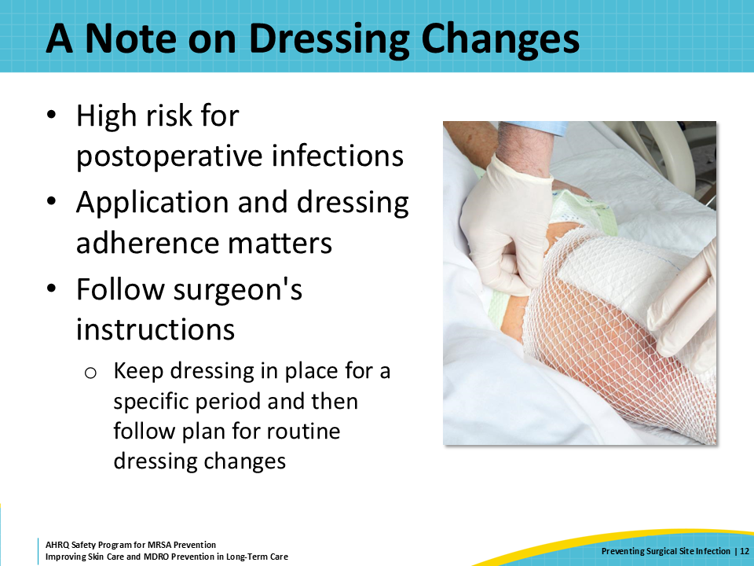
Culturing Surgical Wounds  SAY:  When a suspected infection is present, a wound culture may be ordered to determine what kind of infection a resident has. Wound culturing technique is important to accurately diagnosis surgical wound infection. Cultures should only be collected by people who are qualified and trained to do this safely.  For wounds in which there is a concern for infection, clean the area before attempting to collect a sample for culture. Do not use antiseptics. Once the wound bed and the surrounding skin are clean, remove soiled gloves, perform hand hygiene, and don clean gloves.  If the culture swab is not premoistened, use a few drops of sterile saline to make it moist.  Apply the sterile swab to the area of concern. Select an area of clean, viable tissue no larger than 1 square centimeter. Avoid wound edges and necrotic tissue. Rotate the swab on that region for 5 seconds and then return the swab to a sterile container.  It might not seem like this technique is working to obtain a satisfactory wound culture. But it really does work to get bacteria onto the swab!  Closed surgical wounds, such as stapled or sutured wounds, are difficult to culture. If there is an opening from a sutured or stapled wound from which frank pus or exudate can be expressed, clean the wound as described above. After performing hand hygiene and putting on clean gloves, use one hand to gently express the pus and collect that on to the tip of the swab without touching the skin. | Slide 13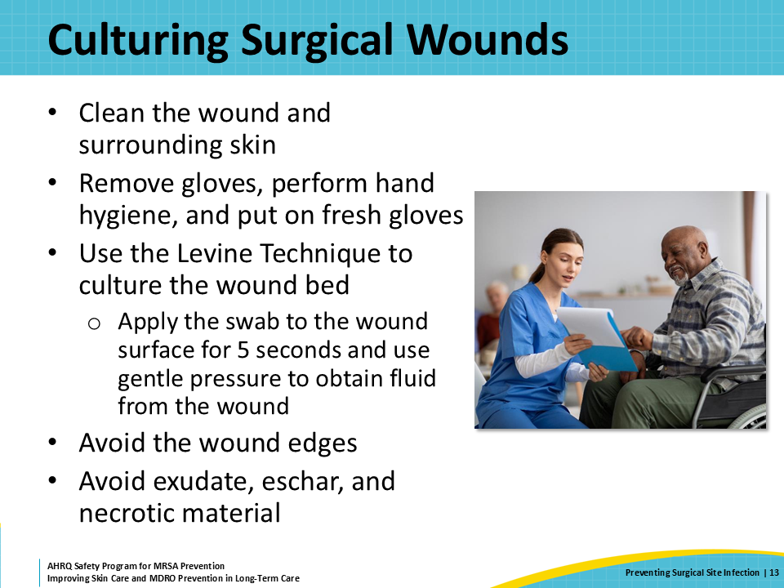
Teachable Moment  SAY:  Please consider the following questions for this presentation’s teachable moment:  First, what is your role in preventing surgical site infections?  And second, how can team members that assist with bathing help prevent surgical site infections? | Slide 14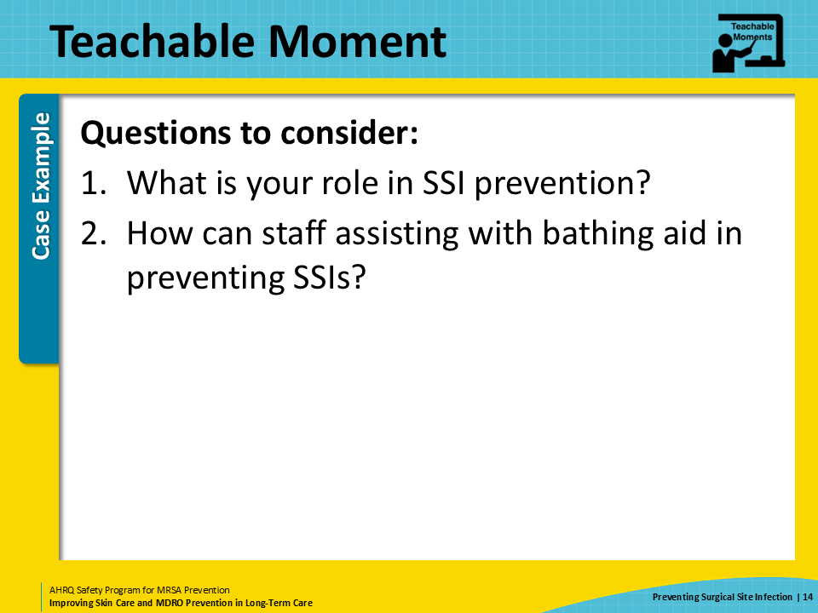
The Case  SAY:  This presentation’s case is of a certified nursing assistant or CNA assisting a 65-year-old man with a bed bath. The resident had surgery for a total hip replacement 3 days ago. At this point he is getting wound assessments and dressing changes once daily. | Slide 15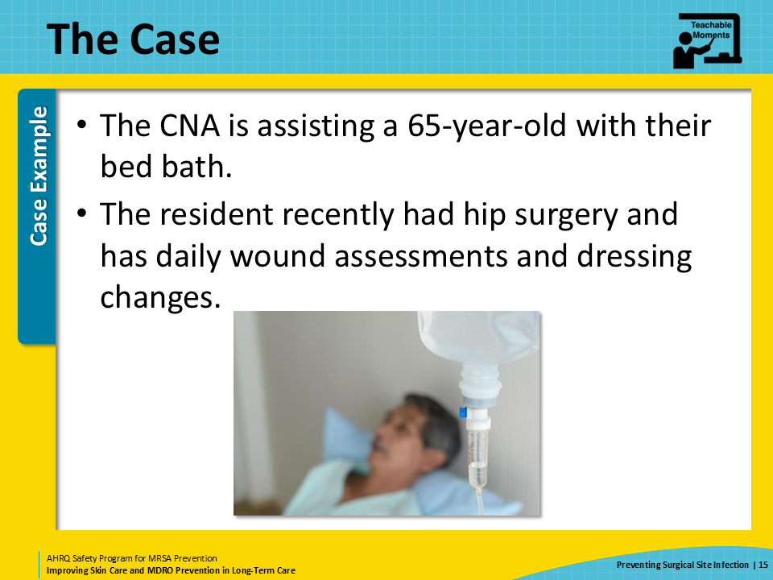
The Challenge  SAY:  A challenge in the care for this resident is cleaning his perineal and genital areas while also making sure that the dressing covering his surgical site does not get wet. | Slide 16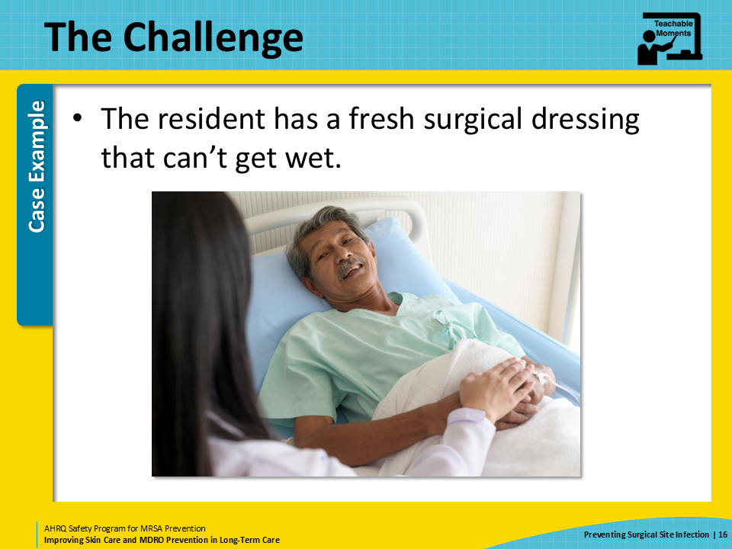
Knowledge Check  SAY:  What can the CNA do to prevent the dressing from becoming wet during the bed bath? | Slide 17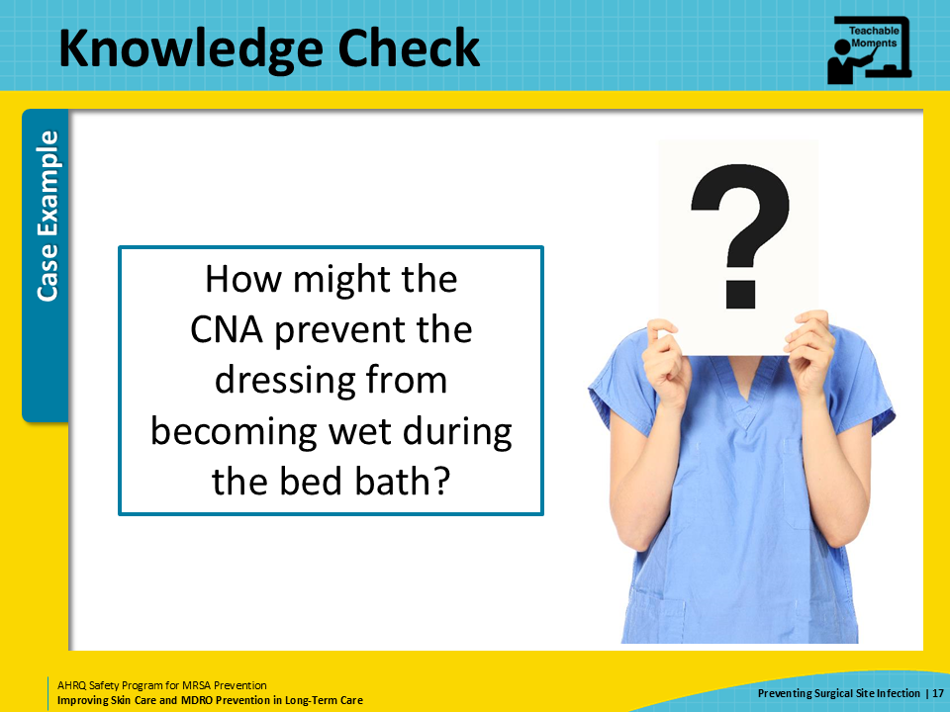
The Error  SAY:  While cleaning the resident’s backside, the CNA takes care to avoid the dressing covering the surgical site for the hip replacement.  When cleaning the resident’s leg, however, the CNA does not wring out the soapy washcloth. Soapy water drips down the leg and saturates part of the surgical dressing.  The CNA uses a dry cloth to wipe up the excess fluid, but the dressing is still completely saturated. She is a little embarrassed and does not tell the resident’s nurse that the dressing accidentally became wet during the bed bath. She reasons that because it is clean soapy water, it will not do any harm. | Slide 18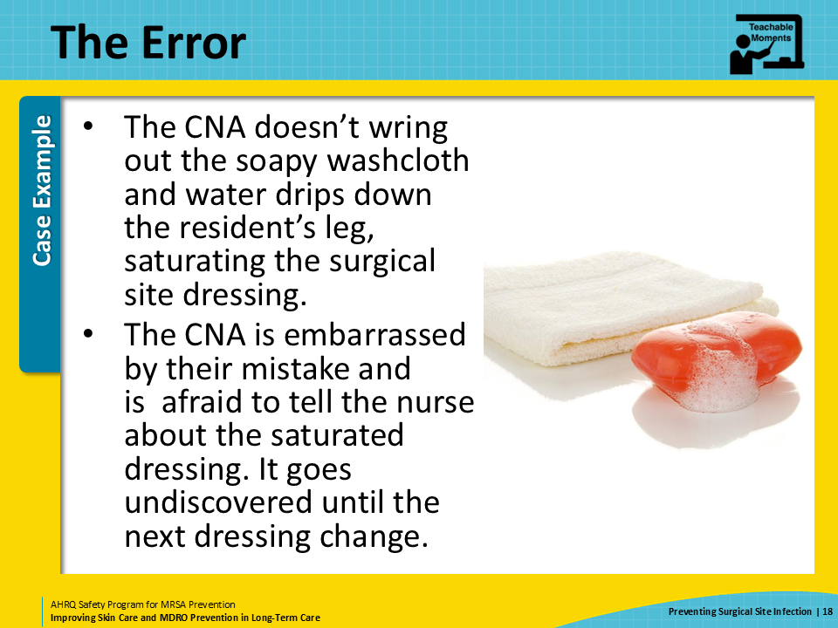
The Consequence  SAY:  The dressing over the surgical incision becomes wet. This wetness encourages bacteria from the skin surface to enter the wound. Once inside, the bacteria find a nice, dark, warm, and moist place to grow.  The next day, the nurse caring for the resident notices a little more redness around the most dependent portion of the wound. He is not concerned and plans to keep an eye on it.  The following day, however, the area surrounding the wound is swollen and painful. The skin is darker with violet hues and is hot to the touch. The resident states that his hip hurts more than the day before.  It takes about another 6 hours to arrange for a transfer back to the hospital where he eventually must undergo intraoperative wound debridement. The hip implant is retained, and the resident is placed on 6 weeks of intravenous antibiotics to treat a methicillin-resistant Staphylococcus aureus infection. He returns to the nursing home after a few days with a PICC line.  His functional status is decreased due to the second surgery and second hospitalization. What was intended to be a short stay for rehabilitation has become much longer for the resident. After his intravenous antibiotics are done, he must still take oral antibiotics for several more weeks. | Slide 19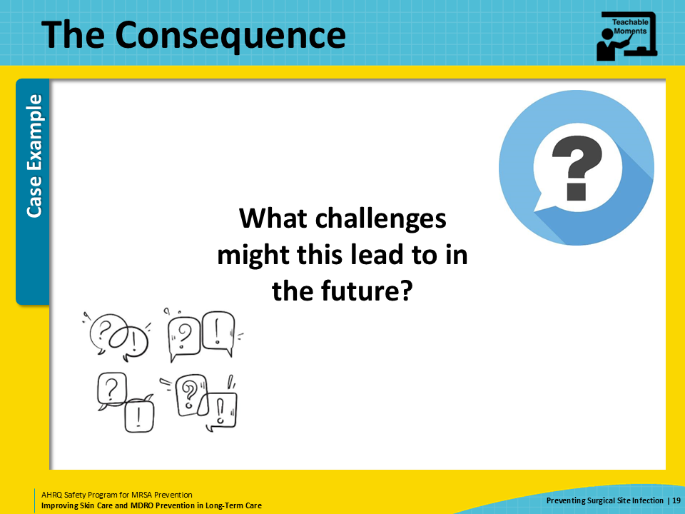
Patient Safety in the Moment  SAY:  The CNA should have removed excess moisture from the washcloth so water did not drip down the resident’s leg. As an additional measure to help protect the dressing, the CNA can use a dry cloth to cover the skin just above the dressing so any drips are caught in that dry cloth. After the dressing became saturated, the CNA should have informed the nursing staff so that the dressing could be promptly changed. | Slide 20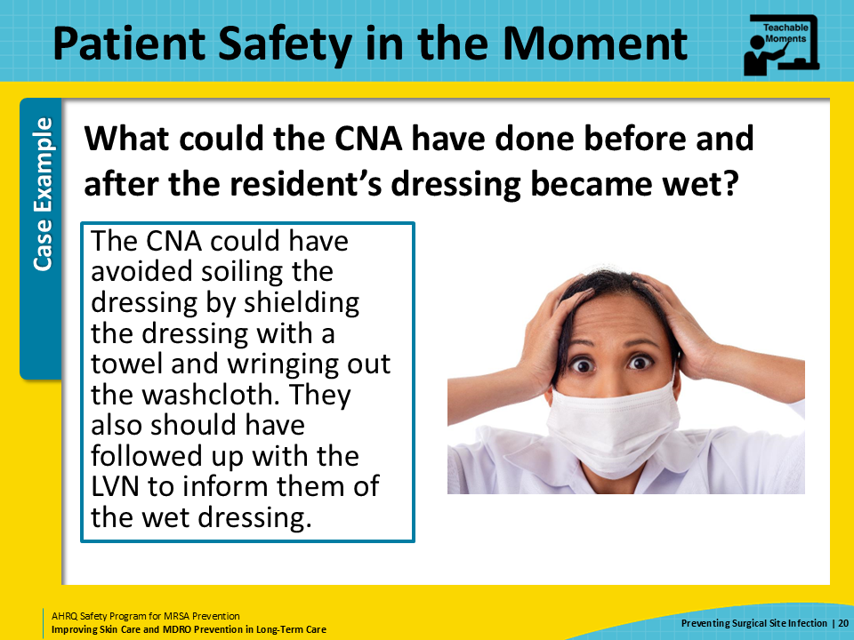
Preventing the Next Harm  SAY:  To prevent this kind of error from happening again, CNAs should receive specific training about caring for residents with surgical wounds, specifically about how to give a bed bath to someone with limited mobility and pain.  The nursing home might also consider in investing in some premoistened bathing cloths to be used in the care of residents with recent surgical wounds.  Although it was not a contributing factor in our case, performing regular dressing checks and following scheduled dressing changes is also very important to wound care and preventing surgical site infections. | Slide 21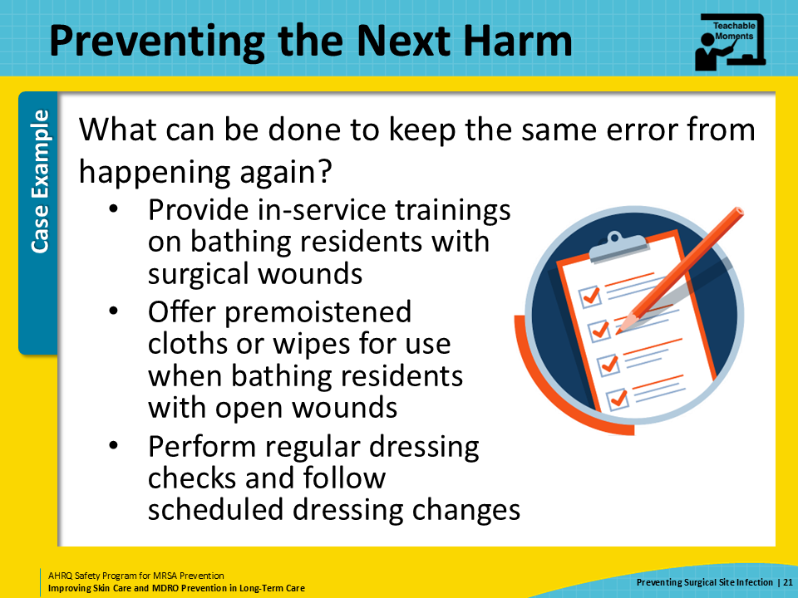
System-Based Safety Challenges  SAY:  Even with the best of intentions and technique, sometimes unexpected events occur. The gravest mistake that the CNA made in this case was to not let the nurse know about the wet dressing.  The last time the CNA asked for help, it came with a reprimand. That time, she had just donned PPE and realized that she needed a new container of germicidal wipes. One of the nurses brought her a new container and told her that she needed to learn to think ahead. This, and similar types of interactions, have created a culture in the building in which the CNAs avoid asking nurses for help and are afraid to acknowledge errors.  Leadership in the building must empower CNAs to be able to talk to nurses and other staff members without fear of consequences. The expectation should be that any concerns around resident safety are always taken seriously and given priority. Staff members should be able to ask for and receive help in a way that makes it clear that everyone is part of the same team, and working toward the same goals, which is to provide good care for their residents and for each other. | Slide 22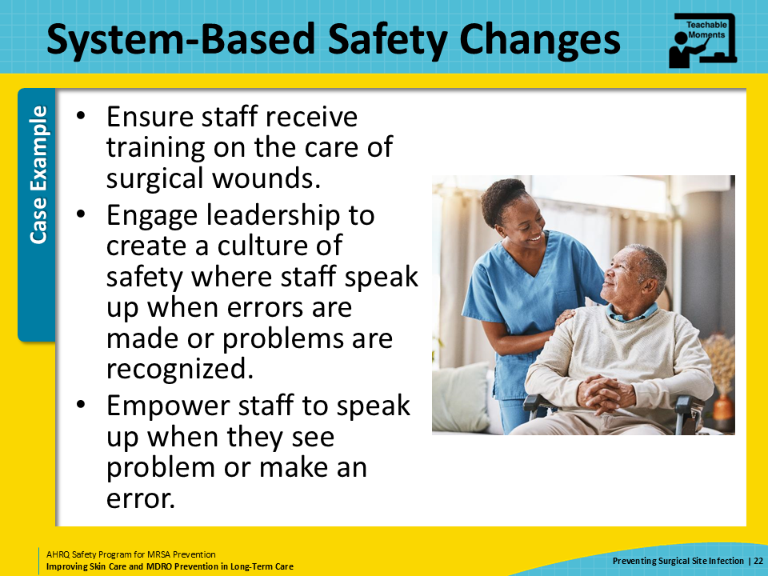
Key Takeaways  SAY:  This slide reviews key takeaways from this presentation.  First, good care of surgical wounds helps prevent surgical site infections.  Second, detecting signs and symptoms of wound infections can help support early recognition of surgical site infections. This includes a systematic approach to assessing and documenting wounds.  Finally, all staff should be encouraged and rewarded for speaking up when they need help, especially when they have made a mistake and need help in correcting that mistake. | Slide 23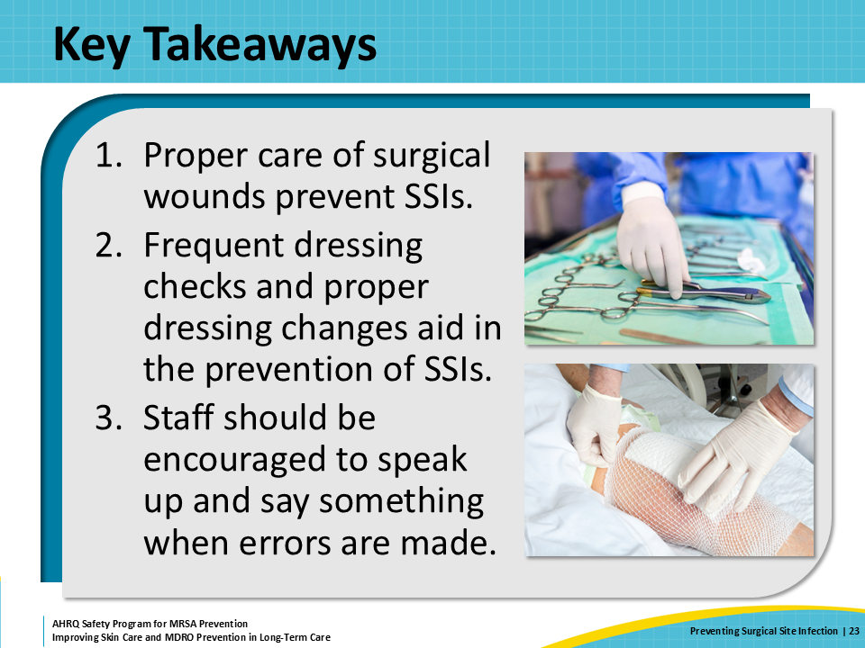
Supporting Materials  SAY:  The supporting materials for this presentation include teachable moments: The Case of Insufficient Communication Between Care Teams, The Case of the Wet Surgical Dressing, and a link to a document on the Levine Technique, How to Collect a Wound Culture. | Slide 24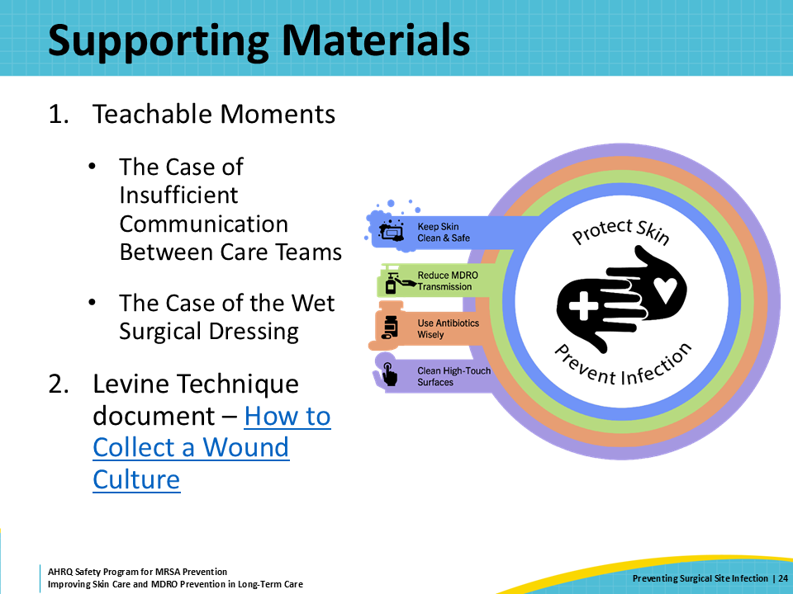
Disclaimer  SAY:  The findings and recommendations in this presentation are those of the authors, who are responsible for its content, and do not necessarily represent the views of AHRQ. No statement in this presentation should be construed as an official position of AHRQ or of the U.S. Department of Health and Human Services.  Any practice described in this presentation must be applied by healthcare practitioners in accordance with professional judgment and standards of care in regard to the unique circumstances that may apply in each situation they encounter. These practices are offered as helpful options for consideration by healthcare practitioners, not as guidelines. | Slide 25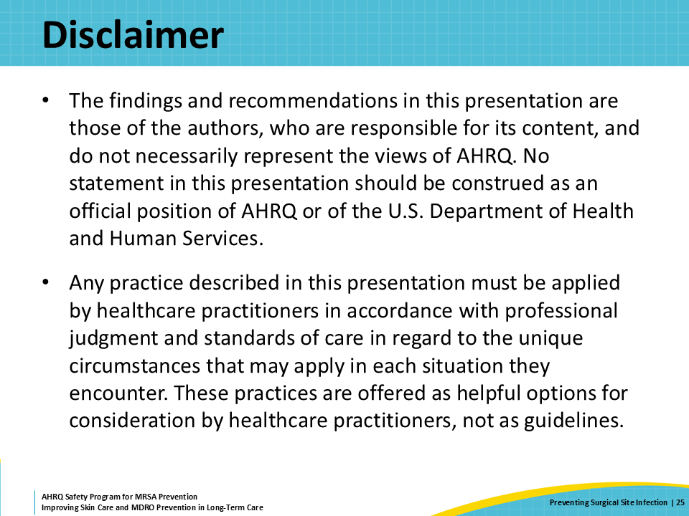
References  SAY:  Here are the references for this presentation. | Slide 26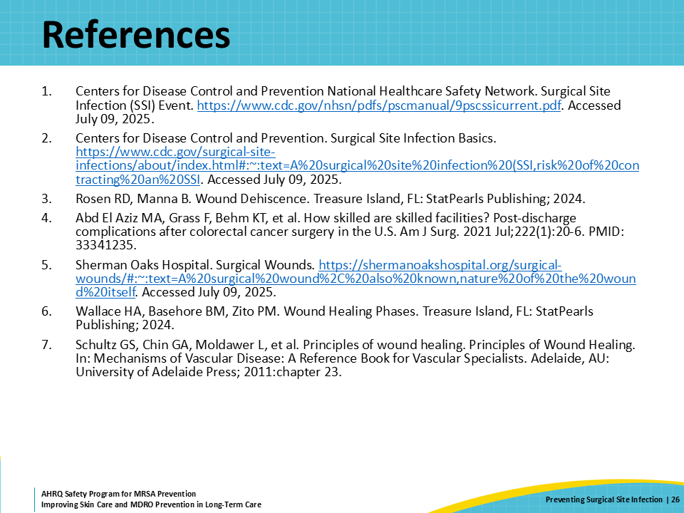
AHRQ Pub. No. 25(26)-0066
October 2025

