Choosing the Right Drug for the Right Bug: Antibiotic Stewardship for Skin and Soft Tissue Infections
AHRQ Safety Program for MRSA Prevention
Slide Title and Commentary | Slide Number and Slide
Choosing the Right Drug for the Right Bug: Antibiotic Stewardship for Skin and Soft Tissue Infections  SAY:  Welcome to this presentation on “Choosing the Right Drug for the Bug: Antibiotic Stewardship for Skin and Soft Tissue Infection,” part of the AHRQ Safety Program for MRSA Prevention: Improving Skin Care and MDRO Prevention in Long-Term Care. | Slide 1  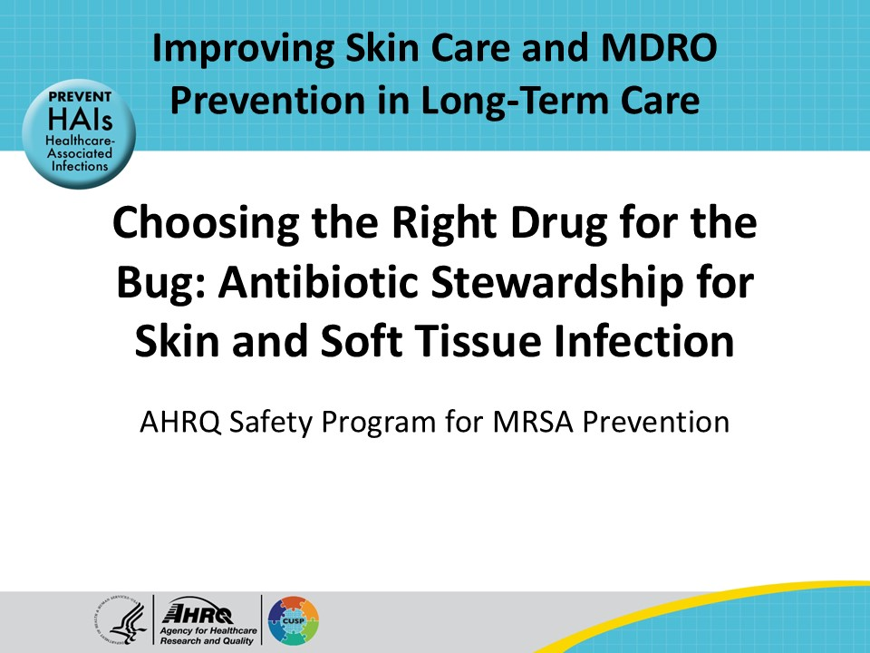
All Staff Support Resident Safety and Care  SAY:  The information provided in this presentation is important in the care of long-term care (LTC) residents. In LTC facilities each member of the facility’s staff supports resident care and safety. Some actions described in these presentations may not be in your scope of practice, but it is important to learn how all staff contribute to resident care and safety. | Slide 2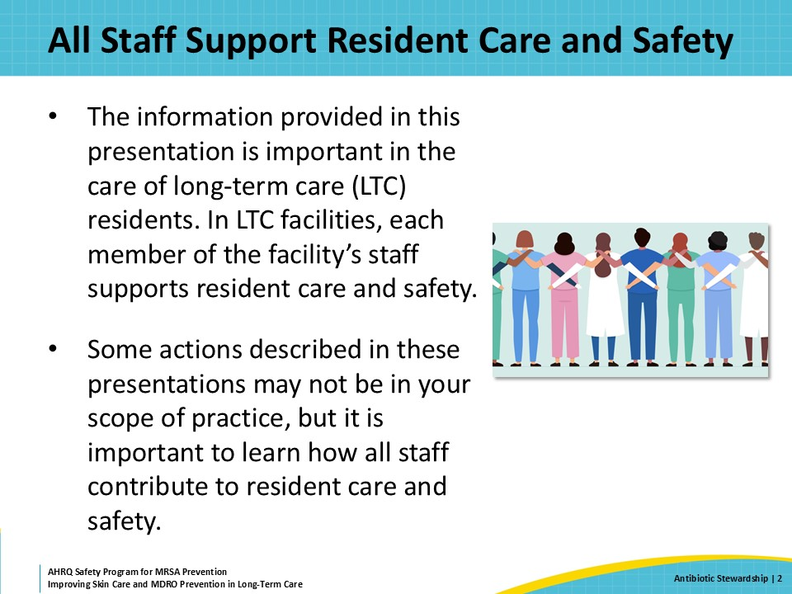
Educational Objectives  SAY:  The learning objectives for this presentation are to define antibiotic stewardship and its importance in nursing homes, recognize when antibiotics are needed for skin and soft tissue infections, and finally, discuss the diagnostic approach and empiric management of skin and soft tissue infections. | Slide 3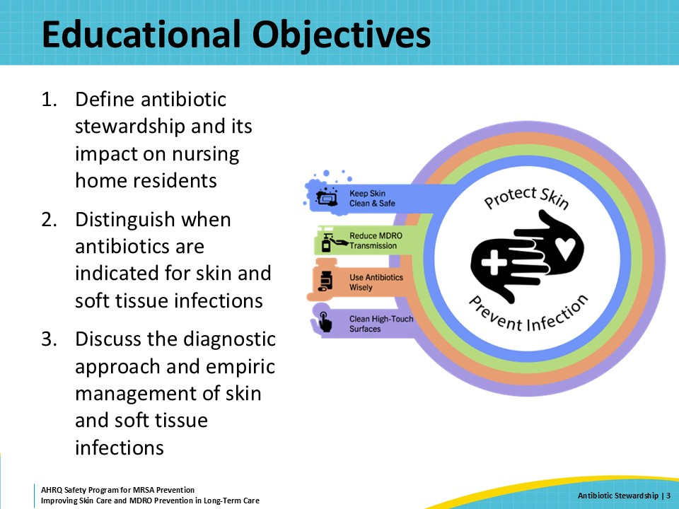
What Is Antibiotic Stewardship?  SAY:  The basic idea of antibiotic stewardship is to improve the use of antibiotics so that these important medications can remain available to help people with bacterial infections.  Sometimes, people need antibiotics to treat what is clearly a bacterial infection. Other times, people are prescribed antibiotics that are unnecessary.  One of the most common examples of unnecessary use is prescribing antibiotics to someone with an acute upper respiratory infection (URI). The vast majority of acute URIs are caused by viruses. More than 200 viruses can cause “the common cold.” Antibiotics do not treat viral infections, so they will not help the person get better. The person taking the antibiotic gets no benefit from the medication and is still at risk for potential negative consequences from taking the antibiotics.  It is important to note that antibiotic stewardship does not mean that patients are not prescribed antibiotics when they need them. Rather, strong antibiotic stewardship emphasizes a coordinated effort throughout the healthcare team to make sure patients receive the correct antibiotic, when it is needed, and for only as long as it needed to treat an infection caused by bacteria. | Slide 4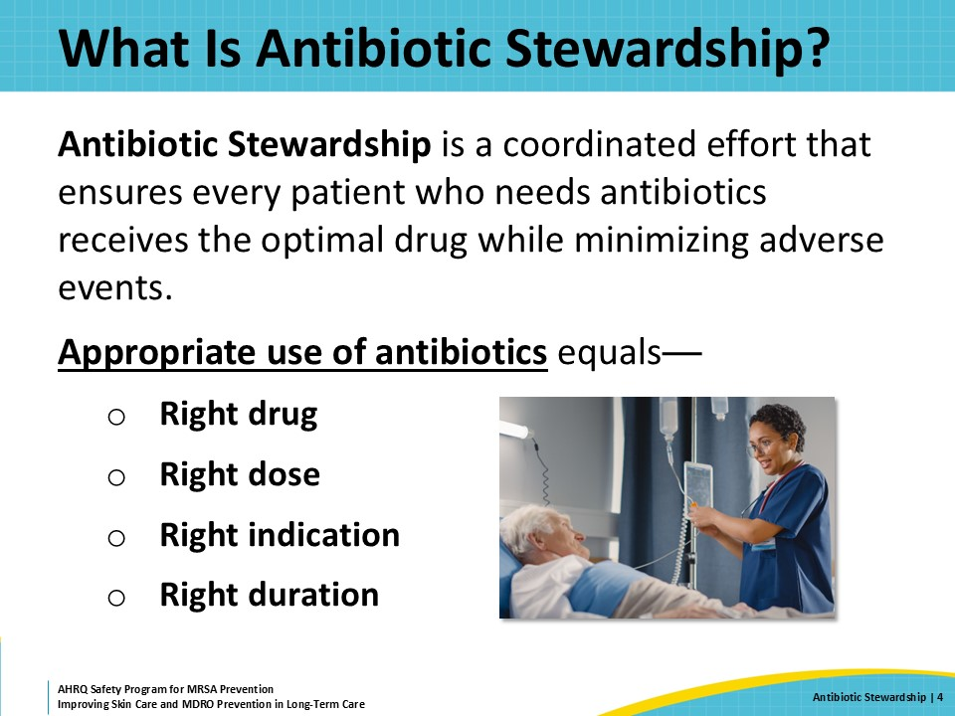
Potential Consequences  SAY:  The use of antibiotics is not without consequences. It is important to consider some of the possible side effects from antibiotics.  Most people are aware of the risk of an allergic reaction. Allergic reactions can be mild, for example an itchy rash, or severe, like anaphylaxis.  Other side effects of antibiotic usage include loss of appetite, diarrhea, kidney damage, liver damage, cardiac arrhythmias, seizure, confusion, and mental status changes.  Antibiotics can also lead to infection with Clostridioides difficile, or C. diff, and increase the risk for colonization or infection with antibiotic-resistant bacteria. Both C. diff and resistant bacteria can then be transmitted to others. This is one of the most distressing features of antibiotics. Using antibiotics in one person carries risks to people around that person. This is an important concern specifically in the long-term care setting.  These are just some of the side effects that residents can experience from antibiotic exposure, so it is best to avoid these powerful medications when they are not necessary. Antibiotic stewardship can help prevent some of these consequences and protect the residents in the facility. | Slide 5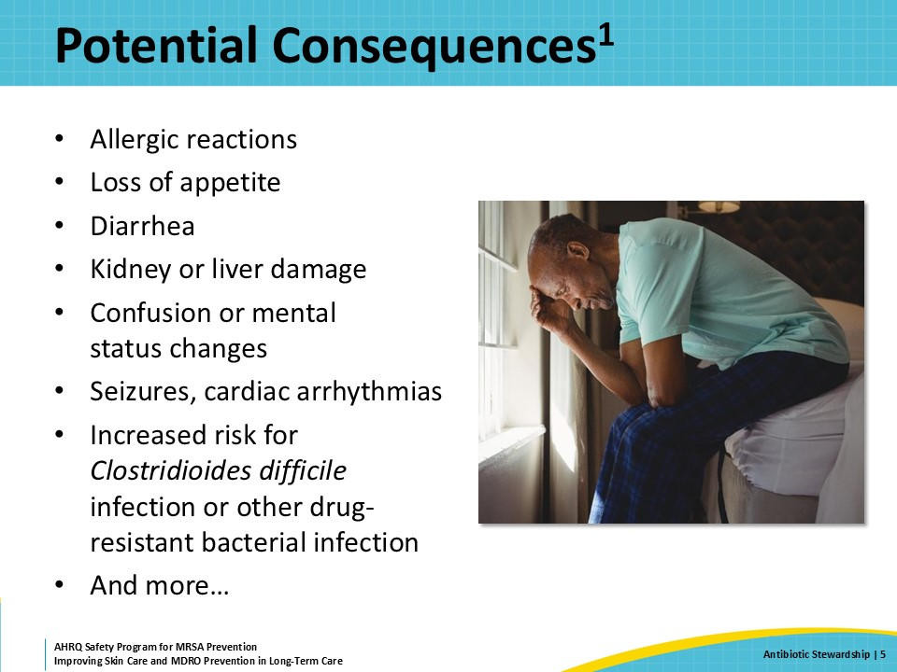
Antibiotic Overuse in Nursing Homes  SAY:  Antibiotic overuse is very common in nursing homes. Up to 75 percent of antibiotics prescribed in nursing homes are considered inappropriate or unnecessary.  Older adults are over 50 percent more likely than their younger counterparts to receive antibiotics. Older women, specifically, are more likely to receive antibiotics at 62 percent, than older men at 38 percent.  In nursing homes, one of the most common reasons for inappropriate or unnecessary antibiotic use is in response to a positive urinalysis or urine culture. To be diagnosed with a urinary tract infection, a nursing home resident should have signs and symptoms that are specific to the urinary tract. The most common symptom is dysuria or painful urination. A positive urinalysis and urine culture in someone without symptoms that localize to the urinary tract is called asymptomatic bacteriuria. About half of nursing home residents have asymptomatic bacteriuria. Yet many nursing home residents, especially those with dementia, receive antibiotics because of a “positive urine.”  One additional concern about antibiotic overuse in nursing homes is that adults living with dementia are more likely to receive antibiotics despite not meeting criteria for treatment.  So, why does this overuse occur in nursing homes? | Slide 6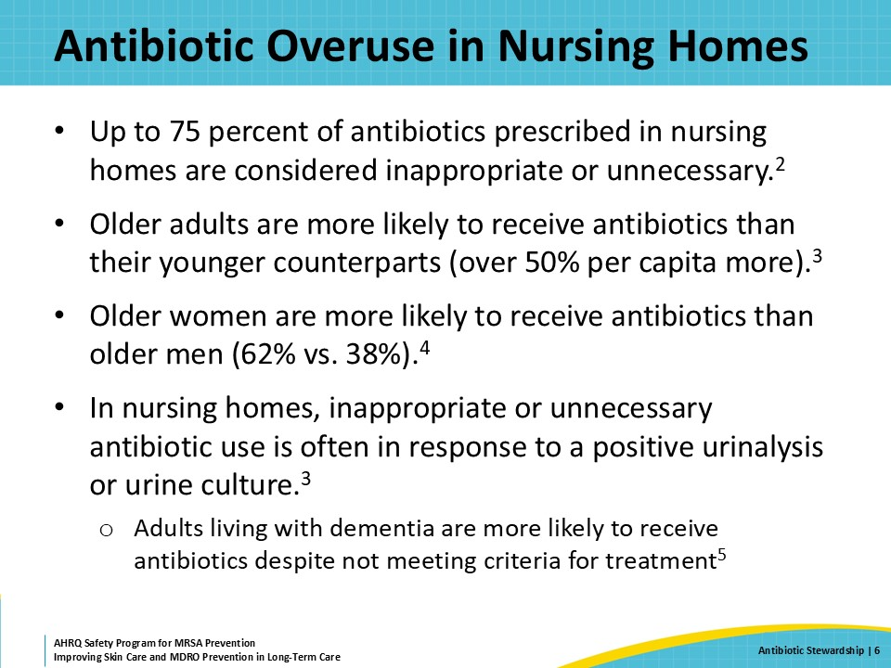
Treating Older Adults Is Complicated  SAY:  Treating older adults with infections can be complicated. Nursing home residents have chronic medical conditions and are frail. When they get an infection, they may have some atypical signs and symptoms. This can make it hard to know if someone has an infection or there is some other reason for their symptoms. Also, older adults have a lower baseline body temperature, making it more difficult to recognize a fever in this population. It can be even more challenging for someone with dementia, as those individuals may not be able to express themselves well.  For patients that cannot express specific symptoms, it is important to identify changes such as acute mental status changes, refusal of food, or increased fatigue. These subtle changes should be communicated throughout the healthcare team, and the resident should be more closely monitored with frequent vital signs and regular check-ins. This makes it easier to identify signs of infection, such as an increased respiratory rate or a drop in blood pressure, that may warrant further diagnostic workup or empiric antibiotics.  People who work at nursing homes recognize that residents who might have an infection are at high risk for adverse outcomes. The hope that an antibiotic will prevent a bad outcome is one of the reasons for antibiotic overuse in nursing home residents.  Unfortunately, it is not always easy to know when a resident will benefit from an antibiotic.  And just like with any other medication, taking an antibiotic, regardless of whether it is needed, poses some risk. In addition, the stakes are often higher when treating older adults. Older adults can get sick very quickly and have less of a reserve to fight infection, so providers favor antibiotic use in the hopes of preventing sepsis. Close monitoring, with documentation and tracking of the resident’s trajectory, can help identify true infection and reduce initiation of unnecessary antibiotics that can be harmful. | Slide 7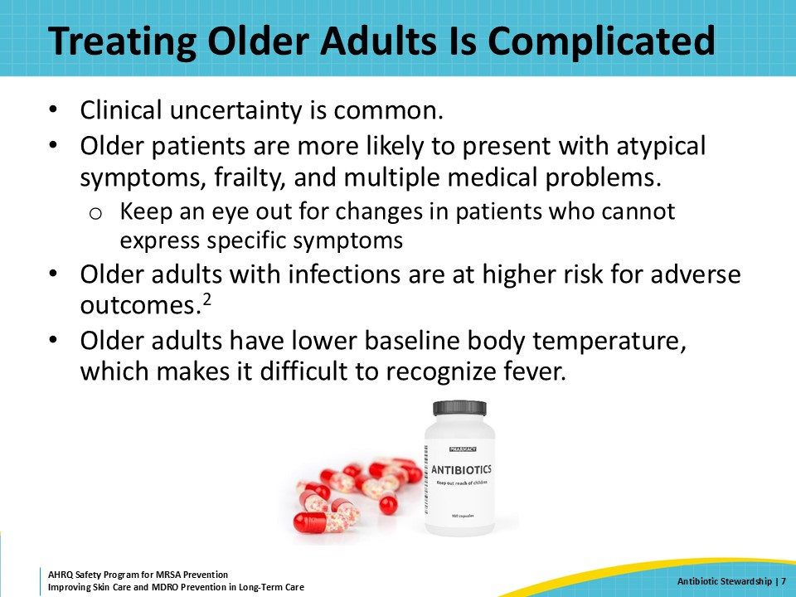
Distinguishing When a Patient Needs Antibiotics  SAY:  Presumed skin and soft tissue infections are another common reason for antibiotic prescriptions in long-term care settings. Sometimes they are started when residents do not truly have an infection or are continued longer than needed.  Cellulitis is a bacterial infection of the dermis and subcutaneous tissue. It manifests as red, painful, and hot skin. Other common conditions lead to a red leg or legs, including deep vein thrombosis and peripheral vascular disease. Deep vein thrombosis is often unilateral and can be diagnosed with an ultrasound.  Peripheral vascular disease is caused by poor blood flow in the legs. Manifestations of peripheral vascular disease are commonly but not always bilateral. Noninfectious dermatitis due to venous stasis or peripheral arterial disease can appear red but should not have other hallmarks of cellulitis, including tender skin, skin that is hot touch, and sometimes a fever.  Lymphedema can also manifest as swollen red leg.  Elevating the legs, applying lotions or emollient therapies, and using compression stockings can help some of the symptoms of noninfectious dermatitis. After a while, most people who have venous stasis will have long-lasting changes to the color of their legs. | Slide 8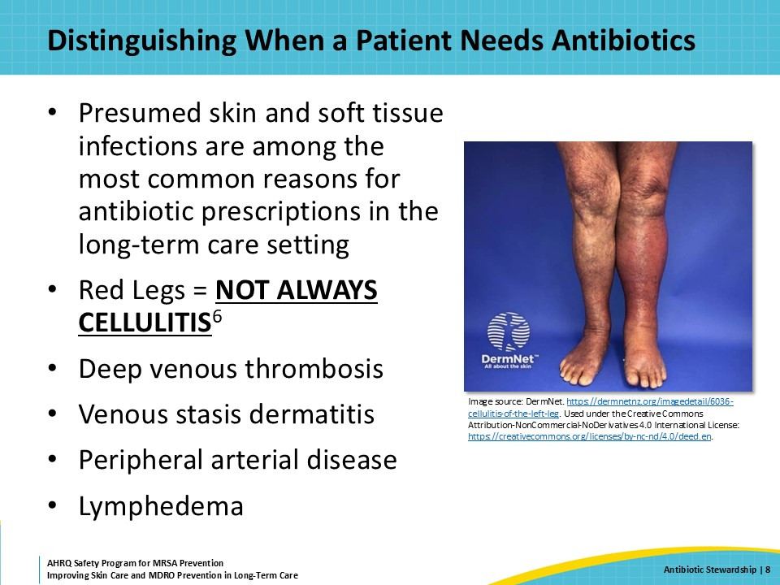
Empiric Therapy Based on Clinical Presentation  SAY:  With cellulitis, the causative organism is often inferred based on the resident’s clinical presentation. It is important to assess whether the patient has nonpurulent or purulent cellulitis.  In nonpurulent cellulitis, there is no fluid collection, abscess, or pus. People may sometimes develop superficial blisters filled with clear fluid. The skin over top of these is thin enough to see the fluid within the blister or vesicle.  Typically, nonpurulent cellulitis is caused by a Streptococcal species. Nonpurulent cellulitis does not require cultures unless the patient is systemically ill and there is a concern for a bloodstream infection. If there is concern for a bloodstream infection, blood cultures should be considered. Nonpurulent cellulitis can be treated empirically with an anti-streptococcal agent, such as penicillin or cephalexin.  In purulent cellulitis, there is a fluid collection, pus, phlegmon, or an abscess associated with the cellulitis. This is sometimes referred to as a suppurative cellulitis. Purulent cellulitis is often caused by Staphylococcus aureus.  If there is evidence of a fluid collection or abscess, drain the fluid collection and send a sample for microbiological culture. Culture results identify the pathogens and indicate their susceptibilities. This allows selection of antibiotics that will provide effective treatment, which is especially important when considering therapy for methicillin-resistant Staphylococcus aureus or MRSA. | Slide 9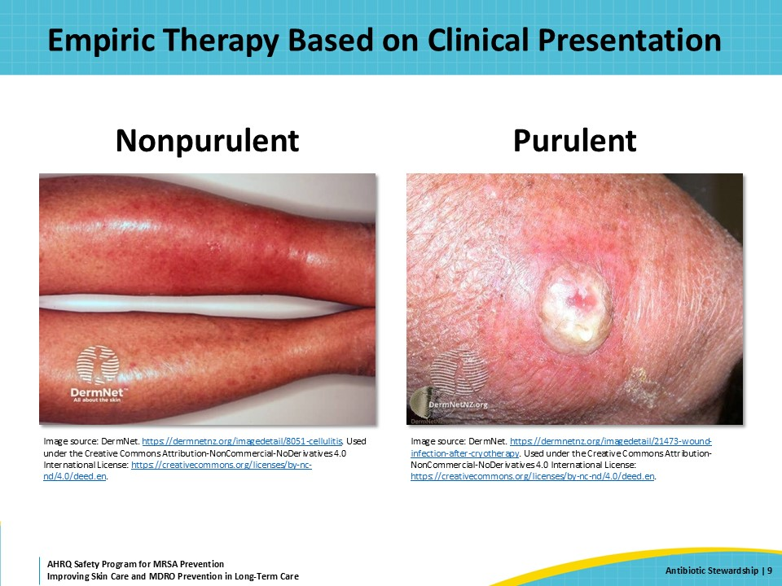
Empiric Therapy for Cellulitis  SAY:  To review, for purulent cellulitis, which is typically caused by a Staphylococcus aureus, the first step is to drain the abscess and then send the fluid for culture. Draining the abscess will improve symptoms significantly. Especially for abscess that are less than 5 centimeters in diameter, antibiotics may not be needed.  If the patient or resident does have systemic signs or symptoms of infection, or if the abscess is greater than 5 centimeters in diameter, oral options for empiric treatment are trimethoprim-sulfamethoxazole, linezolid, or doxycycline, any of which cover most strains of MRSA. Culture results are still important here, as MRSA can be resistant to these empiric antibiotics. Residents should be watched closely for failure to respond.  The picture on the slide shows a 4-centimeter erythematous lesion on the thigh with a small amount of central purulence. That dark area in the middle of the red skin is likely a scab that developed along with the abscess. It’s hard to appreciate on this two-dimensional image but the erythematous region is also raised with the greatest area of swelling around that central lesion. These features are consistent with an abscess caused by Staphylococcus aureus.  For nonpurulent cellulitis, which is typically caused by a Streptococcal species, a penicillin or cephalexin is appropriate for empiric therapy. In residents with a penicillin allergy, first determine if the resident can receive a cephalosporin. (Recall that there is low cross reactivity between penicillin and cephalosporin allergies).  In residents with a true allergy to cephalexin or cefazolin, consider a short course of linezolid or clindamycin. This should be done with close monitoring, as clindamycin therapy carries a high risk of subsequent C. diff infection. | Slide 10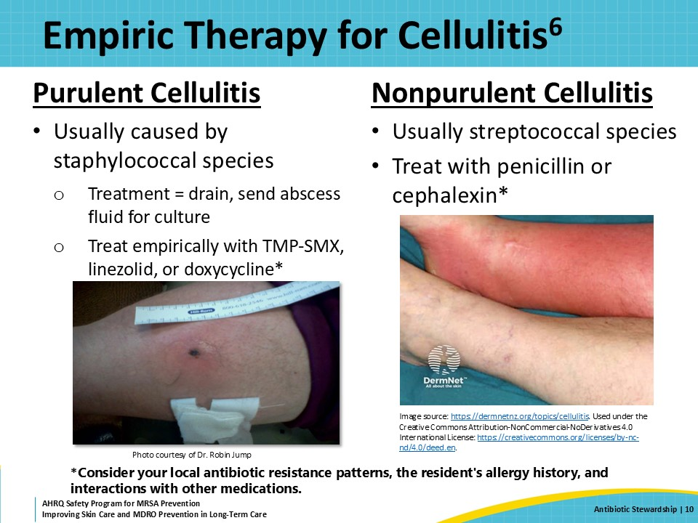
Duration of Therapy for Cellulitis  SAY:  Research shows that 5–7 days of antibiotic therapy is appropriate, and not inferior to longer courses of therapy, like 10–14 days, unless the infection is complicated.  It may be helpful to draw a line at the borders of the cellulitis area to monitor changes in the appearance of cellulitis after starting antibiotics.  Cellulitis often looks worse before it looks better. This picture was taken about 36 hours after starting antibiotics. Note how red and angry the skin looks, but the borders have not changed. By the time this picture was taken, the resident felt better, despite how red her leg looked.  In general, expect to see worsening skin changes in the first 1 to 2 days after starting antibiotics. Once the antibiotics start, the bacteria within the skin are killed, which can lead to some ugly, but usually temporary, skin changes. These changes include increased redness and sometimes blisters or vesicles or superficial layers of skin peeling off. However, the skin should not be as warm or as painful, and the patient should otherwise feel improved.  Generally, there will not be complete resolution of redness and tenderness in 5 days, but there should be a noticeable improvement in symptoms by 3 days at the most. The resident should have less pain, their fever and elevated white blood cell count should have returned to normal or near normal, the affected skin should have less redness, and most importantly, the resident should feel better. | Slide 11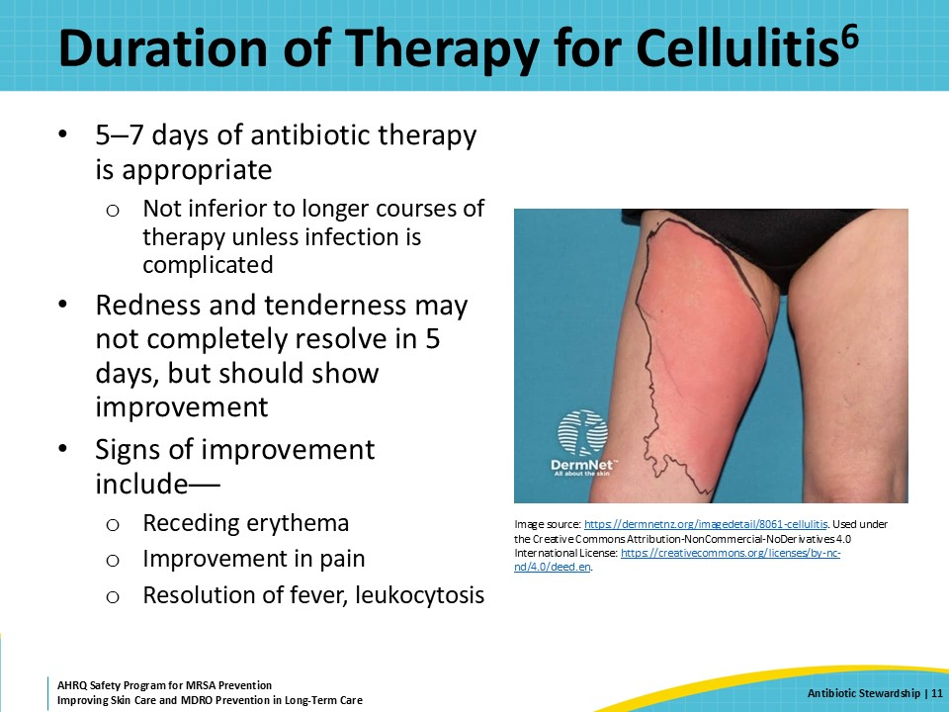
Preventative and Supportive Measures  SAY:  Several preventive and supportive measures can help reduce the risk of skin and soft tissue infections among nursing home residents. They include minimizing edema, treating fungal infections, and performing good skin care to help reduce the risk of minor traumas leading to skin damage.  Many residents have underlying lymphedema or venous stasis that can make it difficult to clear infection or see complete resolution of symptoms. Edema can also increase the risk of recurrent infection. Leg elevation and reduction of tissue edema through compression stockings or diuretics can help. Residents should be encouraged to walk and, when they are not moving, put their legs up. Leg elevation needs to be high enough to let fluid leave the legs—so simply putting legs up on a low stool is not enough.  Once the skin has improved, the physical therapist can help by prescribing compression stockings and recommending exercises to improve the blood flow to the area. Diuretics can also help to reduce edema in people with congestive heart failure and related conditions.  There is evidence that treating fungal foot infections, including tinea pedis and onychomycosis, can reduce the recurrence of cellulitis. People with evidence of fungal disease should receive treatment.  Finally, reducing the risk of wounds or skin breakdown helps prevent bacteria from entering skin. Emollient lotions can help to reduce cracks in the skin, and Unna boots can help to improve the symptoms of venous stasis, if they are indicated. | Slide 12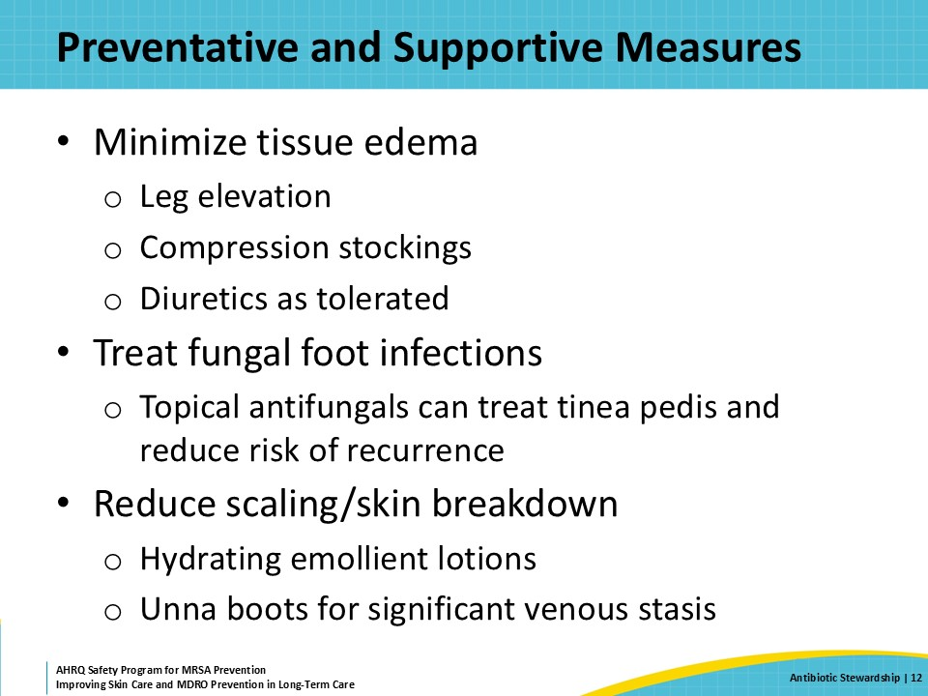
Triangle of Transmission  SAY:  Antibiotic stewardship activities can help interrupt all directions of the chain of transmission.  Direct care staff should refrain from prescribing antibiotics unless they are indicated. This can reduce the cultivation of resistant organisms in the resident.  In turn, this decreases the burden of resistant organisms throughout the facility environment and among the residents and staff. | Slide 13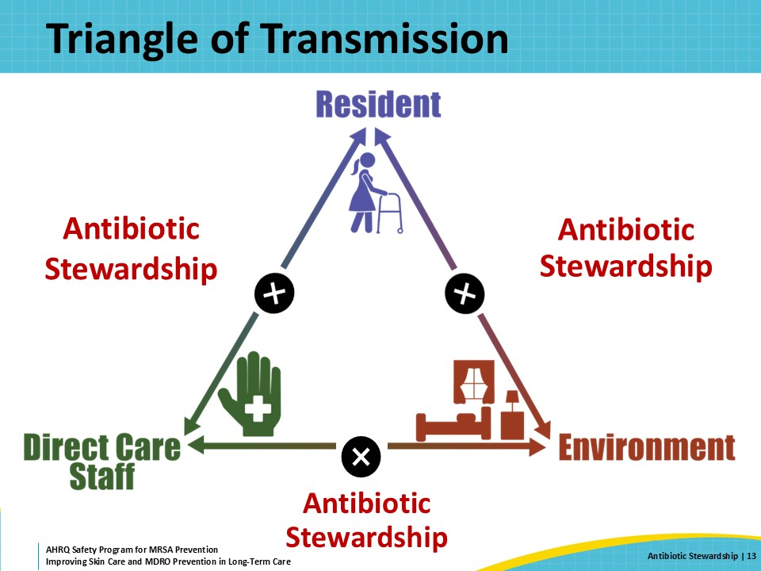
Teachable Moment  SAY:  For this presentation’s case study, consider each person’s role in the antibiotic stewardship process and how it can impact decisions about starting or stopping antibiotics.  Also consider how staff can identify and monitor skin and soft tissue infections for when they may or may not require antibiotics. | Slide 14
The Case: The Resident  SAY:  This case focuses on a 75-year-old resident with congestive heart failure and chronic lower extremity swelling and discoloration consistent with chronic venous stasis.  There is an outdoor barbecue for Father’s Day at his nursing home, and he is on his feet for a long time. He chooses to indulge in many salty meats and French fries, even though this is against his low-sodium diet.  The next morning, the resident complains of some soreness in both his lower extremities, but otherwise, he feels fine. He says his legs do not feel particularly worse than usual. His vitals are all within normal limits. | Slide 15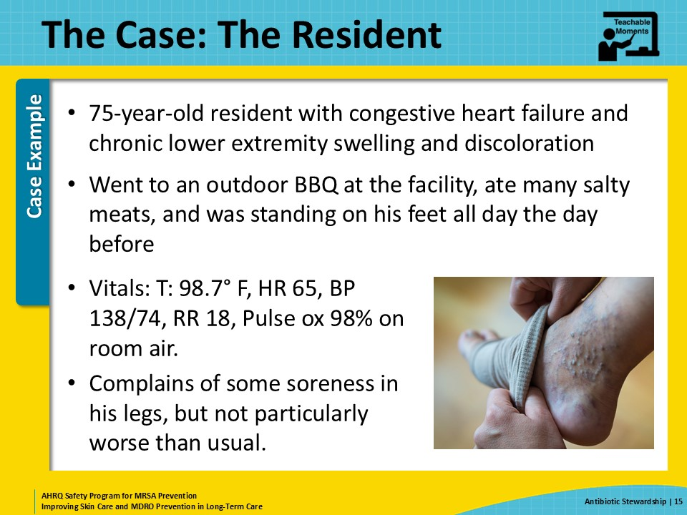
The Case: A Request for Antibiotics  SAY:  His daughter comes to see him and is concerned about the swollen and discolored appearance of both her dad’s legs. She asks for antibiotics to treat the infection. | Slide 16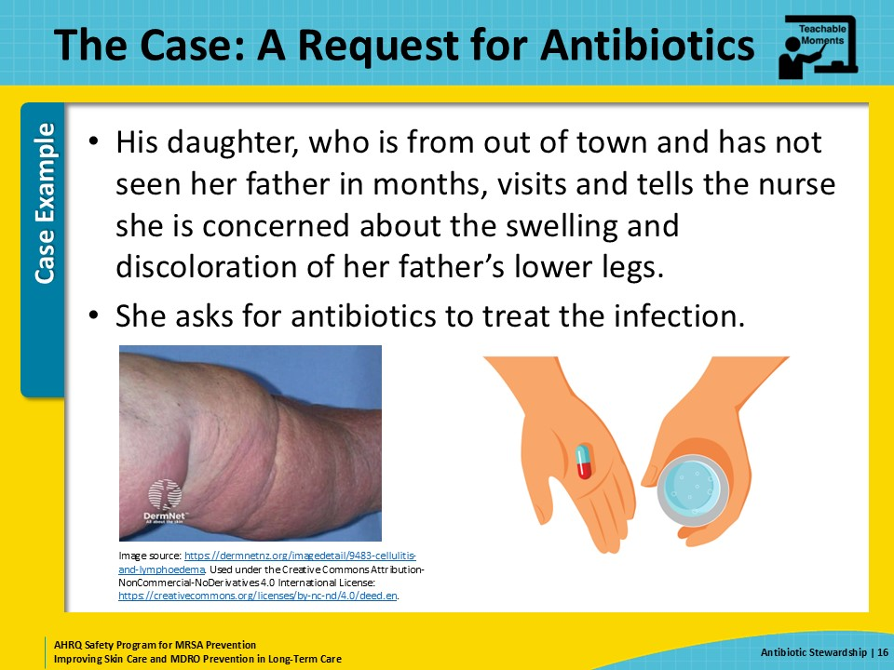
The Challenge  SAY:  The nurse does not see any change in the skin discoloration of his legs from their baseline. She notes they are both a little more swollen than normal but not far off from his baseline. His daughter is insistent on antibiotics, so the nurse pages the on-call doctor and asks him to start antibiotics for a skin infection.  The doctor covering overnight is not familiar with the patient and can’t get in to assess his legs, so he orders a 7-day course of cephalexin.  The resident develops diarrhea and nausea due to the cephalexin. A urine culture collected 2 months later unfortunately grows E. coli that is resistant to cephalexin. | Slide 17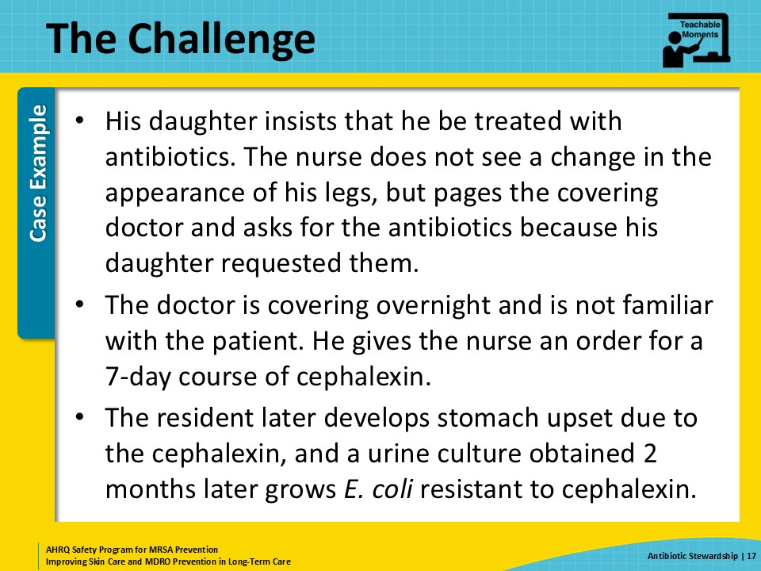
Knowledge Check  SAY:  After reviewing this case, take a moment to pause and consider how the nurse and the prescriber could have handled this situation differently to improve the resident’s outcome. | Slide 18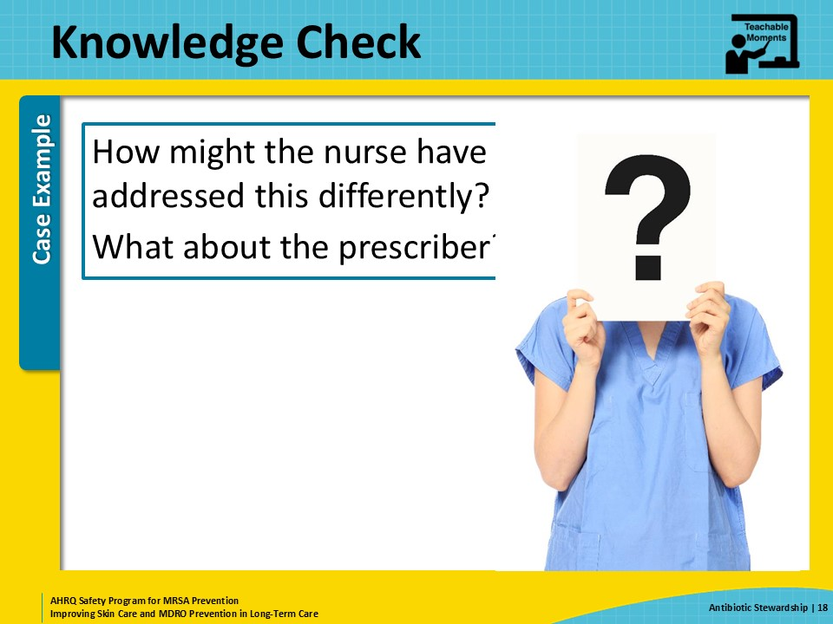
The Error  SAY:  A few errors occurred in this case. The nurse knew that the resident’s daughter was not familiar with the chronic appearance of her father’s legs, and she did not take the time to educate the daughter on other supportive measures they were taking to help reduce the swelling in his legs.  Bilateral cellulitis is very uncommon, and the resident had no other signs or symptoms of infection. Eating salty foods and standing a lot the day before increase the swelling in his lower extremities.  The nurse should have taken the time to educate the daughter about her father’s condition and discuss the risks of starting antibiotics when they are not indicated. It often helps to describe actions the healthcare team is taking to help the resident, such as keeping the lower limbs elevated, applying emollient lotions, using compression stockings, and monitoring closely for any skin changes.  The nurse should have offered a more complete description to the covering provider, including that the resident has chronic edema and venous stasis dermatitis affecting both lower extremities. Also, the provider should also have taken the time to ask more questions about the resident’s condition, including his most recent vitals and whether this was a significant change for the resident before prescribing a full course of antibiotics. | Slide 19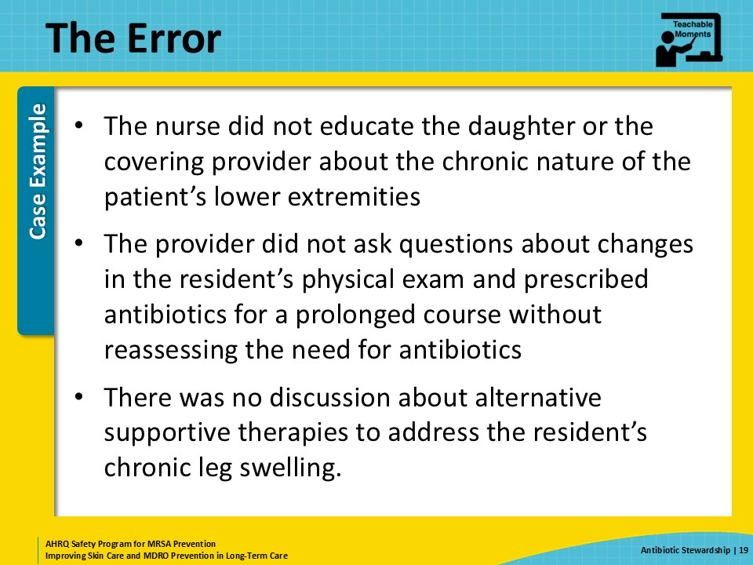
The Consequence  SAY:  As mentioned above, the resident experienced side effects from taking the antibiotic, specifically an upset stomach and antibiotic-associated diarrhea. Thankfully did not have a C. diff infection. Unfortunately, because of the side effects from the cephalexin, his medical record now lists cephalexin as an allergy. He experienced normal side effects, not a true allergic reaction, but because cephalexin is now listed as an allergy, it can affect treatment for true infections in the future. This is critical—confirming and documenting true allergies can have significant impacts on a resident’s clinical outcome. Allergy history should always be discussed during any transition of care or before any treatment decision. Remember, side effects such as gastrointestinal upset are not allergies and should not be documented as such. Also, the resident acquired an antibiotic-resistant E. coli. This consequence will not be recognized for some time—and will not likely ever be related back to this antibiotic course as the reason for the drug-resistant E. coli. However, antibiotic exposure definitely contributes to people becoming colonized or infected with drug-resistant bacteria. | Slide 20
Patient Safety in the Moment  SAY:  The nurse should have let the daughter know that the resident has chronic venous stasis, meaning his legs are often swollen, with chronic skin color changes, which includes looking a little pink. She could have also pointed out that after standing up more than usual and eating salty foods—as he did during the cookout the day before—leg swelling is common. Other educational points include sharing that cellulitis is nearly always only present in one leg, that the skin is red and hot (not warm and pink), and that it hurts to touch. Note that applying pressure to skin to assess pitting edema can also cause pain. The tenderness associated with cellulitis is to light touch, not pressure.  The nurse could have also suggested other ways to help support and care for the resident’s swollen legs, including leg elevation, compression stockings, returning to a low-sodium diet, and applying lotions to help prevent cracks from developing in the skin of his swollen legs. | Slide 21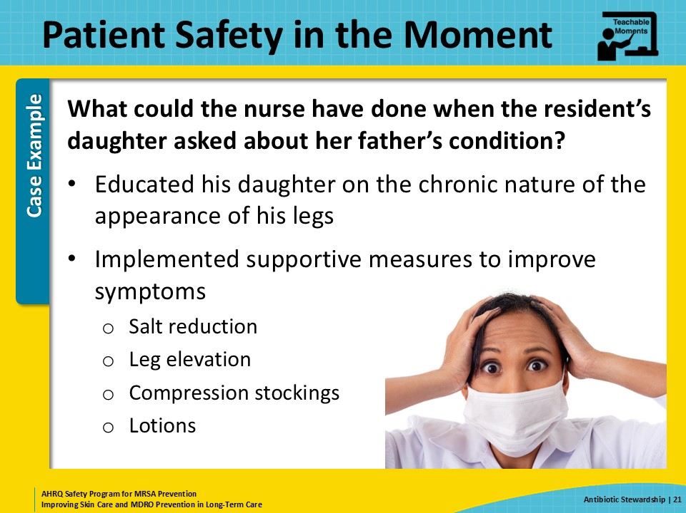
Preventing the Next Harm  SAY:  The circumstances of the communication between the nurse and the resident’s daughter are unknown. Perhaps the nurse did not know what to say, or perhaps she has tried to communicate with the daughter about other concerns in the past, without success.  To help avoid this situation again, the nurse may need some coaching on how to talk to family members about their concerns. When asking for an antibiotic, the daughter is expressing concern for her father’s health and asking for action to be taken.  With some coaching, the nurse may be able to respond to those sentiments better the next time. She might begin by agreeing that her father’s legs do look swollen and that this happens when people are on their feet for a long time. She can also provide some validation of the observations that the skin is discolored. The nurse can follow that up with reassurance that what the daughter is noticing is not new for her father and is actually pretty common among older adults.  The nurse should also indicate what she will do to help care for the resident. This may include checking his weight to know how much “water weight” the resident has gained. It may also include applying lotion to his legs and feet once he’s gone to bed for the evening. Finally, she can work with the daughter and resident to help properly elevate his legs.  The nurse might also have alerted the physicians of her impressions. An SBAR, which stands for situation, background, assessment, and recommendations, communication form could help organize her thoughts prior to the call in the following way:  - S, Situation. The resident’s daughter is worried about his leg swelling and requests an antibiotic.  - B, Background. The resident has venous stasis dermatitis, and he attended our cookout yesterday—where he ate more salty food and was on his feet more than usual.  - A, Assessment. His legs are more swollen than usual but otherwise look fine. They are pink, not red; warm, not hot; and are not painful. He looks and feels fine with a temperature of 98.0°F, a pulse of 72, and blood pressure of 135/86.  - R, Recommendations. I think leg elevation would be helpful, and let’s give it some time. I’ll get a weight on him and have someone assess his legs first thing tomorrow morning. If they look worse, they will alert his provider. | Slide 22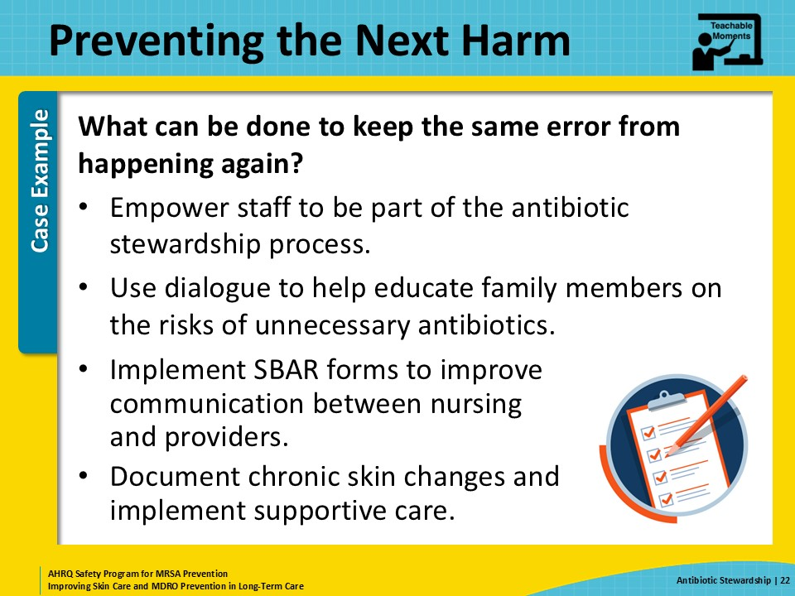
System-Based Safety Challenges  SAY:  Many people outside of healthcare view antibiotics as harmless medications and are unaware of the potential consequences. It would help the nurse and other staff members to have handouts or pamphlets that walk through the potential short- and long-term risks of antibiotics.  This might be part of a broader program within the nursing home to support antibiotic stewardship efforts, which includes tracking antibiotic use and reporting or sharing that information with the staff.  Leadership should also support a culture of safety in which staff feel comfortable discussing resident care with offsite providers. A key part of this is being able to have ongoing dialogue between professionals. By indicating that the nurse will check up on the resident and will call back if the situation changes, the physician can feel reassured. Rather than prescribe an antibiotic in response to a family request or in hopes of preventing a potentially bad outcome, the physician and nurse can work together to see how the resident does over the next few hours or days. If there is a change indicating an infection, then an antibiotic can be prescribed. | Slide 23
Key Takeaways  SAY:  This slide reviews the key takeaways from this presentation.  First, antibiotic stewardship helps ensure residents get an appropriate antibiotic if and only when an antibiotic is indicated.  Second, antibiotics can cause some serious consequences in older adults and are often overused, particularly in nursing home residents.  Third, all staff members who work in the nursing home have a role in supporting antibiotic stewardship. Some of this includes supporting good decisions when considering whether an antibiotic is necessary. Antibiotics stewardship also includes taking good care of residents, including hygiene and good skin care, both of which help reduce the risk for getting an infection.  Antibiotic stewardship is one of the most important ways to help reduce the cultivation of resistant bacteria and ensure residents are being treated appropriately.  This means working together to ensure every resident is on the right antibiotic, at the right dose, for the correct indication, and for the correct duration depending on evidence-based recommendations for treatment. | Slide 24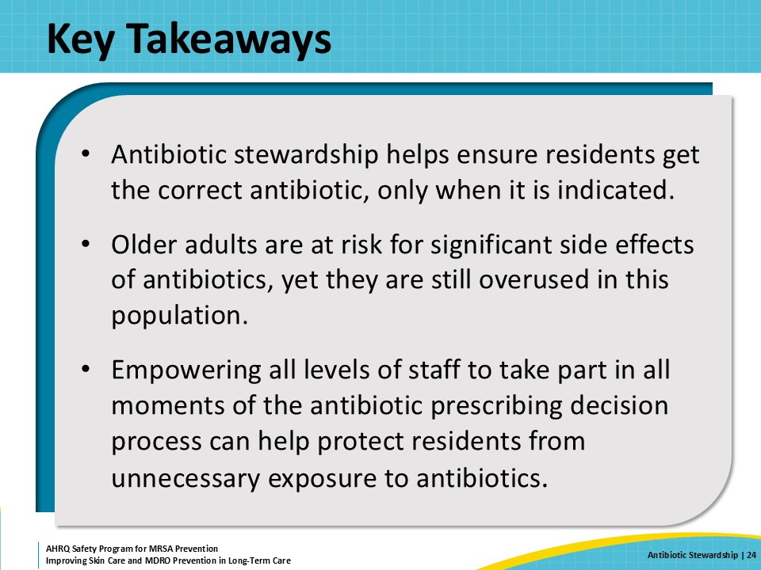
Supporting Materials  SAY:  The supporting materials for this presentation include a teachable moment: The Case of the Resident Who Attended the BBQ, an AHRQ Safety Program for Antibiotic Use in LTC toolkit, AHRQ skin and soft tissue infection pocket cards, and a poster about the Four Moments of Antibiotic Decision Making in LTC. | Slide 25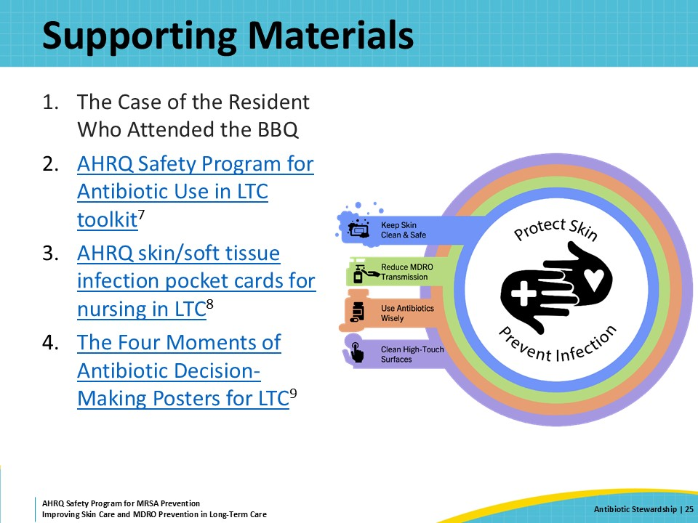
Disclaimer  SAY:  The findings and recommendations in this presentation are those of the authors, who are responsible for its content, and do not necessarily represent the views of AHRQ. No statement in this presentation should be construed as an official position of AHRQ or of the U.S. Department of Health and Human Services.  Any practice described in this presentation must be applied by healthcare practitioners in accordance with professional judgment and standards of care in regard to the unique circumstances that may apply in each situation they encounter. These practices are offered as helpful options for consideration by healthcare practitioners, not as guidelines. | Slide 26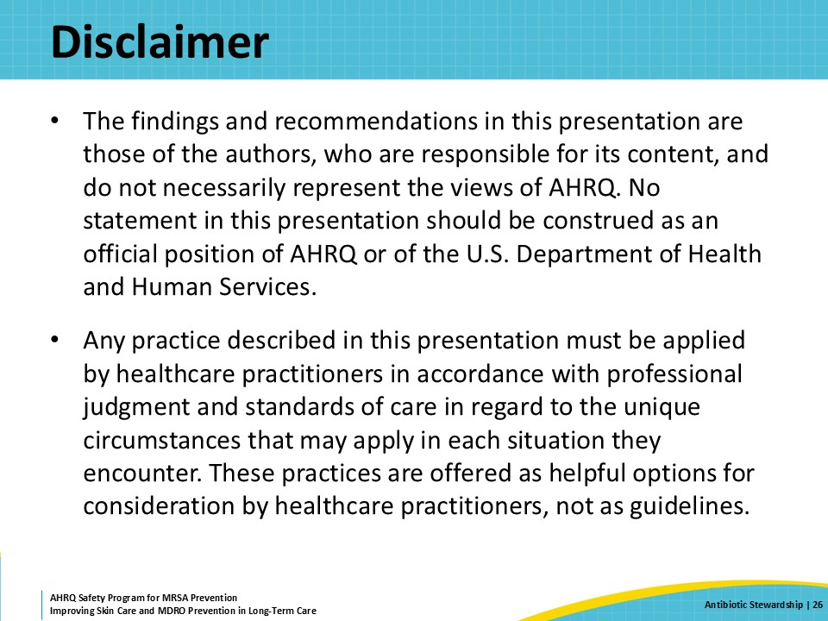
References—1  SAY:  Here are the references for this presentation. | Slide 27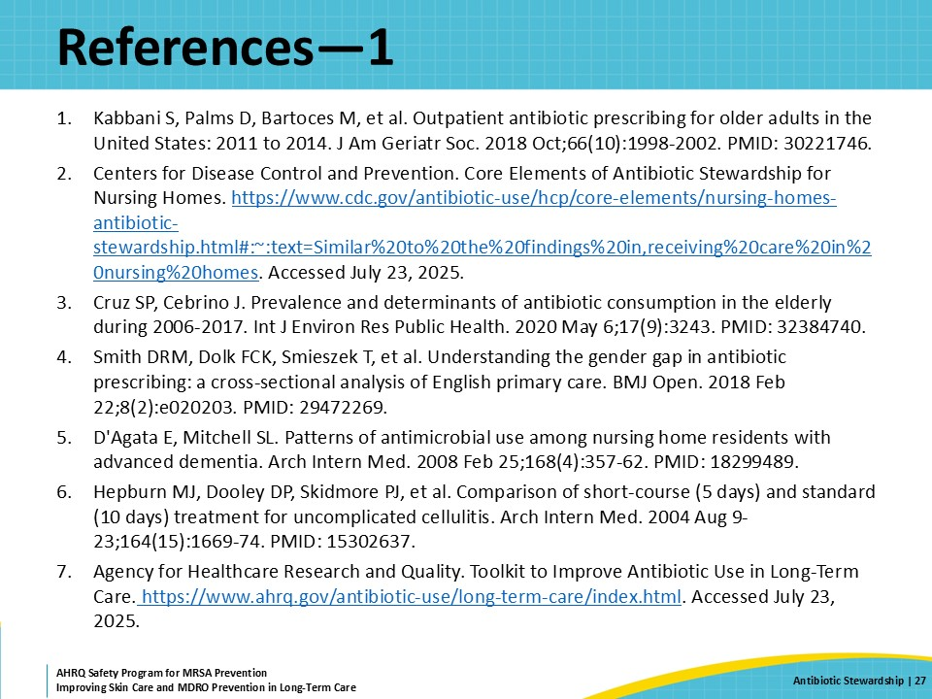
References—2 | Slide 28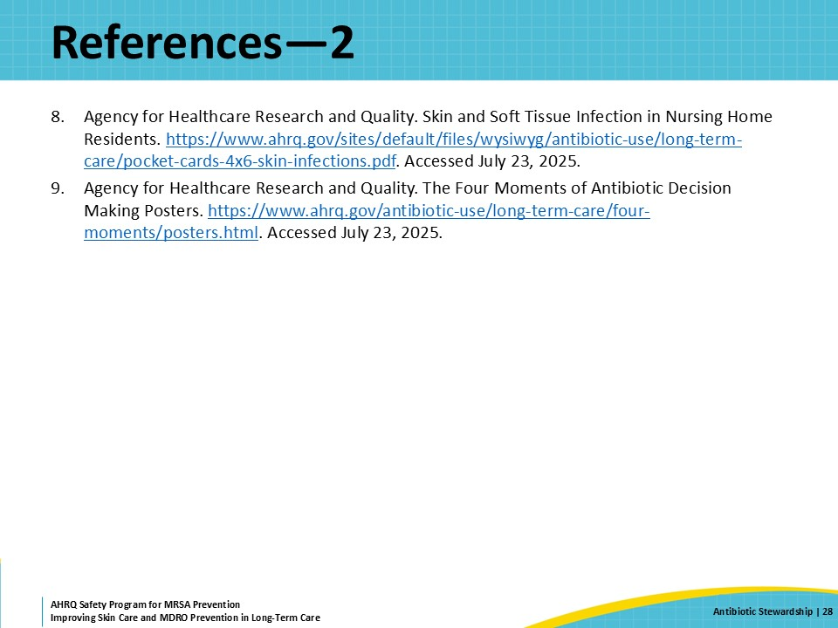
AHRQ Pub. No. 25(26)-0066
October 2025

