The 3 Cs of Healthcare: Working Together To Prevent Infection
AHRQ Safety Program for MRSA Prevention
Slide Title and Commentary | Slide Number and Slide
The 3 Cs of Healthcare: Working Together to Prevent Infection  SAY:  Welcome to this presentation on “The 3 Cs of Healthcare: Working Together To Prevent Infection,” part of the AHRQ Safety Program for MRSA Prevention: Improving Skin Care and MDRO Prevention in Long-Term Care. | Slide 1  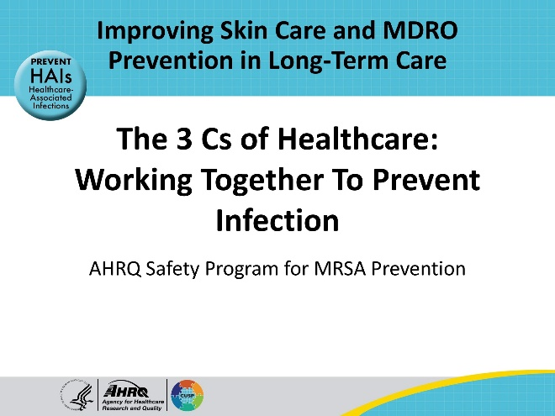
All Staff Support Resident Care and Safety  SAY:  The information provided in this presentation is important in the care of long-term care (LTC) residents. In LTC facilities, each member of the facility’s staff supports resident care and safety. Some actions described in these presentations may not be in your scope of practice, but it is important to learn how all staff contribute to resident care and safety. | Slide 2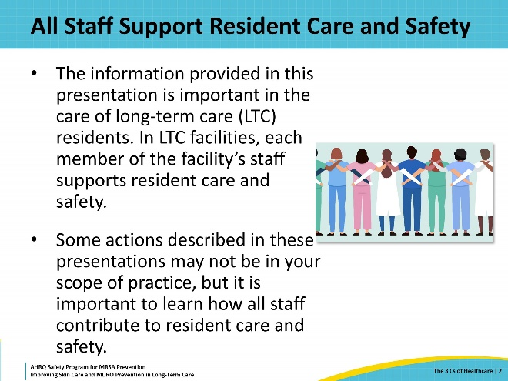
Educational Objectives  SAY:  The objectives of this presentation are to discuss the importance of communication, collaboration, and connection (3 Cs) in providing safe, quality healthcare; promote strategies for using the 3 Cs in the care of residents; and review a case that uses the 3 Cs to facilitate safe, quality resident care. | Slide 3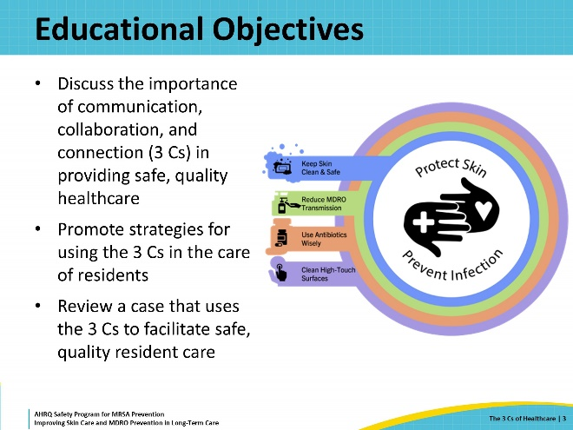
What Are the 3 Cs of Healthcare?  SAY:  Individuals who operate in a clinical environment within a healthcare organization are referred to as the healthcare team. The healthcare team is comprised of both clinical and nonclinical healthcare personnel who provide a set of skills and services to individuals seeking healthcare. This group is referred to as a team because it is important to work together to accomplish the goal of providing safe, quality care.  What actually is a team? According to the American Society for Quality, “A team is defined as a group of people who perform interdependent tasks to work toward accomplishing a common mission or specific objective.” In healthcare, the shared goal is to provide safe, quality healthcare. It is essential to work together to accomplish this goal, as everyone’s role is important in accomplishing this task. To do this, it must be recognized that interpersonal relationships as a part of the healthcare team can directly influence the care provided for residents.  This presentation discusses how to develop and strengthen healthcare teams by introducing the concept of the 3 Cs: fostering connection, improving communication, and working in collaboration with one another. | Slide 4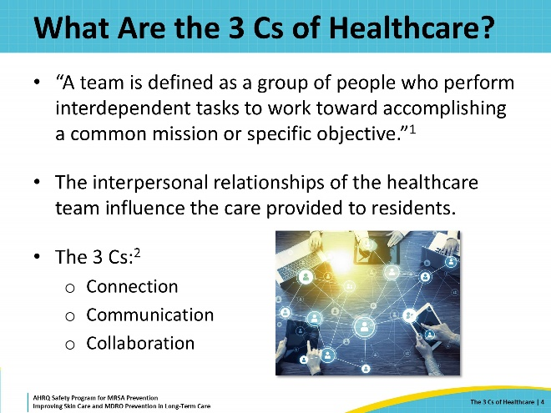
Triangle of Transmission  SAY:  The Triangle of Transmission shows how germs can be spread between direct-care staff, residents, and the environment. Think of each side or leg of the triangle as a two-way street. The healthcare team works to disrupt or put a break in each leg of the triangle.  The 3 Cs can be applied to prevent transmission along all sides of the Triangle of Transmission.  Collaboration between staff members can assist staff with transferring a dependent resident without causing a skin injury.  Communication between staff and different roles on the healthcare team can ensure that the environment is appropriately cleaned and disinfected, preventing transmission of resistant organisms to residents from the environment.  Finally, connection between residents and team members can ensure that everyone trusts and respects one another, opening the door to more open communication and collaboration.  These three elements of healthy interpersonal relationships all work together in the clinical setting to improve teamwork and keep residents safe from infections, including those caused by methicillin-resistant Staphylococcus aureus (MRSA) and other MDROs. | Slide 5  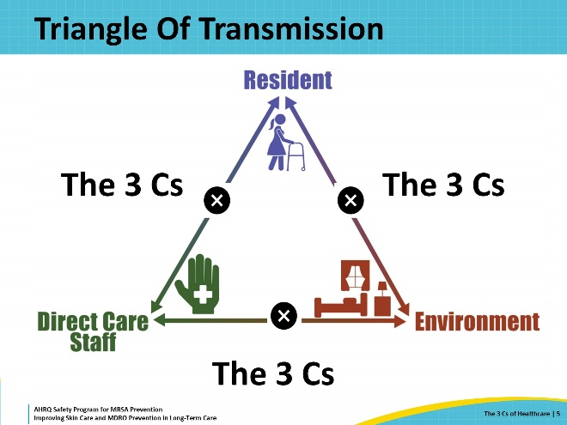
Communication: An Exchange of Information  SAY:  The first C of healthcare is communication.  As emphasized in the journal Infection Control Today, “Communication is defined as an exchange of information, thoughts, and feelings through a variety of mechanisms.”  It is important to discuss how to be a member of the healthcare team who strives to communicate in a healthy and productive way. While the idea of communication might be simple, creating an environment filled with healthy, productive communication is often much more complex.  Information can be shared through numerous different routes, especially in today’s technology-saturated culture. There is the obvious route of verbal communication, where an individual communicates verbally and in person. However, in-person communication may also occur through nonverbal routes, such as a look of disapproval or a smile. People can also communicate remotely through paper, email, texting, or social media.  When communicating with one another, it is important to carefully choose what is communicated and how that message is communicated. Healthy communication involves recognizing when a message needs to be delivered through spoken word and in person or when it is acceptable to send a digital form of communication, such as through text or email. For example, when experiencing a conflict with another person, it is better to discuss that conflict and your concerns face to face.  Communication also should have a productive result or outcome. This can be a positive action, shared knowledge, improved connection or collaboration, or the resolution of conflict. Healthy communication should also seek to benefit the healthcare team and the population that is being cared for.  Examples of healthy communication include recognizing someone in a positive and public way. During a staff meeting, a nurse manager might note that she liked how an employee took extra time to soothe an agitated resident during a bath. The infection preventionist might comment when she notices a staff member in the room of someone on enhanced barrier precautions that she's so happy to see the individual wearing personal protective equipment and wearing it correctly. Remembering to thank and acknowledge people’s efforts goes a long way.  Examples of unhealthy communication include gossiping, criticisms, and belittling. These forms of communication are not helpful in the shared goal of providing safe, quality care. | Slide 6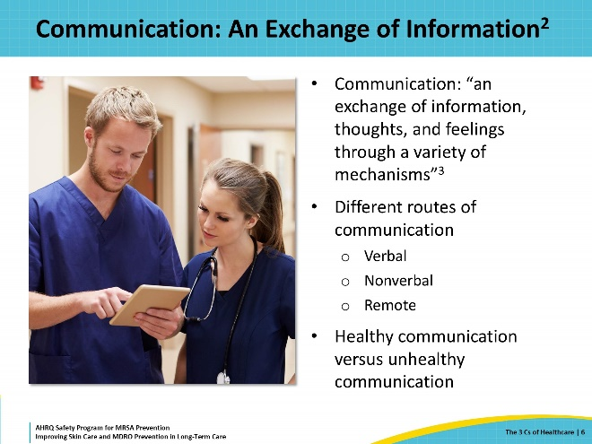
Collaboration: Reaching Toward a Common Goal  SAY:  The second of the 3 Cs of healthcare is collaboration.  According to the American Association of Colleges of Nursing, collaboration can be defined as “efforts between various independent teams or groups” to achieve a goal. In this case, the goal is to achieve safe, quality care for residents, as well as a healthy working environment for the healthcare team.  Collaboration benefits the healthcare team at all levels. It provides increased assistance and resources that may be lacking when tasks are accomplished independently. This increase in resources and assistance often translates to improved and safer quality of care. Collaboration in practice can look like team members helping one another to complete a bed bath for a resident, or an organization working with public health partners to improve the prevention of MDROs in the facility.  Collaboration between healthcare facilities can promote safer transfers and maintain continuity of care across the healthcare spectrum. As an example, infection prevention departments at different facilities can work together to develop common transfer forms. | Slide 7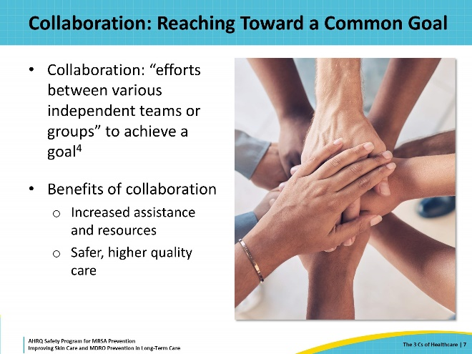
Connection: Bringing It All Together  SAY:  The last of the 3 Cs is connection.  Connection, according to Cambridge Dictionary, can be defined as “the state of being related to someone or something.” Some like to think of connection as the glue that holds everyone all together. For communication and collaboration to be effective, it is necessary to have healthy collegial relationships that go beyond accomplishing tasks together. It is essential to listen to one another and build healthy relationships with the team.  Good relationships across the entire team facilitate improved communication and collaboration in all directions. When seeking to connect with one another, it is important to take the time to listen to, empathize with, and have a better understanding of one another.  This level of connection can be found in a variety of ways—including team-building exercises and personal highlights. These opportunities allow staff to show interest and care regarding who their fellow team members are as individuals, outside of the tasks performed at work. Connection can also exist in remote forms, such as email, text, and social media. An employee feature on a social media page can also be a great way to encourage connection.  The overarching theme of connection is that it can be accomplished in simple, small ways. Individuals can seek to connect with other members of the healthcare team by taking appropriate interest in them as people. One may ask the certified nursing assistant (CNA) assigned to a patient how her son’s soccer game went over the weekend, or one may ask a team member who has been working hard if he could use a break to get some fresh air or a cup of water.  When we take interest in each other as individuals, these interactions will help build healthy relationships within the healthcare team that ultimately lead to better communication and collaboration. These values will lead to fostering a better working environment for the team and a safer, higher quality of care for residents. Keeping the 3 Cs in mind helps achieve these worthy goals. | Slide 8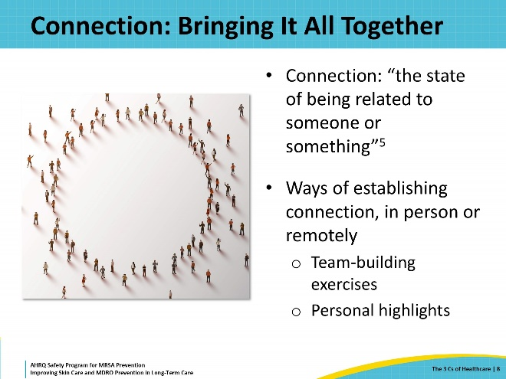
Barriers to the 3 Cs  SAY:  Sometimes, despite the best intentions of modeling these three values in daily work, unavoidable barriers make it challenging to maintain a high level of communication, collaboration, and connection throughout the healthcare team.  It can be challenging to communicate effectively. With everything competing for time and attention, unclear, incomplete, or untimely communication may be the first barrier.  When communication is unclear or incomplete, misunderstandings can arise that lead to further challenges in providing quality care. Unclear or incomplete communication can also lead to errors, such as medication errors. Identifying opportunities for improving communication so that it’s clear, complete, and concise can help to improve healthcare team relationships and ensure the provision of safe, quality care.  Another communication barrier occurs through misunderstandings in culture and language. Language and cultural barriers can make communication difficult. For example, leadership should ensure that education, policies, and other key resources are clearly communicated to staff members in a language they can understand. Staff should also be sensitive and understanding of cultural differences to encourage a welcoming and respectful environment for all team members.  With any training and education, it is important that teams feel supported by receipt of timely educational resources and trainings that improve the safety of the healthcare environment. Staff who feel supported by employers are more likely to be effective communicators and collaborators and feel connected in a healthy way with colleagues.  Staff turnover and ratios of residents to staff can also significantly impact a team’s ability to effectively communicate, collaborate, and connect with one another. Continuing to improve staffing ratios and retention can go a long way to ensuring a cohesive healthcare team. Finally, none of the 3 Cs of healthcare would be possible with a poor organizational culture. An example of poor organizational culture is one that does not value resident safety, job satisfaction, and an environment that encourages the 3 Cs of communication, collaboration, and connection in the healthcare team. | Slide 9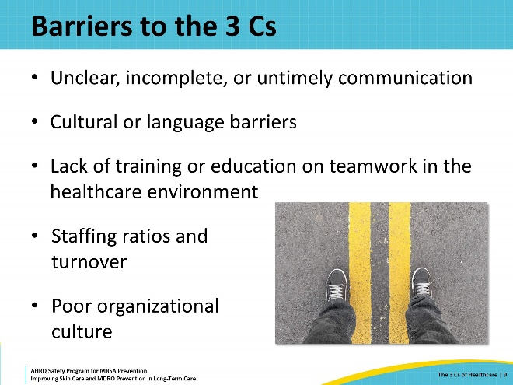
Overcoming Barriers  SAY:  When a healthcare team lacks one or all three of the 3 Cs, leadership should seek to evaluate possible underlying barriers.  Leadership should also look to see whether standards are in place within the organization to encourage healthy communication, connection, and collaboration in the healthcare team.  There is a lot of focus on training healthcare teams on how the jobs should be performed, but there is generally not a lot of time spent discussing how to be more effective in work and more connected with one another. Organizations should spend time educating teams on how to improve communication, collaboration, and connection in the culture of the organization, as this is important for ensuring the safety of the healthcare environment.  Promoting cultural competence and providing language support is important not only in resident and staff relationships but in staff-to-staff relationships. Organizations should also address this in educational programs, building an organizational culture who respects and builds a diverse healthcare team.  Finally, leaders should model healthy communication, collaboration, and connection themselves. Leaders can model this by seeking to help the healthcare teams in day-to-day work, and by quickly identifying and addressing employees who are problematic and could contribute to the development of a toxic healthcare environment. | Slide 10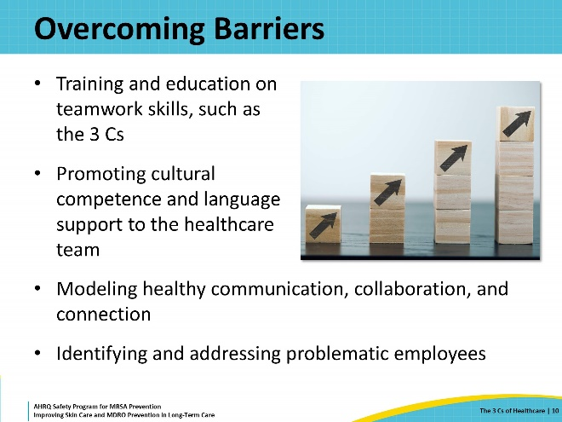
3 Cs Tools and Resources  SAY:  Individuals and team leaders can employ the use of productivity and organizational tools to assist healthcare teams in adopting healthy communication, collaboration, and connection skills.  Tools like checklists and goal worksheets are effective in aligning teams with a single goal and the steps toward accomplishing this goal. Checklists and goal worksheets help ensure that teams are paying attention to important safety guidelines, such as ensuring Foley catheters are removed when they’re no longer needed. Daily huddles and other communication aids can help teams work together toward a common goal and communicate more frequently and effectively, by exchanging important information on a regular basis.  Safety teams are small multidisciplinary groups of individuals who join to help improve the organization's safety. These teams can be on the unit level or for the entire facility, and these teams often focus on finding solutions to improve safety in the facility. A safety team might discuss an increase in infections caused by MDROs at the facility and assist in investigations to determine the cause. This information might provide a catalyst for change, and champion new measures to improve prevention of MDROs including MRSA.  Other tools, such as SharePoint, a shared digital technology, can further improve team collaboration around common goals, by allowing team members to access education and provide feedback electronically. | Slide 11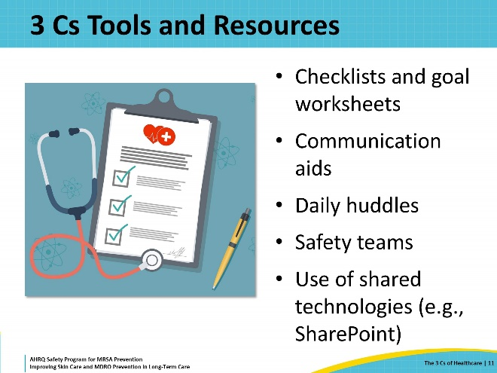
Team Member Shadowing  SAY:  Team member shadowing is an incredibly effective way of improving the 3 Cs in an organization. Often, tensions can disrupt communication between roles in a healthcare facility. Team member shadowing is a way to elicit empathy for each other’s roles by having team members shadow individuals in another role within the facility. This is particularly helpful when encouraging team members to work together toward the care of a resident. A nurse could shadow a member of the environmental services (EVS) team or a member of the EVS team could shadow a CNA. Team shadowing helps to foster the 3 Cs by instilling empathy for one another. It also doubles as a method for identifying barriers and solutions to challenges that arise in the workplace. | Slide 12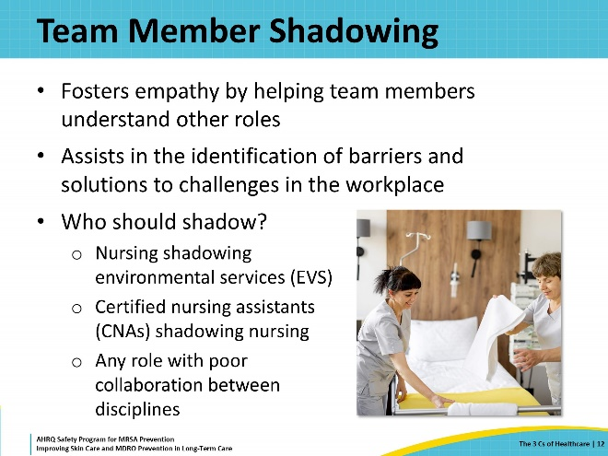
Teachable Moment  SAY:  For the Teachable Moment, this presentation will examine a case. When going through the case, think about the following questions:  - Where are opportunities for each of the 3 Cs?  - How could staff have better communicated, collaborated, or connected to improve resident outcomes? | Slide 13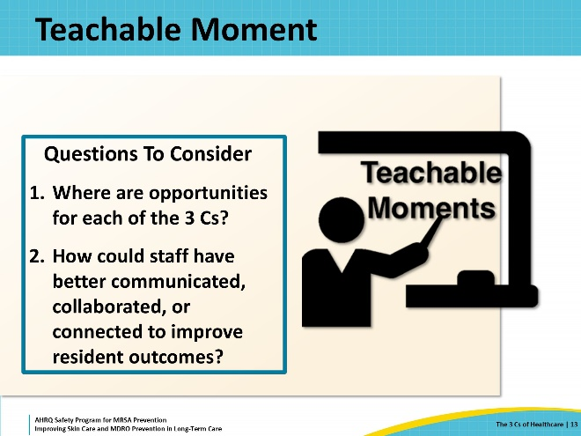
The Case  SAY:  Ms. Daniels is a 65-year-old postoperative patient who was recently admitted to the facility for rehabilitation after surgery. Ms. Daniels was cooking stew for the family when she slipped on a wet spot on the floor, causing her to fall and break her right hip. She’s doing really well after her surgery and is expected to make a full recovery. Her surgeons recommended closure of the surgical wound with a wound vacuum-assisted closure (VAC), for which the wound care team performs routine rounds and dressing changes. | Slide 14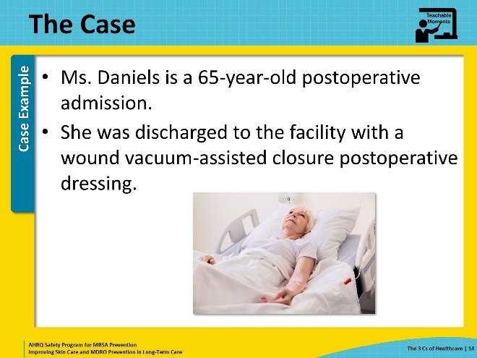
The Challenge  SAY:  This facility has an excellent wound care team. They round every day to check on the wound VAC. They are very thorough with the exams of the residents and careful with wound care. They are responsible for all the dressing changes; there is always someone from the team on call! This facility is really lucky to have a wound care team caring for these residents. Lately, however, the wound care team’s schedule seems to conflict with the EVS schedule for daily cleaning. EVS is getting frustrated that the wound care team is always at the bedside when EVS needs to complete the daily cleaning. | Slide 15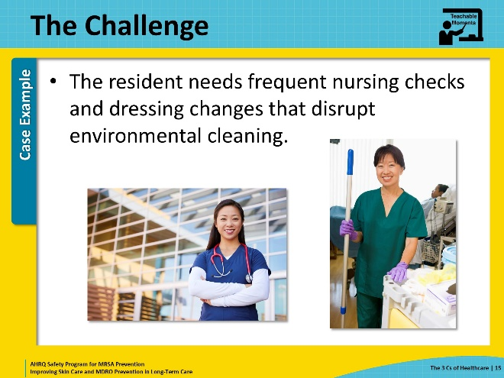
Knowledge Check  SAY:  How might EVS and nursing work together to ensure daily cleaning is taking place as well as proper wound care? | Slide 16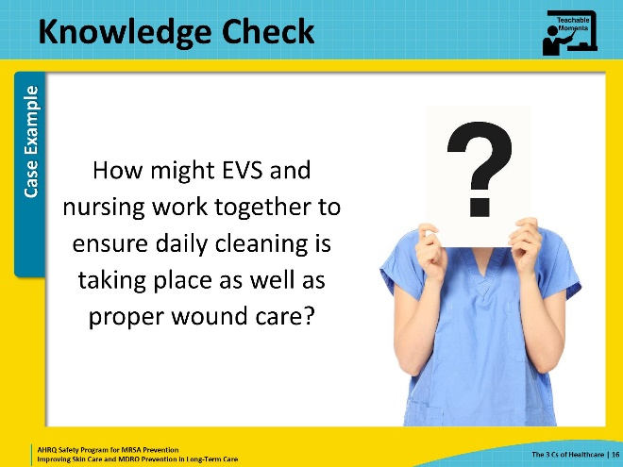
The Error  SAY:  The wound care nurse often acts dismissively and with annoyance toward the EVS staff member, continually telling the EVS staff member to return to the room later. Every time the EVS staff member returns to the room, another member of the nursing team is present and tells them that “now is a bad time.” By the time the EVS staff member is able to return to the room, the workday is finished, and the resident’s family is at the bedside visiting. Frustrated, the EVS staff member skips the daily clean and goes home.  During the day shift, a CNA forgets to wash her hands after caring for a resident with MRSA. While filling water pitchers, she transfers MRSA from her hands to the bedside table. Later, while preparing dressing supplies for Ms. Daniels, one of the wound care nurses unknowingly contaminates the dressing supplies, transferring MRSA to the clean dressing, and subsequently, the resident’s wound. | Slide 17  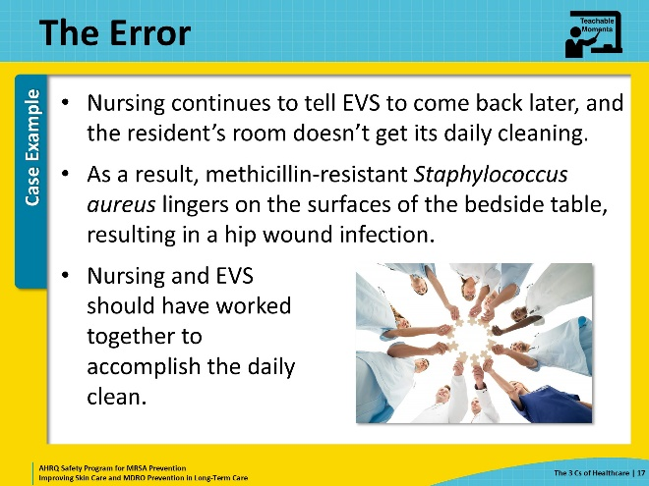
The Consequence  SAY:  Several days later, the wound care team assesses the surgical wound and sees that the healing appears stalled, and the wound appears inflamed, red, and tender to touch. Wound cultures are collected and return with MRSA. The resident develops a fever, and the team notes a new area of undermining along one of the wound edges. The resident requires transfer back to the hospital for a postoperative surgical infection that requires surgical debridement. | Slide 18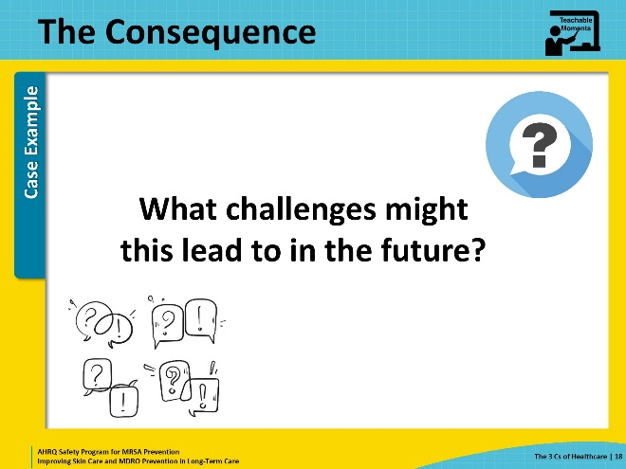
Patient Safety in the Moment  SAY:  Several errors occurred that led to the resident’s MRSA infection. The CNA should have washed her hands after contact with the resident colonized with MRSA. The wound care nurse might have avoided contamination if an aseptic technique to open the wound care supplies was used. If the EVS staff member was able to complete the daily clean, MRSA may not have been present in the environment to contaminate the supplies. So, what could nursing and EVS have done to accomplish both the room cleaning and resident care? Could communication, collaboration, and connection have an impact in this case? What if EVS and nursing collaborated as a part of the same team? What if they had a connection with one another that facilitated that collaboration? What if they felt comfortable communicating with each other and saw the value of each other’s roles in keeping staff and residents safe? | Slide 19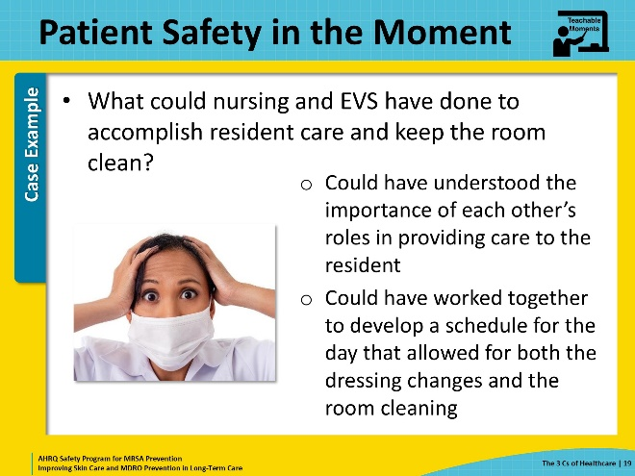
Preventing The Next Harm  SAY:  Behind many of the errors and infection prevention opportunities in healthcare are gaps in communication, collaboration, and connection across the healthcare team. The goal should be to form a team of individuals who collaborate with one another to keep residents safe from harm through clear communication, collaboration, and collegial connections.  To prevent the mistake in this case from occurring again, leadership should include EVS in the healthcare team’s daily huddles, seek to include them in the team, and elevate the importance of cleaning and disinfection in the healthcare environment. Daily cleaning can be prioritized by incorporating it into the overall schedule for the day.  Everyone on the team should receive education on the importance of communication, collaboration, and connection in the healthcare environment. A strong team improves implementation and adherence to important infection prevention measures.  Finally, the use of checklists or daily goal sheets can help keep everyone aligned on goals and what needs to be accomplished in the day. | Slide 20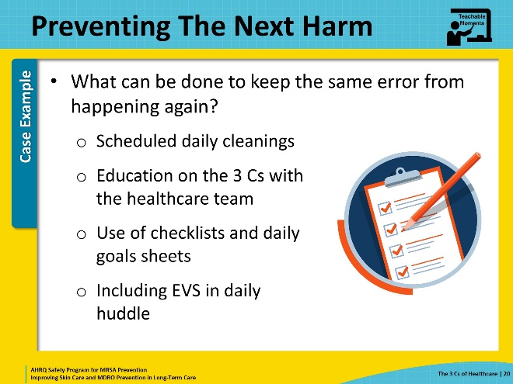
System-Based Safety Changes  SAY:  At the leadership and organizational level, the concept of the 3 Cs can be elevated to create a culture of healthcare personnel who work together toward preventing and controlling the spread of infections. Often, people are just looking to be understood. Helping different roles understand one another can foster a sense of empathy for challenges. In addition to including EVS and nursing in each other's huddles or team meetings, consider scheduling shadow opportunities for team members to experience a different role firsthand.  Administration can also encourage a culture that adopts the 3 Cs with team-strengthening exercises, targeted language in emails and signage, and modeling of healthy communication, collaboration, and connection. | Slide 21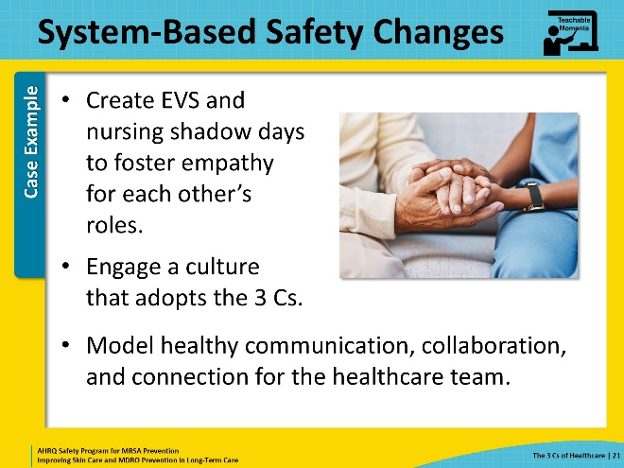
Supporting Materials  SAY:  Some supporting materials to use as a supplement to this presentation include—  - Communication, Collaboration, and Connection in Healthcare Teachable Moment  - The Case of the Inappropriate Communication Between Care Teams  These supporting materials also can be accessed on the toolkit website. | Slide 22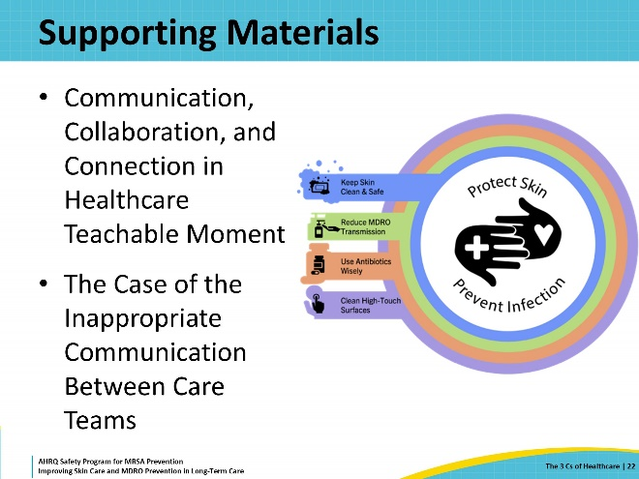
Key Takeaways  SAY:  In conclusion, communication, collaboration, and connection, otherwise known as the 3 Cs, are important concepts for the implementation of safe healthcare practices in nursing homes.  The healthcare environment contains barriers to achieving a healthy combination of the 3 Cs among the healthcare team.  It is important for leadership to encourage a culture that is communicative, collaborative, and connected. | Slide 23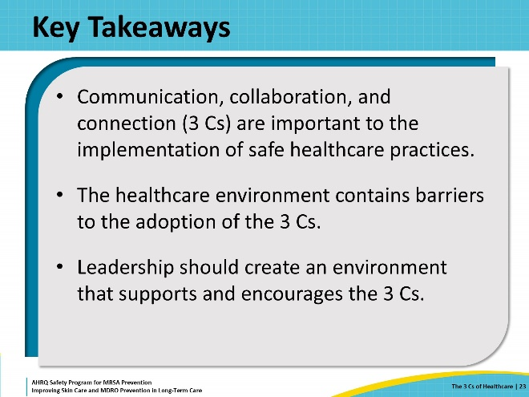
Disclaimer  SAY:  The findings and recommendations in this presentation are those of the authors, who are responsible for its content, and do not necessarily represent the views of AHRQ. No statement in this presentation should be construed as an official position of AHRQ or of the U.S. Department of Health and Human Services.  Any practice described in this presentation must be applied by healthcare practitioners in accordance with professional judgment and standards of care in regard to the unique circumstances that may apply in each situation they encounter. These practices are offered as helpful options for consideration by healthcare practitioners, not as guidelines. | Slide 24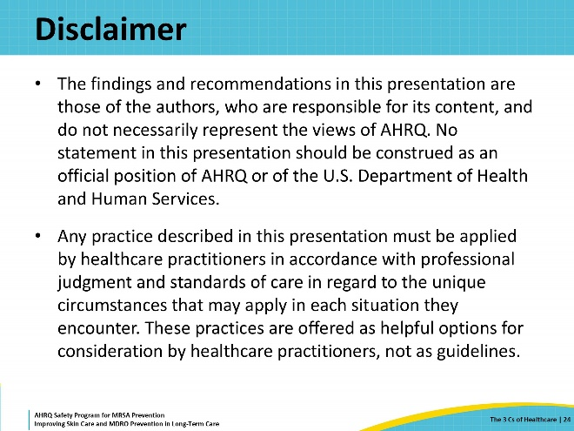
References  SAY:  Please take a moment to review the references. | Slide 25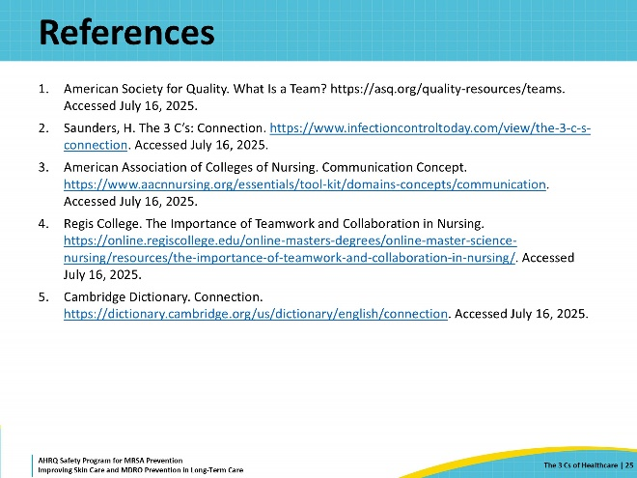
AHRQ Pub No. 25(26)-0066
October 2025

