Cutting Corners and Workarounds
AHRQ Safety Program for MRSA Prevention
This document describes some common ways direct care staff may cut
corners or use a workaround, and examples for how to respond to these choices.
Caring for residents takes a lot of time and energy. Sometimes, direct care staff try to “cut corners” to be more efficient with their time or efforts. Alternatively, to address a problem with workflow, direct care staff may develop a “workaround.” These choices are made with good intentions, and may initially solve an immediate problem; however, workarounds can lead to some big consequences, including harm to residents. Cutting corners and workarounds are also warning signs that there may a gap in education or problems with workflow.
To recognize these indications as warning signs of lapses in care, and to make improvements, the nursing home culture needs to permit open discussion when employees do something that is different from accepted or best practice. There are three steps to consider when responding to cutting corners and workarounds.
- Coach the person to understand the potential harms of their choice.
- Review other contributing factors.
- Change workflow or make other improvements to prevent the need for cutting corners and workarounds.

Example #1

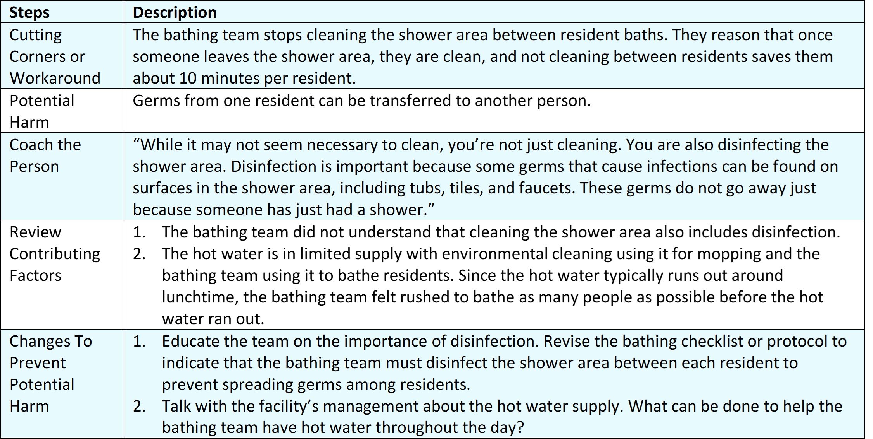

Example #2
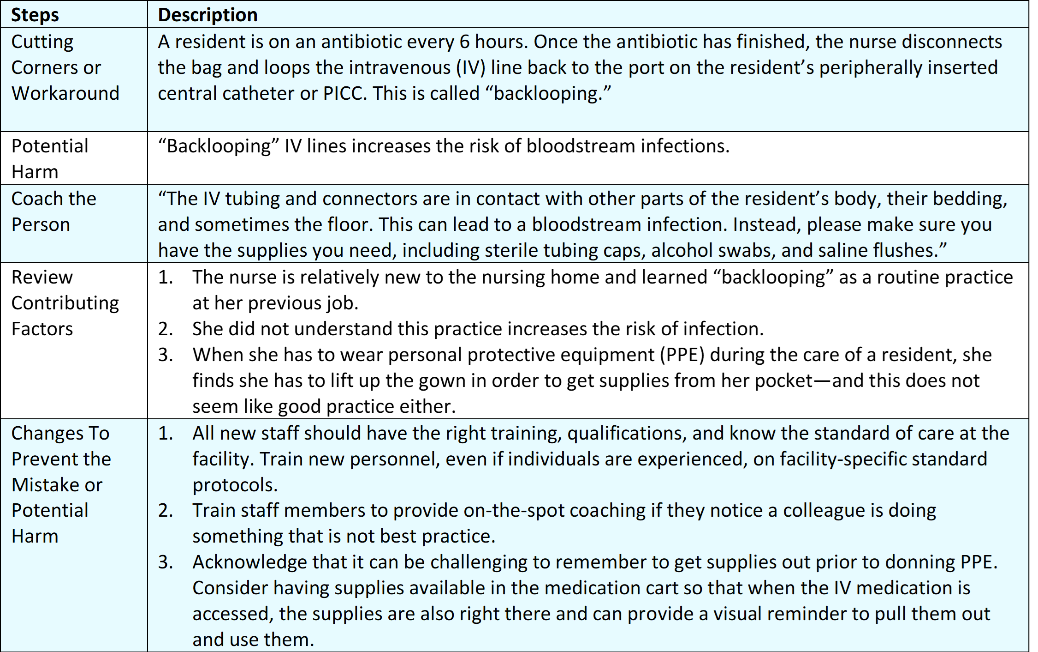

Suggestions for Improving the Safety Culture at Your Nursing Home
Turn the observations and skill assessments into chances to teach and learn how to do things efficiently. It may be the case that someone new to the building brings along some good practices or ideas that can help other people.
Try to have an attitude of curiosity when talking to someone about cutting corners or workarounds. Try to figure out the why of what they were doing. This can help bring to light the problem the staff member was trying to address and bring about better solutions.

Reference
Gaur S, Kumar R, Gillespie SM, et al. Integrating principles of safety culture and just culture into nursing homes: lessons from the pandemic. J Am Med Dir Assoc. 2022 Feb;23(2):241-246. PMID: 34958744.
AHRQ Pub. No. 25(26)-0066
October 2025

