Why We Wear Gloves
AHRQ Safety Program for MRSA Prevention
Why do we wear gloves when providing care for our residents? Use this document to indicate reasons to wear gloves. The first column includes reasons someone may or may not wear gloves. In each row, place a check in the column that matches your response.
Reason | Yes, a Reason To Wear Gloves | No, Not a Reason To Wear Gloves
Because gloves look good
To avoid chipping nails
To prevent germ transmission from a resident’s skin to the hands of direct care staff
To prevent germ transmission from surfaces to hands
To make it easier to keep germs off hands
To prevent transferring germs to other people with your hands
To avoid getting hands dirty when working with bodily fluids
To avoid using alcohol- based hand rub
To avoid having to wash hands with soap and water

Answer Key
Reason | Yes, a Reason To Wear Gloves | No, Not a Reason To Wear Gloves
Because gloves look good |  | X
To avoid chipping nails |  | X
To prevent germ transmission from resident’s skin to the hands of direct care staff | X
To prevent germ transmission from surfaces to hands | X
To make it easier to keep germs off hands | X
To prevent transferring germs to other people with your hands | X
To avoid getting hands dirty when working with bodily fluids | X
To avoid using alcohol- based hand rub |  | X
To avoid having to wash hands with soap and water |  | X
Explanation:
Gloves provide an easily removable layer of protection to help prevent the spread of germs from residents and surfaces to the hands of direct care staff. Gloves also help prevent the spread of germs from the hands of direct care staff to residents and surfaces. So, gloves are worn to protect both direct care staff and residents. Remember: Gloves do not replace hand hygiene!
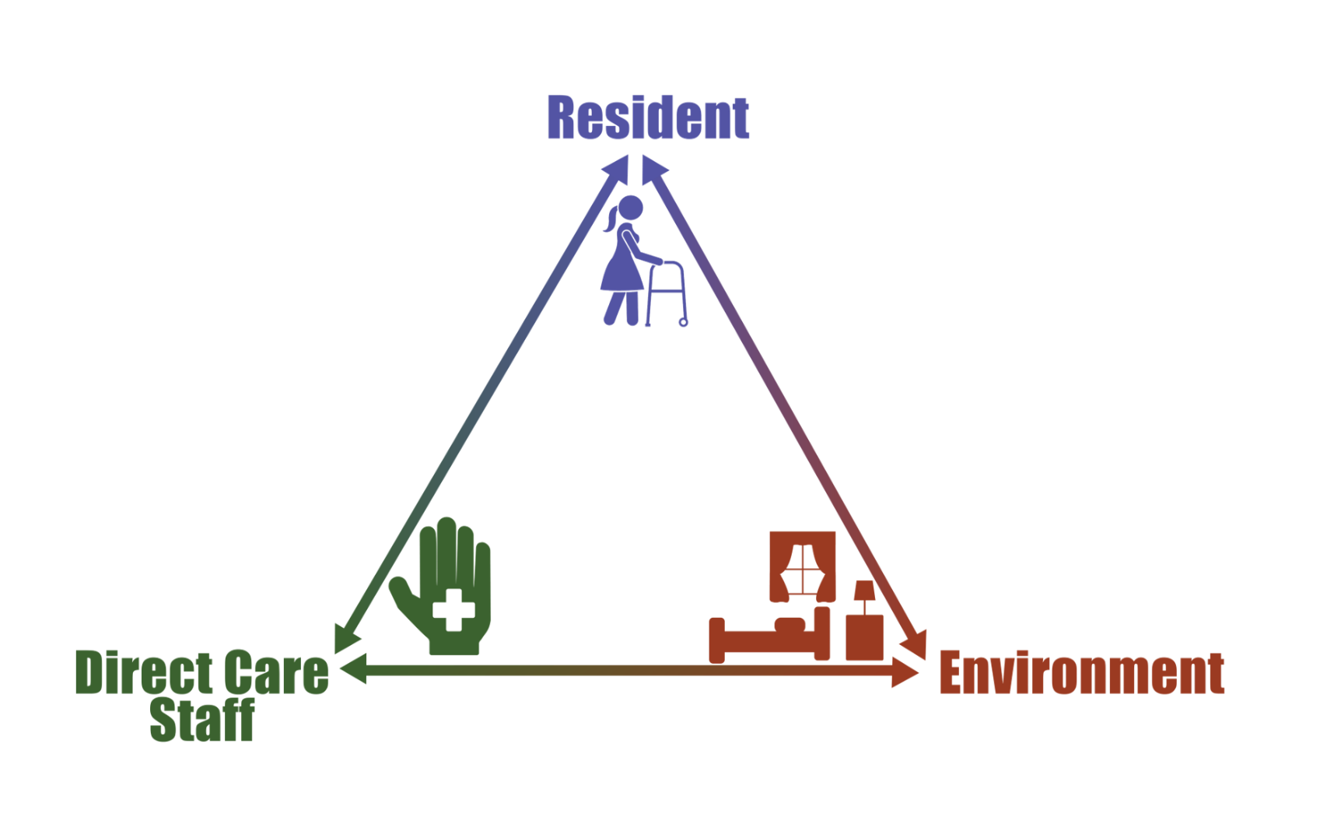
AHRQ Pub. No. 25(26)-0066
October 2025

