Mistakes Happen!
AHRQ Safety Program for MRSA Prevention
Use this document to guide discussion around mistakes in your facility.
Despite the best of intentions, mistakes happen! Sometimes mistakes are minor and can be readily overcome—like dropping something on the floor and having to discard it. Other mistakes may seem minor but can have big consequences—like forgetting to let the nurse know that a resident has diarrhea. Mistakes that lead to potential or actual harm are also opportunities to learn and to do better the next time. To learn from mistakes, and to make improvements, the nursing home culture needs to permit open discussion of mistakes.

Three Steps To Consider When Responding to a Mistake
- Accept that everyone makes mistakes.
- Review other contributing factors that may be driving these mistakes.
- Change workflow or make other improvements to prevent this mistake from happening again.
Example #1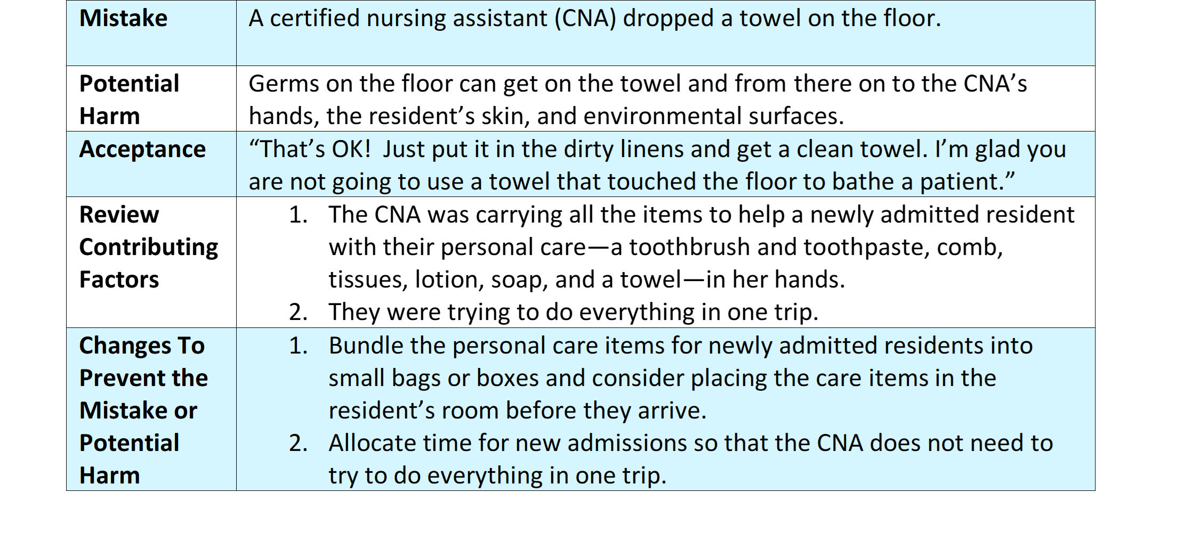

Example #2
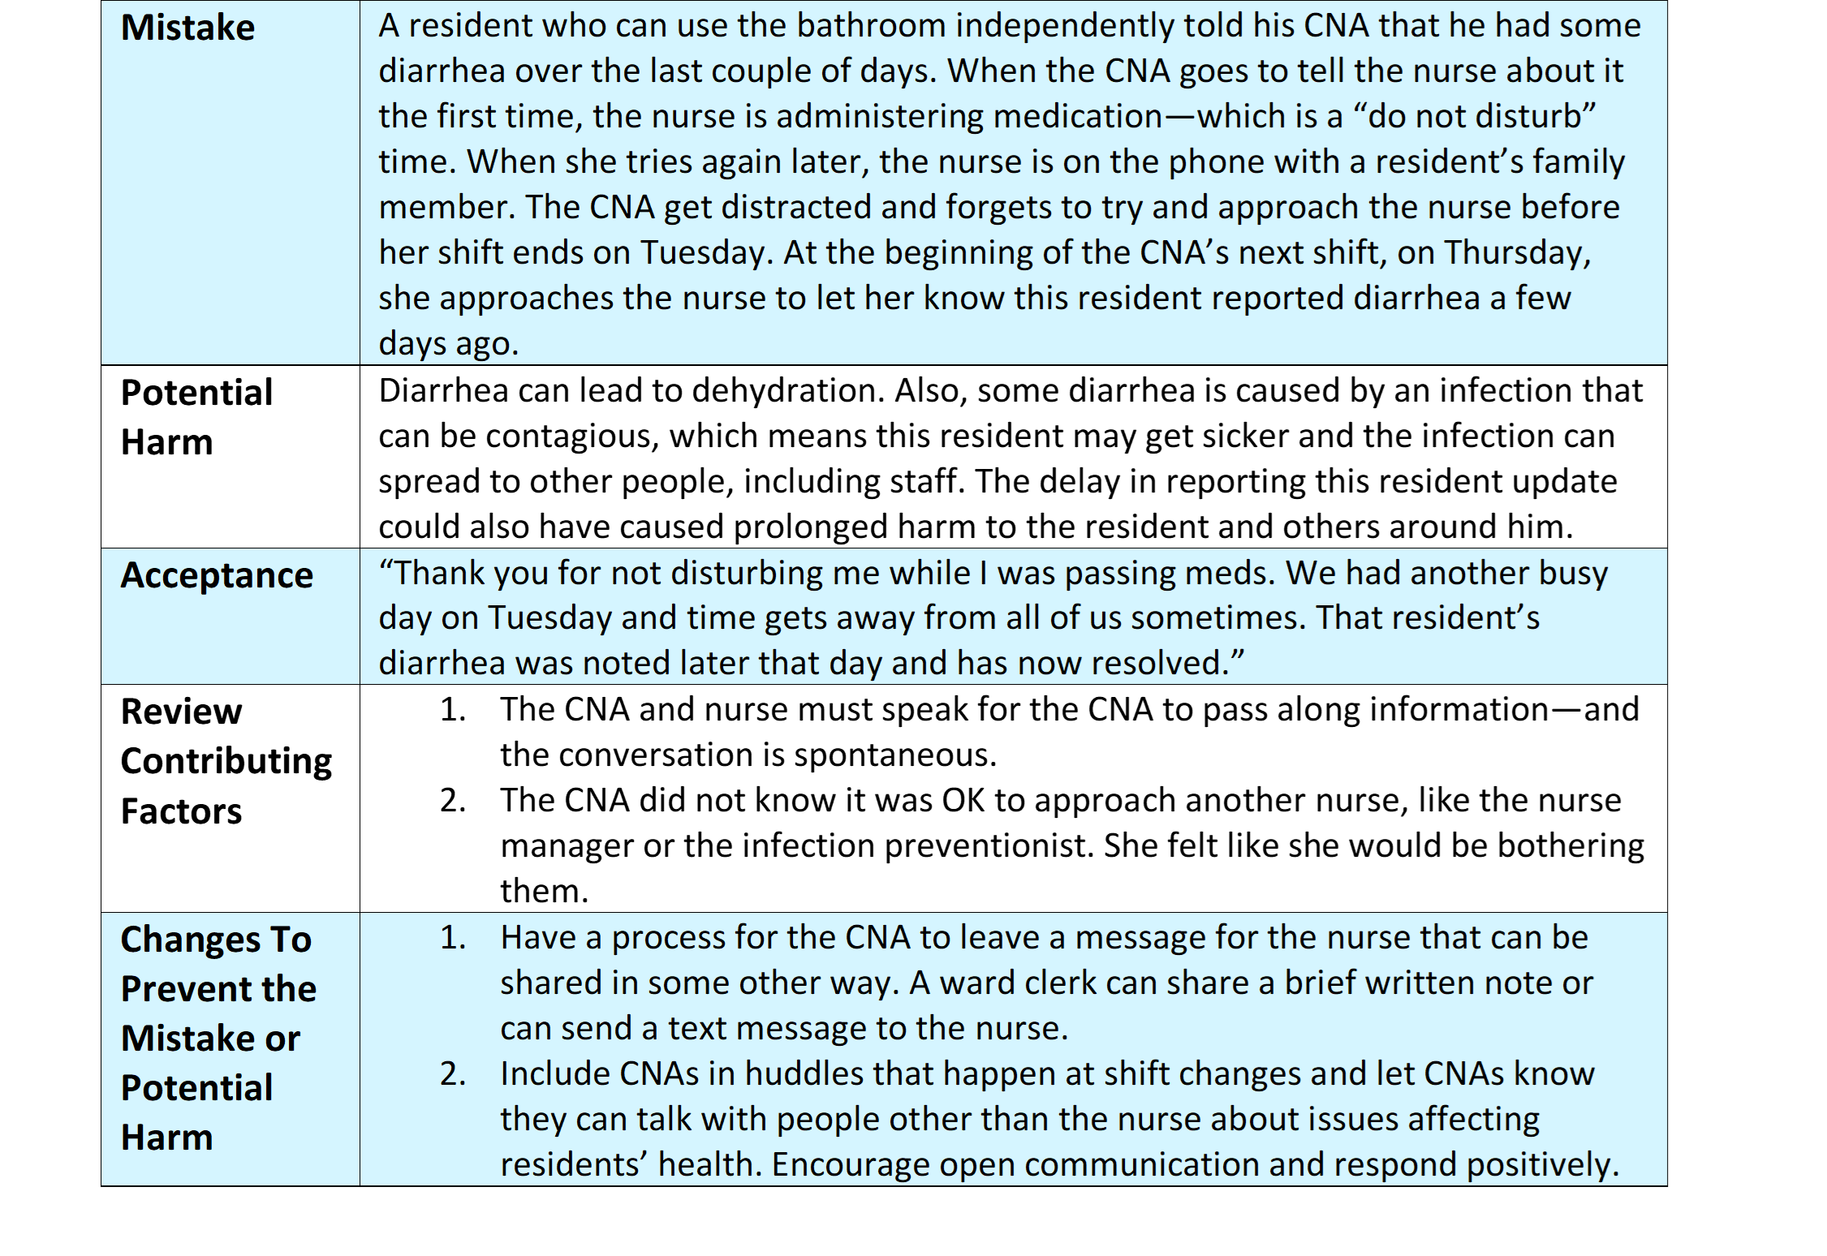

Suggestions for Improving the Safety Culture at Your Nursing Home
Have someone in a leadership position talk about a recent mistake they made at work. Consider making this a routine part of large staff meetings. Here is a simple outline:
- What happened?
- What were the contributing factors?
- What has changed to make this less likely to happen?
Reward someone for asking for help after an error. In a positive way, discuss the mistake with staff members and acknowledge that it took courage for the individual to come forward and ask for help. Stress that this was a resident safety issue. Walk through the same outline as above.

Reference
Gaur S, Kumar R, Gillespie SM, et al. Integrating principles of safety culture and just culture into nursing homes: lessons from the pandemic. J Am Med Dir Assoc. 2022 Feb;23(2):241-246. PMID: 34958744.
AHRQ Pub. No. 25(26)-0066
October 2025

