Implementation Guide
AHRQ Safety Program for MRSA Prevention

Executive Summary
This implementation guide provides a structured, phased approach to improving infection prevention and skin care practices in long-term care facilities. It is a part of the AHRQ Safety Program for MRSA Prevention: Improving Skin Care and MDRO Prevention in Long-Term Care Toolkit. The toolkit is designed for Infection preventionists, directors of nursing, and facility leadership, as well as any staff involved in the care of long-term care residents. It includes actionable strategies, team training resources, data tracking tools, and communication supports to foster a culture of safety and quality. This implementation guide contains an overview of the toolkit content and is intended to help direct care providers share the content in a way that facilitates uptake by its target audiences.

Introduction
Developing a program to improve skincare and prevent multidrug-resistant organism (MDRO) transmission is a process that takes time, planning, and team engagement. Whether you’re launching a new initiative or strengthening an existing one, the AHRQ Safety Program for MRSA Prevention: Improving Skincare and MDRO Prevention in Long-Term Care Toolkit emphasizes tangible actions that long-term care staff can take to minimize pathogen transmission between direct care staff, residents, and the environment. Designed to be implemented over several months, the toolkit includes evidence-based resources that can be tailored to your facility’s unique needs. Implementation of the toolkit can reduce the risk of skin breakdown and prevent transmission of MDROs—protecting residents and supporting staff in delivering safe, high-quality care. Below, we will outline three steps to implement the toolkit effectively: Prepare for Implementation, Engage Four Key Strategies to Protect Skin and Prevent Infection, and Develop a Culture of Safety and Learn Best Practices Around Improving Skincare and Preventing Infection.

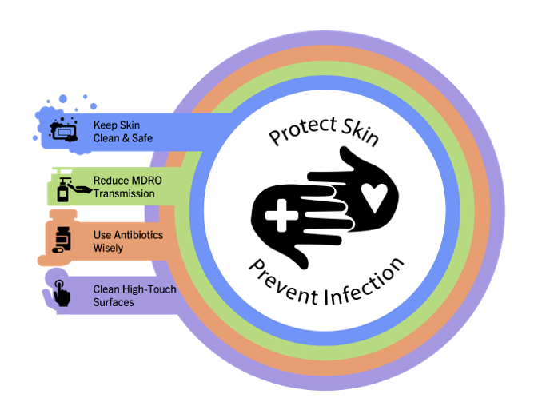
Toolkit Structure and Types of Tools
The Improving Skincare and MDRO Prevention in Long-Term Care toolkit includes four key strategies that support the central theme of “Protect Skin, Prevent Infection.” The graphic to the right illustrates the connection between the strategies and the theme. The website is organized by topic-specific modules that fit into each of the four strategies plus modules that cover teamwork and sustainability. Three general categories of tools are included:

- Presentations are resources that can be used in training sessions. The PowerPoint files are slides alone and the corresponding facilitator guides are Word documents that contain pictures of the slides with accompanying script. The presentations are case based and emphasize topics such as the importance of skincare, appropriate bathing practices, and ways to reduce the risk of pressure injuries and wounds. Most of the presentations are organized around a consistent structure, first framing the topic within the Triangle of Transmission, which is a simple model to show how pathogens are spread and transferred between staff, residents, and the environment, then discussion of the topic in greater depth, followed by a real-world scenario that addresses the topic and potential strategies to avoid the error from happening again, including system-based changes that can improve resident safety. These presentations are intended for all staff in the long-term care setting, though certain topics may be more applicable to specific roles.
- Teachable Moments are focused learning tools intended to engage direct care staff in infection prevention and quality care improvement in long-term care. They allow for nurse educators and/or infection preventionists to disseminate high yield topics in bite-sized (5-minute) didactics to direct care staff (CNAs, RNs/LPNs, EVS staff) during daily huddles or meetings. They are accompanied by a log-in sheet that can be shared with surveyors to document active training and engagement by the infection prevention team. These materials complement the presentations and provide an opportunity to promote evidence-based, good quality care.
- Supporting Materials include an array of documents, such as a resident bathing preference menu, a skin assessment tool, and a hand hygiene observation tool.
Users may access the above materials via the toolkit website. The website pages are organized by topic-specific modules, which include the presentations, and the related Teachable Moments and Supporting Materials. The Teachable Moments and Supporting Materials can also be accessed separately on the website.

Toolkit Implementation
The following materials are intended to guide and support program implementation.

Step 1: Prepare for Implementation
- The Gap Analysis for Infection Prevention is a tool to assess gaps and weaknesses relevant to infection prevention and control in your nursing home. It can help determine areas of your skincare and infection prevention program that may benefit from improvement. If significant gaps are identified—particularly those that might lead to noncompliance with Centers for Medicare & Medicaid Services (CMS) requirements—bring your findings to administrative leadership to manage the deficiencies. This may lead to the development of a management plan, including resource requests for additional clinical staff or data support.
- The Commitment Poster is used to display your facility’s commitment to preventing healthcare-associated infections. There is space to add the facility’s logo as well as signatures from staff and leadership. Displaying the signed Commitment Poster in public spaces indicates to your staff, residents, and their friends and family that your facility is dedicated to improving skin care and preventing infection.
- The Team Checkup Tool is a brief assessment to track month-by-month progress.
- Printable Stickers are intended show staff commitment to infection prevention and improving skincare. These can be worn on badges or placed in high-visibility areas. They can be printed in color or in black and white.

Step 2: Engage the Four Key Strategies To Protect Skin and Prevent Infection
Next, familiarize yourself with the Four Key Strategies to Protect Skin and Prevent Infection. Consider reviewing the presentations and providing the material to the staff at your facility. Regardless of whether your facility already has a strong infection prevention program, introducing these strategies can reinforce consistent practices and help engage residents, family members, and the entire care team in the shared responsibility of prevention.
Each strategy is accompanied by topic-specific modules:
  - Within Keep Skin Clean and Safe, you will find the following modules:
    - Skin Assessment and Resident Bathing/Caring for Aging Skin
    - Preventing Pressure Injury
    - Preventing Surgical Site Infection (SSI) in Long-Term Care
  - Within Reduce MDRO Transmission, you will find the following modules:
    - Enhanced Barrier Precautions (EBP)
    - Hand Hygiene
    - Enteric Pathogens
    - Central line associated bloodstream infection
    - Preventing Urinary Tract Infections
  - Within Use Antibiotics Wisely, you will find the following modules:
    - Antibiotic Stewardship
  - Within Clean High-Touch Surfaces, you will find the following modules:
    - Environmental Cleaning
Then, integrate the Four Key Strategies into regular practice:
- Use presentations, Teachable Moments, and supporting materials to help integrate the core ideas related to Protect Skin, Prevent Infection into the institutional culture.
- Develop local guidelines or best practices using pertinent resources from the toolkit and incorporate the Four Key Strategies graphic in your content to convey the message visually and more effectively. These might include protocols to assess skin during bathing, guidance for wound care, indications for ordering diagnostic tests, and criteria for initiating empiric antibiotic therapy as well as for modifying or discontinuing antibiotics.
- Individuals and team leaders can use productivity and organizational tools to help address gaps and weaknesses identify by the Gap Analysis.

Step 3: Develop a Culture of Safety and Learn Best Practices Around Improving Skincare and Preventing Infection
As you put the foundational elements of your improving skincare and MDRO prevention program in place, it is also important to support a culture of safety at your nursing home. This is critical for the success of any prevention program. The real-world scenarios provided in the presentations can be used as examples to help staff identify opportunities to prevent pathogen transmission and infection. The presentations focus on strategies and interventions to promote a culture of safety and provide best practices to improve skincare and prevent infection.
Personnel involved in leadership and infection prevention may consider reviewing the following two modules that focus on safety culture:
- The 3 Cs of Healthcare: Working Together To Prevent Infection provides strategies for strengthening team connections, improving communication, and working in collaboration across roles. The accompanying case example involves dynamics from EVS, direct care staff, and the resident.
  - The teachable moment associated with Communication, Collaboration, and Connection in Healthcare is a three-part document. This document provides leaders with a guide for implementing the 3 Cs, a survey on organizational culture, and sample interventions for improving the 3 Cs.
- Implementation and Sustainability reviews foundational principles of skin care and infection prevention as well as the AHRQ Safety Program for MRSA Prevention: Improving Skincare and MDRO Prevention in Long-Term Care. The presentation also describes metrics and data points that can be used to track progress and sustain efforts.
Sharing the modules as well as the accompanying teachable moments and supporting materials with direct care staff may help improve individual choices and the overall institutional culture to enhance skin care practices and to prevent infections.

Conclusion
The Toolkit for Improving Skin Care and MDRO Prevention in Long-Term Care includes evidence-based, action-focused resources to help facilities reduce pressure ulcers and infections among its residents. Nursing leadership and facility educators can review tools and disseminate the material to direct care staff. Daily huddles and trainings can be conducted to emphasis key concepts and build team cohesion on a regular basis. The teachable moments tools in particular can be helpful to support teaching when limited time is available. Participation in training can be tracked to monitor engagement in infection prevention activities. All personnel, including senior executives, administrators, medical staff, infection preventionists, nursing leadership, and direct care staff, can work together to identify specific gaps at the facility and consider how this toolkit can be applied to develop, implement, and maintain best practices to improve skin care, augment infection prevention, and enhance quality of life for residents.

