Concise Antibiogram Toolkit

How to Enter Data Manually Into an Antibiogram Template

Once you’ve printed your results from WHONET, you’re ready to enter the percent (%) susceptibilities into the antibiogram template.

First, find the needed data on the WHONET printout. Note the “Number of patients” column (see red arrow in Figure 1 below). This column contains the number of patients who had cultures from which each organism was isolated at least once. The percent (%) susceptibilities for each organism are based on susceptibility results from the number of isolates noted in the “Number of patients” column. Some of these numbers may be quite low, which could give unreliable percent (%) susceptibilities. For example, in Figure 1 you can see there is a “2” in the “Number of patients” column next to “Enterobacter cloacae” (see blue arrow). This means the percent (%) susceptibilities for E. cloacae are only based on two isolates and, as you can see, will all be 0 percent, 50 percent, or 100 percent. These numbers are clearly not very helpful, as even one more isolate with a different susceptibility pattern could change the percent (%) susceptibilities significantly.

Use the following standards while making your antibiogram:
- Include an organism in your antibiogram if it has been isolated from thirty or more residents. You may use additional months or years of data to reach that number.
The CLSI standard for the minimum number of diagnostic isolates to include in an antibiogram is 30. Note that this standard may change from time to time. If you are creating your own antibiogram, you should review the standard periodically to see if there have been changes. The threshold of 30 isolates per year will be difficult for many nursing homes to reach and the CLSI indicates that it is permissible to include additional months or years of data to achieve this number. The antibiogram should always clearly indicate when this has been done.

- Because of the difficulty nursing homes may have in reaching 30 isolates even when using multiple years of data, we recommend that you include an organism in your antibiogram if it has been isolated from at least 20 patients and clearly indicate this in the antibiogram.
This lower number of isolates should be interpreted with caution. Percent (%) susceptibilities based on 20 isolates should still give a general idea of how effective various antibiotics are against those organisms, but organisms with more isolates will likely produce more accurate results in which the prescriber can have greater confidence.
Additionally, a higher number of isolates implies that that organism is infecting more people in your facility. For this reason, it is critical to indicate the time period covered when additional years of data are needed to reach 20 isolates.
If you decide to include organisms for which a minimum of 20 isolates are not available, this should be prominently and clearly indicated on the antibiogram by, for example, highlighting those rows or by placing these organisms together in a separate section. You should also include a note on the antibiogram advising caution in using these less reliable results.
Title: Figure 1. Top section of the WHONET percent (%) susceptibilities printout.
Headings: Number of patients, Organism
Description: This figure shows the top section of the WHONET percent (%) susceptibilities printout. The red arrow points out the “number of patients” column which contains the number of patients who had cultures from which each organism was isolated at least once. The percent (%) susceptibilities for each organism are based on susceptibility results from the number of isolates noted in the “number of patients” column, as indicated by the blue arrow. It is recommended that only organisms with at least four isolates be included in the antibiogram.
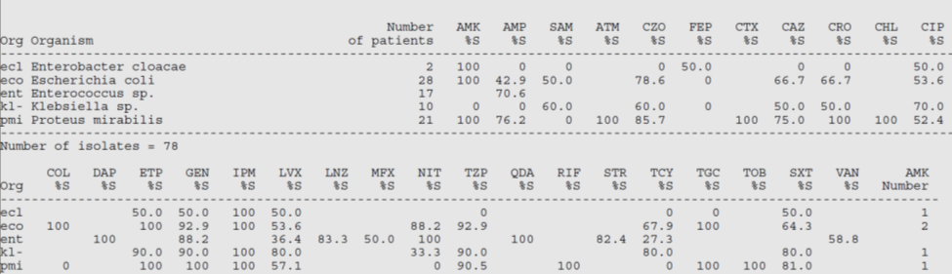

- Only include percent (%) susceptibilities for antibiotics where at least 70 percent of the isolates were tested against that antibiotic:
If you look toward the bottom of your printout, you will see that after the percent (%) susceptibilities, numbers are listed for each organism under each antibiotic (e.g., “AMP Number,” “SAM Number,” etc.; see Figure 2). These numbers indicate the number of isolates of each organism that were tested against a given antibiotic. For a given organism, this could be any number from 0 (blank) up to the total number of isolates included (listed in the “Number of patients” column). Different isolates of an organism are not always tested for susceptibilities to the exact same antibiotics. For example, in Figure 1 above you can see a “28” next to Escherichia coli in the “Number of patients” column, indicating that this nursing home had 28 first isolates of E. coli contributing susceptibility data to their antibiogram. However, you can see in Figure 2 below that there is a “27” under the “IPM Number” column next to E. coli (abbreviated “eco;” see red arrow). This indicates that only 27 of the E. coli isolates were tested against imipenem.

Title: Figure 2. Lower section of the WHONET percent (%) susceptibilities printout.
Headings: Org, CAZ Number, IPM Number
Description: This figure shows the lower section of the WHONET percent (%) susceptibilities printout. The red and blue arrows in the figure note the number of isolates of each organism that were tested against a given antibiotic. For example, there is a “27” under the “IPM Number” column next to E. coli (abbreviated “eco;” see red arrow). This indicates that only 27 of the E. coli isolates were tested against imipenem.
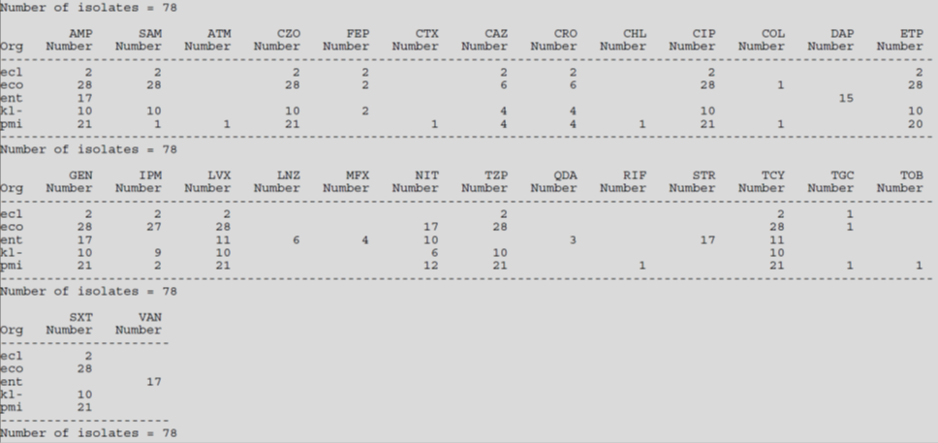
Similar to how a low number of overall isolates may lead to unreliable or misleading data, a low number of an organism’s isolates tested against a given antibiotic may lead to an inaccurate interpretation of susceptibility patterns. For example, while 27 out of 28 E. coli isolates tested against imipenem likely gives a fairly accurate idea of the overall percent (%) susceptibility of E. coli to imipenem in a facility, imagine if only six of the isolates were tested against an antibiotic. This would make it much harder to gauge E. coli’s actual overall percent (%) susceptibility to imipenem. Although you can see in Figure 1 that 66.7 percent (or 4/6) of the E. coli isolates tested were susceptible to ceftazidime, imagine all 22 of those not tested happened to be resistant. In this case, the apparent susceptibility of 66.7 percent would in reality be much lower (only 14.3%). Because of this uncertainty, we recommend you only include percent (%) susceptibilities for antibiotics where at least 70 percent of the isolates were tested against that antibiotic. So, in the example, percent (%) susceptibilities for antibiotics which about 20 or more E. coli isolates were tested against should be included in the antibiogram.
Taking these two critical points into account, you can begin to enter the percent (%) susceptibilities from your WHONET printout into the cells of the antibiogram template. For each percent (%) susceptibility which you are going to include, find the cell in the template which corresponds to that organism and antibiotic and enter the value. A key for the antibiotic abbreviations is listed at the bottom of the printout (see Figure 3). Color any empty cells grey to make the antibiogram easier to read. Also, fill in the “Number of patients” column for each organism based on the numbers from the corresponding column on the WHONET printout. Add notes to indicate variations in time period covered by the analysis and warnings about insufficient numbers of isolates as needed.
Title: Figure 3. WHONET Percent (%) Susceptibilities Printout
Headings: Organism, Number of patients
Description: This figure illustrates an example of the full printout of percent (%) susceptibilities using the WHONET software.


