Slide Title and Commentary | Slide Number and Slide
Title Slide  Toolkit 3. How To Develop and Implement an Antibiogram Program  Phase 3. Implementation  Training Slides for Prescribing Clinicians  [PRINT OUT COPIES OF THE VIGNETTES AND ANTIBIOGRAMS FOR ALL PARTICIPANTS. PASS OUT THE VIGNETTES EARLY, THEN PROVIDE THE ANTIBIOGRAM WHEN FIRST DISCUSSING THE ANTIBIOGRAM, BUT NOT BEFORE.]  SAY:  [INTRODUCTIONS: TRAINER’S NAME; IF SMALL GROUP, CONDUCT INTRODUCTIONS FOR ALL.]  The purpose of today’s training is to discuss using an antibiogram to decide which antibiotics to use for residents in a nursing home. | Slide 1  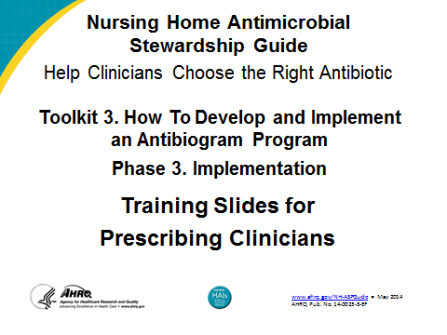

Slide Title and Commentary | Slide Number and Slide
Ms. Lee  SAY:  First, I would like to get your thoughts on how to treat Ms. Lee.  [PASS OUT VIGNETTES TO ATTENDEES.]  How would you treat Ms. Lee? On what basis?  Ms. Lee is a 71-year-old woman who is a long-term resident of your facility, with dementia and no recent hospitalizations. She complains to a nurse of dysuria, urinary frequency, and urinary urgency since 8 p.m. last night. You assess the patient and find that her vital signs are HR 88, RR 16, BP 136/84, T 100.2 F, SpO₂ 98%. A urine dip shows 2+ leukocytes and 2+ nitrites. The patient generally appears well and has some mild suprapubic tenderness.  - In addition to ordering a urine culture, which of the following procedures would you follow?  - Wait for the urine culture results.  - Have the patient transferred to the emergency department for evaluation.  - Prescribe an oral antibiotic.  - Prescribe an IV antibiotic. | Slide 2  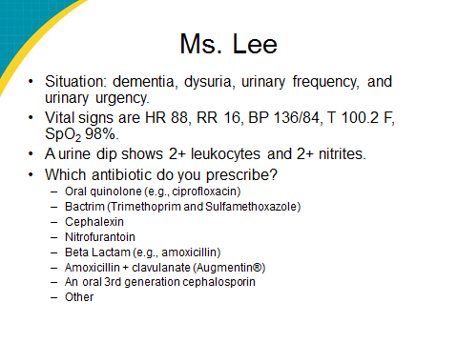
Ms. Lee (continued)  ASK:  - Which of the following do you think is/are the most appropriate antibiotic(s) for the above-described symptoms?  SAY:  - Oral quinolone (e.g., ciprofloxacin)  - Bactrim (trimethoprim (TMP) and sulfamethoxazole (SMX))  - Cephalexin  - Nitrofurantoin  - Beta lactam (e.g., amoxicillin)  - Amoxicillin + clavulanate (Augmentin®)  - An oral 3rd-generation cephalosporin  - Other | Slide 2
Mr. Jones  SAY:  Now I would like to do the same thing for Mr. Jones. How would you treat Mr. Jones? What is your rationale for that?  Mr. Jones is a 76-year-old man who is a long-term resident of your facility, with dementia and no recent hospitalizations. His other medical problems include hypertension and osteoarthritis. You are called by a nurse as Mr. Jones has been coughing for 3 days and today developed a fever. He has a hacking cough, is bringing up yellow/green sputum, and his vital signs are T 100.5 F, HR 88, RR 16, BP 136/84, SpO₂ 95%.  - In addition to ordering a chest x-ray, which of the following procedures would you follow?  - Wait for the chest x-ray results.  - Have the patient transferred to the emergency department for evaluation.  - Prescribe an oral antibiotic.  - Prescribe an IV antibiotic.  - Which of the following do you think is/are the most appropriate antibiotic(s) for the above-described symptoms?  - 3rd- or 4th-generation quinolone (e.g., levofloxacin)  - Macrolide (e.g., azithromycin)  - Beta lactam (e.g., amoxicillin)  - Amoxicillin + clavulanate (Augmentin®)  - Bactrim (TMP and SMX)  - Doxycycline  - 3rd-generation cephalosporin (e.g., cefpodoxime)  - Other [FREE TEXT] | Slide 3  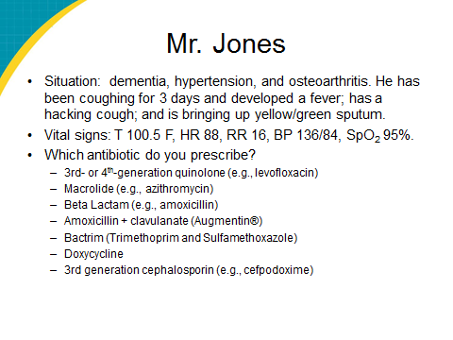
Objectives  SAY:  We are conducting today’s training with the objectives of using an antibiogram to make initial decisions for antibiotics and to follow the effect of the antibiogram on nursing home prescribing. | Slide 4  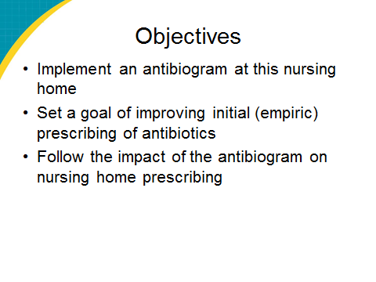
Background: Antibiotic Prescribing  SAY:  Antibiotics are the most frequent medications prescribed, and in some cases they are overprescribed. Antibiotic use can lead to side effects, multidrug resistance, and healthcare-associated infections, such as Clostridium difficile.  Decisions are made by factors such as symptoms, previous history, nursing home factors, and preference and knowledge of antibiotics. Typically, a clinician does not have cultures or test results to identify a specific medication to prescribe. | Slide 5  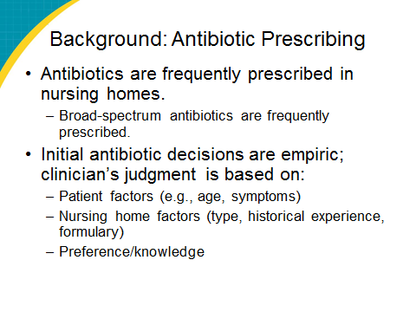
Background: Antibiograms  SAY:  What is an antibiogram? Essentially, it is a one-page document that lists the sensitivity data related to various bacteria strains for a given nursing home. | Slide 6  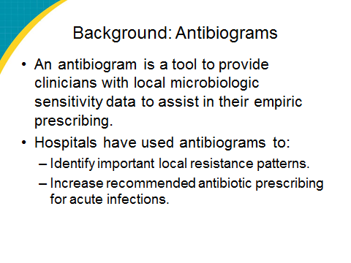
Sample Antibiogram  [PASS OUT COPIES OF THE ANTIBIOGRAM.]  SAY:  Here is a copy of this nursing home’s antibiogram. What does it mean? | Slide 7  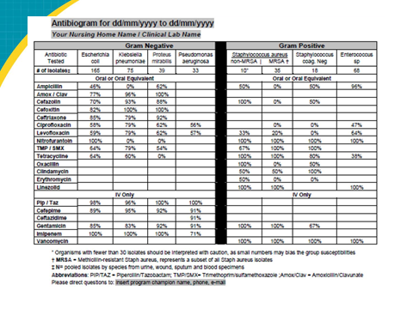
Key Findings From Antibiogram  [EDIT SLIDE TO REFLECT ANTIBIOGRAM DATA.]  SAY:  As you can see, of the cultures used to make the antibiograms, the most common were urine/wound/sputum. Antibiograms are most applicable when selecting antibiotics to treat urinary tract infections (UTIs) or systemic infections resulting from a urine infection. The most common positive urine cultures were…. | Slide 8  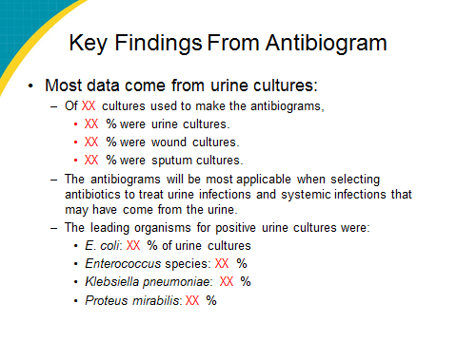
Key Findings From Antibiogram  SAY:  You will also notice from the antibiogram that not all antibiotics are tested—usually just one from each class. The reason is that antibiotics from the same class are likely to have similar resistance patterns. | Slide 9  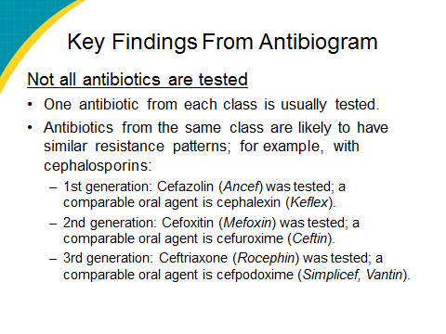
Key Findings From Antibiogram  SAY:  Based on this antibiogram, [explain findings, enter in data that are red]. | Slide 10
Key Findings From Antibiogram  SAY:  Based on this antibiogram, [explain findings, enter in data that are red]. | Slide 11  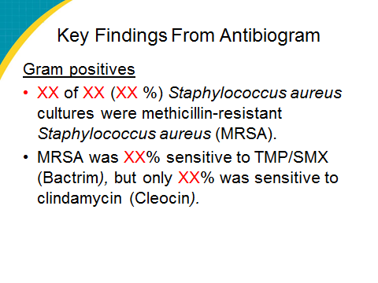
Ms. Lee  [DISCUSSION CAN GO BACK TO MS. LEE AND MR. JONES OR GO TO THE OTHER TWO VIGNETTES OF MS. WILLIAMS AND MR. JACKSON.]  ASK:  So, going back to Ms. Lee, would you change anything? [Review the following as necessary.]  SAY:  Ms. Lee, a 71-year-old woman, is a long-term resident of your facility, with dementia and no recent hospitalizations. She complains to a nurse of dysuria, urinary frequency, and urinary urgency since 8 p.m. last night. You assess the patient and find that her vital signs are HR 88, RR 16, BP 136/84, T 100.2 F, SpO₂ 98%. A urine dip shows 2+ leukocytes and 2+ nitrites. The patient generally appears well and has some mild suprapubic tenderness.  - In addition to ordering a urine culture, which of the following procedures would you follow?  - Wait for the urine culture results.  - Have the patient transferred to the emergency department for evaluation.  - Prescribe an oral antibiotic.  - Prescribe an IV antibiotic. | Slide 12  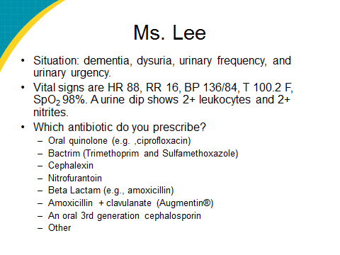
Ms. Lee (continued)  ASK:  - Which of the following do you think is/are the most appropriate antibiotic(s) for the above-described symptoms?  SAY:  - Oral quinolone (e.g., ciprofloxacin)  - Bactrim (TMP and SMX)  - Cephalexin  - Nitrofurantoin  - Beta lactam (e.g., amoxicillin)  - Amoxicillin + clavulanate (Augmentin®)  - An oral 3rd-generation cephalosporin  - Other | Slide 12
Mr. Jones  ASK:  What about Mr. Jones? Would you change anything for Mr. Jones? [Review the following as necessary.]  SAY:  Mr. Jones, a 76-year-old man, is a long-term resident of your facility. He has dementia and no recent hospitalizations. His other medical problems include hypertension and osteoarthritis. You are called by a nurse, as Mr. Jones has had a hacking cough for 3 days, today developed a fever, and is bringing up yellow/green sputum and his vital signs are T 100.5 F, HR 88, RR 16, BP 136/84, SpO₂ 95%.  - In addition to ordering a chest x-ray, which of the following procedures would you follow?  - Wait for the chest x-ray results.  - Have the patient transferred to the emergency department for evaluation.  - Prescribe an oral antibiotic.  - Prescribe an IV antibiotic.  - Which of the following do you think is/are the most appropriate antibiotic(s) for the above-described symptoms?  - 3rd- or 4th-generation quinolone (e.g., levofloxacin)  - Macrolide (e.g., azithromycin)  - Beta lactam (e.g., amoxicillin)  - Amoxicillin + clavulanate (Augmentin®)  - Bactrim (TMP and SMX)  - Doxycycline  - 3rd-generation cephalosporin (e.g., cefpodoxime)  - Other [free text] | Slide 13  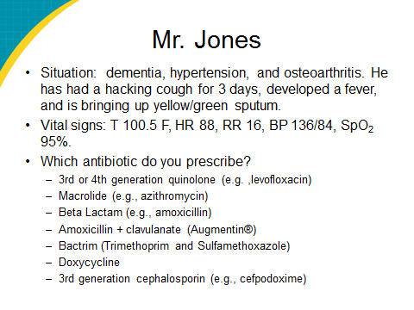
Limitations  SAY:  What are the limitations? One is that it depends where a resident acquired the infection. An antibiogram is most applicable if he or she acquired the infection while in the nursing home. Also, if fewer than 30 isolates exist, the data should be interpreted with caution as they may not be reliable. | Slide 14  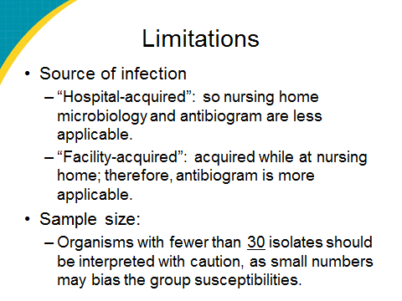
Questions?  ASK:  Has anyone used an antibiogram to make decisions? How did that work for you? | Slide 15

