Slide Title and Commentary | Slide Number and Slide
Title Slide  Toolkit 2. Common Suspected Infections: Communication and Decision Making for Four Infections  Tool 4. Tools To Improve Communication and Decision Making  SAY:  Today we are introducing you to new tools to help improve communication and help prescribing clinicians make better decisions about antibiotics. | Slide 1  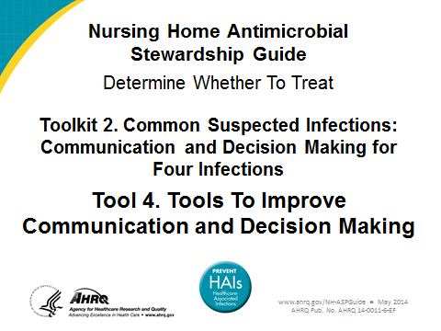

Slide Title and Commentary | Slide Number and Slide
Quality Improvement for Antibiotic Prescribing  SAY:  Each of the upcoming slides will provide information on these issues. | Slide 2  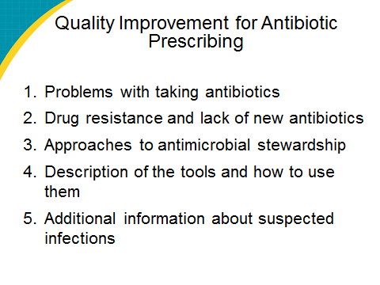
Problems With Taking Antibiotics  SAY: | Slide 3  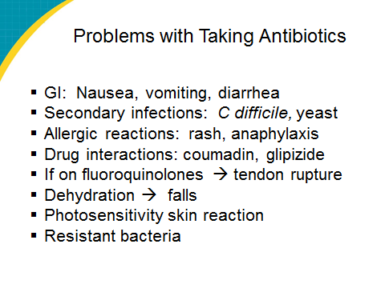
Antibiotic Resistance  SAY:  The sad fact is that multi-drug resistance is increasingly common in everyday practice.  For example, we used to know with confidence that pneumococcal pneumonia would respond to penicillin; now it increasingly does not.  Methicillin-resistant Staph aureus is now more common than methicillin-sensitive Staph aureus in many areas; and vancomycin and linezolid resistance is growing.  In urinary tract infections, we no longer can prescribe any oral agent with confidence, as drug-resistant Enterococcus, E. coli, and Pseudomonas infections are increasingly common.  In wound infections among soldiers in the Middle East, multidrug-resistant Acinetobacter infections have emerged as a huge problem.  In developing countries, multidrug-resistant tuberculosis is an ever-increasing challenge.  These are just some examples. | Slide 4  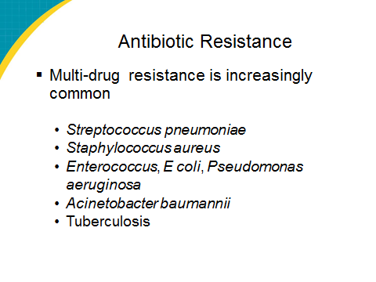
Resistant Strains Spread Rapidly  SAY:  With so much national and global travel taking place, resistant bacterial strains spread rapidly. This graph shows how rapidly resistant strains of MRSA, vancomycin-resistant Enterococcus, and fluoroquinolone-resistant Pseudomonas have spread nationally once they emerged. | Slide 5  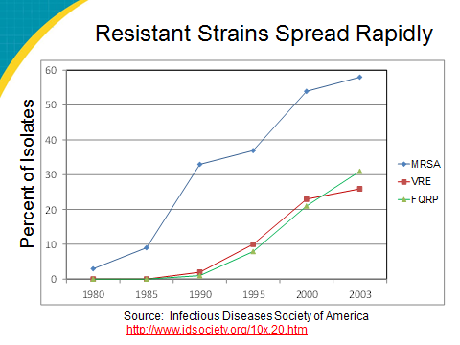
Few New Antibiotics  SAY:  To return to the big picture, not only are resistant strains proliferating, but new drug development is not keeping pace. This is the other side of the problem.  As this slide indicates, the number of new antibiotics has been dwindling for over 20 years.  Not only that, but the antibiotic development pipeline is dry. As of 2009, there were only 15 or 16 new antibiotics in development, none of which had made it to phase 3 trials, and none of which had activity against bacteria that are resistant to all currently available drugs. | Slide 6  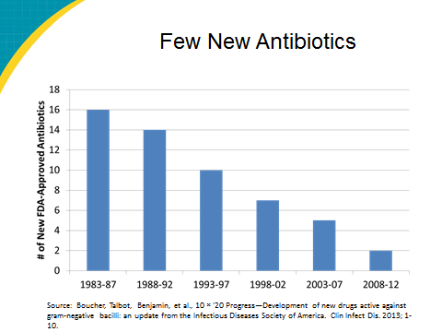
Developing a New Drug Is Expensive  SAY:  There are many reasons for the lack of development of new antibiotics. Several relate to return on investment.  As this slide shows, using constant dollars as its reference point, the cost of bringing a new drug to market has increased by a factor of 13 over 25 years.  So when drug companies think about where to put their investment money, they have to think about cost-benefit. Unfortunately, antibiotics come up short, because they are taken for only a week or two. In contrast, a new drug for a chronic problem such as high cholesterol or congestive heart failure will be purchased and taken for many years, increasing the potential for per-person profit. Furthermore, because of concerns about antibiotic resistance, use of new agents is discouraged by the medical community. Yet if antibiotic resistance does develop, it will limit the effective lifespan of the drug. | Slide 7  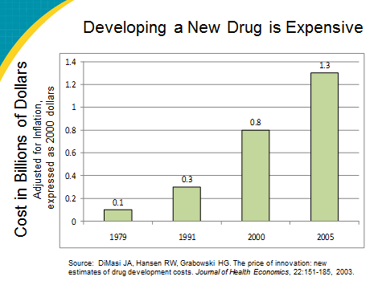
Consequences  SAY:  The intent here is that, by now, there will be strong buy-in regarding the importance of the topic. | Slide 8  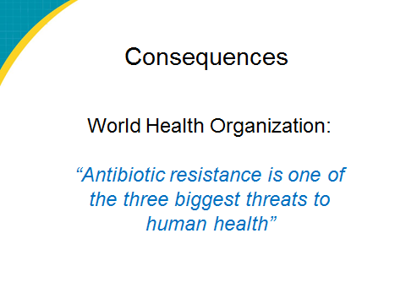
Indications of Overuse  ASK:  Did you know that 25 to 75 percent of antibiotics do not meet clinical guidelines for prescribing? What do you think of that?  SAY:  One-third of residents receiving antibiotics for a “UTI” are asymptomatic. If they don’t have symptoms, they should not be receiving antibiotics, yet they often are. | Slide 9  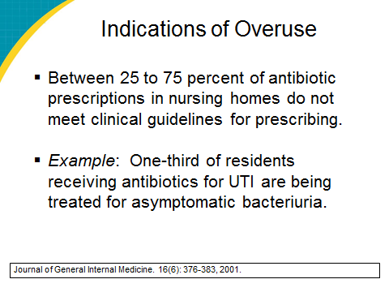
Approaches to Antimicrobial Stewardship  SAY:  Here, we are pointing out national initiatives, including a focus on long-term care (which is why this project is being done).  In response to very real concerns about running out of effective antibiotics, authorities have recommended two general approaches.  One is to stimulate research. A consortium of scientific and governmental agencies has launched the 10 by ’20 initiative, which targets the development of 10 new classes of antibiotics by 2020, by encouraging governmental and other incentives for drug development. This ambitious campaign faces many obstacles, however. Regulatory barriers have to be reduced, and hard-to-get federal dollars may be needed to help stimulate antibiotic research. Also, society has to be prepared to pay a lot more for new antibiotics that are developed.  The other key approach is to slow the development of resistance by limiting overuse of antibiotics.  The target area that we are talking about today is to reduce overuse in medical practice in the United States. Already efforts have been successful in reducing unnecessary prescriptions for children with respiratory infections and ear infections and sinusitis in adults. This QI project is part of a national effort directed at another population with high antibiotic prescription rates—older persons residing in long-term care facilities. | Slide 10  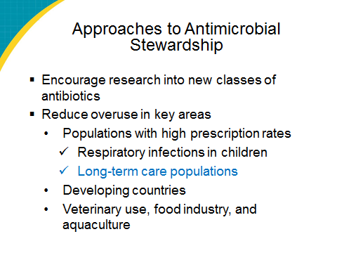
Approaches to Antimicrobial Stewardship (continued)  SAY:  [IF PARTICIPANTS ASK, OTHERWISE SKIP]:  In developing countries antibiotics are generally available without prescription, at low cost, and are widely used. This may explain why the newest bacterial resistance gene—one that makes urinary tract pathogens resistant to carbapenem antibiotics—originated in India and then spread rapidly, often by medical tourists who had come to India from Europe or America for low-cost surgery. Thus, resistance is a global issue, and efforts to reduce antibiotic overuse are being conducted worldwide.  Other areas of antibiotic overuse are veterinary care, food production, and aquaculture. Efforts to better regulate these areas are also under way. | Slide 10
Goal: Better-Informed Prescribing  SAY:  Now, I would like to switch over and talk about making better prescription choices based on better information. | Slide 11  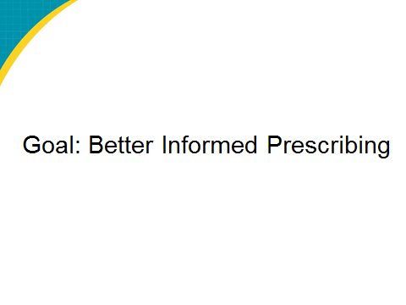
Components of the Communication and Decision Making for Four Infections  SAY:  The remaining slides will discuss each of the five components in more detail, beginning with the MCRF. | Slide 12  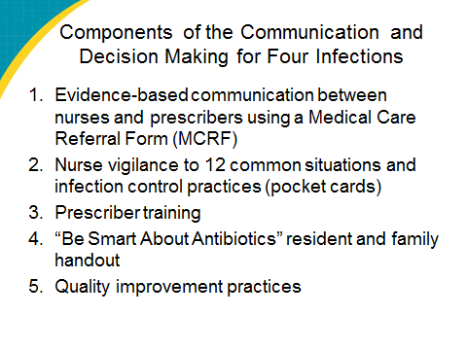
Evidence-Based Communication Between Nurses and Prescribers  SAY: | Slide 13  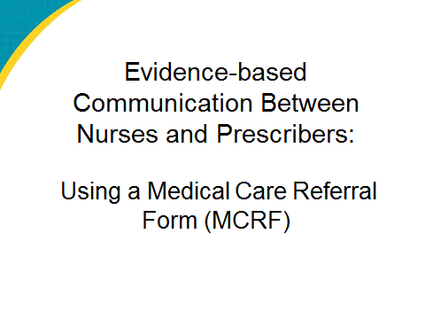
Development and Rationale for Use: Medical Care Referral Form (MCRF)  SAY:  This and the upcoming slides are to sell the use of the MCRF. | Slide 14  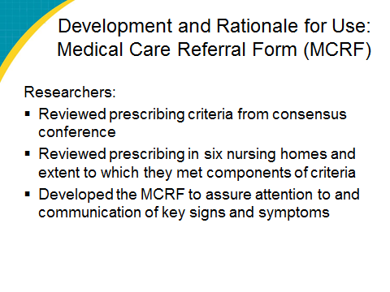
The Medical Care Referral Form (MCRF)  SAY: | Slide 15  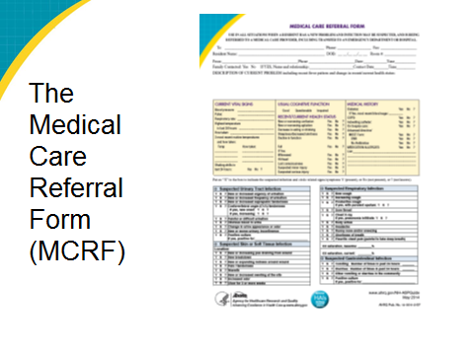
Medical Care Referral Form (MCRF)  SAY: | Slide 16  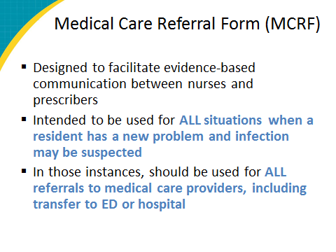
MCRF: Components  SAY:  This is the point where the form itself is reviewed and discussed.  Note that falls are included to facilitate the use of the MCRF for ALL referrals. | Slide 17  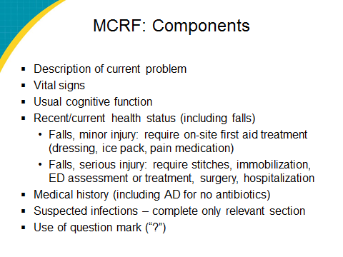
End-of-Life  SAY:  The MCRF includes a section on advance directives for antibiotics, which are underused at the end of life.  The researchers used the North Carolina MOST form, which stands for Medical Orders for Scope of Treatment. It has been adopted by North Carolina as the preferred method of recording advance directives. MOST is an accepted POLST program. For state-specific information, go to http://www.polst.org/  educational-resources/resource-library/.  Ideally, all long-term care facility residents should have a POLST accepted form on the chart and have it reviewed and updated periodically. The form is on bright pink paper so it can be easily identified in case of an emergency.  A physician, physician assistant, or nurse practitioner must complete the POLST accepted form based on a discussion with the resident. Section C identifies preferences related to antibiotics. | Slide 18  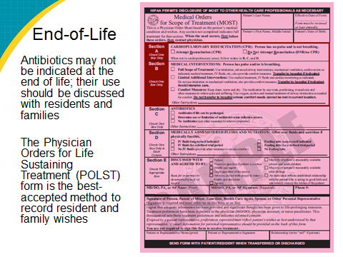
Twelve Common Situations and Infection Control Practices and the Pocket Card  SAY: | Slide 19  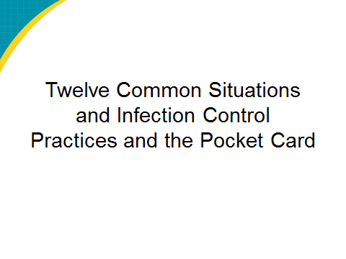
Situations in Which Systemic Antibiotics Are Generally Not Indicated  SAY:  An evidence-based review of the literature identified nine situations that occur in long-term care where antibiotics may not be appropriate.  They include:  - a positive urine culture in an asymptomatic resident  - a positive urine culture ordered because of change in urine appearance  - pharyngitis without Group A strep  - bronchitis or asthma in a resident who does not have COPD  - suspected or proven influenza in the absence of a secondary infection  - a skin wound without cellulitis, sepsis, or osteomyelitis, regardless of culture result  - any resident with an advance directive to not institute antibiotics  - residents with advanced dementia who have respiratory symptoms and are terminally ill, on palliative care, and  - acute vomiting and/or diarrhea in the absence of a positive stool culture for Shigella or Salmonella, or Clostridium difficile toxin  In the next three modules, we discuss the decision-making challenges around many of those situations, focusing on the three most common infections for which decisions about antibiotics are difficult: urinary tract disease, respiratory disease, and skin diseases. Our last module will then provide some guidelines on antibiotic selection. | Slide 20  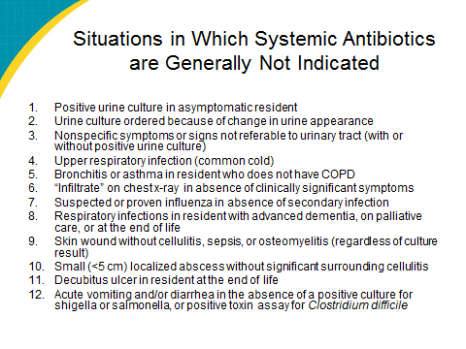
Infection Control Guidelines  SAY: | Slide 21  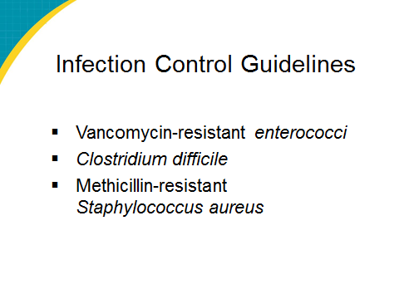
Pocket Card  SAY: | Slide 22  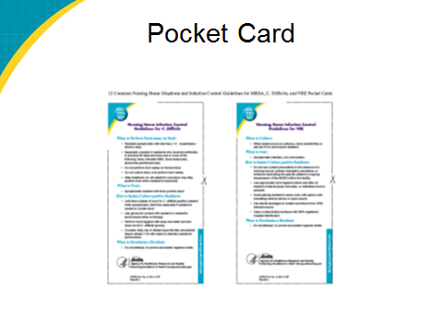
Pocket Card  SAY: | Slide 23  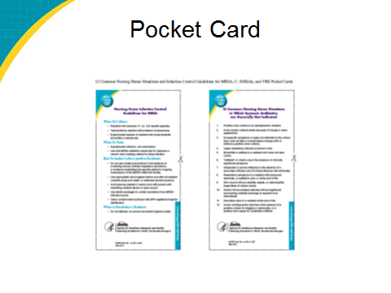
“Be Smart About Antibiotics” Handout  SAY:  Prescribing clinicians will be trained in more detail on prescribing criteria and their own practices.  Note that resident/family/staff education is important because some people assume antibiotics are the right treatment in all instances. | Slide 24
“Be Smart About Antibiotics” Handout  SAY: | Slide 25
“Be Smart About Antibiotics” Handout  SAY: | Slide 26  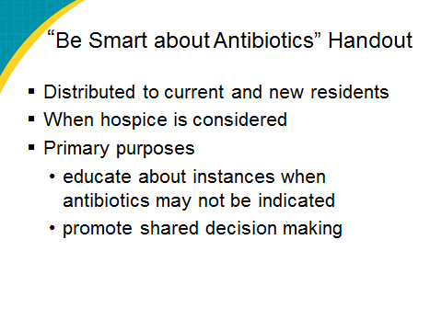
Quality Improvement Practices  SAY:  This program will be a focus of monthly QI team meetings. | Slide 27  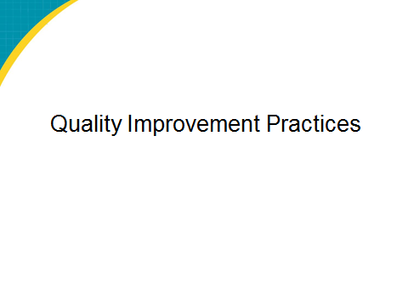
Monthly Meetings  SAY:  Monthly meetings should be held to review progress and address any challenges. Staff champions as well as any staff involved should attend the monthly meetings. | Slide 28  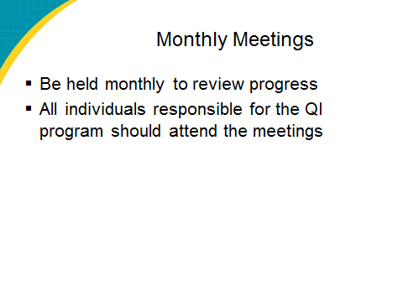
Additional Information About Infections and Symptom Management  SAY: | Slide 29  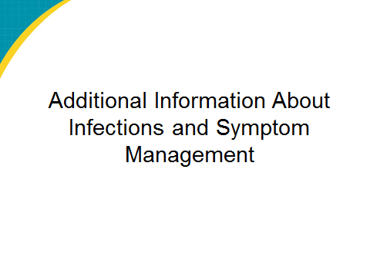
Fever and Older Adults  SAY: | Slide 30  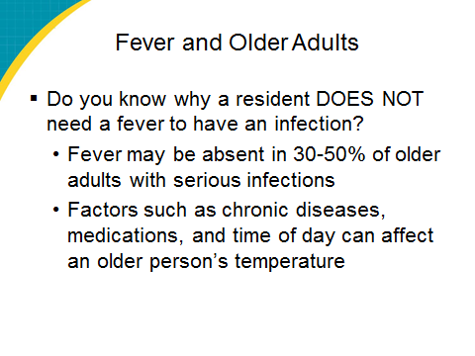
Suspected UTI Cloudy or Smelly Urine: To Culture or Not?  SAY:  Often the trigger for a urine culture is a call from a facility saying that the resident’s urine is cloudy or foul smelling. The scientific literature has quite a bit to say on cloudy, smelly urine. It shows that:  - Most symptomatic UTIs are accompanied by cloudy or smelly urine. However, there are many other causes of changes in the urine, such as poor oral intake, dehydration, crystallization after urine passage, and other non-infectious causes. Studies have shown that a positive culture obtained solely because of a change in urine appearance will over-diagnose infection at least one-third of the time.  - For this reason, most experts have concluded that the evidence supports managing malodorous urine not with a culture but with increased fluid intake and improved toileting, and reserving cultures for residents with urinary tract symptoms such as dysuria or new incontinence. | Slide 31  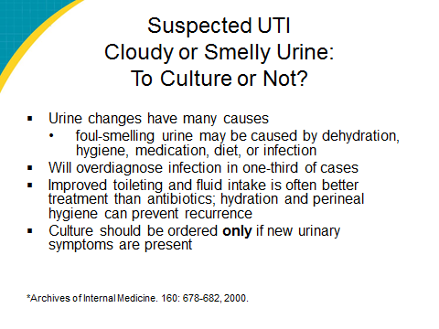
When to Order a Urine Culture Diagnostic Pathway  SAY: | Slide 32  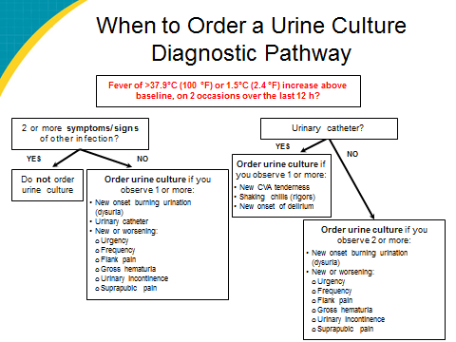
Suspected Respiratory Infection  SAY: | Slide 33  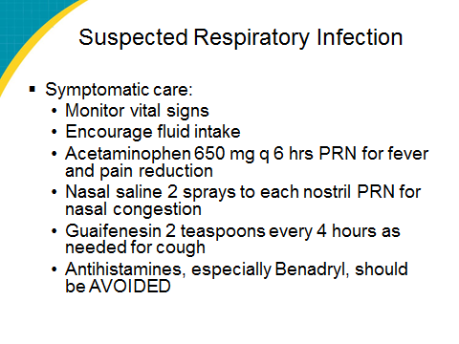
Suspected Skin/Soft-Tissue Infection  SAY: | Slide 34  