CUS Tool

I am CONCERNED!

I am UNCOMFORTABLE!

This is a SAFETY ISSUE!

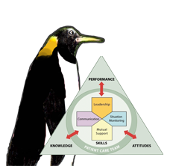

As seen in TeamSTEPPS®