SAY:  The purpose of the Patient and Family Engagement in the Ambulatory Surgical Environment module is to augment the existing hospital setting Patient and Family Engagement module of the Comprehensive Unit-based Safety Program (or CUSP) Toolkit, available on the AHRQ Web site. The module you are reviewing now will focus on patient and family engagement within the ambulatory surgery center environment. | Slide 1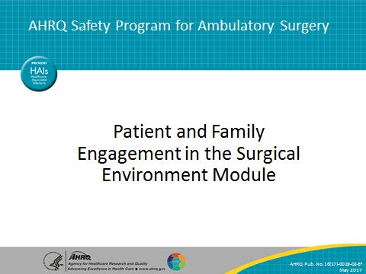
SAY:  After viewing this module you will be able to—  Define patient and family engagement, including core principles, barriers, and facilitators;  Explain the importance of engaging patients and family members in the care of the surgical patient in an ambulatory surgery center (or ASC);  Determine the level of patient and family engagement at your own facility;  Distinguish between different methods of engaging patients and family members in the health care and safety of the surgical patient; and,  Apply the methods learned to scenarios in the ASC setting. | Slide 2  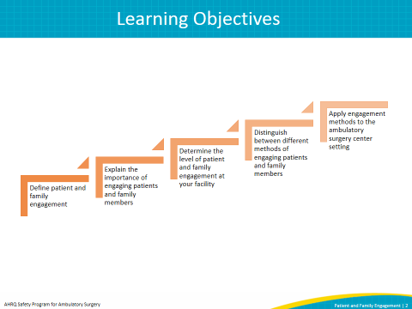
SAY:  This module will begin by giving background information for patient and family engagement and then offer reasons why an ASC should support engagement within its facilities. Next, it will provide patient and family expectations for care, as well as barriers, facilitators, and motivators to engagement from the patient, family, and provider perspective. It will then discuss how to understand and measure engagement in your facility. Next, it will cover the methods your facility can use to engage patients and their family members, including the utilization of patient advisers. Finally, it will conclude with examples of opportunities for patient and family engagement at the facility level. | Slide 3  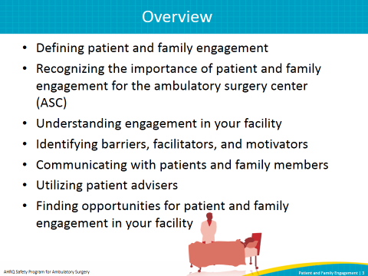
SAY:  According to the Institute for Patient- and Family-Centered Care, patient- and family-centered care involves “collaborating with patients and families of all ages, at all levels of care, and in all health care settings. [Patient- and family-centered care] acknowledges that families, however they are defined, are essential to patients’ health and well-being.”  Core concepts of patient and family engagement include: Dignity and respect, information sharing, participation, and collaboration.  Dignity and Respect  Health care practitioners invite, listen to, and honor patient and family perspectives and choices. Patient and family makeup, knowledge, values, beliefs, and religious and cultural backgrounds are incorporated into care planning and delivery.  Information Sharing  Health care practitioners share complete and unbiased information with patients and families in ways that are easily understood and that address concerns or questions. Patients and families receive timely, complete, and accurate information to participate in care and decision making.  Participation  Patients are encouraged to participate in care and decision making at the level they choose. The patient decides how their family will participate in care and decision making. Once the patient has told providers their preference, the providers honor the patient’s decision.  Collaboration  Patients, families, health care practitioners, and health care leaders collaborate in policy and program development, execution, and evaluation, as well as in facility design, professional education, and care delivery. | Slide 4  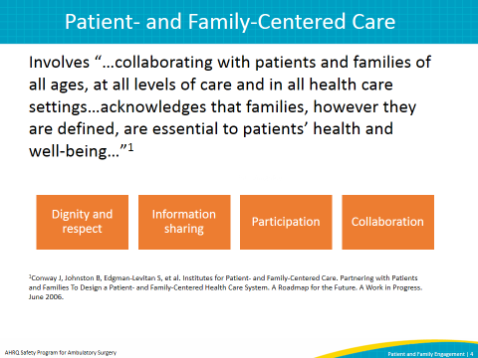
SAY:  The ultimate goal of patient and family engagement is to create conditions for patients, family members, clinicians, and ASC facility staff to work together as partners to improve the quality and safety of care. This partnership is important because health care quality and safety directly affect patients and families. Patients and family members take part in changes and improvements by providing input from their point of view. It is valuable for the ASC to invite patients and family members to give feedback about their experiences and ways they could have been improved.  On one level, patient and family engagement means providing day-to-day care experiences that welcome and engage patients and families as members of the health care team. For example, care team members can provide opportunities for patients and family members to be involved in care by—  - Making sure patients and family members are invited to partner with their health care team.  - Involving patient and family members with the surgical process (including the Safe Surgery Checklist) as much as possible.  - Involving and educating patients and families in postoperative planning for safe care at home.  ASK: How does your ASC facility provide opportunities for partnership and engagement before and after the procedure/surgery?  On another level, patient and family engagement means that patients and family members are involved beyond their own care as organizational partners, or advisers, such as by working with staff, clinicians, and leaders to improve policies, processes, programs, facility design, and education for patients, families, ASC staff, clinicians, and trainees in health professions.  Patient and family engagement is not—  - Getting patients and families to do what caregivers want them to. It is a shared partnership where patients and care team members listen to each other and decide on the best plan of action.  - Getting patients and families to like clinicians. It is about improving quality and safety by communicating and partnering more effectively.  - Handing patients and families a brochure. A piece of paper alone will not get patients and families engaged.  - Abandoning critical judgment. Clinicians work with the patient and family to help them choose what is right for them. They bring clinical judgment to the table. It is an important perspective as part of the health care team, but it’s not the only important perspective. | Slide 5  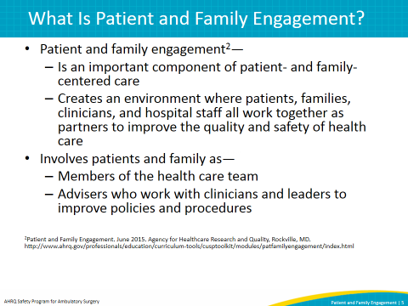
SAY:  Patient and family engagement benefits not only patients and their families. Engagement helps ASC facilities improve overall quality of care, patient safety, and patient outcomes. Patient and family engagement builds rapport between facility staff and patients and their families. This increased rapport generally increases the satisfaction of the patient, their family, and the staff. As policies become more patient and family centered, facilities will align their engagement practices. Facilities can not only report on their engagement as a metric for the success of the surgical procedure, but also evaluate patient, family, and staff satisfaction. | Slide 6  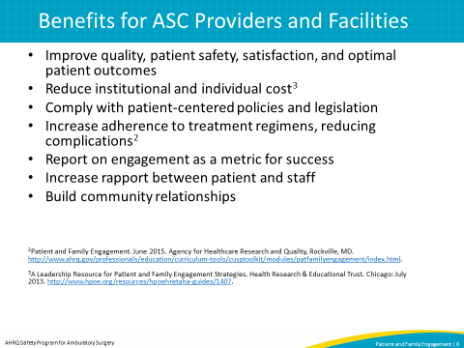
SAY:  There are many benefits to engaging patients and families in their care. While many of these benefits overlap, it is important to remember that engagement may look different for patients than it does for family members.  For patients, safety is improved because the patient can provide and clarify information and ask questions about their care. With an engaged patient, the health care provider can more easily access a patient’s history, and the patient can provide timely feedback during care. Patient participation will not only incorporate important cultural and religious perspectives, but also will help build a trusting relationship with the provider by welcoming open communication.  Participation of family members in the patient’s care may also contribute to improved patient safety. Family members are generally familiar with the patient’s health history and may be able to alert the provider to any observed response to care or treatment, or behaviors not normal for the patient. Family participation is also an opportunity to teach caregivers about a patient’s perioperative care to prevent complications after the patient leaves the facility. | Slide 7  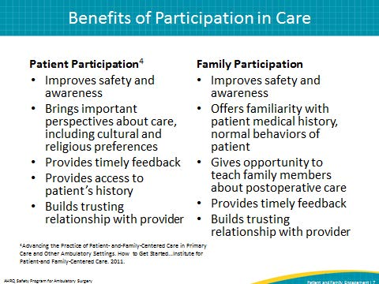
SAY:  In general, patients and family members assume that the health care system is set up to prevent medical errors. When an error does occur, patients and families tend to blame the provider and not the system. Also, patients and family members tend to underestimate the occurrence of medical errors.  Engagement in health care may decrease medical errors. Engaged patients are informed, asking questions about and participating in their care. This can help prevent safety events and/or medical errors. Engaged patients are more likely to report on safety events after the fact. | Slide 8  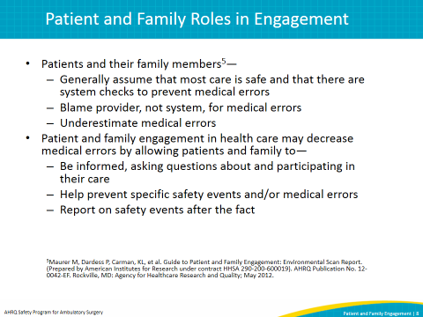
SAY:  Patients and their family members have specific expectations about the quality and transparency of the patient’s health care. Some identified by The Institute for Healthcare Improvement include:  To be listened to, taken seriously, and respected as a care partner. This includes having family and care-givers treated the same, as well as participating in decision making at the level the patient chooses or understands.  To be told the truth, including having information explained fully and clearly and receiving an explanation and apology if things go wrong.  To have information communicated to the entire care team. This includes having timely and well-documented care and having access to health records if requested.  To have coordination among all members of the health care team across settings.  To be supported emotionally as well as physically.  To receive high-quality, safe care. | Slide 9  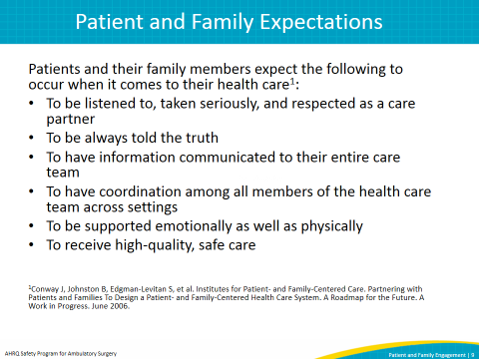
SAY:  The ASC environment is a different environment from that of a hospital, and therefore patients and families may not know what to expect. In the ASC facility setting, patients and families should expect to—  - Be educated about the entire perioperative experience, through face-to-face education and written take-home materials.  - Have family, caregivers, and advocates included at the patient’s desired or age- or condition-appropriate level.  - Be respected as an individual and not be identified as a surgical name or number.  - Be given the opportunity to have all of their questions answered.  - Be able to stop the process if they believe there are questions or problems. | Slide 10  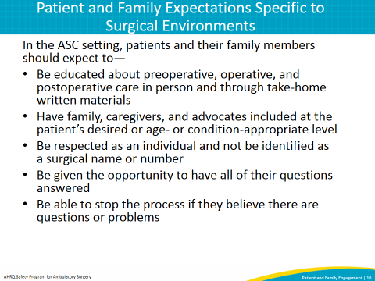
SAY:  Several barriers can prevent patients and families from engaging in their health care.  Fear and Uncertainty  Many patients and/or their family members may be afraid of or uncertain about the surgical procedure or diagnosis. This fear of the unknown may prevent them from being willing or able to fully participate in their care.  Comprehension and Literacy Levels  A patient’s ability to comprehend medical information is vital to engagement. Decreased cognitive abilities may hinder engagement, as well as age-related comorbidities. Literacy levels, such as low literacy or non-native English speakers, may further prevent communication with the provider at a desired level, despite the use of translators. Friends and family can be immensely helpful here.  Provider Bedside Manner  Health care providers who dismiss a patient’s or family member’s concerns or react poorly to a patient’s or family member’s questions may keep them from playing an active role in the patient’s care. Power dynamics may still be in effect even when providers are friendly and compassionate, so providers need to actively elicit a patient’s concerns.  Family Reaction  The family’s reaction to a patient’s medical condition and/or family dynamics may make it difficult for the patient and the family to fully engage in their care. If the patient and/or family are stressed due to the patient’s procedure, it may be difficult for them to engage as a cohesive unit.  Resources To Support Surgery and Postsurgical Care  Resources, including the cost of a procedure, transportation to and from the procedure, and support and resources for postsurgical care at home, may contribute to the obstacles patients and families face in engaging in care.  Dismissive Attitudes  Many patients may feel as though a procedure or surgery in the ambulatory surgery center is minor because of its outpatient nature and may not feel it is worth engaging in. | Slide 11  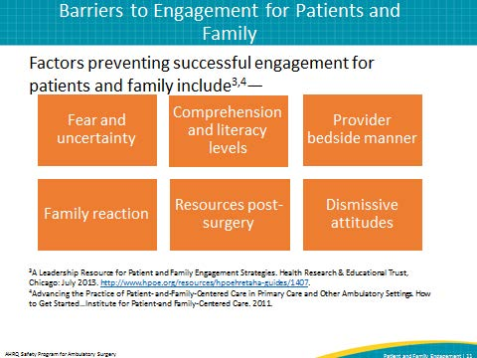
SAY:  Awareness of what patients face when they come to an ambulatory surgery center can help clinicians and ASC facility staff better understand a patient’s perspective. For instance—  - The ASC setting can present a very unfamiliar setting, system, or culture for patients.  - Patients may not understand the roles of different staff performing their surgery/procedure.  - Patients are often uncomfortable or afraid about their surgery/procedure.  - Patients are only at the facility for a short time and may not ask all the questions they have.  - After discharge from the ASC, the patient may be receiving care from family members and caregivers who are unsure of what to do. | Slide 12  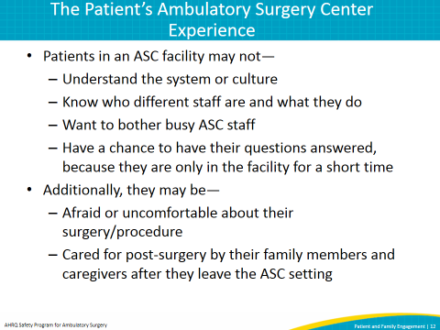
SAY:  Health care personnel have their own barriers when it comes to patient and family engagement, including—  Perceived Level of Time and Effort  The provider may not encourage patient and family engagement if they have time constraints.  Communication Challenges  Communication challenges may exist for the patient, such as cultural differences, language barriers, or family and patient preferences in how care is delivered.  Professional Norms and Experiences  If the provider has not had experience in or does not understand the purpose of engagement, he or she may be less likely to engage with patients. Also, if the workplace culture is not patient and family centered, this most likely will create a barrier for engagement as well. A lack of engagement skills or a negative past experience in engaging patients and families may prevent a provider from engaging in the future.  Patient Situation Upon Discharge  If a patient has been sedated for the procedure, health care personnel may not feel it is worthwhile to engage the patient, even though he or she may be more alert than they think. Also, because patients leave the ASC facility in less than 24 hours, they may not perceive it necessary to engage in that time period.  Fear of Litigation  With patient privacy laws and the fear of oversharing information about adverse events or mistakes, health care personnel may not be transparent in the care of the patient. But keep in mind that failing to share information appropriately is a violation of patient privacy laws. | Slide 13  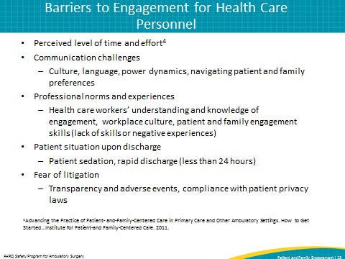
SAY:  The Health Insurance Portability and Accountability Act, or HIPAA, aims to protect patient health information, but may provide unique challenges for patient and family engagement. However, HIPAA and patient and family engagement are aligned in sharing the following objectives:  - To restore and strengthen trust among patients, families, and health care professionals.  - To enhance the patient’s experience.  - To improve the efficiency and effectiveness of care.  - To enhance patient rights. | Slide 14  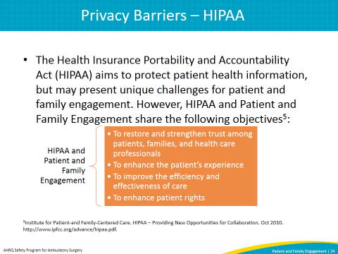
SAY:  Although aligned with patient and family engagement, HIPAA privacy laws may create many barriers to engagement. These include—  - Depersonalizing the patient’s experience by referring to a patient by a number instead of a name.  - Creating concerns with confidentiality by questioning the legality of family members. Legality refers to not only questions surrounding which individuals are considered “family” according to the HIPAA law, but also whether family members have a legal right to patient information.  - In addition, HIPAA laws may discourage the presence of family members before and after surgical procedures.  There are ways to practice patient and family engagement while maintaining HIPAA compliance.  Recommendations include—  - Providing information about patient privacy in written preoperative materials, as well as sharing discharge summary reports with the patient (and family members at the discretion of the patient).  - When possible, encourage family member inclusion in the surgical process before and after surgery.  - Patients should be encouraged to name the person the doctor and facility should communicate with about their health affairs, and to designate health care power of attorney to the person who will handle their health affairs if they are incapacitated or sedated.  - Patients should be told they can sign a release form to give family members access to the patient’s medical record. | Slide 15  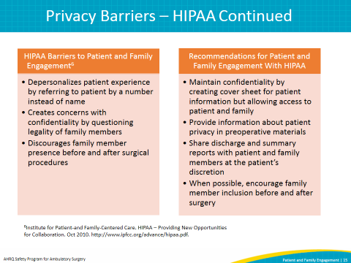
SAY:  To understand the engagement culture in your facility, it may be helpful to complete a culture assessment that includes both health care personnel and patients and families. This will show the level of perceived engagement occurring in your facility and serve as a baseline to help guide the facility on areas for improvement.  ASK:  What is the patient and family engagement level in your facility?  What are your personal attitudes about patient and family involvement in health care? | Slide 16  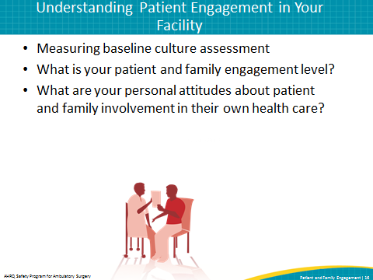
SAY:  A work environment in which patient safety culture is a shared goal and expectation will facilitate patient and family engagement. Having a leadership team that verbalizes its expectations and commitment to patient safety will not only help staff understand the importance of a safe environment of care but also will help foster patient and family engagement.  If health care personnel gain this understanding of patient and family engagement through education, experience, and time, they will be more likely to practice it routinely. The more receptive the team is to engagement, the more members can share their learning experience with each other. Working on engagement as a team creates internal support for health care personnel to engage and create a more patient-centered workplace. | Slide 17  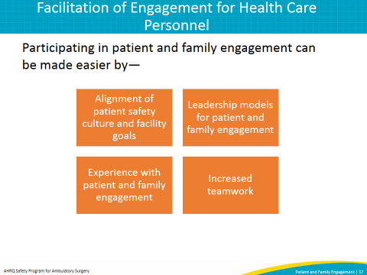
SAY:  Patients are more likely to engage in their care if they are invited to participate in it. Many patients do not understand that they have a right to actively participate in their care until given permission or an invitation to do so. Additionally, patients may not know what questions to ask if they lack information about their diagnosis and procedure. Giving patients clear, accessible information can facilitate engagement. Patients with high levels of self-efficacy, or perceived ability to engage in their own care, are more likely to. Family members with high levels of self-efficacy are also more likely to engage in the care of their loved one.  Engagement by family members may be made easier by similar factors. However, the patient is the one who invites family members to participate in the patient’s care. Also, family members will get involved more easily if they understand the importance of their involvement in pre- and postoperative care. Family inclusion in care discussions with the provider are at the discretion of the patient, but are encouraged. | Slide 18  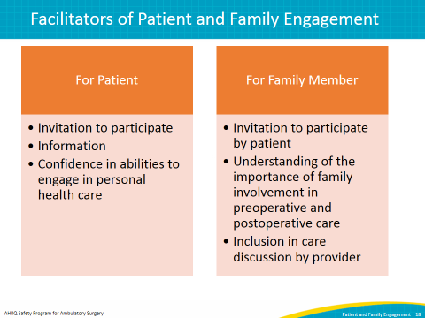
SAY:  When engaging patients and their family members, first ask the patient what matters most to them in private if they are willing, with no family in the room. This will give insight on patient concerns and areas for provider focus and elaboration.  Remember that when it comes to patient and family engagement, no one size fits all. Engagement will look different in different facilities and different patient populations (such as older adults versus children), and for different patients and families. Staff members must assess the patient’s wishes for family involvement before planning the level of engagement at which family members will be invited to join. | Slide 19  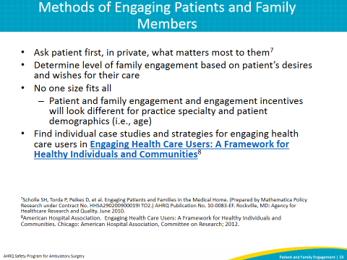
SAY:  When communicating with patients and family members, certain communication techniques can build relationships that lead to better health care quality and safety. A few of these include—  Make eye contact, smile, and make introductions (yourself and others) to the patient and family members and ask how the patient would like to be addressed. This helps establish rapport and puts the patient and family at ease.  Include the patient and family as members of the health care team. Invite the family members to join the health care team, even physically including them in the group surrounding the patient. This inclusion implies a strong message of equality amongst the team. It is vital to ask about and listen to the patient’s and family’s needs and concerns.  Help the patient and family understand the health condition, procedure, and next steps in their care by checking to see if things were explained well and if the patient and family understand. Using the “Teach Back” method, verify that a patient understands by asking them to explain the information back to you. This will aid in preventing post-surgery complications and improve confidence in caring for themselves or their loved one if there is mutual understanding on the steps to follow after surgery. The goal is to work with patients to ensure that they fully understand health information and use that knowledge to make informed decisions for themselves.  Use the AHRQ “Communicating to Improve Quality” checklist tool as a reminder to practice effective communication with patients and family members. | Slide 20  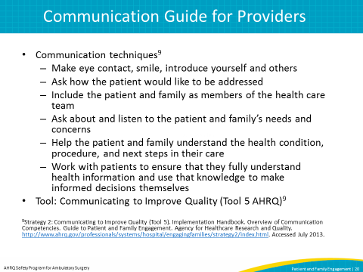
SAY:  One difference between an ASC setting and a hospital surgery environment is that the responsibility of postoperative care may shift to the family member or other caregivers in an ASC setting. Due to the increased expectations on the patient and family, patient- and family-centered materials are useful in guiding patients through their care.  Question prompt sheets, such as AHRQ’s “Questions are the Answer,” assist the patient and family members in asking questions about care that they might have forgotten or do not feel comfortable asking. Question prompt sheets usually focus on the most important information and allow the user to write in their own questions as well.  Written preoperative materials may aid the patient in having a better understanding of how to best prepare for a surgery and what to expect. An example of a preoperative guide is “Helpful Information for the Day of Your Surgery,” which explains the roles of different health care providers; describes what to expect before, during, and after surgery; and includes a Safe Surgery Checklist for the patient. Preoperative guides ideally are provided at an office visit before the day of the surgery, allowing the patient and family to review its contents and ask questions.  An informed consent includes the risks and benefits of the procedure and must be fully explained so that the patient can agree, or consent, to the procedure. A copy of the informed consent is helpful for the patient to have so they can review it again before the day of surgery. This review reminds them of any last-minute questions. | Slide 21  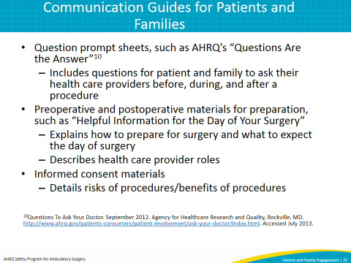
SAY:  Another opportunity for patient and family engagement in your facility is to make sure the patient knows who you are and what your role is within the facility and for the patient. A simple introduction from a health care provider can put a patient at ease by letting them know who is taking care of them and what their role is. This may facilitate engagement if the patient wants to ask a question of a specific provider.  The following video shows an example of encouraging patient and family engagement through health care staff introductions. This allows the patient to understand the identities and roles of each staff member and assists the staff in identifying each another.  Note: This slide includes a video. If you have trouble accessing the video on this slide, it is also available here: https://youtu.be/X3KGKqFChi8.  DO:  Play the video.  ASK: In what ways does your facility engage patients and family members? What opportunities exist within your facility to engage patients and family members? | Slide 22  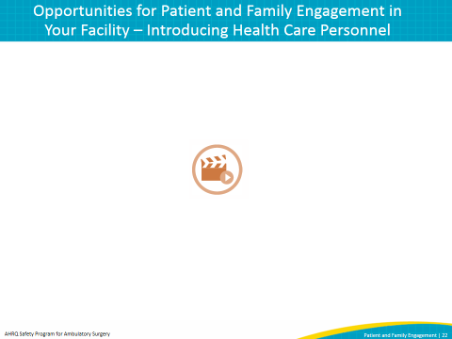
SAY:  An opportunity exists for patients and families to be active participants in the use of the safe surgical checklist. Patients and family members (if the patient wishes) should be in the room when the checklist is used. This may also serve as an additional safety check. Because some patients and family members may have varying reading or comprehension levels, participation can be verbal and consist of easy to answer questions involving surgery site, medication allergies, surgery preparedness, comfort level, and discharge instructions. If a patient or family member is not English speaking, a medical translator can be provided at any time during the perioperative experience, including during the checklist process, to aid in engagement.  The following videos show a patient and his family member engaged in the checklist process with their health care provider. Engagement in this process allows the patient and family members an opportunity to ask questions and discuss any concerns they may have for their health care team.  Note: This slide includes two videos. If you have trouble accessing the videos on this slide, they are also available here:  Preoperative: https://youtu.be/8gmMfZ__ibw  Recovery: https://youtu.be/GpsdM9-Hi6s  DO:  Play the videos.  ASK: In what ways does your facility engage patients and family members? What opportunities exist within your facility to engage patients and family members? | Slide 23  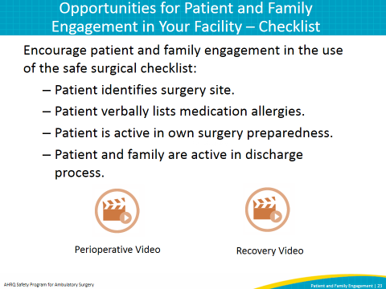
SAY:  The informed consent process is an opportunity to not only inform the patient and their family about the possible risks, benefits, alternatives, and procedural information about the surgery, but to also answer any questions that the patient or family may have. This should be done well in advance of the procedure if possible, preferably at the doctor’s appointment where the procedure is discussed, yet making sure to adhere to validity time windows as needed. Patients should be provided a copy of the informed consent document at that time so they understand what they will be expected to sign on the day of surgery. Patients should be made to understand that they are free to make their own decision about having a procedure. A patient may consent to a procedure without having a full understanding of the risks involved, especially if they are not familiar with medical terminology, are frightened or anxious about the procedure, or have issues with cognitive abilities. This is an opportunity for health care personnel to ask the patient if they have any questions or need further information. Risks, benefits, and alternatives should be explained using terms and language understood by the patient, allowing enough time for questions from the patient and family before the patient is asked to sign. If there is any concern that a patient may not fully understand the information provided, it may be useful to use the “Teach Back” method to have the individual describe the risks of the procedure the way he or she understands it, in order to clear up any misconceptions.  ASK: In what ways does your facility engage patients and family members? What opportunities exist within your facility to engage patients and family members? | Slide 24  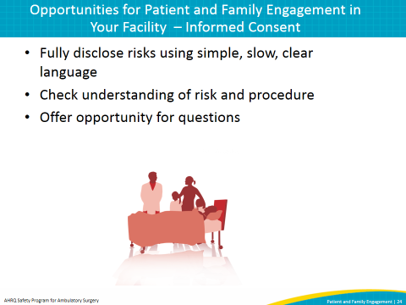
SAY:  Discharge from the ASC is one of the most important times to engage with patients and families regarding the patient’s care. Using the IDEAL discharge planning method will help prevent postdischarge complications and avoidable readmissions, as well as demonstrate that ASC staff view the patient and family perspective as important.  The 5 steps of IDEAL discharge planning are—  - Include the patient and family (as the patient wishes) in the patient’s health care.  - Discuss with the patient and family five key areas in which to prevent problems at home. This discussion will educate the patient and family about how to prevent complications and infections while the patient is cared for outside of the ASC environment. This is important since most of the caregiving responsibility may fall on the family members and/or other caregivers. Provide a phone number that patients and families can call anytime with questions so they do not feel nervous if they have questions.  - Educate the patient and family throughout their time in the ASC facility. Unlike the hospital setting, where the patient and family may have a longer stay and more opportunities for education, these opportunities are more limited in the ASC setting. Use interactions to educate the patient and family members about the patient’s condition and what will happen after care.  - Use Teach Back to assess how well health care providers explain the diagnosis, condition, and next steps in their care. Teach Back allows the patient or family to explain in their own words what the health care providers have instructed them on, to determine how well the concept was taught and if the provider should reteach any information.  - Listen to and honor the patient and family’s goals, preferences, observations, and concerns. Request and collect patient and family feedback. This is the foundation of patient and family engagement and motivates participation.  ASK: In what ways does your facility engage patients and family members? What opportunities exist within your facility to engage patients and family members? | Slide 25  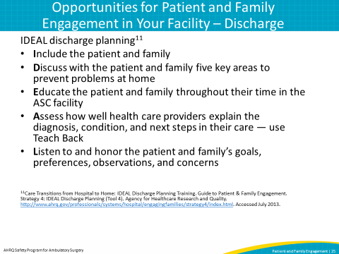
SAY:  No matter the expertise of the health care providers or the precautions taken to prevent adverse outcomes, mistakes can and do happen. When they do occur, health care staff members need to know how to communicate effectively and support patient and/or family engagement.  If an adverse outcome occurs, take the following immediate steps:  - Provide care for the patient – The first priority for a provider is to address the current health care needs of the patient.  - Report to appropriate parties – Providers will use their facility’s policies to report adverse events. In some facilities, this requires reporting to the patient’s physician, risk management department, and a provider’s direct manager. Communication about adverse events is a delicate process that requires collaboration with and guidance from trained staff.  - Communicate with the patient – Providers communicate by sharing relevant facts about an adverse event and answering questions. Providers assure the patient and family they will be informed as factual information becomes available about the adverse event.  - Document the event in the medical record – Providers must document in the medical record the facts of the incident and any care the patient received as a result of the incident. The discussion with the patient and/or family should also be documented. The documentation should include an objective description of the event, the patient’s response to the event, and the care provided as a result of the event.  SAY:  When an incident occurs, it will be investigated and analyzed (e.g., a root cause analysis may be conducted) to determine if patient harm has occurred. If the facility staff has determined that unreasonable care has been provided, the following information should be communicated to the patient and/or family:  - An apology for any unreasonable care  - An explanation of what happened  - A meaningful discussion of projected outcomes  - An early offer of remediation (such as waiving hospital bills) and/or compensation  Information learned from the investigation should be used to identify and implement system and process improvement. Necessary data should be tracked, trended, and analyzed for quality assurance and other identified purposes. Initial and continual training requirements are established for professional, administrative, and support staff. | Slide 26  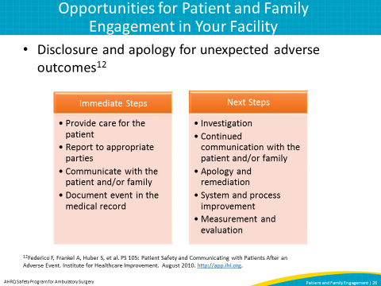
SAY:  A facility adviser is a former patient or a family member of a former patient who is a collaborative partner at all stages in developing facility policies, procedures, and practices.  Advisers collaborate with facility staff to develop patient- and family-centered policies and procedures. ASC staff members rely on the opinions of patient and family advisers and consult them when deciding matters concerning patient experiences, health care quality and safety, care delivery, educational materials, and facility design. Patients and family members traverse many levels of the health care system and have a global perspective on quality and safety issues that often escapes providers.  ASK:  Are patients and family members currently playing an advisory role at your facility? If not, is there an opportunity for patient advisers? | Slide 27  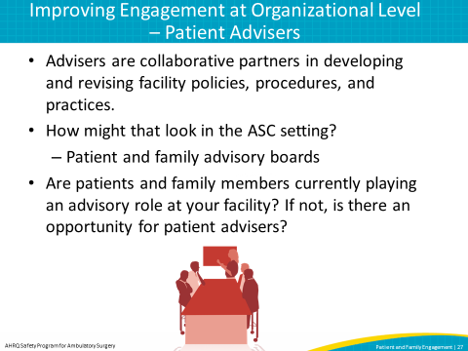
SAY:  Effective engagement and communication among patients, family members, and other members of the health care team impact health outcomes and patient, family, and staff satisfaction.  Although patients, families, and health care personnel face barriers to engaging in patient care, creating a patient-centered environment that encourages open communication by all parties and involves patients and families in their care can facilitate engagement.  Opportunities for engagement exist throughout the ambulatory surgery center experience.  Organizations should be prepared to respond and communicate proactively when adverse events occur. | Slide 28  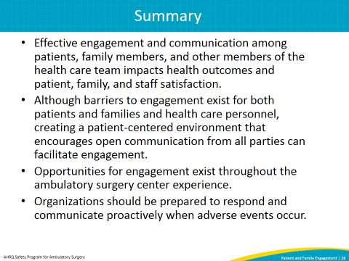
SAY:  The tools in this module will assist ASC facilities in participating in patient and family engagement within their facility, as well as in presenting communication strategies to patients and family members. Please note that some of these tools may need to be further modified for the ASC environment or tailored directly for your facility or department.  For patients and families:  Get To Know Your Health Care Team  This tool gives patients and family members an overview of the roles and responsibilities of their health care team.  Getting Ready for Your Ambulatory Surgery  Provides information to patients and families about how to prepare for the day of surgery.  Questions Are the Answer  This serves as a question prompt sheet for patients to remember to ask their provider important questions about their care.  For providers:  Advancing the Practice of Patient- and-Family-Centered Care in Primary Care and Other Ambulatory Settings. How to Get Started…  This brochure helps facilities learn about patient- and family-centered care and provide guidance and resources to help facilities incorporate the concepts into practice.  Readiness for Advisers  This tool allows providers to assess how ready they are to engage with patients and family members within their facility, according to their beliefs and level of comfort with the engagement process.  Senior Leader Checklist  This tool helps leaders and staff plan, implement, and evaluate patient and family engagement in safety projects in ambulatory surgery environments.  IDEAL Discharge Planning  Explores the components of a discharge plan and provides guidance on involving the patient and family members in the discharge discussion.  For more support tools and free downloads, please refer to the Patient- and Family-Centered Care Web site at http://www.ipfcc.org.  For ongoing implementation support, please refer to “A Leadership Resource for Patient and Family Engagement Strategies.” | Slide 29  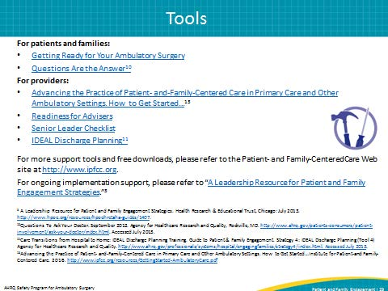
Slide 30
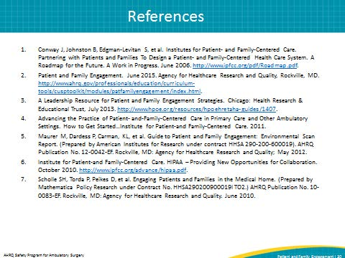
Slide 31
