**Do you have trouble remembering to take your medicines?**

**Ask us for help in setting up a system.**

**We can provide:**

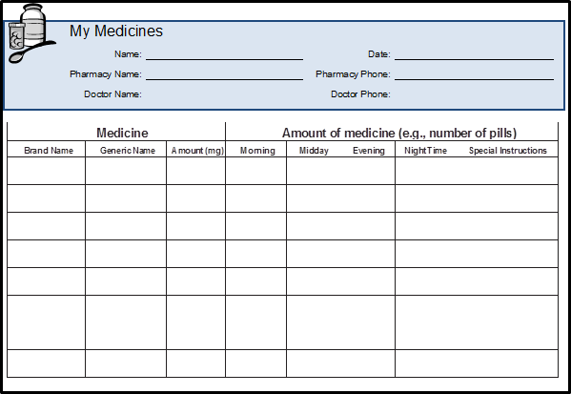**1. Medicine Chart—**

A list of your medicines, when to take them, and why you take them.

MCj02805600000[1]**2. Medicine Card—**

A picture of your medicines and when to take them.

**3. Pill Box—**

A plastic box with sections to hold the pills you take in the morning, noon, evening, and bedtime.