Fall Prevention Toolkit

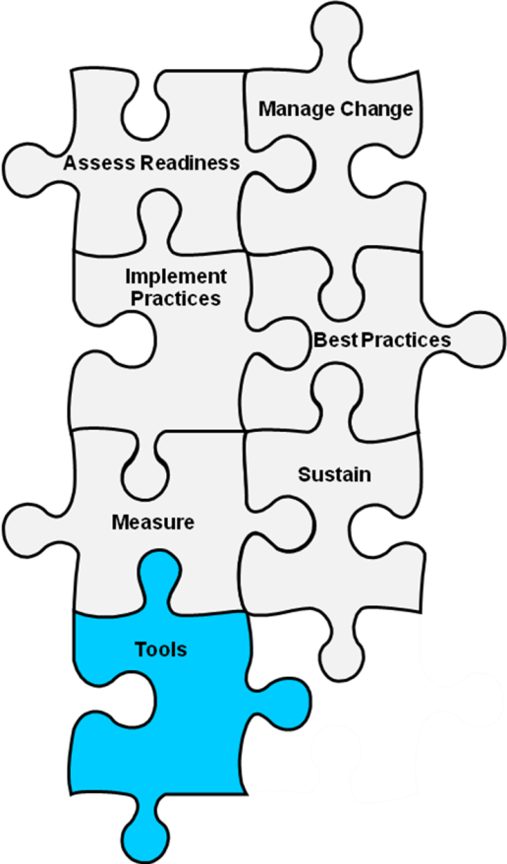
Module 4 Tools
Tool 4A: Assigning Responsibilities for Using Best Practices
Tool 4B: Staff Roles
Tool 4C: Assessing Staff Education and Training
Tool 4D: Implementing Best Practices checklist
Action Plan for Fall Prevention Staff Education and Training

4A: Assigning Responsibilities for Using Best Practices
Background: This tool can be used to determine who will be responsible for each task identified in your set of best practices for preventing falls. One way to generate interest and buy-in from the staff is to ask them to self-assign their responsibilities from a prioritized list of tasks that need to be accomplished.
Reference: Developed by Falls Toolkit Research Team.
How to use this tool: Complete the table by entering the different best practices and the specific individuals who will be responsible for completing each task. This tool should be filled out by the Implementation Team leader in collaboration with the other team members.
Use this tool to assign and clarify the roles and responsibilities of each staff member. Types of staff and the types of responsibilities they might take on are summarized in Tool 4B, “Staff Roles.”

What practices will we use? | Who will be responsible?
Example:  Perform comprehensive fall risk assessment on admission, daily, or if condition deteriorates. | Example:  RN

4B: Staff Roles
Background: This table gives an example of how responsibilities may be assigned among different staff members on the Unit Team and hospital personnel whose work brings them to the unit or includes interactions with the unit.
Reference: Developed by Falls Toolkit Research Team.
How to use this tool: The unit manager can use this tool to help assign specific individuals or groups to each task in Tool 4A, “Assigning Responsibilities for Using Best Practices.”

Staff | Roles
RN | - Conducts or supervises accurate assessment and documentation of assessment of fall risk factors on admission, daily, and if condition deteriorates (or according to facility policy).  - Documents care plan tied to identified risk:  - Mental status.  - Continence.  - Mobility level.  - Environmental risks (e.g., hooked up to IV).  - Performs or supervises performance of care plan procedures or treatments:  - Close observation of delirious patients.  - Toileting schedule.  - Use of assistive devices.  - Maintenance of clutter-free environment.  - Files incident report for new falls and carries out postfall assessment.  - Educates patient/family about fall risk factors.
LPN | - Conducts accurate assessment and documents assessment of fall risk factors on admission, daily, and if condition deteriorates (or according to facility policy).  - Documents care plan tied to identified risk:  - Mental status.  - Continence.  - Mobility level.  - Environmental risks (e.g., hooked up to IV).  - Performs or supervises performance of care plan procedures or treatments:  - Close observation of delirious patients.  - Toileting schedule.  - Use of assistive devices.  - Maintenance of clutter-free environment.  - Collaborates with other staff to ensure timely and accurate reporting of any falls and completion of postfall assessment.
CNA | - Reports any new fall risks to nurse.  - Keeps environment around bed clutter free.  - Offers assistance with toileting for patients with frequent toileting needs.  - Keeps assistive devices within easy reach of patient.
Treating medical provider (e.g., physician, nurse practitioner, physician assistant) | - Reviews needs for specific types of rehabilitation therapy and orders such therapy, if appropriate.  - Writes orders for activity level.  - Reviews medications for fall risk.
Physical and/or occupational therapist | - Assesses patient’s function and mobility levels according to scheduled protocol (e.g., after orthopedic procedures) or upon consultation.  - Determines need for assistive devices and exercise program according to scheduled protocol (e.g., in rehabilitation unit) or upon consultation.  - Educates patient and family on safety with transfers and ambulation.
Pharmacist | - Reviews medication lists of patients at high risk based on medication profile.  - Discusses medications that may increase fall risk with physician using standardized approach (e.g., note in chart, rounds with hospitalist).
Environmental services staff | - Responds to reports of fall hazards (e.g., spills).  - Keeps rooms and hallways free of clutter.
Dietitian | - Monitors patient’s weight and nutritional status to avoid unintentional weight loss and loss of muscle mass.  - Provides tube feed regimens that maximize mobility (e.g., choosing bolus rather than continuous tube feeding where appropriate).
Patient educator | - Works with nurse to provide appropriate educational materials and teaching to patients at risk for falls and their families.
Facilities engineer | - Participates in regularly scheduled environmental rounds to identify equipment in need of repair.  - Responds to repair requests submitted by unit staff.
Information technology support personnel | For units with electronic health records:  - Develops or refines documentation systems for fall risk assessment and care planning.  - Develops or refines computerized order sets (e.g., mobility protocol).  - Implements computerized alerts for medications that present high risk for falls, where appropriate.

4C: Assessing Staff Education and Training
Background: The purpose of this tool is to assess current staff education practices and to facilitate the integration of new knowledge on fall prevention into existing or new practices.
Reference: Adapted from Facility Assessment Checklist developed by Quality Partners of Rhode Island. Available at: www.healthinsight.org/Internal/assets/Nursing%20Home/PRU%20-%20Facility%20Assessment%20Checklist.pdf.
How to use this tool: Complete the form by checking the response that best describes your hospital. This tool should be filled out by the Implementation Team leader or designee in collaboration with the other team members.
This tool can be used to identify areas for improvement and develop educational programs where they are missing.

Facility Assessment
Date:
A. Does your hospital have initial and ongoing education on fall prevention and management for both nursing and nonnursing staff?
__ No. If no, this is an area for improvement.
__ This is an area we are working on.
__ Yes.
B. Does your facility’s education program for fall prevention and management include the following components?
 | Yes | No | Person Responsible | Comments
Are new staff assessed for their need for education on fall prevention and management?
Are current staff provided with ongoing education on the principles of fall prevention and management?
Does education of staff provide discipline-specific education for fall prevention and management?
Is there a designated clinical expert available at the facility to answer questions from all staff about fall prevention and management?
Is the education provided at the appropriate level for the learner (e.g., CNA vs. RN?)
Does the education provided address risk factor assessment tools and procedures?
Does the education include staff training on documentation methods related to falls (e.g., circumstances of fall if applicable, risk factors for falls, how those risk factors have been addressed)?

C. In which areas of knowledge does the assessment suggest staff need more education?

4D: Implementing Best Practices Checklist
Background: This tool can be used to monitor your progress on implementing best practices.
Reference: Developed by Falls Toolkit Research Team.
How to use this tool: The Implementation Team leader (or individual designated by the leader) should complete the checklist.
Use this tool to ensure you have not skipped any essential steps in your fall prevention efforts.

Implementing best practices checklist
Task | Date Completed
Roles and Responsibilities of Staff
Assign specific roles and responsibilities to:
Members of the Unit Team
Unit Champion
Organizing the Prevention Work
Identify paths of ongoing communication and reporting
Develop mechanisms to address accountability
Identify strategies for building new practices into daily routine
Refine preliminary implementation plan
Ensure support from key stakeholders
Initiate plan to pilot test new practices
Establish strategy for engaging staff
Create education plans to help staff learn new practices

Action Plan for Fall Prevention Staff Education and Training
Best Practices to be Used | Staff Education Needs | Who will be responsible?
 |  | For Training Development | For Training Implementation
Example:  Perform standardized fall risk assessment on admission, daily, or if condition deteriorates. | Example:  Didactic training on using the Morse or Stratify Fall Risk Factor Assessment Scale | Example:  Education Department | Example:  Nursing Department

