Module 2: How To Manage Change

Module Aim
The aim of this module is to support change in your organization to maximize the possibility of successful implementation of the Pressure Injury Prevention Program.

Module Goals
The goals of Module 2 are to identify necessary actions to improve organizational readiness and maximize the possibility of successful implementation of the Pressure Injury Prevention Program by addressing the following questions:
- How can you set up the Implementation Team for success?
- What needs to change, and how do you need to redesign practice?
- How should goals and plans for change be developed?
- How do you bring staff into the process?

Timing
This module will take 90 minutes to present.
Allow 10 minutes to present slides 1–8. That leaves 80 minutes to present and discuss the findings from Tools 2A, 2B, 2C, 2D, 2E, 2F, and 2I (slides 9–27).

Learning Methodology Checklist
- Large group discussion
- PowerPoint slide presentation

Additional Related Training Resources
- Toolkit for Using the AHRQ Quality Indicators: How To Improve Hospital Quality and Safety https://www.ahrq.gov/professionals/systems/hospital/qitoolkit/index.html

Materials Checklist
- LCD projector and laptop
- “Parking lot” flip chart page (with tape or sticky band) and markers
- Flip chart page with “Ground Rules” written at the top

Instructor Preparation
- Add the specific hospital name to the first slide.
- Discuss with the Team Leader if the hospital currently uses a quality improvement (QI) change methodology, such as Plan, Do, Study, Act (PDSA); Lean Six Sigma (LSS); or another methodology.
- Meet with the Team Leader(s) prior to the day of training to decide how the Team will operate. Address the following questions and present the decisions during Slide 6:
Questions
1. How often will the Team meet? (The recommended meeting frequency is once a week, at least in the beginning.)
2. What are the ground rules for managing meeting time and communication?
How will you communicate about progress on assignments? In person? Via email?
How will the patient care Unit Team communicate with the Implementation Team?
How will you communicate about successes?
Ask your Information Technology (IT) Team member for ideas on how to communicate electronically between meetings to keep all Team members updated on progress.
3. How will the Team do its work?
Will you do most of your work in small groups and update everyone at the weekly meetings? Or do you plan to have working meetings?
- Alert the Implementation Team Leaders(s) or designee(s) to be ready to present and discuss findings from Tools 2A, 2B, 2C, 2D, 2E, and 2F.
Assessment Topic | Completed With Copies? Y/N | Presenter
Tool 2A: Multidisciplinary Team
Tool 2B: Quality Improvement Process
Tool 2C: Current Process Analysis
Tool 2D: Assessing Pressure Ulcer Policies
Tool 2E: Assessing Screening for Pressure Ulcer Risk
Tool 2F: Assessing Pressure Ulcer Care Planning
- Alert the Implementation Team Leader to be ready to discuss and decide who will oversee administering the Pieper Pressure Ulcer Knowledge Test to staff, and who will be in charge of assessing the results and folding them into planning for staff training. (This happens during slides 19–20.)
- Have the PowerPoint file Module 2 cued on the computer and minimized.
- Have a copy of the following materials for all participants:
- Module 2 PowerPoint slide presentation handout, 3 slides to a page
- Tool 2A: Multidisciplinary Team (completed by the Implementation Team Leader, with names and positions of Implementation Team members)
- Tool 2B: Quality Improvement Process (completed by the Implementation Team Leader or designee)
- Tool 2C: Current Process Analysis on patient care unit(s) (completed by the Implementation Team Leader or designee)
- Tool 2D: Assessing Current Pressure Ulcer Policies (completed by the Implementation Team Leader)
- Tool 2E: Assessing Screening for Pressure Ulcer Risk (completed by the Implementation Team Leader or designee)
- Tool 2F: Assessing Pressure Ulcer Care Planning (completed by the Implementation Team Leader or designee)
- Tool 2I: Action Plan

Module 2: How To Manage Change
Slide | Script
Slide 1  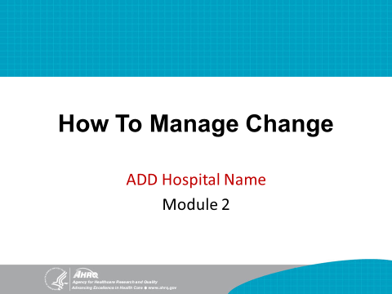 | SAY: This training module focuses mainly on managing the change process, which starts with assessing the current state of pressure injury prevention practices in this hospital.
Slide 2  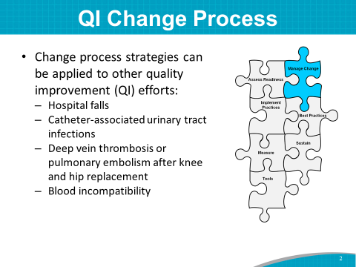 | SAY: The strategies used in the change process for pressure injury prevention can also be applied to other quality improvement efforts in a hospital, such as preventing:  - Hospital falls.  - Catheter-associated urinary tract infections.  - Deep vein thrombosis or pulmonary embolism following knee or hip replacement.  - Blood incompatibility.
Slide 3  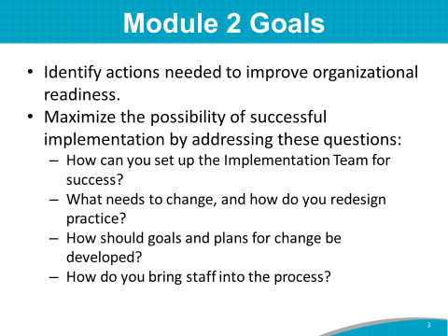 | SAY: The goals of Module 2 are to:  - Identify needed actions to improve organizational readiness.  - Maximize the possibility of successful implementation of the Pressure Injury Prevention Program by beginning to address the following questions:  - How can you set up your Implementation Team for success?  - How does your Implementation Team work with other teams involved in pressure injury prevention?  - What needs to change, and how do you redesign practice? What aspects of the care process already follow best practices?  - How should goals and plans for change be developed?  - How do you bring staff into the process?
Slide 4  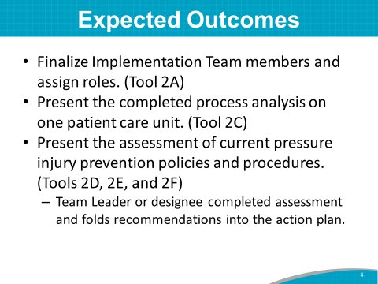 | SAY: The expected outcomes of Module 2 are to:  - Finalize the Team members and their roles.  - Review and discuss the completed process analysis on one or more patient care units.  - Review and discuss the completed assessments of this hospital’s current pressure injury prevention policies and procedures. (Name of Implementation Team Leader or designee) has already completed the tools.  This module discusses the assessment of what is currently happening in pressure injury prevention policies and practices in this hospital.  Our discussion of the results will help identify areas that need improvement. Determining current practices is an important step in figuring out what needs to change to improve our hospital’s pressure injury prevention practices.
Slide 5  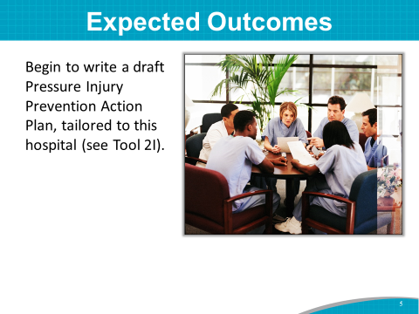 | SAY: We’ll start by identifying and prioritizing opportunities for improvement, and then we’ll begin drafting a new or revised Pressure Injury Prevention Action Plan tailored to this hospital, using Tool 2I.  At the end of this module, we’ll draft preliminary Action Plan tasks for Key Intervention 1: Analyze current state of pressure injury prevention practices at this institution.
Slide 6  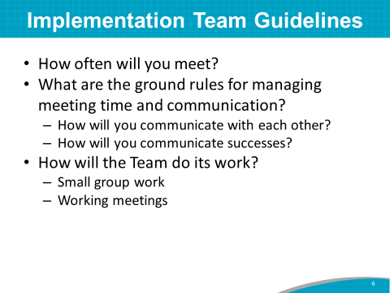 | SAY: The Team Leaders met before this training to decide how the Team will operate.  Instructor’s Note: Communicate the decisions the Team Leaders made. Tailor the following statements to reflect the decisions:  SAY:  - The Team Leaders decided that the Team will meet at least weekly in the beginning, every (day of the week) at (time of day).  - The Team Leaders decided that the Team will communicate via (email/intranet site/in person/other) with all Team members about our meetings and progress on assignments. The patient care Unit Team or frontline staff will communicate with the Implementation Team via (Unit Champions/Unit Manager/other). The Team will communicate successes by (unit learning board/presentations to hospital board/written progress updates/other) to all stakeholders.  - The Team Leaders decided that the Team will (do most of the work in small groups and update everyone at the weekly meetings/have working meetings).  DO: Write the decisions on the flip chart.
Slide 7  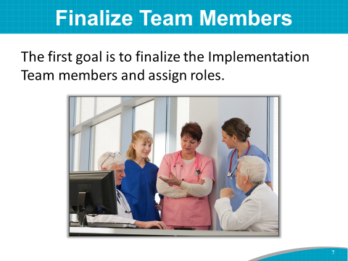 | SAY: The first goal is to finalize the Implementation Team members and assign roles.  Instructor’s Note: The Implementation Team may be called by a different title at the hospital, such as the Pressure Injury Prevention Group or the Wound Care Group. The Team may have a different name than the title in the Toolkit.
Slide 8  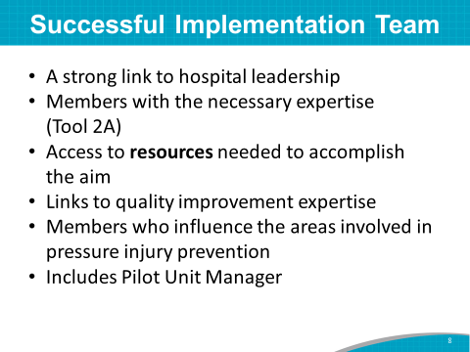 | SAY: A successful Implementation Team has:  - A strong link to hospital leadership (a champion from senior leadership).  - Members with the necessary expertise (Tool 2A).  - Access to resources needed to accomplish the aim.  - A link to quality improvement expertise (that is, someone with expertise in systematic process improvement methods and in team facilitation from the quality improvement or performance improvement department).  - Members who influence the areas involved in pressure injury prevention.  - Membership of the Unit Managers from the pilot study patient care units.  Instructor’s Note: If the Team has a project charter that was developed and shared in Module 1, you may be able to share again the leadership sponsor of the project and other information on the charter.
Slide 9  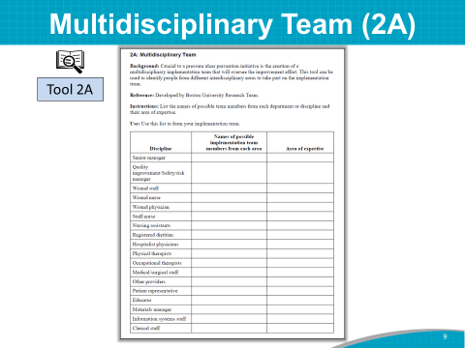 | DO: Using a laptop, display completed Tool 2A on the wall, or hand out copies of completed Tool 2A.  SAY: (Name of Implementation Team Leader) has identified the Team members and their discipline or expertise. You are the Implementation Team.  ASK: Is there anyone else you think should be on the Team?  DO: Write down the names of suggested additions to Tool 2A.  SAY: Later, you can fill in the names of others who will be on the Team on an as-needed basis.  Instructor’s Note: If you don’t already have a senior administrative manager listed, consider adding a member from the top-level hospital administration’s office. You will likely need an administrative champion for the Pressure Injury Prevention Program. This will help ensure there is a budget allocated for patient safety activities and help create a hospital culture whereby patient safety is a priority.
Slide 10  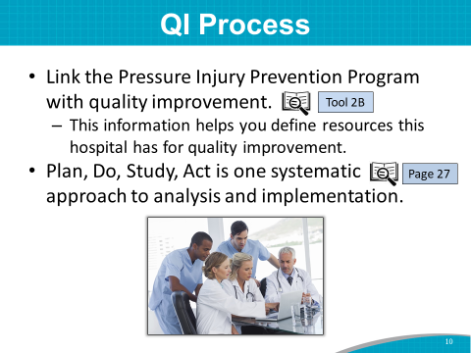 | SAY: A hospital QI Team or expert can lend tremendous expertise to the Implementation Team by helping to apply a systematic approach to the change process.  The purpose of Tool 2B: Quality Improvement Process Tool is to link the Pressure Injury Prevention Program with your QI program. The information gleaned from the questions in this tool is intended to help you define the extent to which this hospital has QI resources.  Improvement efforts tend to be most successful when teams follow a systematic QI approach to analysis and implementation. Multiple approaches are available. The Plan, Do, Study, Act, or PDSA, approach and other systematic approaches are described on page 27 of the Toolkit.  ASK: Do you use the PDSA approach in this hospital for quality improvement projects? If not, do you use another systematic quality improvement approach?
Slide 11  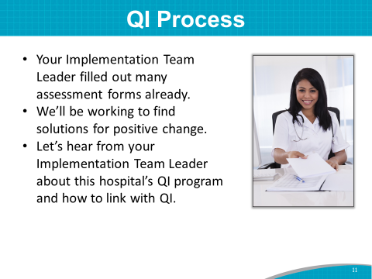 | SAY: (Name of Implementation Team Leader or designee) filled out Tool 2B in consultation with the QI Department. The idea is to connect the Pressure Injury Prevention Program with existing processes and identify opportunities for improvement to strengthen quality and performance. (Name), will you please share the findings from this tool?  DO: Have the Implementation Team Leader or designee review the findings of Tool 2B with the group and suggest ways to link with QI in the hospital.
Slide 12  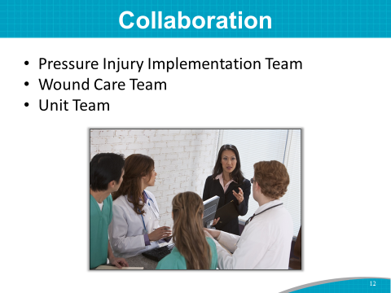 | SAY: The Implementation Team cannot carry out the entire project alone. In addition to the QI Team, the Implementation Team will need to collaborate with at least two other types of teams in any patient care unit where changes are to be implemented: the Wound Care Team and the Unit Team.  ASK: Do you have a Wound Care Team or Wound Care Nurse in this hospital?  SAY: The next slide illustrates the relationship between the three possible teams.  Instructor’s Note: Depending on the hospital, prevention tasks may be carried out by a variety of professionals (e.g., the Wound Care Team works on the project, but the Implementation Leads manage the project). They may also refer to their teams by other names.
Slide 13  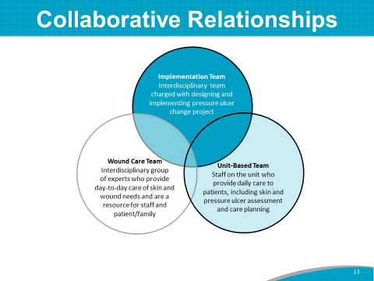 | SAY: This slide shows the overlapping and interdisciplinary nature of the team roles.  The Implementation Team should outline roles for the other teams that are clear and workable.  The Implementation Team should also consider what ongoing communication and reporting are needed and what the best linking methods across the teams might be.  Again, use the IT Team member, as he or she may have good ideas for how to communicate electronically between meetings to keep all Team members updated on progress.
Slide 14  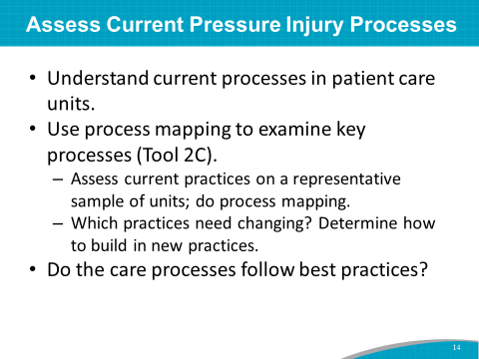 | SAY: As we mentioned in the beginning of this module, the second goal is to work through the current process analysis of pressure injury prevention practices in this hospital. Again, this tool was (started/completed) by (name of Implementation Team Leader or designee) prior to today’s training using Tool 2C.  By doing a process analysis, you can find out what process this hospital currently uses for pressure injury prevention.  A process analysis usually answers these questions:  - What prevention practices are being used, and when does the practice occur?  - Who does it?  - What happens if a patient is found to have risk factors or experiences a pressure injury?  Once you examine and understand current practices that are being used to help prevent pressure injuries, you can assess:  - If the care processes follow best practices.  - What practices need changing.  - How to build new practices into ongoing routines.
Slide 15 | Practice Insight  SAY: An acute-care hospital used a 2-month shadowing program to assess how Skin Wound Analysis Team (SWAT) consults were handled on the units. A SWAT representative, nurse manager, and quality representative shadowed nursing staff to ensure they were consulting SWAT when needed and implementing orders.  The shadowing worked, with strong SWAT membership buy-in. Because of this process analysis, a standardized SWAT consult process was instituted and monitored. Nursing staff were held accountable when they did not follow the process. The program required the nurse manager to validate orders to ensure they were being followed and in place at the bedside. A quality representative checked charts and conducted random bedside checks to make sure the process was hardwired.
Slide 16  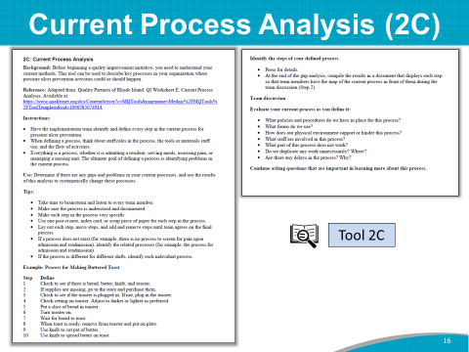 | SAY: The Implementation Team Leader asked (names) to conduct the mapping.  Assessment results can be compared across units to determine:  - Which prevention challenges are organizationwide and which may be unit specific.  - Which practices need changing and how the new practices can be built into ongoing routines. (We will discuss this process in Module 3.)
Slide 17  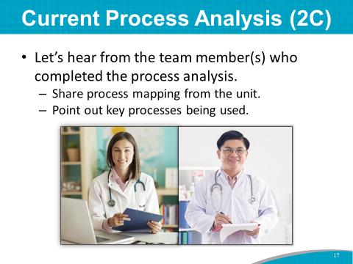 | SAY: (Name) has completed a process analysis of (name of patient care unit). I’d like to have (him/her) describe how (he/she) mapped the key processes of pressure injury prevention activities and then share the process mapping from these units. (He/she) will point out the key processes being used.  DO: Show the completed Tool 2C via computer projection, or hand out in hard copy.  SAY: As (name) is presenting this process analysis, please jot down notes and ideas about the process. Ask yourself:  - Are we following this process?  - Is this process working? Why or why not?  - What changes might be needed?  DO: After the process has been presented, ask for a few people to share what they made note of. Encourage participants to keep their list handy for consideration when developing the Action Plan later in the training. Capture all responses to the above questions on the flip chart.  SAY: These findings will help determine which practices may need to be changed. They will also show areas where staff training may be needed.  Instructor’s Note: This may be a difficult assignment for the Team. A draft process analysis on the pilot study unit would be a good start.
Slide 18  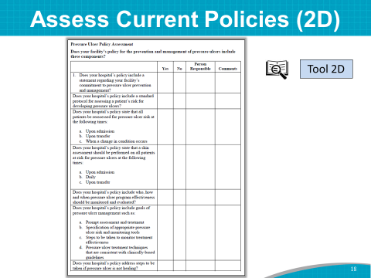 | SAY: The process analysis we just heard about is the flow of what and how pressure injury prevention practices are currently conducted on the patient care units.  Goal 3 for the Module 2 training is to assess the current written pressure injury prevention policies and procedures in the hospital using Tool 2D.  This assessment tool helps you identify what processes of care this hospital has in place and what areas need improvement.
Slide 19  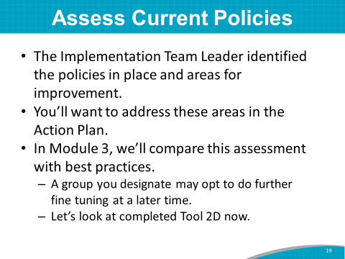 | SAY: (Name of Implementation Team Leader or designee) filled out Tool 2D to assess and identify areas that need improvement.  DO: Show the completed Tool 2D via computer projection, or hand out in hard copy.  SAY: (Name of Implementation Team Leader or designee) identified the following policies that are in place and areas that could use improvement. We will compare this assessment with best practices in Module 3. This assessment may undergo further fine tuning by your group later.  (Name of Implementation Team Leader or designee), please present the findings from your assessment of the current pressure injury prevention policies and procedures.  While (name) is presenting this assessment, please jot down notes and ideas about policies and procedures.  Ask yourself:  - Are we following these policies and procedures?  - Are these policies and procedures working? Why or why not?  - What changes might be needed?  DO: After the policies and procedures have been presented, ask for a few people to share what they made note of. Encourage participants to keep their list handy for consideration when developing the Action Plan later in the training. Capture responses to the above questions on the flip chart.  SAY: Thank you, (name of presenter), for reviewing the assessment. It will be very helpful when we get to Modules 3 and 4, when we will decide on best practices and how to implement the best practices for a multicomponent program.
Slide 20  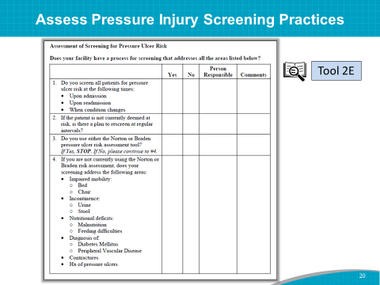 | SAY: Next, we have results from an assessment on when and how any pressure injury risk screening is done in the hospital.  (Name) completed this assessment and will walk us through Tool 2E, which assesses screening practices for pressure injury risk in patients.  DO: Have the Implementation Team Leader or designee review Tool 2E with the group.
Slide 21  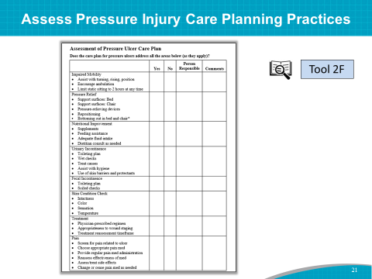 | SAY: (Name), please present the assessment of the current care planning process (Tool 2F).  DO: Have the Implementation Team Leader or designee review Tool 2F with the group.  ASK: Are there any questions about the current care planning process?  Does this hospital’s pressure injury care plan include all areas of risk listed in Tool 2F? If not, which areas of risk are not represented?
Slide 22  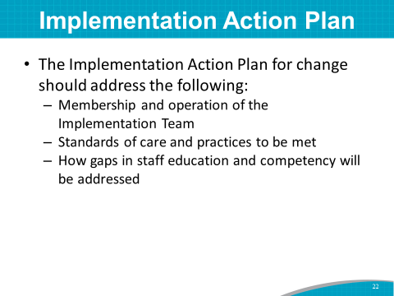 | SAY: Now that you have completed and discussed assessments of current policies and practices, you understand what this hospital currently does to prevent pressure injuries. These completed assessments will help you determine what should be changed in this hospital. You may already have a sense of what needs to change to improve hospital-acquired pressure injury rates.  Using the completed assessment, we will begin to identify opportunities for improvement. These opportunities can then be prioritized to develop an Implementation Action Plan for the Pressure Injury Prevention Program. The Implementation Action Plan will address many areas:  - Membership and operation of the Implementation Team.  - Standards of care and best practices to be met.  - How gaps in staff education and competency will be addressed. This task requires time and effort, so set realistic goals.
Slide 23  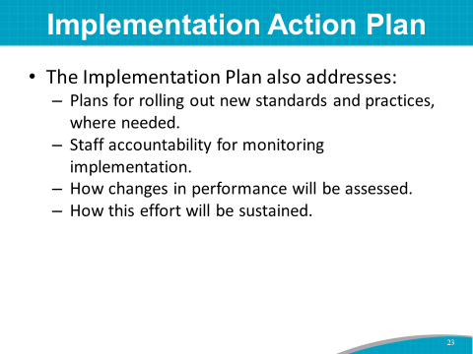 | SAY: The Implementation Action Plan also addresses your plan for rolling out new standards and practices where needed.  As mentioned earlier, the change process of rolling out new practices tends to be most successful when teams follow a systematic approach to analysis and implementation, such as the Plan, Do, Study, Act improvement process, described on page 27 of the Toolkit.  Consider implementing small tests of change, whereby one staff nurse tries out the new practice for one day, and then two or more nurses implement the new practice for one or two days. This helps to work out any problems before rolling out the new practice to the whole unit. This systematic approach (described on page 27) helps to perfect a practice.  Other items addressed in the Action Plan include:  - Staff accountability for monitoring implementation.  - The ways changes in performance will be assessed. Audits or observations by the Implementation Team occur at designated times (such as during the first, second, and fourth weeks after rollout).  - How this effort will be sustained.  This plan may look easy on paper, but getting to a sustained program may take up to 8 months or so from now.
Slide 24  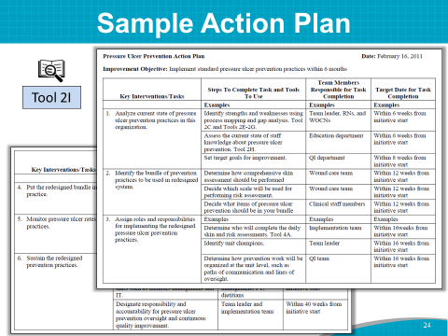 | SAY: We will use Tool 2I to develop the Implementation Action Plan.  This slide shows a sample Implementation Action Plan. Take out Tool 2I.  Tool 2I lists six key tasks. For each, the Implementation Team will write in the second column the steps that will be taken to address the task, including tools to be used.  In the last two columns, determine who will have lead responsibility for completing each task, and map out an estimated timeframe.  The plan should guide the implementation process, and it can be continually amended and updated during the planning stages.
Slide 25  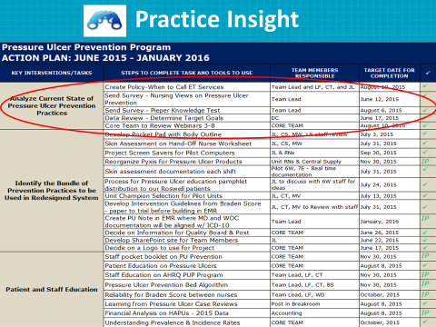 | Practice Insight  SAY: This slide shows an example of an Action Plan that was developed by a Team, like yourselves, to decrease pressure injury incidence in an acute-care hospital.  Let’s look at Key Intervention 1, which is to analyze the current state of pressure injury prevention in this organization. This hospital team completed the assessment tools from the Toolkit, just as you did. The remaining action items they identified for analyzing or assessing the current state of pressure injury prevention include:  - Create needed hospital policies.  - Assess educational needs and attitudes of nurses.  - Review historical pressure injury data to identify goals.  - Review pressure injury prevention training webinars.
Slide 26  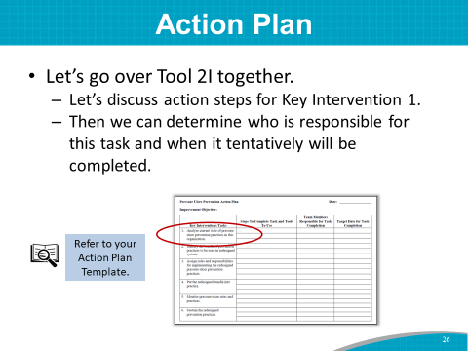 | DO: Start a discussion of action steps for the key interventions/tasks.  SAY: Let’s take a first stab at starting an Action Plan for this hospital, using the sample Action Plan as a guide. What are the steps to analyze the current state of pressure injury prevention in this organization (Key Intervention 1)?  DO: On the flip chart, write down steps the hospital Team would like to take to continue to assess the current state of prevention practices. Then do a quick prioritization exercise to identify the most impactful strategies for pressure injury prevention on the pilot units. Write the steps as participants present them.  ASK: Who is responsible for this task? What is a draft target date for completing this task?  DO: Write the Team member responsible and the target date for completion on the form.  SAY: Keep Tool 2I available in your packet of information, as we will fill out Key Interventions 2 to 5 in the upcoming modules.  Within 2 weeks of this training, the Implementation Team or a Core Pressure Injury Prevention Team should finalize the Action Plan and share it with the entire Team.
Slide 27  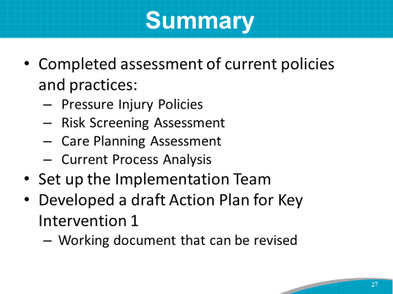 | SAY: In summary, you accomplished the following:  - You completed assessment of current policies and practices.  - Pressure Injury Policies  - Risk Screening Assessment  - Care Planning Assessment  - Current Process Analysis (may be in very draft form at this point)  - You finalized Implementation Team members and assigned roles using Tool 2A.  - You completed a prioritized list of opportunities for improvement or a draft Action Plan for Key Intervention 1.  - This is a working document that can be revised as the Team works through its planning processes.  You also decided on ground rules for the Team.  You accomplished a lot during this module. Let’s take a 15-minute break and then move on to Module 3.

